SUPPORTING INFORMATION FOR
Complete mineralization of acetic acid using catalytic ozonation with a high energy efficiency enhanced by MnO₂/γ-Al₂O₃
Ruiyun Meng¹ • Shuiliang Yao ^{1,2,*} • Erhao Gao ^{1,2} • Zuliang Wu ^{1,2} • Jing Li ^{1,2} • Erdeng Du¹
¹ School of Environmental and Safety Engineering, Changzhou University, Jiangsu 213164, China
² Advanced Plasma Catalysis Engineering Laboratory for China Petrochemical Industry, Jiangsu 213164, China

*Corresponding author
Shuiliang Yao
School of Environmental and Safety Engineering
Changzhou University
No. 21, Gehu Middle Road, Wujin District, Changzhou, Jiangsu 213164
People’s Republic of China
Email: yaos@cczu.edu.cu (Yao S)
Phone: +13738109696
S1: Additional experimental results
Fig. S1 O₃ concentration and O₃ concentration drop as a function of time during acetic acid ozonation without a catalyst

Fig. S2 Influence of ozonation temperature on acetic acid degradation without catalyst. Experimental condition: acetic acid concentration: 1.0 g L^{–1}, initial pH: 3.42, O₃ concentration: 30.0-40.0 g Nm^{–3}
Fig. S3 O₃ concentration drops at various ozonation time (a) and at different ozonation temperatures (b). Experimental condition: with catalyst as per Fig. 4g; without catalyst as per Fig. S2
Fig. S4 The influence of initial pH on the energy efficiency of acetic acid. Experimental condition: acetic acid concentration: 1.0 g L^{–1}, 3.0 g 1.0wt.% MnO₂/γ-Al₂O₃ catalyst dosage, 30.0-40.0 g Nm^{–3} O₃ concentration, 25 °C ozonation temperature

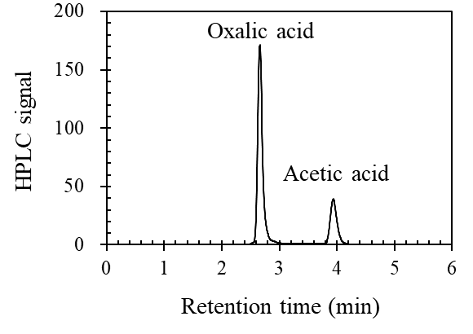
Fig. S5 HPLC spectrum of a liquid sample after 120-min acetic acid ozonation

