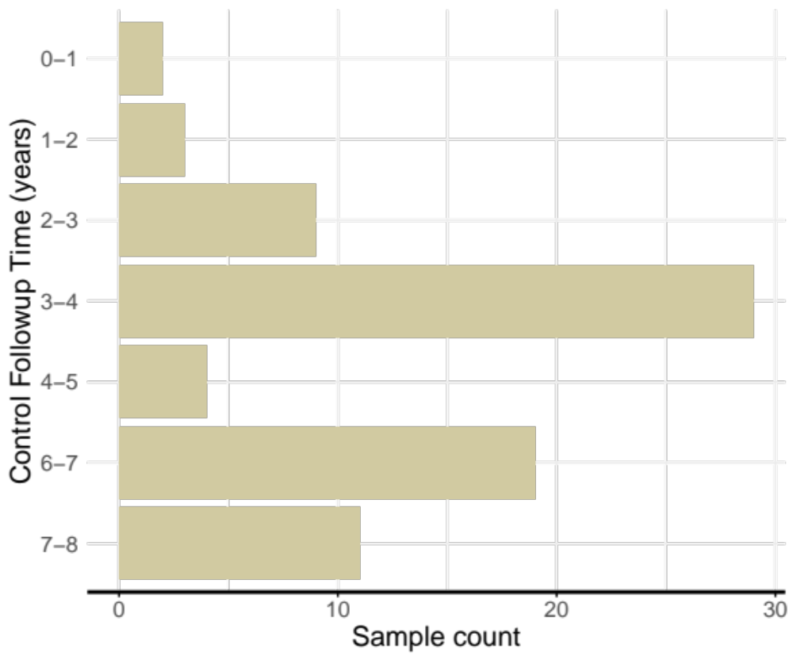
Extended Data Figure 1: Follow-up time distribution among cancer-free control plasma
Plasma samples from control participants (n = 72) were matched to cases by sex, age and time of sample collection. Each row represents incremental timepoints between blood collection and last date of follow up.

Extended Data Figure 2: Flowchart of filters applied to enrich for tumour-derived DMRs and reduce background regions methylated in peripheral blood leukocytes. Feature search space started with genome-wide coverage profiles across 9,542,589 300-bp nonoverlapping tiled windows. To reduce background signals derived from peripheral blood cells (PBLs) and enrich for tumour-derived signals, regions frequently methylated in PBLs whole-genome bisulfite sequencing data from IHEC were filtered out (n = 79). To enrich for CpG dense and regulatory regions, windows with at least six or more CpG sites, and located at CpG islands, shores, shelves, or FANTOM5 enhancers and promoters were selected. To enrich for tumour-derived cfDNA signal which are typically shed at low frequencies, we retained regions lowly methylated in train set controls

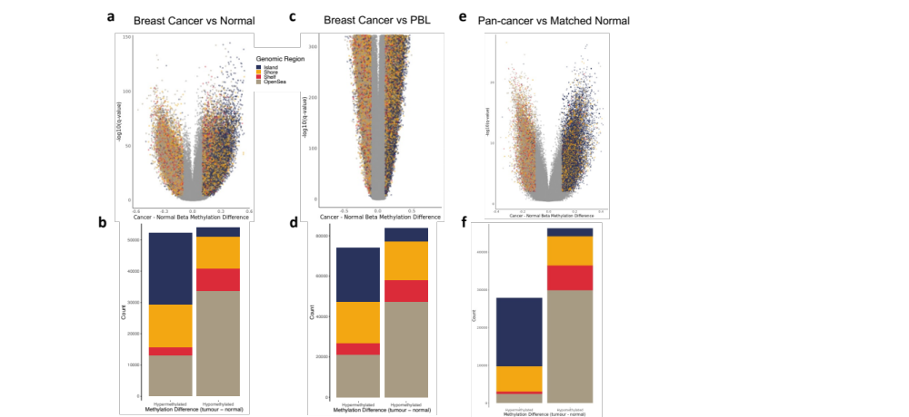
Extended Data Figure 3: Differential methylation analysis on 450k methylation array data between cancer and non-cancer tissues. Differential methylated CpG sites were identified between (a & b) TCGA breast cancer versus breast normal tissue, (c & d) breast cancer versus PBLs and (e & f) between 976 paired healthy and normal tissue biopsies spanning 12 cancer types (a, c & e). Volcano plot of differentially methylated CpG sites between tumour and normal tissues. Each dot is a CpG site colored by the location with respect to genomic regions. The x-axis represents log10 transformed FDR adjusted q-value, and the y-axis indicates the absolute difference in methylation between cancer and normal tissue (b, d & e) Number of significantly differentially methylated CpG sites hypermethylated and hypomethylated (FDR adjust mean q–value < 0.01 & absolute change in methylation > 0.1). Colors indicate genomic region CpG site is located in.

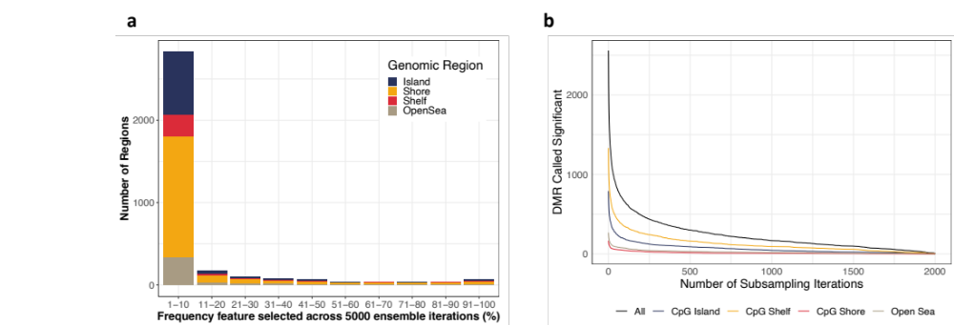

Extended Data Figure 4: Frequency of significantly (p < 0.05) hypermethylated pre-diagnosis breast cancer cfDNA DMRs passing all feature filters across 2000 subsampling iterations. (a) Proportion of subsampling iterations cfDNA regions were called significant. The x-axis represents the percentage of subsampling iterations and y-axis represents the number of significant regions called. (b) Total number of DMRs significant across increasing number of ensemble iterations. The y-axis represents the total number of regions significant across incremental number of subsampling iterations (x-axis). Colors indicate the genomic region of differentially methylated regions.

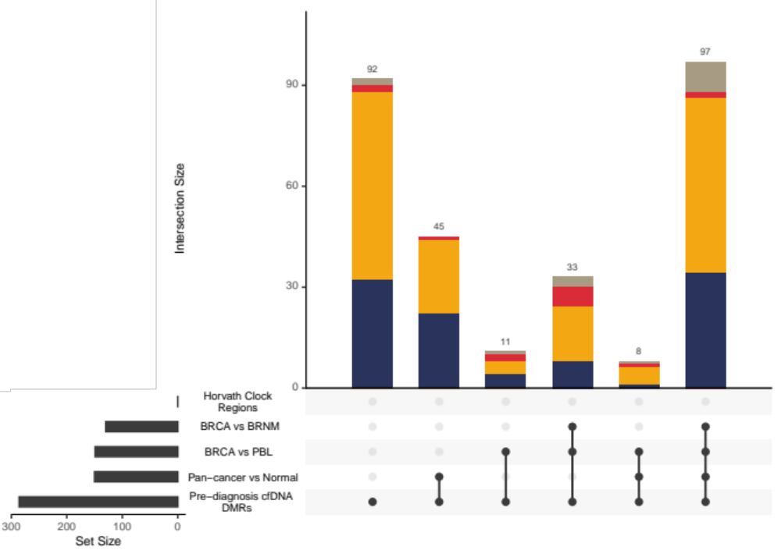

Extended Data Figure 5: Overlap between pre-diagnosis cfDNA DMRs and 450k methylation array tissue DMRs. Overlap between pre-diagnosis breast cancer cfDNA DMRs, pan-cancer DMRs between paired cancer versus normal tissue across 12 different tissue types, breast cancer versus breast normal tissue, and breast cancer versus PBL DMRs. 286 out of 487 pre-diagnosis breast cancer cfDNA DMRs contain at least one CpG site covered by 450k methylation array. Lines below bar plot indicate overlapping set of DMRs. Colors indicate the genomic region of differentially methylated regions.

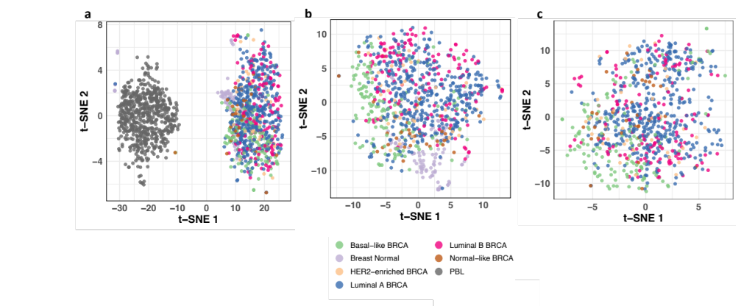
Extended Data Figure 6: t-SNE clustering of TCGA 450k methylation array of solid breast cancer tissue (n = 787), normal breast tissue (n = 97) and peripheral blood leukocytes (n = 628) across 85 CpG sites overlapping the top 50 pre-diagnosis breast cancer cfDNA DMRs. Clustering with (a) PBLs, breast cancer, and breast normal tissue, (b) breast cancer and breast normal tissue (c) breast cancer tissue only. Colors indicate PAM50 breast cancer subtypes, breast normal tissue or PBLs.

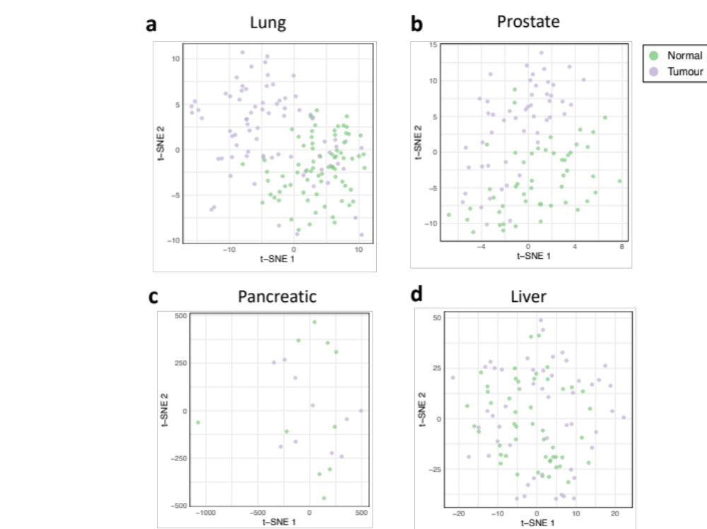
Extended Data Figure 7: t-SNE clustering of TCGA 450k DNA methylation array paired cancer and adjacent normal tissue using 85 CpG sites overlapping the top 50 pre-diagnosis breast cancer cfDNA DMRs. t-SNE clustering between paired (a) lung (b) prostate (c) pancreatic and (d) liver tissues. Colors indicate whether the tissue is cancer (purple) or normal (green)

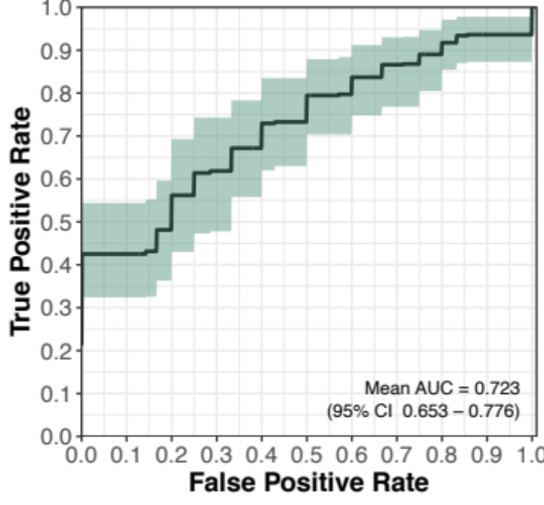
Extended Data Figure 8: Binary AUC performance across 200 10-fold cross validated repeats stratified by participants diagnosed with breast cancer at least three years after blood sample collection and among controls followed up to at least three years. Black lines indicate mean performance across 2000 subsampling iterations, and green shading indicate 95% confidence intervals

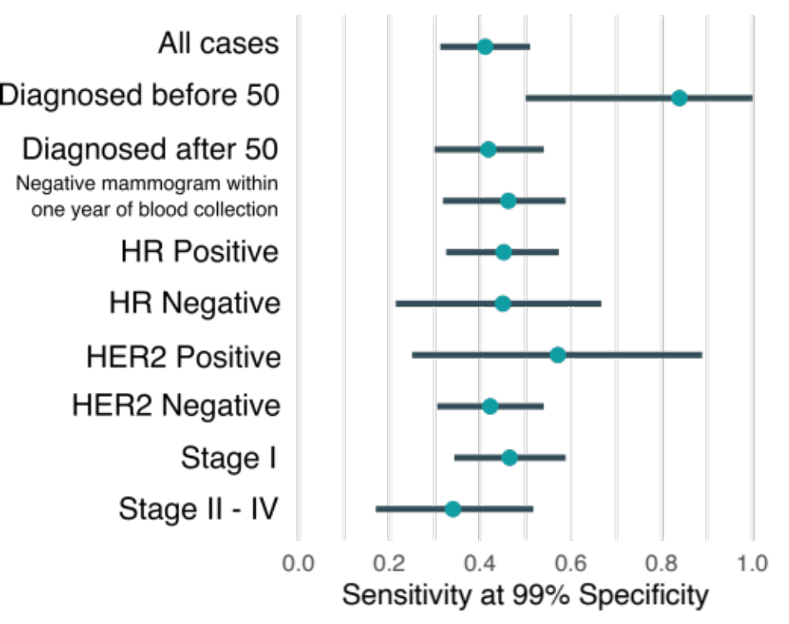

Extended Data Figure 9: Mean sensitivity at 99% specificity for predicting pre-diagnosis breast cancer subgroups across 200 10-fold cross validated repeats. Dots indicate mean sensitivity and lines represent confidence intervals. Subgroups include cases diagnosed before 50, cases diagnosed after 50, cases with a negative mammography within one year of biologic collection, breast cancer subtypes, and stage at diagnosis.

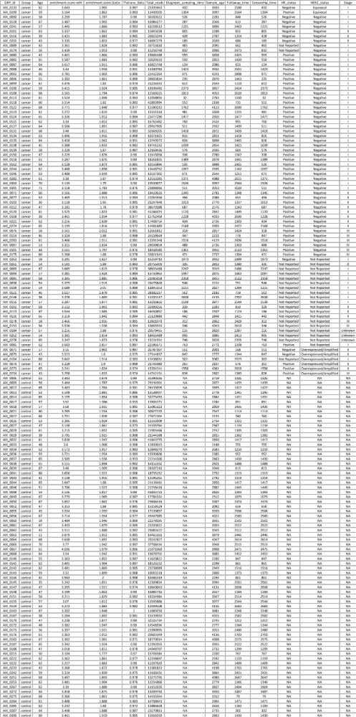
Extended Data Table 1: Sample quality control metrics and diagnosis information. Quality control metrics for sample inclusion and participant age at time of sample collection. Stage and tumour subtype indicated at time of diagnosis, in addition to time to diagnosis from blood collection indicated by diagnosis sampling time among cancer cases and follow up times among controls.

