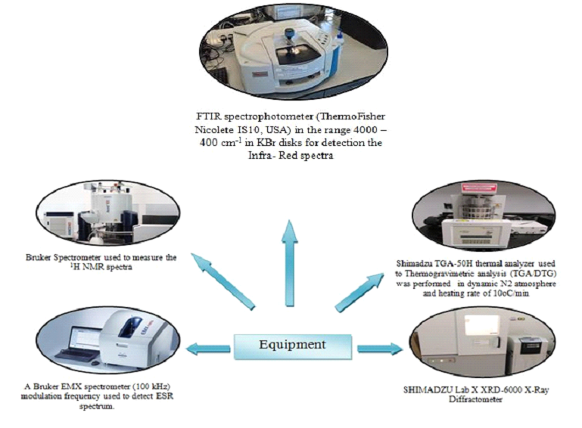

Scheme 1S. The equipment used to illustrate the isolated compounds
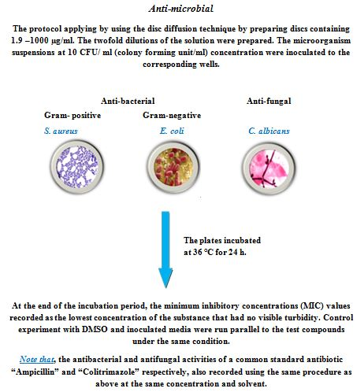

Scheme 2S.The antibacterial and antifungal activities for investigated compounds

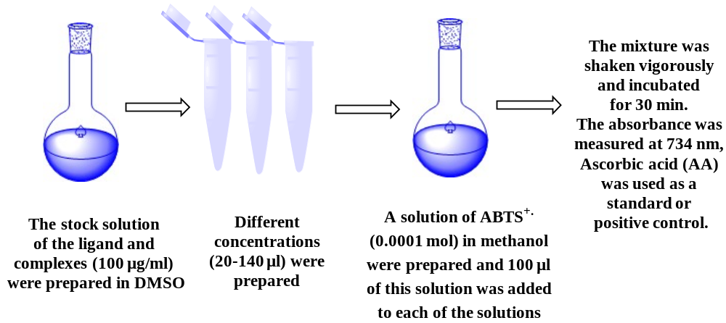

Scheme 3S: The outline of the steps of antioxidant activity assay ABTSfor ligands and their complexes

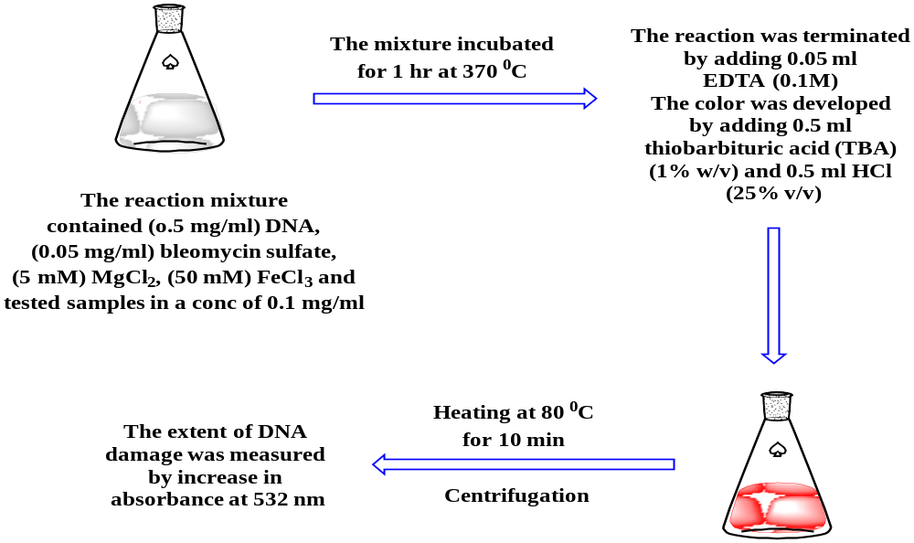
Scheme 4S: The outline of the steps of Bleomycin-dependent DNA damage for ligands and their complexes

(A)
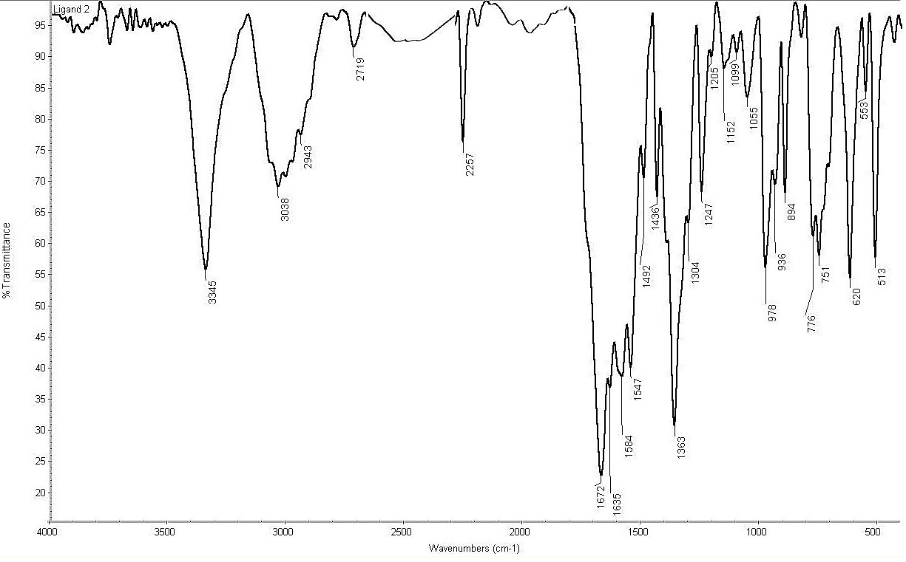

(B)
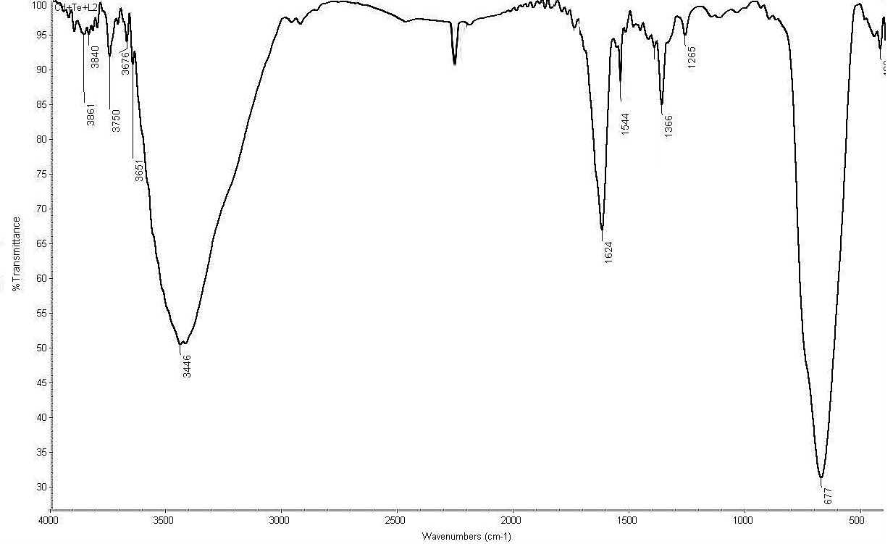

Fig. 1S. IR spectra of (A) HCPA and(B)Na₂[Cd(CPA)(TeO₃)(H₂O)Cl].2H₂O complex

(A)
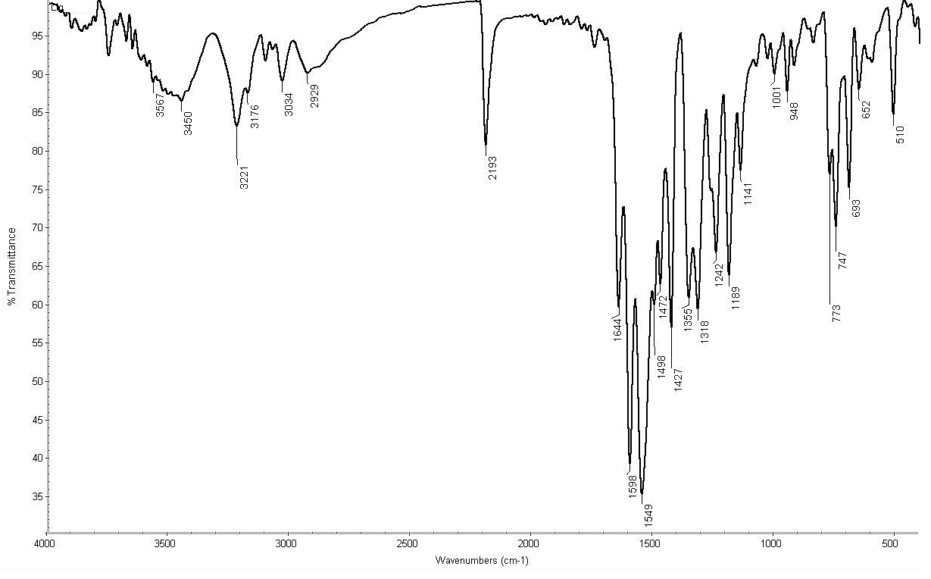

(B)

Fig. 2S. IR spectra of (A) HCMPPAand (B)Na₂[Cd(CMPPA)(TeO₃)(H₂O)Cl].2H₂O complex

Table 1S: Bond lengths (Å) of HCPA using DFT method

Bond | length (Å) | Bond | length(Å) | Bond | length (Å)
N(18)-H(19) | 1.012 | C(11)-O(12) | 1.211 | C(2)-H(8) | 1.084
C(16)-N(17) | 1.152 | C(5)-H(10) | 1.086 | C(2)-C(3) | 1.384
C(13)-C(16) | 1.459 | C(5)-N(6) | 1.340 | C(1)-N(18) | 1.402
C(13)-H(15) | 1.092 | C(4)-H(9) | 1.082 | C(1)-N(6) | 1.330
C(13)-H(14) | 1.093 | C(4)-C(5) | 1.388 | C(1)-C(2) | 1.407
C(11)-N(18) | 1.391 | C(3)-H(7) | 1.084
C(11)-C(13) | 1.527 | C(3)-C(4) | 1.397

Table 2S: Bond lengths (Å) of Na₂[Cd(CPA)(TeO₃)(H₂O)Cl].2H₂O complex using DFT method

Bond | length (Å) | Bond | length(Å) | Bond | length (Å)
C(26)-N(27) | 1.147 | C(13)-H(16) | 1.070 | O(3)-Te(8) | 1.964
N(22)-H(24) | 1.000 | C(12)-N(21) | 1.348 | O(2)-H(7) | 0.960
C(20)-C(26) | 1.540 | C(12)-H(15) | 1.070 | O(2)-H(6) | 0.960
C(20)-H(25) | 1.070 | C(12)-C(14) | 1.398 | Cd(1)-N(21) | 2.127
C(19)-N(22) | 1.452 | C(11)-N(22) | 1.479 | Cd(1)-Cl(10) | 2.400
C(19)-C(20) | 1.355 | C(11)-N(21) | 1.374 | Cd(1)-O(5) | 2.059
C(18)-H(23) | 1.070 | C(11)-C(13) | 1.405 | Cd(1)-O(4) | 2.131
C(14)-C(18) | 1.388 | Te(8)-O(9) | 1.786 | Cd(1)-O(3) | 2.131
C(14)-H(17) | 1.070 | O(5)-C(19) | 1.407 | Cd(1)-O(2) | 2.070
C(13)-C(18) | 1.391 | O(4)-Te(8) | 1.963

Table 3S: Bond lengths (Å) of HCMPPA using DFT method

Bond | length (Å) | Bond | length(Å) | Bond | length (Å)
N(32)-H(33) | 1.012 | N(19)-C(21) | 1.421 | C(5)-N(6) | 1.338
C(28)-H(31) | 1.084 | N(19)-H(20) | 1.011 | C(4)-H(10) | 1.079
C(26)-H(30) | 1.084 | S(17)-H(18) | 1.349 | C(4)-C(5) | 1.402
C(26)-C(28) | 1.394 | C(15)-N(16) | 1.157 | C(3)-H(7) | 1.084
C(24)-H(29) | 1.084 | C(14)-N(19) | 1.372 | C(3)-C(4) | 1.389
C(24)-C(28) | 1.394 | C(14)-S(17) | 1.777 | C(2)-H(9) | 1.083
C(23)-H(27) | 1.083 | C(13)-C(15) | 1.422 | C(2)-C(3) | 1.394
C(23)-C(26) | 1.392 | C(13)-C(14) | 1.381 | C(1)-H(8) | 1.086
C(22)-H(25) | 1.085 | C(11)-N(32) | 1.384 | C(1)-N(6) | 1.335
C(22)-C(24) | 1.392 | C(11)-C(13) | 1.500 | C(1)-C(2) | 1.391
C(21)-C(23) | 1.399 | C(11)-O(12) | 1.217
C(21)-C(22) | 1.399 | C(5)-N(32) | 1.406

Table 4S: Bond lengths (Å) of Na₂[Cd(CMPPA)(TeO₃)(H₂O)Cl].2H₂O complex using DFT method

Bond | length (Å) | Bond | length(Å) | Bond | length (Å)
C(34)-H(40) | 1.088 | C(23)-N(29) | 1.387 | C(11)-N(18) | 1.389
C(34)-C(35) | 1.411 | C(23)-S(27) | 1.845 | C(11)-C(13) | 1.429
C(33)-H(39) | 1.087 | C(22)-C(26) | 1.434 | Te(8)-O(9) | 1.840
C(33)-C(34) | 1.405 | C(22)-C(23) | 1.389 | O(5)-C(21) | 1.322
C(32)-H(38) | 1.087 | C(21)-C(22) | 1.482 | O(4)-Te(8) | 1.879
C(32)-C(33) | 1.408 | C(20)-H(24) | 1.087 | O(3)-Te(8) | 1.880
C(31)-H(37) | 1.087 | N(19)-C(21) | 1.327 | O(2)-H(7) | 0.971
C(31)-C(32) | 1.408 | C(14)-C(20) | 1.416 | O(2)-H(6) | 0.988
C(30)-H(36) | 1.086 | C(14)-H(17) | 1.085 | Cd(1)-N(18) | 2.280
C(30)-C(35) | 1.411 | C(13)-C(20) | 1.392 | Cd(1)-Cl(10) | 4.761
C(30)-C(31) | 1.404 | C(13)-H(16) | 1.083 | Cd(1)-O(5) | 2.183
N(29)-H(41) | 1.015 | C(12)-N(18) | 1.372 | Cd(1)-O(4) | 2.354
N(29)-C(35) | 1.434 | C(12)-H(15) | 1.086 | Cd(1)-O(3) | 2.378
S(27)-H(28) | 1.396 | C(12)-C(14) | 1.393 | Cd(1)-O(2) | 2.281
N(25)-C(26) | 1.184 | C(11)-N(19) | 1.379

(A)
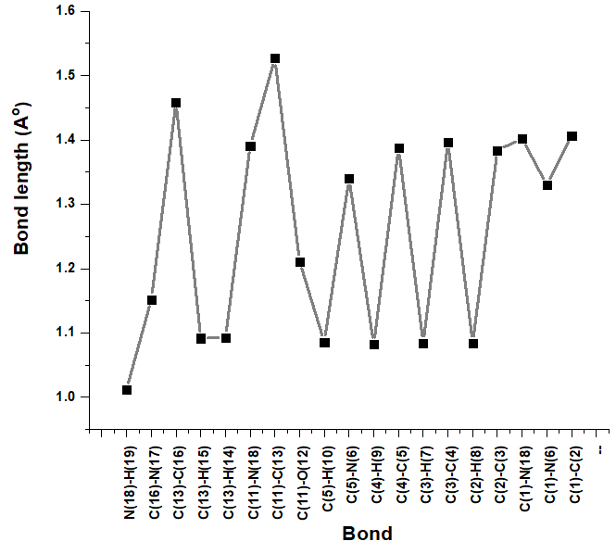

(B)
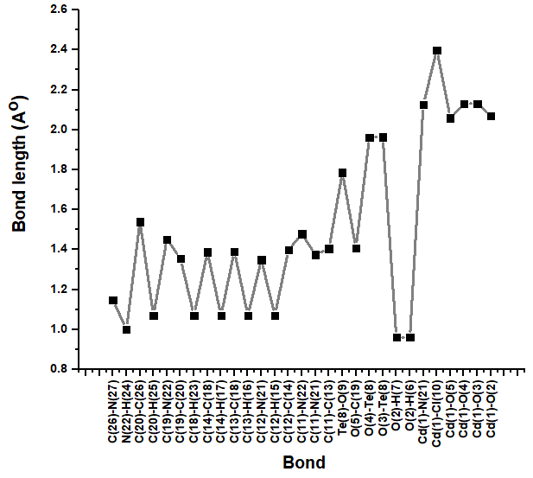

Fig. 3S. Bond lengths (Å) of (A) HCPA and (B) Na₂[Cd(CPA)(TeO₃)(H₂O)Cl].2H₂O complex using DFT method

(A)

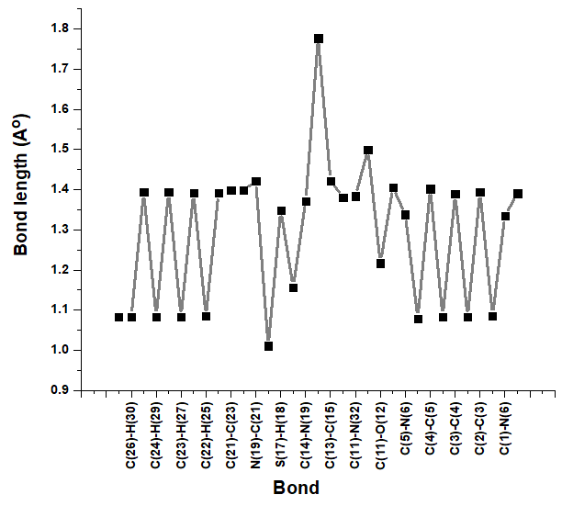

(B)

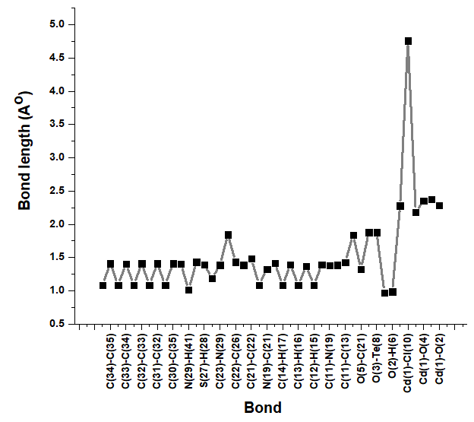

Fig. 4S. Bond lengths (Å) of (A) HCMPPA and (B) Na₂[Cd(CMPPA)(TeO₃)(H₂O)Cl].2H₂O complex using DFT method

Table 5S: Bond angles of HCMPPA using DFT method

Bond | Angle | Bond | Angle | Bond | Angle
H(19)-N(18)-C(11) | 110.486 | N(18)-C(11)-C(13) | 118.190 | H(7)-C(3)-C(4) | 120.673
H(19)-N(18)-C(1) | 115.667 | N(18)-C(11)-O(12) | 119.085 | H(7)-C(3)-C(2) | 119.950
C(11)-N(18)-C(1) | 133.847 | C(13)-C(11)-O(12) | 122.724 | C(4)-C(3)-C(2) | 119.377
N(17)-C(16)-C(13) | 176.691 | C(5)-N(6)-C(1) | 118.003 | H(8)-C(2)-C(3) | 121.059
C(16)-C(13)-H(15) | 109.967 | H(10)-C(5)-N(6) | 115.580 | H(8)-C(2)-C(1) | 120.674
C(16)-C(13)-H(14) | 109.957 | H(10)-C(5)-C(4) | 120.656 | C(3)-C(2)-C(1) | 118.267
C(16)-C(13)-C(11) | 112.260 | N(6)-C(5)-C(4) | 123.765 | N(18)-C(1)-N(6) | 119.204
H(15)-C(13)-H(14) | 104.807 | H(9)-C(4)-C(5) | 120.655 | N(18)-C(1)-C(2) | 117.965
H(15)-C(13)-C(11) | 109.797 | H(9)-C(4)-C(3) | 121.588 | N(6)-C(1)-C(2) | 122.830
H(14)-C(13)-C(11) | 109.788 | C(5)-C(4)-C(3) | 117.757

Table 6S: Bond angles of Na₂[Cd(CPA)(TeO₃)(H₂O)Cl].2H₂O complex using DFT method

Bond | Angle | Bond | Angle | Bond | Angle
C(20)-C(26)-N(27) | 180.000 | C(18)-C(13)-C(11) | 119.913 | O(2)-Cd(1)-N(21) | 133.458
H(24)-N(22)-C(19) | 107.339 | H(15)-C(12)-N(21) | 119.420 | O(2)-Cd(1)-O(5) | 84.307
H(24)-N(22)-C(11) | 109.120 | H(15)-C(12)-C(14) | 119.420 | O(2)-Cd(1)-O(4) | 130.892
C(19)-N(22)-C(11) | 111.793 | N(21)-C(12)-C(14) | 121.160 | O(2)-Cd(1)-O(3) | 85.526
C(12)-N(21)-C(11) | 120.656 | N(21)-C(11)-N(22) | 122.187 | Cl(10)-Cd(1)-Te(8) | 96.494
C(12)-N(21)-Cd(1) | 117.247 | N(21)-C(11)-C(13) | 120.164 | Cl(10)-Cd(1)-N(21) | 88.286
C(11)-N(21)-Cd(1) | 122.084 | N(22)-C(11)-C(13) | 117.641 | Cl(10)-Cd(1)-O(5) | 134.282
C(19)-C(20)-H(25) | 120.000 | O(9)-Te(8)-Cd(1) | 152.772 | Cl(10)-Cd(1)-O(4) | 82.883
C(19)-C(20)-C(26) | 120.000 | O(9)-Te(8)-O(4) | 119.337 | Cl(10)-Cd(1)-O(3) | 131.465
H(25)-C(20)-C(26) | 120.000 | O(9)-Te(8)-O(3) | 119.337 | Te(8)-Cd(1)-N(21) | 127.390
C(20)-C(19)-N(22) | 118.427 | Cd(1)-Te(8)-O(4) | 46.906 | Te(8)-Cd(1)-O(5) | 126.147
C(20)-C(19)-O(5) | 118.426 | Cd(1)-Te(8)-O(3) | 46.902 | Te(8)-Cd(1)-O(4) | 42.739
N(22)-C(19)-O(5) | 123.143 | O(4)-Te(8)-O(3) | 86.237 | Te(8)-Cd(1)-O(3) | 42.804
H(23)-C(18)-C(13) | 120.634 | C(19)-O(5)-Cd(1) | 114.748 | N(21)-Cd(1)-O(5) | 78.767
H(23)-C(18)-C(14) | 120.634 | Te(8)-O(4)-Cd(1) | 90.354 | N(21)-Cd(1)-O(4) | 86.649
C(13)-C(18)-C(14) | 118.733 | Te(8)-O(3)-Cd(1) | 90.295 | N(21)-Cd(1)-O(3) | 134.414
H(17)-C(14)-C(18) | 120.318 | Cd(1)-O(2)-H(6) | 109.471 | O(5)-Cd(1)-O(4) | 138.678
H(17)-C(14)-C(12) | 120.318 | Cd(1)-O(2)-H(7) | 109.471 | O(5)-Cd(1)-O(3) | 84.198
C(18)-C(14)-C(12) | 119.363 | H(6)-O(2)-H(7) | 109.471 | O(4)-Cd(1)-O(3) | 78.935
H(16)-C(13)-C(18) | 120.044 | O(2)-Cd(1)-Cl(10) | 73.389
H(16)-C(13)-C(11) | 120.044 | O(2)-Cd(1)-Te(8) | 97.497

Table 7S: Bond angles of HCMPPA using DFT method

Bond | Angle |  | Bond | Angle |  | Bond | Angle
H(33)-N(32)-C(11) | 118.446 | C(23)-C(21)-C(22) |  | 119.778 | C(5)-N(6)-C(1) |  | 118.098
H(33)-N(32)-C(5) | 112.001 | C(23)-C(21)-N(19) |  | 121.646 | N(32)-C(5)-N(6) |  | 112.394
C(11)-N(32)-C(5) | 128.827 | C(22)-C(21)-N(19) |  | 118.492 | N(32)-C(5)-C(4) |  | 124.236
H(31)-C(28)-C(26) | 120.192 | C(21)-N(19)-H(20) |  | 115.398 | N(6)-C(5)-C(4) |  | 123.368
H(31)-C(28)-C(24) | 120.215 | C(21)-N(19)-C(14) |  | 129.225 | H(10)-C(4)-C(5) |  | 120.301
C(26)-C(28)-C(24) | 119.592 | H(20)-N(19)-C(14) |  | 115.369 | H(10)-C(4)-C(3) |  | 122.361
H(30)-C(26)-C(28) | 120.109 | H(18)-S(17)-C(14) |  | 95.676 | C(5)-C(4)-C(3) |  | 117.335
H(30)-C(26)-C(23) | 119.314 | N(6)-C(1)-C(2) |  | 123.399 | H(7)-C(3)-C(4) |  | 119.475
C(28)-C(26)-C(23) | 120.566 | N(16)-C(15)-C(13) |  | 178.296 | H(7)-C(3)-C(2) |  | 120.500
H(29)-C(24)-C(28) | 120.208 | N(19)-C(14)-S(17) |  | 119.364 | C(4)-C(3)-C(2) |  | 120.025
H(29)-C(24)-C(22) | 119.497 | N(19)-C(14)-C(13) |  | 122.441 | H(9)-C(2)-C(3) |  | 121.659
C(28)-C(24)-C(22) | 120.292 | S(17)-C(14)-C(13) |  | 118.078 | H(9)-C(2)-C(1) |  | 120.566
H(27)-C(23)-C(26) | 120.228 | C(15)-C(13)-C(14) |  | 119.096 | C(3)-C(2)-C(1) |  | 117.775
H(27)-C(23)-C(21) | 120.042 | C(15)-C(13)-C(11) |  | 114.370 | H(8)-C(1)-N(6) |  | 115.797
C(26)-C(23)-C(21) | 119.727 | C(14)-C(13)-C(11) |  | 126.368 | H(8)-C(1)-C(2) |  | 120.804
H(25)-C(22)-C(24) | 120.380 | N(32)-C(11)-C(13) |  | 115.453 | C(24)-C(22)-C(21) |  | 120.027
H(25)-C(22)-C(21) | 119.593 | N(32)-C(11)-O(12) |  | 123.256 | C(13)-C(11)-O(12) |  | 121.285

Table 8S: Bond angles of Na₂[Cd(CMPPA)(TeO₃)(H₂O)Cl].2H₂O complex using DFT method

Bond | Angle | Bond | Angle |  | Bond | Angle
C(34)-C(35)-C(30) | 119.987 | S(27)-C(23)-C(22) | 121.462 | N(18)-C(11)-C(13) |  | 118.768
C(34)-C(35)-N(29) | 118.151 | C(26)-C(22)-C(23) | 120.332 | O(9)-Te(8)-O(4) |  | 121.077
C(30)-C(35)-N(29) | 121.744 | C(26)-C(22)-C(21) | 114.198 | O(9)-Te(8)-O(3) |  | 120.898
H(40)-C(34)-C(35) | 119.860 | C(23)-C(22)-C(21) | 125.357 | O(4)-Te(8)-O(3) |  | 95.000
H(40)-C(34)-C(33) | 120.181 | C(22)-C(21)-N(19) | 117.457 | C(21)-O(5)-Cd(1) |  | 128.480
C(35)-C(34)-C(33) | 119.949 | C(22)-C(21)-O(5) | 115.259 | Te(8)-O(4)-Cd(1) |  | 97.058
H(39)-C(33)-C(34) | 119.523 | N(19)-C(21)-O(5) | 127.284 | Te(8)-O(3)-Cd(1) |  | 96.239
H(39)-C(33)-C(32) | 120.139 | H(24)-C(20)-C(14) | 120.404 | H(7)-O(2)-H(6) |  | 114.773
C(34)-C(33)-C(32) | 120.333 | H(24)-C(20)-C(13) | 120.179 | H(7)-O(2)-Cd(1) |  | 142.712
H(38)-C(32)-C(33) | 120.287 | C(14)-C(20)-C(13) | 119.417 | H(6)-O(2)-Cd(1) |  | 97.113
H(38)-C(32)-C(31) | 120.290 | C(21)-N(19)-C(11) | 129.073 | N(18)-Cd(1)-Cl(10) |  | 85.067
C(33)-C(32)-C(31) | 119.422 | C(12)-N(18)-C(11) | 119.651 | N(18)-Cd(1)-O(5) |  | 83.239
H(37)-C(31)-C(32) | 119.997 | C(12)-N(18)-Cd(1) | 116.153 | N(18)-Cd(1)-O(4) |  | 121.027
H(37)-C(31)-C(30) | 119.285 | C(11)-N(18)-Cd(1) | 124.143 | N(18)-Cd(1)-O(3) |  | 94.635
C(32)-C(31)-C(30) | 120.717 | C(20)-C(14)-H(17) | 121.848 | N(18)-Cd(1)-O(2) |  | 140.466
H(36)-C(30)-C(35) | 120.208 | C(20)-C(14)-C(12) | 118.099 | Cl(10)-Cd(1)-O(5) |  | 149.276
H(36)-C(30)-C(31) | 120.205 | H(17)-C(14)-C(12) | 120.053 | Cl(10)-Cd(1)-O(4) |  | 44.926
C(35)-C(30)-C(31) | 119.586 | C(20)-C(13)-H(16) | 122.173 | Cl(10)-Cd(1)-O(3) |  | 44.190
H(41)-N(29)-C(35) | 114.599 | C(20)-C(13)-C(11) | 120.891 | Cl(10)-Cd(1)-O(2) |  | 132.368
H(41)-N(29)-C(23) | 116.599 | H(16)-C(13)-C(11) | 116.934 | O(5)-Cd(1)-O(4) |  | 121.884
C(35)-N(29)-C(23) | 128.586 | N(18)-C(12)-H(15) | 115.586 | O(5)-Cd(1)-O(3) |  | 165.193
H(28)-S(27)-C(23) | 92.776 | N(18)-C(12)-C(14) | 123.157 | O(5)-Cd(1)-O(2) |  | 69.192
N(25)-C(26)-C(22) | 176.959 | H(15)-C(12)-C(14) | 121.254 | O(4)-Cd(1)-O(3) |  | 71.697
N(29)-C(23)-S(27) | 114.727 | N(19)-C(11)-N(18) | 125.618 | O(4)-Cd(1)-O(2) |  | 97.868
N(29)-C(23)-C(22) | 123.801 | N(19)-C(11)-C(13) | 115.613 | O(3)-Cd(1)-O(2) |  | 104.855

(A)

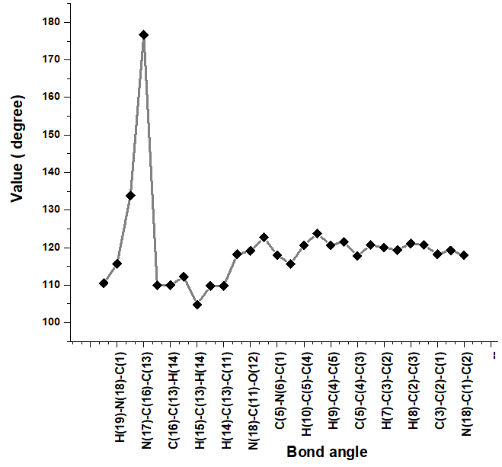

(B)
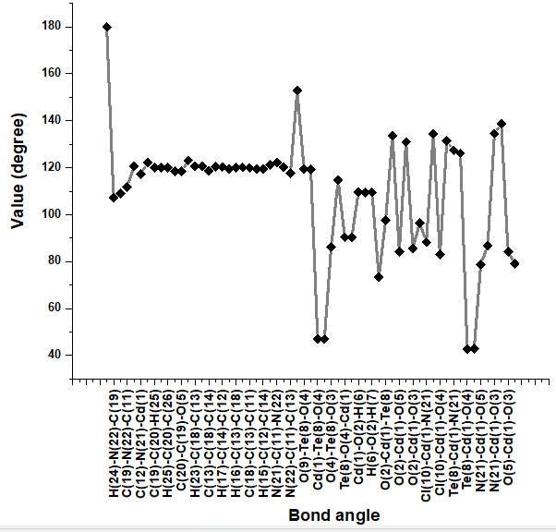

Fig. 5S. Bond angles of (A) HCPA and (B) Na₂[Cd(CPA)(TeO₃)(H₂O)Cl].2H₂O complex using DFT method

(A)

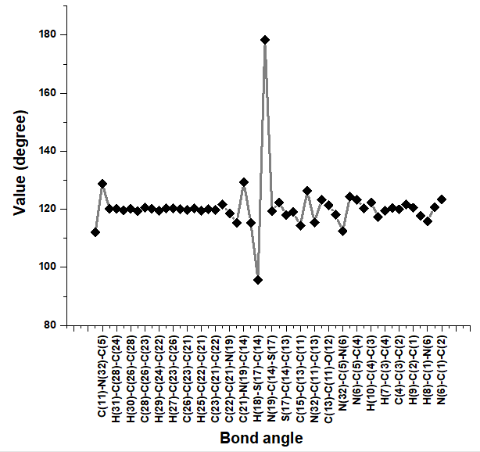

(B)

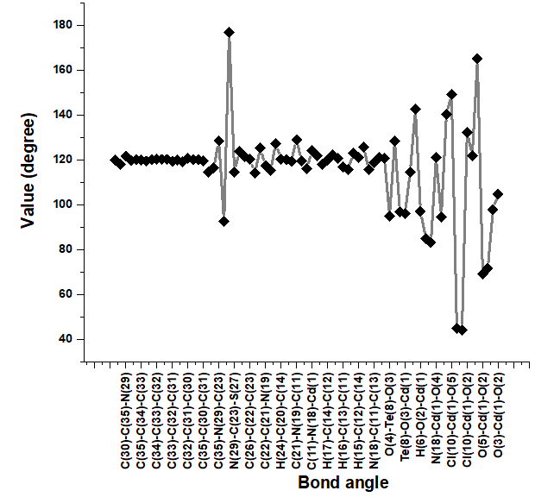

Fig. 6S. Bond angles of (A) HCMPPA and (B) Na₂[Cd(CMPPA)(TeO₃)(H₂O)Cl].2H₂O complex using DFT method

Table 9S: Antimicrobial activities for HCPA and its Cd(II) complex

Compounds | E. coli  (mg/ml) |  | S. aureus  (mg/ml) |  | C. Albicans  (mg/ml)
Compounds | Diameter of  inhibition  zone (mm) | %  Activity index | Diameter of  inhibition zone(mm) | %  Activity  index | Diameter of  inhibition  zone (mm) | %  Activity  index
Ampicillin | 26 | 100 | 24 | 100 | NA | ----
Colitrimazole | NA | ---- | NA | ---- | 27 | 100
HCPA | 4 | 15.4 | 8 | 33.3 | 5 | 18.5
Na₂[Cd(CPA)(TeO₃)(H₂O)Cl].2H₂O | 2 | 7.7 | 6 | 25 | 7 | 25.9

Table 10S: Antimicrobial activities for HCMPPA and its Cd(II) complex

Compounds | E. coli  (mg/ml) |  | S. aureus  (mg/ml) |  | C. Albicans  (mg/ml)
Compounds | Diameter of  inhibition  zone (mm) | %  Activity index | Diameter of  inhibition  zone(mm) | %  Activity  index | Diameter of  inhibition  zone (mm) | %  Activity  index
Ampicillin | 26 | 100 | 24 | 100 | NA | ----
Colitrimazole | NA | ---- | NA | ---- | 27 | 100
HCMPPA | 17 | 62.4 | 21 | 87.5 | 19 | 70.4
Na₂[Cd(CMPPA)(TeO₃)(H₂O)Cl].2H₂O | 8 | 30.8 | 15 | 62.5 | 15 | 55.5

Table 11S:The antioxidant activity assay ABTS method for HCPA and its Cd(II) complex

Method | ABTS  [Abs(control)-Abs(test)/Abs(control)]x100
Compounds | Absorbance of samples | % inhibition
Control of ABTS | 0.510 | 0
Ascorbic acid | 0.059 | 88.4
HCPA | 0.357 | 30
Na₂[Cd(CPA)(TeO₃)(H₂O)Cl].2H₂O | 0.349 | 31.6

Table 12S: The antioxidant activity assay ABTS method for HCMPPA and its d (II) complex

Method | ABTS  [Abs(control)-Abs(test)/Abs(control)]x100
Compounds | Absorbance | % inhibition
Control of ABTS | 0.510 | 0
Ascorbic acid | 0.059 | 88.4
HCMPPA | 0.167 | 67.2
Na₂[Cd(CMPPA)(TeO₃)(H₂O)Cl].2H₂O | 0.253 | 50.4

Table 13S: Bleomycin-dependent DNA damage assay of HCPA and its Cd(II) complex

Method | Bleomycin dependent-DNA damage
Compounds | Absorbance of samples
Ascorbic acid | 0.069
HCPA | 0.107
Na₂[Cd(CPA)(TeO₃)(H₂O)Cl].2H₂O | 0.122

Table 14S: Bleomycin-dependent DNA damage assay of HCMPPA and its Cd(II) complex

Method | Bleomycin dependent-DNA damage
Compounds | Absorbance of samples
Ascorbic acid | 0.069
HCMPPA | 0.072
Na₂[Cd(CMPPA)(TeO₃)(H₂O)Cl].2H₂O | 0.081

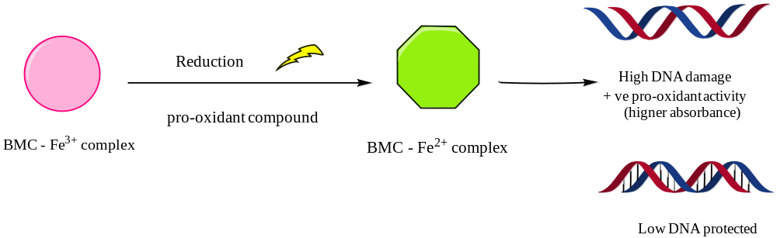

Fig.7S. Schematic representation of BMC-dependent DNA damage assay

