Supplementary Table 1 Immunohistochemical primary antibodies used in the study
Antibody | Clone | Dilution | Company
p63 | 4A4 | Prediluted Ready to use | MXB® Biotechnologies, Fuzhou, China
p40 | ZR8 | Prediluted Ready to use | MXB® Biotechnologies, Fuzhou, China
CK7 | OV-TL12/30 | Prediluted Ready to use | MXB® Biotechnologies, Fuzhou, China
S100 | 4C4.9 | Prediluted Ready to use | MXB® Biotechnologies, Fuzhou, China
Ki67 | MIB-1 | Prediluted Ready to use | MXB® Biotechnologies, Fuzhou, China
P53 | DO-7 | Prediluted Ready to use | MXB® Biotechnologies, Fuzhou, China
NICD1 (Cleaved Notch1) (Val1744) | D3B8 (ref 4147S) | 1:100 | Cell Signaling Technology Danvers, Massachusetts; EU
v-Myb+cMyb (phospho S11) | EP769Y | 1:100 | Abcam, Cambridge, UK
PI3 Kinase p110α | C73F8 | 1:100 | Cell Signaling Technology Danvers, Massachusetts; EU
Anti-AKT (phospho T308) | ab38449 | 1:100 | Abcam, Cambridge, UK

Supplementary Table 2:The copy number variants in the cases of solid-type ACC

Sample_name | Gene | CN | Statue
1956 | MAP3K1 | 0 | known
1957 | MYC | 12 | known
4820 | SMAD4 | 0 | known
4820 | MYCL1 | 6 | known
4821 | FGFR2 | 342 | known
4818 | MYC | 13 | known
4818 | RAD21 | 9 | known
4818 | NBN | 9 | VUS
4809 | NOTCH2 | 9 | VUS
4809 | HSD3B1 | 9 | VUS

Supplementary Figure 1
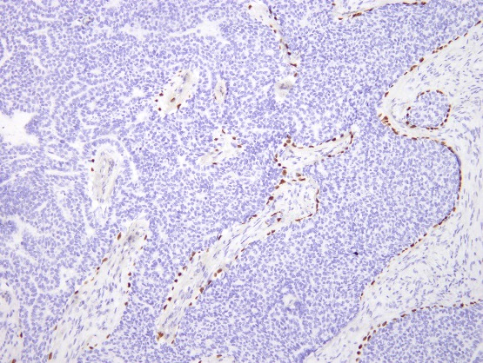
The distribution pattern of p63 immunostaining in case 4819 is peripheral

Supplementary Figure 2
Case 1957
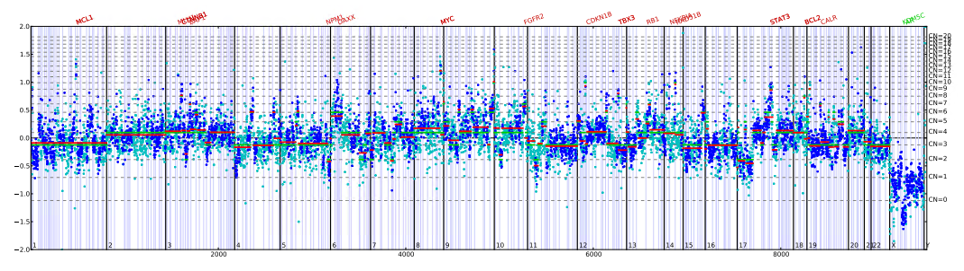
Case 1956
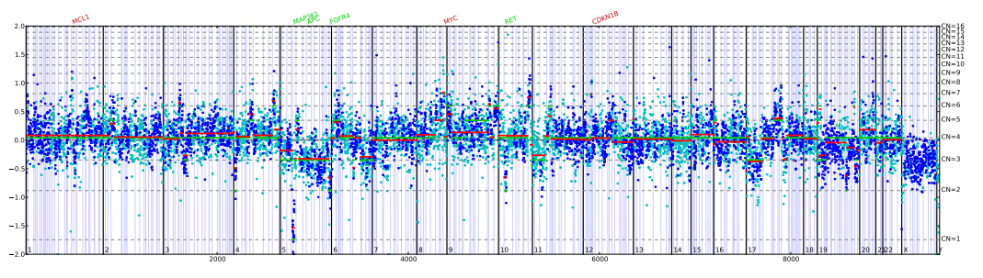
Case 4820
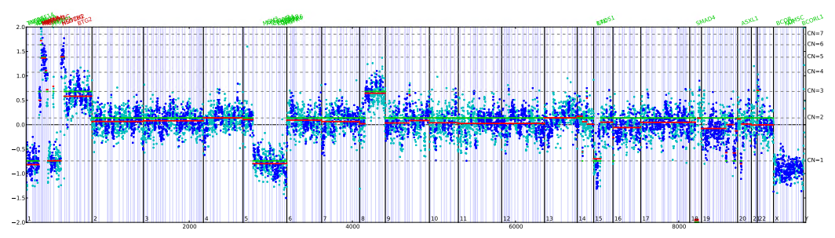

Case 4818
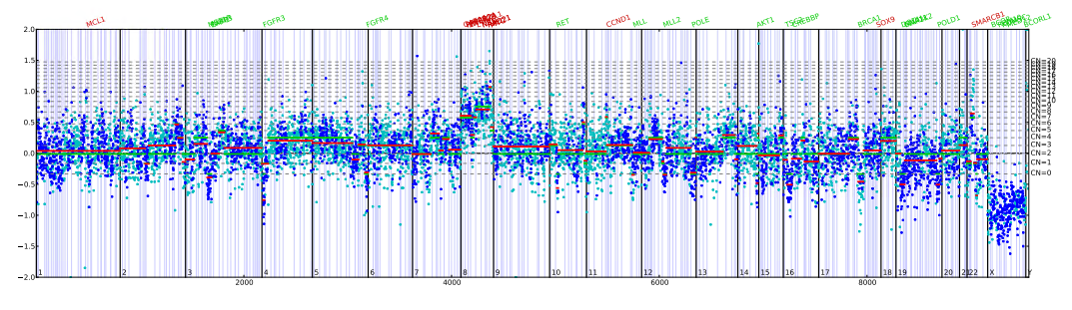
Case 4821
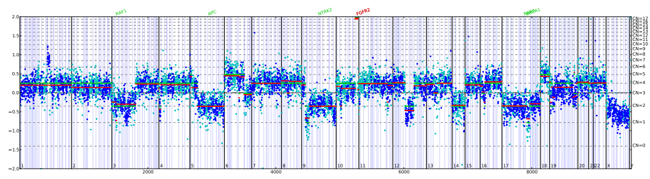
The gene copy number profiles of the cribriform/tubular component and the solid component in ACC4809. The copy number variant of NOTCH2 was verified. In the genome plots, Log2 ratios were plotted on the y-axis according to their genomic positions indicated on the x-axis.
(the cutoff of gains is 6)

Supplementary Figure 3
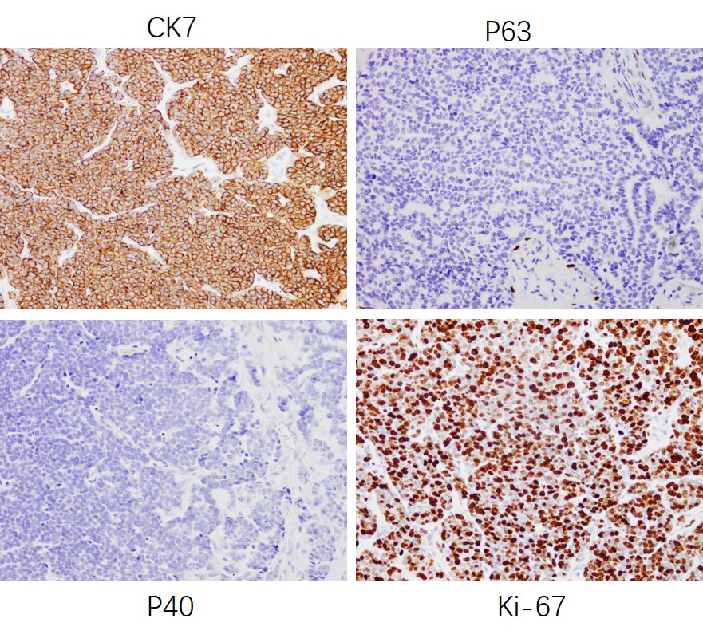
The immunostaining of p63, p40, CK7 and Ki-67 in solid type ACC: The solid component was diffusely positive for CK7 and negative or weak for p63 and p40. The Ki-67 immunostaining indicated that the proportion of proliferating cells was more than 10% (positive nuclear staining).
Supplementary Figure 4

FISH analysis showed that the typical patterns with an intact signal (fused orange/green signals) and a split signal (separated orange and green signals) was shown in the cribriform components (b), while the atypical pattern with one fusion signal and one green signal was present in the solid components (a) in case4802.

