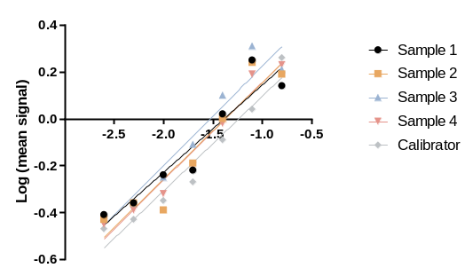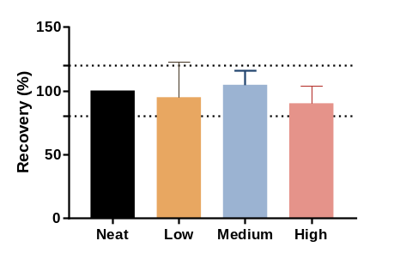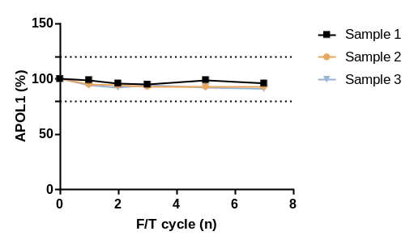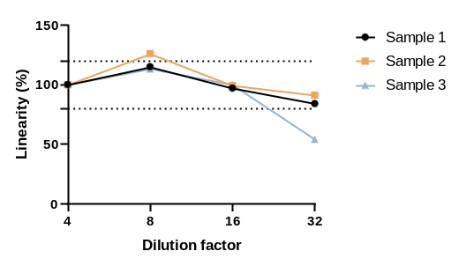
A
B
C
D

Supplementary Figure 2. APOL1 immunoassay performance in CSF.
(A) Parallelism shows that APOL1 in CSF is parallel to the calibration curve which indicates a reliable measurement of APOL1 over the range of the standard curve. (B) Recovery (%) indicates the normalized APOL1 levels after spiking CSF (n=5) with low, medium and high concentrations of recombinant APOL1 protein which shows that the recovery was within the acceptable range. (C) CSF was spiked with a high concentration of APOL1 protein and diluted 4 to 32-times. Linearity (%) indicates the expected APOL1 value after correcting for the dilution factor. No hook effect for APOL1 in CSF was observed and levels follow a linear decrease after dilution within the acceptable range. (D) APOL1 levels in CSF remain stable after multiple freezing and thawing (F/T) cycles. Dotted lines indicate the acceptable range of 80% and 120%.

