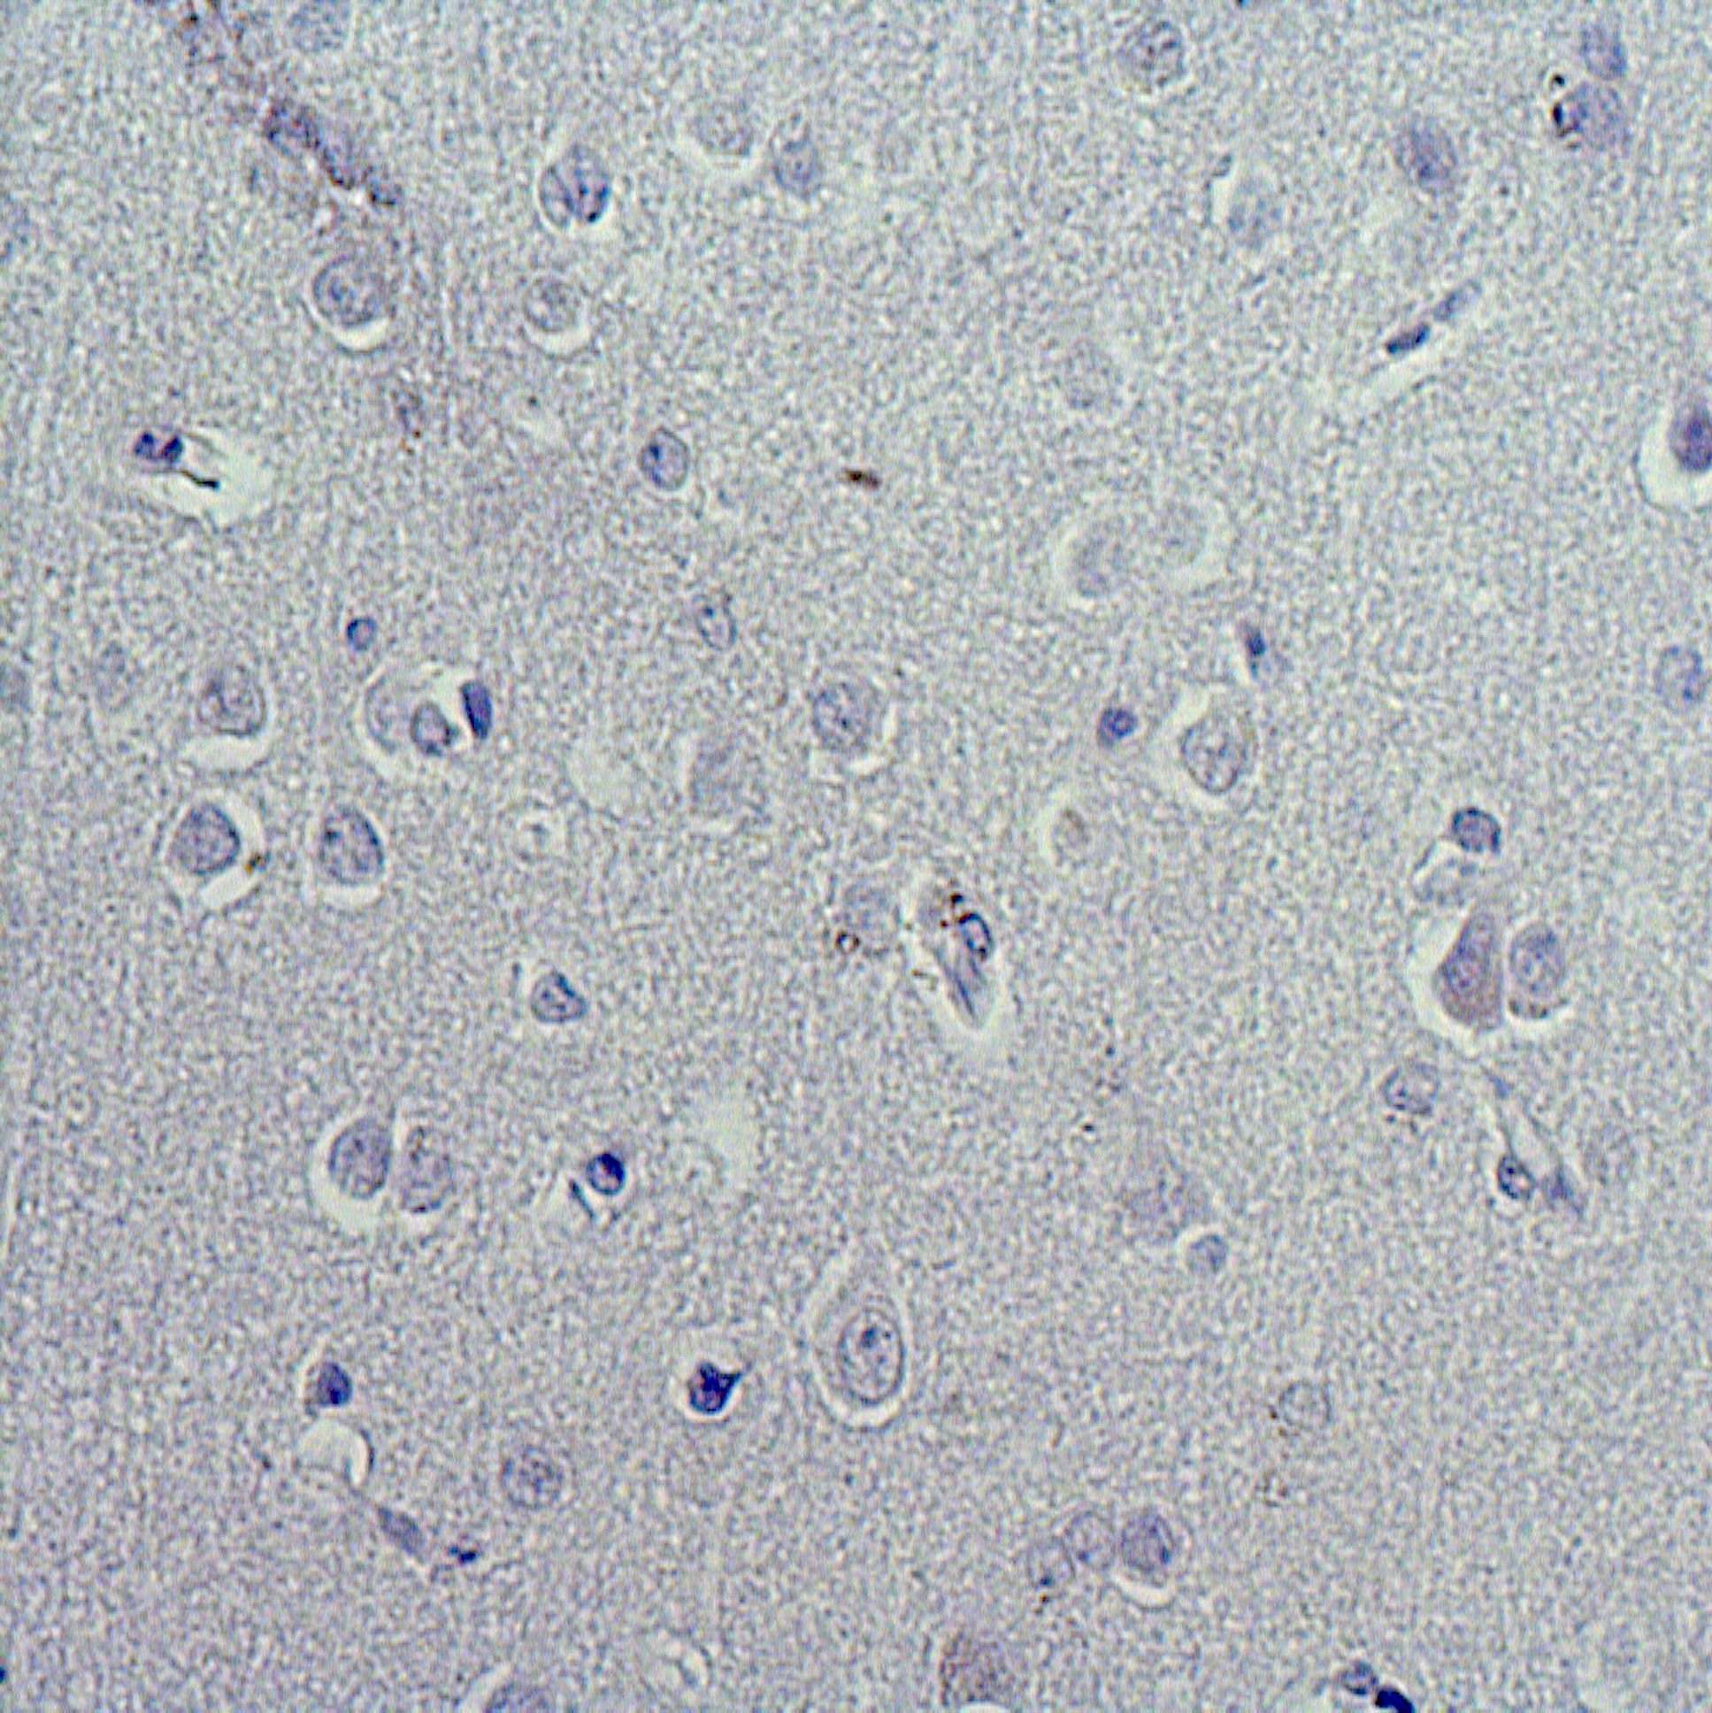
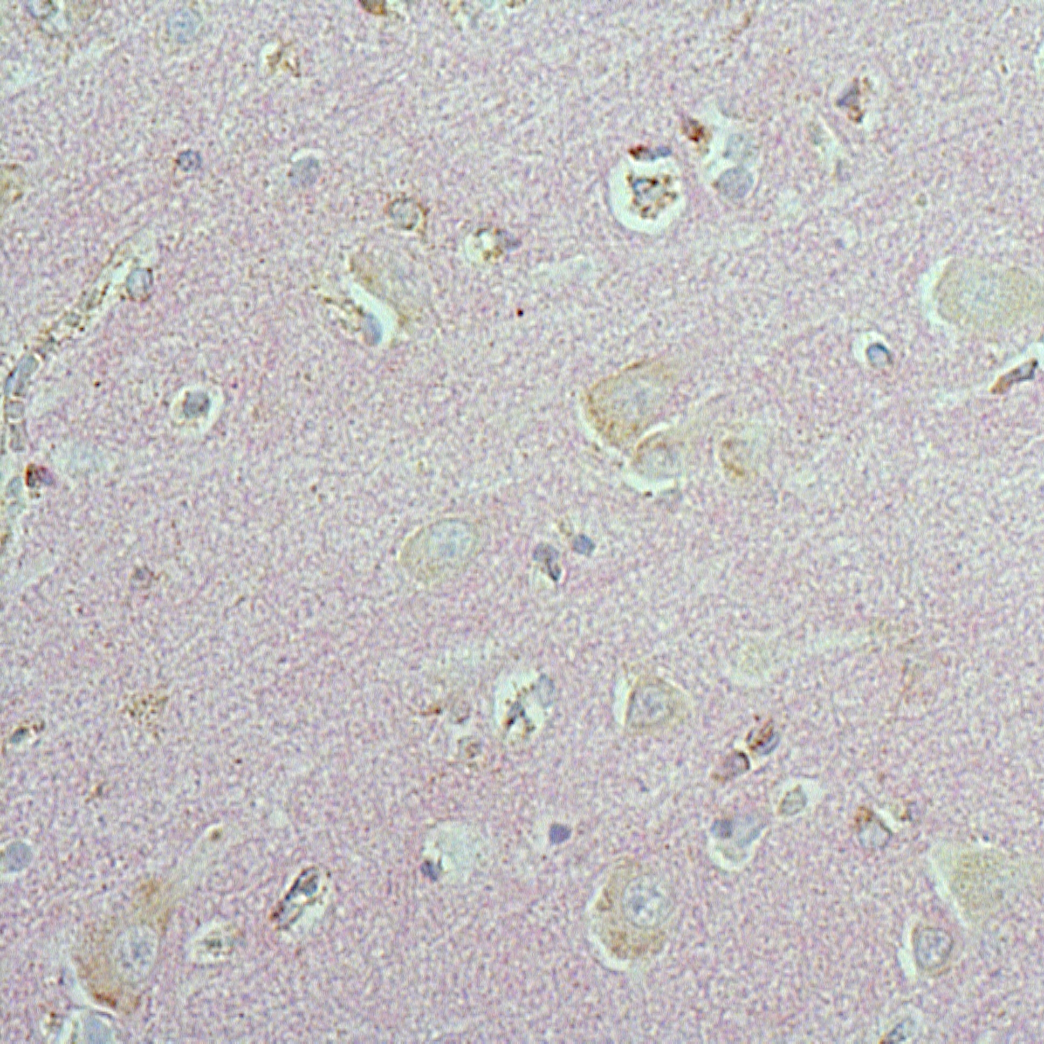
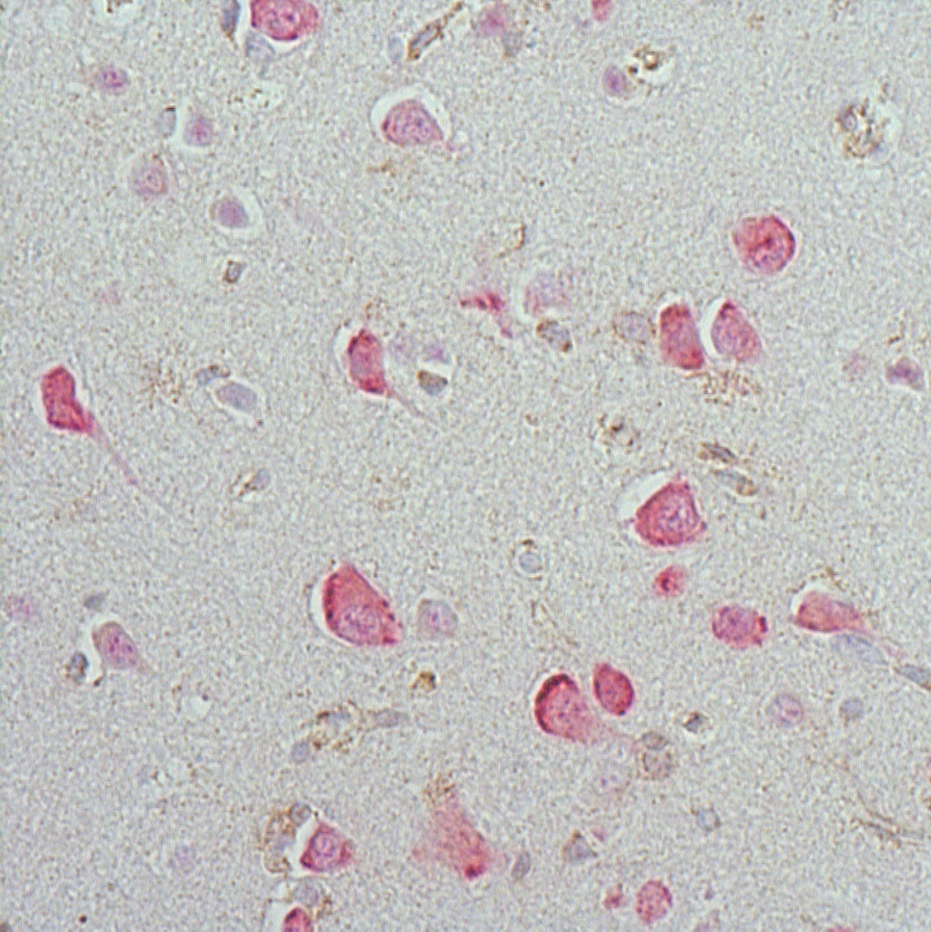
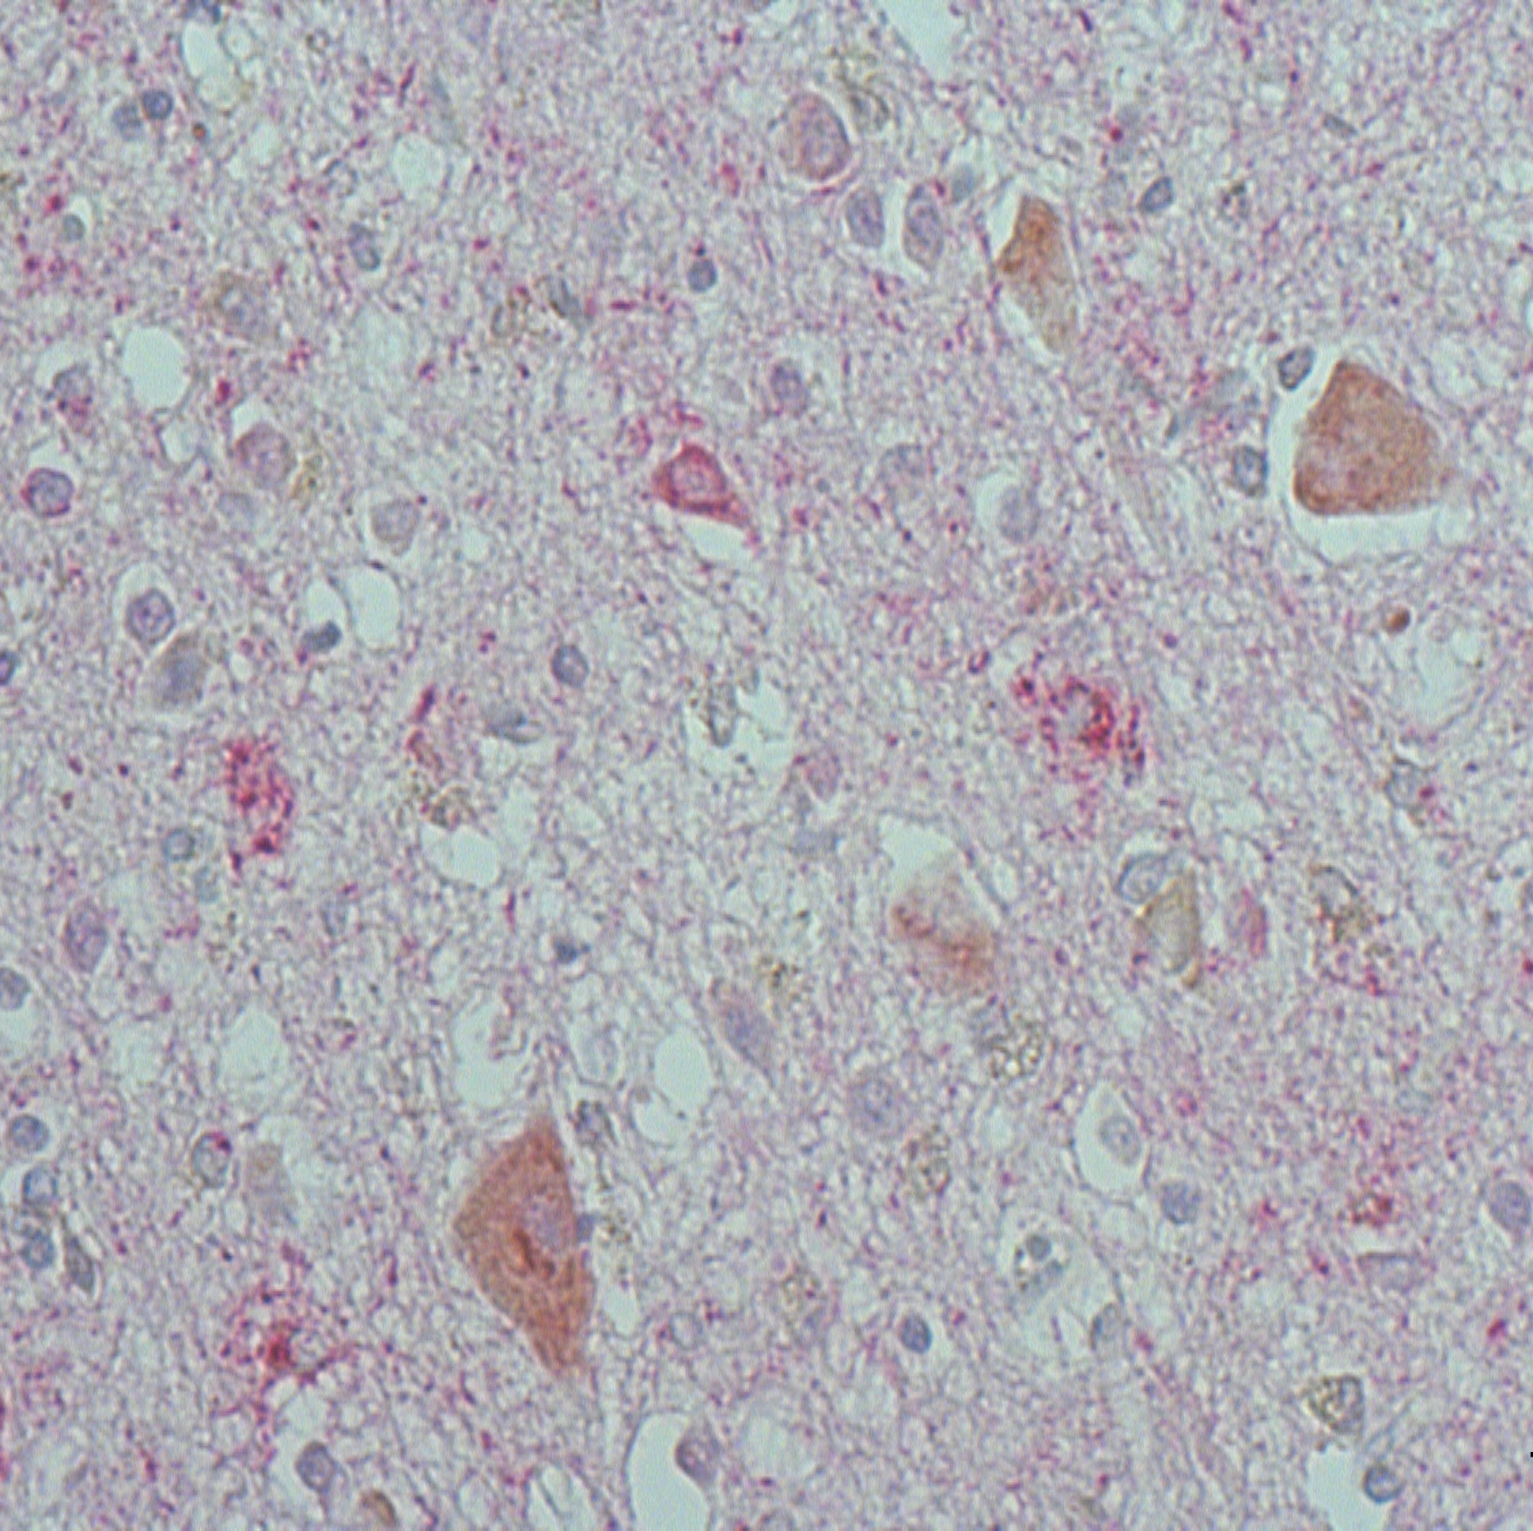
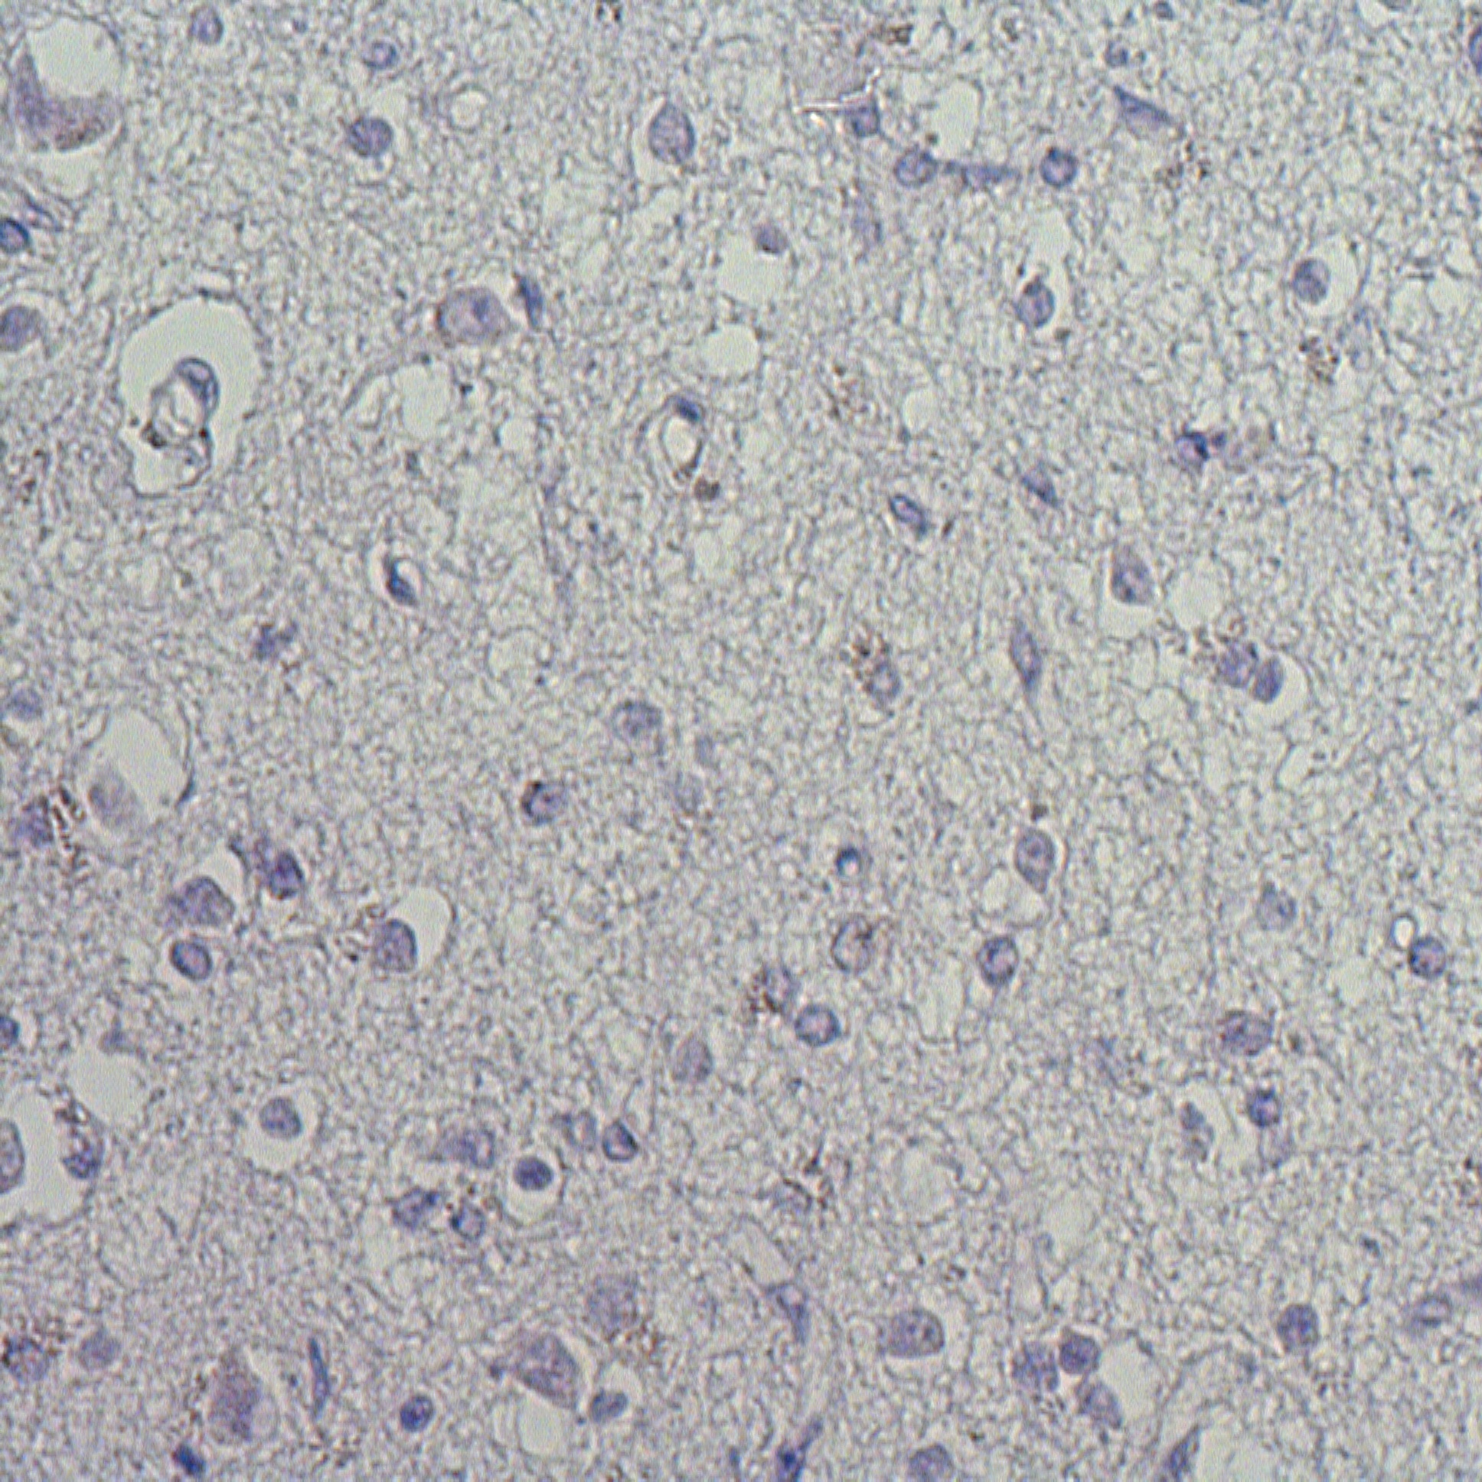
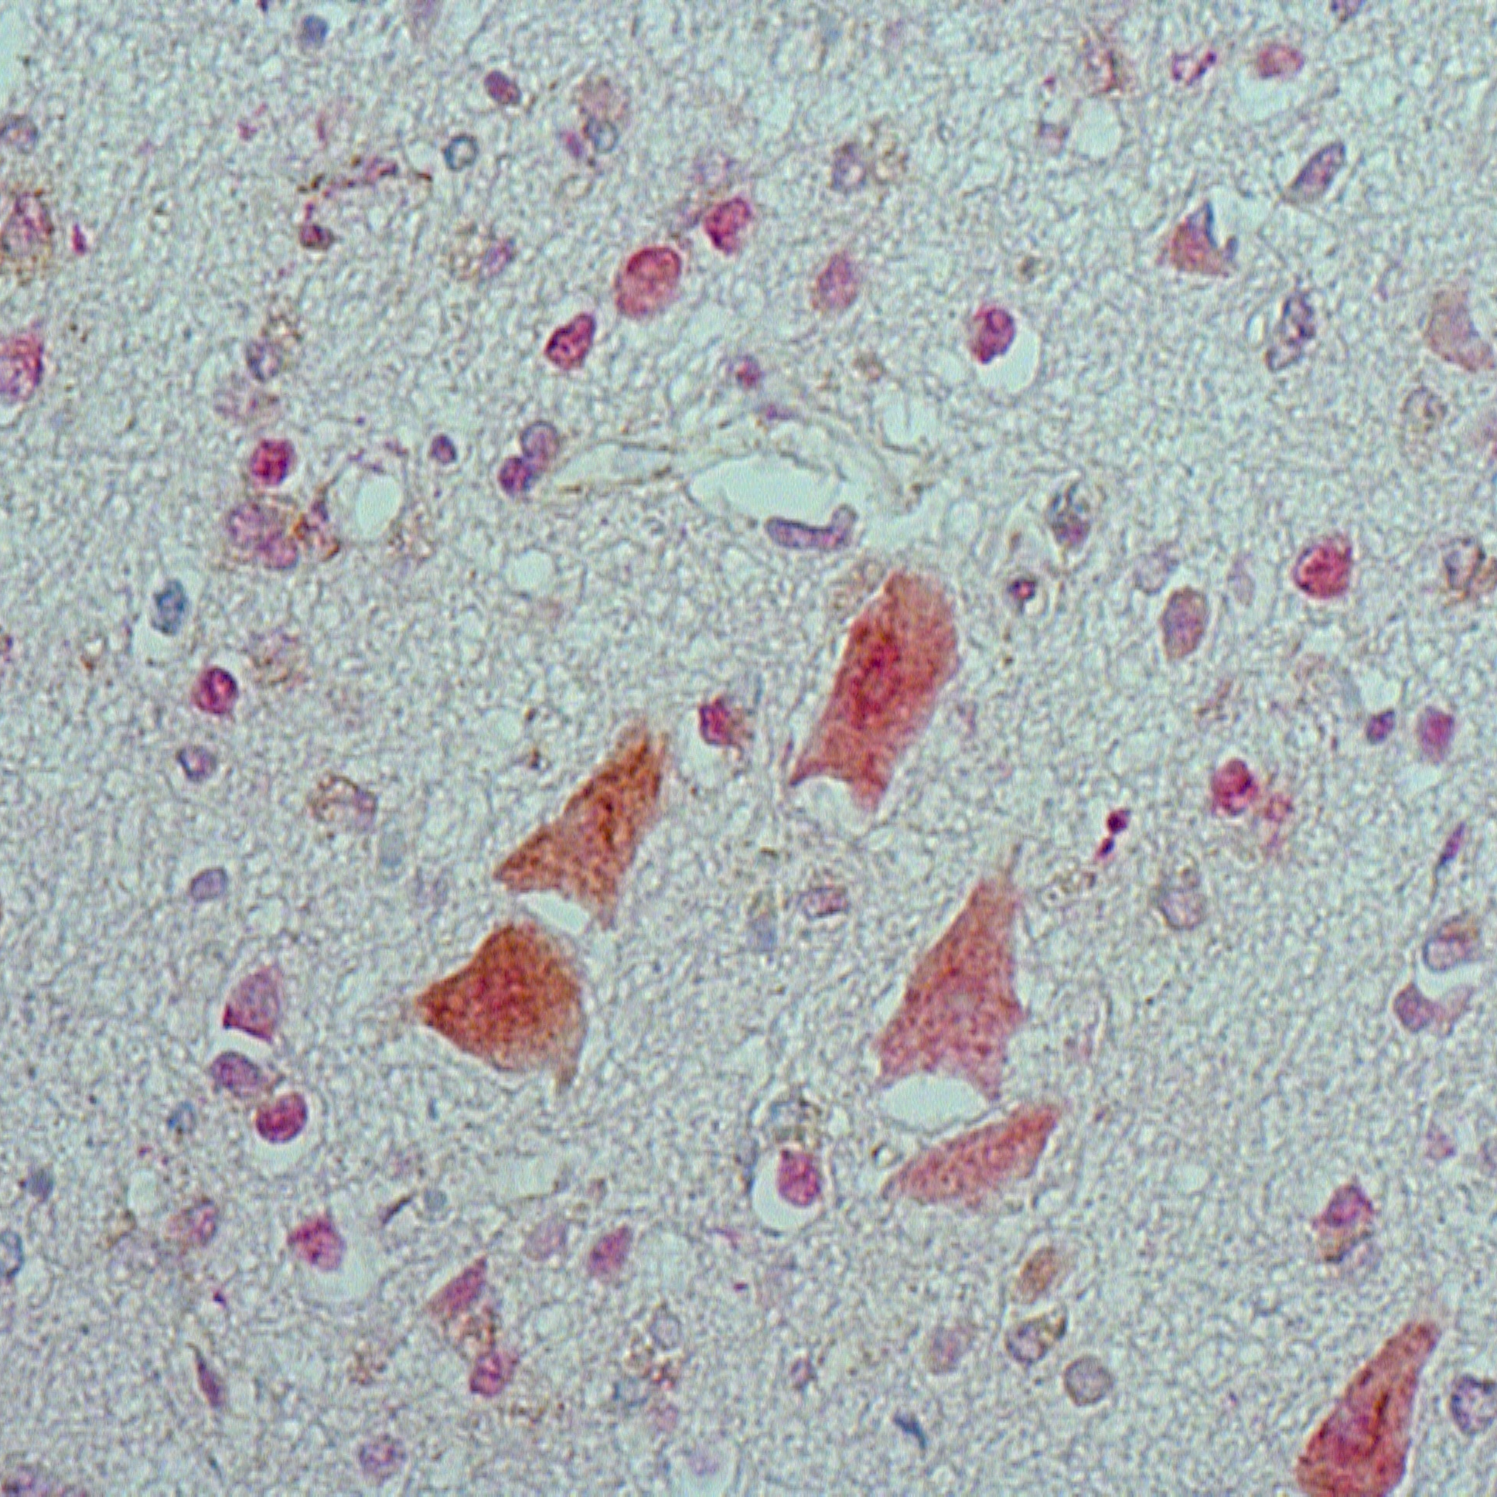
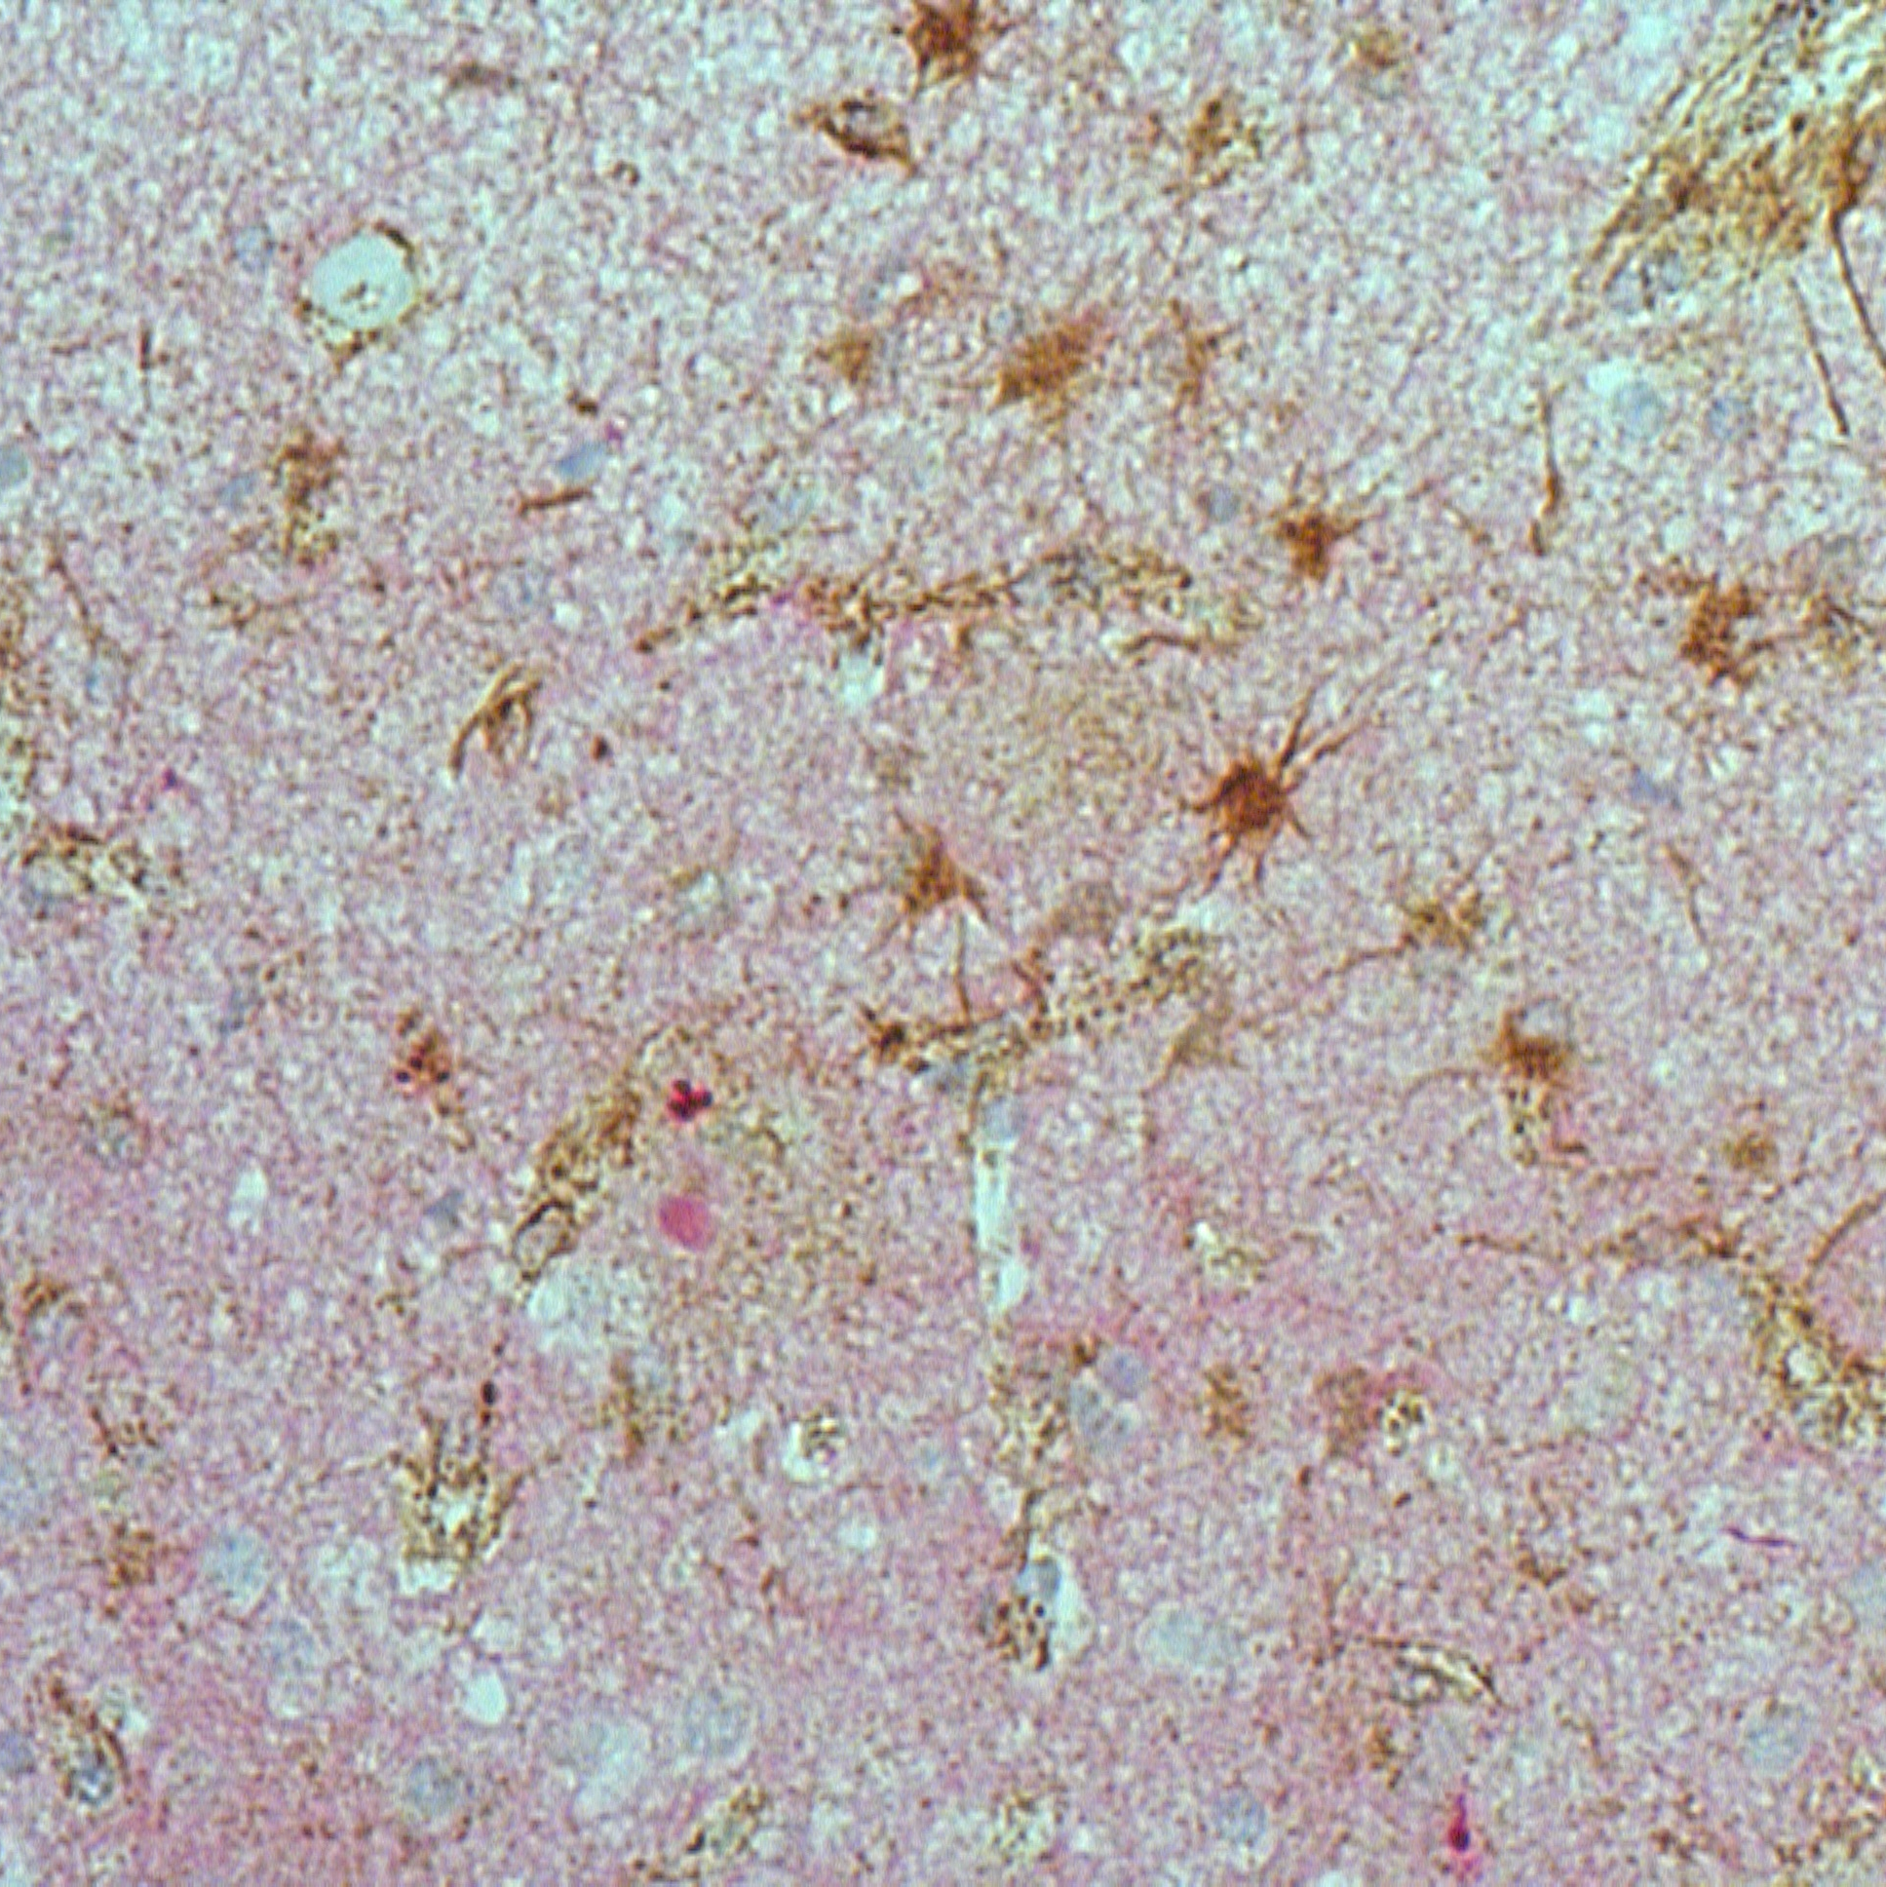
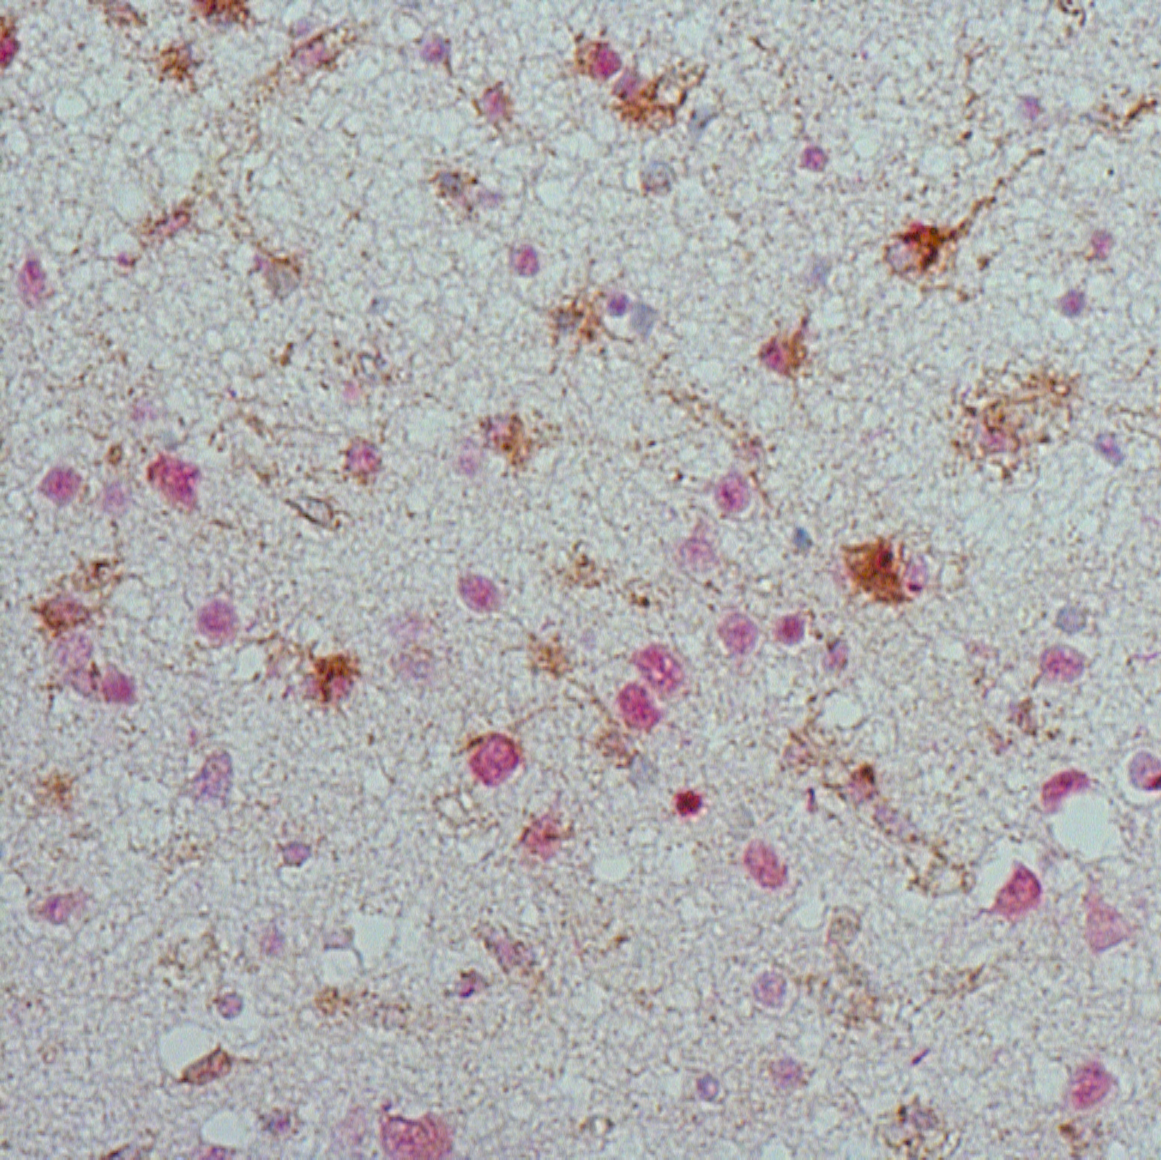
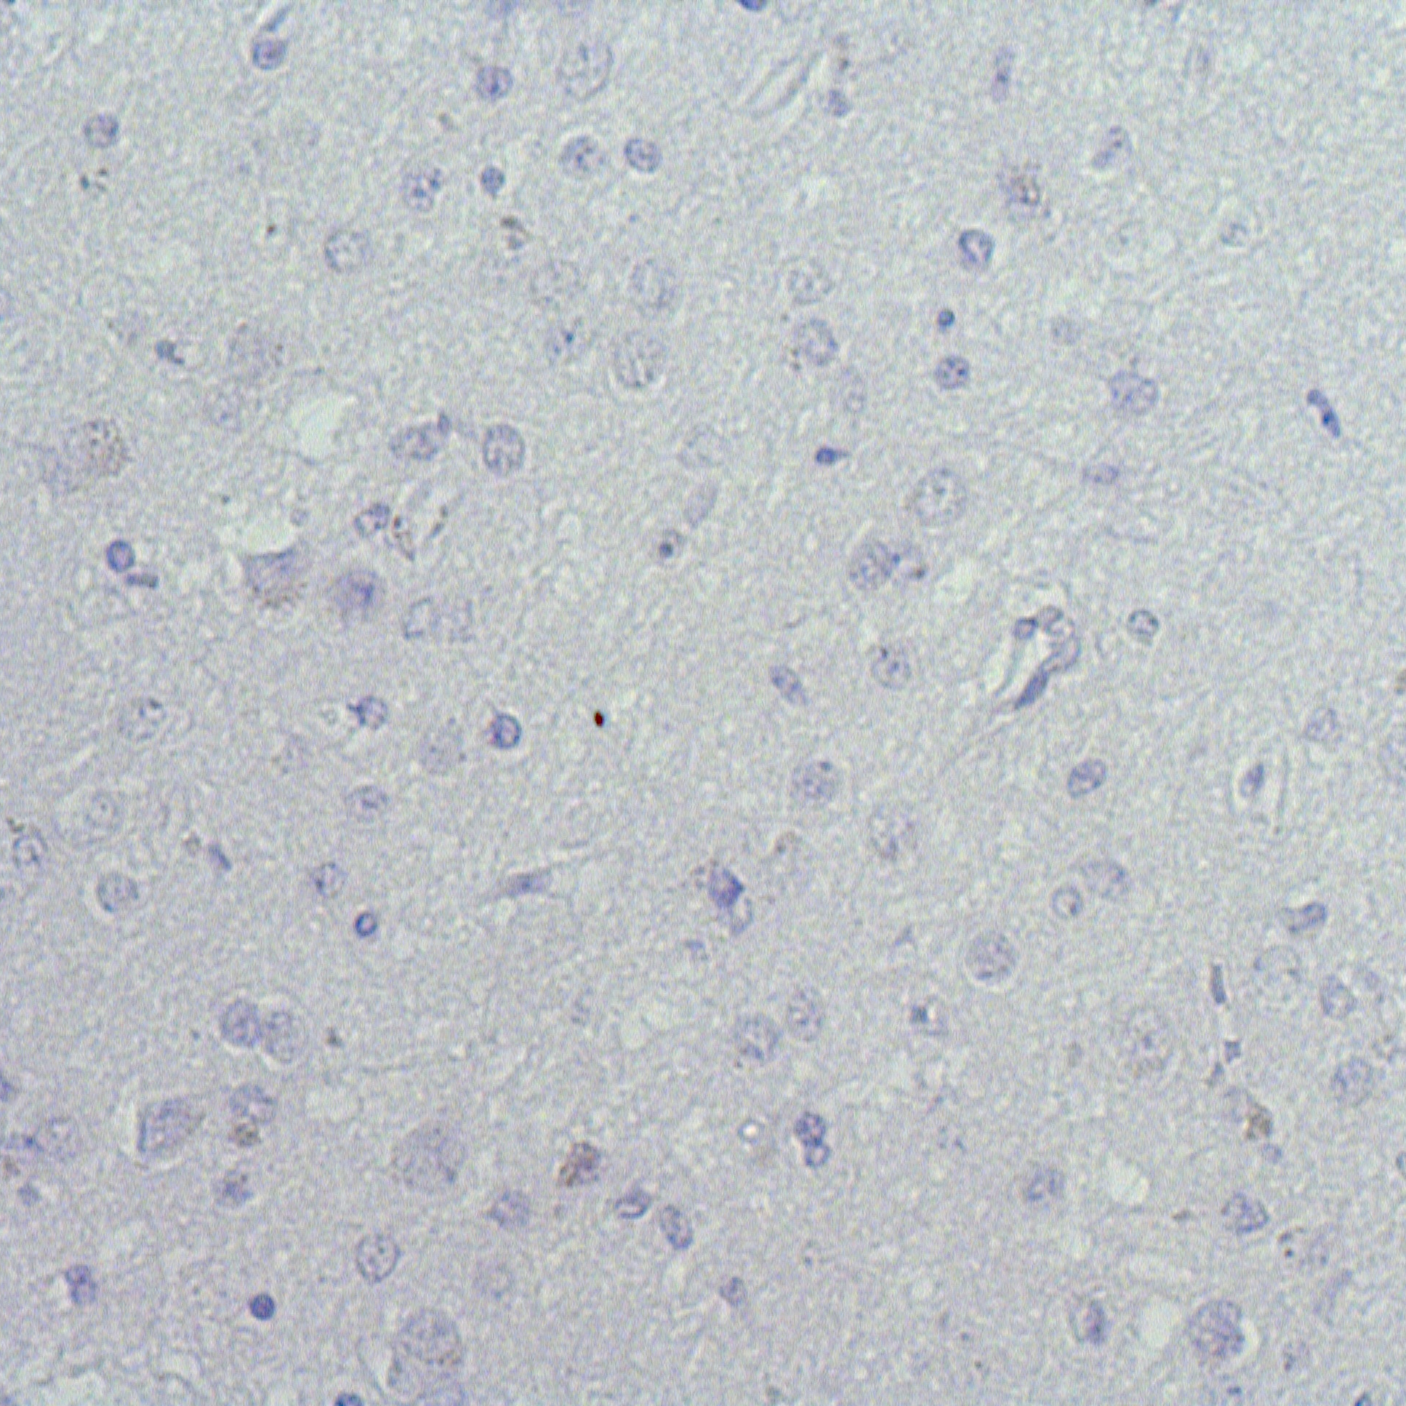
FTLD-Tau
Control
FTLD-TDP
APOL1/pTDP-43
APOL1/AT8
Negative
Supplementary Figure 3. APOL1 immunoreactivity does not associate with FTLD pathologies.
Representative images of APOL1 immunoreactivity together with pTau and pTDP43 in frontal cortex sections of controls and FTLD (FTLD-Tau and FTLD-TDP) cases. No pTau immunoreactivity was observed in controls and FTLD-TDP cases. In controls and FTLD-Tau cases, pTDP43 immunoreactivity was shown to be localized in the nucleus while for the FTLD-TDP immunoreactivity was localized mainly in the cytoplasm. Scale bars represent 50µM.

