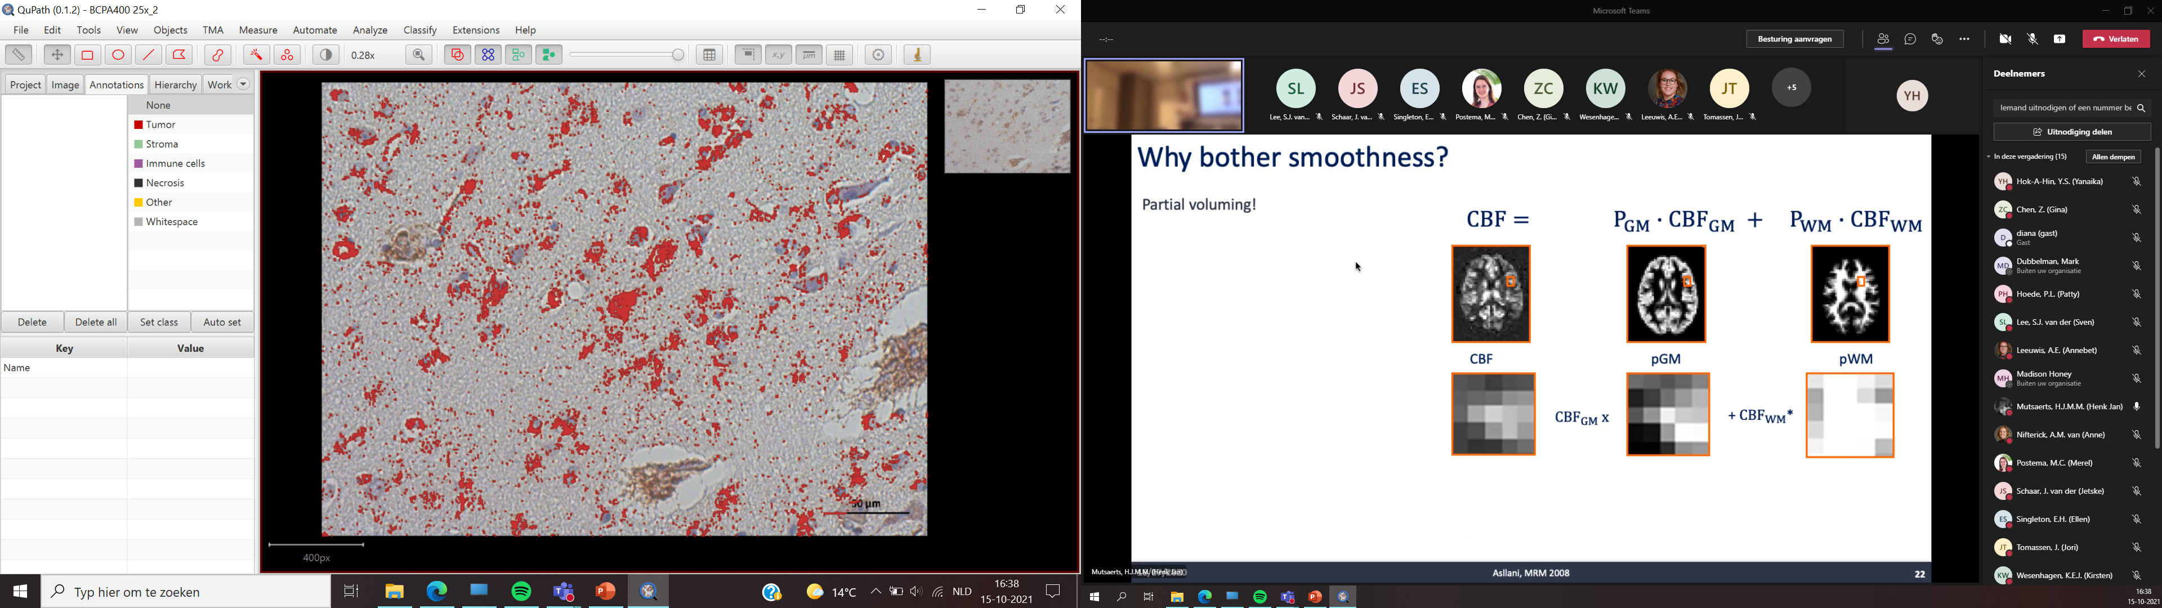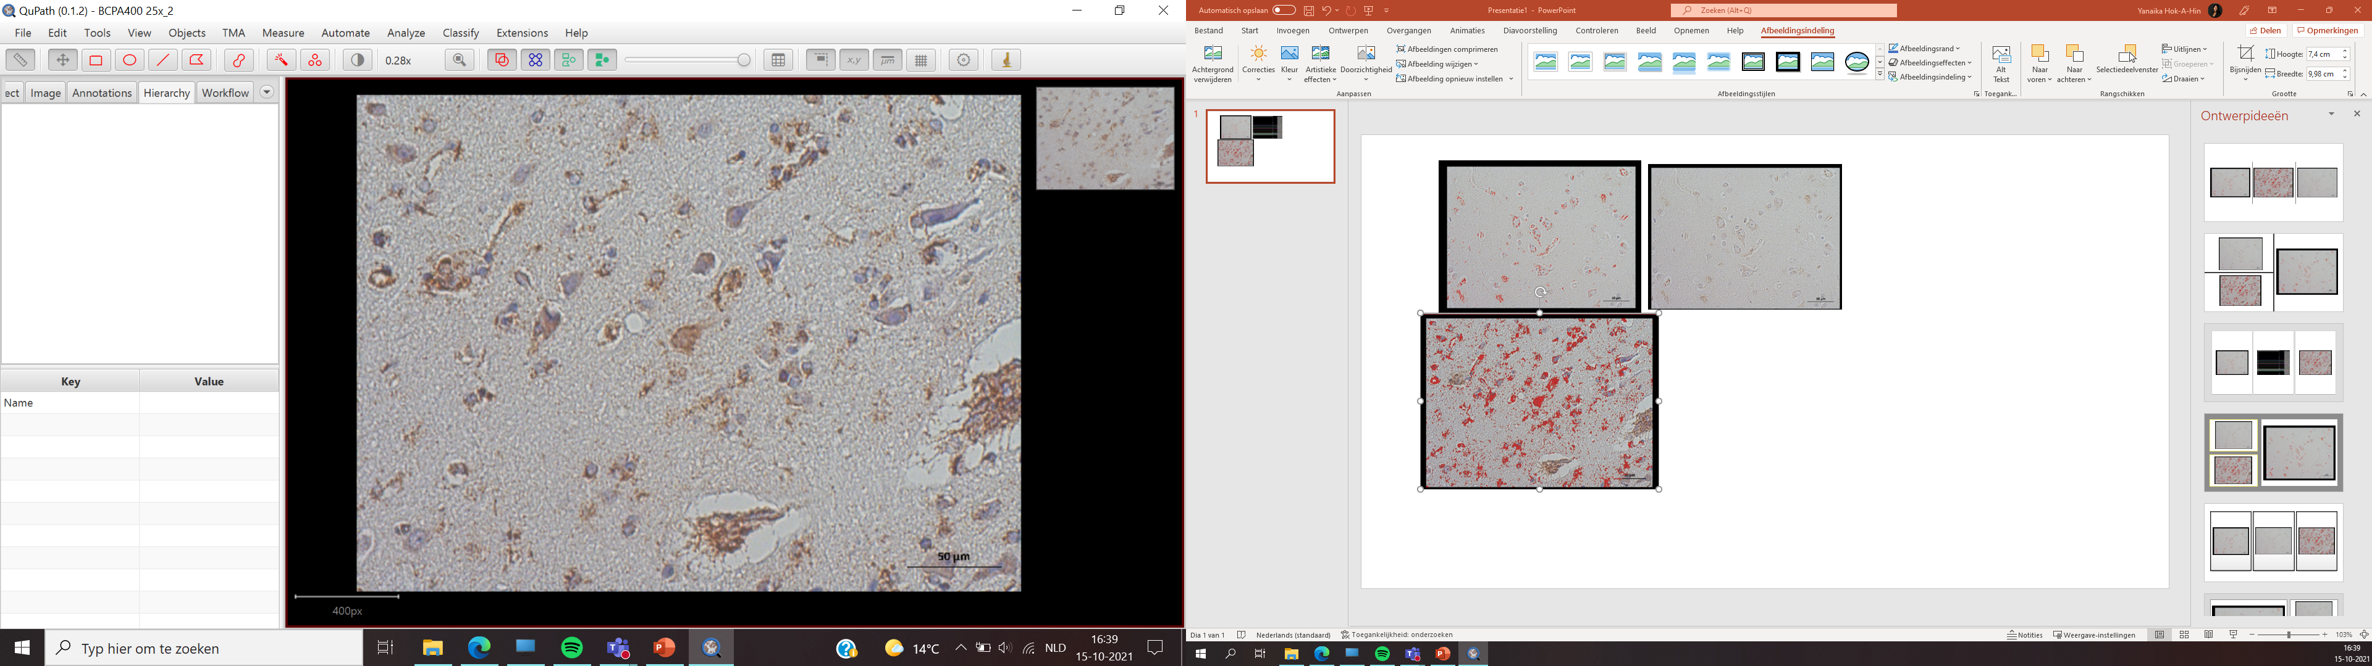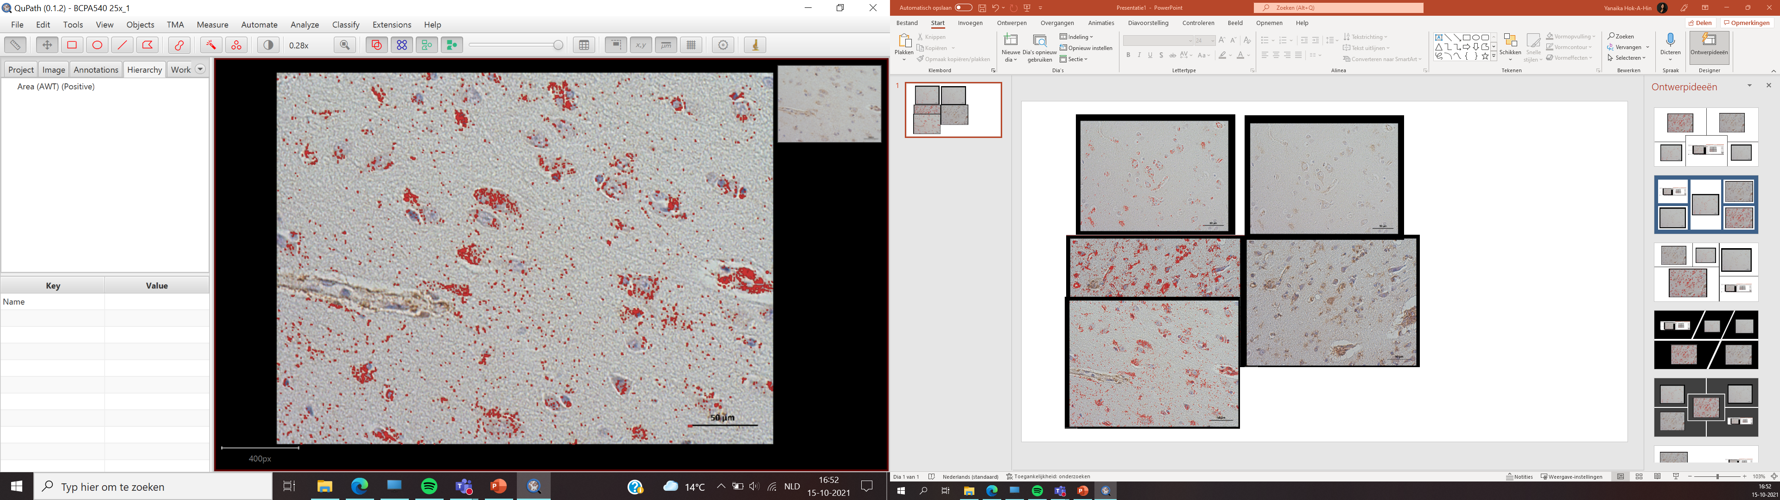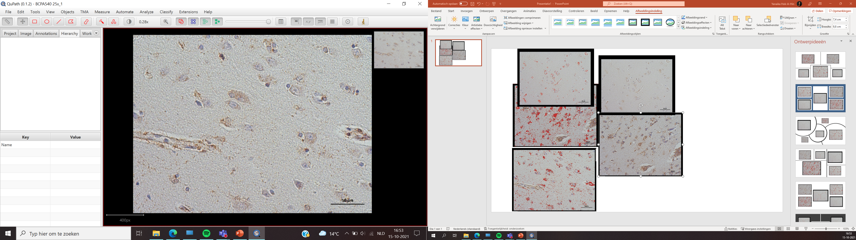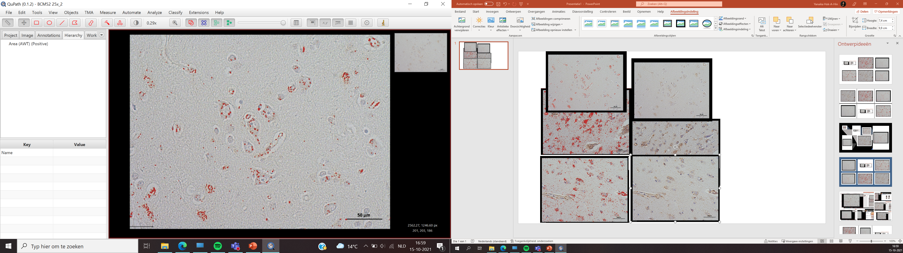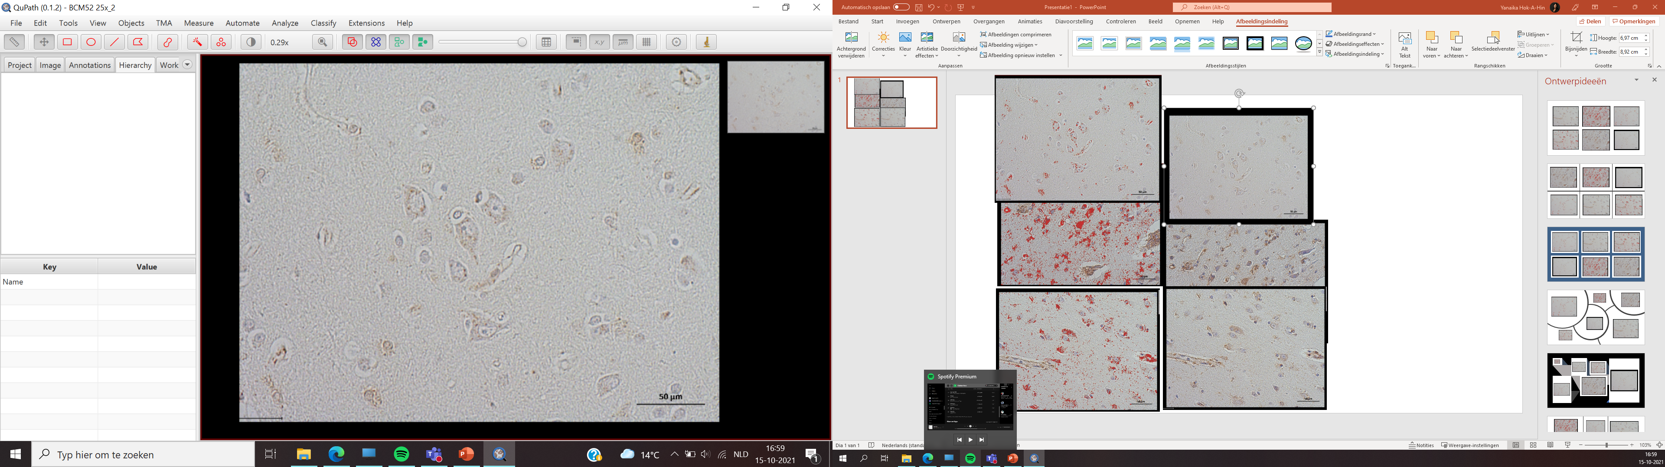
A
B
Control
FTLD-Tau
FTLD-TDP
Supplementary Figure 1. Semi-quantitative assessment of the APOL1 immunoreactivity.
(A) Frontal cortex sections from controls and FTLD (FTLD-Tau and FTLD-TDP) cases showed APOL1 immunoreactivity, indicated by the brown staining. The APOL1 immunoreactivity was analyzed with the Qupath software using DAB positive pixel count parameter. We used a threshold that represented the intensity of all DAB positive pixels in the field, depicted in red, this threshold was applied for all images (B).

