Supporting information

Anhydrous Grotthuss mechanism for fast proton transport in a dense oxide-ion array of α-MoO₃

Zihan Ma^{1‡}, Xiang-Mei Shi^{1‡}, Shin-ichi Nishimura¹, Seongjae Ko¹, Masashi Okubo², Atsuo Yamada^{1,*}

¹Department of Chemical System Engineering, School of Engineering, The University of Tokyo, Hongo 7-3-1, Bunkyo-ku, Tokyo 113-8656, Japan.
² Department of Electrical Engineering and Bioscience, School of Advanced Science and Engineering, Waseda University, Okubo 3-4-1, Shinjuku-ku, Tokyo 169-8555, Japan.

*e-mail address of corresponding author: yamada@chemsys.t.u-tokyo.ac.jp

‡These authors contributed equally.

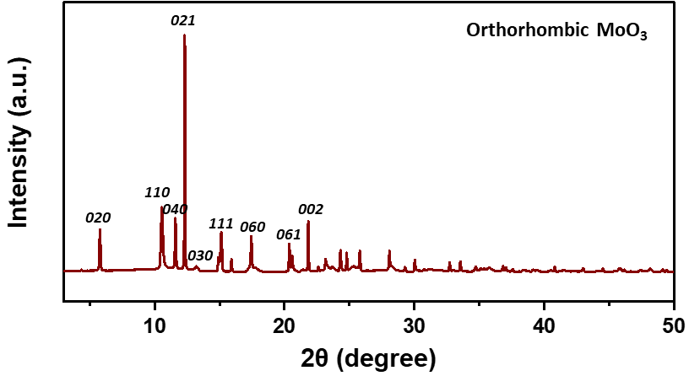

Figure S1. Synchrotron XRD pattern of α-MoO₃.

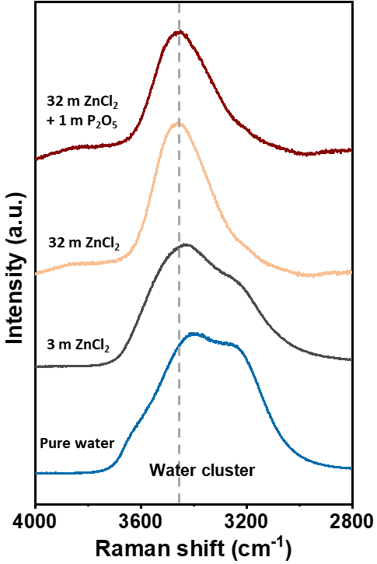

Figure S2. Raman spectra of three ZnCl₂-based aqueous electrolytes: conventional Zn²⁺ electrolyte (3 mol kg^{‒1} ZnCl₂/H₂O), superconcentrated Zn²⁺ electrolyte (32 mol kg^{‒1} ZnCl₂/H₂O), and superconcentrated dual-ion (Zn²⁺/H⁺) electrolytes (32 mol kg^{‒1} ZnCl₂ and 1 mol kg^{‒1} P₂O₅/H₂O). The Raman bands observed in the range of 2800–4000 cm⁻¹ correspond to the O–H stretching modes of water molecules. The broad bands in the range of 2900 -3700 cm⁻¹ are attributed to clusters of water molecules with various hydrogen-bonding environments. The peak at 3464 cm⁻¹ (gray dashed line) is attributed to Zn²⁺ solvated water molecules that are not clustered through hydrogen bonding.

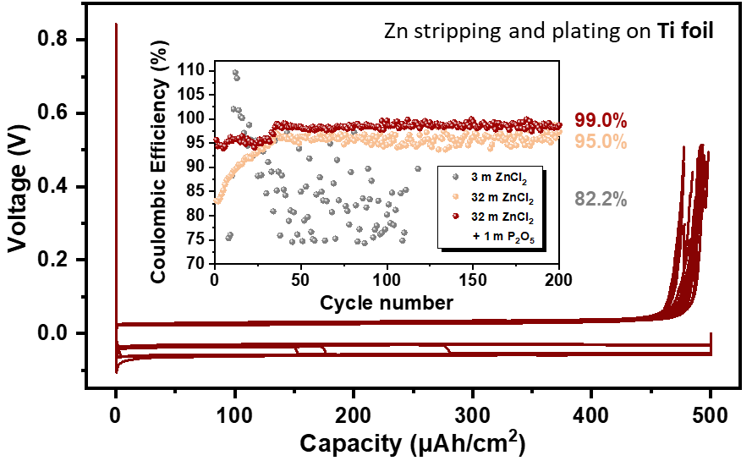

Figure S3. Zn stripping and plating at 0.5 mA cm⁻² on Ti foil in a 32 m ZnCl₂ + 1 m P₂O₅ aqueous electrolyte. Inset: coulombic efficiency in three ZnCl₂-based aqueous electrolytes: conventional Zn²⁺ electrolyte (3 mol kg^{‒1} ZnCl₂/H₂O, gray dot), superconcentrated Zn²⁺ electrolyte (32 mol kg^{‒1} ZnCl₂/H₂O, orange dot), and superconcentrated dual-ion (Zn²⁺/H⁺) electrolytes (32 mol kg^{‒1} ZnCl₂ and 1 mol kg^{‒1} P₂O₅/H₂O, red dot).

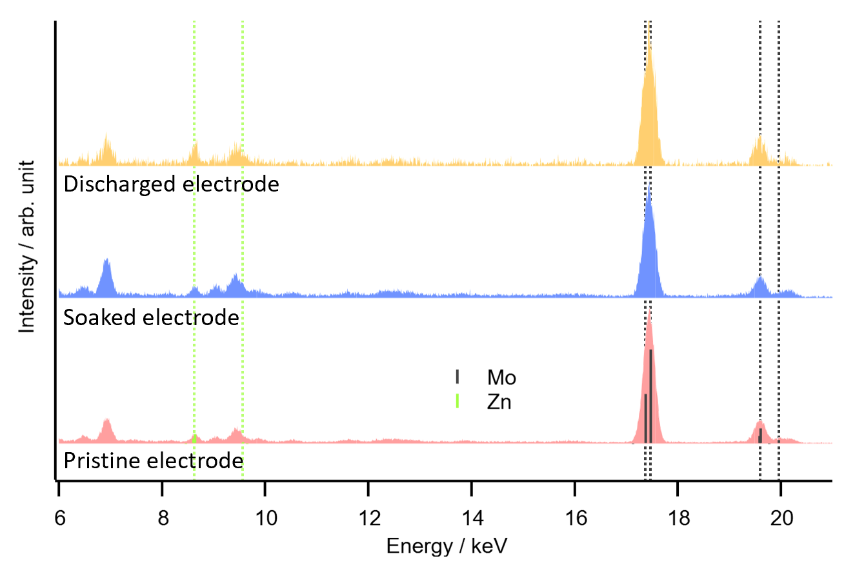

Figure S4. XRF spectra of MoO₃ electrodes: (1) pristine, (2) soaked for 1 day, and (3) discharged in a 32 m ZnCl₂ + 1 m P₂O₅ aqueous electrolyte. The soaked electrode and discharged electrode were carefully extracted from electrolyte, rinsed with water, dried with acetone. The green dashed lines at 8-10 keV corresponds to zinc and the gray dashed lines at 17-20 keV corresponds to molybdenum. The zinc peak intensity did not increase after soaking or discharged, indicating no zinc ion intercalation.

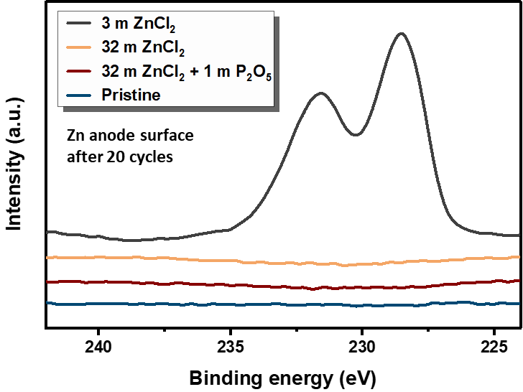

Figure S6. X-ray photoelectron spectroscopy (XPS) spectra of the zinc metal anode cycled in three ZnCl₂-based aqueous electrolytes after 20 cycles: conventional Zn²⁺ electrolyte (3 mol kg^{‒1} ZnCl₂/H₂O), superconcentrated Zn²⁺ electrolyte (32 mol kg^{‒1} ZnCl₂/H₂O), and superconcentrated dual-ion (Zn²⁺/H⁺) electrolytes (32 mol kg^{‒1} ZnCl₂ and 1 mol kg^{‒1} P₂O₅/H₂O). The peaks in conventional Zn²⁺ electrolyte correspond to Mo(0).

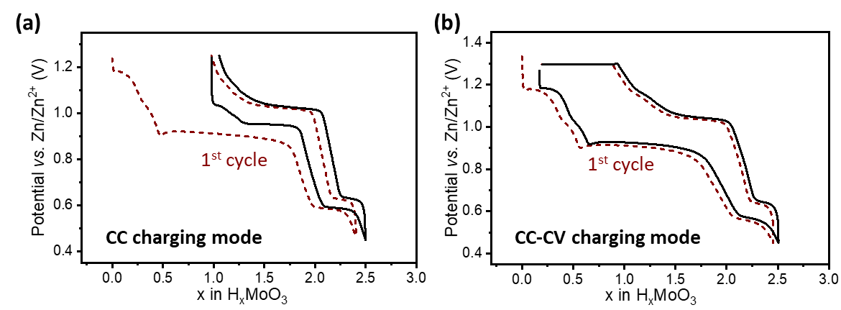

Figure S7. Charge/discharge curves of a MoO₃-zinc cell with (a) galvanostatic (CC) charging mode and (b) galvanostatic + potentiostatic (CC-CV) charging mode in a 32 m ZnCl₂ + 1 m P₂O₅ aqueous electrolyte. The “irreversible capacity” in CC charging mode can be recovered by a 3h-constant voltage step.

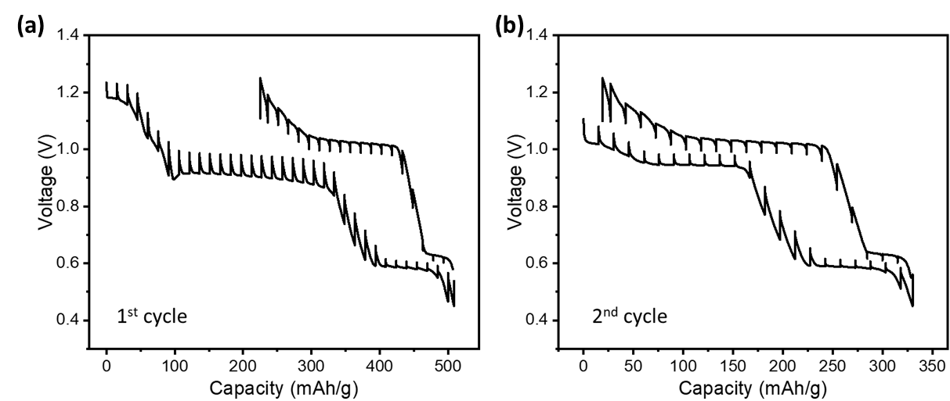

Figure S8. Galvanostatic intermittent titration technique (GITT) curves of a MoO₃-zinc cell in a 32 m ZnCl₂ + 1 m P₂O₅ aqueous electrolyte. Even under the GITT condition, a voltage hysteresis of approximately 0.5 V remains, indicating different routes upon protonation and deprotonation.

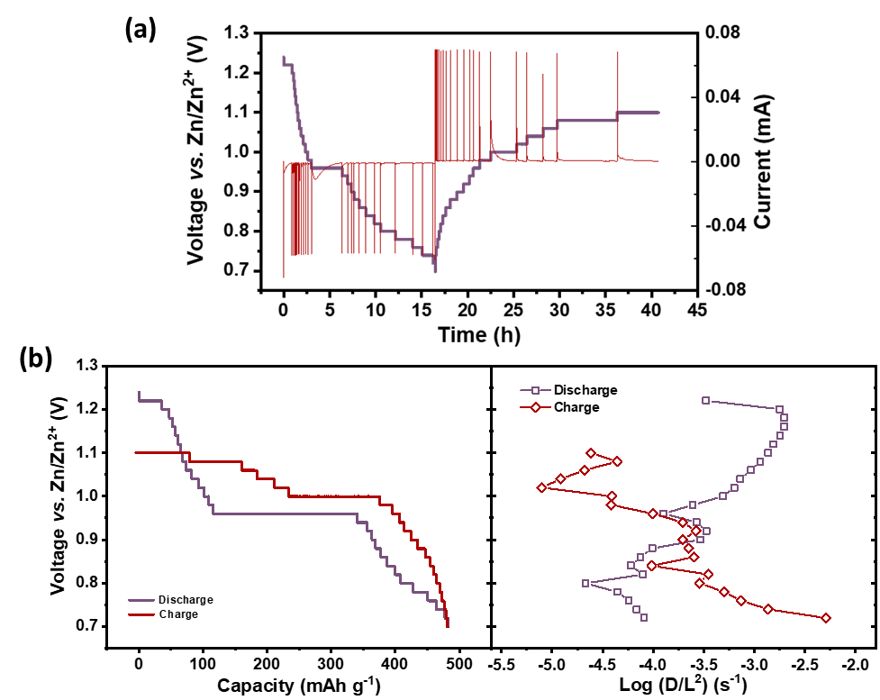

Figure S9. Potentiostatic intermittent titration technique (PITT) results of a MoO₃–zinc cell in a 32 m ZnCl₂ + 1 m P₂O₅ aqueous electrolyte. (a) Current and voltage respose versus time. (b) Diffusion coefficient (D) normalized by the diffusion length (L).

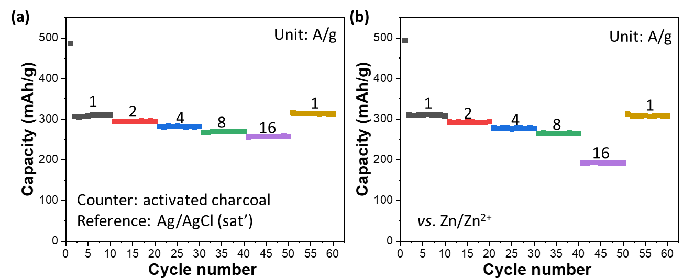
Figure S10. Rate capability of MoO₃ in a 32 m ZnCl₂ + 1 m P₂O₅ aqueous electrolyte with (a) activated charcoal as a counter electrode and Ag/AgCl as a reference electrode, and (b) zinc metal as both counter and reference electrodes. The capacity at the rates of 1-8 A g^{‒1} is identical in both systems while the capacity for the cell with zinc anode at the rate of 16 A g^{‒1} is much lower than that with an activated charcoal counter electrode, indicting the overpotential of zinc anode is rate-limiting in the proposed MoO₃-Zn battery.

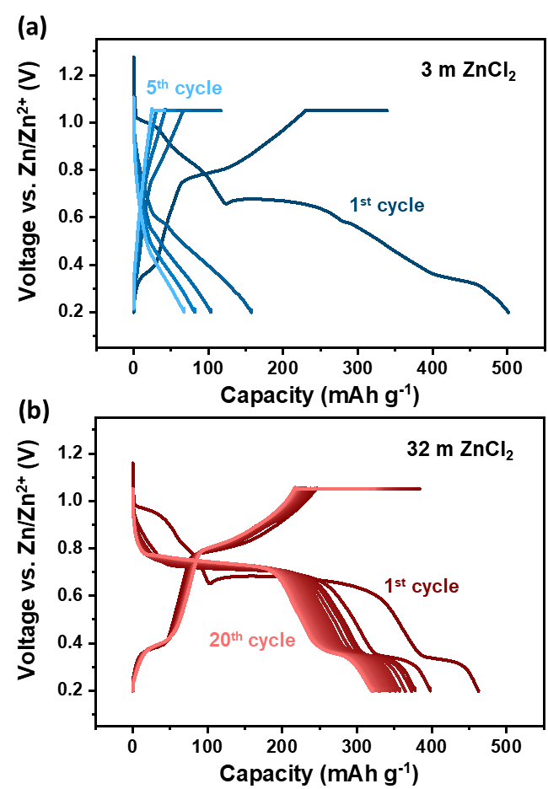

Figure S11. galvanostatic + potentiostatic (CC-CV) charge/discharge curves of a MoO₃–zinc cell in (a) 3 m ZnCl₂, and (b) 32 m ZnCl₂ electrolytes.

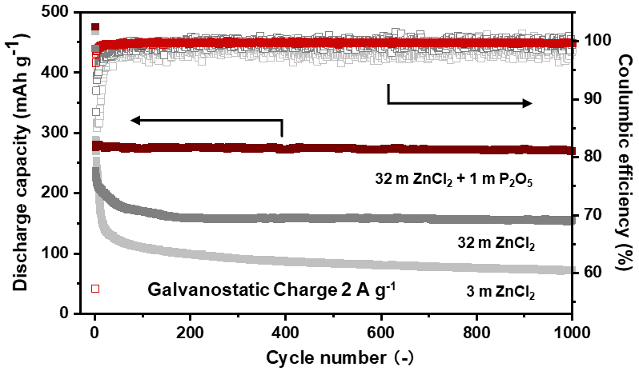
Figure S12. Capacity retention of MoO₃–zinc cells using a conventional Zn²⁺ aqueous electrolyte (3 mol kg^{‒1} ZnCl₂/H₂O), a superconcentrated Zn²⁺ aqueous electrolyte (32 mol kg^{‒1} ZnCl₂/H₂O), and a superconcentrated dual-ion (Zn²⁺/H⁺) aqueous electrolytes (32 mol kg^{‒1} ZnCl₂ and 1 mol kg^{‒1} P₂O₅/H₂O) with galvanostatic charge.

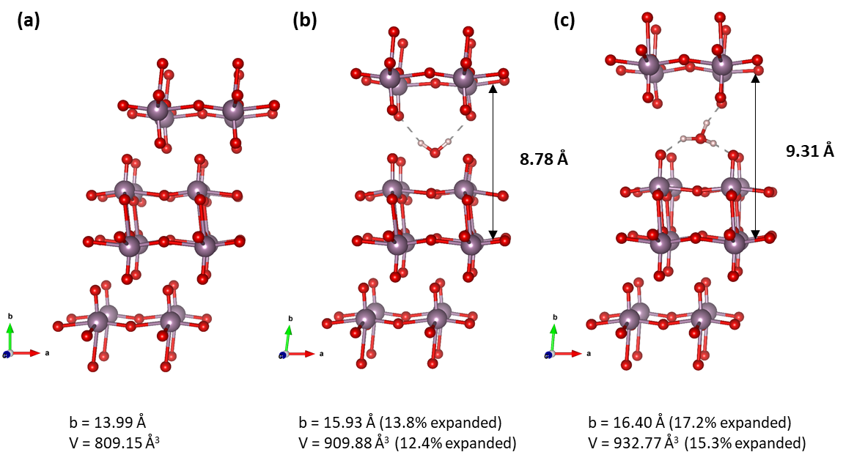
Figure S13. Snapshots of simulated (a) pristine, (b) water inserted and (c) hydronium inserted structures.

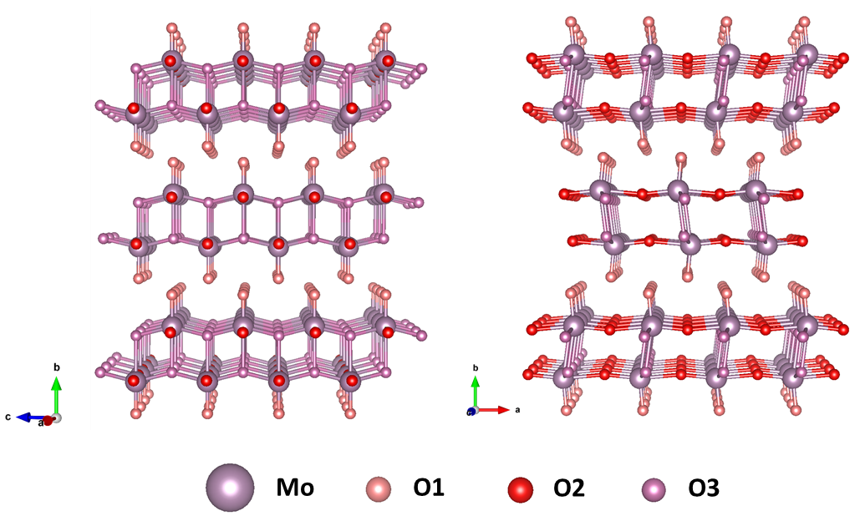

Figure S14. Schematic representation of three different types of oxygen in MoO₃ structure: the terminating oxygen coordinated to one Mo (O1), the bridging oxygen coordinated to two Mo (O2) and the oxygen shared with three Mo (O3).

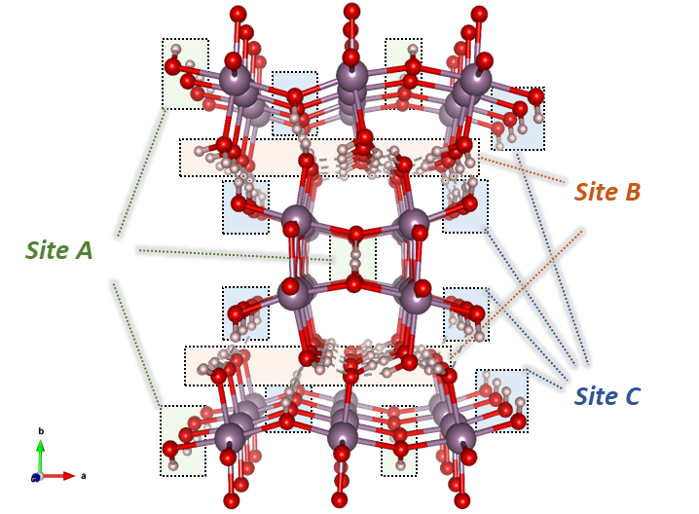
Figure S15. Snapshot of calculated protonated H_{2.5}MoO₃ structure via DFT simulation.

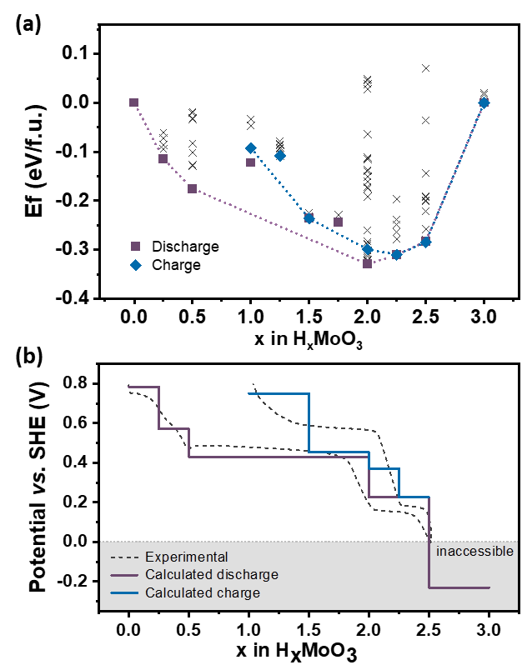

Figure S16. (a) Convex hull of discharge and charge process. (b) Simulated voltage curve compared with an experimental curve.

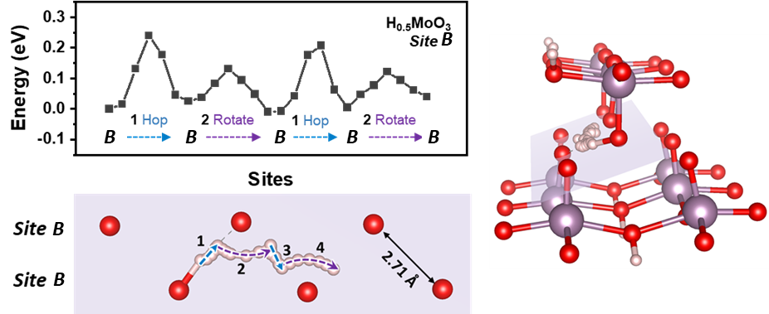
Figure S17. Protonation energy barrier in H_{0.5}MoO₃ with O-O length of 2.71 Å

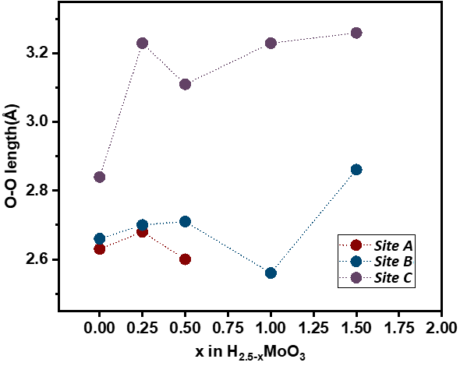
Figure S18. Statistics of the shortest O-O distances in lattice oxygen in different deprotonation states.

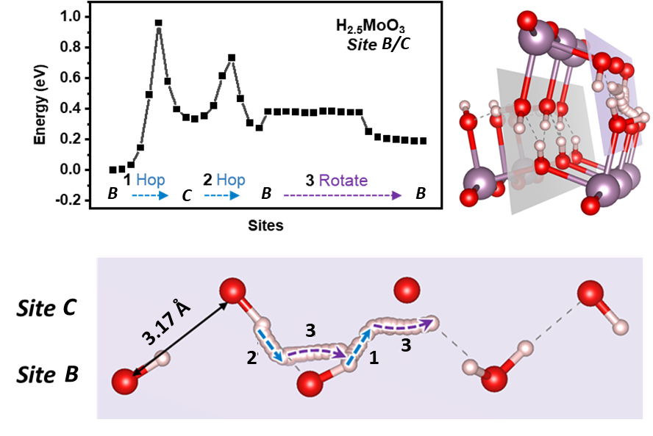
Figure S19. Deprotonation energy barrier in a channel in H_{2.5}MoO₃ with O-O length of 3.17 Å. The channel in gray plane is the same with that in figure 5d.

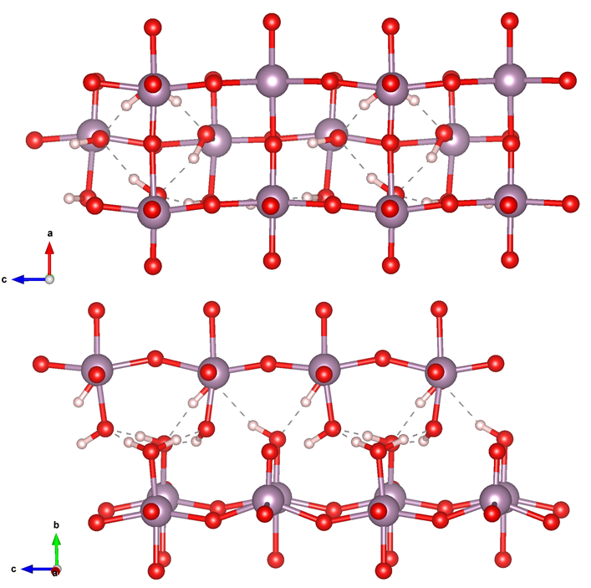
Figure S20. Simulated structure of charged HMoO₃. No long-range 1D proton transfer channel can be found in the structure, therefore, the Grotthuss-type proton transport is disrupted.

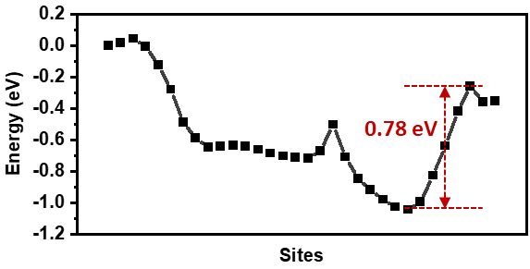
Figure S21. Deprotonation energy barrier in HMoO₃.

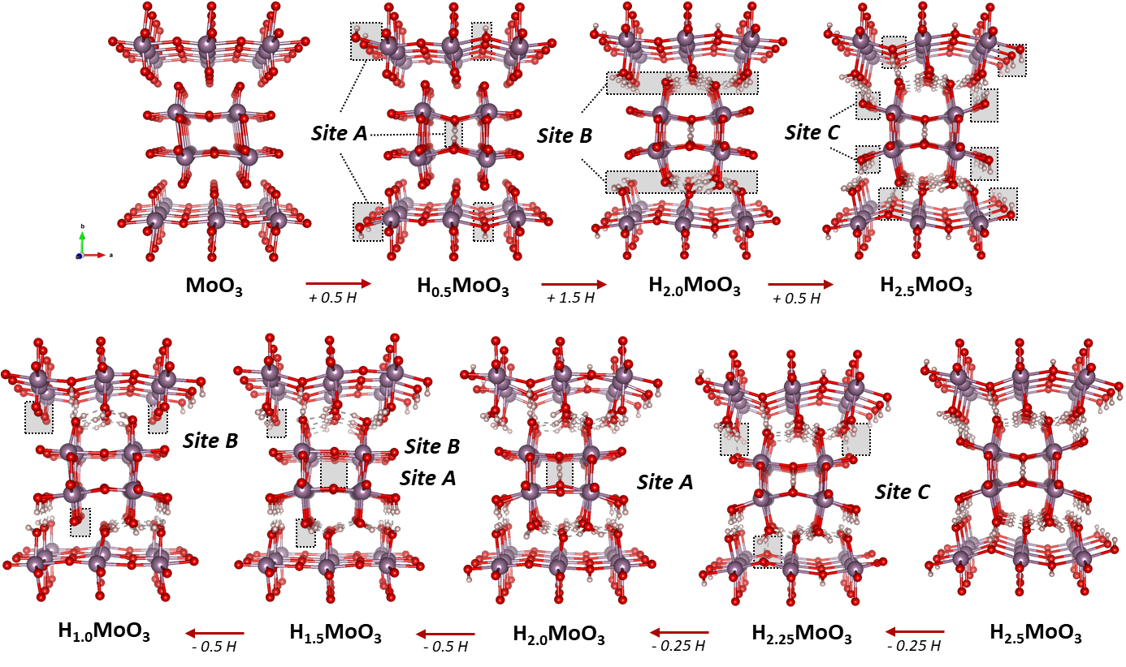

Figure S22. Structure evolution via DFT simulation.

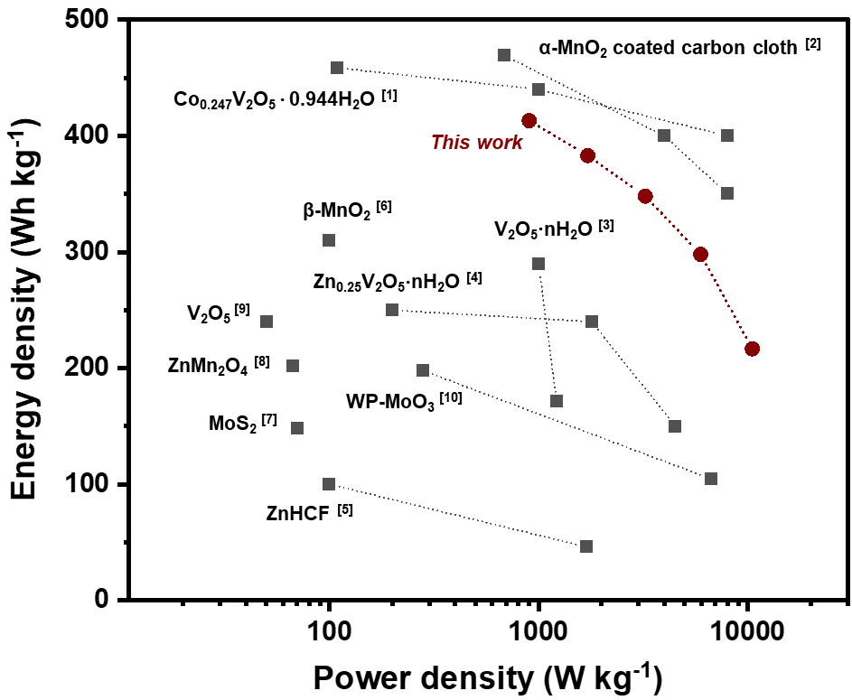
Figure S23. Regan plot: comparison of the energy density and power density of this work to other zinc-ion or proton batteries.

References
[1] Ma, L. et al. Achieving Both High Voltage and High Capacity in Aqueous Zinc-Ion Battery for Record High Energy Density. Advanced Functional Materials 29, 1906142 (2019).
[2] Qiu, W. et al. High-performance flexible quasi-solid-state Zn–MnO2 battery based on MnO2 nanorod arrays coated 3D porous nitrogen-doped carbon cloth. J. Mater. Chem. A 5, 14838–14846 (2017).
[3] Yan, M. et al. Water-Lubricated Intercalation in V2O5·nH2O for High-Capacity and High-Rate Aqueous Rechargeable Zinc Batteries. Advanced Materials 30, 1703725 (2018).
[4] Kundu, D., Adams, B. D., Duffort, V., Vajargah, S. H. & Nazar, L. F. A high-capacity and long-life aqueous rechargeable zinc battery using a metal oxide intercalation cathode. Nature Energy 1, 1–8 (2016).
[5] Zhang, L., Chen, L., Zhou, X. & Liu, Z. Towards High-Voltage Aqueous Metal-Ion Batteries Beyond 1.5 V: The Zinc/Zinc Hexacyanoferrate System. Advanced Energy Materials 5, 1400930 (2015).
[6] Zhang, N. et al. Rechargeable aqueous zinc-manganese dioxide batteries with high energy and power densities. Nature Communications 8, 405 (2017).
[7] Li, H. et al. MoS2 nanosheets with expanded interlayer spacing for rechargeable aqueous Zn-ion batteries. Energy Storage Materials 19, 94–101 (2019).
[8] Zhang, N. et al. Cation-Deficient Spinel ZnMn2O4 Cathode in Zn(CF3SO3)2 Electrolyte for Rechargeable Aqueous Zn-Ion Battery. J. Am. Chem. Soc. 138, 12894–12901 (2016).
[9] Hu, P. et al. Zn/V2O5 Aqueous Hybrid-Ion Battery with High Voltage Platform and Long Cycle Life. ACS Appl. Mater. Interfaces 9, 42717–42722 (2017).
[10] Zhang, H. et al. Interlayer Engineering of α-MoO3 Modulates Selective Hydronium Intercalation in Neutral Aqueous Electrolyte. Angewandte Chemie International Edition 60, 896–903 (2021).

