Neurotoxic Amyloidogenic Peptides in the Proteome of SARS-COV2: Potential Implications for Neurological Symptoms in COVID-19

Mirren Charnley^{1,2},+, Saba Islam^{3,}+, Guneet Bindra⁴, Jeremy Engwirda³, Julian Ratcliffe⁵, Jiangtao Zhou⁶, Raffaele Mezzenga⁶, Mark Hulett⁴, Kyunghoon Han⁷, Joshua T. Berryman⁷,*, and Nicholas P. Reynolds³,*

¹Centre for Optical Sciences and Department of Health Sciences and Biostatistics, Swinburne University of Technology, Hawthorn, Victoria 3122, Australia
²Immune Signalling Laboratory, Peter MacCallum Cancer Centre, Parkville, Victoria, 3000, Australia
³Department of Chemistry & Physics, La Trobe Institute for Molecular Science, La Trobe University, Bundoora, Victoria, 3086, Australia
⁴Department of Biochemistry & Genetics, La Trobe Institute for Molecular Science, La Trobe University, Bundoora, Victoria, 3086, Australia
⁵La Trobe University Bioimaging Platform, Bundoora 3086, Victoria, Australia
⁶ETH Zurich, Department of Health Science & Technology, Schmelzbergstrasse 9, LFO, E23, 8092 Zurich, Switzerland
⁷Department of Physics and Materials Science, Faculty of Science, Technology and Medicine, University of Luxembourg, 162a Avenue de la Faïencerie, L-1511 Luxembourg

Supplementary Data

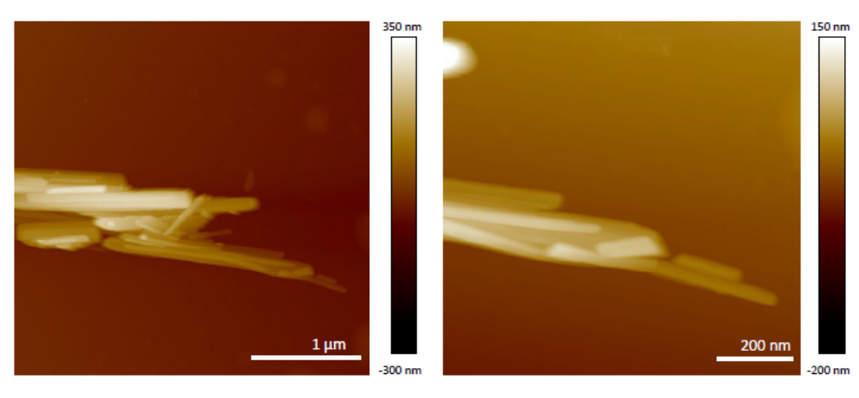
Figure S1: AFM Images of RNYIAQVD assemblies [1 mg mL⁻¹] after 2 h assembly

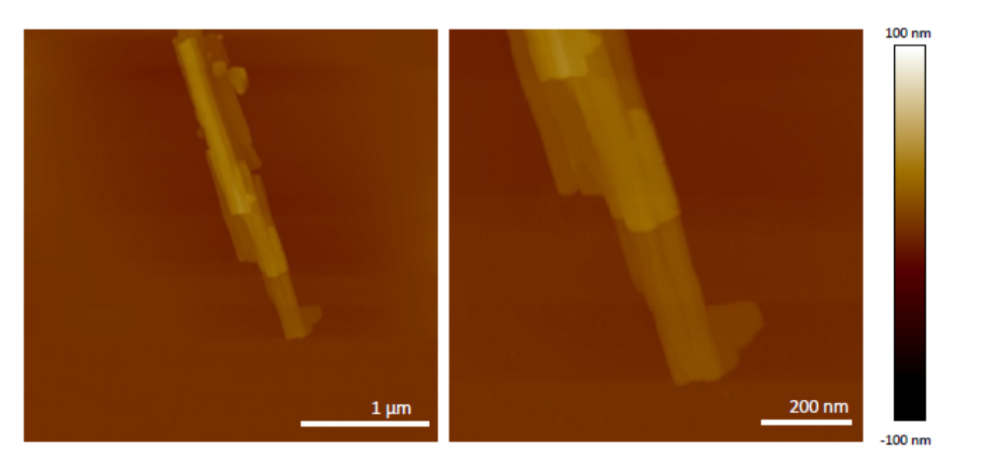
Figure S2: AFM Image of ILLIIM assemblies [1 mg mL⁻¹] after 2 h assembly

Figure S3: Line scans of ILLIIM assemblies (5 mg mL⁻¹) (24 h assembly)

Figure S4: Line scans of RNYIAQVD assemblies (5 mg mL⁻¹) (24 h assembly)

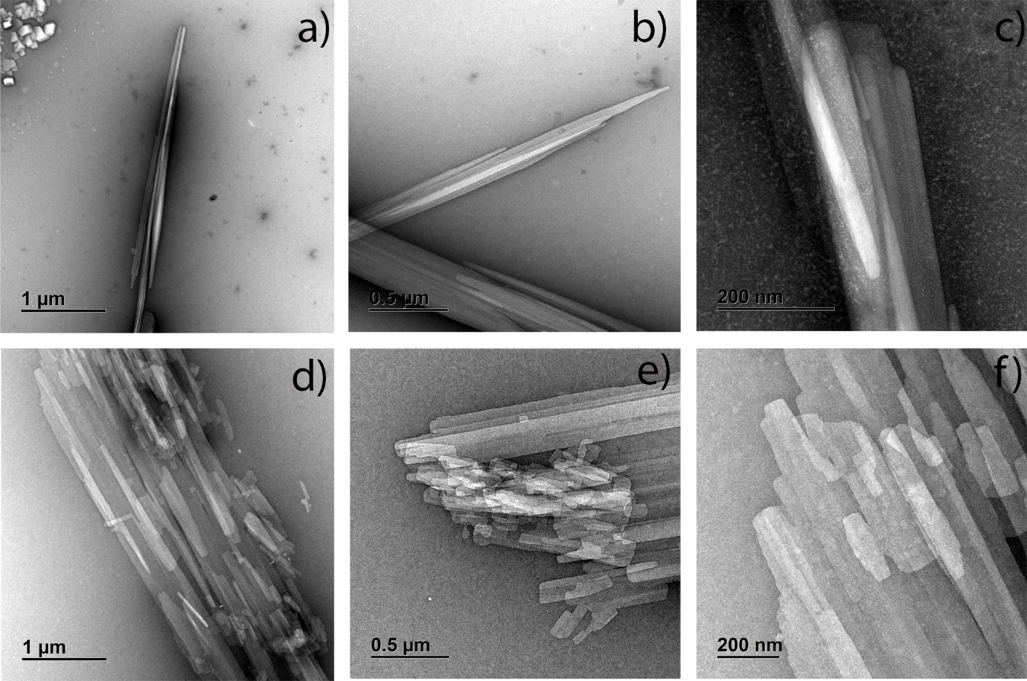
Figure S5: Additional TEM images a-c) RNYIAQVD d-f) ILLIIM (24 h assembly)

Figure S6: Mean-Square end-to-end persistence length calculations for both peptide assemblies

Figure S7: Secondary Structure Analysis from BestSel of a) RNYIAQVD and b) ILLIIM

Figure S8: Cytotoxicity assays showing the toxicity of PBS in the concentrations used for peptide cytotoxicity assays

