Supplementary information

Highly Reliable Flexible Device with Charge Compensation Layer

Hyojung Kim, Jongwoo Park*, Taeyoung Khim, Hyuncheol Hwang, Jungmin Park, Chanhee Han, Jongmin Yoo, Dongbhin Kim, Jangkun Song, and Byoungdeog Choi*

Dr. H.J. Kim, Dr. Jongwoo Park, Dr. Taeyoung Khim, Hyuncheol Hwang
Quality Reliability Team, OLED Business Samsung Display Co., Ltd., 181 Samsung-Ro, Tangjeong-myeon, Asan-si 31454, Republic of Korea
Dr. H.J. Kim, Dr. J.M. Park
Department of Semiconductor and Display Engineering, Sungkyunkwan University, Cheoncheon-dong 300, Jangan-gu, Suwon-si 16419, Republic of Korea

C.H. Han, J.M. Yoo, D.B. Kim, Prof. J.K. Song, Prof. B.D. Choi
Department of Electrical and Computer Engineering, Sungkyunkwan University, Cheoncheon-dong 300, Jangan-gu, Suwon-si 16419, Republic of Korea
E-mail: jongwoo.s.park@samsung.com , bdchoi@skku.edu

Keywords: flexible electronic device, polyimide substrate, SiCOH, thin film transistor, a-IGZO device, image sticking, NBTS, device characterization, Kelvin probe force microscopy, SIMS

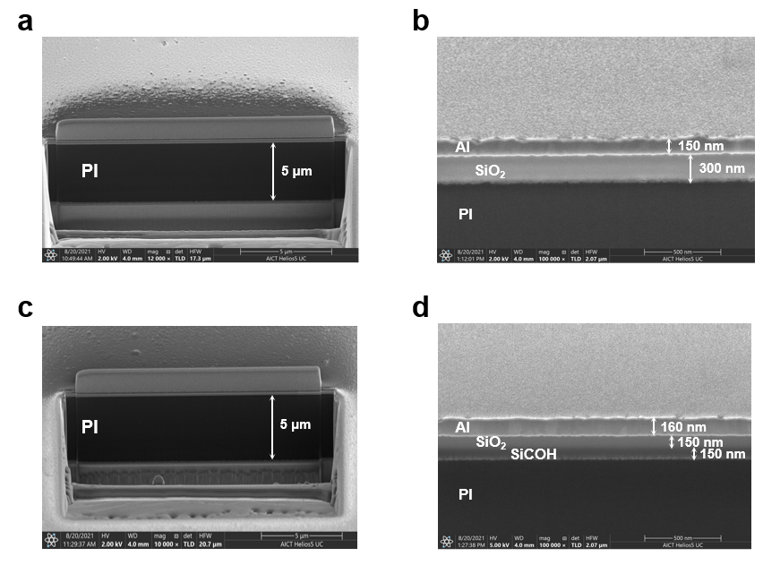
Supplementary Figure 1: Vertical cross-section images by SEM to measure the thicknesses of MIM capacitor dielectric. (a) Measured PI thickness of MIM A with the Al/SiO₂/PI/Al structure. (b) Enlarged image of MIM A to measure the SiO₂ thickness. (c) Measured PI thickness of MIM B with Al/SiO₂/SiCOH/PI/Al. The measured PI thickness was similar to the measured PI in MIM A. (d) Enlarged image of MIM B to measure the thickness of SiO₂ and SiCOH. Total barrier thickness is controlled to 300 nm for both MIM A and MIM B.

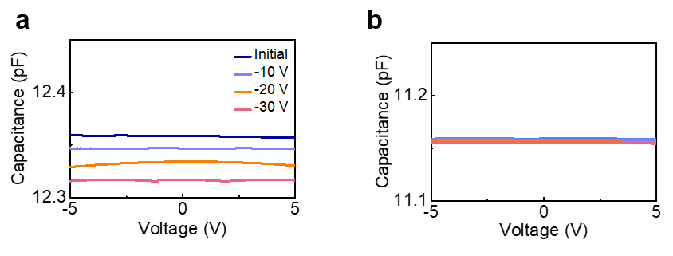
Supplementary Figure 2: C–V characteristics of the MIM capacitor before and after NBTS. (a) MIM A (Al/SiO₂/PI/Al). (b) MIM B (Al/SiO₂/SiCOH/PI/Al). -10 V, -20 V, and -30 V were applied to the top electrode of the MIM capacitor, and C–V measurement was performed at 70 °C. The change in capacitance under the bias stress was larger in MIM A than in MIM B.

Supplementary Fig. 2 presents the results of the C–V measurement of MIM capacitors with different structures. Changes in capacitance were conducted by applying −10, −20, and −30 V at 70 °C to the top electrode of the MIM capacitors. In the MIM A capacitor with the SiO₂ barrier layer, the change in capacitance increased as the voltage increased, but the MIM B capacitor with the SiO₂/SiCOH bilayer showed no change in the capacitance even with increased voltages.

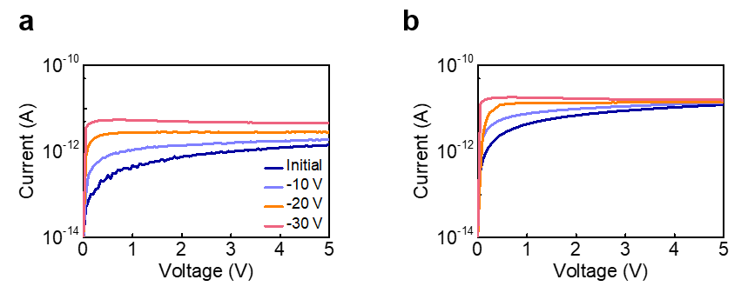 Supplementary Figure 3: I-V characteristics of the MIM capacitor before and after NBTS. (a) MIM A (Al/SiO₂/PI/Al). (b) MIM B (Al/SiO₂/SiCOH/PI/Al). -10 V, -20 V, and -30 V were applied to the top electrode of the MIM capacitor, and I–V measurement was performed at 70 °C. The change in current under the bias stress was larger in MIM A than in MIM B.

Supplementary Fig. 3 depicts the I–V plots of the MIM capacitors according to the applied voltage stress at 70°C. The I–V results show the leakage currents of MIM A and MIM B with the applied voltage; however, MIM B showed less fluctuations in the leakage current according to the applied voltage. There can be two main reasons for the increase in the leakage current of the MIM capacitors under bias. First, it is considered that the bonds of the molecular chains inside the PI are broken by the injected electrons, resulting in defect generation, which increases the leakage current. The second reason is related to the density of the insulator including barrier layers. If the density of the layer is low, the leakage current path increases by the accumulated voltage stress. However, it can be assumed that the first reason is the main cause of leakage current fluctuations because the density of SiO₂ is much larger than that of SiCOH as a barrier layer.

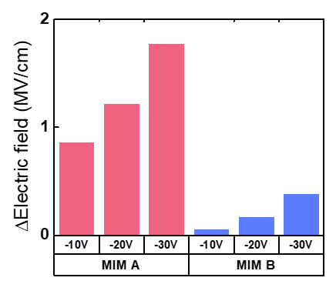
Supplementary Figure 4: Comparison of the electric field after the negative bias temperature stress of MIM A (Al/SiO₂/PI/Al) and MIM B (Al/SiO₂/SiCOH/PI/Al) extracted from the amount of charging in the PI layer as a function of the applied voltage.

After NBTS, the amount of change in capacitance was obtained through the C–V curve of MIM capacitors, and the ΔQ (charge change in Coulombs) value was extracted from the equation ΔQ=ΔC×V. To confirm whether it can affect the a–IGZO TFT active area fabricated on the PI substrate, the extracted charge can be converted into the electric field (E=V/d) that affects the actual active layer in the PI/ barrier/ a–IGZO TFT structure. Supplementary Fig. 4 shows the accumulated electric field in the interface between the PI and barrier layer as a bar graph.

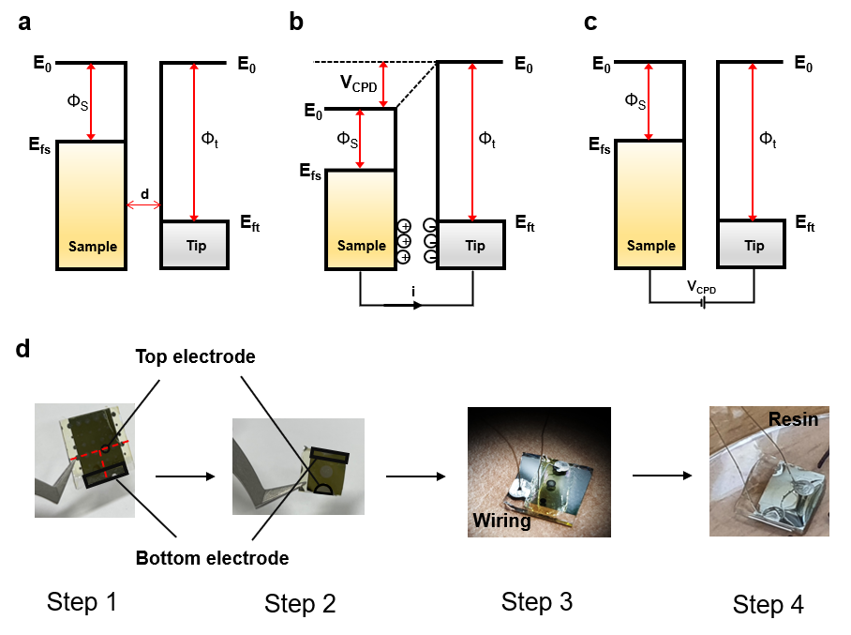
Supplementary Figure 5: Principle of KPFM measurement and the sample preparation. (a) Energy levels of the tip and sample separated by distance d without the electrical contact. (b) Tip and sample under the electrical contact. (c) V_{CPD} nullified with the external bias applied between tip and sample. (d) MIM capacitor sample preparation for KPFM measurement (Step 1 - In the MIM structure, cut the top electrode in half along the red line in the figure. Step 2 - To apply voltage to the top and bottom electrodes during KPFM measurement, a wiring for both top electrode and bottom electrode was carried out followed by molding with resin. Step 3 - polishing the resin until the cut top electrode is exposed for KPFM measurements. Step 4 - measuring KPFM before/after applying voltage stress. The voltage stress can be applied through the wires connected to the top and bottom electrode.)

Kelvin probe force microscopy (KPFM) is an atomic force microscopy (AFM)-based technique that is used to study the electronic properties of nanoscale materials and devices. KPFM detects the electrostatic force and measures the contact potential difference (CPD) between the AFM probe and the sample surface, which is caused by the difference in the work function of the material itself, the surface charge, and non-equilibrium charging such as dipole and photo-induced charge separation^{1,2}. Basically, the probe and sample form a capacitance, and the energy stored in this capacitor is expressed as the following equation.

$U_{cap}=\frac{1}{2}C{(∆V)}^{2}$,

where C is the capacitance between the probe and the sample, and ∆V is the difference in charge potential between the probe and the sample surface. At this time, the force acting on the probe can be obtained by differentiating the energy of the above equation by the distance d between the probe and the sample surface:
$$\frac{{∂U}_{cap}}{∂d}≡F_{cap}=-\frac{1}{2}\frac{∂C}{∂d}{\left(∆V\right)}^{2}.$$
∆V can be expressed as:
$$∆V={∆V}_{DC}+{∆V}_{AC}sinsin ω_{KP}t$$

where, $ω_{KP}$ is the vibration frequency of the Kelvin probe. Also, ${∆V}_{DC}$ can be expressed as the following equation. Here, ${∆V}_{DC,cap}$ means the difference in the DC potential energy of the capacitor, $∆∅_{S}$ means the difference in the surface potential between the probe and the sample surface, and $∆∅_{S}=eV_{CPD}$. V_{CPD} can be expressed by the following equation:
$$V_{CPD}=\frac{∅_{s}-∅_{t}}{e}.$$

Supplementary Figs. 5a-c show the principle of KPFM. This is based on the alignment of the Fermi level when two conductive or semiconducting materials are in electrical contact. One material represents the sample, while and the other represents the conductive AFM tip with different work functions ϕ_{s} and ϕ_{t}, respectively (Supplementary Fig. 5a). In Supplementary Fig. 5b, when an electrical contact occurs between the tip and the sample, the sample and the Fermi level of the tip are aligned as electrons flow from the sample to the tip. This in turn causes a contact potential difference V_{CPD} between the tip and the sample. In KPFM, V_{CPD} is compensated at each point of the scan by applying a DC bias (V_{DC}) that equals V_{CPD}, as shown in Supplementary Fig. 5c.
Supplementary Fig. 5d shows the sampling procedure process of KPFM measurement using the MIM capacitor, which consists of 4 steps as follows: Step (1) – In the MIM structure, the top electrode is cut in half along the red line in the figure. Step (2) – To apply voltage to the top and bottom electrodes of the cut part, they are connected with wiring, and molded with resin. Step (3) – the electrodes are polished, until the cut surface with the top electrode is exposed for KPFM measurements. Step (4) – KPFM is measured before and after applying voltage through the wire connected to the top and bottom electrodes.

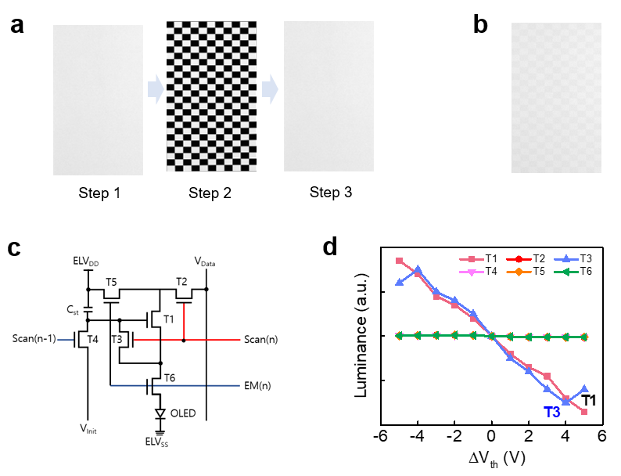
Supplementary Figure 6: Image sticking of OLED panel. (a) Image sticking assessment by using the checkerboard test pattern (Steps 1–2–3). (b) Image sticking phenomenon (image retention). (c) Pixel circuitry consisting of transistors (T1-T6) and capacitor (C_{st}). (d) Correlation between luminance and ΔV_{th} of each transistor. When the V_{th} of the T1 and T3 TFTs is positively shifted, the luminance is decreased, and when the V_{th} is negatively shifted, the luminance is increased.

One of the metrics that can measure the display panel quality is the display image sticking evaluation. Image sticking refers to a phenomenon in which previously written data affects the next frame. Supplementary Fig. 6a represents the evaluation method for display image sticking^{3,4}. The luminance is measured at the first 64-gray pattern, then aged for a certain time under the pattern where the black/white pattern intersects, and the luminance is measured again at the 64-gary pattern. The level at which the luminance exceeds a certain level in the late 64-gray pattern compared to the initial 64-gray pattern is evaluated as an afterimage time value. However, Supplementary Fig. 6b shows that the panel manufactured on the PI substrate has an image sticking phenomenon. In particular, it was confirmed that the luminance of the aged part of the black pattern decreased.
This phenomenon may occur due to the shift in V_{th} of a specific TFT of the organic light-emitting diode (OLED) pixel driving circuit. In the OLED display, V_{th} distribution is important because the luminance is controlled by the current flowing through the driving TFT, but LTPS TFT or a–IGZO TFT has poor V_{th} distribution because it is manufactured inside a large substrate. Therefore, as Supplementary Fig. 6c shows, a V_{th} compensation circuit has been used to keep the current flowing through the OLED constant even if the V_{th} of the driving TFT is different⁵. However, when the V_{th} of the switching TFT (T3) acting as a compensation circuit is shifted, Supplementary Fig. 6d shows that this may cause the panel luminance deviation. Supplementary Fig. 6d shows the simulation results to determine if the difference in luminance in the actual panel can be changed by changing the V_{th} of all TFTs constituting the circuit from (−5 to +5) V.
As a result, it was confirmed that the V_{th} change of the driving TFT (T1) and the switching TFT (T3) can induce luminance deviation in the panel. Through these results, it was confirmed that the V_{th} of a specific TFT could decrease the luminance during positive shift and increase the luminance during V_{th} shift.

Supplementary Table 1. Electrical properties of a–IGZO TFT before and after NBTS.
Parameter | Device A | Device B | Device C
V_{th} (V) | 1.36 | 1.43 | 1.31
S.S (V/dec) | 0.11 | 0.12 | 0.12
ΔV_{th} (V) after NBTS | -0.36 | 0.45 | -0.25
ΔS.S (V/dec) after NBTS | 0.047 | 0.018 | 0.022

Supplementary Table 2. Material parameters extracted from the SEM and C–V measurement.
 | PI | SiO₂ | SiO₂/SiCOH
Thickness (µm) | 5 | 0.3 | 0.15/0.15
Dielectric constant | 3.92 | 3.9 | -
Capacitance (F) | 3.72⋅10⁻¹¹ | 8.13⋅10⁻¹² | 1.40⋅10⁻¹²

Supplementary References

1. Reid, O. G. et al. Space charge limited current measurements on conjugated polymer films using conductive atomic force microscopy. Nano Lett. 8, 1602-1609 (2008).
2. C. Li, Y. Bando, D. Golberg. Current imaging and electromigration-induced splitting of GaN nanowires as revealed by conductive atomic force microscopy. ACS Nano 4, 2422-2428 (2010).
3. I. Rostscholl, U. Kruger. Aspects of Image Sticking Evaluations Using Imaging Luminance Measurement Devices. SID Symp. Dig. Tech. 50, 695-698 (2019).
4. Kim, J. M. et al. An Evaluation Methodology for Display Retention Measurement. SID Symp. Dig. Tech. 49, 80-83 (2018).
5. Chung, H. K. et al. Organic light emitting device pixel circuit and driving method therefor. U.S. Patent No 7,414,599 (2008).

