Impacts of urbanization at city cluster scale on ecosystem services along an urban-rural gradient: A case study of Central Yunnan City Cluster, China

Appendix A. Supplementary data

Supplementary Information A

Table S1. Land use changes in CYCC from 1995 to 2018.
Class | Area/km²
Class | 1995 | 2005 | 2015 | 2018
Agriculture | 23745.75 | 23608.84 | 23321.02 | 23255.31
Forest | 56557.45 | 56556.85 | 56544.45 | 56257.23
Grass | 31540.59 | 31554.71 | 31418.13 | 30796.95
Open water | 1316.70 | 1313.49 | 1328.26 | 1491.88
Constructed | 1279.29 | 1405.82 | 1809.31 | 2633.39
Unused | 160.22 | 160.29 | 178.84 | 165.25
Total | 114600 | 114600 | 114600 | 114600

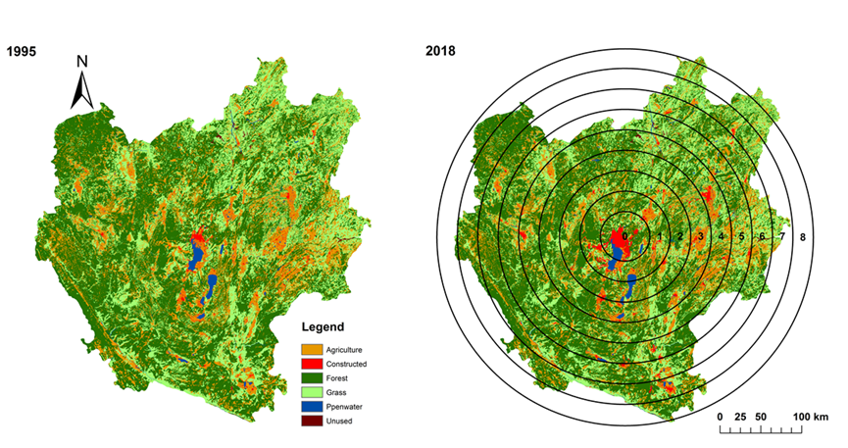

Fig. S1. Land-use and land-cover maps for CYCC in 1995 and 2015.

Supplementary information 1: Calibration and validation of InVEST and parameters

Monitoring and literature data were applied in this study to calibrate the models and validate the simulation results. The carbon storage model was calibrated using data extracted from literature sources (Tables S3 and S4). Simulation results were validated using other reported data^{[1-4]}.
The carbon storage model was calibrated using data extracted from literature sources (Tables S3 and S4). The simulation results were validated using other reported independent data. Simulated forest carbon storage was 2.72×106 t in 2015, which is close to the 1.96×106 t reported for 2008 by Li et al. (2011). Simulated water yield was 0.73×109 m3 in 1995 and 0.78×109 m3 in 2015 which, considering the variation in annual rainfall variation, is similar to the reported water yield in 2009 and 2011 of 0.45-0.75×109 m3 (Cao et al., 2016). Simulated soil retention was 0.31×109 t in 1995, which was fairly close to the 0.15×109 t reported for that year by Gong (2016). Simulated annual nitrogen export ranged from 1980.42 t (1995) to 1794.85 t (2015), while according to relevant monitoring and research data it varies from 1240 t to 1951.1 t (Li et al., 2011), i.e., the simulated values were in the reasonable range. Key parameters and biophysical attributes tables, which we calibrated and validated in a previous study (Wang et al., 2021), are presented in Supplementary Information 1.

Supplementary information 2: InVEST models

The InVEST (Version.3.7.0) suite of models has been designed to enable decision makers to assess trade-offs among and within ecosystem services and to compare the consequences of different scenarios in future, for example those related to land use or climate changes^{[5]}. In the present study, we selected the carbon storage and sequestration model (for carbon storage), the water yield model (for water yield service), the sediment delivery ratio model (for soil retention service), and the nutrient delivery ratio model (for nitrogen export), to evaluate the corresponding ecosystem services in CYCC.
Carbon storage evaluation in the InVEST model was performed using LUCC rasters and carbon pool parameters (from biophysical attributes tables; see Tables S2 and S3), representing the carbon quantity captured and stored in a certain landscape on a certain occasion (Sharp et al., 2016). Water yield evaluation was simplified as precipitation minus evapotranspiration, representing water production per pixel of a certain landscape on a certain occasion. The main driving data included annual precipitation and evapotranspiration, plant-available water content (PAWC), and soil depth. Soil retention evaluation was based on generation and delivery of overland sediment to streams in a certain landscape on a certain occasion, with main input data including digital elevation map (DEM), soil texture, precipitation, land cover, and biophysical attributes based on soil erosion caused by LUCC (Tables S2 and S4). Nitrogen export evaluation was based on the principle of mass conservation, to calculate generation and loss of nutrient mass while flowing through a certain landscape, with main driving data including DEM, precipitation, LUCC rasters, and a biophysical attributes table (based on the nutrient loading and retention efficiency related to LUCC in Tables S2-S4).

Supplementary information 2.1: Carbon storage and sequestration (CSS) model

Using maps of land use and land cover types, and data on the amount of carbon stored in carbon pools, this model estimates the net amount of carbon stored in a land parcel over time as:

$$C_{total}=C_{above}+C_{below}+C_{soil}+C_{dead}$$

where C_{total} is the total amount (Mg/ha) of carbon storage; and C_{above}, C_{below}, C_{soil}, and C_{dead} represents the amount (Mg/ha) of carbon stored in aboveground biomass, belowground biomass, soil, and dead organic matter, respectively.

Supplementary information 2.2: Water yield (WY) model
Annual water yield for pixel on land use/land cover (LULC), 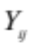 (mm/yr), is estimated based on mean annual precipitation and the Budyko curve:
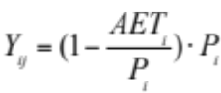
where 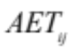 (mm/yr) is actual annual evapotranspiration for pixel on LULC and 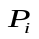 (mm/yr) is annual precipitation for pixel .

For vegetated LULC, the evapotranspiration portion of the water balance, 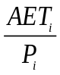, is based on an expression of the Budyko curve proposed by Fu (1981) and Zhang et al. (2004)^{[6, 7]}:
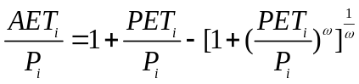
where 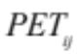 is potential evapotranspiration and 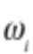 is a non-physical parameter that characterizes the natural climate-soil properties.
Potential evapotranspiration, , is defined as:
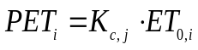
where 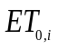is the reference evapotranspiration from pixel and ${\text{k}}_{\text{ij}}$ is the vegetation evapotranspiration coefficient associated with the pixel $\text{i }$on LULC $\text{j:}$
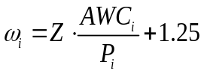
where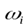is a non-physical parameter that characterizes the natural climate-soil properties; 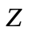is a dimensionless constant, ranging from 1 to 30, that captures the local precipitation pattern and hydrogeological characteristics; 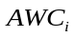(mm) is the volumetric plant-available water content; 1.25 is the minimum value of ^{[8]}; 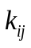is the evapotranspiration coefficient for pixel on LULC; 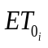 (mm/yr) is the reference evapotranspiration for pixel ; and $\text{PAWC}$ (mm) is the plant-available water capacity.
For non-vegetated LULC (e.g., water, construction land), the actual annual evapotranspiration is computed directly from the reference evapotranspiration and has an upper limit defined by the precipitation:
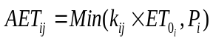
where is the evapotranspiration coefficient for pixel on LULC ; (mm/yr) is the reference evapotranspiration for pixel and (mm/yr) is the annual precipitation for pixel .

Supplementary information 2.3: Sediment delivery ratio (SDR) model
The InVEST sediment delivery model is designed to map overland sediment generation and delivery to the stream. The sediment export from a pixel , 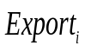 (ton ha⁻¹ yr⁻¹), and the total sediment export of the evaluated area,  (ton·ha⁻¹·yr⁻¹), is given by:
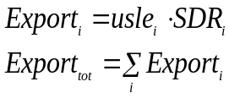
The amount of annual soil loss on pixel , 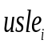, is given by the revised universal soil loss equation (usle):
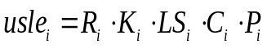
where 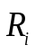 (MJ mm (ha hr)⁻¹) is the rainfall erosivity; 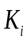 (ton ha hr (MJ ha mm)⁻¹) is the soil erodibility; 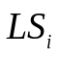is the slope length-gradient factor; 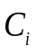is the crop-management factor; and 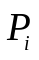 is the support practice factor.
The connectivity index is given by:
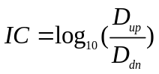
is the upslope component defined as:
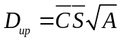
where 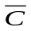is the average 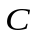factor of the upslope contributing area; 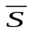 (m/m) is the average slope gradient of the upslope contributing area; (m²) is the upslope contributing area; and 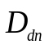is the downslope component, defined as:
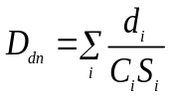
where and 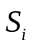 are the factor and the slope gradient on pixel ; and 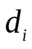 (m) is the length of the flow path along pixel .
The 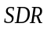 for pixel , , is derived from the connectivity index :
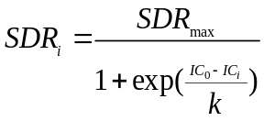
where is the maximum theoretical; and 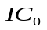and are calibration parameters that define the shape of the SDR-IC relationship.

Supplementary information 2.4: Nutrient delivery ratio (NDR) model
The InVEST nutrient delivery ratio model maps nutrient sources from watersheds and nutrient transport to streams. Nutrient export from each pixel is calculated based on the product of the load and:
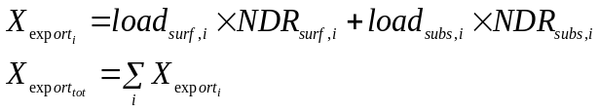
Each pixel’s load is modified to account for the local runoff potential, which can be divided into surface and subsurface runoff. The ratio between these two types of nutrient sources is given by the parameter 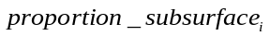; therefore, the 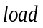(kg·ha⁻¹·yr⁻¹) for pixel is defined as:
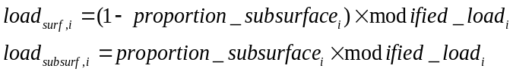
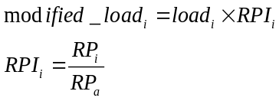
where 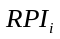 is the runoff potential index for pixel ; 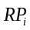 is the nutrient runoff proxy for runoff on pixel ; and 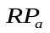is the average 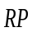 over the entire area.
The delivery ratios (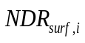and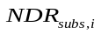) are computed based on the concept of the nutrient delivery ratio.

(1) Surface NDR
The surface is the product of a delivery factor, representing the ability of downstream pixels to transport nutrients without retention, and a topographic index, representing the position on the landscape. For pixel :

where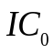 and are calibration parameters; 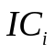is a topographic index; and 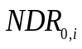 is the proportion of nutrient that is not retained by downstream pixels (irrespective of the position of the pixel on the landscape).

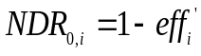
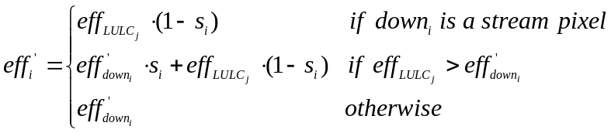
where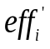is retention efficiency for pixel ; 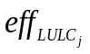is the maximum retention efficiency that 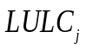 can reach; 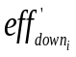is the effective downstream retention on the pixel directly downstream from pixel ; and 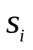is the step factor, defined as:
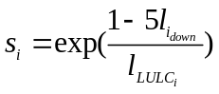
where  is the length of the flow path from pixel to its downstream neighbor; and 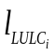 is the LULC retention length of the land cover type on pixel .
is the index of connectivity:
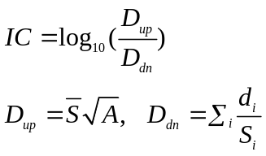
where (m/m) is the average slope gradient of the upslope contributing area; (m²) is the upslope contributing area; and 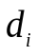 (m) is the length of the flow path along pixel .

(2) Subsurface NDR
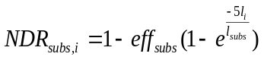
where 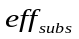 is the maximum nutrient retention efficiency that can be achieved through subsurface flow; is the distance from the pixel to the stream; and 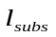is the subsurface flow retention length (i.e., the distance after which it can be assumed that soil retains the nutrient at its maximum capacity).

Supplementary information 3: InVEST parameterization

Table S2. Data requirements for the InVEST models. CSS = carbon storage and sequestration model; WY = water yield model; SDR = sediment delivery ratio model; NDR = nutrient delivery ratio model
Data | Type | Data source | Note | Related model
Digital Elevation Model | Raster | http://www.gscloud.cn/  http://www.resdc.cn | Resolution is 90m×90m | NDR, SDR
Annual average precipitation | Raster | http://data.cma.cn/site/index.html?tdsourcetag=s_pcqq_aiomsg | Resolution is 90m×90m | WY, NDR, SDR
Reference evapo-transpiration | Raster | http://www.cgiar-csi.org/data/global-aridity-and-pet-database | Resolution is 90m×90m | WY
Plant-available water content | Raster | Defined according to the LULC and InVEST user’s guide | Resolution is 90m×90m | WY
Land use/land cover | Raster | http://www.resdc.cn | LULC in 1995 and 2015, including forest, shrub, grass, open water, agriculture, constructed, bare. Resolution is 90m×90m | WY, NDR, SDR,  CSS
Depth to root restricting layer | Raster | Defined according to the LULC and InVEST user’s guide | Resolution is 90m×90m | WY
Watersheds | Shape file | http://ngcc.sbsm.gov.cn/article/xxfw/bgxz/ | Shapefile determined by DEM raster using ArcGIS tool | WY,  NDR, SDR
Rainfall erosivity index | Raster | Defined according to the literature^{[9]} and mean annual precipitation | Resolution is 90m×90m | SDR
Soil erodibility | Raster | Standards for classification and gradation of soil erosion (SL190-2007) | Resolution is 90m×90m | SDR
Biophysical table | .CSV file | - | Including attributes of each LULC, Kc (plant evapotranspiration coefficient), load of nutrients, efficiency of nutrient retention, etc. | WY, SDR, NDR, CSS

Table S3. Key parameters used in the present study
Parameter | Description | Computation
Kc | Evapotranspiration coefficient for each pixel | Defined according to the InVEST user’s guide
Load_n | Load of nitrogen for each LULC | Defined according to the InVEST user’s guide
Eff_n | The maximum retention efficiency of nitrogen for each LULC, varying between 0 and 1. | Defined according to the InVEST user’s guide
C_above | Aboveground carbon values for each LULC | Defined according to the literature data^{[10-12]}
C_below | Belowground carbon values for each LULC. | Defined according to the literature data^{[10-12]}
C_soil | Dead carbon value for each LULC. | Defined according to the literature data^{[10-12]}
C_dead | Soil carbon values for each LULC. | Defined according to the literature data^{[10-12]}

Table S4. Critical parameter settings in the biophysical attributes table
LULC_desc | Kc | Root_depth | C_above | C_below | C_soil | C_dead | usle_c | usle_p | sedret_eff | Load_n | Eff_n
Forest | 1 | 7000 | 39.63 | 10 | 42.4 | 40 | 0.003 | 0.2 | 0.6 | 2.8 | 0.8
Shrub | 0.85 | 4570 | 9.303 | 2 | 25.6 | 3 | 0.01 | 0.2 | 0.5 | 2 | 0.8
Grass | 0.65 | 2000 | 6 | 0.75 | 18.2 | 5.2 | 0.02 | 0.25 | 0.4 | 8 | 0.75
Open water | 1 | 1000 | 0 | 0 | 0 | 0 | 0.001 | 0.001 | 0.8 | 0.001 | 0.05
Agri-  culture | 0.6 | 700 | 5 | 1 | 25.6 | 0 | 0.5 | 0.4 | 0.25 | 100 | 0.5
Constructed | 0.3 | 500 | 0 | 0 | 21 | 0 | 0.001 | 0.001 | 0.05 | 10 | 0.05
Bare | 0.2 | 10 | 0 | 0 | 8.6 | 0 | 0.25 | 0.01 | 0.2 | 4 | 0.05

Table S5. Land use/land cover classes used in the maps for CYCC
Code | Class/Value | Description
1 | Agriculture | Includes cultivated crops, described as areas used for the production of annual crops, such as corn, soybean, vegetables, tobacco, and cotton. This class also includes all actively tilled land.
2 | Forest | All areas characterized by tree cover (natural or semi-natural woody vegetation, generally greater than 6 m tall); tree canopy accounts for 25-100% of the cover.
3 | Grass | Refers to all kinds of grassland mainly growing herbaceous plants, covering more than 5%, including shrubby grassland mainly for grazing and open forest and grass land with canopy density below 10%.
4 | Open water | All areas of open water, generally with less than 25% vegetation or soil cover.
5 | Constructed | Includes developed open spaces with a mixture of some constructed materials, but mostly vegetation in the form of lawn grasses such as large-lot single-family housing units, parks, golf courses, and vegetation planted in developed settings for recreation, erosion control, or aesthetic purposes. Also included are lands of low, medium, and high intensity development with a mixture of construction forms and vegetation, such as single-family housing units, multi-family housing units, and areas of retail, commercial, and industrial uses.
6 | Unused | Refers to land other than agricultural land and construction land, mainly including wasteland, saline-alkali land, marshland, sandy land, bare land, bare rock, etc.

Table S6. Data requirements and data processing method.
Factor attribute | Driver factors | Data acquisition and processing method/s
Physical geography  factors | Elevation | The DEM was obtained from the official website of GS Cloud, and it was cropped with the Yunnan boundary map with a spatial resolution of 30 m
Physical geography  factors | Slope | Obtained by slope analysis of elevation data using ArcGIS software, and the spatial resolution was consistent with the elevation data
Physical geography  factors | Aspect | Obtained by aspect analysis of elevation data using ArcGIS software, and the spatial resolution was consistent with the elevation data
Physical geography  factors | Distance to nearest river | River system map of China was obtained from the official website of OpenStreet. After projection transformation, the river system map of YUNNAN was extracted by the watershed boundary map of YUNNAN . And then ArcGIS was used to analyze the Euclidean distance.
Physical geography  factors | NDVI | Obtained from the official website of Resources and Environmental Science and Data Center of Chinese Academy of Sciences. After projection transformation, the NDVI map of YUNNAN was extracted by the watershed boundary map of YUNNAN .
Socioeconomic factors | Population density | Regional population data were obtained from statistical yearbooks. A population density map was created by the ArcGIS grid generation method.
Socioeconomic factors | GDP density | Regional GDP data were obtained from statistical yearbooks. A GDP density map was created by the ArcGIS grid generation method.
Socioeconomic factors | Night light index | Obtained from the official website of NOAA. After projection transformation, the Night light index map of YUNNAN was extracted by the watershed boundary map of YUNNAN .
Socioeconomic factors | Distance to the nearest road | A road map of China was obtained from the official website of OpenStreet. After projection transformation, the road map of YUNNAN was extracted by the watershed boundary map of YUNNAN . ArcGIS was used to analyze the Euclidean distance.
Socioeconomic factors | Distance to nearest town | Coordinates on towns were obtained from the official website of Openstreet. After projection transformation, the road map of YUNNAN was extracted by the watershed. ArcGIS software was used to analyze the Euclidean distance.

References:
- Li J, Gong X, Zhang Y, Duan C, Gao W. Evaluation of forest ecosystem carbon sequestration and oxygen release service in Dianchi Basin. Journal of Yunnan University (Natural Science edition) 2019; 41: 629-637.
- Cao Y, Yi Q, Wang X, Dou X, et al. The potential and spatial and temporal distribution characteristics of rainwater resources in the Dianchi Lake Basin. Journal of Water Resources and Water Engineering 2016; 27: 60-66.
- Gong X. The study of ecological assets evaluation and ecological Compensation in the Dianchi Basin. Master. Yunnan University, 2018.
- Li W, He J, Xu X, Zheng Y, Li Y, et al. Quantitative study on urban rainfall runoff pollution Load in Dianchi Basin. Environmental monitoring management and Technology 2011; 23: 37-42.
- Sharp, R., Tallis, H.T., Ricketts, T., Guerry, A.D., Wood, S.A., Chaplin-Kramer, R., et al., 2016. InVEST +VERSION+ User’s Guide. The Natural Capital Project, Stanford University, University of Minnesota, The Nature Conservancy, and World Wildlife Fund.
- Fu, B.P. On the Calculation of the Evaporation from Land Surface. Scientia Atmospherica Sinica, 1981, ( 5), 23-31.
- Zhang, L., Hickel, K., Dawes, W. R., Chiew, F. H. S., Western, A. W., and Briggs, P. R. A rational function approach for estimating mean annual evapotranspiration, Water Resour. Res., 2004, (40), W02502,.
- Donohue, R. J., M. L. Roderick, and T. R. McVicar. Roots, storms and soil pores: Incorporating key ecohydro-logical processes into Budyko 's hydrological model, Journal of Hydrology, 2012, (436-437), 35-50.
- Zhang, W.B., Fu, J.S. Rainfall erosivity estimation under different rainfall amount. Resources Science, 2003, (01):35-41
- Fang, J.Y., Guo, Z.D., Piao, S.L., et al. Terrestrial vegetation carbon sinks in China, 1981–2000. Science in China Series D: Earth Sciences, 2007, 50(9):1341-1350.
- Xie, X.L., Sun, B., et al. Soil carbon stocks and their influencing factors under native vegetations in China. Acta Pedologica Sinica, 2004, (05):687-699.
- Zhang, J., Luo, G.S., et al. Carbon stock estimation and sequestration potential of crops in the upper Yangtze river basin. Southwest China Journal of Agricultural Sciences, 2009, 22(02):402-408

