Supplementary materials

Gottfriedia endophyticus sp. nov., a novel indole-acetic acid producing bacterium isolated from the roots of rice plant
Geeta Chhetri, Inhyup Kim and Taegun Seo*
Department of Life Science, Dongguk University Seoul, Goyang, 10326, South Korea

*Corresponding author:
Taegun Seo
Department of Life Science, Dongguk University-Seoul, Goyang, 10326, South Korea
Tel: +82-31-961-5135
Fax: +82-31-961-5348
E-mail: tseo@dongguk.edu

Author Notes: The draft genome and 16S rRNA gene sequences of strain RG28^{T} have been deposited in GenBank/EMBL/DDBJ under accession numbers JAGIYQ000000000 and MW386408 respectively.
Fig. S1. A maximum-likelihood tree based on 16S rRNA gene sequences, showing the phylogenetic position of strain RG28^{T} and other closely related members. Numbers at nodes are levels of bootstrap support based on 1000 resamplings. Persicobacter diffluens NBRC 15940^{T}(AB260929) was used as an out-group. GeneBank accession numbers are given in parenthesis. Bar, 0.020 substitutions per nucleotide position.

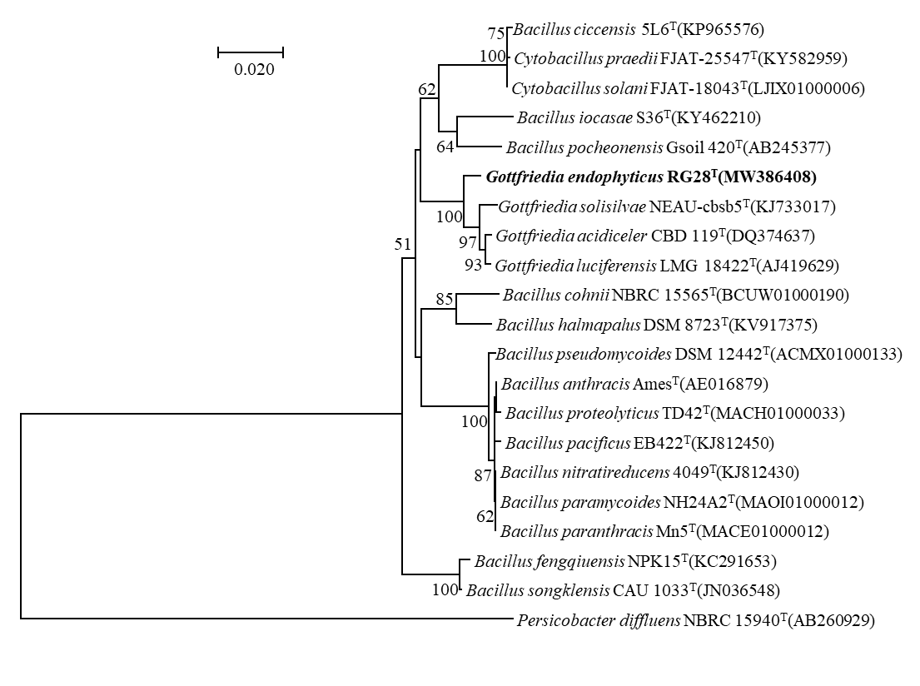

Fig. S2. A minimum-evolution tree based on 16S rRNA gene sequences, showing the phylogenetic position of strain RG28^{T} and other closely related members. Numbers at nodes are levels of bootstrap support based on 1000 resamplings. Persicobacter diffluens NBRC 15940^{T}(AB260929) was used as an out-group. GeneBank accession numbers are given in parenthesis. Bar, 0.020 substitutions per nucleotide position.

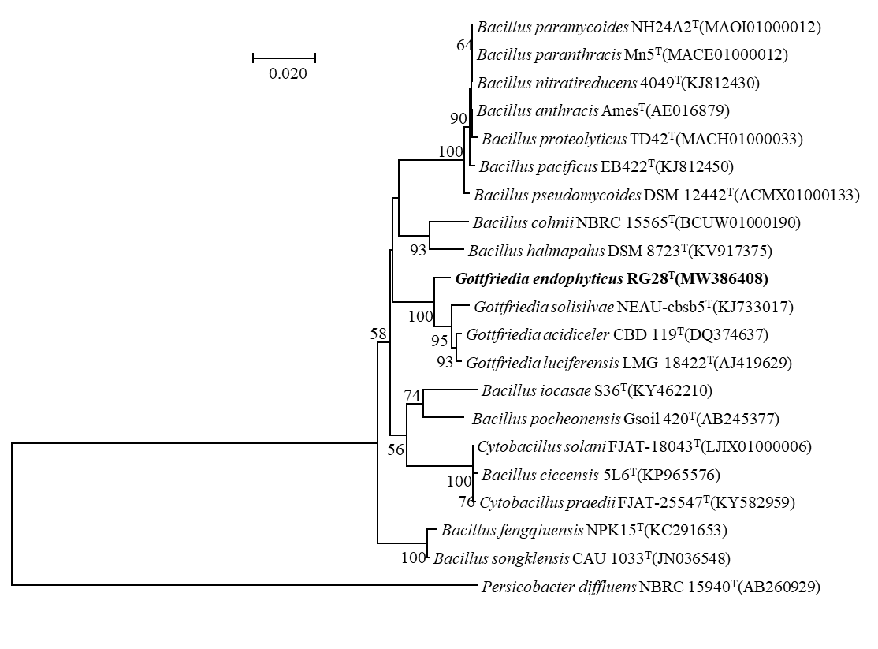

Fig. S3. A maximum-parsimony tree based on 16S rRNA gene sequences, showing the phylogenetic position of strain RG28^{T} and other closely related members. Numbers at nodes are levels of bootstrap support based on 1000 resamplings. Persicobacter diffluens NBRC 15940^{T}(AB260929) was used as an out-group. GeneBank accession numbers are given in parenthesis. Bar, 50 substitutions per nucleotide position.

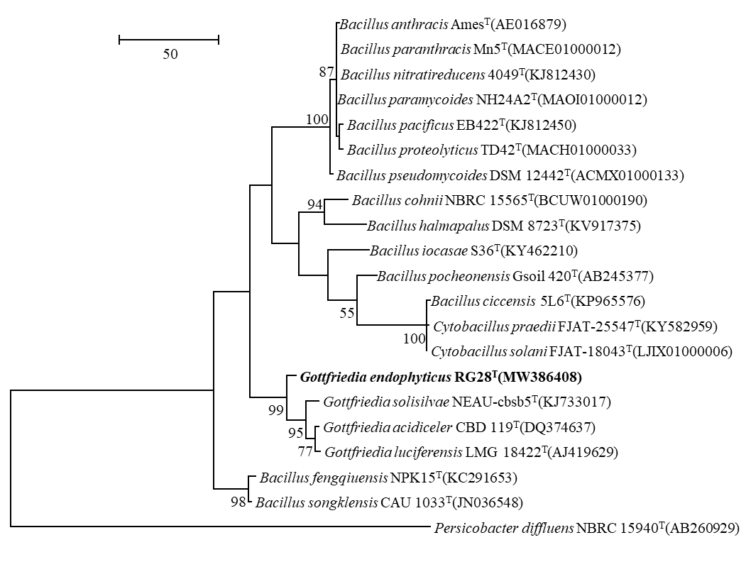

Fig. 4. Phylogenomic tree of strain RG28^{T} and closely related strains based on core genomes was constructed using UBCG, genomes of all 17 related strains are available on NCBI GenBank. GenBank accession numbers are shown in parentheses. Bootstrap analysis was carried out using 100 replications. Percentage bootstrap values (>50%) are given at branching points. Bar, 0.020 substitution per position.

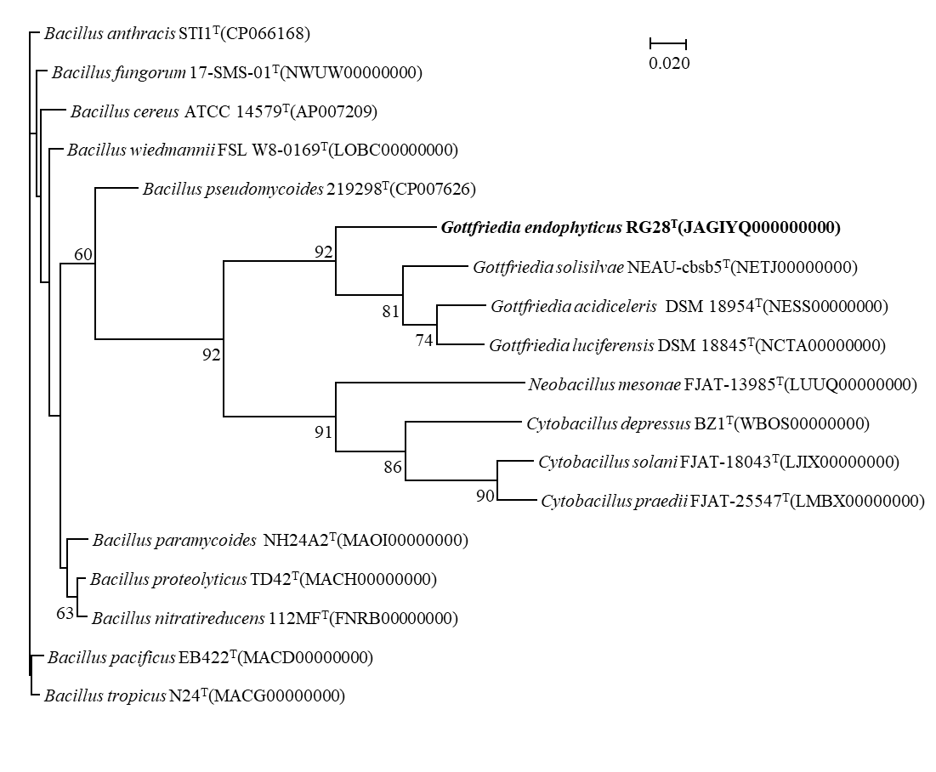

Table S1. Presence of genes associated with sporulation and spore formation in genome of strain RG28^{T}.
Accession | Start | Stop | Locus tag | Length | Protein Name
Sporulation
NZ_JAGIYQ010000001.1 | 353530 | 354291 | J5Y03_RS01710 | 253 | sporulation protein
NZ_JAGIYQ010000001.1 | 24319 | 25506 | J5Y03_RS00130 | 395 | sporulation protein (YqfD)
NZ_JAGIYQ010000001.1 | 25556 | 25840 | J5Y03_RS00135 | 94 | sporulation protein (YqfC)
NZ_JAGIYQ010000001.1 | 502431 | 503264 | J5Y03_RS02370 | 277 | putative sporulation protein (YtxC)
NZ_JAGIYQ010000001.1 | 535609 | 535950 | J5Y03_RS02500 | 113 | YtrH family sporulation protein
NZ_JAGIYQ010000011.1 | 121116 | 121340 | J5Y03_RS15170 | 74 | YjcZ family sporulation protein
NZ_JAGIYQ010000016.1 | 17972 | 18058 | J5Y03_RS17135 | 28 | YjcZ family sporulation protein
NZ_JAGIYQ010000016.1 | 18144 | 18227 | J5Y03_RS17140 | 27 | YjcZ family sporulation protein
NZ_JAGIYQ010000016.1 | 19704 | 19907 | J5Y03_RS17150 | 67 | sporulation YhaL family protein
NZ_JAGIYQ010000002.1 | 204591 | 204710 | J5Y03_RS03640 | 39 | YjcZ family sporulation protein
NZ_JAGIYQ010000021.1 | 22676 | 22990 | J5Y03_RS19075 | 104 | sporulation protein (YabP)
NZ_JAGIYQ010000021.1 | 39227 | 40102 | J5Y03_RS19155 | 291 | sporulation peptidase (YabG)
NZ_JAGIYQ010000003.1 | 247005 | 247145 | J5Y03_RS06045 | 46 | YjcZ family sporulation protein
NZ_JAGIYQ010000005.1 | 346806 | 347966 | J5Y03_RS10280 | 386 | sporulation protein (YhbH)
NZ_JAGIYQ010000006.1 | 35141 | 35962 | J5Y03_RS10630 | 273 | sporulation protein (YunB)
NZ_JAGIYQ010000001.1 | 215076 | 215216 | J5Y03_RS01015 | 46 | sporulation histidine kinase inhibitor (Sda)
NZ_JAGIYQ010000001.1 | 320138 | 320902 | J5Y03_RS01565 | 254 | YhcN/YlaJ family sporulation lipoprotein
NZ_JAGIYQ010000012.1 | 24312 | 24956 | J5Y03_RS15310 | 214 | sporulation membrane protein (YtaF)
NZ_JAGIYQ010000012.1 | 105190 | 105642 | J5Y03_RS15655 | 150 | YhcN/YlaJ family sporulation lipoprotein
NZ_JAGIYQ010000002.1 | 46688 | 47830 | J5Y03_RS02880 | 380 | stage II sporulation protein P
NZ_JAGIYQ010000002.1 | 145799 | 146062 | J5Y03_RS03355 | 87 | stage VI sporulation protein F
NZ_JAGIYQ010000002.1 | 209673 | 210242 | J5Y03_RS03670 | 189 | stage V sporulation protein AE
NZ_JAGIYQ010000002.1 | 212111 | 212539 | J5Y03_RS03690 | 142 | stage V sporulation protein AB
NZ_JAGIYQ010000002.1 | 212517 | 213143 | J5Y03_RS03695 | 208 | stage V sporulation protein AA
NZ_JAGIYQ010000002.1 | 331660 | 332448 | J5Y03_RS04270 | 262 | sporulation transcription factor (Spo0A)
NZ_JAGIYQ010000002.1 | 352288 | 352800 | J5Y03_RS04370 | 170 | stage III sporulation protein (SpoAB)
NZ_JAGIYQ010000021.1 | 49007 | 49834 | J5Y03_RS19205 | 275 | stage 0 sporulation family protein
NZ_JAGIYQ010000022.1 | 11344 | 11781 | J5Y03_RS19295 | 145 | GerW family sporulation protein
NZ_JAGIYQ010000003.1 | 306131 | 308071 | J5Y03_RS06355 | 646 | stage V sporulation protein D
NZ_JAGIYQ010000003.1 | 324536 | 324814 | J5Y03_RS06425 | 92 | YlmC/YmxH family sporulation protein
NZ_JAGIYQ010000004.1 | 229828 | 230097 | J5Y03_RS07790 | 89 | sporulation transcriptional regulator (SpoIIID)
NZ_JAGIYQ010000006.1 | 32262 | 32852 | J5Y03_RS10615 | 196 | YhcN/YlaJ family sporulation lipoprotein
NZ_JAGIYQ010000001.1 | 287809 | 289362 | J5Y03_RS01375 | 517 | stage V sporulation protein B
NZ_JAGIYQ010000001.1 | 523101 | 524216 | J5Y03_RS02460 | 371 | sporulation integral membrane protein (YtvI)
NZ_JAGIYQ010000012.1 | 103317 | 103667 | J5Y03_RS15640 | 116 | stage V sporulation protein AE
NZ_JAGIYQ010000012.1 | 103680 | 104681 | J5Y03_RS15645 | 333 | stage V sporulation protein AD
NZ_JAGIYQ010000012.1 | 104681 | 105157 | J5Y03_RS15650 | 158 | stage V sporulation protein AC
NZ_JAGIYQ010000017.1 | 65150 | 65773 | J5Y03_RS17765 | 207 | sporulation-specific diadenylate cyclase (CdaS)
NZ_JAGIYQ010000002.1 | 142615 | 144093 | J5Y03_RS03340 | 492 | stage IV sporulation protein A
NZ_JAGIYQ010000002.1 | 210249 | 210599 | J5Y03_RS03675 | 116 | stage V sporulation protein AE
NZ_JAGIYQ010000002.1 | 210611 | 211618 | J5Y03_RS03680 | 335 | stage V sporulation protein AD
NZ_JAGIYQ010000002.1 | 211635 | 212090 | J5Y03_RS03685 | 151 | stage V sporulation protein AC
NZ_JAGIYQ010000002.1 | 230342 | 230992 | J5Y03_RS03790 | 216 | stage II sporulation protein M
NZ_JAGIYQ010000002.1 | 349149 | 349832 | J5Y03_RS04345 | 227 | stage III sporulation protein AG
NZ_JAGIYQ010000002.1 | 349840 | 350457 | J5Y03_RS04350 | 205 | stage III sporulation protein AF
NZ_JAGIYQ010000002.1 | 350466 | 351635 | J5Y03_RS04355 | 389 | stage III sporulation protein AE
NZ_JAGIYQ010000002.1 | 351658 | 352044 | J5Y03_RS04360 | 128 | stage III sporulation protein AD
NZ_JAGIYQ010000002.1 | 352072 | 352275 | J5Y03_RS04365 | 67 | stage III sporulation protein AC
NZ_JAGIYQ010000002.1 | 352797 | 353723 | J5Y03_RS04375 | 308 | stage III sporulation protein AA
NZ_JAGIYQ010000021.1 | 17325 | 19799 | J5Y03_RS19040 | 824 | stage II sporulation protein E
NZ_JAGIYQ010000021.1 | 27122 | 27658 | J5Y03_RS19095 | 178 | stage V sporulation protein T
NZ_JAGIYQ010000025.1 | 7702 | 8643 | J5Y03_RS19550 | 313 | stage V sporulation protein K
NZ_JAGIYQ010000003.1 | 290023 | 291264 | J5Y03_RS06280 | 413 | sporulation integral membrane protein (YlbJ)
NZ_JAGIYQ010000003.1 | 312356 | 313456 | J5Y03_RS06375 | 366 | stage V sporulation protein E
NZ_JAGIYQ010000003.1 | 368331 | 368414 | J5Y03_RS06630 | 27 | stage V sporulation protein (SpoVM)
NZ_JAGIYQ010000004.1 | 179825 | 180598 | J5Y03_RS07540 | 257 | stage II sporulation protein R
NZ_JAGIYQ010000004.1 | 224871 | 225881 | J5Y03_RS07775 | 336 | stage II sporulation protein D
NZ_JAGIYQ010000001.1 | 227297 | 228022 | J5Y03_RS01075 | 241 | RNA polymerase sporulation sigma factor SigK
NZ_JAGIYQ010000018.1 | 15606 | 16256 | J5Y03_RS17930 | 216 | RNA polymerase sporulation sigma factor SigH
NZ_JAGIYQ010000018.1 | 74847 | 75614 | J5Y03_RS18260 | 255 | polysaccharide deacetylase family sporulation protein (PdaB)
NZ_JAGIYQ010000002.1 | 214138 | 214896 | J5Y03_RS03700 | 252 | RNA polymerase sporulation sigma factor SigF
NZ_JAGIYQ010000003.1 | 321495 | 322214 | J5Y03_RS06410 | 239 | RNA polymerase sporulation sigma factor SigE
NZ_JAGIYQ010000003.1 | 323418 | 324197 | J5Y03_RS06420 | 259 | RNA polymerase sporulation sigma factor SigG
NZ_JAGIYQ010000007.1 | 143119 | 143556 | J5Y03_RS12200 | 145 | sporulation inhibitor of replication protein SirA
NZ_JAGIYQ010000009.1 | 40273 | 40533 | J5Y03_RS13375 | 86 | MULTISPECIES: stage V sporulation protein (SpoVS)
NZ_JAGIYQ010000004.1 | 305527 | 306633 | J5Y03_RS08110 | 368 | endospore germination permease
Spore formation
NZ_JAGIYQ010000001.1 | 49061 | 50647 | J5Y03_RS00255 | 528 | spore germination protein
NZ_JAGIYQ010000001.1 | 88060 | 89523 | J5Y03_RS00450 | 487 | spore germination protein
NZ_JAGIYQ010000001.1 | 263091 | 263411 | J5Y03_RS01255 | 106 | spore coat protein
NZ_JAGIYQ010000002.1 | 100173 | 100715 | J5Y03_RS03125 | 180 | spore coat protein
NZ_JAGIYQ010000002.1 | 101280 | 101774 | J5Y03_RS03130 | 164 | spore coat protein
NZ_JAGIYQ010000002.1 | 197645 | 198178 | J5Y03_RS03600 | 177 | spore maturation protein
NZ_JAGIYQ010000002.1 | 198180 | 198773 | J5Y03_RS03605 | 197 | spore maturation protein
NZ_JAGIYQ010000002.1 | 208223 | 209752 | J5Y03_RS03665 | 509 | spore germination protein
NZ_JAGIYQ010000003.1 | 32507 | 32725 | J5Y03_RS05070 | 72 | spore germination protein
NZ_JAGIYQ010000003.1 | 34261 | 34482 | J5Y03_RS05095 | 73 | spore germination protein
NZ_JAGIYQ010000003.1 | 89854 | 90450 | J5Y03_RS05360 | 198 | spore coat protein
NZ_JAGIYQ010000004.1 | 231405 | 232919 | J5Y03_RS07800 | 504 | spore germination protein
NZ_JAGIYQ010000004.1 | 303975 | 305558 | J5Y03_RS08105 | 527 | spore germination protein
NZ_JAGIYQ010000005.1 | 274878 | 276425 | J5Y03_RS09790 | 515 | spore germination protein
NZ_JAGIYQ010000005.1 | 308478 | 309767 | J5Y03_RS09940 | 429 | spore germination protein
NZ_JAGIYQ010000008.1 | 165932 | 166969 | J5Y03_RS13155 | 345 | spore protein O
NZ_JAGIYQ010000010.1 | 19055 | 19327 | J5Y03_RS14055 | 90 | spore coat protein CotJB
NZ_JAGIYQ010000003.1 | 32740 | 33159 | J5Y03_RS05075 | 139 | spore germination protein GerPE
NZ_JAGIYQ010000003.1 | 33159 | 33335 | J5Y03_RS05080 | 58 | spore gernimation protein GerPD
NZ_JAGIYQ010000003.1 | 33335 | 33946 | J5Y03_RS05085 | 203 | spore gernimation protein GerPC
NZ_JAGIYQ010000003.1 | 33981 | 34184 | J5Y03_RS05090 | 67 | spore gernimation protein GerPB
NZ_JAGIYQ010000004.1 | 20675 | 21256 | J5Y03_RS06825 | 193 | spore protease YyaC
NZ_JAGIYQ010000001.1 | 354379 | 355407 | J5Y03_RS01715 | 342 | spore coat protein YsxE
NZ_JAGIYQ010000010.1 | 18822 | 19055 | J5Y03_RS14050 | 77 | spore coat associated protein CotJA
NZ_JAGIYQ010000012.1 | 123904 | 124623 | J5Y03_RS15760 | 239 | spore cortex-lytic enzyme
NZ_JAGIYQ010000004.1 | 126694 | 127038 | J5Y03_RS07315 | 114 | spore coat protein GerQ
NZ_JAGIYQ010000006.1 | 27956 | 28978 | J5Y03_RS10585 | 340 | spore coat protein YutH
NZ_JAGIYQ010000007.1 | 126202 | 126342 | J5Y03_RS12100 | 46 | acid-soluble spore protein N
NZ_JAGIYQ010000009.1 | 31369 | 31905 | J5Y03_RS13335 | 178 | outer spore coat protein CotE
NZ_JAGIYQ010000021.1 | 22071 | 22679 | J5Y03_RS19070 | 202 | spore cortex biosynthesis protein YabQ
NZ_JAGIYQ010000005.1 | 278814 | 278948 | J5Y03_RS09805 | 44 | small, acid-soluble spore protein L
NZ_JAGIYQ010000007.1 | 131590 | 131730 | J5Y03_RS12130 | 46 | small acid-soluble spore protein P
NZ_JAGIYQ010000001.1 | 47838 | 49058 | J5Y03_RS00250 | 406 | Ger(x)C family spore germination protein
NZ_JAGIYQ010000001.1 | 85866 | 86987 | J5Y03_RS00440 | 373 | Ger(x)C family spore germination protein
NZ_JAGIYQ010000001.1 | 487056 | 487265 | J5Y03_RS02295 | 69 | small acid-soluble spore protein SspI
NZ_JAGIYQ010000020.1 | 13868 | 14233 | J5Y03_RS18720 | 121 | gamma-type small acid-soluble spore protein
NZ_JAGIYQ010000020.1 | 17419 | 17577 | J5Y03_RS18745 | 52 | small, acid-soluble spore protein K
NZ_JAGIYQ010000004.1 | 232912 | 234096 | J5Y03_RS07805 | 394 | Ger(x)C family spore germination protein
NZ_JAGIYQ010000004.1 | 306630 | 307793 | J5Y03_RS08115 | 387 | Ger(x)C family spore germination protein
NZ_JAGIYQ010000005.1 | 83658 | 83837 | J5Y03_RS08825 | 59 | H-type small acid-soluble spore protein
NZ_JAGIYQ010000005.1 | 277537 | 278703 | J5Y03_RS09800 | 388 | Ger(x)C family spore germination protein
NZ_JAGIYQ010000005.1 | 306289 | 307545 | J5Y03_RS09935 | 418 | Ger(x)C family spore germination protein
NZ_JAGIYQ010000007.1 | 125934 | 126161 | J5Y03_RS12095 | 75 | small acid-soluble spore protein Tlp
NZ_JAGIYQ010000007.1 | 130653 | 130802 | J5Y03_RS12120 | 49 | small acid-soluble spore protein O
NZ_JAGIYQ010000001.1 | 322751 | 325078 | J5Y03_RS01580 | 775 | SafA/ExsA family spore coat assembly protein
NZ_JAGIYQ010000016.1 | 36762 | 36956 | J5Y03_RS17240 | 64 | alpha/beta-type small acid-soluble spore protein
NZ_JAGIYQ010000017.1 | 71690 | 71950 | J5Y03_RS17810 | 86 | alpha/beta-type small acid-soluble spore protein
NZ_JAGIYQ010000021.1 | 38204 | 38383 | J5Y03_RS19145 | 59 | small, acid-soluble spore protein, alpha/beta type
NZ_JAGIYQ010000022.1 | 6945 | 7151 | J5Y03_RS19275 | 68 | alpha/beta-type small acid-soluble spore protein
NZ_JAGIYQ010000003.1 | 165966 | 166154 | J5Y03_RS05655 | 62 | alpha/beta-type small acid-soluble spore protein

Fig. S5. Transmission electron microscopy of strain RG28^{T}. Three days old (a), (b) (c) and (d). Cells of strain RG28^{T} were negatively stained with phosphotungstic acid after growth at 30℃ on R2A agar. Bar (a), (b) and(c) 0.5 μm.
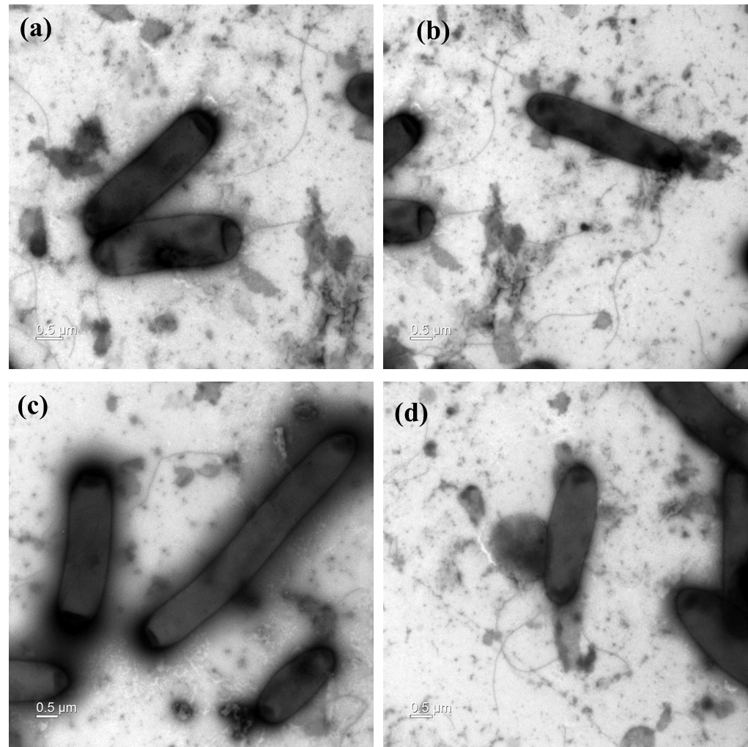

Fig. S6. The endospore staining using malachite green stain after cell growth on R2A for 3 days. Endospores are blue in colour.

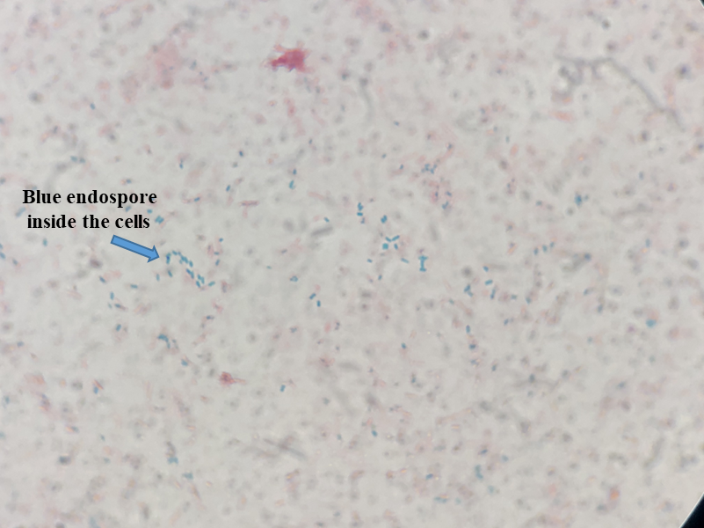

Table S2. Cellular fatty acid compositions (%) of strain RG28^{T} and reference strains of the closely related species.
Strain: 1. RG28^{T}; 2, G. acidiceleris KEMB 1602-188^{T}; 3, G. solisilvae DSM 100485^{T}; 4, G. luciferensis KEMB 7305-013^{T}. All data were taken from this study. Values are percentages of total fatty acids, and only fatty acids representing more than 1% for at least one of the strains are shown. -, Not detected; TR, trace amounts (<1%).

Fatty acid | 1 | 2 | 3 | 4
Saturated:
C_{16:0} | 25.5 | 15.8 | 24.5 | 28
C_{17:0} | 1.1 | 2.1 | - | TR
C_{18:0} | - | 2 | TR | 1.2
Unsaturated:
C_{16:1}ω7c | 3.2 | - | 3.9 | 4.8
C_{17:1}ω7c | TR | 1.8 | 1.3 | TR
C_{18:1}ω9c | 2.7 | 2.1 | 2 | -
Branched-chain:
iso-C_{13:0} | - | 2.8 | 2.5 | 4.9
iso-C_{15:0} | 26.4 | 28.5 | 22.6 | 23.2
iso-C_{15:1} F | 3.3 | 2.4 | 2.1 | 3.2
anteiso-C_{15:0} | 33.4 | 36.2 | 35.4 | 30.3
anteiso-C_{17:0} | 3 | 6.2 | 4.7 | 4.3
Summed feature 3 | 1.4 | TR | 1 | -

*Summed Features are fatty acids that cannot be resolved reliably from another fatty acid using the chromatographic conditions chosen. The MIDI system groups these fatty acids together as one feature with a single percentage of the total. Summed feature 3 comprises C_{16:1}ω7c and/or C_{16:1}ω6c.

Fig. S7. Two-dimensional thin-layer chromatogram of the polar lipids from strain RG28^{T} detected with reagents: 5% molybdophosphoric acid (a), molybdenum blue spray reagent (b), ninhydrin reagent (c), and a-napthol reagent (d). Abbreviations: PE, phosphatidylethanolamine; DPG, diphosphatidylglycerol; PG, phosphatidylglycerol; APGL1-4, APL1-4, unidentified aminophospholipids; AGL, unidentified aminoglycolipid; GL1-2, unidentified glycolipids; L1-4, unidentified lipids.

