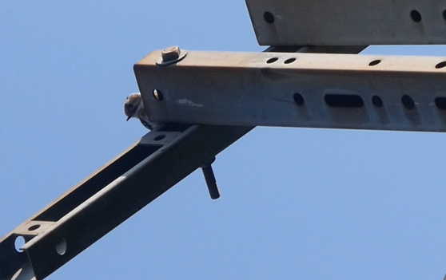
Figure 1- a, The bird drumming at the point of the metal plate with the highest sound.

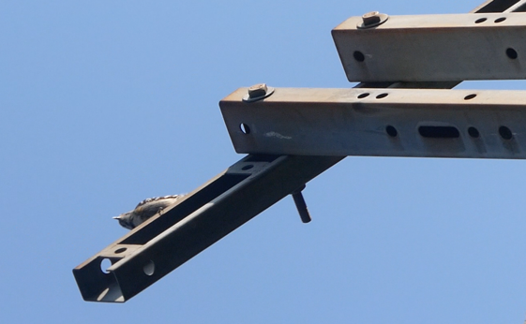
Figure1-b, The bird drumming the plate part which created a low-pitched sound.

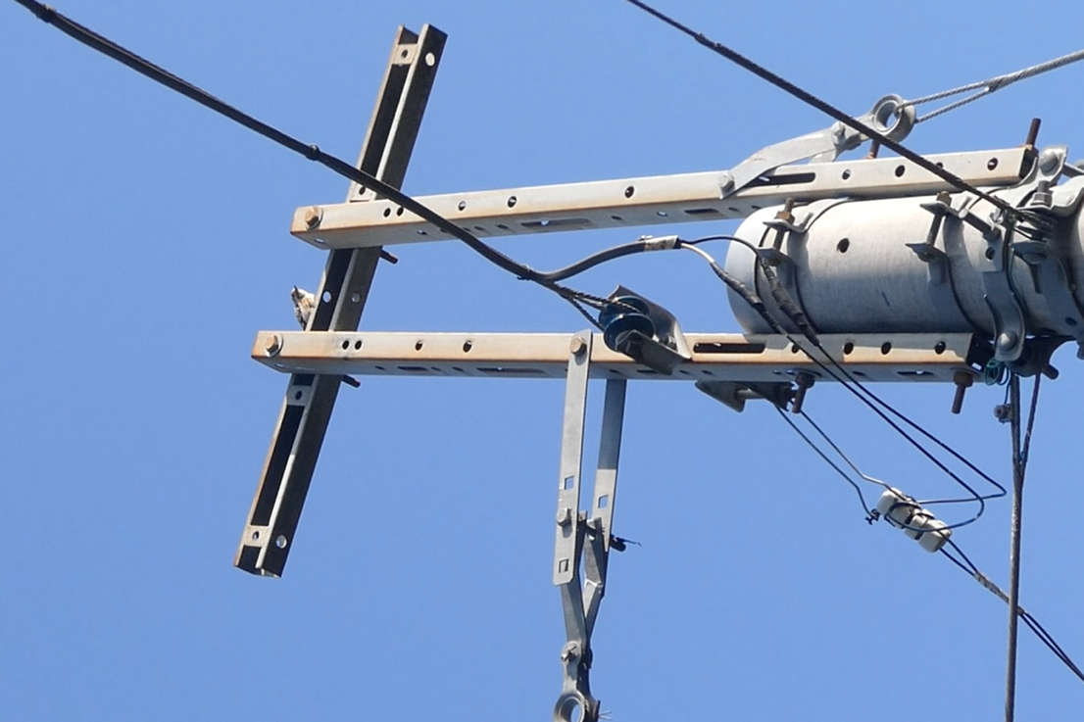
Figure1-c, drumming the part with high-pitched sound.

Extended Data Figure 1: research area and observation point (blue circle).
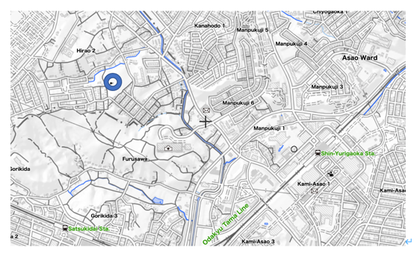
Extended Data Figure 1-a
（Source: https://maps.gsi.go.jp/multil/index.html#11/35.528315/139.791412/&base=pale2&ls=pale2%7Chillshademap%2C0.1%7Cchuki_eng&blend=0&disp=111&lcd=chuki_eng&vs=c1), and b, Photographic map (Source: https://www.google.com/maps/place/〒215-0026+神奈川県川崎市麻生区古沢/@35.6037014,139.4880905,2832m/data=!3m2!1e3!4b1!4m5!3m4!1s0x6018fa4f8c6c2101:0x2322945b7d3b9975!8m2!3d35.6033863!4d139.4968256.)

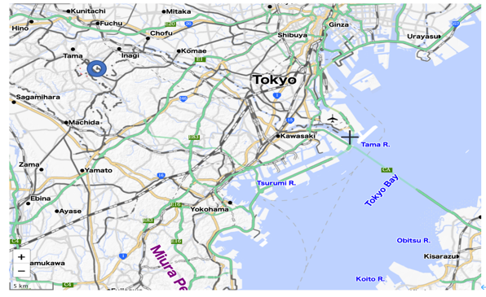
Extended Data Figure 1-b

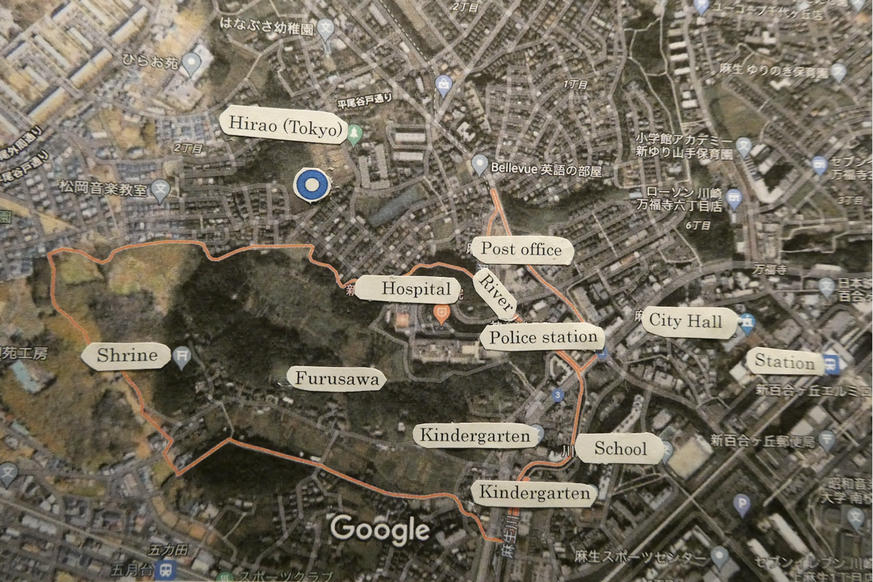
Extended Data Figure 1-c

Extended data Figure 2: Pictures of the observation location.
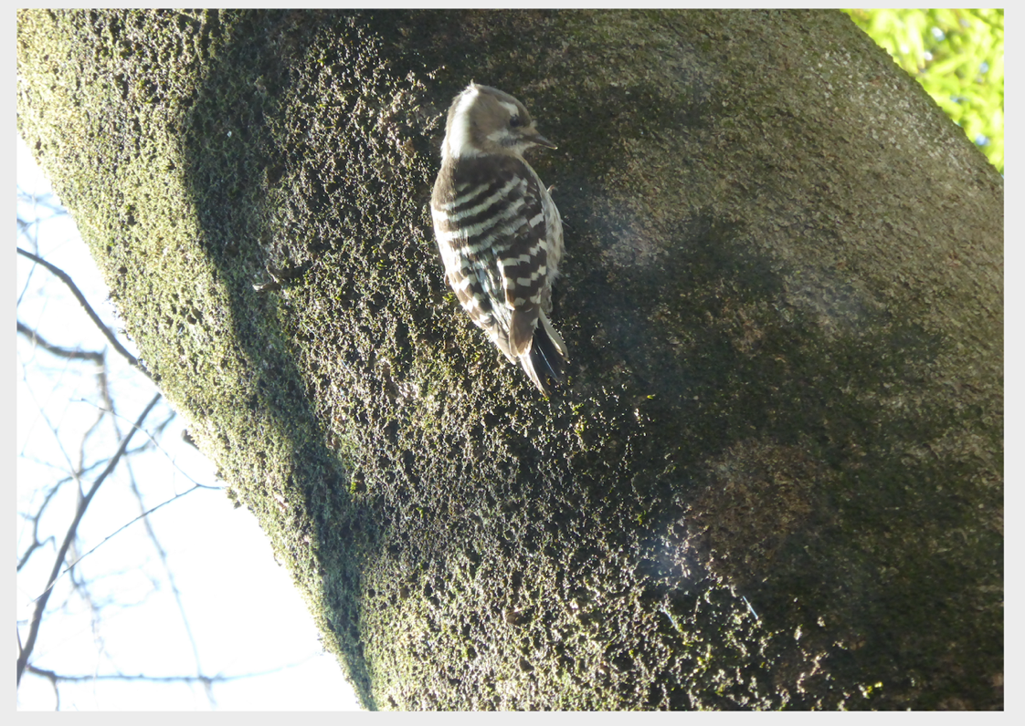
Extended data Figure 2-a, The Japanese pygmy woodpecker (Dendrocopos kizuki), body size 13-15 centimetres.

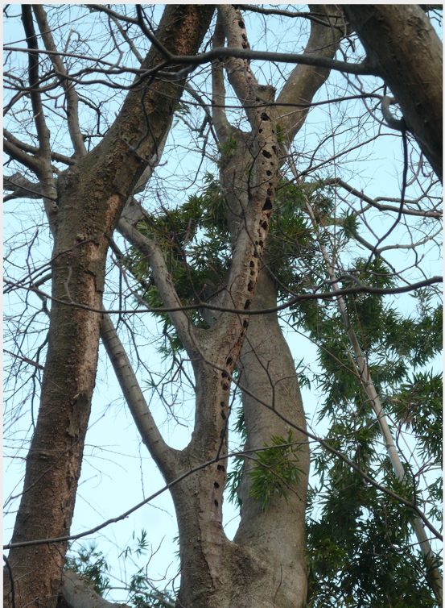
Extended data Figure 2-b, The hackberry tree with holes excavated by woodpeckers.
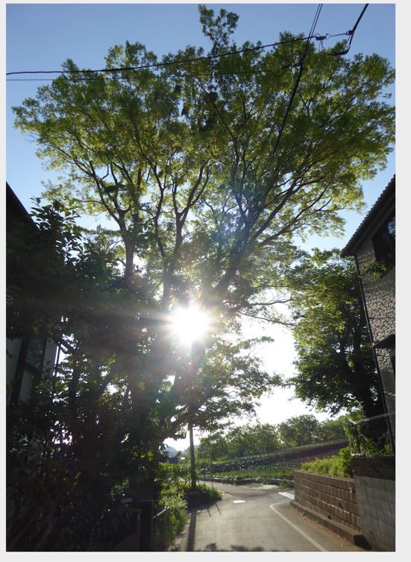
Extended data Figure 2-c, The hackberry tree (left side of the road), which was cut down in 2016, and the cherry tree (right side of the road), which was removed in 2020. The pictures were taken on 15 February 2013, 26 March 2015, and 1 May 2015, respectively. Picture credit: Setsuko Onoda, Tokyo

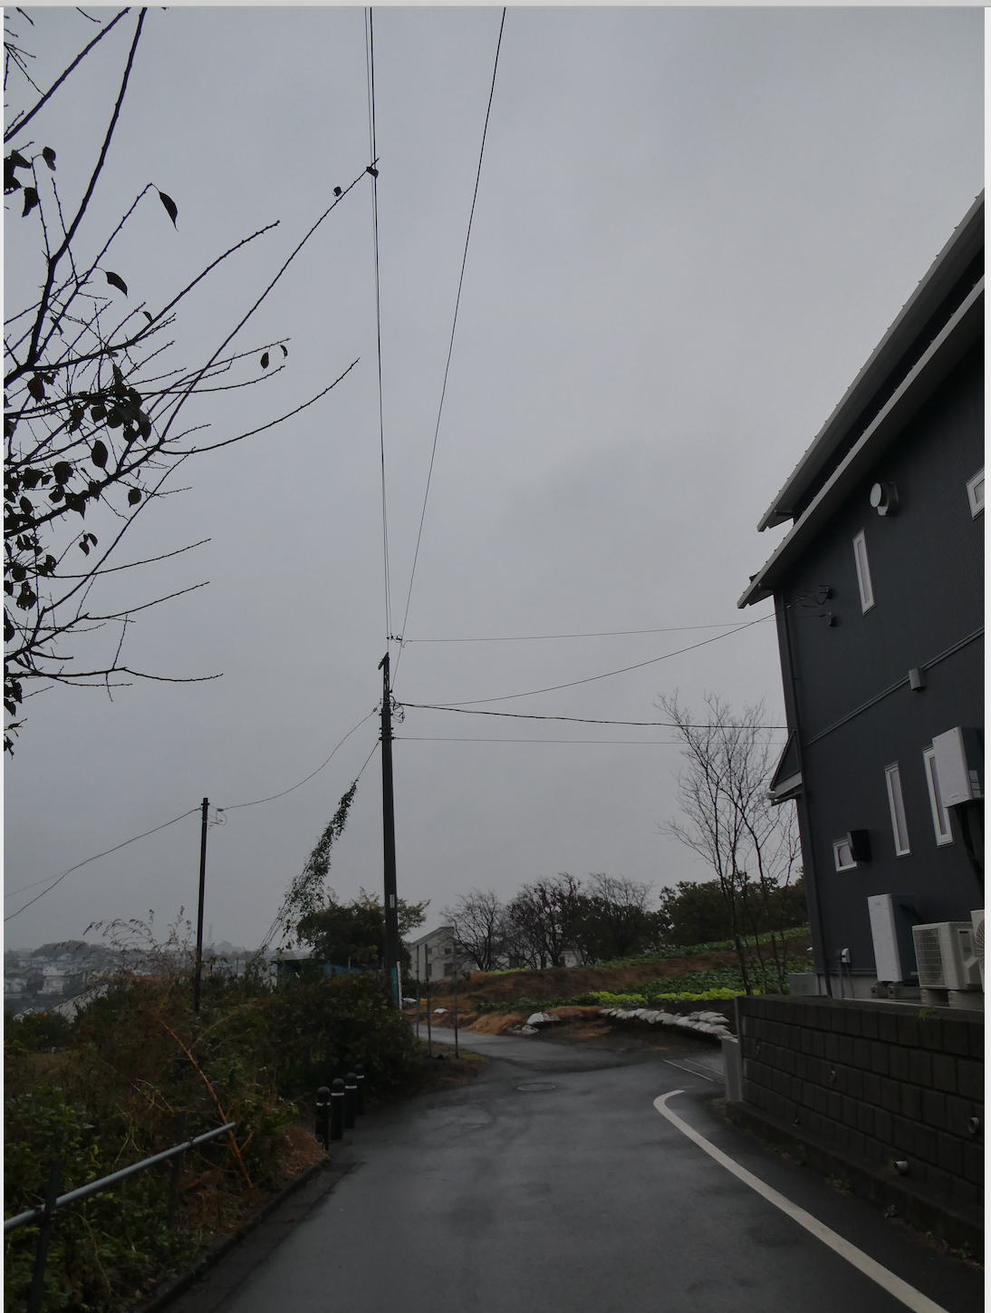
Extended data Figure 3: Picture of the landscape after removal of the Hackberry tree and the cherry tree.

