Supplemental Information
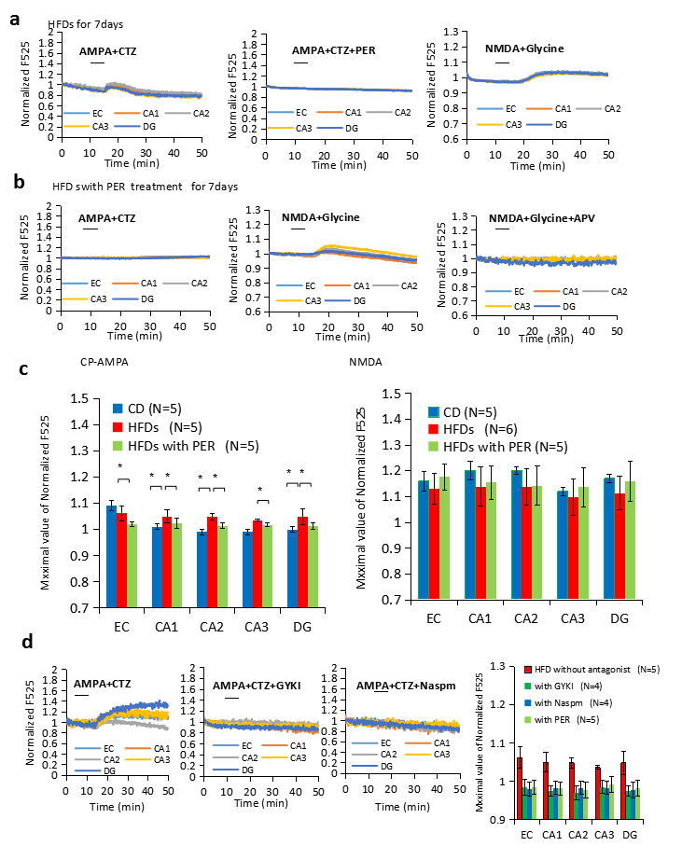
Fig.S1 Alternation of AMPAR and NMDAR function in HFD-feeding mice for 7 days (a, b, c); Suppressive effect of 1-naphthylacetyl spermine (Naspm), (Ca²⁺-permeable AMPA receptor [CP-AMPAR] antagonist) and GYKI (selective non-competitive AMPAR antagonist) for CP-AMPA response in hippocampus (d)
a, CP-AMPAR and NMDAR function of EC, CA1, CA2, CA3, and DG regions in HFD-feeding (from 16 weeks to 17 weeks) mice (17 weeks old). b, CP-AMPAR and NMDAR function of EC, CA1, CA2, CA3, and DG regions in HFD plus PER-feeding (from 16 weeks to 17 weeks) mice (17 weeks old). c, Statistical comparison of CP-AMPAR and NMDAR function of EC, CA1, CA2, CA3, and DG regions among CD, HFD, and HFD plus PER-feeding mice for 7 days. d, Suppressive effect of 1-naphthylacetyl spermine (Naspm) (selective antagonist of CP-AMPAR) and GYKI (selective non-competitive AMPAR antagonist) in acute brain slices of the hippocampus of HFD-feeding mice for 7 days. AMPA: 100 μM; CTZ: 100 μM; NMDA: 50 μM; glycine: 10 μM.*:p<0.05 (t-test).

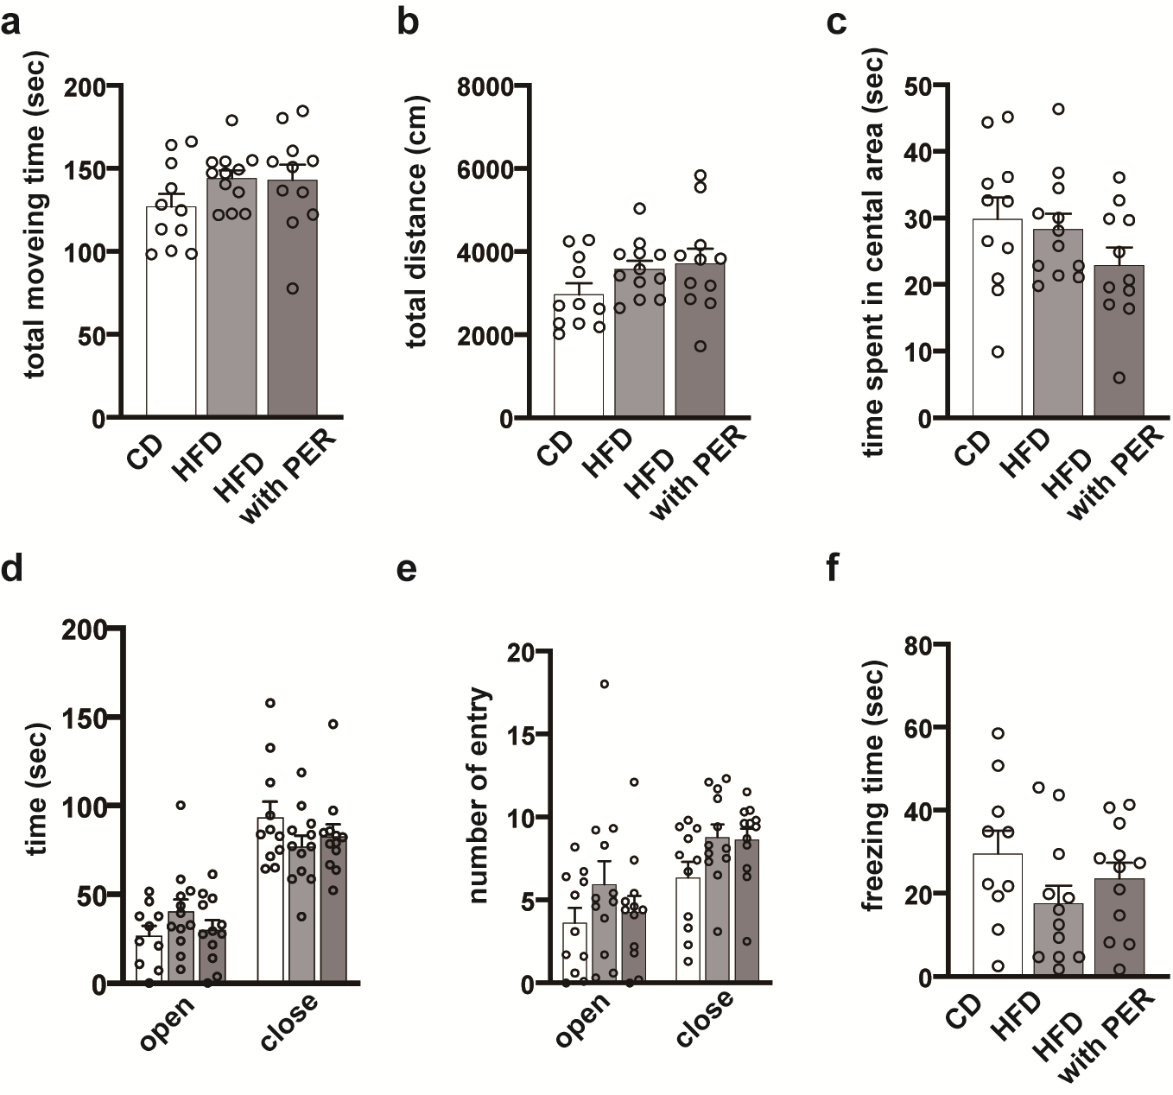
Fig. S2 Behavioral analysis of open field test (a–c), elevated plus maze test (d, e), and contextual fear conditioning test (f).
Average value of the total moving time (a), total distance (b), time spent in the central area (c), average value of time spent (d), and entrance tome (e) in the open or closed arm, and the average value of the freezing time (f) fed by CD (n=11), HFD (n=12), and HFD with PER (n=12) . Mouse age: 12 weeks old, HFD or HFD with PER treatment: from 4 weeks to 12 weeks. Data are shown as mean ± SD. The symbol overlapping the bar graph indicates the individual data.

Fig. S3 Quantitative analysis of MAP2, GluA1, and GluA2 expression of CD, HFD, and HFD with PER mice
Mouse age: 17 weeks old; HFD or HFD with PER 1 week treatment: from 16 weeks to 17 weeks; HFD or HFD with PER 10 week treatment: from 6 weeks to 17 weeks. Bar: 100 μm.
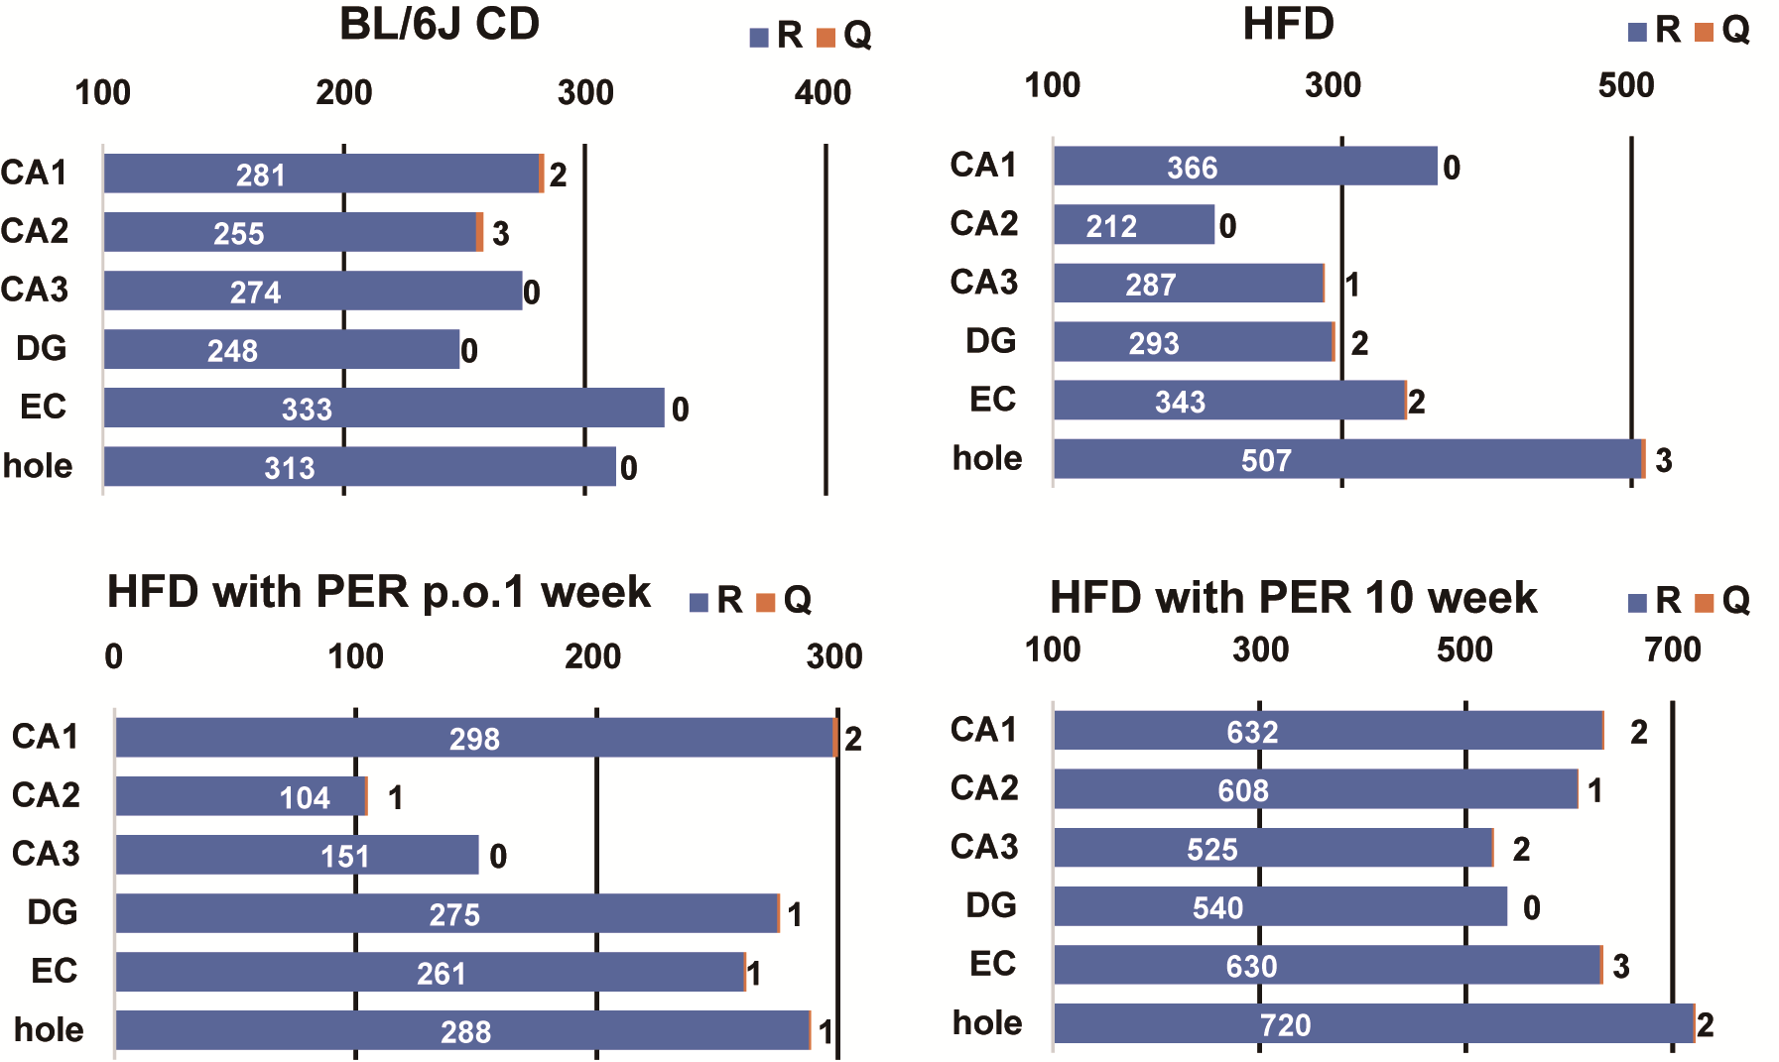
Fig. S4 GluA2 (R/Q) editing level, in CD, HFD, HFD with PER 1-week or 10-week treatment mouse.
Editing level was calculated as the ratio of the total number of reads aligned to GluA2 R/Q editing site. Mouse (BL/6J) age: 17 weeks old; CD: without HFD or HFD with PER treatment, HFD or HFD with PER 1 week treatment from 16 weeks to 17 weeks; HFD or HFD with PER 10 week treatment: from 6 weeks to 17 weeks.

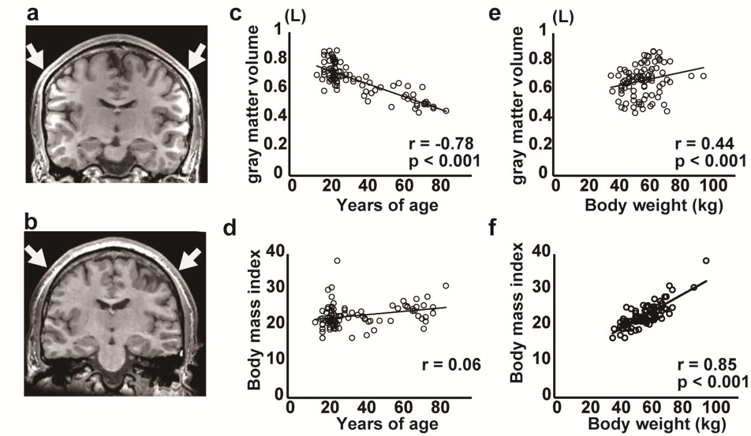

Fig. S5 Relationship between human GM volume of the whole brain, body weight, BMI and age.
a,b, Representative T1-weighted coronal images of normal weight (a) and obese (b) groups. Note that the normal weight MRI image shows that the parietal and temporal lobes are bulging outwards; however, in obesity, they are dented without protrusion. c-f, Plot graphs show results of the partial correlation analysis between the gray matter volume of the whole brain (GM) and age (c) or body weight (e) and between the BMI and age (d) or body weight (f).

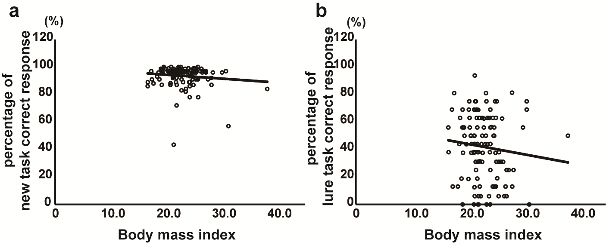

Fig. S6 Relationship between BMI and percentage of correct responses in the new and the lure task.
a-b, Plot graphs showing the results of the partial correlation analysis between BMI and percentage of correct responses in the new task (a) and lure task (b). There was no significant negative correlation between BMI and percentage of correct responses in the new task (r = -0.05, p = 0.58) or the lure task (r = -0.07, p = 0.43).

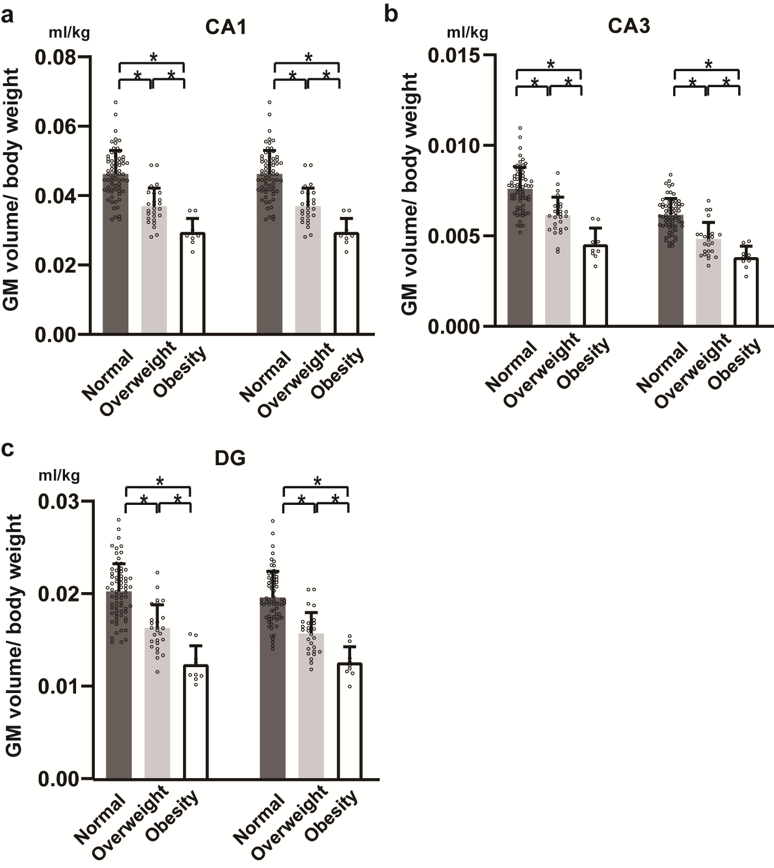
Fig. S7 Decrease of human hippocampus subregions by MRI
a-c, The averaged and individual volume data of the CA1 (a), CA3 (b), and DG (c) of the normal weight, overweight, and obese groups. The circle indicates the individual data. * : p<0.05.

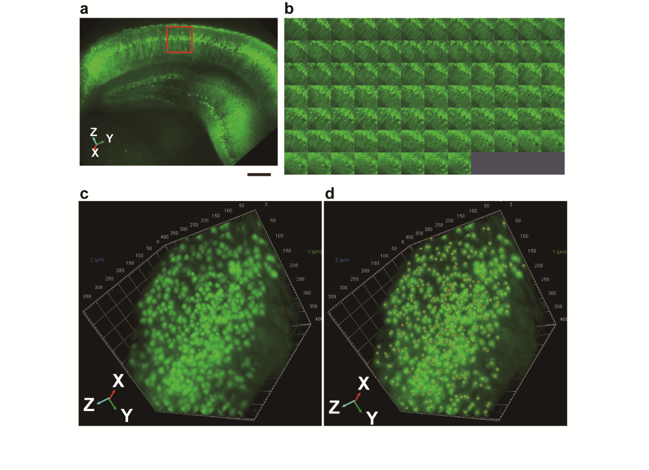

Fig. S8 Quantification of Thy1-YFPH⁺-cell in hippocampal subregion; CA1. a, An image of the whole hippocampus of a CD-fed mouse, 17 weeks old (x10 water immersion objective lens) (Voxel size is X-axis, 4.013 μm；Y-axis, 4.013μm；Z-axis, 5.016μm) (Methods, Supplementary Movie S4). Red box indicates cut region. Bar: 400μm. b, Panel view of a subset selected cells. c, 3D reconstruction of the cut region d, Bob filter rending image (average size, 20 μm; threshold, 5μm).

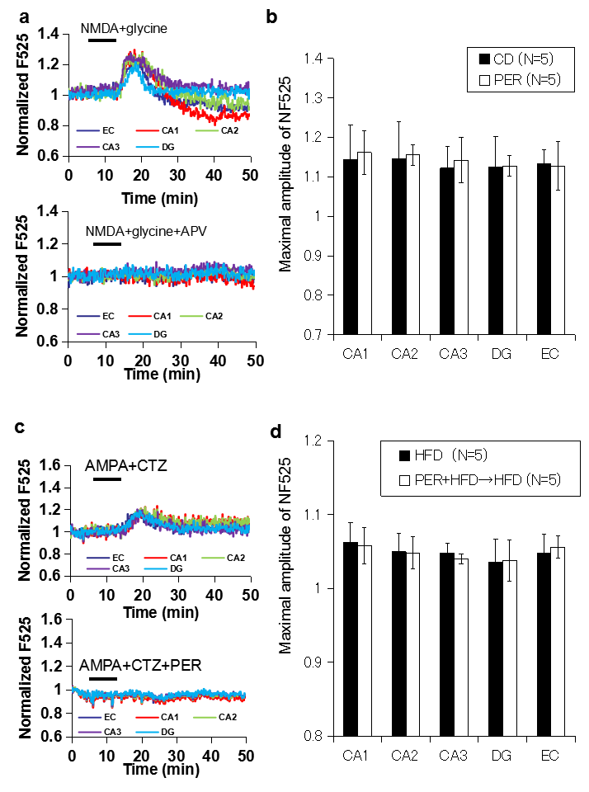
Fig. S9 No side effect of perampanel administration for NMDA receptor and CP-AMPA receptor function
a, Perampanel administration did not change the NMDA receptor function.
NMDA:50μM；glycine:10μM；APV:50μM
b, Statistical comparison of NMDA receptor function between perampanel administration group (PER) and peramanel non-administration group (CD, shown in Fig. 1g)
mouse: PER: 17 weeks old, from 15 week to 17 week perampanel administration (n=5); CD: 17 weeks old (n=5)
c, HFD induced CP-AMPA receptor function once treated with a perampanel plus HFD
AMPA: 100 μM; CTZ: 100 μM; PER: 100 μM
d, Statistical comparison of HFD induced CP-AMPA receptor function between once treated with perampanel plus HFD PER+HFD→HFD group (PER+HFD→HFD) and HFD group (HFD ,shown in Figure S1A)
mouse: PER+HFD : 17 weeks old, from 15week to 16 week perampanel administration then from 16 week to 17 week HFD (n=5); HFD: 17 weeks old, from 16 week to 17 week HFD (n=5)

Table S1 Composition table of CE-2 feed (per 100 g)
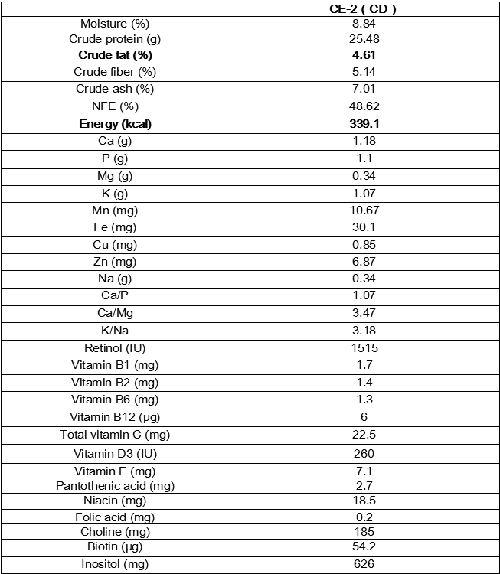

Table S2 Comparison CP-AMPA and NMDA response in the hippocampal regions in CD, HFD, and HFD with PER mice
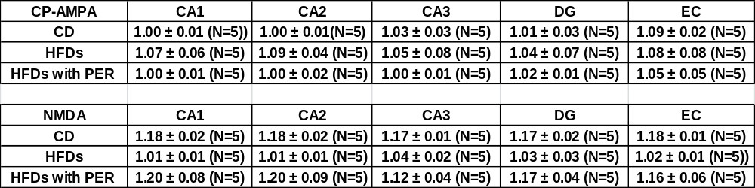

Table S3 Ca²⁺-permeability index of CA1, CA3, DG, and EC hippocampal subregions in mice fed with CD, HFD, and HFD with PER treatment.
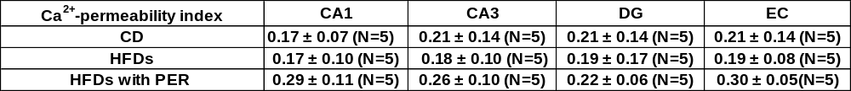
*We defined “GluA2’s RNA amount/(GluA1+GluA3+GluA4’s RNA amount) ratio” as Ca²⁺-permeability index.

Table S4 Number of human subjects in MRI analysis
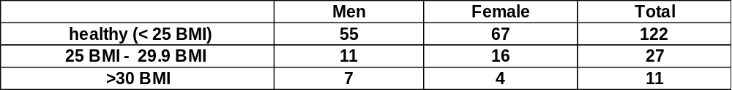

Table S5 Mouse primer set for RT-PCR
Gene name | Forward primer | Reverse primer
beta-actin | ACAGCTTCACCACCACAGCT | TGCGGCAGTGGCCATCTCCT
GluA1 | CTGTGAATCAGAACGCCTCA | GGAAACCTGTCACATTGGCT
GluA2 | CCCTGGAGCACACACAGCGA | CTGCTTCCGAAGATTGCGGA
GluA3 | GTGCAGTTATACAACACCAACCA | GAGCAGAAAGCATTAGTCACAGA
GluA4 | GGCTCAGGAGTGCACCTCTCA | CTTCTGCAGTGCTCTGCACA
GluN1 | CATCGGCATGCGCAAGGACA | TGTCTTATCCAGGTCTTCCA
GluN2A | GGGTCACAGAGCAACATGCT | AGCTCTTTTGGGTGAGTCCA
GluN2B | GTGAGAGCTCCTTTGCCAAC | TCAGGGTAGAGCGACTTGCT
GluN2C | AAGGCCTTTTGTCATTGTGG | CTTGAGGATGTCGATGCAGA
GluN2D | GACTACTCCTTCAATGAGGA | GTTCCCAGCTGCCCACCACT
GluN3A | CCAGTCAGAGGTTTCACAGA | CCATCTTCTCCATCTGCTCT
GluN3B | CTTGGCTAGGTTTCTGAGCA | GCGTAAGCTCCATACCTTGA
ADAR1 | AAGACTCGGAGAAACCAGCA | CCTTCTTTGGACAGGAGACG
ADAR2 | TGCCTTGGCTACTGTCTTCA | CCAGAGAGCACTTTCCTTCG
ADAR3 | CCAGGAAAGTCTCCCCACTT | CCGTGTGCTTAGCCTACCAT
REST | ACATGCGGACTCATTCAGGT | GAGGTTTAGGCCCGTTGTGA
RP58 | GCTTTCGCTCTCCTGCTTGA | TGTGGAGATAACTGGCAGCT

Table S6 Significant differences of hippocampal subfield activation among three (normal weight, overweight, and obese) groups. The participants in this study were 117 healthy volunteers (mean age 37.8 ± 19.6 years; 65 females, 52 males) and 5 patients with benign tumors (mean age 55.5 ± 9.6 years; 2 females, 3 males). They were divided into three groups by body mass index (BMI) according to WHO criteria: normal weight (BMI < 25), overweight (BMI ≥ 25 and < 30), and obese (BMI ≥ 30 ). There were 84 patients in the normal-weight group (mean BMI: 20 ± 1.8), 27 in the overweight group (mean BMI: 26 ± 1.2), and 11 in the obese group (mean BMI: 32 ± 2.3).
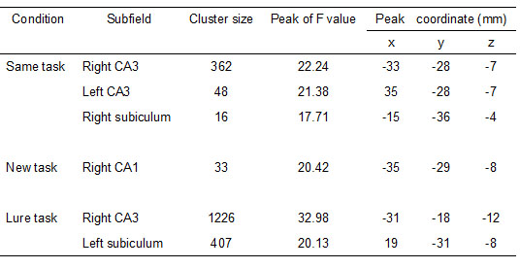
Statistical analysis was done by one-way ANOVA. Voxel-level threshold at p < 0.05, corrected for multiple comparisons (family-wise error).

Table S7 The amplitude and the latency of BOLD responses in normal, overweight, and obese groups.
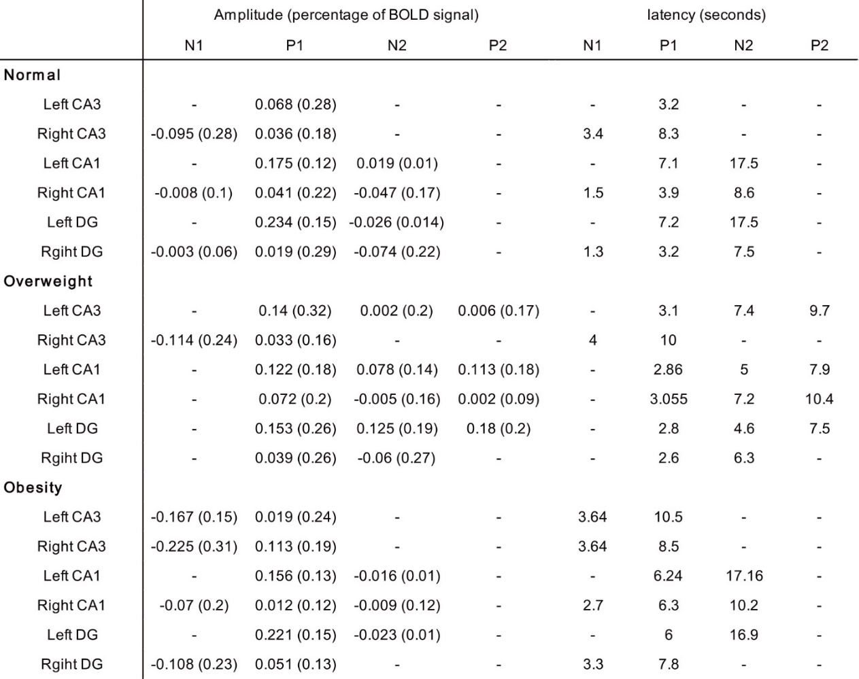
This table explains the BOLD responses of CA3, CA1, and DG in Figs. 5. The values indicate the averages of amplitudes and latency, respectively. Values in parentheses indicate standard deviation.

Movie S1 Visualizing calcium signaling in hippocampal slices
Low-magnification video of calcium signaling in CP-AMPAR’s response in the hippocampus under CD and HFD conditions. This is a time-lapse video acquired by confocal microscopy of hippocampal slices of mice. The slice contains fluorescent calcium indicators that glow more brightly when the concentration of calcium increases inside the cell. The movie is a time-lapse recording of an experiment that is approximately 50 min long and compressed to 30 s. Calcium enters the cytoplasm through calcium-permeable AMPA or NMDA channels in the cell membrane. The long axis and short axis of the hippocampus were approximately 3 mm and 2 mm, respectively. Mouse age is 17 weeks old. AMPA (100 μM) and CTZ (100 μM) cocktail was applied 10 min after the start of the video until 15 min. MovieS1-1.mp4: CP-AMPAR’s response under CD conditions. MovieS1-2.mp4: CP-AMPAR’s response under HFD conditions. Technical details; Format: MOV

Movie S2 Low-magnification video of calcium signaling in NMDAR’s response in the hippocampus under CD and HFD conditions. NMDA (50 μM) and glycine (10 μM) cocktail was applied 10 min after the start of the video until 15 min.MovieS2-1.mp4: NMDAR’s response under CD conditions
MovieS2-2.mp4: NMDAR’s response under HFD conditions. Technical details; Format: MOV

Movie S3 Low-magnification video of calcium signaling in CP-AMPAR’s and NMDAR’s response in the hippocampus under HFD with PER condition. AMPA (100 μM) and CTZ (100 μM) cocktail was applied 10 min after the start of the video until 15 min. NMDA (50 μM) and glycine (10 μM) cocktail was applied 10 min after the start of the video until 15 min. MovieS3-1.mp4: AMPAR’s response under HFD with PER conditions. MovieS3-2.mp4: NMDAR’s response under HFD with PER conditions
Technical details; Format: MOV

Movie S4 Visualizing 3D images of CA1 subregion (Movie S4), whole hippocampus of Thy1-YFPH transgenic wild type mouse (Movie S5) , whole hippocampus of Thy1-YFPH transgenic HFD-fed mouse (Movie S6), and HFD-fed with PER mouse (Movie S7). Movie 4: High-magnification imaging of Thy1-YFPH positive neurons in the CA1 subregion of CD-fed mouse. Movie 5: High-magnification imaging of Thy1-YFPH positive neurons in the whole hippocampus of CD-fed mouse.
Movie 6: High-magnification imaging of Thy1-YFPH positive neurons in the whole hippocampus of HFD-fed mouse. Movie 7: High-magnification imaging of Thy1-YFPH positive neurons in the whole hippocampus of HFD-fed with PER treatment mouse. The subregion movie is approximately 5 s while the whole hippocampus is 20~40 s long.
Technical details; Format: MOV

