Supplementary files for the article: Functional genomics analysis to disentangle the role of genetic variants in major depression
Judith Pérez-Granado¹, Janet Piñero^{1,2}, Alejandra Medina-Rivera^{3,4}, Laura I. Furlong^{1,2,4}
¹ Research Programme on Biomedical Informatics (GRIB), IMIM (Hospital del Mar Medical Research Institute), UPF (Pompeu Fabra University), Dr. Aiguader, Barcelona, Spain
² MedBioinformatics Solutions SL, Almogàvers 165, 08018 Barcelona, Spain
³ Laboratorio Internacional de Investigación sobre el Genoma Humano, Universidad Nacional Autónoma de México, Campus Juriquilla, Blvd Juriquilla 3001, Santiago de Querétaro 76230, Mexico
⁴ Corresponding authors

Supplementary figures 1-4
(this file)
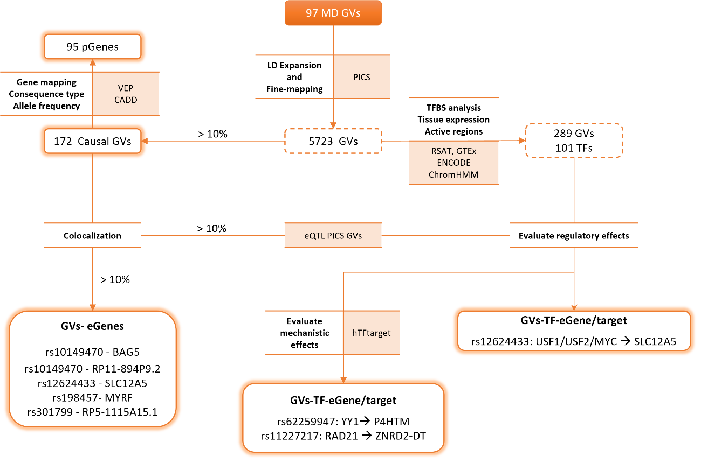
Supplementary Figure 1. Study overview. Overview of the developed and implemented analysis pipeline including: fine-mapping, eQTL colocalization and TF binding analysis.
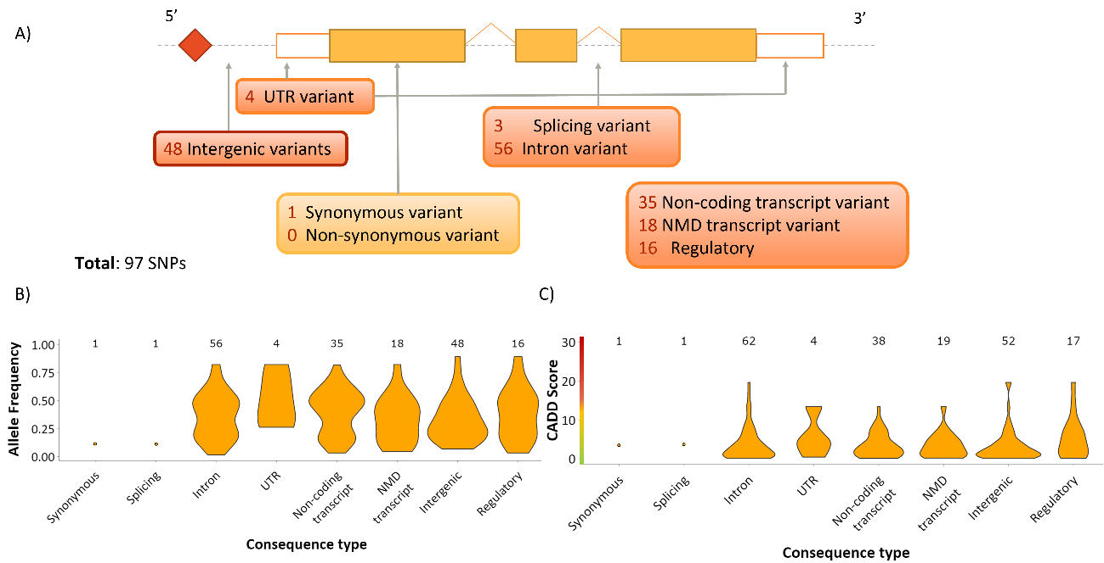
Supplementary Figure 2. MD lead GVs characterization. A) GVs distributed along the genome according to its consequence type predicted with VEP. B) Allele frequency density, according to GV’s consequence type, also predicted with VEP. C) Pathogenicity score (predicted by CADD) density per consequence type. NMD: Nonsense Mediated Decay.

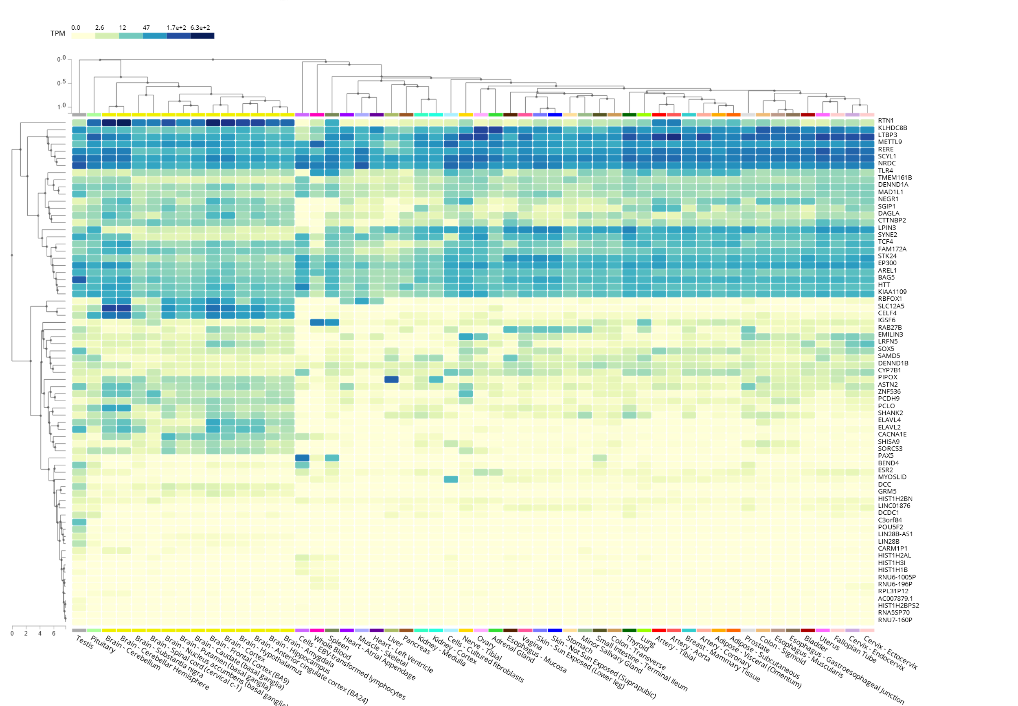
Supplementary Figure 3. Tissue expression of pGenes. Heatmap of pGenes tissue expression according to GTEx expression data (V8).
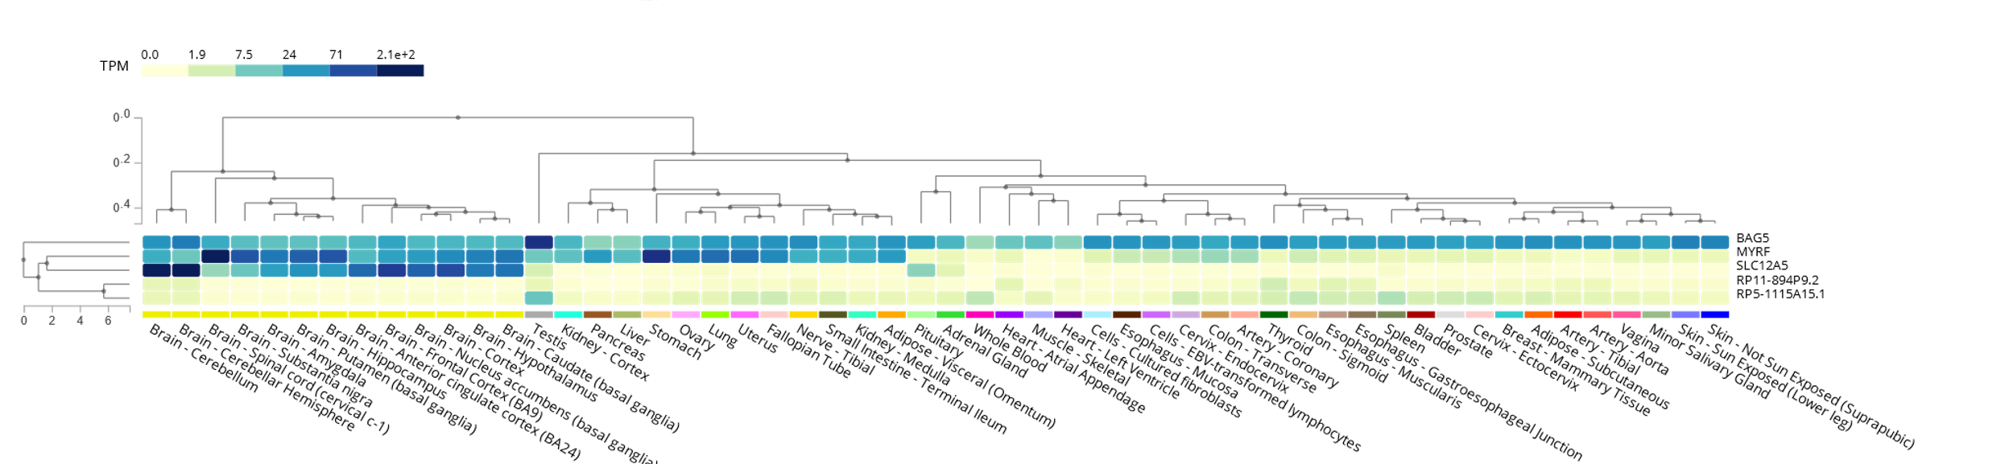
Supplementary Figure 4. Tissue expression of eGenes. Heatmap of eGenes tissue expression according to GTEx expression data (V8).

Supplementary tables 1-6

File: Perez-Granado-Supplementary_tables_1-6.xlsx
Supplementary Table 1. Causal GVs for MD.
Supplementary Table 2. pGenes functional and disease enrichment analysis.
Supplementary Table 3. Fine-mapped MD causal GVs disease enrichment analysis.
Supplementary Table 4. Colocalizing GWAS-eQTLs association to disease.
Supplementary Table 5. TFBS analysis.
Supplementary Table 6. GVs state annotation.

