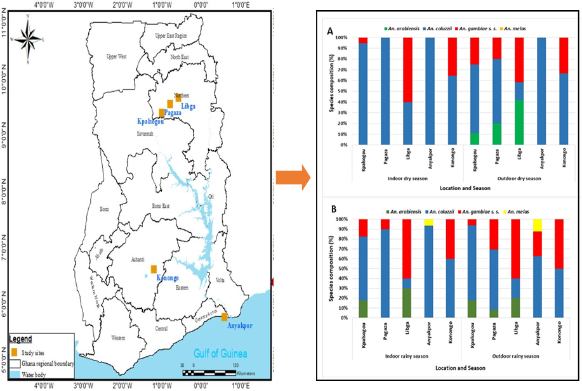

Seasonal composition of Anopheles species resting indoor and outdoor in A: Dry season and B: Rainy season in different sites at three main ecological zones of Ghana.

