Supplementary information

Tracking the formation and degradation of fatty-acid-accumulated mitochondria using label-free chemical imaging

Chi Zhang^{1#} and Stephen A. Boppart^{1,2,3,4,5*}
¹Beckman Institute for Advanced Science and Technology
²Department of Bioengineering
³Department of Electrical and Computer Engineering
⁴Cancer Center at Illinois
⁵Carle Illinois College of Medicine
University of Illinois at Urbana-Champaign

Corresponding author
* boppart@illinois.edu

Supplementary figures
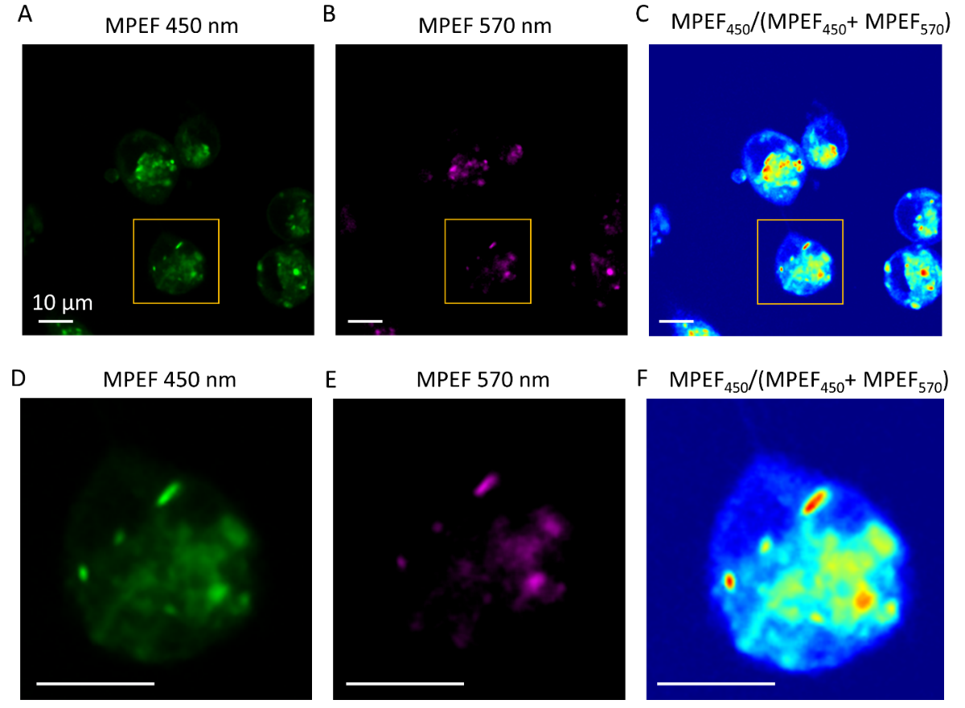
Figure S1. (A-C) MPEF images of MIAPaCa-2 cells at 450 nm (from NADH) and 570 nm (from FAD), and the intensity ratio of MPEF_{450nm}/(MPEF_{450nm}+MPEF_{570nm}), respectively. The ratio has an arbitrary unit. (D-F) Magnified selected areas from the yellow boxed regions in panels (A-C), respectively.

Supplementary videos
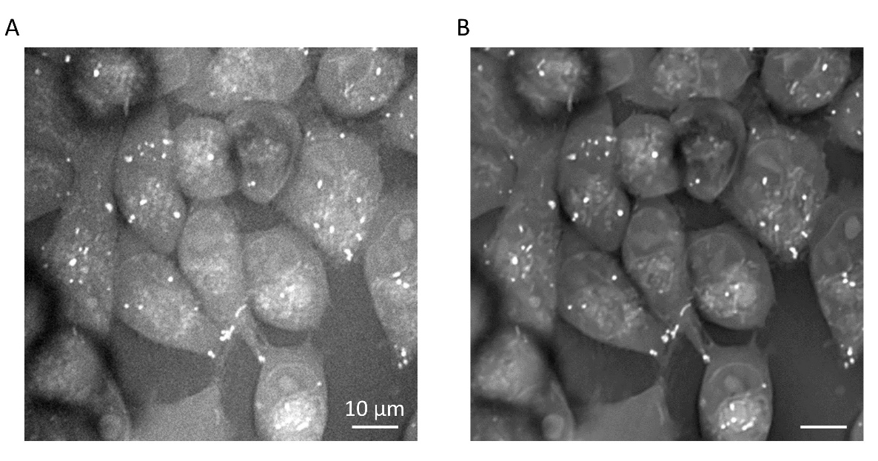
Video S1. (A) and (B) are the original and denoised CARS videos of MIAPaCa-2 cells at CH₂ stretching vibrations, respectively.

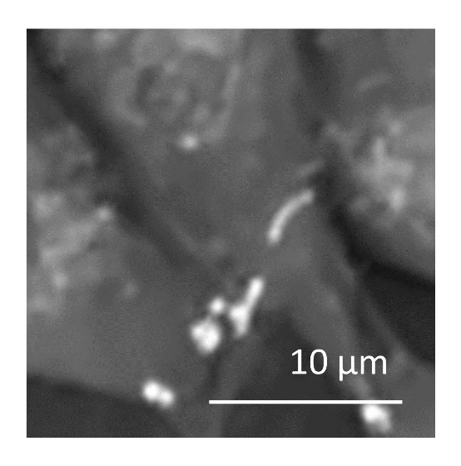
Video S2. A time-lapse video of the FA-accumulated mitochondria relocation in living cells.

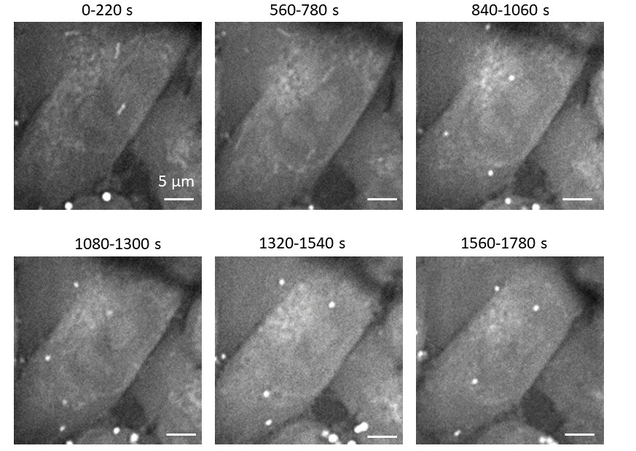
Video S3. Time-lapse videos of the FA-accumulated mitochondria degradation in a live MIAPaCa-2 cell. From 0 to 220 s, the cells were in the hypothermia environment. At ~380 s, the rewarming started.

