Table S1 Percentage changes with 95% confidence intervals in health endpoints associated with increases in PM_{2.5} concentrations.
Health Endpoints | change | 95%CI | P
Blood pressure
SBP | －3.92 | (－6.11,－1.73) | 0.001
DBP | －2.47 | (－5.10,0.17) | 0.066
PP | －5.94 | (－10.1,－1.78) | 0.006
Blood lipid
GLU | 0.44 | (－1.69,2.57) | 0.682
TG | －2.88 | (－13.13,7.36) | 0.575
TC | －0.57 | (－3.97,2.83) | 0.739
HDL | 2.73 | (－0.65,6.12) | 0.111
LDL | －1.29 | (－4.97,2.39) | 0.484
APOA | 1.54 | (－2.55,5.63) | 0.454
APOB | －1.82 | (－5.25,1.61) | 0.292
Oxidative stress
CAT | －16.04 | (－43.7,11.62) | 0.250
SOD | 0.01 | (－4.1,4.13) | 0.995
MDA | －12.80 | (－22.99,－2.61) | 0.015
GSH-PX | 4.80 | (0.22,9.38) | 0.040
Inflammation
IL-6 | －18.95 | (－26.67,－11.22) | <0.001
TNFα | －18.77 | (－29.21,－8.34) | 0.001
CRP | －28.29 | (－45.45,－11.12) | 0.002
IL-8 | －1.44 | (－13.65,10.77) | 0.814
Definition of abbreviations: SBP = systolic blood pressure; DBP = diastolic blood pressure; PP = pulse pressure; GLU = glucose; TG = Total cholesterol; TC = Triglyceride; LDL-C = Low-density lipoprotein cholesterol, HDL-C = high-density lipoprotein cholesterol; APOA = apolipoprotein A; APOB = apolipoprotein B; CAT = catalase; SOD = superoxide dismutase; MDA = malondialdehyde; GSH-Px = glutathione peroxidase; IL-6 = interleukin 6; TNF-α = tumor necrosis factor α;CRP = C-reactive protein; IL-8 = interleukin 8.
The change was calculated by taking the absolute difference between the change of health indicators (Δbiomarker) in vitamin C supplementation group and the Δbiomarker in placebo group, dividing that by the average of this biomarker among all participants, and multiplying by 100%. This β is the absolute differences between the change of health indicators (Δbiomarker) vitamin C supplementation group and the Δbiomarker in placebo group..

Table S2 Percentage changes with 95% confidence intervals in health endpoints associated with increases in PM₁₀ concentrations.
Health Endpoints | change | 95%CI | P
Blood pressure
SBP | －3.94 | (－6.13,－1.75) | 0.001
DBP | －2.44 | (－5.07,0.2) | 0.069
PP | －6.02 | (－10.18,－1.86) | 0.005
Blood lipid
GLU | 0.42 | (－1.71,2.54) | 0.697
TG | －3.04 | (－13.28,7.19) | 0.554
TC | －0.54 | (－3.94,2.86) | 0.751
HDL | 2.73 | (－0.66,6.12) | 0.112
LDL | 1.35 | (－1.96,4.67) | 0.418
APOA | 1.55 | (－2.55,5.64) | 0.452
APOB | －1.79 | (－5.22,1.65) | 0.302
Oxidative stress
CAT | －15.82 | (－43.38,11.73) | 0.255
SOD | 0.07 | (－4.05,4.18) | 0.974
MDA | －12.84 | (－23.02,－2.67) | 0.014
GSH-PX | 4.83 | (0.25,9.42) | 0.039
Inflammation
IL-6 | －18.88 | (－26.61,－11.15) | <0.001
TNFα | －18.7 | (－29.13,－8.26) | 0.001
CRP | －28.14 | (－45.29,－10.98) | 0.002
IL-8 | －1.37 | (－13.56,10.81) | 0.822

Definition of abbreviations: SBP = systolic blood pressure; DBP = diastolic blood pressure; PP = pulse pressure; GLU = glucose; TG = Total cholesterol; TC = Triglyceride; LDL-C = Low-density lipoprotein cholesterol, HDL-C = high-density lipoprotein cholesterol; APOA = apolipoprotein A; APOB = apolipoprotein B; CAT = catalase; SOD = superoxide dismutase; MDA = malondialdehyde; GSH-Px = glutathione peroxidase; IL-6 = interleukin 6; TNF-α = tumor necrosis factor α;CRP = C-reactive protein; IL-8 = interleukin 8.
The change was calculated by taking the absolute difference between the change of health indicators (Δbiomarker) in vitamin C supplementation group and the Δbiomarker in placebo group, dividing that by the average of this biomarker among all participants, and multiplying by 100%. This β is the absolute differences between the change of health indicators (Δbiomarker) vitamin C supplementation group and the Δbiomarker in placebo group.

Table S3 Percentage changes with 95% confidence intervals in health endpoints associated with increases in PM2.5 and PM10 concentrations.
Health Endpoints | change | 95%CI | P
Blood pressure
SBP | －3.93 | (－6.14,－1.71) | 0.001
DBP | －2.48 | (－5.09,0.13) | 0.062
PP | －6.01 | (－10.17,－1.84) | 0.005
Blood lipid
GLU | 0.37 | (－1.74,2.49) | 0.724
TG | －2.85 | (－13.05,7.35) | 0.578
TC | －0.49 | (－3.9,2.91) | 0.773
HDL | 2.72 | (－0.69,6.13) | 0.115
LDL | －1.20 | (－4.87,2.48) | 0.517
APOA | 1.55 | (－2.57,5.68) | 0.454
APOB | －1.73 | (－5.15,1.69) | 0.314
Oxidative stress
CAT | －16.53 | (－44.37,11.3) | 0.239
SOD | 0.02 | (－4.08,4.13) | 0.991
MDA | －12.84 | (－23.04,－2.64) | 0.015
GSH-PX | 4.84 | (0.27,9.42) | 0.039
Inflammation
IL-6 | －18.80 | (－26.5,－11.1) | <0.001
TNFα | －18.63 | (－29.21,－8.04) | 0.001
CRP | －28.19 | (－45.41,－10.98) | 0.002
IL-8 | －1.54 | (－13.76,10.69) | 0.802
Definition of abbreviations: SBP = systolic blood pressure; DBP = diastolic blood pressure; PP = pulse pressure; GLU = glucose; TG = Total cholesterol; TC = Triglyceride; LDL-C = Low-density lipoprotein cholesterol, HDL-C = high-density lipoprotein cholesterol; APOA = apolipoprotein A; APOB = apolipoprotein B; CAT = catalase; SOD = superoxide dismutase; MDA = malondialdehyde; GSH-Px = glutathione peroxidase; IL-6 = interleukin 6; TNF-α = tumor necrosis factor α;CRP = C-reactive protein; IL-8 = interleukin 8.
The change was calculated by taking the absolute difference between the change of health indicators (Δbiomarker) in vitamin C supplementation group and the Δbiomarker in placebo group, dividing that by the average of this biomarker among all participants, and multiplying by 100%. This β is the absolute differences between the change of health indicators (Δbiomarker) vitamin C supplementation group and the Δbiomarker in placebo group.

Table S4 Percentage changes with 95% confidence intervals in health endpoints associated with increases in VC concentrations.
Health Endpoints | change | 95%CI | P
Blood pressure
SBP | －3.43 | (－5.35,－1.52) | 0.001
DBP | －1.66 | (－4.00,0.67) | 0.159
PP | －6.09 | (－9.74,－2.44) | 0.002
Blood lipid | 0.99 | (－0.89,2.86) | 0.295
GLU | -1.02 | (－9.98,7.95) | 0.821
TG | 1.09 | (－1.94,4.11) | 0.474
TC | 2.30 | (－0.63,5.23) | 0.122
HDL | 0.91 | (－2.44,4.26) | 0.587
LDL | 1.61 | (－1.83,5.04) | 0.352
APOA | 0.62 | (－2.52,3.76) | 0.693
APOB | －14.22 | (－38.19,9.75) | 0.239
Oxidative stress | －0.86 | (－4.12,2.39) | 0.597
CAT | －4.92 | (－14.18,4.33) | 0.291
SOD | 6.32 | (2.52,10.11) | 0.002
MDA | －19.27 | (－26.05,－12.49) | <0.001
GSH-PX | －16.83 | (－25.95,－7.71) | 0.001
Inflammation | －32.89 | (－47.78,－18) | <0.001
IL-6 | －1.49 | (－11.78,8.80) | 0.772
TNFα | －3.43 | (－5.35,－1.52) | 0.001
CRP | －1.66 | (－4.00,0.67) | 0.159
IL-8 | －6.09 | (－9.74,－2.44) | 0.002
Definition of abbreviations: SBP = systolic blood pressure; DBP = diastolic blood pressure; PP = pulse pressure; GLU = glucose; TG = Total cholesterol; TC = Triglyceride; LDL-C = Low-density lipoprotein cholesterol, HDL-C = high-density lipoprotein cholesterol; APOA = apolipoprotein A; APOB = apolipoprotein B; CAT = catalase; SOD = superoxide dismutase; MDA = malondialdehyde; GSH-Px = glutathione peroxidase; IL-6 = interleukin 6; TNF-α = tumor necrosis factor α;CRP = C-reactive protein; IL-8 = interleukin 8.
The change was calculated by taking the absolute difference between the change of health indicators (Δbiomarker) in vitamin C supplementation group and the Δbiomarker in placebo group, dividing that by the average of this biomarker among all participants, and multiplying by 100%. This β is the absolute differences between the change of health indicators (Δbiomarker) vitamin C supplementation group and the Δbiomarker in placebo group.

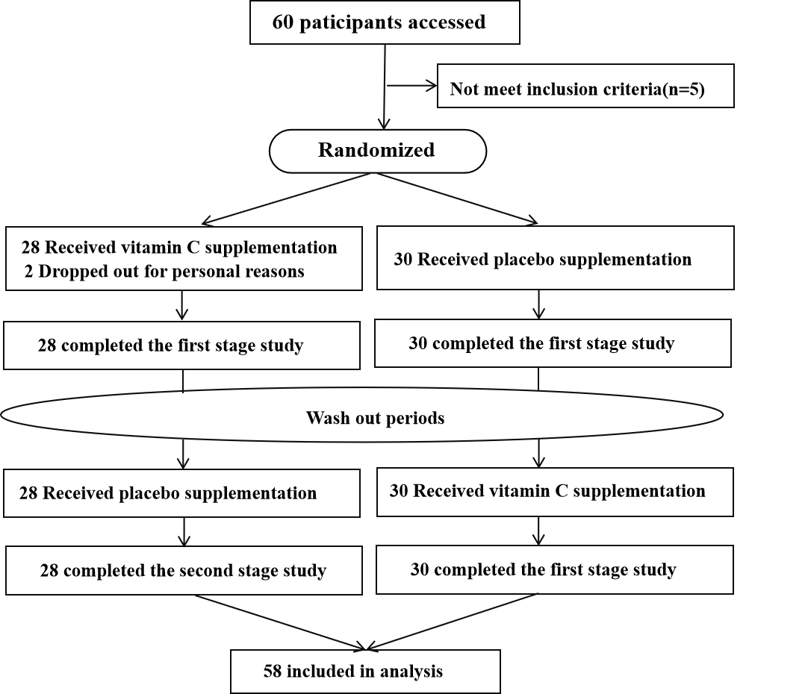
Figure S1. Flow chart of the study.
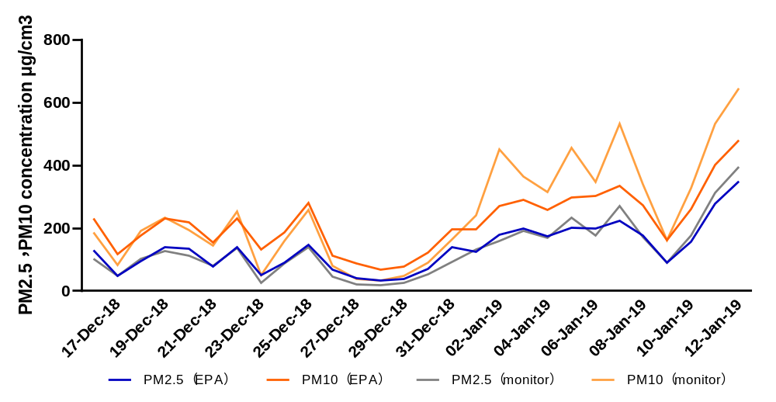

Figure S2. The time-varying PM_{2.5} and PM₁₀ concentration of EPA data and monitor recording data.

