RNA-seq reveals allele-specific expression of somatic mutations in neuroblastoma

Xiaoqing Li^{1,2†}, Lan Sun^{1,2,3†}, Qian Liu^{4,†}, Lingli Tu³, Andres Stucky³, Jingyi Wang², Zhongjun Wu^{2 Δ}, Xi Zhang^{3Δ}, Kai Wang⁴, Jiang F. Zhong³

¹Department of Oncology, the People’s Hospital of Bishan District, Chongqing, 402760, China;
²Chongqing Medical University, Chongqing, China;
³Department of Otolaryngology, Keck School of Medicine, University of Southern California, Los Angeles, CA, USA;
⁴Raymond G. Perelman Center for Cellular and Molecular Therapeutics, The Children’s Hospital of Philadelphia, Philadelphia, PA, USA
†: These authors are contributed equally to this work.
Δ: Corresponding authors: Xi Zhang and Zhongjun Wu.

Author list:

Xiaoqing Li:lxq8210@gmail.com
Lan Sun: ls_000@usc.edu

Qian Liu: liuqianhn@gmail.com
Lingli Tu: tulingli425@gmail.com

Andres Stucky: astucky@usc.edu

Jingyi Wang: xiaoduo_duo.com@foxmail.com

Xi Zhang: zhangxxi@sina.com

Zhongjun Wu: wzjtcy@126.com

Kai Wang: kaichop@gmail.com
Jiang F. Zhong: jzhong@usc.edu

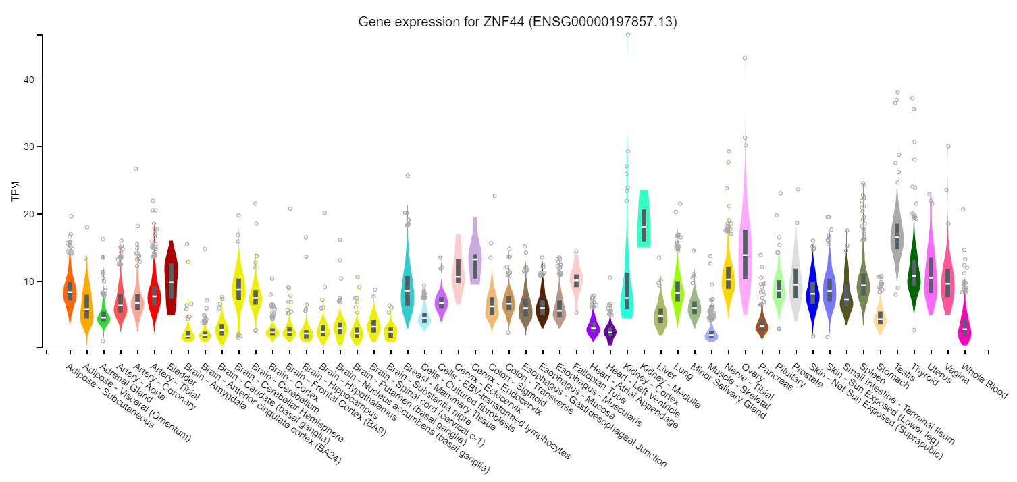

Suppl Fig 1. ZNF44 gene expression in different organs and tissues (cBioPortal website). TPM: transcripts per million, the unit of transcript expression.

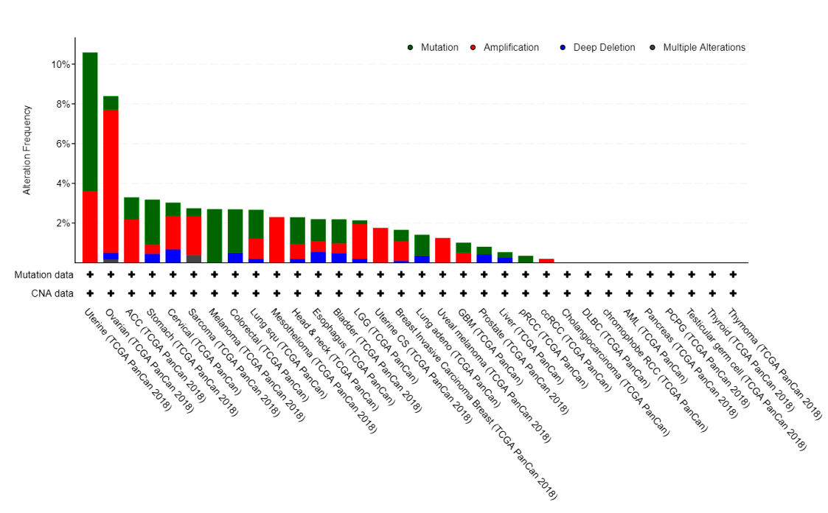

Suppl Fig 2. ZNF44 mutations in different cancers (cBioPortal website)

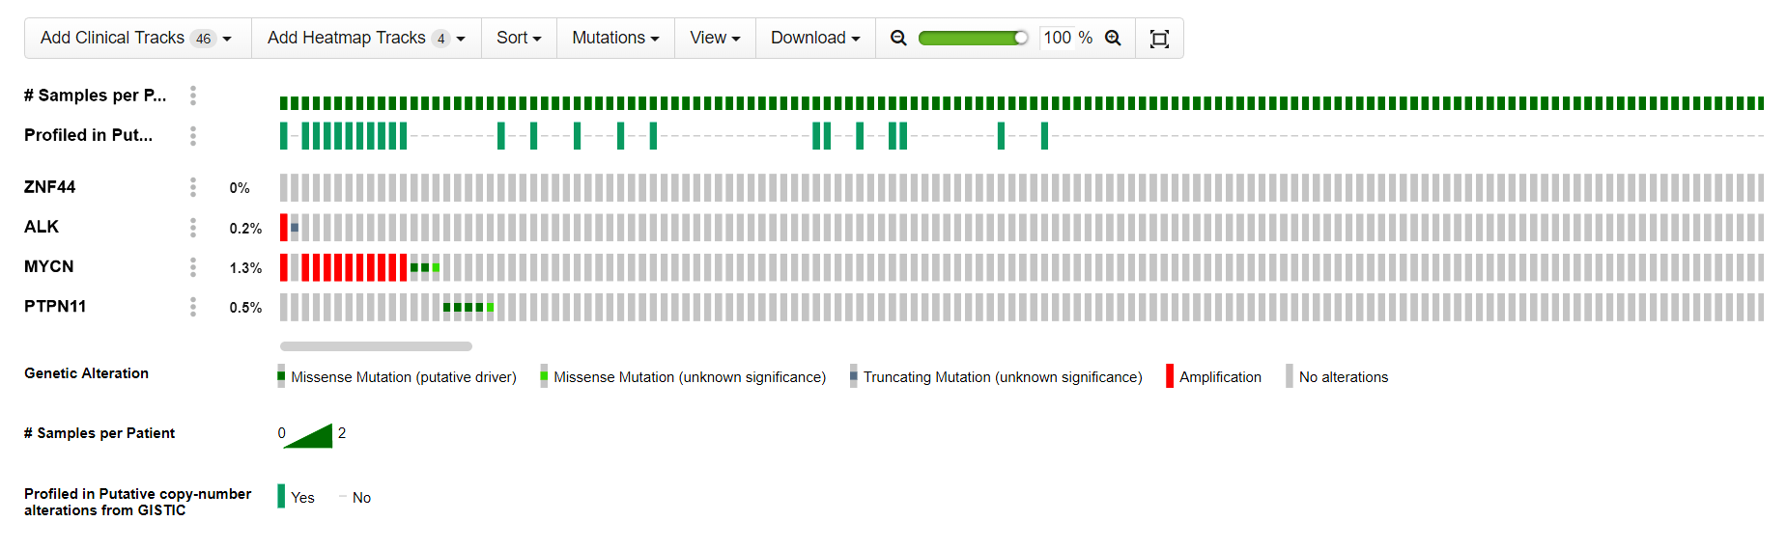

Suppl Fig 3. Variants of ALK, MYCN, PTPN11 and ZNF44 occurring in neuroblastoma samples. (cBioPortal website)

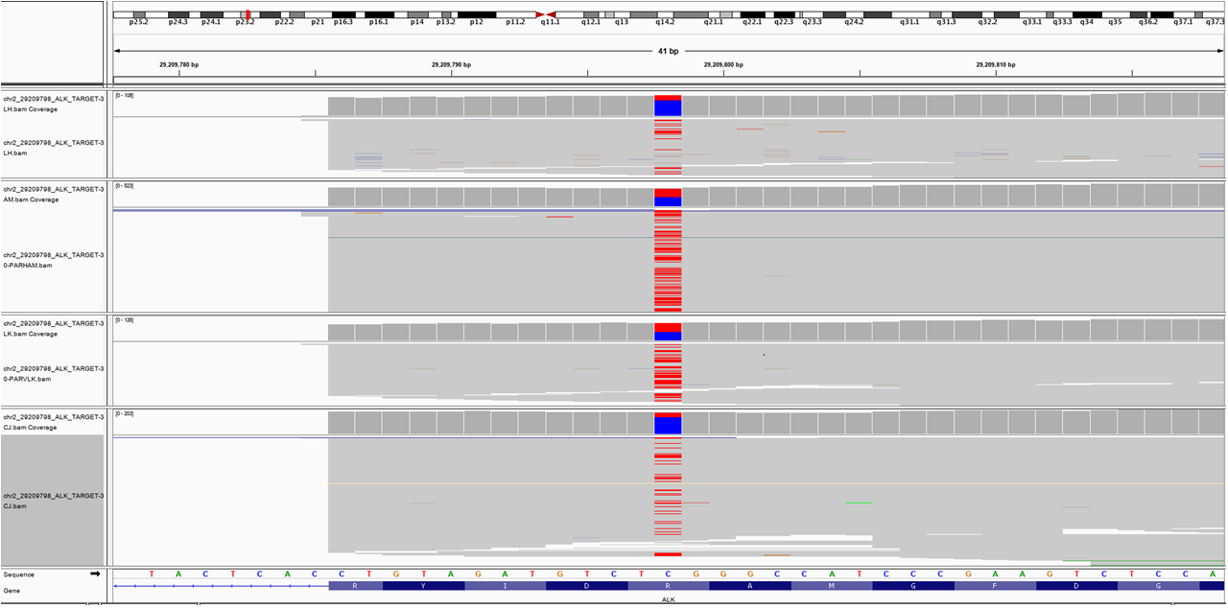

Suppl Fig. 4. IGV plot for the variants chr2:29209798/C>T in the ALK gene from RNA-seq data for 4 samples out of the total of 7 samples (the other 3 samples are shown in Fig. 2)

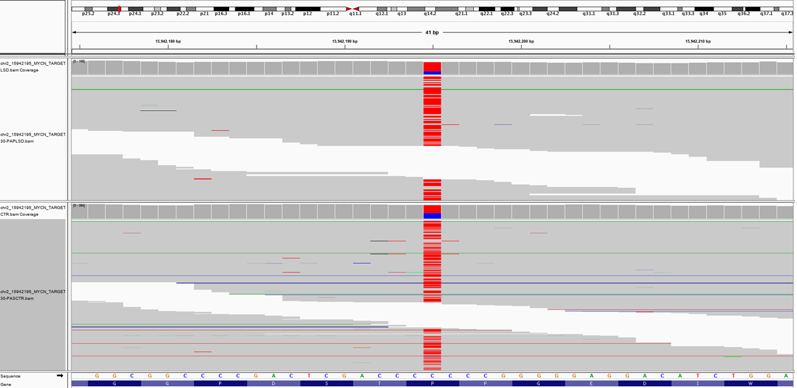

Suppl Fig. 5. IGV plot for the variants chr2:15942195/C>T in the MYCN gene from RNA-seq data for the 2 samples.

