Supplementary Information for “Near unity Raman $β$-factor of surface enhanced Raman scattering in a waveguide”

Ming Fu¹, Mónica P. dS. P. Mota¹, Xiaofei Xiao¹, Andrea Jacassi¹, Yi Li^{1,2}, Ahad Riaz¹,
Stefan A. Maier^{1,3}, Rupert F. Oulton^{1,*}
¹Blackett Laboratory, Imperial College, Prince Consort Road, London SW7 2BZ, UK
²School of Microelectronics, MOE Engineering Research Center of Integrated Circuits for Next Generation Communications, Southern University of Science and Technology, Shenzhen 518055, China
³Chair in Hybrid Nanosystems, Nanoinstitute Munich, Faculty of Physics, Ludwig-Maximilians-Universität München, 80539 Munich, Germany
* Corresponding author: r.oulton@imperial.ac.uk

Table of contents
- Simulation of Plasmonic Gap Waveguide and Coupler
- Propagation Length of Gap Waveguides Coated with 4-ATP Molecules
- Raman Scattering of 4-ATP Molecules Coated on Au Film
- Theory of Raman Scattering in a Plasmonic Waveguide
- Local Field Enhancement by Gap Waveguide
- Ratios of Stokes Scattering from Waveguide Outputs
- Raman Purcell and β Factors
- Raman Enhancement Factor
- Waveguide Mode Calculations
- Waveguide SERS Enhancement Parameters

- Simulation of Plasmonic Gap Waveguide and Coupler

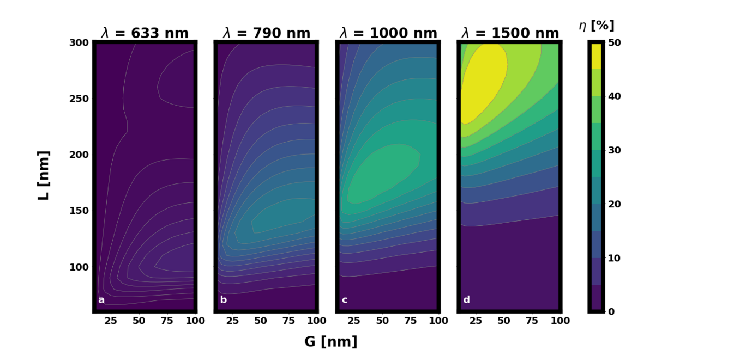
Figure S1. Simulated maximum incoupling efficiency $η_{in}$ in for the “infinite” perfectly matched layers (PML) system for a range of antenna lengths and gap widths at (a) $λ$ = 633 nm, (b) 790 nm, (c) 1000 nm and (d) 1500 nm.

- Propagation Length of Gap Waveguides Coated with 4-ATP Molecules

Raman scattering of the gap waveguides coated with 4-ATP was found to be reduced compared to waveguide without molecules. Thus, further Rayleigh scattering measurements were undertaken to confirm molecular absorption as the origin of the discrepancy. Indeed, Figure S3 confirms that the propagation length in these waveguides is affected by the 4-ATP at both the pump and Raman wavelengths. Attenuation is found to be greater at the pump wavelength and this is consistent with experimental findings.

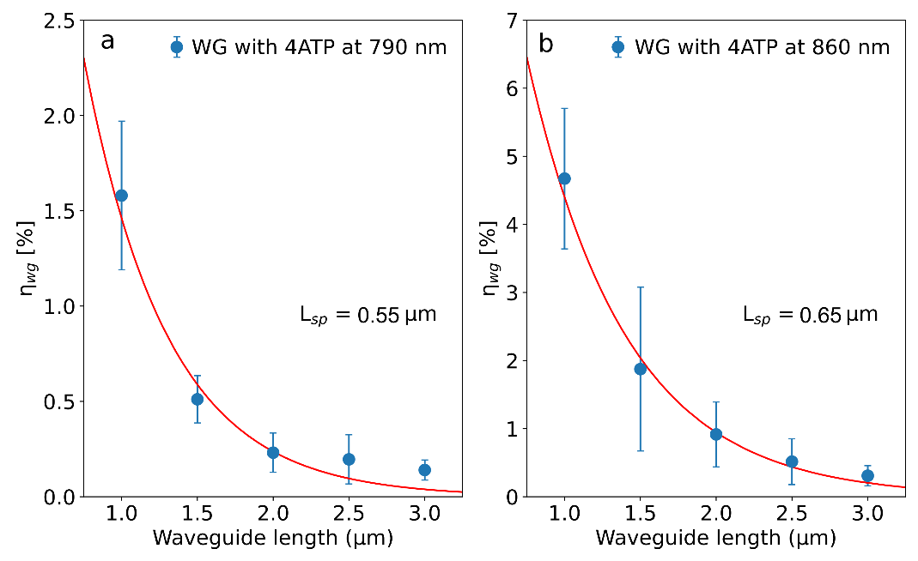
Figure S2. The couple efficiency of waveguide $η_{wg}$ coated with 4-ATP molecules, as a function of the waveguide length. The surface plasmon propagation lengths are $0.55 ±0.04 μm$ and $0.65±0.05 μm$ respectively, with the incident laser wavelength of (a) 790 nm and (b) 860 nm.

From the fitting of Figure S3, we find the antenna coupling efficiency at 790 nm $η_{in}\left(λ=790 nm\right)=η_{out}\left(790 nm\right)=0.31±0.01$, which is consistent with the waveguide without 4-ATP molecules. The antenna coupling efficiency at 860 nm is $η_{in}\left(λ=860 nm\right)=η_{out}\left(860 nm\right)=0.46±0.01$. Note that the extracted propagation lengths here are lower than observed in Raman scattering measurements.

- Raman Scattering of 4-ATP Molecules Coated on Au Film

Raman scattering exited and collected from an input antenna of a waveguide was directly compared with Raman scattering from a planar gold film. Data are shown in Figure S2. Signal from the gold film is significantly weaker despite similar numbers of molecules over the beam area being excited. The beam is focused though an air objective ($60×$, NA=0.95) onto the gold film, $ρ=0.41λ/NA=0.34 μm$, giving a focal spot are, $πρ^{2}≈0.36 μ$m². Meanwhile the active area is taken for an optimal waveguide length for Raman scattering, $L=2L_{sp}=1.4 μ$m, as described in Section S4. The gap waveguide active area is thus approximately twice the gap length times gap height, $2×2L_{sp}×0.06 =0.17 μ$m². The value of $L_{sp}=0.7±0.1 μ$m was taken from the fitting in Fig. 3q. The intensity ratio of the two techniques from Figure S2 of $6147±107$, is normalised by the ratio of active areas, $R_{mol}≈0.36/0.17=2.12$, to give the enhancement of $13,032±227$.
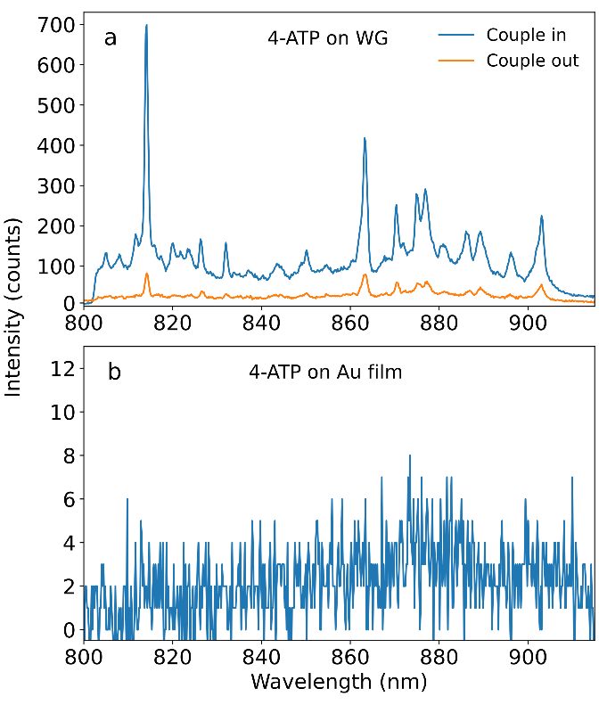
Figure S3. (a) Raman spectra of 4-ATP molecules coated on plasmonic waveguide with length = $2 μm,$ excited by 790 nm laser with pump power of $200 μW$, integration time of 10 s. (b) Raman spectrum of 4-ATP coated on Au film, excited by 790 nm laser with power of 7.5 mW, integration time of 30 s. The Raman scattering intensity ratio of 4-ATP coated on waveguide over Au film is around 6147.

- Theory of Raman Scattering in a Plasmonic Waveguide

We consider Raman scattering in a waveguide as a scalar 1D differential equation in the number of scattered Raman photons. The coupling efficiency into and out of the waveguide is assumed to be $η_{in}$ and $η_{out}$, and is considered separately. The generated Stokes Raman photon numbers along the waveguide, $n_{f}\left(z\right)$ and $n_{b}\left(z\right)$, in the forwards and backwards directions are determined by the 1D differential equations,

$$\frac{dn_{f}(z) }{dz}=-α_{s}n_{f}\left(z\right)+g_{Rw}I_{p}\left(z\right),$$

$$\frac{dn_{b}(z) }{dz}=α_{s}n_{b}\left(z\right)-g_{Rw}I_{p}\left(z\right),$$

where $g_{Rw}$ is the rate of forward and backward Raman scattering into the waveguide mode, and $α_{s}=L_{sp}^{-1}$, is the absorption coefficient at the Stokes wavelength, and where $L_{sp}$ is the propagation distance. Pump light is introduced as a 1D distribution, $I_{p}(z)$, to be determined. Here, we will consider two illumination conditions: direct excitation by coupling pump light to the waveguide mode via an antenna; and indirect excitation by illuminating the centre of the waveguide with a focussed Gaussian beam. Both cases are described in the main text.

Direct optical pumping via waveguide coupling

The optical pump beam can be directly coupled to the same waveguide mode as the Raman scattering, by illuminating the antenna couplers, as described in the main text. The pump intensity distribution can be determined using the following 1D differential equation:

$$\frac{dI_{p}(z)}{dz}=-α_{p}I_{p}\left(z\right)-g_{R}I_{p}\left(z\right)≈-α_{p}I_{p}\left(z\right),$$

where $α_{p}$ is then pump absorption coefficient in the waveguide. Here we assume that the total Raman scattering coefficient, $g_{R}$, is weak and so loss is dominated by waveguide absorption. The optical pump distribution in this case is:

$$I_{p}\left(z\right)=I_{p0}e^{-α_{p}z},$$

where $I_{p0}$ is the local peak pump intensity in the waveguide mode at the input coupler. The differential equations for Stoke’s scattered photons become:

$$\frac{dn_{f}(z) }{dz}+α_{s}n_{f}\left(z\right)=κe^{-α_{p}z},$$

$$\frac{dn_{b}(z) }{dz}-α_{s}n_{b}\left(z\right)=-κe^{-α_{p}z},$$

where $κ=g_{Rw}I_{p0}$. For simplicity, we assume that $α_{s}≈α_{p}$. The solutions to the inhomogeneous differential equation are straightforward to identify with the boundary conditions, $n_{sf}\left(0\right)=0$ and $n_{sb}\left(L\right)=0$, and are:

$$n_{sf}\left(L\right)=κLe^{-\overline{L}},$$

$$n_{sb}(0)=\frac{κ}{2α_{s}}\left({1-e}^{-2\overline{L}}\right).$$

Where $\overline{L}=α_{s}L$. Note that the photon numbers derived do not include the outcoupling efficiency, $η_{out}$, in the Raman wavelength range. Thus, let the number of photons collected from the input coupler, $n_{in}=η_{out}(λ_{s})n_{sb}(0)$, and from the output coupler, $n_{out}=η_{out}(λ_{s})n_{sf}(L)$. Since we are taking ratios of outcoupled signals here, $η_{out}(λ_{s})$, does not appear in the final expressions.

Note that the optimum output from the waveguide is where $n_{sf}\left(L\right)+n_{sb}(0)$ is a maximum, which occurs for $L=2L_{sp}$.

Indirect optical pumping by Gaussian beam

Raman scattering into the waveguide mode can also be excited by illuminating the centre of the waveguide. In this case, part of the waveguide is illuminated with a Gaussian beam of area $A_{0}=πρ^{2}$. Here, $ρ$ is the Gaussian beam waist radius at the focal point on the sample and is defined as the $e^{-2}$ radius of a Gaussian beam when fit to the diffraction limited Airy disk function, such that

$$ρ=0.41\frac{λ}{NA}.$$

where $NA=1.45$. The 1D optical pump profile in this case is,

$$I_{p}\left(z\right)=HI_{g0}e^{-2{(z-L/2)}^{2}/ρ^{2}}.$$

The parameter $H$ accounts for local field enhancement of the Gaussian beam due to the waveguide’s nanostructured geometry. The differential equations for the Stoke’s Raman scattered photons now become:

$$\frac{dn_{f}^{(c)}(z) }{dz}+α_{s}n_{f}^{(c)}\left(z\right)=γHe^{-2{(z-L/2)}^{2}/ρ^{2}},$$

$$\frac{dn_{b}^{(c)}(z) }{dz}-α_{s}n_{b}^{\left(c\right)}\left(z\right)=-γHe^{-2{(z-L/2)}^{2}/ρ^{2}},$$

where $γ=g_{Rw}I_{g0}$, measures the strength of Raman scattering into the waveguide mode via indirect illumination. Solving these equations requires the boundary conditions, $n_{sb}^{(c)}(0)=n_{sf}^{(c)}(L)$ (by symmetry when centrally illuminated) and $n_{sb}^{(c)}(L)=n_{sf}^{(c)}(0)=0$. Solutions are,

$$n_{sf}^{\left(c\right)}\left(z\right)=γHe^{-α_{s}z}\int_{0}^{z}{e^{-2{(t-L/2)}^{2}/ρ^{2}+α_{s}t}dt},$$

$$n_{sb}^{\left(c\right)}\left(z\right)=γHe^{α_{s}z}\left[\int_{0}^{L}{e^{-2{(t-L/2)}^{2}/ρ^{2}-α_{s}t}dt}-\int_{0}^{z}{e^{-2{(t-L/2)}^{2}/ρ^{2}-α_{s}t}dt}\right].$$

Sub $t^{'}=t-L/2$… and, for $ρ≪L$, we can approximate to the standard integral with infinite limits $L↦∞$.

$$\int_{0}^{L}{e^{-2{(t-L/2)}^{2}/ρ^{2}±α_{s}t}dz}=\int_{-L/2}^{L/2}{e^{-2{t^{'}}^{2}/ρ^{2}±α_{s}(t^{'}+L/2)}dz'}≈\sqrt{\frac{π}{2}}ρe^{α_{s}^{2}ρ^{2}/8±\overline{L}/2}.$$

Thus, we find our solutions for the signals at the waveguide ends under central Gaussian beam illumination.

$$n_{sf}^{\left(c\right)}(L)+n_{sb}^{\left(c\right)}(0)=\sqrt{2π}ργHe^{α_{s}^{2}ρ^{2}/8-\overline{L}/2}.$$

The total number of Raman photons collected from both antennas in this case is, $n^{(c)}=η_{out}(λ_{s})\left(n_{sf}^{\left(c\right)}(L)+n_{sb}^{\left(c\right)}(0)\right).$

- Local Field Enhancement by Gap Waveguide

When illuminating the waveguide centrally with a Gaussian beam, the gap structure enhances the local electric field intensity. This is considered in the above theory using the parameter $H$. Figure S4 shows a simulation of the cross section of the waveguide illuminated by a Gaussian beam. Line scans for varying distance from the gold surface were taken so that the surface enhancement could be extrapolated near the gold surface. An average surface intensity enhancement of $H=4.29$ was determined by averaging over a line scan within the waveguide’s gap region. This was normalised against the peak field of the incident Gaussian beam without the waveguide structure.

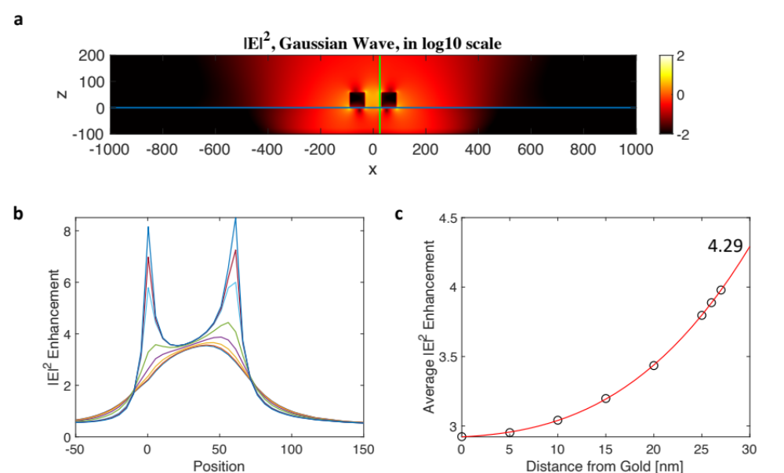
Figure S4. Simulation of the local electric field enhancement of a Gaussian beam polarised along the y-axis by the slot waveguide. (a) Electric field intensity in log10 scale through a cross section of Gaussian illumination beam. (b) Linescans for the positions along the x direction shown in (c). (c) Averaged intensity enhancement for each linescan within the gap region. An extrapolated average surface enhanced intensity of 4.29 is found.

- Ratios of Stokes Scattering from Waveguide Outputs

We can now directly compare the Raman scattering from the ends of the waveguide under the two illumination cases. For direct illumination via the waveguide mode, the ratio of Raman scattered photons from the antennas is

$$\frac{n_{out}}{n_{in}}=\overline{L}{\left[\sinh{\overline{L}}\right]}^{-1}.$$

This equation is used in a direct comparison with experiments in the main text. The only free parameter is the attenuation coefficient of the waveguide, $α_{s}=L_{sp}^{-1}$.

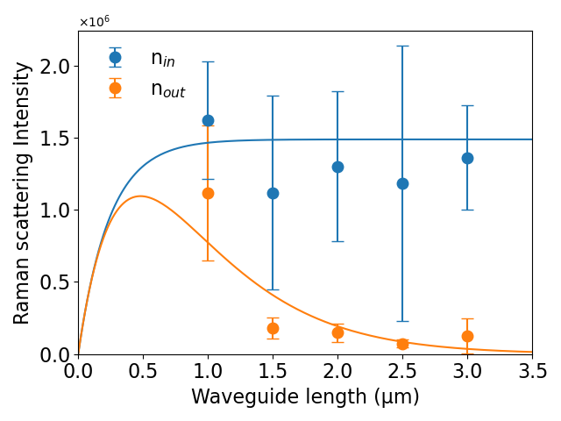
Figure S5. comparing $n_{in}(L)$ and $n_{out}(L)$. (The noisy ones that we did not want to put in the main manuscript.)

When comparing Raman scattered photons by the direct and indirect illumination methods, we must account for the same power, $P_{0}$, of illumination in both cases. For the waveguide mode, the coupled peak intensity in the waveguide is $I_{p0}=η_{in}(λ_{p})n_{g}(λ_{p})P_{0}/A_{wg}(λ_{p})$ where $A_{wg}$ is the mode area and $n_{g}(λ_{p})$ is the group index at the pump wavelength. For the Gaussian beam, the peak intensity is $I_{g0}= 2P_{0}/A_{0}$, where $A_{0}=πρ^{2}$. We thus find the ratio:

$$\left(\frac{n^{(c)}}{n_{in}}\right)=\left(\frac{A_{wg}(λ_{p})}{A_{0}}\right)\frac{4\sqrt{2π}α_{s}ρHe^{α_{s}^{2}ρ^{2}/8-\overline{L}/2}}{η_{in}(λ_{p})n_{g}(λ_{p})\left({1-e}^{-2\overline{L}}\right)}≈\left(\frac{A_{wg}(λ_{p})}{A_{0}}\right)\frac{4\sqrt{2π}α_{s}ρH}{η_{in}(λ_{p})n_{g}(λ_{p})}e^{-\overline{L}/2},$$

where the approximation holds for $L≫α_{s}^{-1}$ and $ρ≪α_{s}^{-1}$. We thus find an expression for the ratio of the Gaussian beam and waveguide mode areas:

$$\left(\frac{A_{0}}{A_{wg}(λ_{p})}\right)=\left(\frac{n_{in}}{n^{(c)}}\right)\frac{4\sqrt{2π}α_{s}ρH}{η_{in}(λ_{p})n_{g}(λ_{p})}e^{-\overline{L}/2}.$$

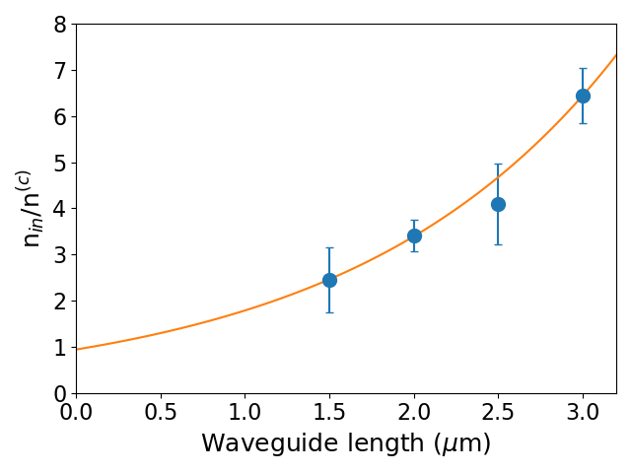
Figure S6. The ratio of antenna and waveguide coupled Raman signals $n_{in}/n^{(c)}$, as expressed in the equation above.

Figure S6 fits the experimental data for the ratio of Raman scattering for the two illumination cases, which is then fit to the equation:
$$\left(\frac{n_{in}}{n^{(c)}}\right)=Ae^{\overline{L}/2}$$

We find A =$0.967±0.009$, and $L_{sp}=0.780±0.004 μ$m .

- Raman Purcell and $β$ Factors

We can also compute the waveguide mode’s contribution to the Purcell factor at the Stoke’s wavelength for the single Raman tensor component sampled (pump and emission polarised perpendicular to the gap) using the formula^{1–3} ,

$$F_{pw}=\frac{g_{RW}}{g_{R}}≈3\frac{n_{g}(λ_{s})}{π}\frac{{\left(λ/2\right)}^{2}}{A_{wg }(λ_{s})},$$

where the value for the group index, $n_{g}(λ_{s})$, and mode area, $A_{wg }(λ_{s})$, must be computed at the Stoke’s wavelength. The total Purcell factor, $F_{p}$ is often approximated by assuming that the coupling to radiation is not modified, so that $F_{p}=1+F_{pw}$.

It is difficult to compute the $β$ factor for any spontaneous radiation process as by definition we must account for all possible channels of radiation and non-radiation. Consider the Raman scattering rate without electromagnetic enhancement, $Γ_{R0}∝g_{R0}$. This rate is a sum over all possible radiation modes, $Γ_{R0}=\sum_{i}{Γ_{R0i}}$. In the waveguide, we assume that the individual radiation mode coupling strengths are not modified and that the waveguide mode coupling strength, $Γ_{Rw}∝g_{RW}$, is the only additional modification to the total rate, such that,

$$Γ_{R}=Γ_{Rw}+\sum_{i}{Γ_{R0i}}.$$

We can thus estimate the Raman Purcell factor,

$$F_{p}≈\frac{Γ_{R}}{Γ_{R0}}=\frac{Γ_{Rw}}{Γ_{R0}}+1.$$

The fraction $β$ of Raman scattering coupling to a given mode is the ratio of the mode’s coupling strength and the total coupling strength. The Raman $β$ factor for the waveguide mode here is thus $β=Γ_{Rw}/Γ_{R}$. Therefore,

$$β=\frac{Γ_{Rw}}{Γ_{R}}=\frac{Γ_{Rw}/Γ_{R0}}{Γ_{R}/Γ_{R0}}≈\frac{F_{pw}}{F_{pw}+1}=\frac{F_{p}-1}{F_{p}}$$

This formula is often quoted in the literature as a simple estimator for the $β$ factor in the case of spontaneous fluorescence.

- Raman Enhancement Factor

Here we compute the Raman enhancement factor of the waveguide SERS system relative to the flat gold interface control sample, as considered experimentally. The peak intensity at the gold film illuminated by a Gaussian beam of radius, $ρ_{f}=0.41λ_{p}/NA$, where $NA=0.95$, is $I_{f0}$. The pump beam intensity on the gold film is influenced by the film’s reflectivity, lowering the peak intensity at the interface by a factor ${\left|1-r\right|}^{2}≈0.16$, where ${\left|r\right|}^{2}$ is the gold film’s reflectivity. Thus, $I_{f0}={2\left|1-r\right|}^{2}P_{0}/A_{f0}$, where $A_{f0}=πρ_{f}^{2}$ is the Gaussian pump beam area on the gold reference film and $P_{0}$ is the incident power. Meanwhile $I_{p0}=η_{in}(λ_{p})n_{g}(λ_{p})P_{0}/A_{wg}(λ_{p})$, as given above. Therefore,

$$\frac{I_{p0}}{I_{f0}}=\frac{η_{in}(λ_{p})n_{g}(λ_{p})}{2{\left|1-r\right|}^{2}}\frac{A_{f0}}{A_{wg}(λ_{p})}.$$

We can determine the total Raman enhancement factor by realising that $F_{pw}={\left|E_{wg}\left(λ_{s}\right)\right|}^{2}/{\left|E_{0}(λ_{s})\right|}^{2}$ and $I_{p0}/I_{f0}={\left|E_{wg}\left(λ_{p}\right)\right|}^{2}/{\left|E_{0}(λ_{p})\right|}^{2}$, where ${\left|E_{wg}\left(λ_{s}\right)\right|}^{2}$ and ${\left|E_{0}(λ)\right|}^{2}$ are the local electric field intensities at the pump and Stoke’s wavelengths. Therefore, the Raman enhancement factor is,

$$F_{R}=F_{pw}\frac{I_{p0}}{I_{f0}}=\frac{{\left|E_{wg}\left(λ_{s}\right)\right|}^{2}}{{\left|E_{0}\left(λ_{s}\right)\right|}^{2}}\frac{{\left|E_{wg}\left(λ_{p}\right)\right|}^{2}}{{\left|E_{0}\left(λ_{p}\right)\right|}^{2}}R_{mol}.$$

Where $R_{mol}≈0.36/0.17=2.12$ is the ratio of the active areas of molecules illuminated in each case. Written out in full, we find,

$$F_{R}=\frac{3}{2π}\frac{η_{in}(λ_{p})}{{\left|1-r\right|}^{2}}n_{g}(λ_{p})n_{g}(λ_{s})\left(\frac{A_{f0}}{A_{wg}(λ_{p})}\right)\left(\frac{{\left(λ/2\right)}^{2}}{A_{wg }(λ_{s})}\right)R_{mol}.$$

Note that this expression functionally resembles that given in Ref⁴ from the main text. In the case of reducing the gap width further, we can now also speculate about the maximum Raman enhancement achievable in this W-SERS system. Figure S7 shows the enhancement factor for this waveguide system as a function of gap width in the range [60,10] nm, which could all be realised in practice. To estimate $R_{mol}$ as a function of gap width, we assumed a proportional reduction in theoretical propagation lengths due to the 4-ATP as for the 60 nm case considered experimentally. This is likely to be an over-estimate here, as 4-ATP dominates the absorption.

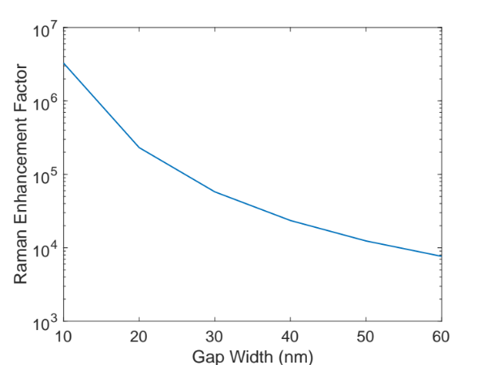
Figure S7. Calculated Raman Enhancement Factor as a function of the Gap Width. As in the main text, the enhancement factor is computed relative to a flat gold film functionalised with 4-ATP.
- Waveguide Mode Calculations

The effective mode area and group index are required to compute waveguide SERS enhancement parameters. These were numerically calculated using Ansys Lumerical finite difference eigenmode (FDE) solver. In the simulations, the cross section of the waveguide was defined by metallic squares of side length 60 nm, positioned at the interface of a silica substrate. To avoid numerical errors due to sharp corners, the corners of the squares were rounded with radius of 5 nm. To avoid the effect of the boundary conditions on the calculated modes, the solver region was set as 600 nm in the x direction and 500 in the y direction. In the solver region, a uniform mesh region with 1 nm scale was applied. Convergence testing was used to verify all simulation settings.

The FDE solver returns the spatial mode profiles and mode properties (effective index and group index) for the fundamental gap plasmon waveguide mode. To calculate the mode area, we used the following definition,

$$A_{mode}\left(r_{0}\right)=\frac{\iint{W\left(r\right).dA}}{1/2ε_{0}{\left|d_{0}.E\left(r_{0}\right)\right|}^{2}}$$

where $d_{0}$ is the dipole orientation and $r_{0}$ is the position. The energy density must be adjusted for the dispersive energy density in the metal. It is thus easier to substitute for the energy velocity,

$$v_{g}=\frac{1/2\iint{R\left\{E×H^{*}\right\}.zdA}}{\iint{W\left(r\right).dA}},$$

And compute the waveguide power flow instead. For this we also use the computed group index, $n_{g}=c/v_{g}$. To compute the waveguide mode area for the Raman scattering in this work, we averaged $A_{mode}\left(l\right)$ over the line of positions 1 nm from the metal surface along one side of the gap region where molecules were functionalised.

$$A_{wg}=\frac{1}{l_{gap}}\int_{l}{A_{mode}\left(l\right)dl}$$

where $l_{gap}=60 nm$ is the length of the line element, $l$. In all simulations the permittivities of gold and silica were adapted from the data of Johnson & Christy⁵ and Palik⁶.

- Waveguide SERS Enhancement Parameters

Table S1 shows Raman enhancement characteristics were extracted from experimental and computational data. This data was computed from the set of parameters shown in Table S2.

Table S1 Calculated waveguide SERS parameters determined experiment and computation.

Parameter | Experimental | Numerical Value
$$\frac{A_{0}}{A_{wg}(λ_{p})}$$ | $$14.94±0.96$$ | 14.68
$$\frac{(λ_{p}^{2}/4)}{A_{wg}(λ_{p})}$$ | $$15.11±0.97$$ | 14.85
$$\frac{I_{p0}}{I_{f0}}$$ | $$84.45±0.87$$ | -
$$F_{p}$$ | - | $$42.55$$
$$β$$ | $$0.993±0.001$$ | $$0.9765$$
$$F_{R}$$ | $$7,504±78$$ | -

Table S2 Experimental and numerical parameters used in the experiment.

Parameter | Experimental Value | Numerical Value
$$λ_{p}$$ | 790 nm | -
$$λ_{s}$$ | 800-920 nm | -
NA (Waveguide) | 1.45 | -
NA (Film) | 0.95 | -
$$η_{in}=η_{out}$$ | $$29.9±1.9\%$$ | $$34.6\%$$
$L_{sp}(λ_{p})$ (No 4-ATP) | $$2.11±0.23 μm$$ | $$1.79 μm$$
$$L_{sp}(λ_{p})$$ | $$0.64±0.08 μm$$ | -
$$L_{sp}(λ_{s})$$ | $$0.780±0.04 μm$$ | -
$$ρ$$ | - | $0.41λ/NA=221$ nm
$$ρ_{f}$$ | - | $0.41λ/NA=340$ nm
$$H$$ | - | 4.29
$$n_{g}(λ_{p})$$ | - | 2.64
$$n_{g}(λ_{R})$$ | - | 2.42
$$(λ_{p}^{2}/4)/A_{wg}(λ_{p})$$ | - | 14.85
$$(λ_{s}^{2}/4)/A_{wg}(λ_{s})$$ | - | 19.02
$$R_{mol}$$ | - | 2.12
References

1. Jun, Y. C., Kekatpure, R. D., White, J. S. & Brongersma, M. L. Nonresonant enhancement of spontaneous emission in metal-dielectric-metal plasmon waveguide structures. Phys. Rev. B 78, 153111 (2008).
2. Genov, D. A., Oulton, R. F., Bartal, G. & Zhang, X. Anomalous spectral scaling of light emission rates in low-dimensional metallic nanostructures. Phys. Rev. B 83, 245312 (2011).
3. Bozhevolnyi, S. I. & Khurgin, J. B. Fundamental limitations in spontaneous emission rate of single-photon sources. Optica 3, 1418–1421 (2016).
4. Eslami, S. & Palomba, S. Integrated enhanced Raman scattering: a review. Nano Converg. 8, 41 (2021).
5. Johnson, P. B. & Christy, R. W. Optical Constants of the Noble Metals. Phys. Rev. B 6, 4370–4379 (1972).
6. Palik, E. D. Handbook of optical constants of solids. Academic Press: Orlando (1985).

The pump propagation distance was computed from the Raman measurements. The fitting to $n_{in}/n^{(c)}$ provided $L_{sp}(λ_{s})$, while the fitting to $n_{in}/n_{out}$ provided the average $〈L_{sp}^{-1}〉=\left(L_{sp}^{-1}(λ_{s})+L_{sp}^{-1}(λ_{p})\right)/2$, from which $L_{sp}^{-1}(λ_{p})$ was computed.

