Chronic lung diseases are associated with gene expression programs favoring SARS-CoV-2 entry and severity

Linh T. Bui^{1†}, Nichelle I. Winters^{2†}, Mei-I Chung¹, Chitra Joseph³, Austin J. Gutierrez¹, Arun C. Habermann², Taylor S. Adams⁴, Jonas C. Schupp⁴, Sergio Poli⁵, Lance M. Peter¹, Chase J. Taylor², Jessica B. Blackburn², Bradley W. Richmond^{2,6}, Andrew G. Nicholson^{7,8}, Doris Rassl⁹, William A. Wallace^{10,11}, Ivan O. Rosas¹², R. Gisli Jenkins³, Naftali Kaminski⁴, Jonathan A. Kropski^{2,6,13 ††}, Nicholas E. Banovich^{1††}* and the Human Cell Atlas Lung Biological Network

Online Data Supplement
HCA Lung Biological Network Members
Supplementary Tables 1-7
Supplementary Figures 1-10
Supplementary references
HCA Lung Biological Network Members

Alexander V. Misharin
Division of Pulmonary and Critical Care Medicine, Northwestern University, Chicago, Illinois
a-misharin@northwestern.edu

Alexander M. Tsankov
Genetics and Genomic Sciences, Icahn School of Medicine at Mount Sinai, New York, NY USA
alexander.tsankov@mssm.edu

Avrum Spira
Department of Medicine, Boston University School of Medicine, Boston, MA, USA; Johnson & Johnson Innovation, Cambridge, MA, USA.
aspira@bu.edu

Pascal Barbry
Université Côte d’Azur, CNRS, IPMC, Sophia-Antipolis, 06560, France
barbry@ipmc.cnrs.fr

Alvis Brazma
European Molecular Biology Laboratory, European Bioinformatics Institute (EMBL-EBI), Wellcome Trust Genome Campus, Hinxton, Cambridge, CB10 1SD, UK
brazma@ebi.ac.uk

Christos Samakovlis
SciLifeLab, Department of Molecular Biosciences, Stockholm University, Stockholm Sweden and Cardiopulmonary Institute, Justus Liebig University; Giessen Germany
christos.samakovlis@scilifelab.se

Douglas P Shepherd
Center for Biological Physics and Department of Physics, Arizona State University, Tempe, AZ USA
douglas.shepherd@asu.edu

Emma L Rawlins
Wellcome Trust/ CRUK Gurdon Institute and Department Physiology, Development and Neuroscience, University of Cambridge
e.rawlins@gurdon.cam.ac.uk

Fabian J Theis
Institute of Computational Biology, Helmholtz Zentrum München and Departments of Mathematics and Life Sciences, Technical University Munich, Germany
fabian.theis@helmholtz-muenchen.de

Jennifer Griffonnet
Nice University-Affiliated Hospital : Pneumology department, Nice, 06002 France
griffonnet.j@chu-nice.fr

Haeock Lee
Department of Biomedicine and Health Sciences, The Catholic University of Korea, Seoul, Korea
haeocklee@gmail.com

Herbert B Schiller
Comprehensive Pneumology Center (CPC) / Institute of Lung Biology and Disease (ILBD), Helmholtz Zentrum München, Member of the German Center for Lung Research (DZL), Munich, Germany
herbert.schiller@helmholtz-muenchen.de

Paul Hofman
Laboratory of Clinical and Experimental Pathology, Pasteur Hospital, University Côte d'Azur, Nice, France / Hospital‐Related Biobank, Pasteur Hospital, University Côte d'Azur, Nice, France / FHU OncoAge, Pasteur Hospital, BP69, 06001 Nice cedex 01, France
hofman.p@chu-nice.fr

Joseph E Powell
Garvan-Weizmann Centre for Cellular Genomics, Garvan Institute of Medical Research, Sydney, NSW, Australia; UNSW Cellular Genomics Futures Institute, University of New South Wales, Sydney, NSW, Australia
j.powell@garvan.org.au

Joachim L Schultze
Department for Genomics & Immunoregulation, LIMES-Institute, University of Bonn, 53115 Bonn, Germany
PRECISE Platform for Single Cell Genomics & Epigenomics, Germany Center for Neurodegenerative Diseases and University of Bonn, Bonn, Germany
j.schultze@uni-bonn.de

Jeffrey Whitsett
Cincinnati Children’s Hospital Medical Center, Cincinnati, Ohio, USA
jeffrey.whitsett@cchmc.org

Jiyeon Choi
Division of Cancer Epidemiology and Genetics, National Cancer Institute, Bethesda, MD, 20892, USA.
jiyeon.choi2@nih.gov

Joakim Lundeberg
SciLifeLab, Department of Gene Technology, KTH Royal Institute of Technology
joakim.lundeberg@scilifelab.se

Jonathan A Kropski
Division of Allergy, Pulmonary and Critical Care Medicine, Department of Medicine, Vanderbilt University Medical Center, Nashville, TN; Department of Veterans Affairs Medical Center, Nashville, TN; Department of Cell and Developmental Biology, Vanderbilt University, Nashville, TN
jon.kropski@vumc.org

Jose Ordovas-Montanes
Broad Institute of MIT and Harvard, Cambridge, MA 02142, USA; Program in Immunology, Harvard Medical School, Boston, MA 02115, USA; Division of Gastroenterology, Hepatology, and Nutrition, Boston Children's Hospital, Boston, MA 02115, USA; Harvard Stem Cell Institute, Cambridge, MA 02138, USA.
jordovas@mit.edu

Jayaraj Rajagopal
Harvard Stem Cell Institute, Cambridge, Massachusetts; Center for Regenerative Medicine, Massachusetts General Hospital, Boston, Massachusetts, USA.
jrajagopal@mgh.harvard.edu

Kerstin B Meyer
Cellular Genetics Programme, Wellcome Sanger Institute, Wellcome Genome Campus, Hinxton, Cambridge CB10 1SA, United Kingdom.
km16@sanger.ac.uk

Mark A Krasnow
Department of Biochemistry and Wall Center for Pulmonary Vascular Disease, Stanford University, Stanford, CA 94305, USA.
krasnow@stanford.edu

Kourosh Saeb‐Parsy
Department of Surgery, University of Cambridge and NIHR Cambridge Biomedical Research Centre, UK
ks10014@cam.ac.uk

Kun Zhang
UCSD Department of Bioengineering, 9500 Gilman Drive, MC0412, PFBH402, La Jolla, CA 92093, USA.
kzhang@bioeng.ucsd.edu

Robert Lafyatis
Division of Rheumatology, Department of Medicine, University of Pittsburgh Medical Center, Pittsburgh, PA, USA.
lafyatis@pitt.edu

Sylvie Leroy
Université Côte d'Azur, CHU de Nice, FHU OncoAge, Department of Pulmonary Medicine and Allergology, Nice, France ; CNRS UMR 7275 - Institut de Pharmacologie Moléculaire et Cellulaire, Sophia Antipolis, France
leroy.s2@chu-nice.fr

Muzlifah Haniffa
Wellcome Sanger Institute, Wellcome Genome Campus, Hinxton, Cambridge CB10 1SA, UK; Biosciences Institute, Faculty of Medical Sciences, Newcastle University, Newcastle upon Tyne NE2 4HH, UK; Department of Dermatology and NIHR Newcastle Biomedical Research Centre, Newcastle Hospitals NHS Foundation Trust, Newcastle upon Tyne NE2 4LP, UK.
m.a.haniffa@ncl.ac.uk

Muzlifah Haniffa
Institute of Cellular Medicine, Newcastle University, Newcastle upon Tyne, U.K.
Department of Dermatology and Newcastle NIHR Biomedical Research Centre, Royal Victoria Infirmary, The Newcastle upon Tyne Hospitals NHS Foundation Trust, Newcastle upon Tyne, U.K.
m.a.haniffa@newcastle.ac.uk

Martijn C Nawijn
Department of Pathology and Medical Biology, University of Groningen, GRIAC Research Institute, University Medical Center Groningen, the Netherlands
m.c.nawijn@umcg.nl

Marko Z Nikolić
UCL Respiratory, Division of Medicine, University College London, London, UK
m.nikolic@ucl.ac.uk

Maarten van den Berge
Department of Pulmonary Diseases, University Medical Center Groningen, and Groningen Research Institute for Asthma and COPD, University of Groningen, NL-9700-RB Groningen, Netherlands
m.van.den.berge@umcg.nl

Malte Kuhnemund
Cartana AB, Nobels vag 16, 17165 Stockholm, Sweden
malte@cartana.se

Charles-Hugo Marquette
Team 4, IRCAN, FHU OncoAge, University Côte d'Azur, CNRS, INSERM, 06107 Nice CEDEX 02, France. marquette.c@chu-nice.fr.
Department of Pneumology and Oncology, CHU Nice, FHU OncoAge, University Côte d'Azur, 06100 Nice, France. marquette.c@chu-nice.fr.
marquette.c@chu-nice.fr

Michael Von Papen
Comma Soft AG, Bonn, Germany
michael.von.papen@comma-soft.com

Naftali Kaminski
Pulmonary, Critical Care and Sleep Medicine, Yale University School of Medicine
naftali.kaminski@yale.edu

Nicholas E. Banovich
Translational Genomics Research Institute
nbanovich@tgen.org

Oliver Eickelberg
oliver.eickelberg@ucdenver.edu

Orit Rosenblatt-Rosen
Klarman Cell Observatory, Broad Institute of MIT and Harvard, Cambridge, MA 02142, USA
orit@broadinstitute.org

Paul A Reyfman
Northwestern University Feinberg School of Medicine, Division of Pulmonary and Critical Care Medicine
paul.reyfman@northwestern.edu

Dana Pe’er
Computational and Systems Biology Program, Sloan Kettering Institute, Memorial Sloan Kettering Cancer Center, New York, New York, USA
peerster@gmail.com

Peter Horvath
Biological Research Centre of the Hungarian Academy of Sciences, Temesvári krt. 62., 6726 Szeged Hungary.
Institute for Molecular Medicine Finland (FIMM), University of Helsinki, Tukholmankatu.
peter.horvath@fimm.fi

Purushothama Rao Tata
Department of Cell Biology, Regeneration Next Initiative, Duke University School of Medicine, Durham, NC, USA, 27710
purushothamarao.tata@duke.edu

Aviv Regev
Broad Institute of MIT and Harvard, Cambridge, MA 02142
Howard Hughes Medical Institute
Department of Biology, MIT, Cambridge, MA 02140
Genentech, 1 DNA Way, South San Francisco, CA 94080
regev.aviv.5@gmail.com (aregev@broadinstitute.org)

Mauricio Rojas
Division of Pulmonary, Allergy and Critical Care Medicine, University of Pittsburgh
rojasm@upmc.edu

Max A Seibold
Department of Pediatrics; Center for Genes, Environment, and Health; National Jewish Health; Denver, CO 80206
seiboldm@njhealth.org

Alex K Shalek
Ragon Institute of MGH, MIT, and Harvard, Cambridge, MA, USA; Institute for Medical Engineering and Science (IMES), Koch Institute for Integrative Cancer Research, and Department of Chemistry, Massachusetts Institute of Technology, Cambridge, MA, USA; Broad Institute of MIT and Harvard, Cambridge, MA, USA
shalek@mit.edu

Jason R Spence
Department of Internal Medicine, Gastroenterology, University of Michigan Medical School, Ann Arbor, MI 48109, USA; Department of Cell and Developmental Biology, University of Michigan Medical School, Ann Arbor, MI 48109, USA; Department of Biomedical Engineering, University of Michigan College of Engineering, Ann Arbor, MI 48109, USA.
spencejr@umich.edu

Sarah A Teichmann
Cellular Genetics Programme, Wellcome Sanger Institute, Wellcome Genome Campus, Hinxton, Cambridge CB10 1SA, United Kingdom.
Dept Physics/Cavendish Laboratory, University of Cambridge, JJ Thompson Ave, Cambridge CB3 0EH, United Kingdom.
st9@sanger.ac.uk

Stephen Quake
Chan Zuckerberg Biohub
steve@czbiohub.org

Thu Elizabeth Duong
Department of Pediatrics, Respiratory Medicine, University of California, San Diego, USA
taduong@ucsd.edu

Tommaso Biancalani
Broad Institute of MIT and Harvard, Cambridge, MA 02142
tbiancal@broadinstitute.org

Tushar Desai
Department of Medicine and Institute for Stem Cell Biology and Regenerative Medicine, Stanford University School of Medicine, Stanford, CA 94116
tdesai@stanford.edu

Xin Sun
Department of Pediatrics, University of California, San Diego, San Diego, CA 92093, USA.
Laboratory of Genetics, University of Wisconsin–Madison, Madison, WI 53706, USA.
xinsun@ucsd.edu

Laure Emmanuelle Zaragosi
Université Côte d’Azur, CNRS, IPMC, Sophia-Antipolis, 06560, France
zaragosi@ipmc.cnrs.fr

SUPPLEMENTARY TABLES

Supplementary Table 1: Number of samples used in the study

Dataset | Control | COPD | IPF | Other ILD
Northwestern | 9 | 0 | 4 | 4
Pittsburg | 9 | 0 | 8 | 0
VUMC/TGen | 22 | 7 | 25 | 15
Yale/BWH | 38 | 24 | 45 | 0
Total | 78 | 31 | 82 | 19

Supplementary Table 2: Demographics of lung donors used for scRNA-seq

 | Control | COPD | IPF | Other-ILD
 | n=78 | n=31 | n=82 | n=19
Age | 44.23 [17-80] | 62 [55-73] | 64.87 [43-78] | 54.95 [37-70]
Ever_smoke | 29 (37.2%) | 28 (90.3%) | 52 (63.4%) | 8 (42%)
Gender (Male) | 44 (56.4%) | 19 (61.3%) | 59 (71.9%) | 10 (52.6%)
Ethnicity
European | 54 (69.2%) | 31 (100%) | 60 (73.2%) | 12 (63.2%)
African | 8 (10.2%) | - | 3 (3.7%) | 3 (15.8%)
Hispanic | 1 (1.3%) | - | 4 (4.9%) | -
Asian | 2 (2.6%) | - | 1 (1.2%) | -
Other/Unknown | 13 (16.7%) | - | 14 (17%) | 4 (21%)

Supplementary Table 3: Total number of each cell type per diagnosis group
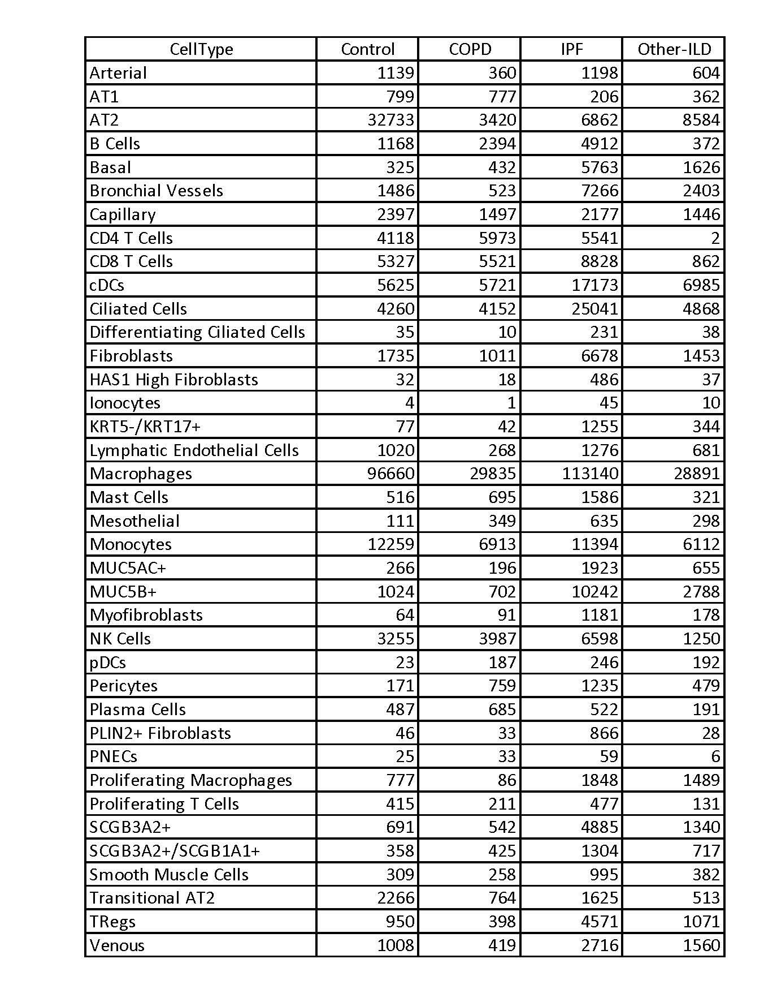

Supplementary Table 4: Count data matrix for unpublished data containing all genes being used in the manuscript (.csv file)
Supplementary Table 5: Excel sheets for all Tukey_HSD statistical tests (Excel file)
Supplementary Table 6: Differential expression analysis for genes used in Figure 2 and Figure 3 (Zip file)
Supplementary Table 7: Spearman correlation coefficient analysis for ACE2 in AT2 cells (Excel file)

SUPPLEMENTARY FIGURES

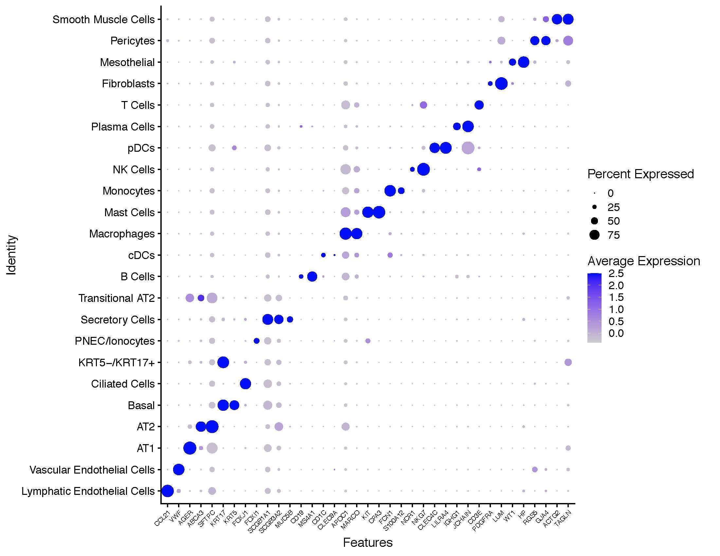
Supplementary Fig 1: Dotplot shows markers used for cell type annotation

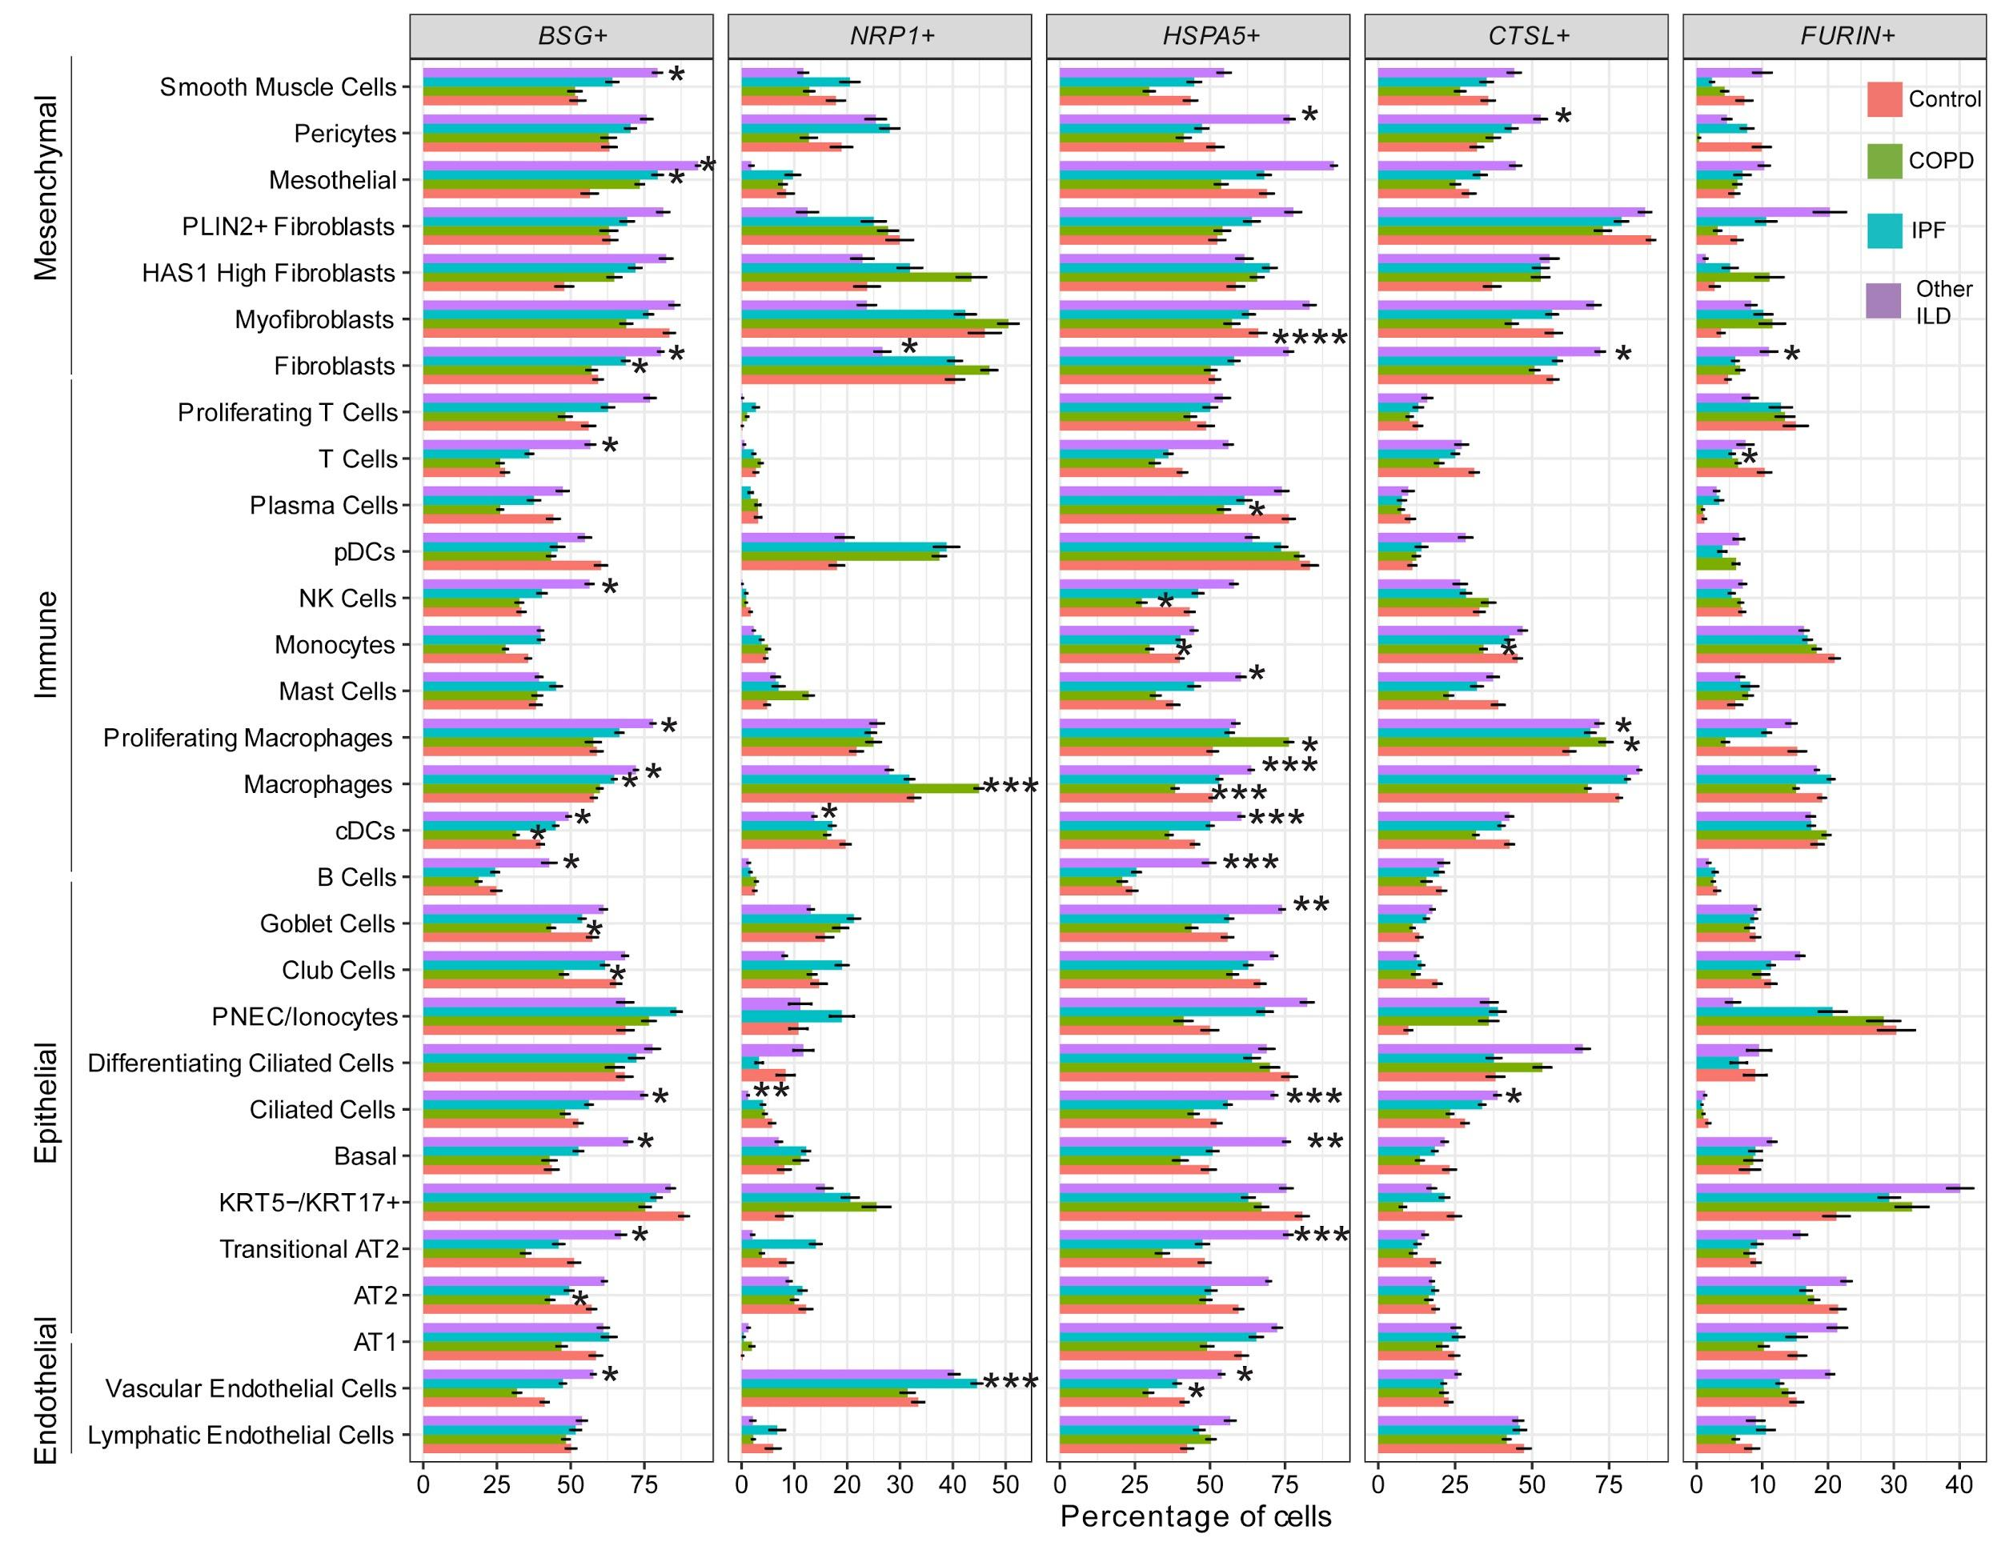
Supplementary Fig 2: Percentage of single positive cells for BSG (CD147), NRP1, HSPA5 (GRP78), CTSL and FURIN in different chronic lung disease groups per cell type. Tukey_HSD post-hoc statistical test showed significant differences between each diagnosis subgroup and control samples, p-value < 0.05: *, p-value < 0.01: **, p-value < 0.001: ***, p-value < 0.0001: ****
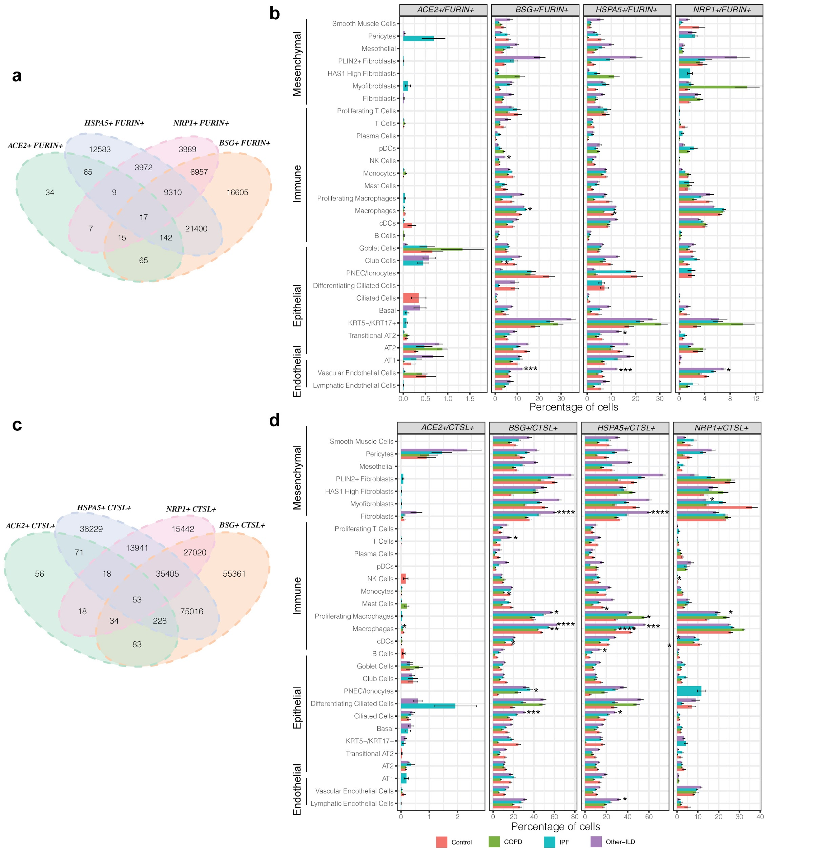
Supplementary Fig 3: Percentage of double positive cells: (a-b) ACE2+ FURIN+, BSG+ FURIN+, HSPA5+ FURIN+, NRP1+ FURIN+ and (c-d) ACE2+ CTSL+, BSG+ CTSL+, HSPA5+ CTSL+, NRP1+ CTSL+ in different chronic lung disease groups per cell type. Tukey_HSD post-hoc statistical test, p-value < 0.05: *, p-value < 0.01: **, p-value < 0.001: ***, p-value < 0.0001: ****
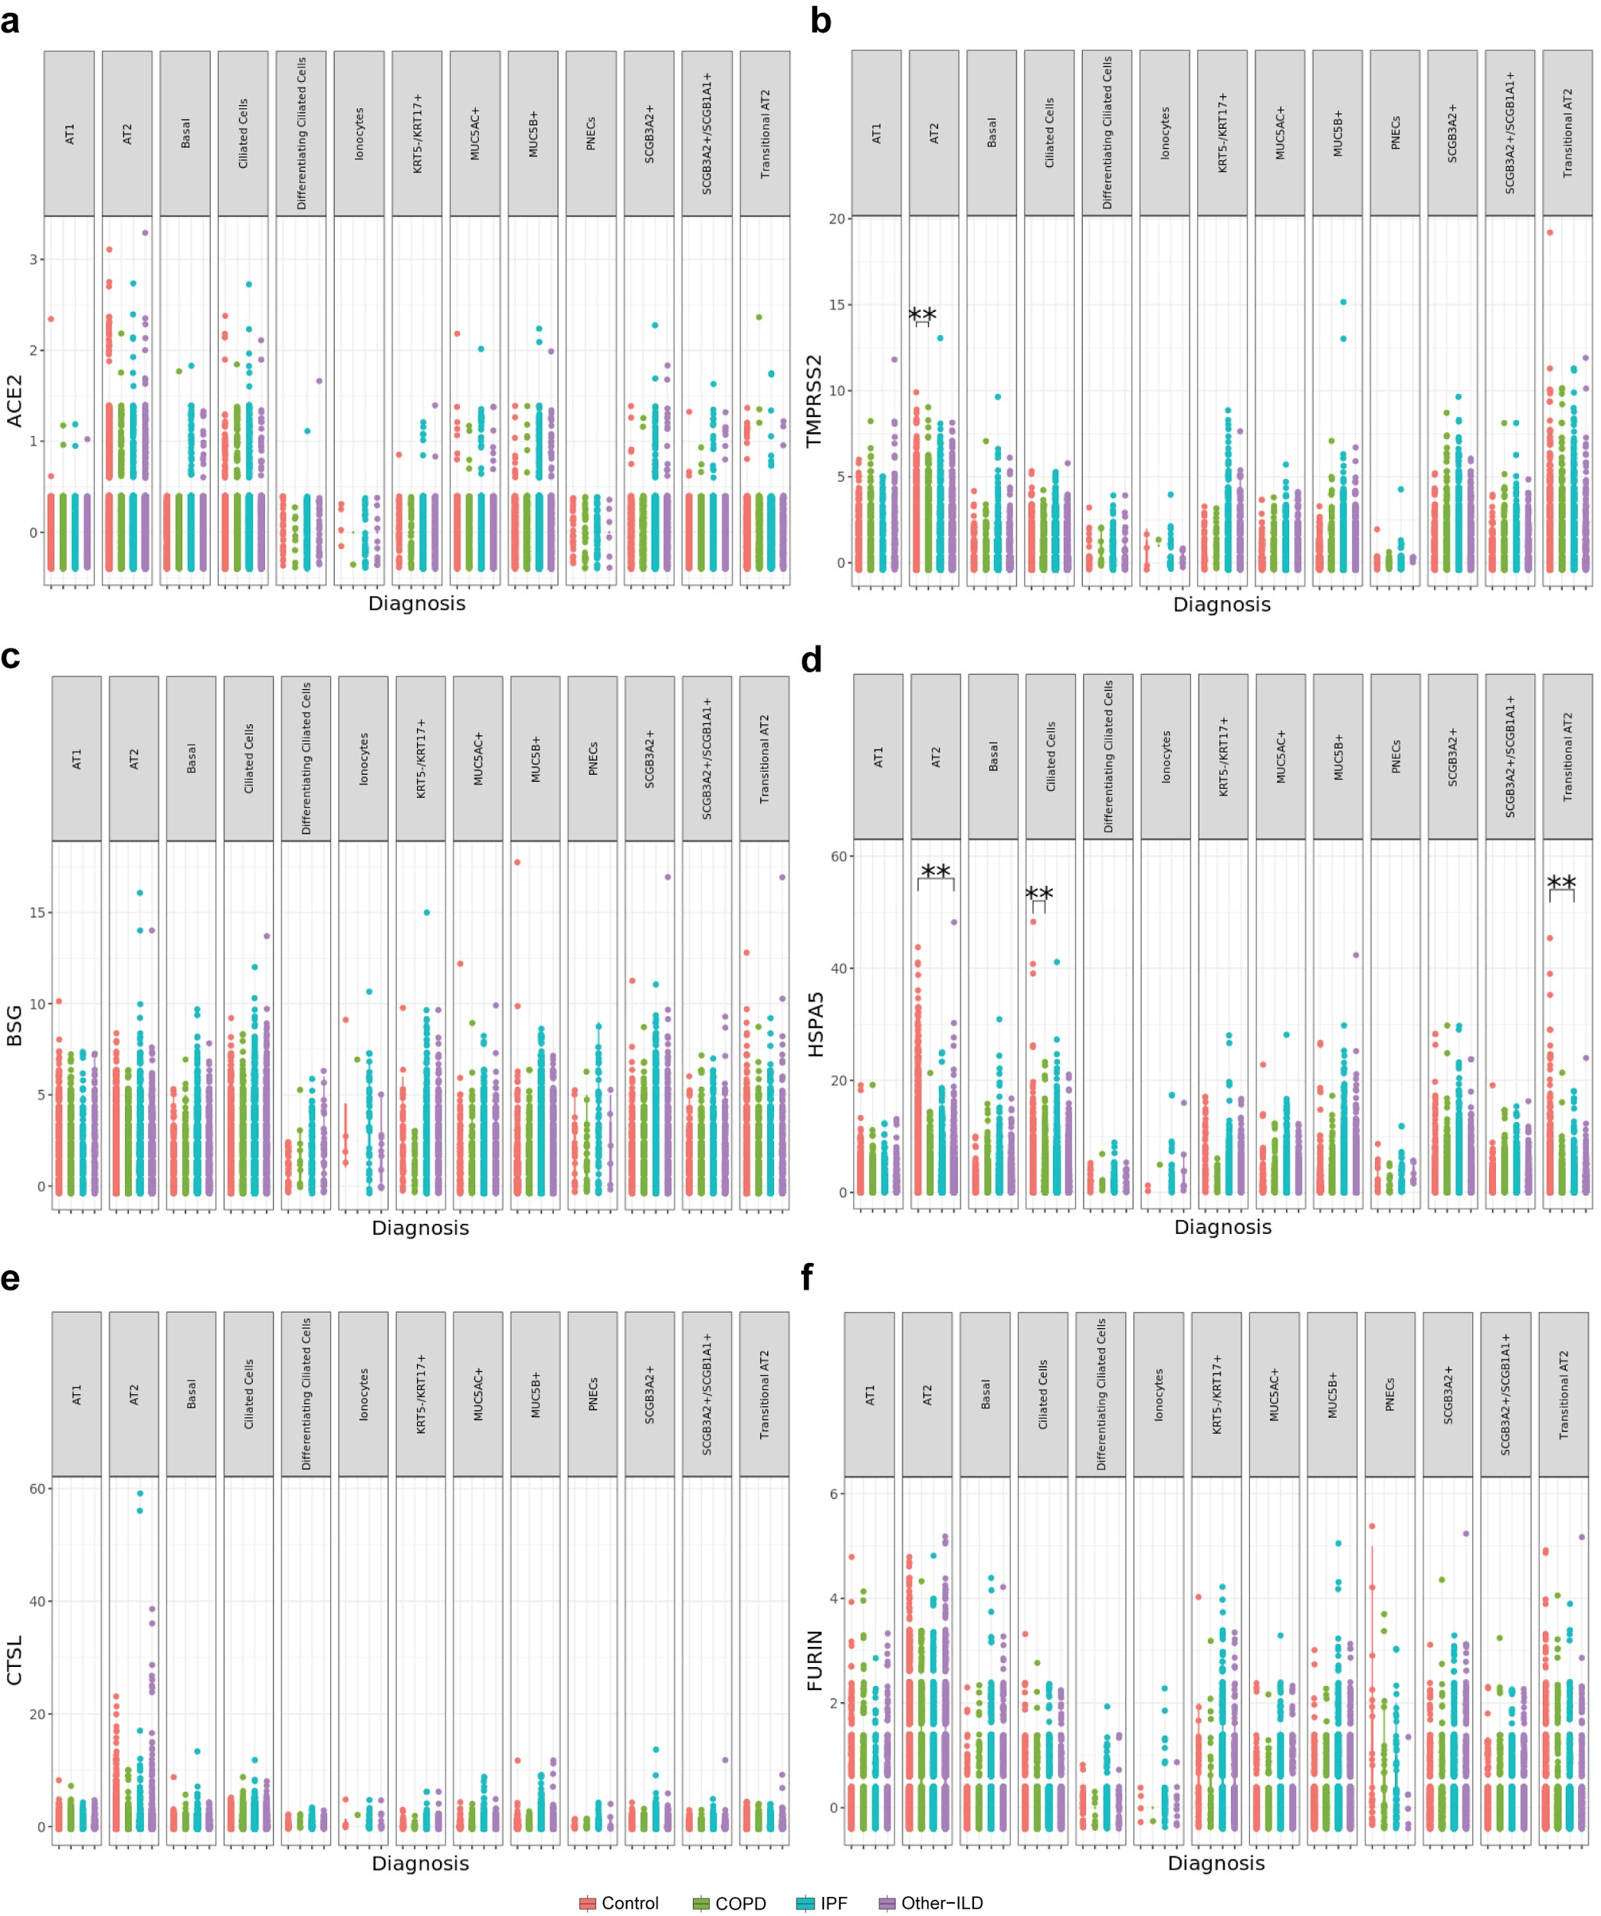
Supplementary Fig 4: Gene expression analysis for SARS-CoV-2 entry mediators in the epithelial cell population. (a) ACE2. (b) TMPRSS2. (c) BSG (CD147). (d) HSPA5 (GRP78). (e) CTSL. (f) FURIN. **: Bonferroni adjusted p_value < 0.05 (Negative binomial test, corrected for Age, Ethnicity, Smoking_status and Dataset)

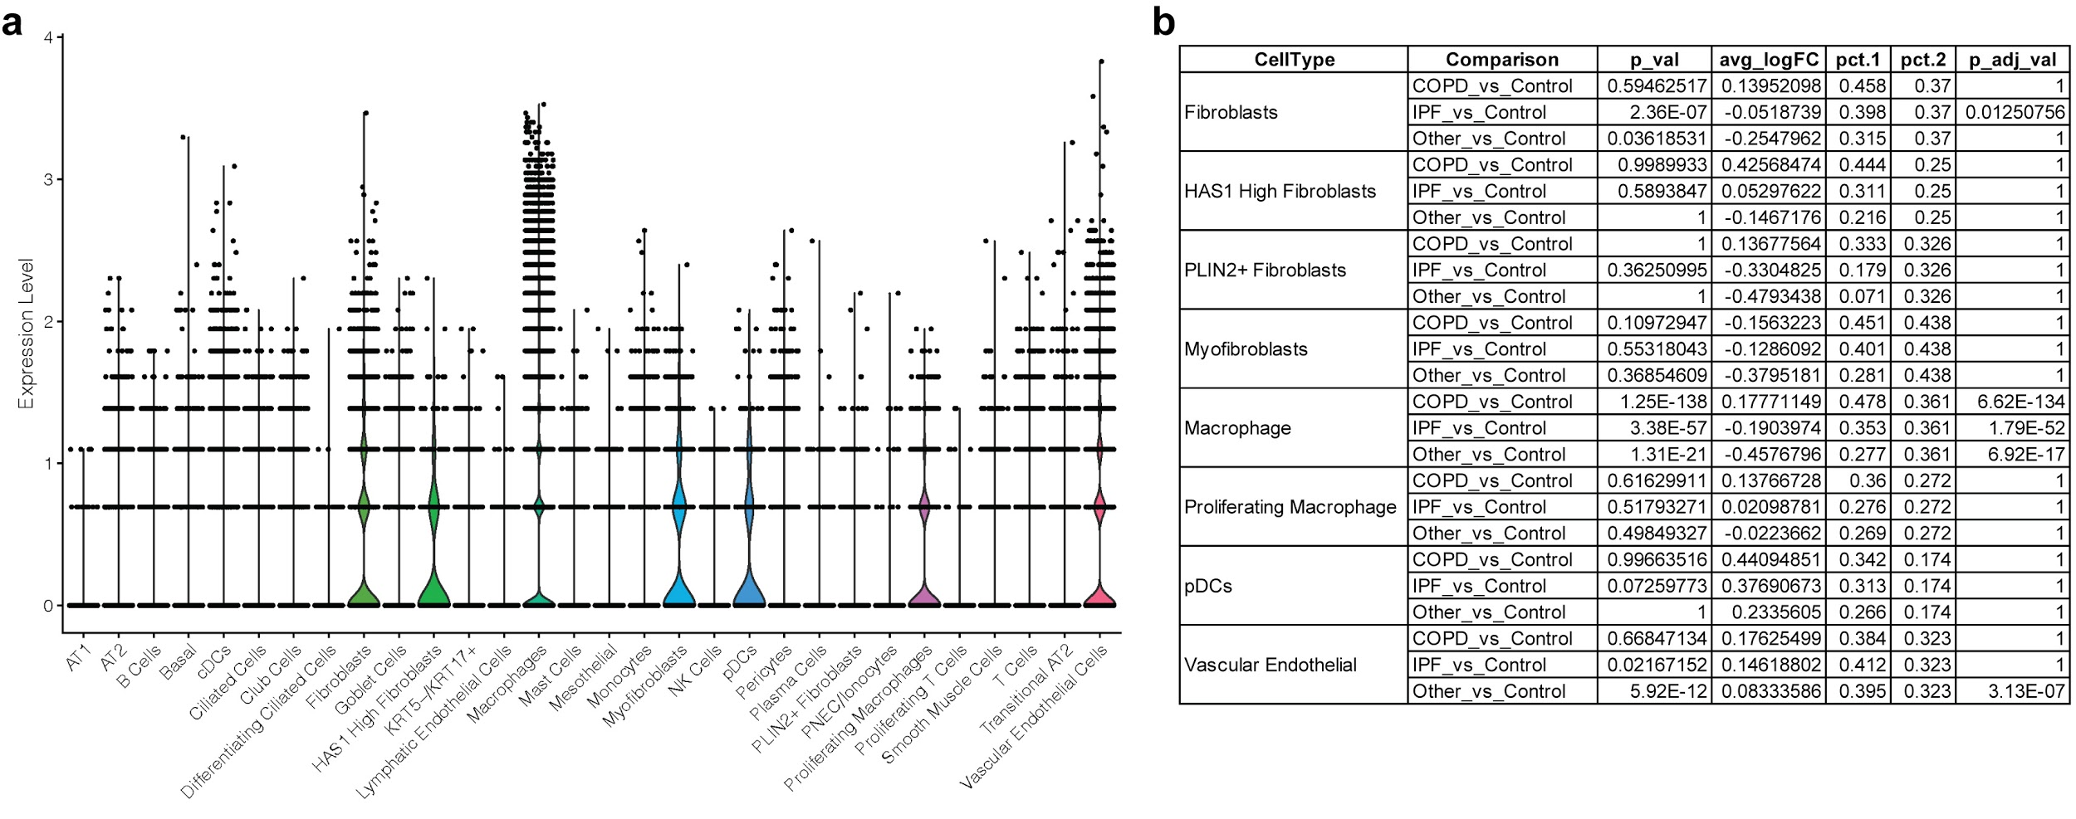

Supplementary Fig 5: Expression of the putative SARS-CoV-2 receptor, NRP1, in the data set. (a) Violin plot shows high expression of NRP1 in some cell types. (b) Differential expression analysis of NRP1 in different disease groups vs. control samples for the cell types having high NRP1 expression in (a). The differential expression analysis was performed using the Seurat FindMarkers function and p_adj_val was Bonferroni adjusted (as described in the Methods section).

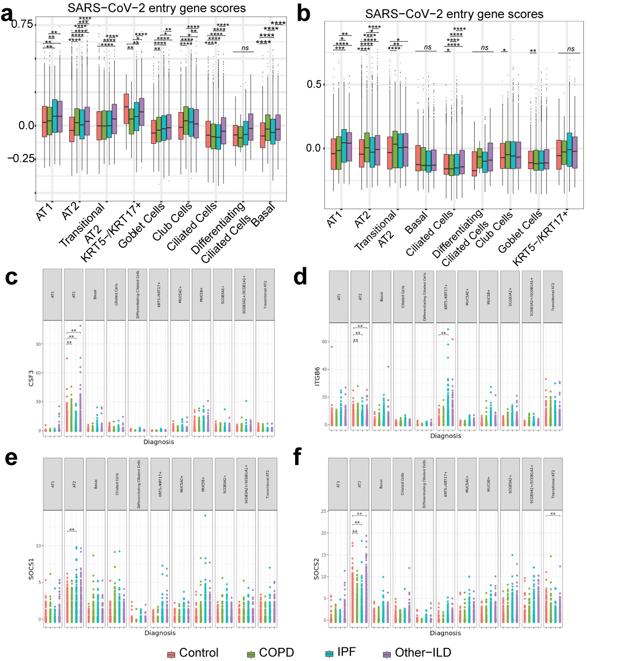
Supplementary Fig 6: SARS-Cov-2 entry genes scores with all outliers included. (a) Gene set 1 (ACE2, BSG, HSPA5, TMPRSS2, CTSL, FURIN, ADAM17). (b) Gene set 2 (ACE2, TMPRSS2, CTSL, FURIN, ADAM17). (c-f) differential expression of Covid-19 response genes in all epithelial cells, a full plot of Fig 2d. In (a) and (b): Tukey_HSD post-hoc statistical test, p-value < 0.05: *, p-value < 0.01: **, p-value < 0.001: ***, p-value < 0.0001: ****. In (c), (d), (e), (f): **: Bonferroni adjusted p_value < 0.05 (negative binomial test, corrected for Age, Ethnicity, Smoking_status and Dataset)

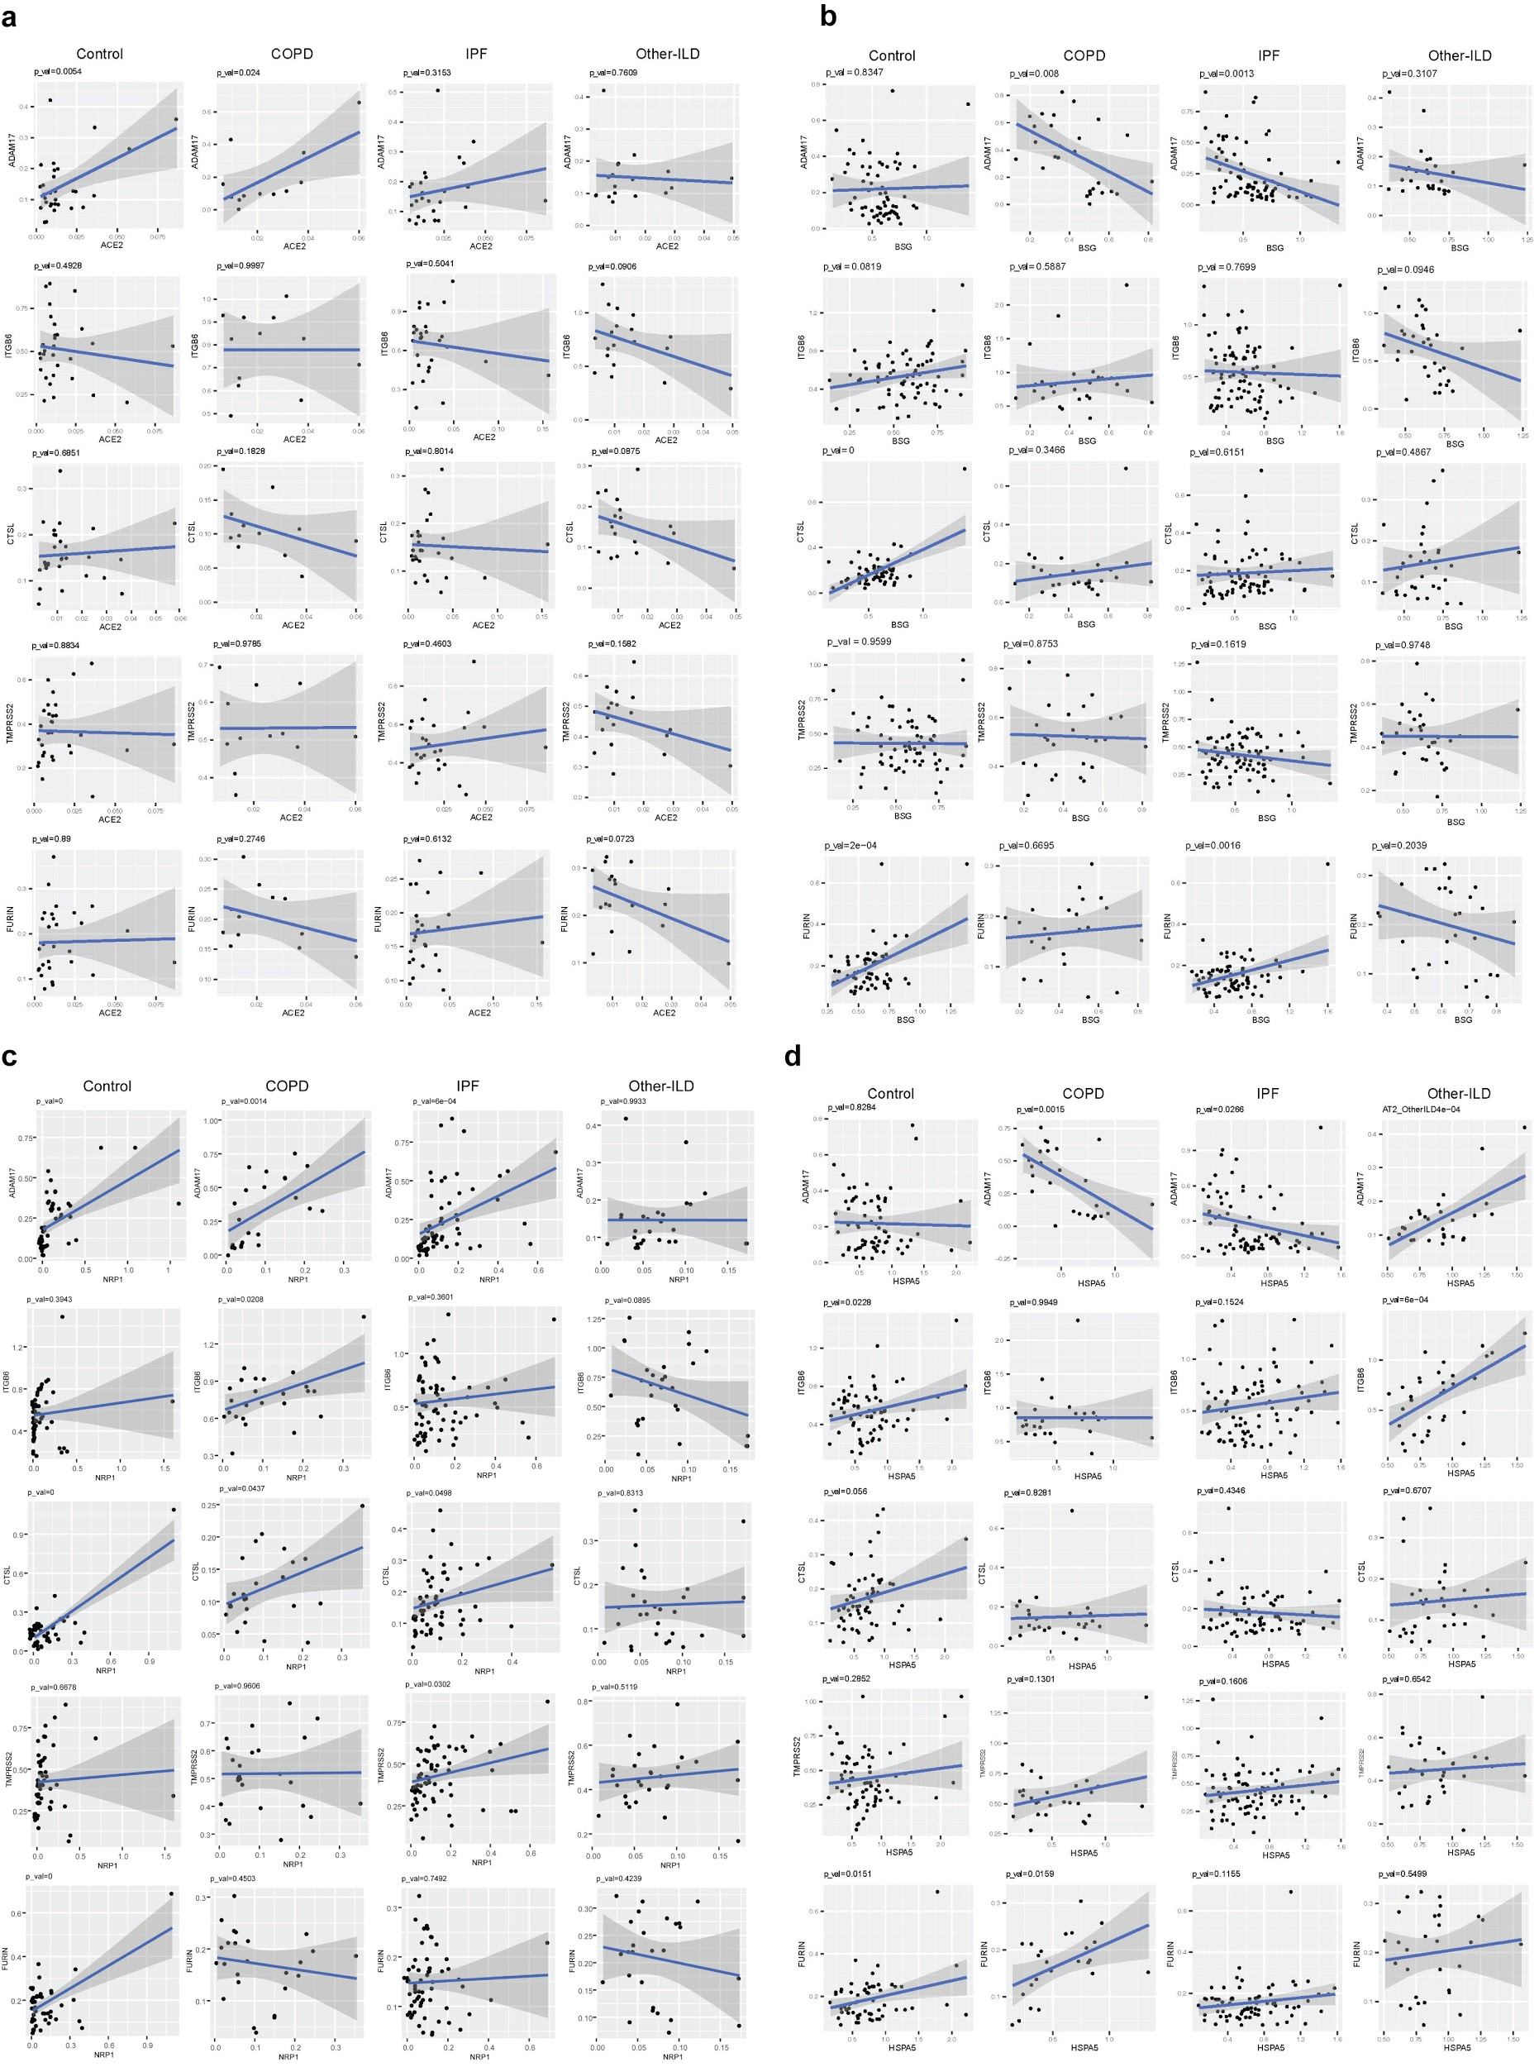
Supplementary Fig 7: Gene expression correlation between SARS-CoV-2 mediators and proteases in the AT2 cell types. (a) Gene correlation with ACE2. (b) Gene correlation with BSG (CD147). (c) Gene correlation with NRP1. (d) Gene correlation with HSPA5 (GRP78)

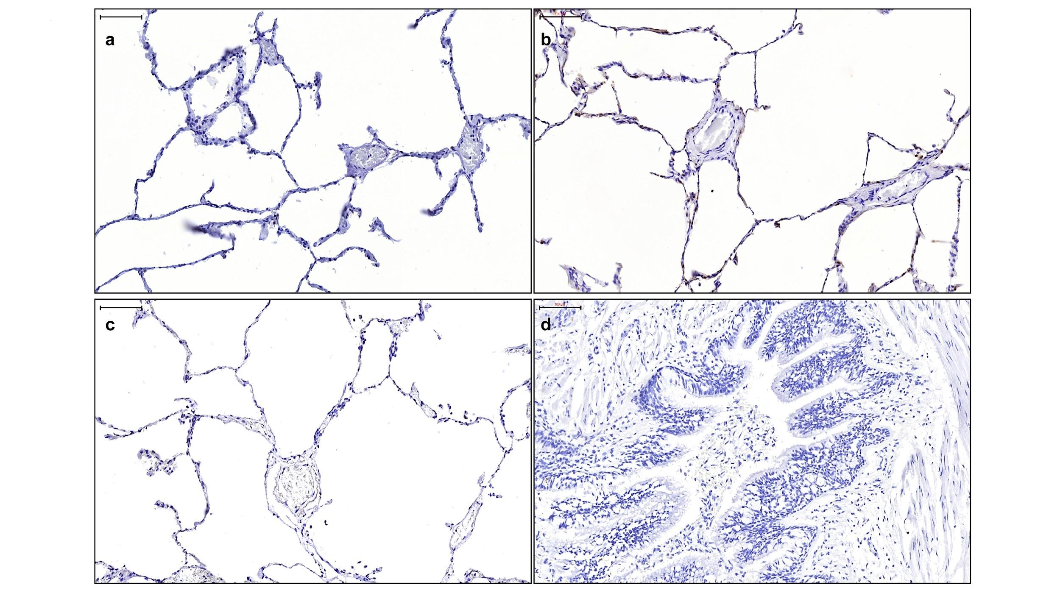

Supplementary Fig 8: Representative sections of control lung sections are shown with each immunomarker. (a) ACE2 staining of the alveolar parenchyma. (b) αvβ6 staining in the alveolar parenchyma. (c-d) Secondary antibody controls for control and IPF section; Scale bars=100 µm.

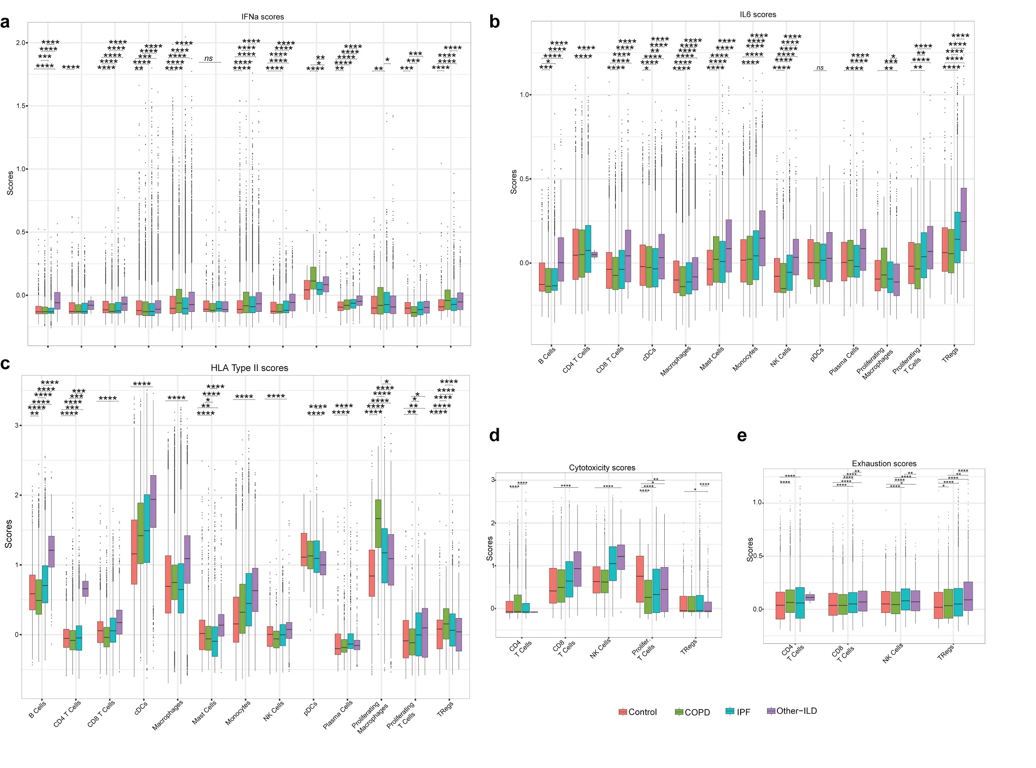
Supplementary Fig 9: Differences in average expression of IFNa (a), IL6 (b) and HLA type II (c) genes in the immune population in different disease groups. (d-e) Cytotoxic scores and exhaustion scores in the T cell population in different disease groups. (b), (d), (e) are the same plots as in Fig. 3d-f, but included outliers. Tukey_HSD post-hoc statistical test, p-value < 0.05: *, p-value < 0.01: **, p-value < 0.001: ***, p-value < 0.0001: ****

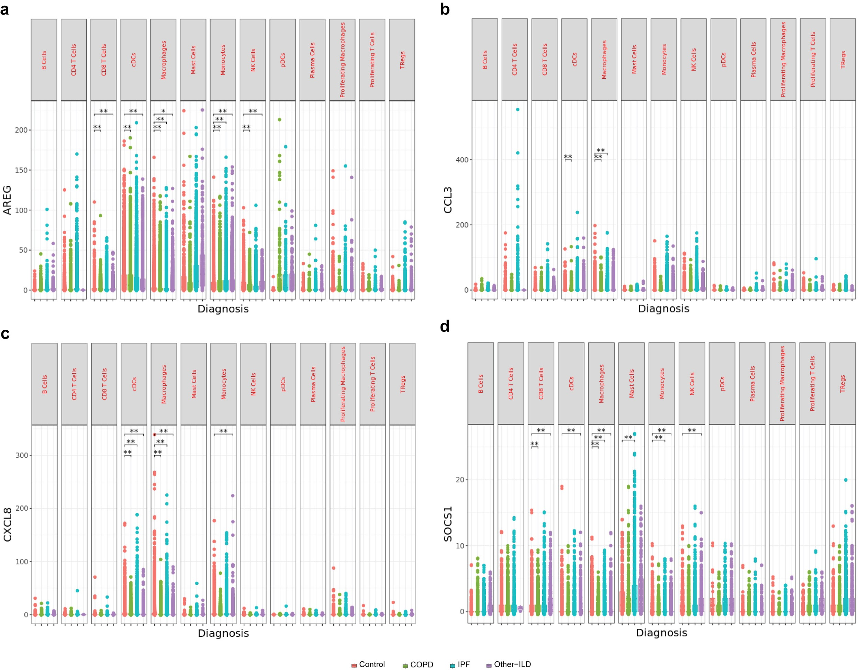

Supplementary Fig 10: Gene expression differences of SARS-CoV-2 immune response genes. (a) AREG. (b) CCL3. (c) CXCL8. (d) SOCS1 in all immune cells. *: p_adjusted_value < 0.1, **: p_adjusted_value < 0.05, p_adjusted_value was Bonferroni adjusted from Seurat FindMarkers differential expression analysis using a negative binomial test and corrected for Age, Ethnicity, Smoking_status and Dataset.

