Supplementary materials for
Effects of Air Pollutants on Mortality of Chronic Kidney Disease Patients with Green Spaces Exposure: A Large Observational Study
Jiyun Jungª, Yong Chul Kim^{b}, Hyewon Lee^{c,d}, Sung Joon Shin^{e,f}, Yon Su Kim^{b,} ^{g}, Sejoong Kim^{h} Jung Pyo Lee^{g,i}, Jae Yoon Park^{e,f*}, Ho Kim^{j*}

Table S1. The annual average concentration of air pollutants in low and high NDVI groups, classified by NDVI percentile criteria

NDVI |  |  | Percentile |  |  |  |  |  |  | Continuous
 |  |  | 50 % |  | 75 % |  | 90 % |  |  | 0.3 |  | 0.35 |  | 0.4
250m buffer |  |  | Low | High | Low | High | Low | High |  | Low | High | Low | High | Low | High
 | PM_{2.5} |  | 26.3 | 25.6 | 26 | 25.7 | 25.9 | 25.7 |  | 26.2 | 25.6 | 26 | 25.6 | 25.9 | 25.7
 | PM₁₀ |  | 58.2 | 53.4 | 56.7 | 53.4 | 56.1 | 53.4 |  | 57.8 | 53.4 | 56.9 | 53.3 | 56.3 | 53.6
 | SO₂ |  | 5.6 | 5.5 | 5.6 | 5.5 | 5.5 | 5.5 |  | 5.6 | 5.5 | 5.6 | 5.5 | 5.6 | 5.5
 | NO₂ |  | 36.1 | 34.4 | 35.6 | 34.1 | 35.4 | 34 |  | 36 | 34.3 | 35.7 | 34.2 | 35.5 | 34.2
 | CO |  | 0.7 | 0.6 | 0.6 | 0.6 | 0.6 | 0.6 |  | 0.7 | 0.6 | 0.7 | 0.6 | 0.6 | 0.6
 | O₃ |  | 50.7 | 54.1 | 51.9 | 54.1 | 52.3 | 53.9 |  | 51 | 54.2 | 51.7 | 54.2 | 52.1 | 54.1
1250m buffer
 | PM_{2.5} |  | 26.3 | 25.6 | 26 | 25.6 | 25.9 | 25.6 |  | 26.3 | 25.6 | 26.1 | 25.6 | 26 | 25.6
 | PM₁₀ |  | 58.5 | 53.2 | 56.7 | 53.2 | 56.1 | 53 |  | 59.1 | 53.3 | 57.3 | 53.2 | 56.5 | 53.2
 | SO₂ |  | 5.6 | 5.5 | 5.6 | 5.5 | 5.6 | 5.5 |  | 5.6 | 5.5 | 5.6 | 5.5 | 5.6 | 5.5
 | NO₂ |  | 36.3 | 34.2 | 35.7 | 33.9 | 35.4 | 33.8 |  | 36.4 | 34.3 | 35.9 | 34 | 35.6 | 33.9
 | CO |  | 0.7 | 0.6 | 0.6 | 0.6 | 0.6 | 0.6 |  | 0.7 | 0.6 | 0.7 | 0.6 | 0.6 | 0.6
 | O₃ |  | 50.4 | 54.4 | 51.9 | 54.2 | 52.3 | 54.2 |  | 49.8 | 54.4 | 51.4 | 54.4 | 52 | 54.2

Table S2. Hazard ratio of mortality and 95 % confidence interval associated with air pollutants in low and high NDVI spaces, classified by percentile
 |  |  | 50% |  | 75% |  | 90%
 |  | IQR | low | high | low | high | low | high
250m
 | NDVI |  | 0.28 |  | 0.36 |  | 0.46
 | PM_{2.5} | 3.8 | 1.09 (0.89,1.33) | 1.00 (0.82,1.23) | 1.06 (0.90,1.24) | 1.00 (0.74,1.34) | 1.06 (0.91,1.22) | 1.13 (0.68,1.88)
 | PM₁₀ | 14.8 | 1.17 (0.98,1.39) | 0.91 (0.70,1.17) | 1.15 (0.98,1.34) | 0.80 (0.56,1.16) | 1.13 (0.97,1.31) | 0.60 (0.32,1.12)
 | NO₂ | 5.8 | 1.06 (0.94,1.20) | 1.13 (0.98,1.30) | 1.12 (1.01,1.24)* | 1.01 (0.82,1.24) | 1.12 (1.01,1.23)* | 0.98 (0.71,1.36)
 | SO₂ | 1.6 | 1.17 (1.04,1.31)* | 1.00 (0.88,1.15) | 1.14 (1.03,1.25)* | 0.93 (0.76,1.14) | 1.09 (1.00,1.20)* | 1.06 (0.75,1.50)
 | CO | 0.1 | 1.08 (0.98,1.20) | 1.03 (0.91,1.16) | 1.08 (0.99,1.17) | 1.03 (0.86,1.23) | 1.09 (1.01,1.19)* | 0.84 (0.60,1.17)
 | O₃ | 11.8 | 1.17 (0.99,1.38) | 0.98 (0.84,1.16) | 1.09 (0.96,1.25) | 1.00 (0.79,1.26) | 1.11 (0.98,1.25) | 0.75 (0.51,1.09)
1250m
 | NDVI |  | 0.31 |  | 0.38 |  | 0.47
 | PM_{2.5} | 3.8 | 1.08 (0.88,1.32) | 0.97 (0.79,1.19) | 1.06 (0.90,1.25) | 1.00 (0.74,1.35) | 1.05 (0.90,1.22) | 1.21 (0.73,2.00)
 | PM₁₀ | 14.8 | 1.07 (0.89,1.29) | 1.08 (0.82,1.42) | 1.12 (0.96,1.32) | 0.88 (0.58,1.32) | 1.10 (0.95,1.28) | 0.68 (0.35,1.35)
 | NO₂ | 5.8 | 1.12 (1.00,1.27)* | 1.05 (0.91,1.21) | 1.08 (0.97,1.20) | 1.13 (0.92,1.40) | 1.11 (1.00,1.22)* | 0.94 (0.66,1.36)
 | SO₂ | 1.6 | 1.24 (1.10,1.38)* | 0.87 (0.75,1.00) | 1.12 (1.01,1.23)* | 1.00 (0.81,1.23) | 1.10 (1.01,1.21)* | 1.08 (0.74,1.58)
 | CO | 0.1 | 1.06 (0.97,1.17) | 1.03 (0.90,1.17) | 1.08 (0.99,1.17) | 0.98 (0.81,1.19) | 1.09 (1.01,1.18)* | 0.77 (0.53,1.11)
 | O₃ | 11.8 | 1.20 (1.01,1.41)* | 0.93 (0.79,1.10) | 1.15 (1.01,1.32)* | 0.92 (0.73,1.16) | 1.12 (1.00,1.27)* | 0.74 (0.50,1.09)
*p-value<0.05

Table S3. Hazard ratio of mortality and 95 % confidence interval associated with air pollutants in low and high NDVI spaces, classified by continuous value
 |  |  | 0.3 |  | 0.35 |  | 0.4
 |  | IQR | low | high | low | high | low | high
250m
 | PM_{2.5} | 3.8 | 1.10 (0.89,1.37) | 1.01 (0.83,1.22) | 1.06 (0.89,1.26) | 1.00 (0.78,1.28) | 1.06 (0.91,1.25) | 1.02 (0.74,1.40)
 | PM₁₀ | 14.8 | 1.18 (0.99,1.39) | 0.90 (0.69,1.18) | 1.18 (1.00,1.38)* | 0.78 (0.55,1.09) | 1.15 (0.98,1.34) | 0.79 (0.52,1.18)
 | NO₂ | 5.8 | 1.08 (0.96,1.22) | 1.11 (0.96,1.29) | 1.13 (1.01,1.25)* | 1.00 (0.82,1.20) | 1.13 (1.02,1.25)* | 0.90 (0.70,1.15)
 | SO₂ | 1.6 | 1.13 (1.01,1.26)* | 1.06 (0.92,1.22) | 1.15 (1.04,1.27)* | 0.96 (0.80,1.16) | 1.11 (1.01,1.23)* | 0.95 (0.75,1.21)
 | CO | 0.1 | 1.09 (0.98,1.20) | 1.01 (0.88,1.15) | 1.08 (0.99,1.18) | 1.01 (0.86,1.20) | 1.08 (0.99,1.18) | 1.04 (0.84,1.28)
 | O₃ | 11.8 | 1.15 (0.98,1.35) | 1.01 (0.85,1.20) | 1.06 (0.92,1.22) | 1.11 (0.89,1.37) | 1.12 (0.99,1.27) | 0.86 (0.66,1.12)
1250m
 | PM_{2.5} | 3.8 | 0.92 (0.71,1.19) | 1.05 (0.88,1.24) | 1.10 (0.91,1.33) | 0.93 (0.75,1.16) | 1.07 (0.90,1.26) | 1.03 (0.76,1.38)
 | PM₁₀ | 14.8 | 1.10 (0.90,1.33) | 1.07 (0.83,1.37) | 1.13 (0.95,1.34) | 0.90 (0.64,1.26) | 1.13 (0.96,1.32) | 0.79 (0.51,1.23)
 | NO₂ | 5.8 | 1.13 (0.99,1.29) | 1.05 (0.92,1.20) | 1.11 (0.99,1.24) | 1.07 (0.90,1.27) | 1.09 (0.98,1.21) | 1.10 (0.88,1.38)
 | SO₂ | 1.6 | 1.25 (1.11,1.41)* | 0.92 (0.81,1.05) | 1.14 (1.02,1.26)* | 0.96 (0.81,1.14) | 1.11 (1.01,1.22)* | 1.02 (0.81,1.29)
 | CO | 0.1 | 1.09 (0.99,1.21) | 1.02 (0.90,1.15) | 1.07 (0.98,1.17) | 1.02 (0.87,1.19) | 1.09 (1.00,1.18)* | 0.89 (0.72,1.10)
 | O₃ | 11.8 | 1.20 (1.00,1.43)* | 0.96 (0.82,1.11) | 1.13 (0.98,1.31) | 0.94 (0.78,1.15) | 1.16 (1.01,1.32)* | 0.88 (0.69,1.13)
*p-value<0.05

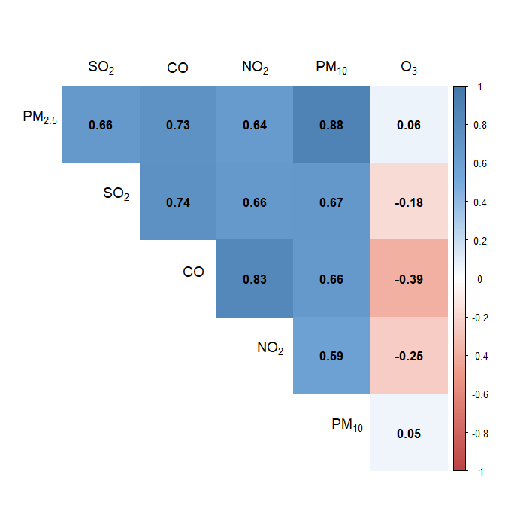
Figure S1. Correlation among air pollutants

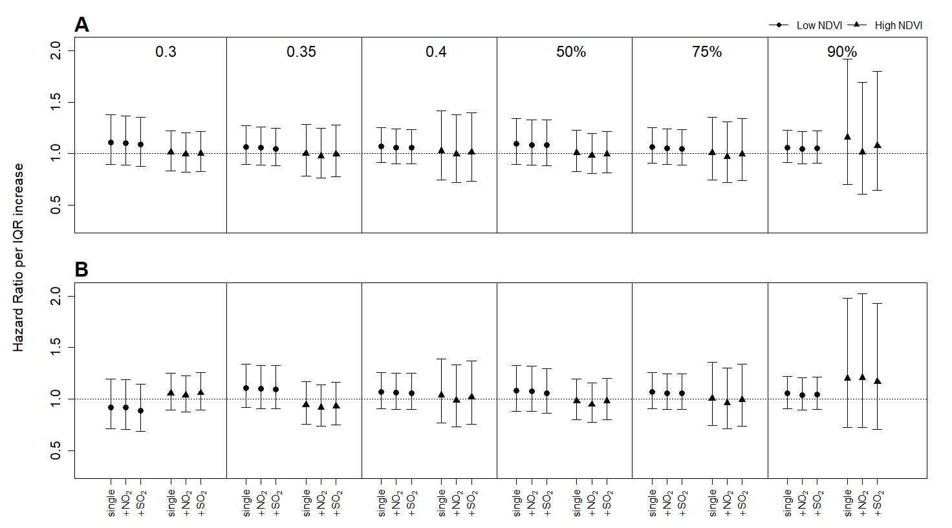
Figure S2. Hazard ratios and 95 % confidence interval associated with IQR increase of PM_{2.5} in various low and high NDVI areas around 250 m (A) and 1250 m (B) radii in single- and co-pollutant models
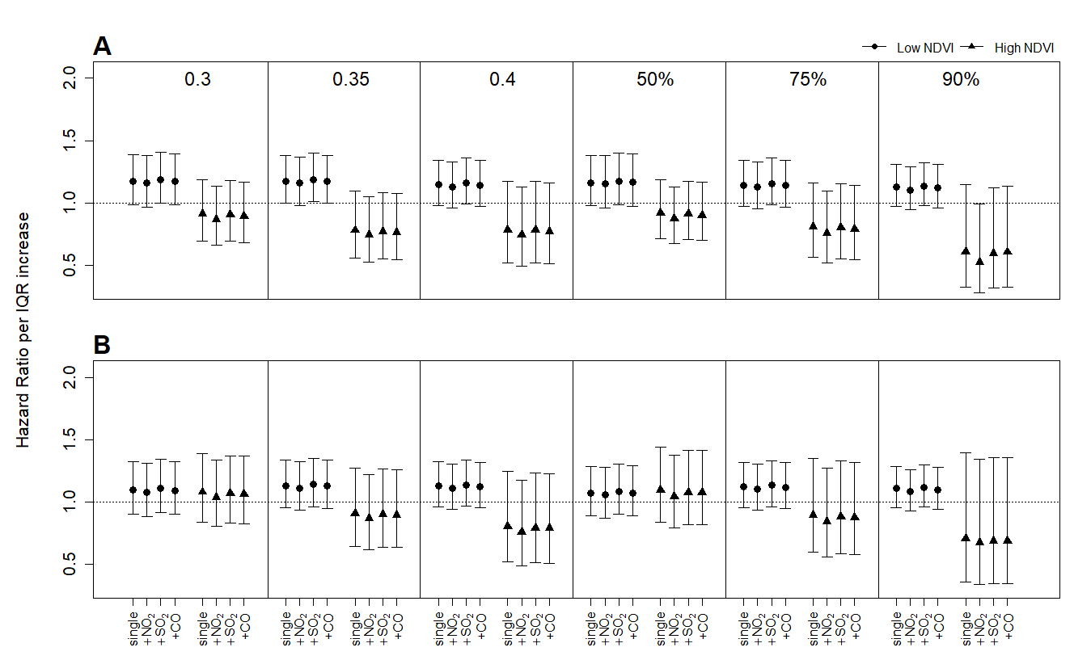

Figure S3. Hazard ratios and 95 % confidence interval associated with IQR increase of PM₁₀ in various low and high NDVI areas around 250 m (A) and 1250 m (B) radii in single- and co-pollutant models
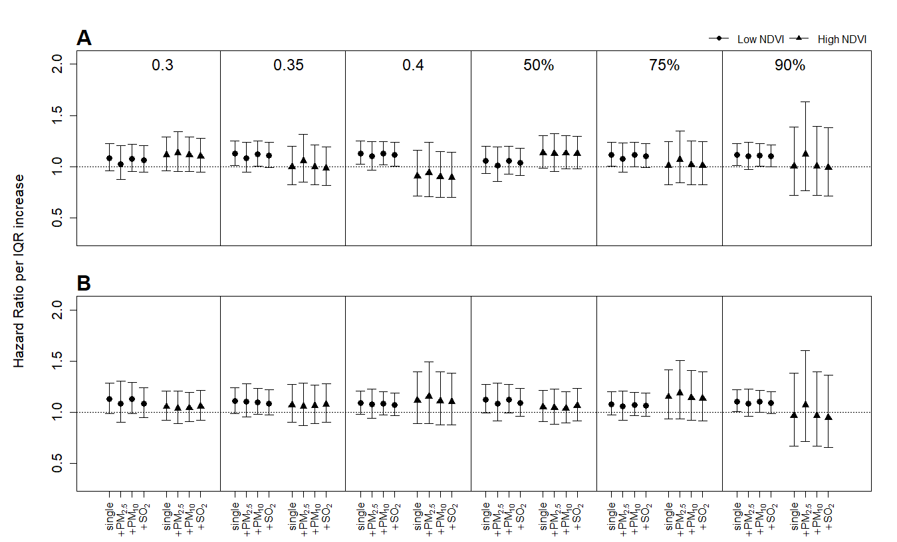
Figure S4. Hazard ratios and 95 % confidence interval associated with IQR increase of NO₂ in various low and high NDVI areas around 250 m (A) and 1250 m (B) radii in single- and co-pollutant models
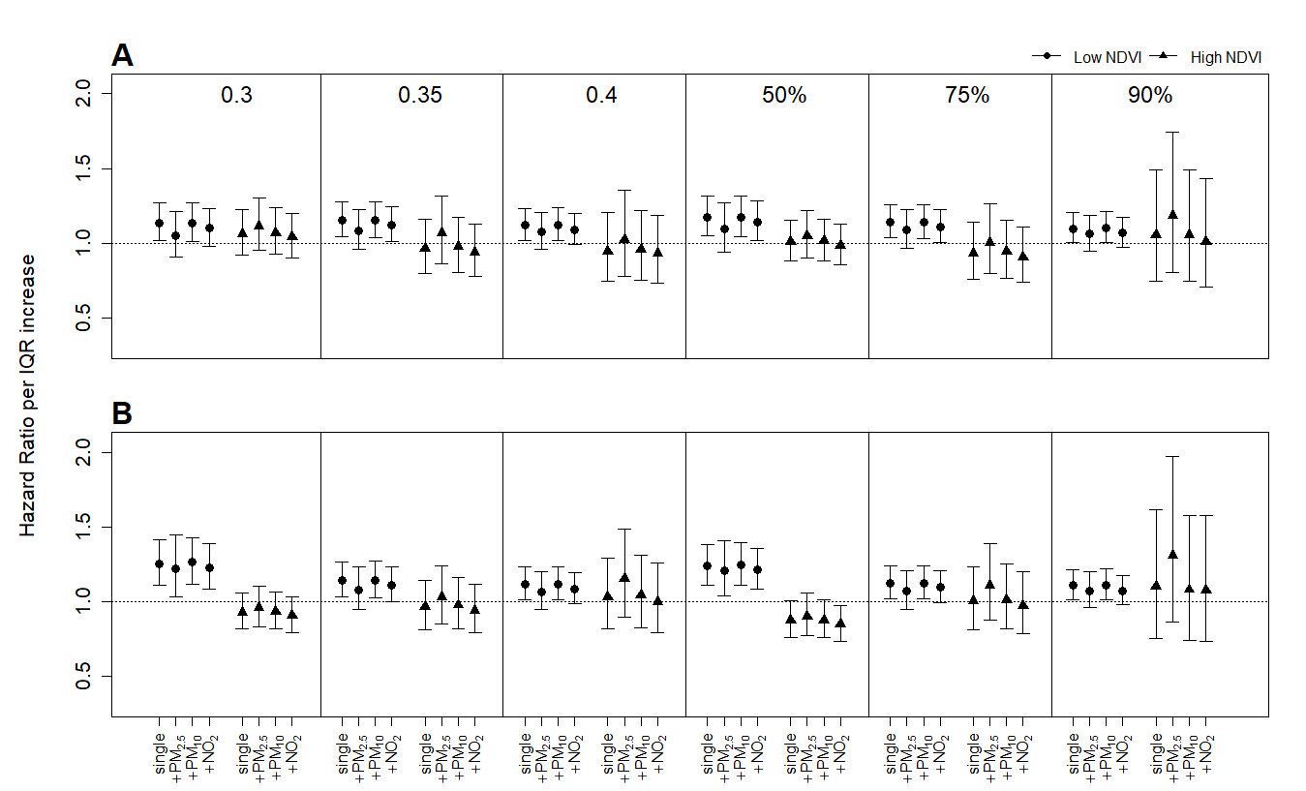

Figure S5. Hazard ratios and 95 % confidence interval associated with IQR increase of SO₂ in various low and high NDVI areas around 250 m (A) and 1250 m (B) radii in single- and co-pollutant models
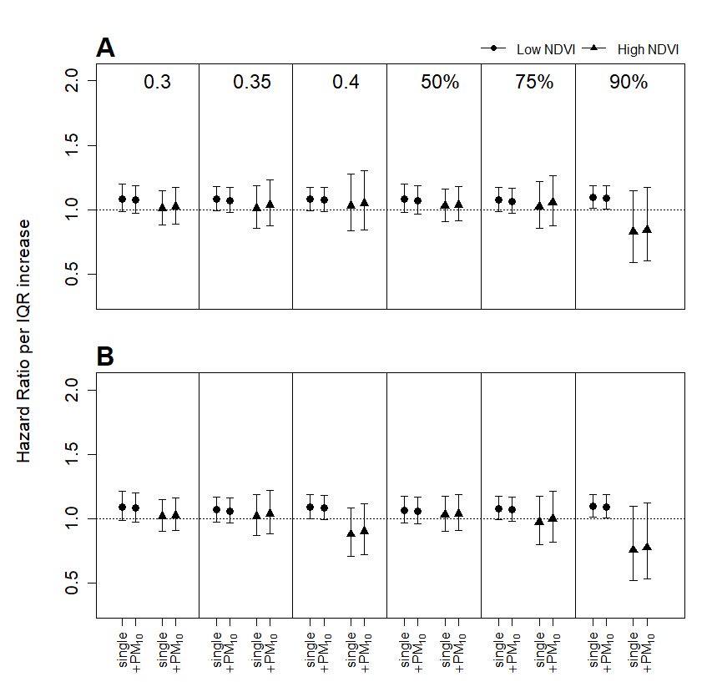
Figure S6. Hazard ratios and 95 % confidence interval associated with IQR increase of CO in various low and high NDVI areas around 250 m (A) and 1250 m (B) radii in single- and co-pollutant models
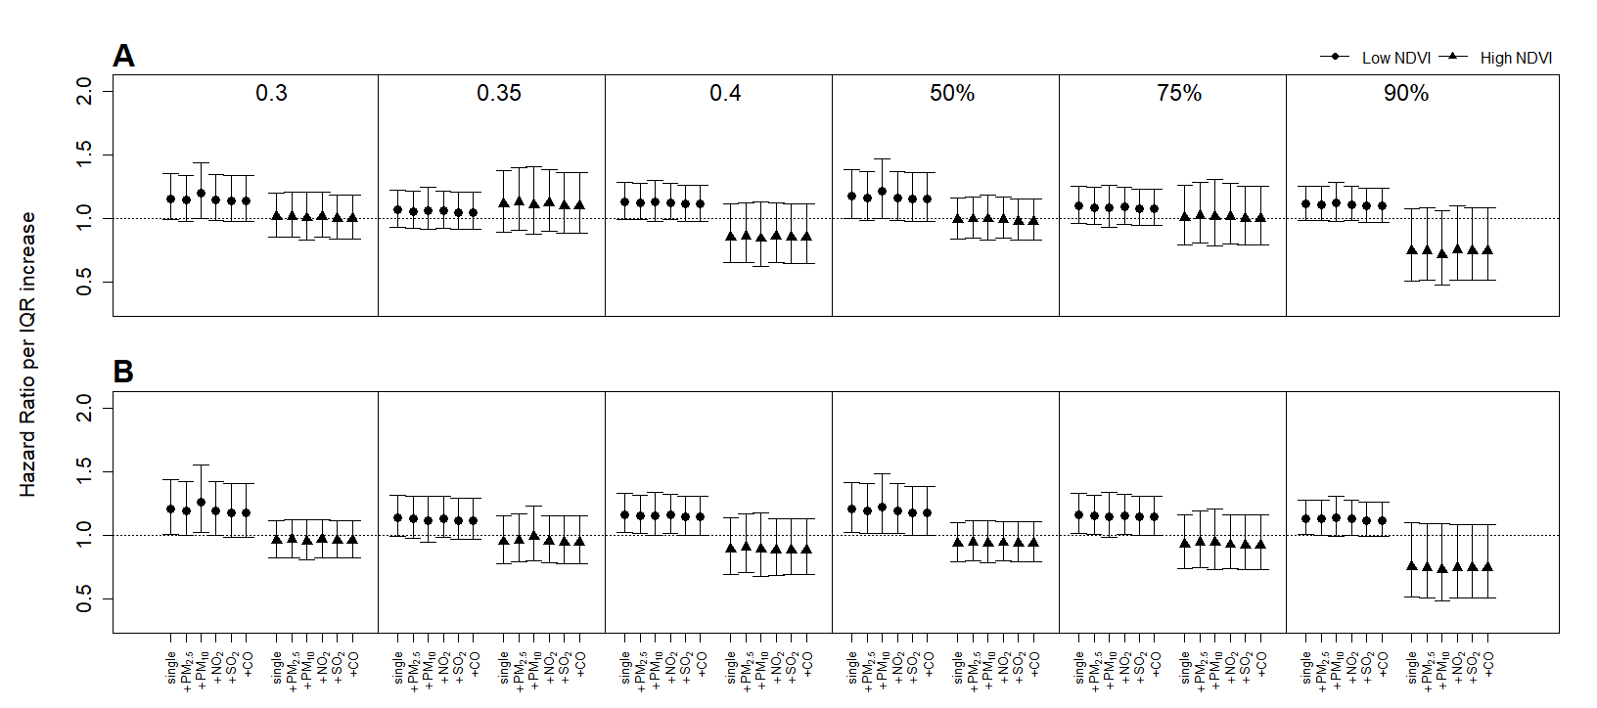

Figure S7. Hazard ratios and 95 % confidence interval associated with IQR increase of O₃ in various low and high NDVI areas around 250 m (A) and 1250 m (B) radii in single- and co-pollutant models

