Supplementary Data

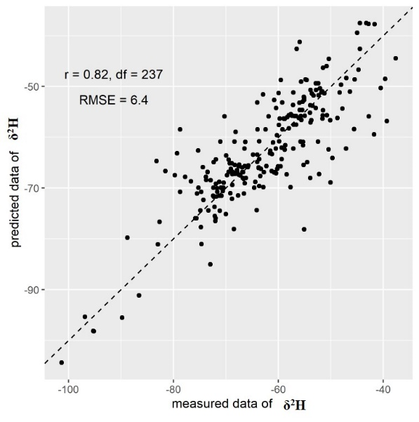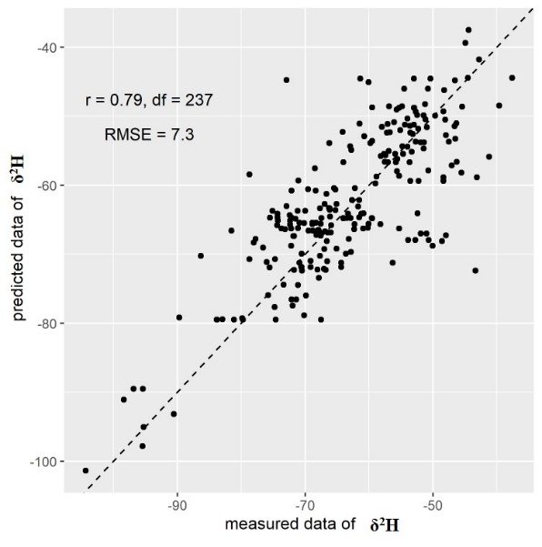
- (b)
Figure S1. Scatter-plots of measured versus predicted δ²H values for the (a) sixth and (b) tenth independent validation datasets. High r values indicate unbiased model predictions.

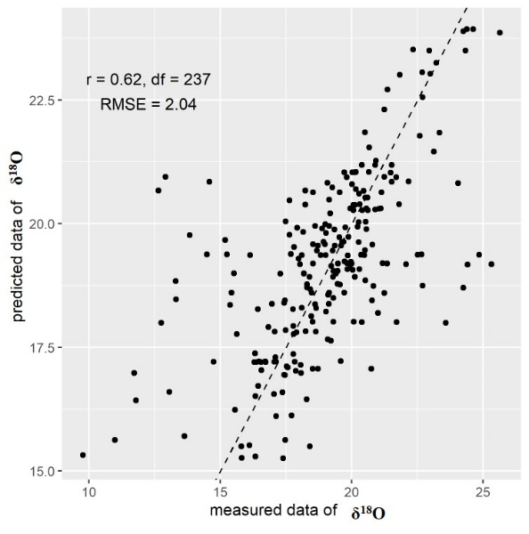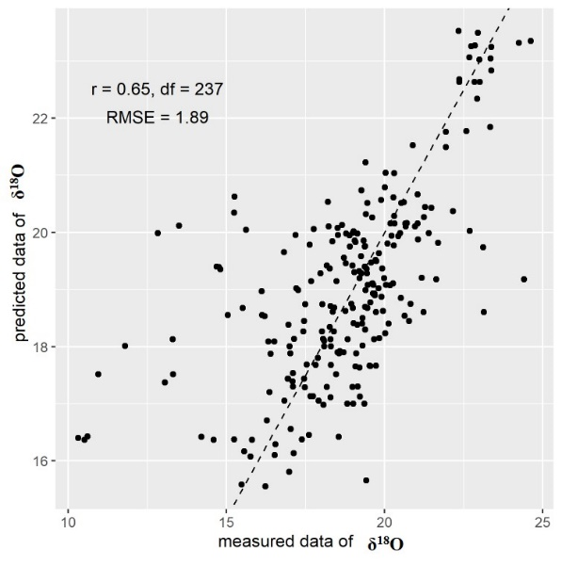
(a) (b)
Figure S2. Scatter-plots of measured versus predicted δ¹⁸O values for the (a) sixth and (b) tenth independent validation dataset. High r values indicate unbiased model predictions.

Table S1. Environmental variables used with stable isotopes for the predictive isoscape model.
Variables | Units | Definition
T | ℃ | Average annual temperatures
Tg | ℃ | Average annual temperatures during growing season (from June to October)
GDD | ℃ days | Growing degree days base 10 ℃
GDDg | ℃ days | Growing degree days during growing season (from June to October) base 10 ℃
RHU | % | Relative humidity
RHUg | % | Relative humidity during growing season (from June to October)
PRE | mm | Annual precipitation
PREg | mm | Annual precipitation during growing season (from June to October)
SSD | h | Sunshine duration
SSDg | h | Sunshine duration during growing season (from June to October)

Table S2. Geographic prediction evaluation results and optimal threshold values based on 10 random samples for δ²H values of rice. RMSE = root mean squared error. MAE = mean average error. r=Pearson’s correlation coefficient. R²=coefficient of determination. p1= the environmental similarity threshold. p2= the target variable similarity threshold. p3= the reliability threshold.

Sampling event | RMSE (‰) | MAE (‰) | R² | r | Optimal threshold values
 |  |  |  |  | p1 | p2 | p3
1 | 7.38 | 5.58 | 0.65 | 0.81 | 0.9 | 0.9 | 0.1
2 | 7.32 | 5.37 | 0.59 | 0.79 | 0.9 | 0.6 | 0.7
3 | 7.38 | 5.38 | 0.57 | 0.77 | 0.9 | 0.9 | 0.2
4 | 6.62 | 4.94 | 0.68 | 0.83 | 0.9 | 0.8 | 0.5
5 | 7.30 | 5.33 | 0.61 | 0.80 | 0.9 | 0.9 | 0.2
6 | 6.40 | 4.67 | 0.66 | 0.82 | 0.9 | 0.8 | 0.4
7 | 7.10 | 5.06 | 0.67 | 0.83 | 0.9 | 0.8 | 0.8
8 | 7.38 | 5.42 | 0.59 | 0.79 | 0.9 | 0.9 | 0.3
9 | 7.14 | 5.38 | 0.61 | 0.79 | 0.9 | 0.9 | 0.2
10 | 7.30 | 5.45 | 0.60 | 0.79 | 0.8 | 0.9 | 0.1
Mean | 7.09 | 5.21 | 0.62 | 0.81 | 0.89 | 0.84 | 0.35

Table S3. Geographic prediction evaluation results and optimal threshold values based on 10 random samples for δ¹⁸O values of rice. RMSE = root mean squared error. MAE = mean average error=Pearson’s correlation coefficient. R²=coefficient of determination.p1= the environmental similarity threshold. p2= the target variable similarity threshold. p3= the reliability threshold.

Sampling event | RMSE (‰) | MAE (‰) | R² | r | Optimal threshold values
 |  |  |  |  | p1 | p2 | p3
1 | 2.07 | 1.36 | 0.37 | 0.61 | 0.8 | 0.7 | 0.8
2 | 2.09 | 1.38 | 0.42 | 0.65 | 0.9 | 0.1 | 0.8
3 | 1.97 | 1.33 | 0.39 | 0.64 | 0.8 | 0.6 | 0.8
4 | 1.94 | 1.29 | 0.37 | 0.63 | 0.8 | 0.7 | 0.7
5 | 2.16 | 1.45 | 0.34 | 0.61 | 0.8 | 0.6 | 0.8
6 | 2.04 | 1.38 | 0.38 | 0.62 | 0.8 | 0.7 | 0.7
7 | 2.21 | 1.45 | 0.36 | 0.64 | 0.9 | 0.7 | 0.7
8 | 1.99 | 1.29 | 0.41 | 0.66 | 0.8 | 0.6 | 0.8
9 | 2.18 | 1.36 | 0.34 | 0.59 | 0.8 | 0.7 | 0.7
10 | 1.89 | 1.29 | 0.41 | 0.65 | 0.7 | 0.6 | 0.8
Mean | 2.06 | 1.36 | 0.38 | 0.63 | 0.81 | 0.6 | 0.76

Table S4. Stable isotope summary statistics for the 10 repeated random sampling events.
Max= Maximum value. Min = Minimum value. SD= Standard deviation
Stable isotopes |  | Number of samples | Mean (‰) | Max (‰) | Min (‰) | SD
Training samples | δ¹³C | 555 | -28.02 | -25.24 | -29.98 | 0.88
Training samples | δ²H | 555 | -62.46 | -27.17 | -106.56 | 11.87
Training samples | δ¹⁸O | 555 | 18.90 | 26.27 | 9.95 | 2.56
Validation samples | δ¹³C | 239 | -28.01 | -25.37 | -29.85 | 0.88
Validation samples | δ²H | 239 | -62.49 | -34.76 | -103.45 | 11.64
Validation samples | δ¹⁸O | 239 | 18.81 | 25.39 | 10.19 | 2.61

