Supplementary Information

Development of “NEC-SD-LAMP,” a New Non-Electrified Infectious Diseases Testing Method
Yusuke Kimura¹, Masashi Ikeuchi¹
¹Department of Biodesign, Institute of Biomedicals and Bioengineering,
Tokyo Medical and Dental University, 2-3-10 Kandasurugadai, Chiyoda-ku, Tokyo, Japan.

* Corresponding author:
Masashi Ikeuchi
Tel: +81-3-5280-8042
Email: ikeuchi.mech@tmd.ac.jp
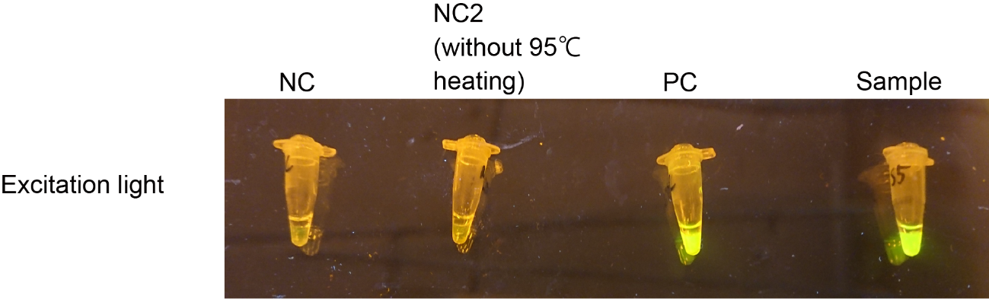
Sup.Fig.1. Verification of the effect of proteinase K inactivation by the exothermic agent reaction. The figure shows the samples in the PCR tube after reaction under excitation light illumination. “NC,” NEC-SD-LAMP was performed using saliva samples without adenovirus DNA. “NC2” used saliva samples containing adenovirus DNA, and the SalivaDirect assay was performed without inactivating proteinase K through the exothermic reaction. After the reaction, the LAMP assay was performed using palmitic acid. “PC,” SalivaDirect and LAMP assays were performed using saliva samples containing adenovirus DNA using a conventional thermal cycler. “Sample,” NEC-SD-LAMP was performed using saliva samples containing adenovirus DNA.

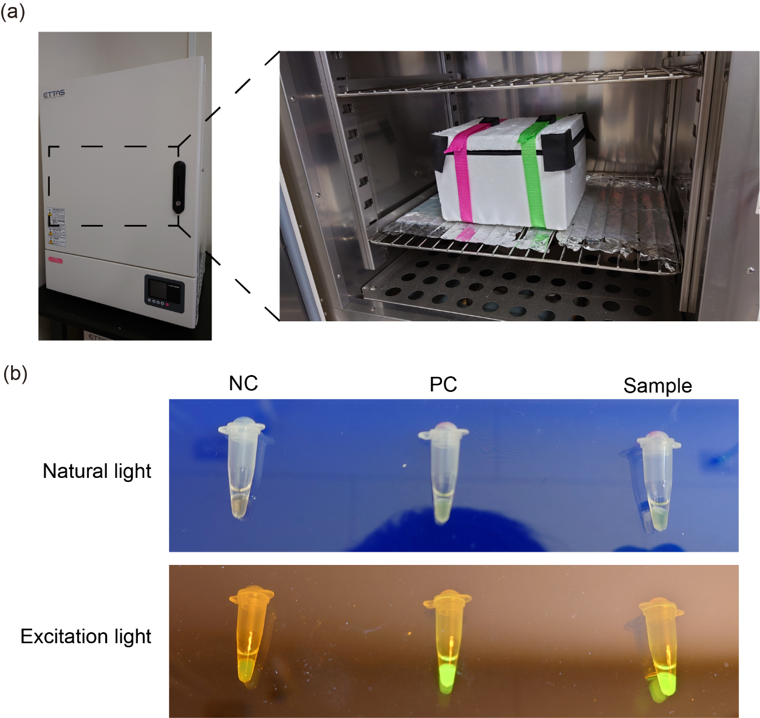
Sup.Fig.2. NEC-SD-LAMP at 50 °C. In this experiment, saliva samples containing adenovirus DNA (final concentration: 100 copies per µL) were used, and NEC-SD-LAMP was performed at the same volume, reagent concentration, and reaction time, as described in the method. (a) View of the NEC-SD-LAMP system during the reaction. All containers were placed in an incubator at 50 °C. (b) Reaction results: these figures show the samples in the PCR tubes after the reaction and were obtained under natural or excitation light irradiation. “NC,” NEC-SD-LAMP was performed using saliva samples without adenovirus DNA in a 50 °C incubator. “PC,” SalivaDirect and LAMP assays were performed using saliva samples containing adenovirus DNA in a conventional thermal cycler. “Sample,” NEC-SD-LAMP was performed using saliva samples containing adenovirus DNA in a 50 °C incubator.

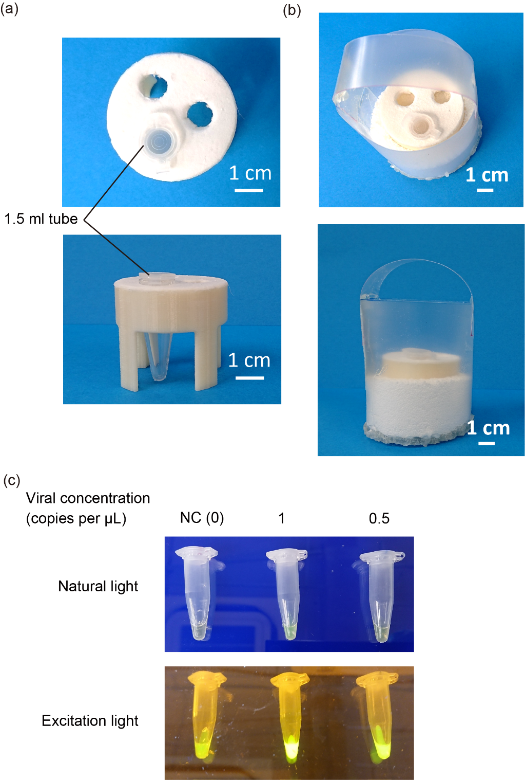
Sup.Fig.3. NEC-SD-LAMP in a large volume using a 1.5-mL tube. This experiment used saliva samples containing adenoviral DNA. NEC-SD-LAMP was performed as previously described. (a) Stand for the SalivaDirect assay. There are several holes on the stand to set the 1.5-mL tube. The stand is an attachment-type stand that can easily be replaced with a PCR tube stand. (b) PP container: the stand for the 1.5-mL tube and palmitic acid were mounted inside the container. (c) Reaction results: these figures show the sample in the 1.5-mL tube after the reaction and were obtained under natural or excitation light irradiation. “NC,” NEC-SD-LAMP was performed using saliva samples without adenovirus DNA.

