Supporting materials

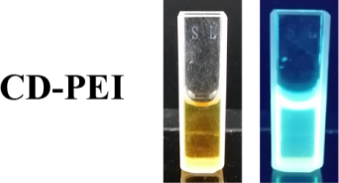

Fig. S1 The optical images of CD-PEI under white light and UV light

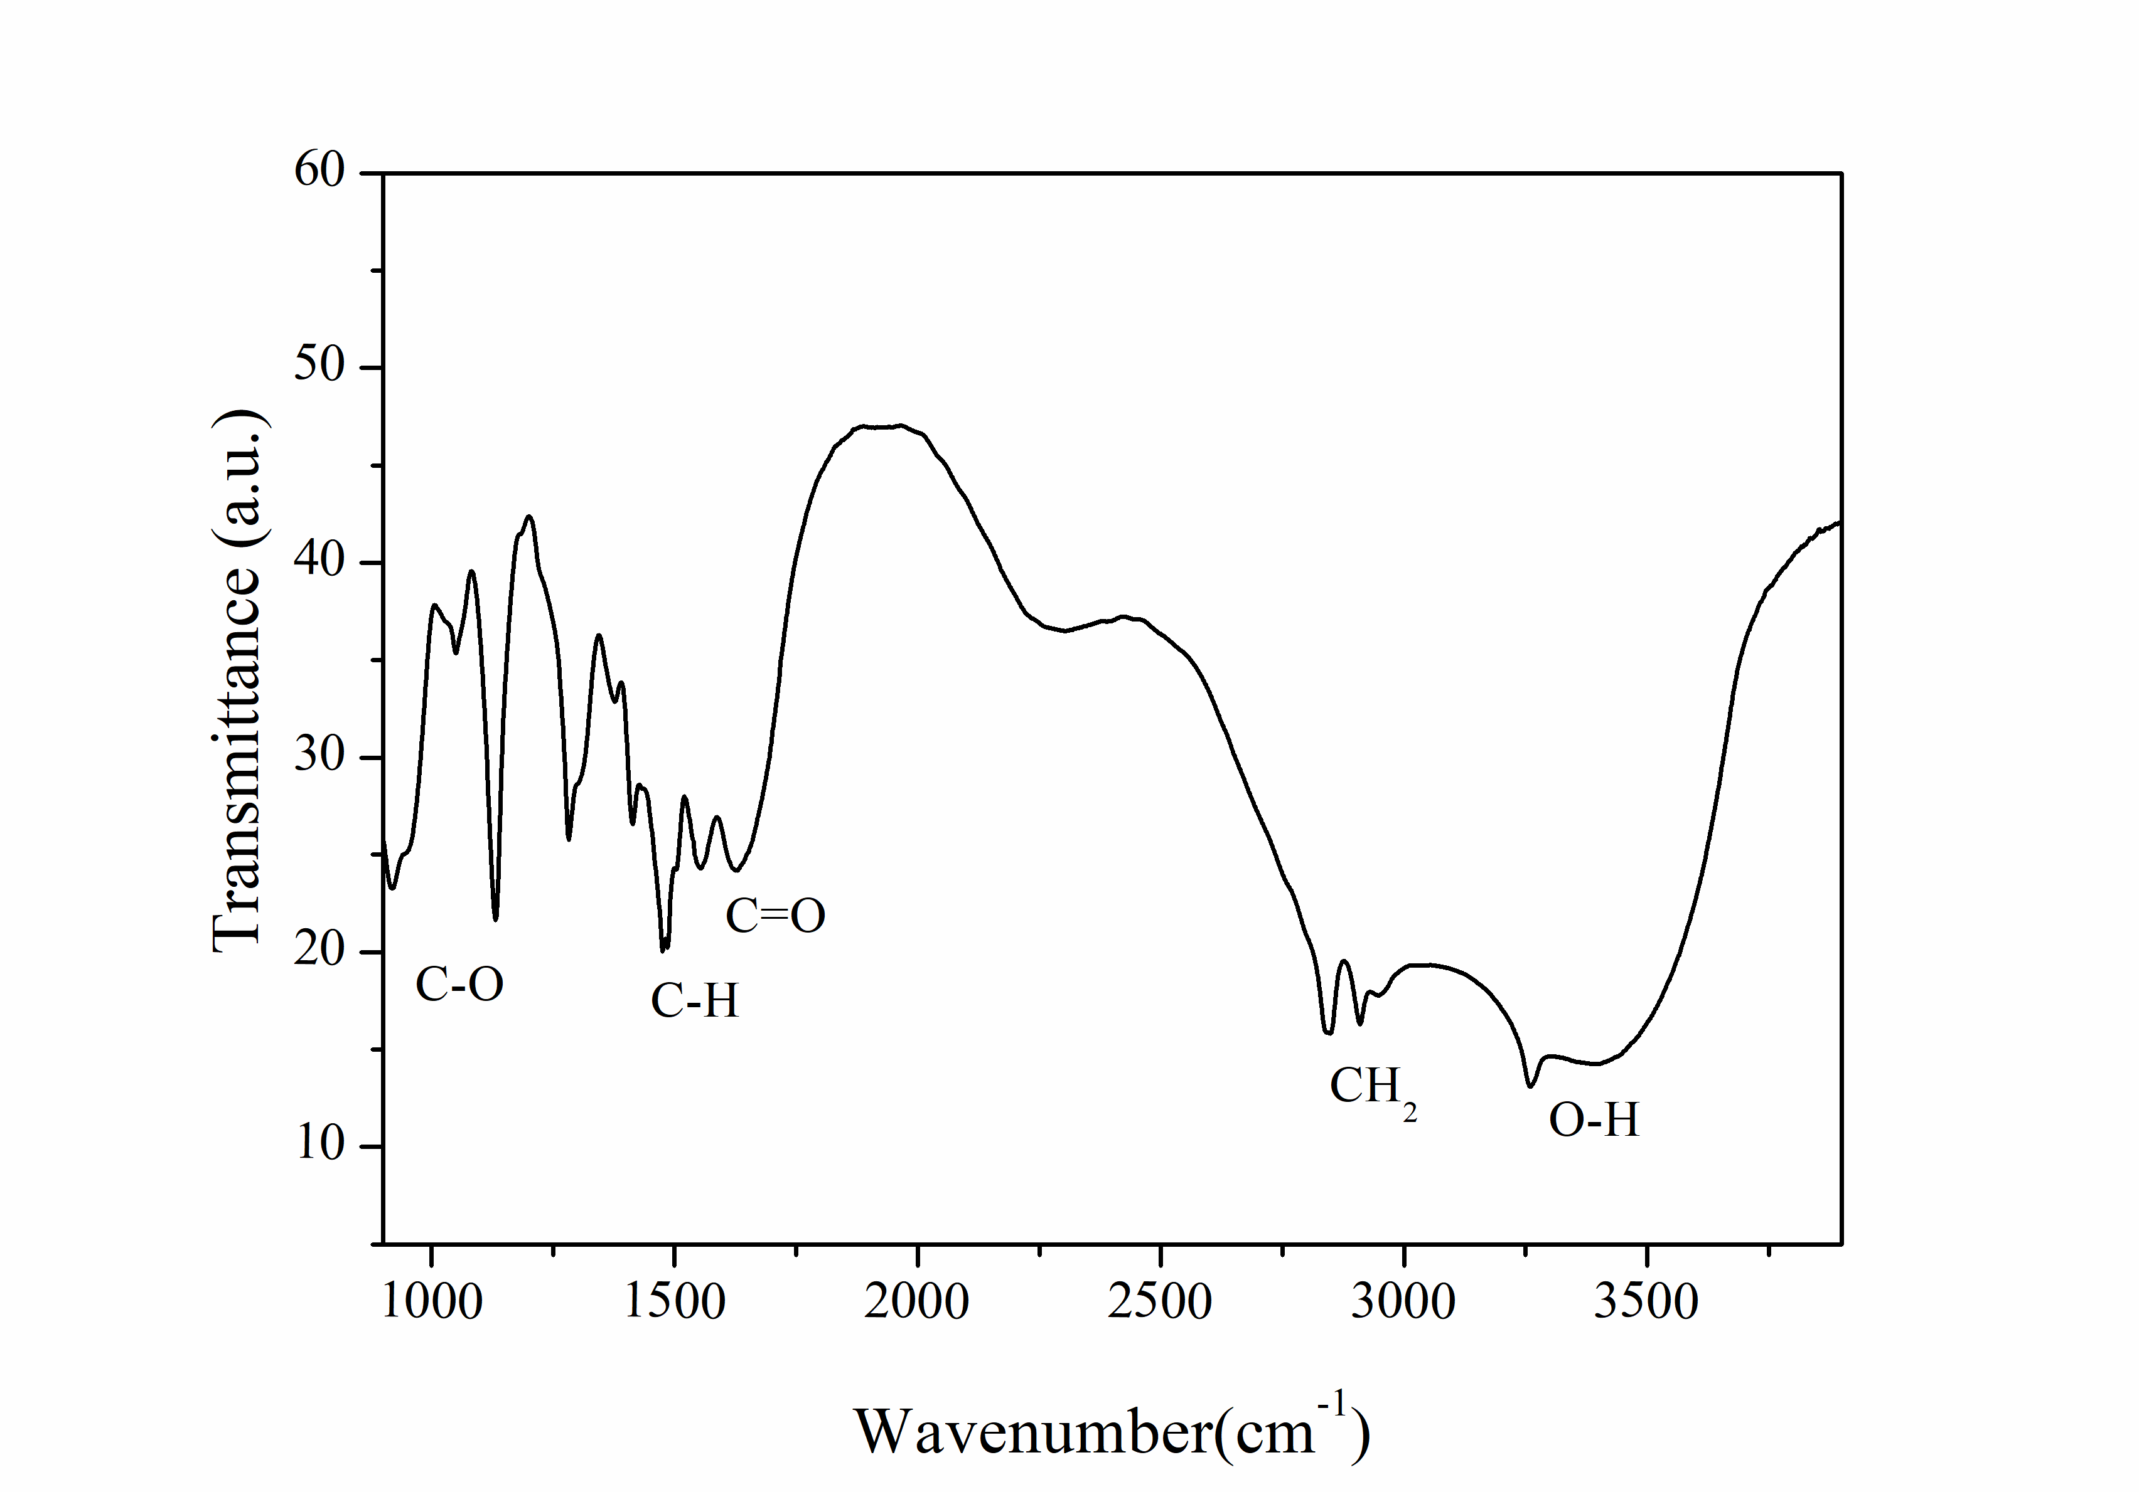

Fig. S2 The FTIR spectrum of PEI.

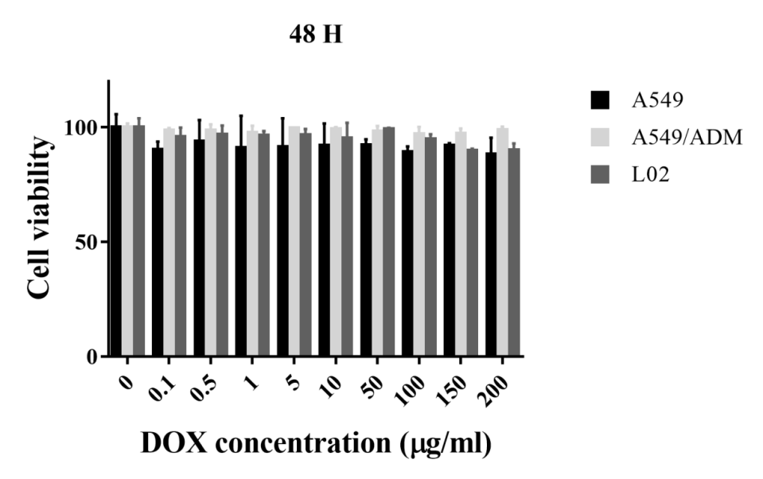
Fig. S3 The cell viability of A549, A549/ADM, L02 incubation with CD-PEI for 48 hours.

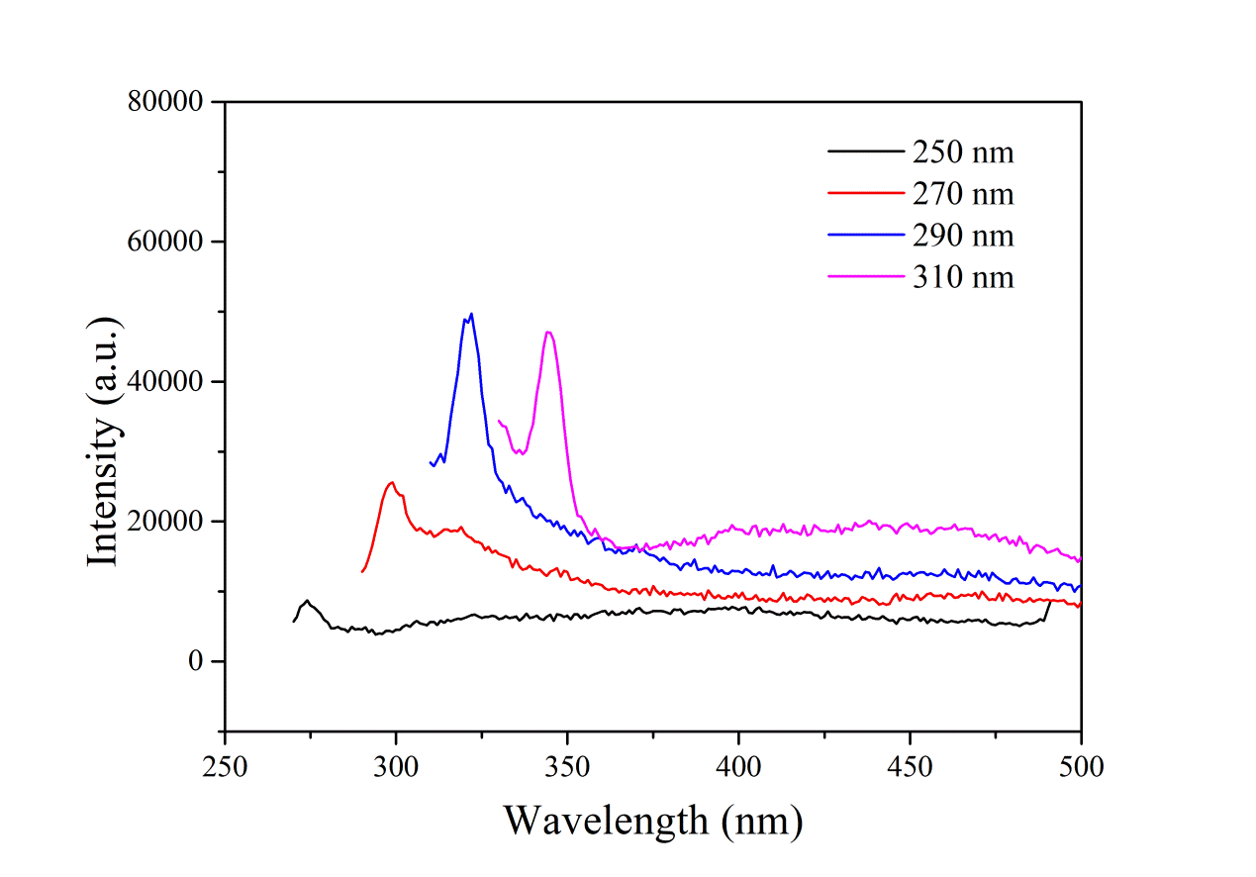
Fig. S4 The PL spectrum of CD-PEI-DOX-siMRP1 under excitation from 250 nm to 310 nm.

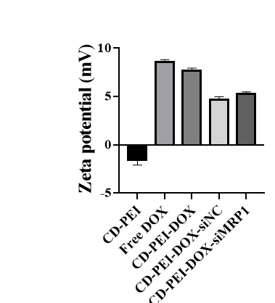
Fig. S5 The Zeta potential of different groups.

Table S1 Percentage of groups obtained from curve fitting the C1s and N1s peaks of nanodrug
 | C1s |  |  |  | N1s
 | C-C/C=C | C-N/C-OH | C=O | O-C=O | C=C-N | N-(C)₃ | N-H
DOX | 66.9% | 11.1% | 17.1% | 4.9% | 56.1% | 26.5% | 17.4%
PEI | 79.2% | 12.1% | 4.5% | 4.2% | 48.8% | 40.0% | 11.2%
CD-PEI | 65.0% | 28.4% | 6.6% |  | 69.8% | 30.2%
CD-PEI-DOX | 45.5% | 33.8% | 12.8% | 7.9% | 65.7% | 30.9% | 3.4%
CD-PEI-DOX-siNC | 63.9% | 28.0% | 3.3% | 4.8% | 74.0% | 26.0%
CD-PEI-DOX-siMRP1 | 78.4% | 16.4% | 2.7% | 2.5% | 80.5% | 19.5%

