SUPPLEMENTARY APPENDIX

Mathematical model construction

(A) Notation:
- : the time between diagnosis and treatment initiation (TTI);
- : the baseline TTI considered for standard operation;
- : the number of patients waiting for treatment at the start of phase ;
- : the time for the beginning of phase ;
- : the speed or volume of treatment (patients per day) during phase ;
- : the demand volume expected (patients per day),
- : the duration of the reduced operation,
- : the duration of mitigation
- : the duration of simulation.
The phases considered are: (normal – under standard circumstances), (reduced – during COVID-19 outbreak), (mitigation – during the period after the pandemic expecting an increase in medical care in order to mitigate the both queue and risk of dying due to the delay in treatment initiation) and (new normal – after the outbreak and mitigation periods).
For convenience, is defined as the piecewise-linear interpolation of such that .

(B) Method 1 – Added hazard prediction from TTI:
For this method, an adapted model of Murphy et al.¹ was employed.

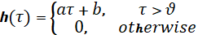

where is the added hazard ratio (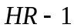) for a TTI of , the model parameters , and represent respectively the minimum TTI to consider hazard and the pair slope and y-intercept of the linear equation, as demonstrated in Figure S1.

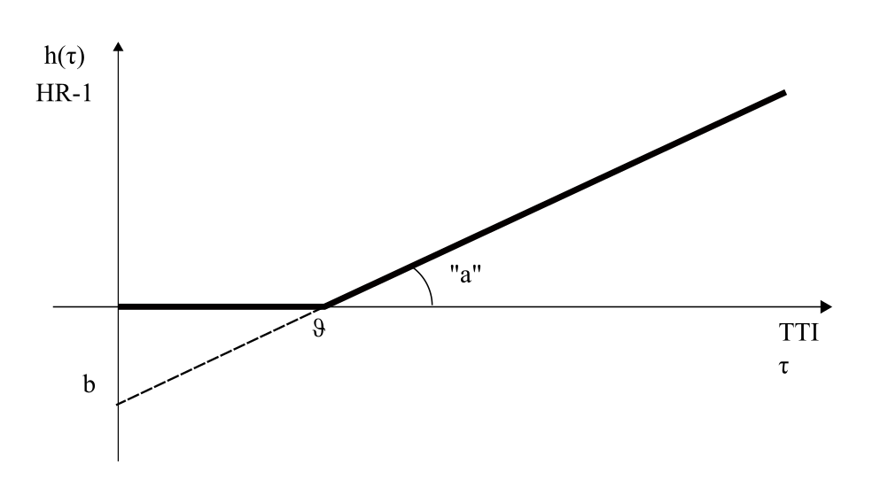
Figure S1. Estimation of additional hazard due to time until treatment initiation. In this simplified model based on Murphy et al.¹, no additional hazard is considered until a threshold TTI value is reached, when the curve becomes linear with slope "a" and y-intercept "b". Respective adopted values were 0.003 and -0.2 with threshold 67 obtained by analysis of the graph.

(C) Method 2 – Format of the operation curve (number of accumulated patients through time)
The duration of the pandemic phase, when volume of medical care is reduced, is obtained as an input variable . The duration of the mitigation phase can be either an input, in which case, the needed operational effort is computed, or conversely, the estimated affordable effort is input (as the volume of treatment during mitigation ) and the time needed for mitigation is computed as:

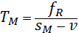

where is the peak number of people waiting for treatment in the simulation. The graph representation of this model is demonstrated in Figure S2

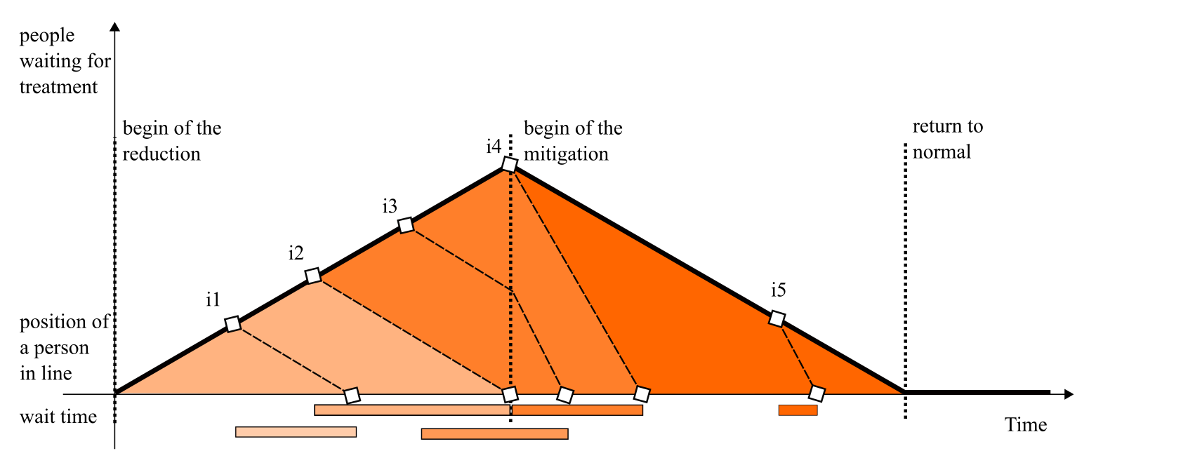
Figure S2. Abstract chart representing the number of patients waiting for treatment through time. This number increases during the phase of the model when reduced volume of treatment takes place due to the outbreak event of the pandemic, from "begin of reduction" until "begin of mitigation", and decreases until the "return to normal" point when the number of waiting patients returns to the standard level as before the event. Individuals i1 and i5 and their positions in the waiting queue are illustrated, showing that i2, the last patient treated in the reduced phase, has the longest waiting duration in the horizontal bars at the bottom. Different shades indicate different cases of computation of the waiting time.

(D) Method 3 – Computation of individuals waiting time
In order to deal with the discontinuities of a multi-phase process, the following algorithm is used to compute the exit time of an individual entering the system at time , by detecting and treating the occurrences of volume changes during the waiting period.

Input: , the arrival time
Output: , the exit time

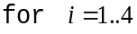

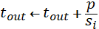
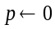

being the times instants when the volume of treatment becomes . These times can be input or computed by Method 2.

(E) Method 4 – Simulation and histograms
Simulated patients enter the system at the rate specified by variable . The simulation is started at time 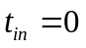 as the first patient arrival time, being the simulation step , which is the time the second patient arrives. All simulated patients that enter the system during simulation time (before time ) have their complete waiting times considered. The number of exposed patients described by is the denominator of the computed averages:

The TTI is computed based on a baseline TTI, that comprises the delays until coming to the first medical visit, given by: . Hazard is estimated by Method 1 considering this TTI computed by Methods 2 and 3.
The overall risk of dying is 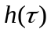, while the added risk of dying is , which is the value added to the normal Hazard Ratio due to the outbreak and its mitigation period. The subtracted reference is the baseline risk of dying 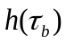.
Simulation can also be used to produce histograms of waiting time and hazard estimations. The maximum waiting time and the corresponding hazard are particularly important information that the simulation can capture.

(F) Method 5 – Continuous formulation
In this method, a continuous representation of the process is constructed, and the derived formulas are used to draw conclusions and numerical predictions. In this specific case, the important prediction is the peak of waiting time and when it occurs. The geometric interpretation allows the estimation of averages TTI and risk for the specific piecewise linear models we adopted.
The main equation is:

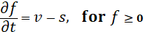

where and are time-dependent variables. A primitive of is , representing the number of people treated in a given time interval, given by:

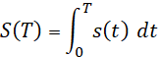

being a stepwise constant function with positive values, is piecewise-linear and increasing, therefore invertible in its domain. Being the waiting time for a patient arriving at time :

This can be read simply as: the number of patients treated between the moment patient arrives until treatment initiation of this patient is the size of the queue when the patient arrived. The general formula to compute the waiting time is therefore:

Considering the three different cases in Figure S2, represented by the different shades in the graph area. Case 1 represents patients arriving and being treated during the pandemic. Case 2 are patients arriving during the outbreak but being treated during the mitigation period. Case 3 describes patients arriving and being treated exclusively during mitigation period.

Case 1:

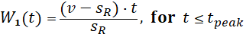

As , the function is increasing in time. The domain of this function stops at when 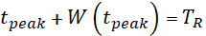. By substituting its own definition, we get:

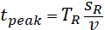

This happens because is decreasing.

Case 2:
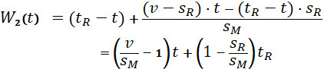

being , the term multiplying is negative, thus, is decreasing. This confirms that is the arrival time for patients when peak waiting time and risk occurs (for increasing risk model).

Case 3:

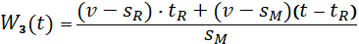

As the peak happens at , the peak waiting time can be computed by applying :

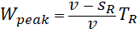

The peak TTI is obtained by adding the basal: .

By considering the area of the triangle, average TTI is given by:

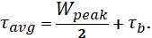

Peak risk is obtained directly from , being the peak added risk: 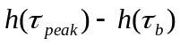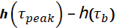. Considering the partial linear model we adopted, the average risk can be computed from the portion of the triangle where waiting time is above , dividing by the appropriate interval length. In the case the average risk 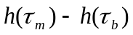 is computed for 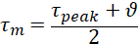. In the case , it is computed for 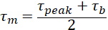. In the last case, , for which the added risk is null.

(G) Model sensitivity analysis
We follow two approaches of sensitivity analysis. In the first one, we inspect the equations of the continuous formulation and draw conclusions from them. We observe that when the mitigation effort tends to zero, the recovery time to the anteriorly established baseline level is infinite. This makes the computation unstable for very low added mitigation effort. A solution to this is to compute the risks for a limited time-range, which is a maximum of five years in our case.
Another observation from formula inspection in that, in the model, the value of peak TTI is compromised if the patient incoming rate tends to zero. This situation will not happen in a practical scenario at floating-point precision.
The second approach to sensitivity analysis, regarding error amplification, we analyze two typical scenarios (with low and high basal TTI), and simulate the addition of an error of ± 10 days for the basal TTI and pandemic duration and ± 10 patients per month for treatment volumes in standard, reduced and mitigation periods, changing only one variable each time. The variations per unit are presented in Table S1 (supplementary data).

Table S1. Model sensitivity analyzes. Variations per unit regarding the simulations’ scenarios.
SIMULATION 1 - Around point (ttib=120, v=90, sr=30, sm=120, tr=90)
output variable | ttib=110 | ttib=130 | v=80 | v=100 | sr=20 | sr=40 | sm=110 | sm=130 | tr=80 | tr=100
mitigation time | 180 | 180 | 113 | 315 | 210 | 150 | 270 | 135 | 160 | 200
peak TTI | 170 | 190 | 176 | 183 | 190 | 170 | 180 | 180 | 173 | 187
1-year risk | 6.7 | 6.7 | 4.7 | 10,5 | 8.7 | 5 | 9 | 5,6 | 5.3 | 8.3
exposed | 810 | 810 | 542 | 1,350 | 900 | 720 | 1,081 | 675 | 720 | 900
 | Change per unit
output variable | ttib |  | v |  | sr |  | sm |  | tr
mitigation time | 0 |  | 10.1 |  | -3 |  | -6.75 |  | 2
peak TTI | 1 |  | 0.35 |  | -1 |  | 0 |  | 0.7
1-year risk | 0 |  | 0.29 |  | -0.185 |  | -0.17 |  | 0.15
exposed | 0 |  | 40.4 |  | -9 |  | -20.3 |  | 9
SIMULATION 2 - Around point (ttib=30, v=120, sr=90, sm=145, tr=60)
output variable | ttib=20 | ttib=40 | v=110 | v=130 | sr=80 | sr=100 | sm=135 | sm=155 | tr=50 | tr=70
mitigation time | 72 | 72 | 34 | 160 | 96 | 48 | 120 | 51 | 60 | 84
peak TTI | 35 | 55 | 41 | 48 | 50 | 40 | 45 | 45 | 43 | 48
1-year risk | 0 | 0 | 0 | 0 | 0 | 0 | 0 | 0 | 0 | 0
exposed | 529 | 529 | 345 | 954 | 625 | 433 | 721 | 445 | 441 | 617
 | Change per unit
output variable | ttib |  | v |  | sr |  | sm |  | tr
mitigation time | 0 |  | 6.3 |  | -2.4 |  | -3.45 |  | 1.2
peak TTI | 1 |  | 0.35 |  | -0.5 |  | 0 |  | 0.25
1-year risk | 0 |  | 0 |  | 0 |  | 0 |  | 0
exposed | 0 |  | 30.45 |  | -9.6 |  | -13.8 |  | 8.8

Table S2. First year added risk of dying and time (days) to recovery by reduction of medical care volume during distinct simulation periods of COVID-19 outbreak duration, considering different scenarios of mitigation after the pandemic and 66 days of baseline time to treatment initiation (the limit days for no baseline risk of dying due to waiting time for treatment).
Mitigation | Medical care volume during 60 days of COVID-19 outbreak
Medical care increment after outbreak (%) | 0% |  | 10% |  | 20% |  | 30% |  | 40% |  | 50% |  | 60% |  | 70% |  | 80% |  | 90%
Medical care increment after outbreak (%) | Risk | Time | Risk | Time | Risk | Time | Risk | Time | Risk | Time | Risk | Time | Risk | Time | Risk | Time | Risk | Time | Risk | Time
0% | 17.7% | - | 15.8% | - | 13.9% | - | 12.4% | - | 10.2% | - | 8.4% | - | 6.6% | - | 5.2% | - | 3.1% | - | 1.4% | -
5% | 15.2% | 1,200 | 13.4% | 1,080 | 11.6% | 960 | 9.8% | 840 | 8.0% | 720 | 6.3% | 600 | 4.6% | 480 | 2.9% | 360 | 1.3% | 240 | 0.4% | 120
10% | 12.9% | 600 | 11.1% | 540 | 9.4% | 480 | 7.7% | 420 | 6.0% | 360 | 4.3% | 300 | 2.8% | 240 | 1.7% | 180 | 0.8% | 120 | 0.2% | 60
15% | 10.7% | 400 | 9.1% | 360 | 7.4% | 320 | 5.8% | 280 | 4.3% | 240 | 3.1% | 200 | 2.1% | 160 | 1.3% | 120 | 0.6% | 80 | 0.2% | 40
20% | 8.8% | 300 | 7.2% | 270 | 5.8% | 240 | 4.6% | 210 | 3.5% | 180 | 2.5% | 150 | 1.7% | 120 | 1.0% | 90 | 0.5% | 60 | 0.2% | 30
25% | 7.3% | 240 | 6.1% | 216 | 4.9% | 192 | 3.9% | 169 | 2.9% | 144 | 2.2% | 120 | 1.5% | 96 | 0.9% | 72 | 0.5% | 48 | 0.2% | 24
50% | 4.4% | 120 | 3.7% | 108 | 3.0% | 96 | 2.4% | 84 | 1.9% | 72 | 1.4% | 60 | 1.0% | 48 | 0.7% | 36 | 0.4% | 24 | 0.1% | 12
75% | 3.4% | 80 | 2.9% | 72 | 2.4% | 64 | 2.0% | 56 | 1.6% | 48 | 1.2% | 40 | 0.9% | 32 | 0.6% | 24 | 0.3% | 16 | 0.1% | 8
100% | 2.9% | 60 | 2.5% | 54 | 2.1% | 48 | 1.7% | 42 | 1.4% | 36 | 1.1% | 30 | 0.8% | 24 | 0.5% | 18 | 0.3% | 12 | 0.1% | 6
 | 90 days of COVID-19 outbreak
0% | 26.7% | - | 23.7% | - | 20.8% | - | 17.9% | - | 15.1% | - | 12.4% | - | 9.7% | - | 7.2% | - | 4.6% | - | 2.2% | -
5% | 24.2% | 1,800 | 21.3% | 1,620 | 18.5% | 1,440 | 15.8% | 1,260 | 13.1% | 1,080 | 10.5% | 900 | 7.9% | 720 | 5.4% | 540 | 3.0% | 360 | 0.9% | 180
10% | 21.9% | 900 | 19.1% | 810 | 16.4% | 720 | 13.8% | 630 | 11.2% | 540 | 8.7% | 450 | 6.2% | 360 | 3.9% | 270 | 1.9% | 180 | 0.6% | 90
15% | 19.7% | 600 | 17.1% | 540 | 14.5% | 480 | 12.0% | 420 | 9.5% | 360 | 7.1% | 300 | 4.8% | 240 | 2.9% | 180 | 1.5% | 120 | 0.5% | 60
20% | 17.8% | 450 | 15.2% | 405 | 12.7% | 360 | 10.3% | 315 | 7.9% | 270 | 5.7% | 225 | 3.9% | 180 | 2.4% | 135 | 1.3% | 90 | 0.4% | 45
25% | 16.0% | 360 | 13.5% | 324 | 11.1% | 288 | 8.8% | 252 | 6.7% | 216 | 4.9% | 180 | 3.4% | 144 | 2.1% | 108 | 1.1% | 72 | 0.4% | 36
50% | 10.0% | 180 | 8.4% | 162 | 6.9% | 144 | 5.6% | 126 | 4.3% | 108 | 3.3% | 90 | 2.3% | 72 | 1.5% | 54 | 0.9% | 36 | 0.3% | 18
75% | 7.7% | 120 | 6.6% | 108 | 5.5% | 96 | 4.5% | 84 | 3.6% | 72 | 2.7% | 60 | 2.0% | 48 | 1.3% | 36 | 0.8% | 24 | 0.3% | 12
100% | 6.6% | 90 | 5.7% | 81 | 4.8% | 72 | 3.9% | 63 | 3.2% | 54 | 2.5% | 45 | 1.8% | 36 | 1.3% | 27 | 0.8% | 18 | 0.3% | 9
 | 120 days of COVID-19 outbreak
0% | 35.7% | - | 31.6% | - | 27.6% | - | 23.7% | - | 19.9% | - | 16.3% | - | 12.7% | - | 9.3% | - | 7.0% | - | 2.8% | -
5% | 33.2% | 2,400 | 29.2% | 2,160 | 25.4% | 1,920 | 21.6% | 1,680 | 18.0% | 1,440 | 14.5% | 1,200 | 11.1% | 960 | 7.8% | 720 | 4.7% | 480 | 1.6% | 240
10% | 30.9% | 1,200 | 27.1% | 1,080 | 23.4% | 960 | 19.8% | 840 | 16.3% | 720 | 12.9% | 600 | 9.6% | 480 | 6.5% | 360 | 2.4% | 240 | 1.1% | 120
15% | 28.7% | 800 | 25.1% | 720 | 21.5% | 640 | 18.0% | 560 | 14.7% | 480 | 11.4% | 400 | 8.3% | 320 | 5.2% | 240 | 2.6% | 160 | 0.9% | 80
20% | 26.8% | 600 | 23.2% | 540 | 19.8% | 480 | 16.4% | 420 | 13.2% | 360 | 10.0% | 300 | 7.0% | 240 | 4.3% | 180 | 2.3% | 120 | 0.8% | 60
25% | 25.0% | 480 | 21.6% | 432 | 18.2% | 384 | 15.0% | 336 | 11.8% | 288 | 8.8% | 240 | 6.1% | 192 | 3.8% | 144 | 2.0% | 96 | 0.7% | 48
50% | 17.8% | 240 | 14.9% | 216 | 12.3% | 192 | 9.9% | 168 | 7.8% | 144 | 5.9% | 120 | 4.2% | 96 | 2.8% | 72 | 1.6% | 48 | 0.6% | 24
75% | 13.8% | 160 | 11.7% | 144 | 9.8% | 128 | 8.0% | 112 | 6.4% | 96 | 4.9% | 80 | 3.6% | 64 | 2.4% | 48 | 1.4% | 32 | 0.6% | 16
100% | 11.9% | 120 | 10.1% | 108 | 8.5% | 96 | 7.0% | 84 | 5.7% | 72 | 4.4% | 60 | 3.3% | 48 | 2.3% | 36 | 1.4% | 24 | 0.6% | 12
 | 180 days of COVID-19 outbreak
0% | 53.7% | - | 47.1% | - | 40.8% | - | 34.7% | - | 28.9% | - | 23.4% | - | 18.1% | - | 13.1% | - | 8.4% | - | 4.0% | -
5% | 51.2% | 3,600 | 44.8% | 3,240 | 38.7% | 2,880 | 32.9% | 2,520 | 27.3% | 2,160 | 22.0% | 1,800 | 16.9% | 1,440 | 12.1% | 1,080 | 7.5% | 720 | 3.2% | 360
10% | 48.9% | 1,800 | 42.7% | 1,620 | 36.8% | 1,440 | 31.2% | 1,260 | 25.8% | 1,080 | 20.7% | 900 | 15.7% | 720 | 11.1% | 540 | 6.7% | 360 | 2.5% | 180
15% | 46.7% | 1,200 | 40.8% | 1,080 | 35.1% | 960 | 29.7% | 840 | 24.4% | 720 | 19.5% | 600 | 14.7% | 480 | 10.2% | 360 | 5.9% | 240 | 2.1% | 120
20% | 44.8% | 900 | 39.0% | 810 | 33.5% | 720 | 28.3% | 630 | 23.2% | 540 | 18.4% | 450 | 13.7% | 360 | 9.4% | 270 | 5.2% | 180 | 1.9% | 90
25% | 43.0% | 720 | 37.4% | 648 | 32.1% | 576 | 27.0% | 504 | 22.0% | 432 | 17.3% | 360 | 12.9% | 288 | 8.6% | 216 | 4.7% | 144 | 1.8% | 72
50% | 35.8% | 360 | 30.9% | 324 | 26.3% | 288 | 21.8% | 252 | 17.4% | 216 | 13.3% | 180 | 9.5% | 144 | 6.3% | 108 | 3.6% | 72 | 1.5% | 36
75% | 30.6% | 240 | 26.3% | 216 | 22.1% | 192 | 18.1% | 168 | 14.4% | 144 | 11.1% | 120 | 8.1% | 96 | 5.5% | 72 | 3.3% | 48 | 1.4% | 24
100% | 26.8% | 180 | 22.9% | 162 | 19.3% | 144 | 15.9% | 126 | 12.8% | 108 | 10.0% | 90 | 7.4% | 72 | 5.1% | 54 | 3.1% | 36 | 1.4% | 18

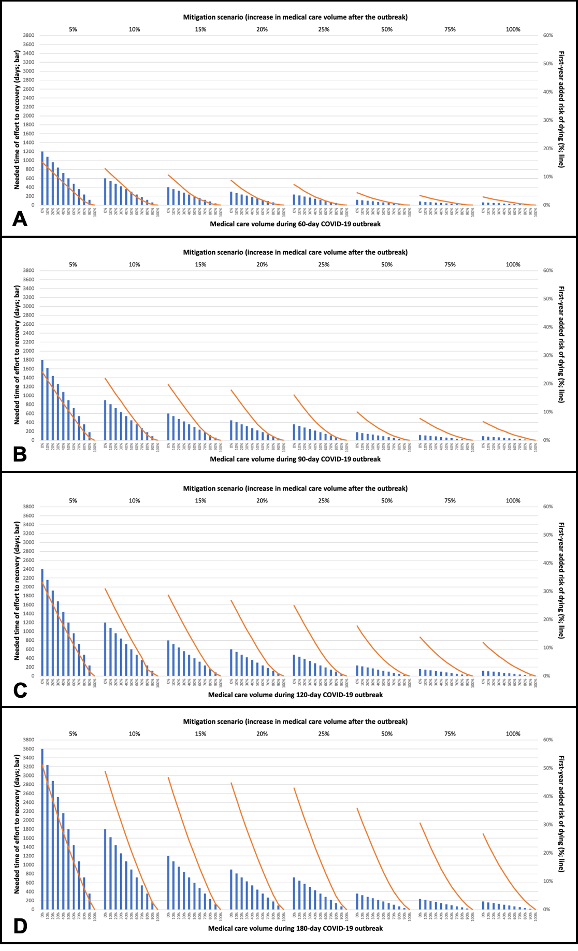
Figure S3. First-year added risk of dying (line) and necessary time of effort to recovery (bar) due to delay in time to treatment initiation considering the reduction of medical care during four simulations of COVID-19 outbreak duration, and also de mitigation of these risks based on increase of medical care volume after the pandemic. Complete and descriptive data of all these values are shown in Table S2 and Figure S3 (supplementary data).

Tables S3. Information of different centers worldwide, regarding medical care volume before and during COVID-19 outbreak and also estimations of mitigation scenarios after the outbreak.
Hospital / Service | Country | Treatment modality | Usual Time to Treatment Initiation* | Patients that come seeking treatment (monthly)* | Number of patients treated (monthly) during COVID-19 outbreak | Medical care reduction during the outbreak | Number of patients treated (monthly, expected) after the outbreak | Medical care increment after the outbreak | Estimated duration (days) of restricted operation due to the outbreak
A | USA | Surgery | 21 | 170 | 85 | 50.0% | 200 | 17.6% | 30
B | Taiwan | Surgery, Clinical Oncology | 23 | 10 | 4 | 60.0% | 10 | 0.0% | 30
C | USA | Surgery | 25 | 40 | 8 | 80.0% | 60 | 50.0% | 28
D | Greece | Clinical Oncology | 30 | 50 | 40 | 20.0% | 53 | 6.0% | 90
E | India | Surgery, Clinical Oncology, Radiation Therapy | 30 | 220 | 70 | 68.2% | 220 | 0.0% | 60
F | South Africa | Surgery, Clinical Oncology, Radiation Therapy | 30 | 30 | 16 | 46.7% | 30 | 0.0% | 270
G | Brazil | Surgery, Clinical Oncology, Radiation Therapy | 30 | 230 | 120 | 47.8% | 276 | 20.0% | 90
H | USA | Radiation Therapy | 30 | 120 | 90 | 25.0% | 145 | 20.8% | 60
I | Italy | Clinical Oncology | 30 | 140 | 80 | 42.9% | 160 | 14.3% | 120
J | UK | Surgery | 30 | 20 | 14 | 30.0% | 20 | 0.0% | 120
K | France | Radiation Therapy | 40 | 20 | 20 | 0.0% | 20 | 0.0% | 0
L | Poland | Surgery, Clinical Oncology, Radiation Therapy | 45 | 180 | 108 | 40.0% | 360 | 100.0% | 60
M | Australia | Radiation Therapy | 47 | 193 | 192 | 0.5% | 193 | 0.0% | 0
N | Canada | Radiation Therapy | 56 | 50 | 55 | ** | 60 | 20.0% | 0
O | Brazil | Radiation Therapy | 80 | 60 | 35 | 41.7% | 70 | 16.7% | 160
P | Colombia | Surgery, Clinical Oncology, Radiation Therapy | 81 | 30 | 15 | 50.0% | 30 | 0.0% | 90
Q | Brazil | Surgery | 120 | 62 | 30 | 51.6% | 75 | 21.0% | 90
R | Brazil | Clinical Oncology | 150 | 120 | 60 | 50.0% | 140 | 16.7% | 90
AVERAGE | - | - | 50 | - | - | 41.4% | - | 16.8% | 77
* Under standard circumstances.
** Increase of medical care due to a particular situation

Table S4. Estimative of treatment impact considering COVID-19 outbreak and mitigation period due to different proposed scenarios.
Hospital / Service | Needed time of effort to recovery (days) | TTI (Peak) | Average TTI | Exposed patients | Baseline risk (baseline TTI) | Added risk  (peak) | Added risk  (average - 1st year)
A | 85 | 36 | 28 | 652 | 0.0% | 0.0% | 0.0%
B | ∞ | 41 | N/E | N/E | 0.0% | 0.0% | #
C | 45 | 47 | 36 | 98 | 0.0% | 0.0% | 0.0%
D | 300 | 48 | 39 | 650 | 0.0% | 0.0% | 0.0%
E | ∞ | 71 | N/E | N/E | 0.0% | 1.3% | 1.2%
F | ∞ | 156 | N/E | N/E | 0.0% | 26.8% | 19.8%
G | 215 | 73 | 52 | 2,339 | 0.0% | 1.9% | 0.0%
H | 72 | 45 | 37 | 529 | 0.0% | 0.0% | 0.0%
I | 360 | 81 | 56 | 2,240 | 0.0% | 0.8% | 0.0%
J | ∞ | 66 | N/E | N/E | 0.0% | 0.0% | #
K | - | - | - | - | - | - | -
L | 24 | 69 | 57 | 504 | 0.0% | 0.7% | 0.0%
M | - | - | - | - | - | - | -
N | - | - | - | - | - | - | -
O | 400 | 147 | 113 | 1,121 | 4.0% | 20.0% | 13.2%
P | ∞ | 126 | N/E | N/E | 4,3% | 13,5% | 12,5%
Q | 222 | 166 | 143 | 645 | 16.0% | 13.9% | 6.0%
R | 270 | 195 | 172 | 1,441 | 25.0% | 6.7% | 0.0%
# Even though no mitigation strategy led to 0% increment in risk of dying, the long-standing ‘novel TTI’ of the service will be higher.
Legend: TTI = time to treatment initiation; N/E: not estimated (absence of mitigation strategy); “-” services that do not experimented reduction of medical care volume during the outbreak

Table S5. Estimative of treatment impact considering COVID-19 outbreak and without the possibility of mitigation at different facilities.
Hospital / Service | Usual Time to Treatment Initiation* | Baseline risk | Long-standing  novel TTI | Long-standing  added risk
A | 21 | 0% | 36 | 0%
B | 23 | 0% | 41 | 0%
C | 25 | 0% | 47 | 0%
D | 30 | 0% | 48 | 0%
E | 30 | 0% | 71 | 1.3%
F | 30 | 0% | 156 | 26.8%
G | 30 | 0% | 73 | 1.9%
H | 30 | 0% | 45 | 0%
I | 30 | 0% | 81 | 4.4%
J | 30 | 0% | 66 | 0%
K | 40 | 0% | - | -
L | 45 | 0% | 69 | 0.7%
M | 47 | 0% | - | -
N | 56 | 0% | - | -
O | 80 | 4.0% | 147 | 20.0%
P | 81 | 4.3% | 126 | 13.5%
Q | 120 | 16.0% | 166 | 13.9%
R | 150 | 25.0% | 195 | 13.5%
Legend: TTI = time to treatment initiation

References

1. Murphy CT, Galloway TJ, Handorf EA, et al. Survival Impact of Increasing Time to Treatment Initiation for Patients With Head and Neck Cancer in the United States. J Clin Oncol 2016;34:169-78.

