Supplementary Materials
Tables
Table S1. The correlation between glycosyltransferases and B7-H3.
Gene | Full name | r-value | p-value
FUT1 | Fucosyltransferase I | 0.431 | 2.10×10⁻¹⁶
FUT2 | Fucosyltransferase II | -0.08 | 0.146
FUT3 | Fucosyltransferase III | -0.039 | 0.479
FUT4 | Fucosyltransferase IV | 0.0884 | 0.109
FUT5 | Fucosyltransferase V | -0.0377 | 0.494
FUT6 | Fucosyltransferase VI | -0.0092 | 0.867
FUT7 | Fucosyltransferase VII | 0.3456 | 1.02×10⁻¹⁰
FUT8 | Fucosyltransferase VIII | 0.3085 | 9.89×10⁻⁰⁹
FUT9 | Fucosyltransferase IX | -0.2523 | 3.34×10⁻⁰⁶
FUT10 | Fucosyltransferase X | 0.1039 | 5.90×10⁻⁰²
FUT11 | Fucosyltransferase XI | 0.4305 | 2.30×10⁻¹⁶
POFUT1 | O-fucosyltransferases I | 0.021 | 7.04×10⁻⁰¹
POFUT2 | O-fucosyltransferases II | 0.3899 | 1.85×10⁻¹³
B4GALT1 | beta-1,4-galactosyltransferase 1 | 0.1448 | 0.00834
B4GALT2 | beta-1,4-galactosyltransferase 2 | 0.4874 | 3.74×10⁻²¹
B4GALT3 | beta-1,4-galactosyltransferase 3 | 0.2706 | 5.79×10⁻⁰⁷
B4GALT4 | beta-1,4-galactosyltransferase 4 | -0.1128 | 0.0402
B4GALT5 | beta-1,4-galactosyltransferase 5 | 0.1865 | 0.000648
B4GALT6 | beta-1,4-galactosyltransferase 6 | 0.1237 | 0.0244
B4GALT7 | beta-1,4-galactosyltransferase 7 | 0.3092 | 9.12×10⁻⁰⁹
B3GALT1 | beta-1,3-galactosyltransferase 1 | -0.3201 | 2.53×10⁻⁰⁹
B3GALT2 | beta-1,3-galactosyltransferase 2 | -0.1432 | 0.00908
B3GALT4 | beta-1,3-galactosyltransferase 4 | -0.1077 | 0.0503
B3GALT5 | beta-1,3-galactosyltransferase 5 | -0.13 | 0.018
B3GALT6 | beta-1,3-galactosyltransferase 6 | 0.4141 | 3.81×10⁻¹⁵
A3GALT2 | alpha 1,3-galactosyltransferase 2 | 0.0221 | 0.689
A4GALT | alpha 1,4-galactosyltransferase | 0.3819 | 6.14×10⁻¹³
C1GALT1 | Glycoprotein-N-acetylgalactosamine 3-beta-galactosyltransferase | 0.1352 | 0.0138
ST3GAL1 | ST3 beta-galactoside alpha-2,3-sialyltransferase1 | 0.3043 | 1.61×10⁻⁰⁸
ST3GAL2 | ST3 beta-galactoside alpha-2,3-sialyltransferase2 | 0.5022 | 1.49×10⁻²²
ST3GAL3 | ST3 beta-galactoside alpha-2,3-sialyltransferase3 | -0.0374 | 0.498
ST3GAL4 | ST3 beta-galactoside alpha-2,3-sialyltransferase4 | 0.0754 | 0.171
ST3GAL5 | ST3 beta-galactoside alpha-2,3-sialyltransferase5 | 0.1264 | 0.0214
ST3GAL6 | ST3 beta-galactoside alpha-2,3-sialyltransferase6 | 0.1529 | 0.00531
ST6GAL1 | ST6 beta-galactoside alpha-2,6-sialyltransferase 1 | 0.0156 | 0.778
ST6GAL2 | ST6 beta-galactoside alpha-2,6-sialyltransferase 2 | 0.1187 | 0.0309
ST6GALNAC1 | ST6 N-acetylgalactosaminide alpha-2,6-sialyltransferase 1 | -0.1347 | 0.0142
ST6GALNAC2 | ST6 N-acetylgalactosaminide alpha-2,6-sialyltransferase 2 | 0.117 | 0.0333
ST6GALNAC3 | ST6 N-acetylgalactosaminide alpha-2,6-sialyltransferase 3 | -0.0723 | 0.19
ST6GALNAC4 | ST6 N-acetylgalactosaminide alpha-2,6-sialyltransferase 4 | 0.0692 | 0.209
ST6GALNAC5 | ST6 N-acetylgalactosaminide alpha-2,6-sialyltransferase 5 | 0.3936 | 1.03×10⁻¹³
ST6GALNAC6 | ST6 N-acetylgalactosaminide alpha-2,6-sialyltransferase 6 | -0.1255 | 0.0224
ST8SIA1 | ST8 alpha-N-acetyl-neuraminide alpha-2,8-sialyltransferase 1 | 0.0509 | 0.356
ST8SIA2 | ST8 alpha-N-acetyl-neuraminide alpha-2,8-sialyltransferase 2 | 0.2412 | 9.11×10⁻⁰⁶
ST8SIA3 | ST8 alpha-N-acetyl-neuraminide alpha-2,8-sialyltransferase 3 | -0.2521 | 3.40×10⁻⁰⁶
ST8SIA4 | ST8 alpha-N-acetyl-neuraminide alpha-2,8-sialyltransferase 4 | 0.0284 | 0.607
ST8SIA5 | ST8 alpha-N-acetyl-neuraminide alpha-2,8-sialyltransferase 5 | -0.0254 | 0.645
ST8SIA6 | ST8 alpha-N-acetyl-neuraminide alpha-2,8-sialyltransferase 6 | -0.1938 | 0.000392

Table S2. The glycosyltransferases highly correlated with B7-H3 expression.
Gene | Name | r-value | p-value
FUT1 | Fucosyltransferase I | 0.431 | 2.10×10⁻¹⁶
FUT7 | Fucosyltransferase VII | 0.3456 | 1.02×10⁻¹⁰
FUT8 | Fucosyltransferase VIII | 0.3085 | 9.89×10⁻⁰⁹
FUT11 | Fucosyltransferase XI | 0.4305 | 2.30×10⁻¹⁶
POFUT2 | O-fucosyltransferases II | 0.3899 | 1.85×10⁻¹³
B4GALT2 | beta-1,4-galactosyltransferase 2 | 0.4874 | 3.74×10⁻²¹
B4GALT3 | beta-1,4-galactosyltransferase 3 | 0.2706 | 5.79×10⁻⁰⁷
B4GALT7 | beta-1,4-galactosyltransferase 7 | 0.3092 | 9.12×10⁻⁰⁹
B3GALT6 | beta-1,3-galactosyltransferase 6 | 0.4141 | 3.81×10⁻¹⁵
A4GALT | alpha 1,4-galactosyltransferase | 0.3819 | 6.14×10⁻¹³
ST3GAL1 | ST3 beta-galactoside alpha-2,3-sialyltransferase1 | 0.3043 | 1.61×10⁻⁰⁸
ST3GAL2 | ST3 beta-galactoside alpha-2,3-sialyltransferase2 | 0.5022 | 1.49×10⁻²²
ST6GALNAC5 | ST6 N-acetylgalactosaminide alpha-2,6-sialyltransferase 5 | 0.3936 | 1.03×10⁻¹³
ST8SIA2 | ST8 alpha-N-acetyl-neuraminide alpha-2,8-sialyltransferase 2 | 0.2412 | 9.8×10⁻⁰⁶
Table S3. The sequences of siRNAs.
Gene | Full-name | siRNA sequence (5’→3’)
Gene | Full-name | Sense | Antisense
FUT1 | Fucosyltransferase I | CGCGGACUUGAGAGAUCCUUUUU | AAAGGAUCUCUCAAGUCCGCGUU
FUT7 | Fucosyltransferase VII | CCCUGAACAAAUCUUGGGUdTdT | ACCCAAGAUUUGUUCAGGGdTdT
FUT8 | Fucosyltransferase VIII | GUGGAGUGAUCCUGGAUAUdTdT | AUAUCCAGGAUCACUCCACdTdT
FUT11 | Fucosyltransferase XI | GAGCUCUUGGCUUUCUUGUUU | ACAAGAAAGCCAAGAGCUCUU
POFUT2 | O-fucosyltransferases II | GCACACGCCAGGUUUUUUTUU | UAAAAAACCUGGCGUGUGCUU
B4GALT2 | beta-1,4-galactosyltransferase 2 | CACGAAGCUGACCAUGAAGUU | CUUCAUGGUCAGCUUCGUGUU
B4GALT3 | beta-1,4-galactosyltransferase 3 | CUACUGUCCAGAACGAUCUdTdT | AGAUCGUUCUGGACAGUAGdTdT
B4GALT7 | beta-1,4-galactosyltransferase 7 | GCCUGAACACUGUGAGGUAUU | UACCUCACAGUGUUCAGGCUU
B3GALT6 | beta-1,3-galactosyltransferase 6 | GGCGGACGACGACUCCUUCTT | GAAGGAGUCGUCGUCCGCCTT
A4GALT | alpha 1,4-galactosyltransferase | UGAAAGGGCUUCCGGGUGGUU | CCACCCGGAAGCCCUUUCAUU
ST3GAL1 | ST3 beta-galactoside alpha-2,3-sialyltransferase1 | CCAUUUCCCACACCUACAUUU | AUGUAGGUGUGGGAAAUGGUU
ST3GAL2 | ST3 beta-galactoside alpha-2,3-sialyltransferase2 | GCCACUUUGACGGUAACAUUU | AUGUUACCGUCAAAGUGGCUU
ST6GALNAC5 | ST6 N-acetylgalactosaminide alpha-2,6-sialyltransferase 5 | CCGCUUUAUCACAGAGAAAUU | UUUCUCUGUGAUAAAGCGGUU
ST8SIA2 | ST8 alpha-N-acetyl-neuraminide alpha-2,8-sialyltransferase 2 | GCCUGGAGAUAUUAUUCAUUU | AUGAAUAAUAUCUCCAGGCUU
GALT | Galactose-1-Phosphate  Uridylyltransferase | GCACUUCCUGAGGUUCAUU | AATGAACCTCAGGAAGTGC

Table S4. The sequences of primers for qPCR.
Gene | Full name | Forward (5’→3’) | Reverse (5’→3’)
FUT1 | Fucosyltransferase I | AGGTATAAACACACCCTCTGTGCTT | GAGTTCAGGGACAGACAGTGGTT
FUT7 | Fucosyltransferase VII | CCACGATCACCATCCTTG | AGGCTTCGGTTGGCACTC
FUT8 | Fucosyltransferase VIII | TCTAGCCGAGAACTGTCC | GCTGCTCTTCTAAAACGC
FUT11 | Fucosyltransferase XI | CTCTTGGCTTTCTTGTCC | ATGACGGAGTGATTGTTC
POFUT2 | O-fucosyltransferases II | TTCACGACCACTATGGAGG | CGGAGCCCAGCTTGACCTT
B4GALT2 | beta-1,4-galactosyltransferase 2 | CACTTCCTCGTGGCCGTCATC | GTTGGGCCGGGAGCAGTTG
B4GALT3 | beta-1,4-galactosyltransferase 3 | ATGTGGACCTCTTGCCAG | TTCCTCATTGCCCTTATCTC
B4GALT7 | beta-1,4-galactosyltransferase 7 | ATCCGGCACCACATCTACG | CAACGTCGTGCATGGCAAT
B3GALT6 | beta-1,3-galactosyltransferase 6 | CGGATGATGCGGGTTTCCAA | ACCGTTGAGCGTACTGTTTTTA
A4GALT | alpha 1,4-galactosyltransferase | TGAGCTGCTTCCCGAATGTC | CACATGAGTGCGATCCTGGA
ST3GAL1 | ST3 beta-galactoside alpha-2,3-sialyltransferase1 | TTGGGTCAGGACAATTCCAT | CAGCTTGATGAAGGCACAGA
ST3GAL2 | ST3 beta-galactoside alpha-2,3-sialyltransferase2 | TGGACGGGCACAACTTCATC | GGGCAGGTTCTTGGCACTCT
ST6GALNAC5 | ST6 N-acetylgalactosaminide alpha-2,6-sialyltransferase 5 | ACTGGACGGATACCTCGGA | TCATGCGGATGACACACTCT
ST8SIA2 | ST8 alpha-N-acetyl-neuraminide alpha-2,8-sialyltransferase 2 | GGCAGAGGTACAATCAGATCAGC | ATGTCTCCATTTGGACGAGGC

Figures
Figure S1. The knock-down efficiency of siRNAs targeting glycosyltransferases in HCT-116 cells.
Figure S2. The overexpression of A4GALT vector in HCT-116 cells.

Figure 1
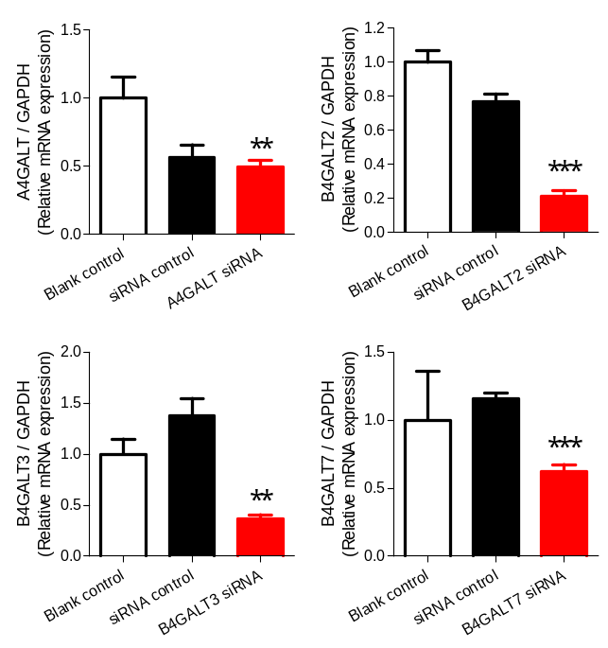
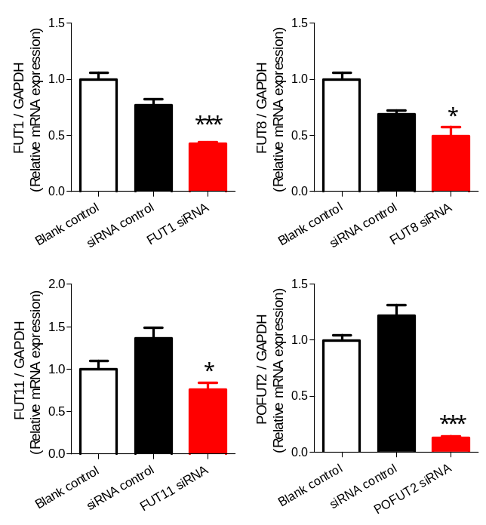

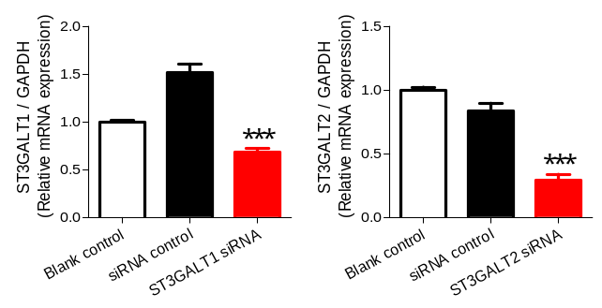
Figure 2
