Supplementary Information

Development and validation of an eco-friendly and high-throughput HPLC method to quantify pyrethroid and pyriproxyfen in long-lasting insecticide-treated nets

Kyle J. Walker^{1*}, Christopher T. Williams^{1*}, Folasade O. Oladepo¹, John Lucas², David Malone³, Mark J.I. Paine¹, and Hanafy M. Ismail^{1§}

¹Vector Biology Department, Liverpool School of Tropical Medicine, Pembroke Pl, Liverpool L3 5QA, U.K.
²John Richard Lucas, Technical Consultant, Cowleigh Park Farm, Cowleigh Road, Malvern
WR13 5HJ, U.K.
³Innovative Vector Control Consortium, Liverpool School of Tropical Medicine, Pembroke Place, Liverpool L3 5QA, U.K.

*Shared first authorship

§Contact: Hanafy.ismail@lstmed.ac.uk

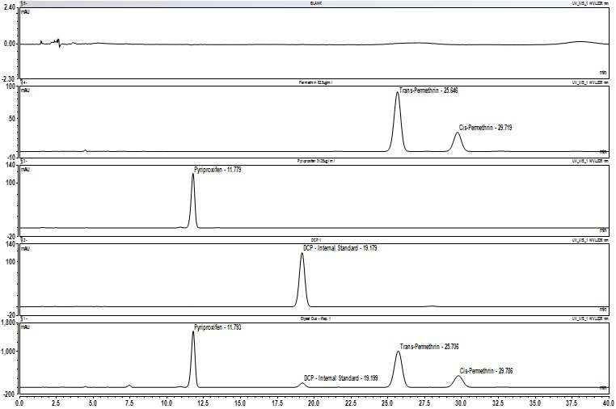
Figure S1. HPLC chromatograms for insecticides extracted from Olyset® Duo and analytical standards insecticide. From top to bottom: blank sample solution, permethrin analytical standard, pyriproxyfen analytical standard, internal standard ‘dicyclohexyl phthalate (DCP)’, and sample solution following extraction of Olyset® Duo. The calculated percentage retention time (%RT= RT _{sample}/RT _{std} x 100) found 100.11 (pyriproxyfen), 100.1 (DCP), 100.23 (trans-permethrin), 100.22 (cis-permethrin). Peaks purity in sample solution was 997 for pyriproxyfen, 1000 for trans-permethrin and 1000 for cis-permethrin.

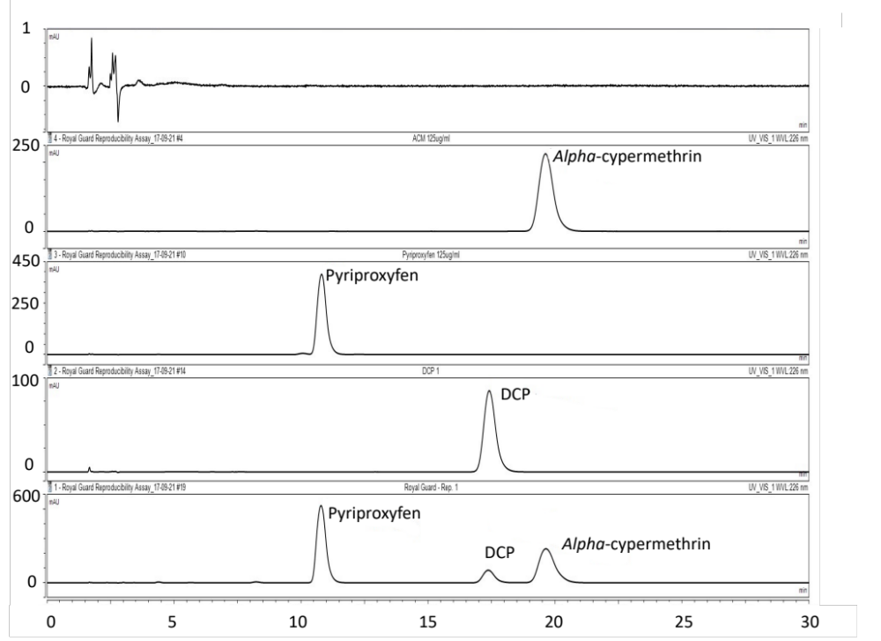
Figure S2. HPLC chromatograms for insecticides extracted from Royal Guard® Net and analytical standards insecticide. From top to bottom: blank sample solution, alpha-cypermethrin analytical standard, pyriproxyfen analytical standard, internal standard ‘dicyclohexyl phthalate (DCP)’, sample solution following extraction of Royal Guard® LLIN. The calculated percentage retention time (%RT= RT _{sample}/RT _{std} x 100) found 99.82% (Pyriproxyfen), 99.77% (DCP), and 100.07% (alpha-cypermethrin). Peaks purity in sample solution was 997 for pyriproxyfen and 1000 for alpha-cypermethrin.

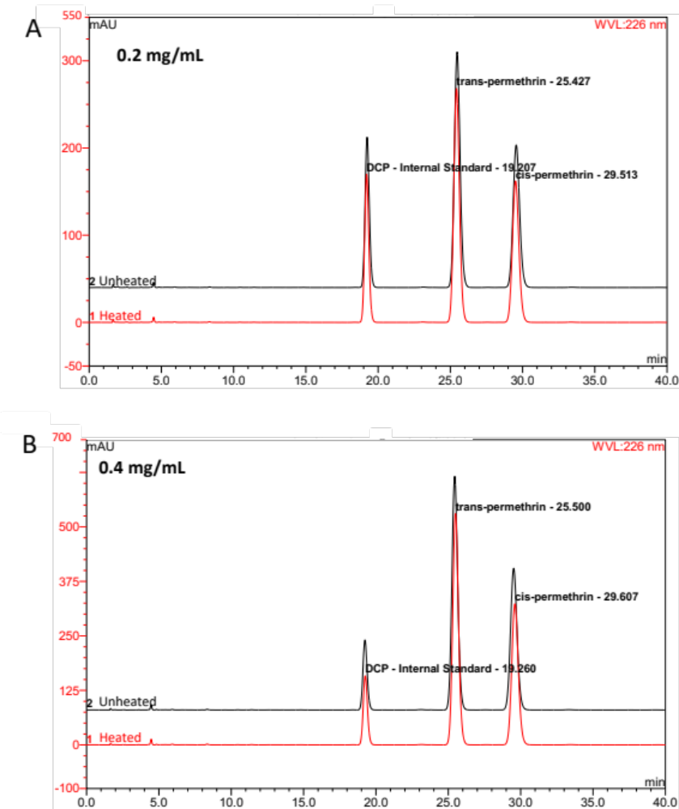
Figure S3. HPLC chromatograms for permethrin heat stability test. (A) heated vs unheated 0.2 mg/mL permethrin standards. (B) heated vs unheated 0.4 mg/mL permethrin standards.

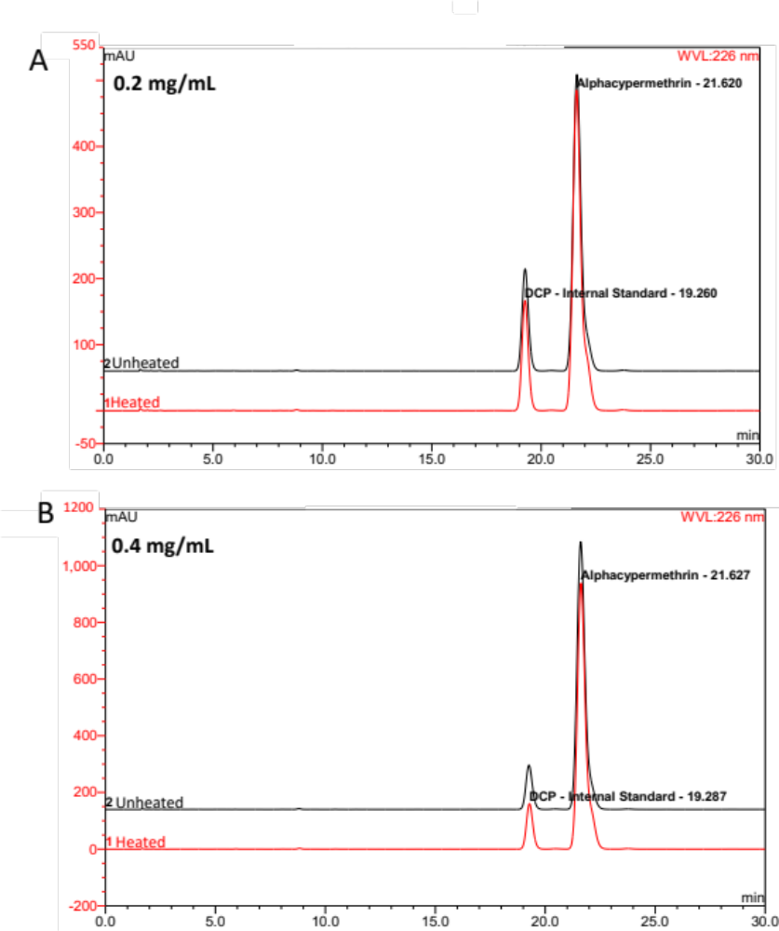
Figure S4. HPLC chromatograms for alpha-cypermethrin heat stability test. (A) heated vs unheated 0.2 mg/mL alpha-cypermethrin standards. (B) heated vs unheated 0.4 mg/mL alpha-cypermethrin standards.

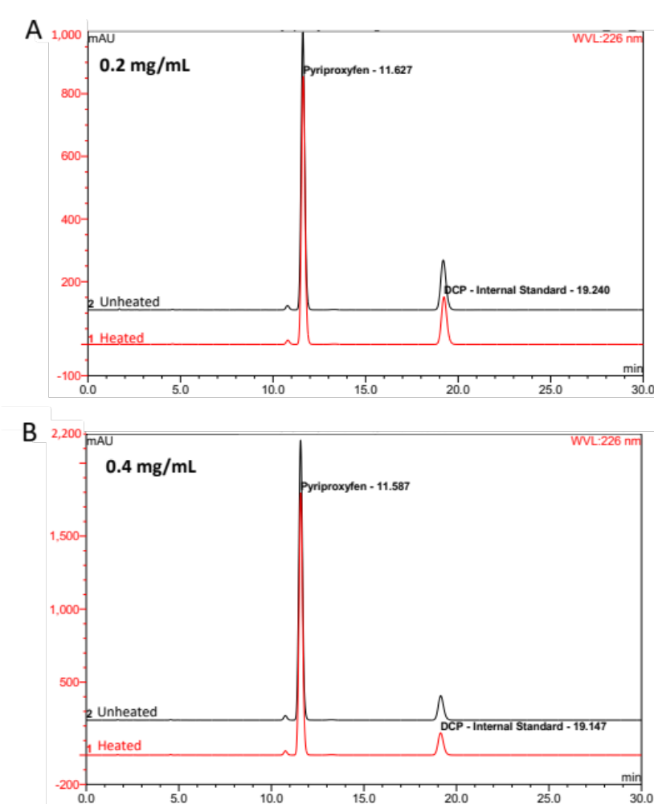

Figure S5. HPLC chromatograms for pyriproxyfen heat stability test. (A) heated vs unheated 0.2 mg/mL pyriproxyfen standards. (B) heated vs unheated 0.4 mg/mL pyriproxyfen standards.

Table S1. Analysis of permethrin content in unused Olyset® nets
Sample name | n | [Permethrin] g/kg | SD | %RSD
Olyset 1 | 3 | 19.4 | 1.0 | 5.2
Olyset 2 | 3 | 19.4 | 0.2 | 1.2
Olyset 3 | 3 | 18.3 | 0.3 | 1.8
Olyset 4 | 3 | 18.5 | 0.1 | 0.5
Olyset 5 | 3 | 18.6 | 0.8 | 4.2
Olyset 6 | 3 | 18.3 | 0.1 | 0.7
Olyset 7 | 3 | 19.5 | 1.8 | 9.1
Olyset 8 | 3 | 18.1 | 0.1 | 0.5
Olyset 9 | 3 | 18.6 | 0.2 | 1.0
Olyset 10 | 3 | 18.7 | 0.1 | 0.4
Olyset 11 | 3 | 18.7 | 0.3 | 1.5
Olyset 12 | 3 | 18.4 | 0.2 | 1.3
Olyset 13 | 3 | 18.2 | 0.0 | 0.2
Olyset 14 | 3 | 18.1 | 0.1 | 0.7
Olyset 15 | 3 | 18.1 | 0.1 | 0.7
Olyset 16 | 3 | 18.2 | 0.1 | 0.7
Olyset 17 | 3 | 18.6 | 0.1 | 0.7
Olyset 18 | 3 | 18.3 | 0.3 | 1.5
Olyset 19 | 3 | 18.6 | 0.3 | 1.5
Olyset 20 | 3 | 18.6 | 0.2 | 1.2
Olyset 21 | 3 | 21.1 | 0.4 | 1.7
Olyset 22 | 3 | 20.5 | 0.2 | 1.0
Olyset 23 | 3 | 20.2 | 0.2 | 1.1
Olyset 24 | 3 | 19.9 | 0.1 | 0.6
n; number of replicates, S.D.; standard deviation (n=3), %RSD: relative standard deviation (S.D./Mean*100)

Table S2. Analysis of permethrin and pyriproxyfen content in unused Olyset® Duo LLIN
Sample name | n | Pyriproxyfen g/kg ± SD | %RSD | Permethrin g/kg ± SD | %RSD
Olyset Duo 1 | 3 | 11 ± 0.3 | 2.4 | 19 ± 0.4 | 2.267
Olyset Duo 2 | 3 | 9.4 ± 0.2 | 2.4 | 16.5 ± 0.4 | 2.164
Olyset Duo 3 | 3 | 9.6 ± 0.1 | 0.7 | 16.8 ± 0.1 | 0.676
Olyset Duo 4 | 3 | 10.6 ± 0 | 0.1 | 18.3 ± 0.0 | 0.234
Olyset Duo 5 | 3 | 10.4 ± 0 | 0.2 | 18 ± 0.0 | 0.083
Olyset Duo 6 | 3 | 10.9 ± 0.4 | 3.3 | 18.9 ± 0.6 | 3.300
Olyset Duo 7 | 3 | 11 ± 0.3 | 2.3 | 19 ± 0.4 | 2.066
Olyset Duo 8 | 3 | 10.8 ± 0.2 | 2.2 | 18.8 ± 0.4 | 1.967
Olyset Duo 9 | 3 | 9.8 ± 0.4 | 4.3 | 18.3 ± 0.8 | 4.353
Olyset Duo 10 | 3 | 10.2 ± 0.2 | 1.6 | 18.8 ± 0.3 | 1.567
Olyset Duo 11 | 3 | 10.2 ± 0.2 | 2.0 | 18.9 ± 0.4 | 2.032
Olyset Duo 12 | 3 | 10 ± 0.1 | 0.5 | 18.5 ± 0.1 | 0.561
Olyset Duo 13 | 3 | 9.7 ± 0.1 | 1.3 | 18.2 ± 0.3 | 1.395
Olyset Duo 14 | 3 | 9.4 ± 0.6 | 6.1 | 17.6 ± 0.9 | 5.328
Olyset Duo 15 | 3 | 9.9 ± 0.2 | 1.6 | 18.5 ± 0.3 | 1.660
Olyset Duo 16 | 3 | 10 ± 0.0 | 0.5 | 18.6 ± 0.0 | 0.216
Olyset Duo 17 | 3 | 10.7 ± 0.2 | 1.5 | 20.6 ± 0.3 | 1.256
Olyset Duo 18 | 3 | 10.4 ± 0.1 | 0.8 | 19.9 ± 0.2 | 0.785
Olyset Duo 19 | 3 | 10.8 ± 0.1 | 1.2 | 20.5 ± 0.3 | 1.289
Olyset Duo 20 | 3 | 10.6 ± 0 | 0.5 | 20.3 ± 0.1 | 0.358
Olyset Duo 21 | 3 | 11.1 ± 0.2 | 1.5 | 21.2 ± 0.3 | 1.337
Olyset Duo 22 | 3 | 11 ± 0.1 | 0.5 | 20.9 ± 0.1 | 0.405
Olyset Duo 23 | 3 | 10.4 ± 0.3 | 2.7 | 20.1 ± 0.4 | 2.074
Olyset Duo 24 | 3 | 11.1 ± 0.2 | 1.4 | 21.1 ± 0.3 | 1.231
n; the number of replicates, S.D.; standard deviation (n=3), %RSD: relative standard deviation (STDEV/Mean*100)

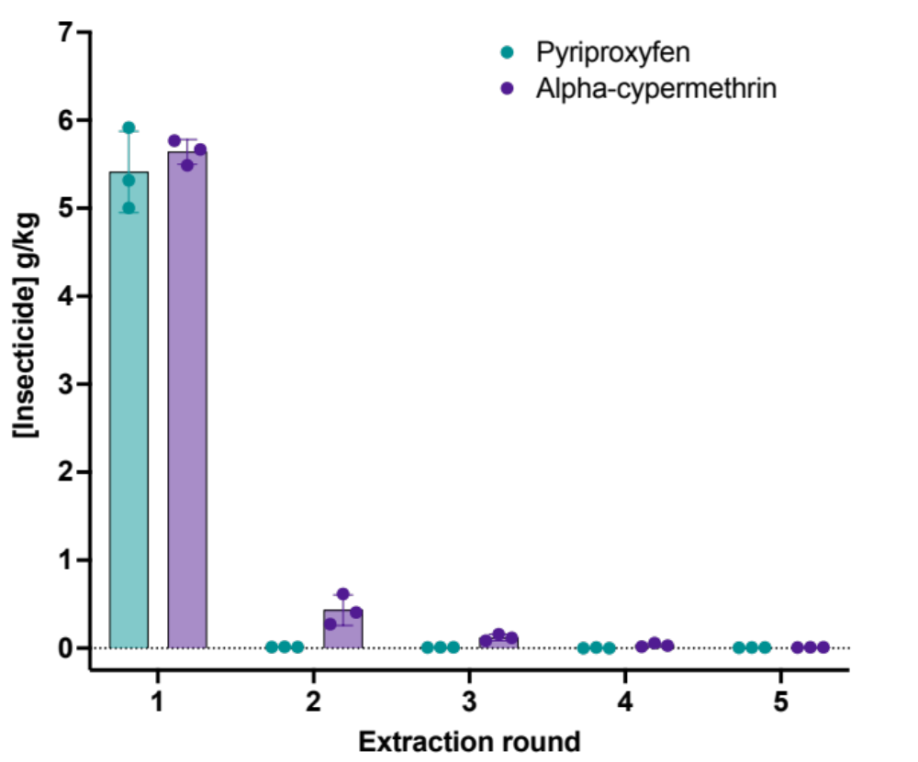
Figure S6. Total insecticide content in Royal Guard® net subjected to five cycles of extraction.

A B
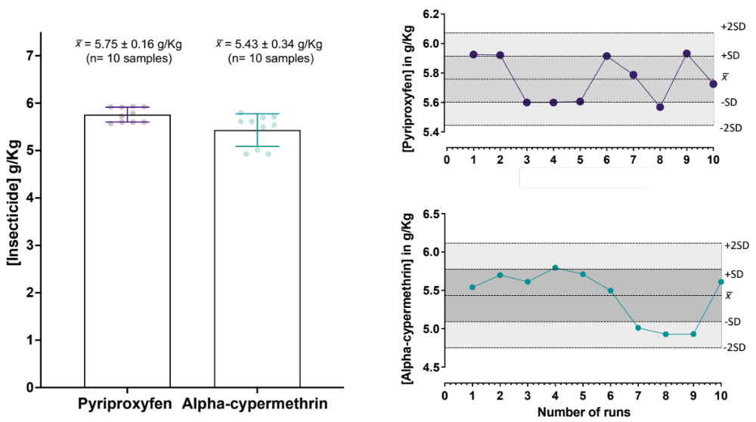
Figure S7. Quality control assessment of single Royal Guard® LLIN determined by the optimized method. (A) The average quantity (x̄) of pyriproxyfen and alpha-cypermethrin ± standard deviation (S.D.) recovered from the Royal Guard® net was analyzed ten times by the optimized method. (B) Levy-Jenning's charts for the one net were analyzed ten times by the optimized method. Pyriproxyfen (top chart) and alpha-cypermethrin (bottom chart) scored an average (x̄) of 5.75±0.16 and 5.43 ± 0.34 g/Kg, respectively. Reference concentrations for both active ingredients declared by the manufacture are denoted as red dotted lines on the charts.

