Supplemental materials

Supplemental material 1: The variation of rodent infestation (plate positivity) per valley and campaign
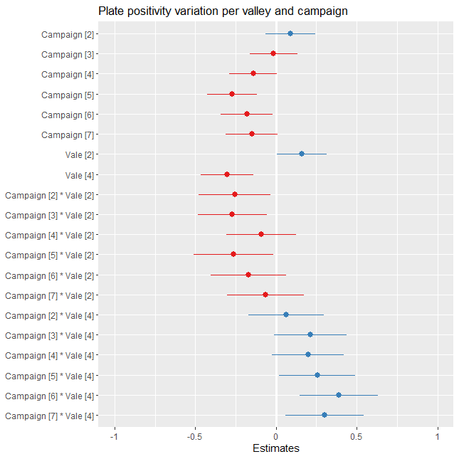

Supplemental material 2: Summary of the bivariate analysis for variables selection in the general model with the variables description and p-values
S/N | Variable | Description of variable | p-value
1. | Valley | Categorical, one of the valleys where the experiment was conducted | 0.0279
2. | Campaign/Treatment | Categorical (pre & post-intervention). Period the campaign was conducted | 8.23e-07
3. | Mud | Presence or absence (1 or 0). Whether there was mud ≤ 20m of the sampling point | 0.009222
4. | Soil | Presence or absence (1 or 0). Whether there was exposed soil ≤ 20m of the sampling point | 0.4473
5. | Vegetation | Presence or absence (1 or 0). Whether there was vegetation ≤ 20m of the sampling point | 0.001757
6. | Dogs | Presence or absence and counts. Whether the sampling point (household) has dogs and the number | 0.253
7. | Chicken | Presence or absence and counts. Whether the sampling point (household) has chicken and the number | 0.878
8. | Garbage | Categorical (Yes or No). Whether there was exposed garbage ≤ 20m of the sampling point | 1.67e-05
9. | Water | Presence or absence (1 or 0). Presence of water access ≤ 20m of the sampling point | 0.413
10. | Food | Presence or absence (1 or 0). Presence of food access ≤ 20m of the sampling point | 0.9370
11. | Sewer | Presence or absence (1 or 0). Presence of sewer access ≤ 20m of the sampling point | 0.002351
12. | Construction materials | Presence or absence (1 or 0). Presence of construction materials ≤ 20m of the sampling point | 0.4771
13. | Debris | Categorical (Yes or No). Presence of debris ≤ 20m of the sampling point | 0.21949

Supplemental material 3a-d: Prediction of rodent dynamics by the significantly correlated variables
