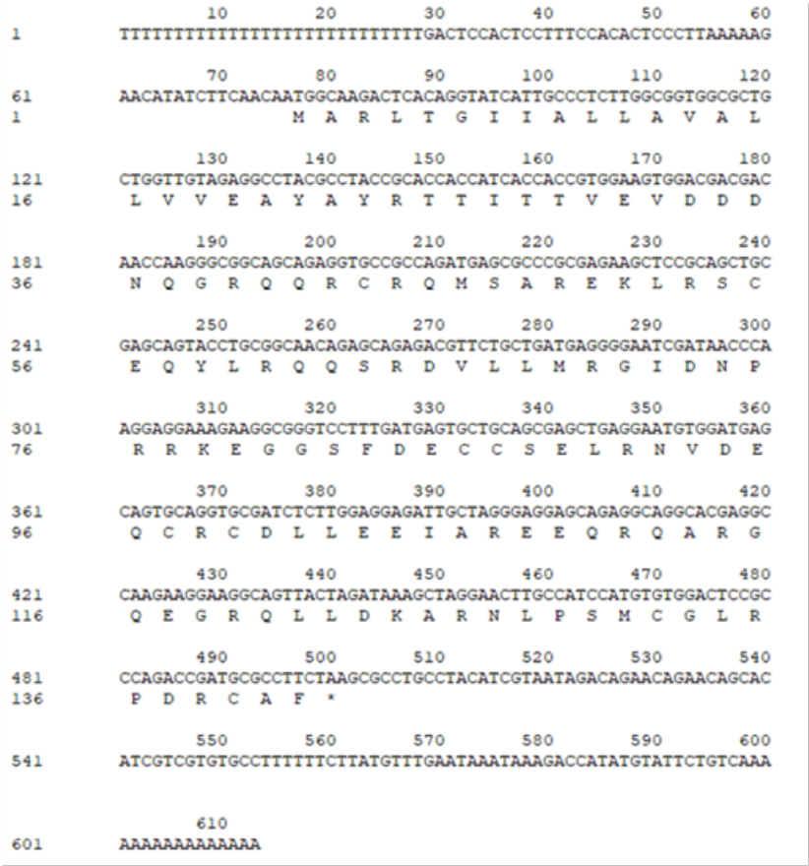
Fig. 1 Full-length of TkAAI cDNA and coding sequence with encode amino acid sequence

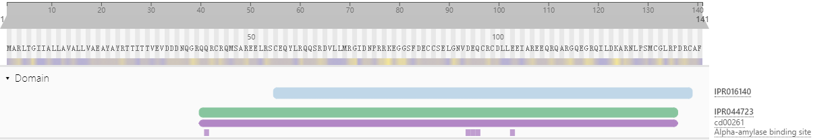
Fig. 2 InterProScan analysis of TkAAI protein domain sequence results. IPR016140 indicated Bifunctional inhibitor/plant lipid transfer protein/seed storage helical domain (http://www.ebi.ac.uk/interpro/entry/InterPro/IPR016140/). SM00499 indicated Plant lipid transfer protein / seed storage protein / trypsin-alpha amylase inhibitor domain family (http://www.ebi.ac.uk/interpro/entry/smart/SM00499/). PF00234 indicated Protease inhibitor/seed storage/LTP family (http://www.ebi.ac.uk/interpro/entry/pfam/PF00234/). CD00261 indicated AAI_SS: Alpha-Amylase Inhibitors (AAIs) and Seed Storage (SS) Protein subfamily (http://www.ebi.ac.uk/interpro/entry/cdd/CD00261/)
Table 1 The source of the 2S albumin seed protein analyzed in this research
Organism | Name | Accession no. | Our designation
Cucurbita maxima | 2S albumin | XP_022993226.1 | C. maxima 2S1
Cucurbita moschata | 2S albumin | XP_022942593.1 | C.moschata2S1
 | 2S albumin-like | XP_022932144.1 | C.moschata2S2
Benincasa hispida | 2S albumin-like | XP_038904176.1 | Bh2S1
 | 2S albumin-like | XP_038889520.1 | Bh2S2
Cucumis sativus | 2S albumin | XP_011650534.1 | C.sativus2S1
Momordica charantia | 2S albumin-like | XP_022154978.1 | Mc2S1
 | 2S albumin-like | XP_022154980.1 | Mc2S2
 | 2S albumin-like | XP_022154961.1 | Mc2S3
 | 2S albumin-like | XP_022154977.1 | Mc2S4
 | 2S albumin-like | XP_022154957.1 | Mc2S5
Papaver somniferum | 2S albumin-like | XP_026396635.1 | Ps2S1
 | 2S albumin-like | XP_026382546.1 | Ps2S2
 | 2S albumin-like | XP_026396625.1 | Ps2S3
 | 2S albumin-like | XP_026396626.1 | Ps2S4
 | 2S albumin-like | XP_026396699.1 | Ps2S5
Nicotiana tomentosiformis | 2S sulfur-rich seed storage protein 2-like | XP_009588326.1 | Nt2S1
Ricinus communis | 2S albumin-like | XP_002522847.1 | Rc2S1
 | 2S albumin | prf||1707274A | Rc2S2
Pistacia vera | 2S albumin-like | XP_031264994.1 | Pv2S1
Rhodamnia argentea | 2S albumin-like | XP_030522646.1 | Ra2S1
Eucalyptus grandis | 2S albumin | XP_010064413.2 | Eg2S1
 | 2S albumin-like | XP_010064411.2 | Eg2S2
Anacardium occidentale | 2S albumin | QRM12804.1 | Ao2S1
 | 2S albumin | QRM12805.1 | Ao2S2
 | 2s albumin | AAL91665.1 | Ao2S3
Cannabis sativa | 2S albumin-like | XP_030503907.1 | C.sativa2S1
Syzygium oleosum | 2S albumin-like | XP_030453631.1 | So2S1
 | 2S albumin-like | XP_030453290.1 | So2S2

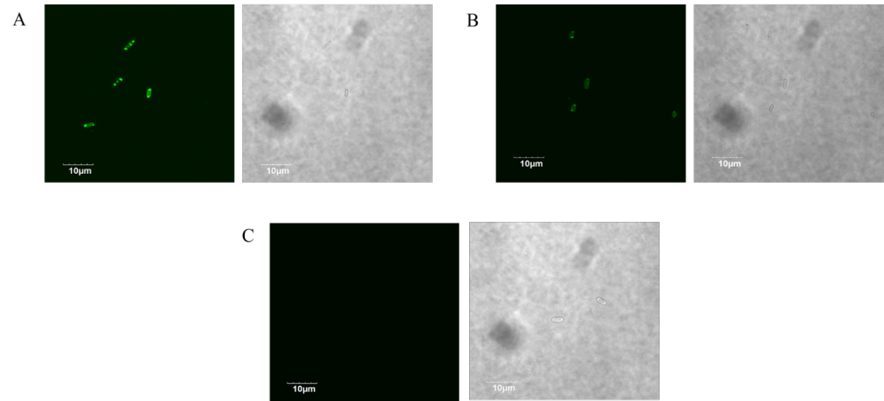
Fig. 3 Confocal fluorescence microscopy imaging to detect fluorescence signal of E. Coli

Table 2 Alpha-amylase inhibition assay data
Repetition | Inhibition ratio (%)
1 | 65.94
2 | 76.69
3 | 39.76

