Table 1: QC phantom specifications as reported in the manufacturer’s datasheets (QRM GmbH, Möhrendorf, Germany) and corresponding QC parameters for which they are used.
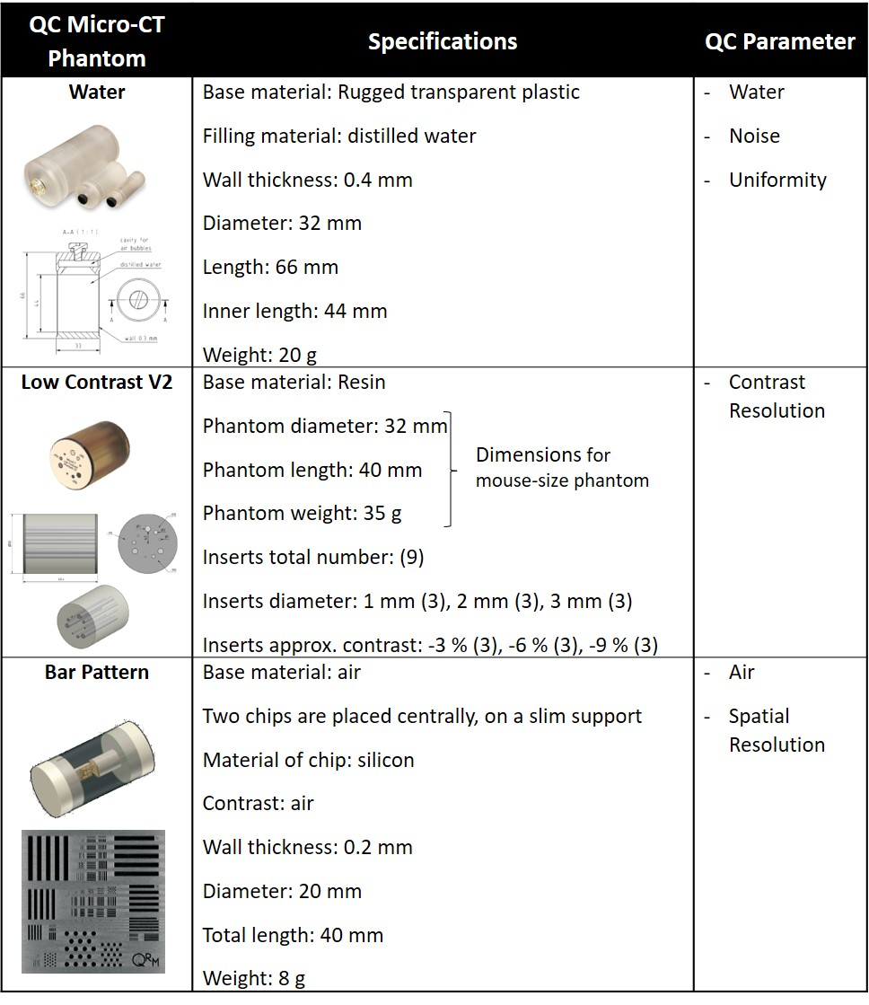

Table 2: Tolerance ranges calculated for all the monitored QC parameters for the Quantum GX micro-CT (PerkinElmer, Inc. Waltham, MA).

