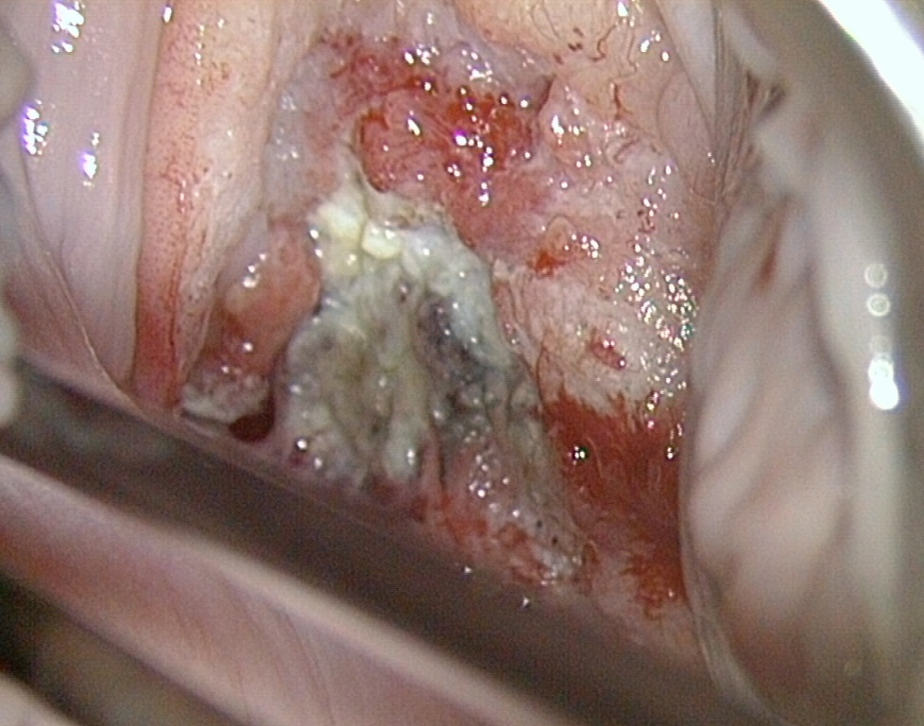
Figure S3
Colposcopy of the ID 6 in Table S5. Necrotic tissue is visible on the cervix.

