Additional file 1
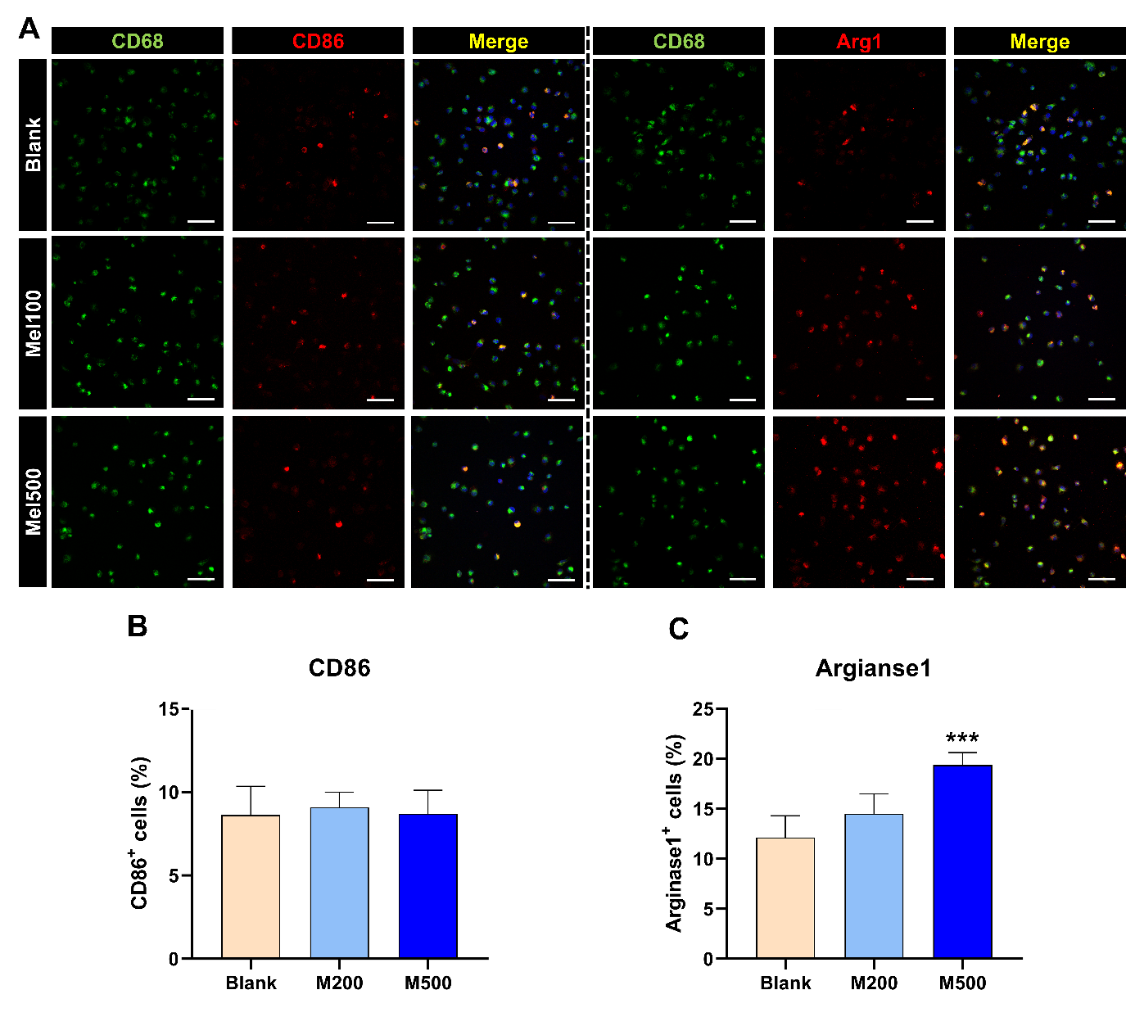
Figure S1. M2 macrophages were also activated by melittin treatment only. (A) Representative images of M1 macrophages (CD86 positive, double-stained with ED1) and M2 macrophages (Arginase 1 positive, double-stained with ED1). White scale bar = 50 µm. (B) Quantitative percentage of the CD86-stained cells (M1) in total CD68-positive cells. (C) Quantitative percentage of the Arg1-stained cells (M2) in total CD68-positive cells. Data are expressed as the means ± SEM. Significant differences indicated as ***p < 0.001 vs. the blank group were analyzed via one-way ANOVA with Tukey’s post-hoc test.

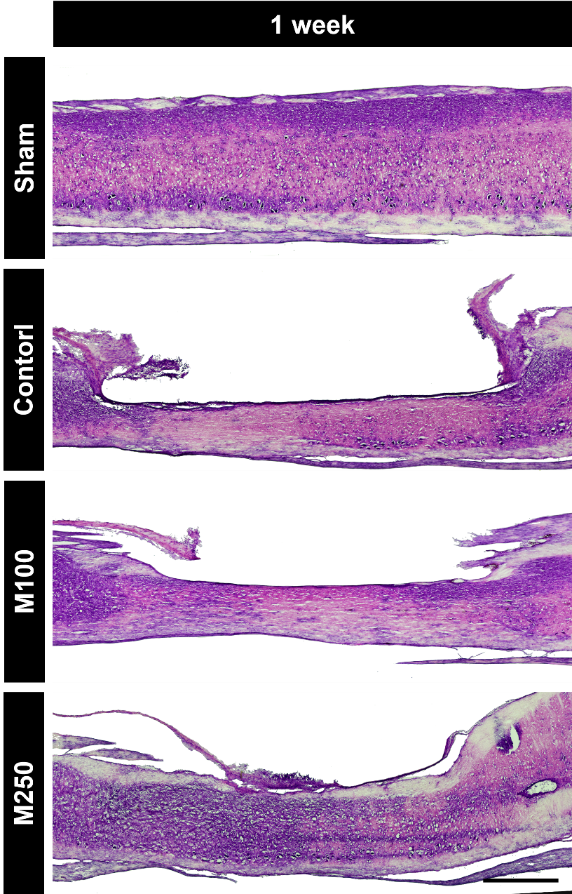

Figure S2. Representative H&E images of spinal cords in each group at 1week after LSS induction. Black scale bar = 1 mm.

