Supplementary information

Direct RBS Engineering of the Biosynthetic Gene Cluster for Efficient Productivity of Violaceins in E. coli
Yuyang Zhang^{a, b,} *, Hongping Chenª, Yao Zhangª, Huifang Yinª, Chenyan Zhou^{a, b}, Yan Wang^{a, b,} *
ª School of Life Sciences and Technology, Xinxiang Medical University, Xinxiang 453003, Henan, China.
^{b} Synthetic Biology Engineering Lab of Henan Province, Xinxiang 453003, Henan, China.
*Address correspondence to Yuyang Zhang, yyzhang2018@xxmu.edu.cn and Yan Wang, wangyan19820527@163.com
Tel: +86-0373-3029887; Fax: +86-0373-3029887

Contents
Table S1. The plasmids used in this study
Fig. S1. The plasmid maps of Vio12472 and dVio12472 constructed in this study
Fig. S2. The phenotypes of Violaceins producing strains compared with the negative controls.
Fig. S3. Characterization of the metabolic products by HPLC and HR-MS.
Fig. S4. The standard curves of violacein (A), deoxyviolacein (B) and L-tryptophan (C) in this study
Fig. S5. The original sequencing data for the first round of RBS mutagenesis in this study
Fig. S6. The SDS-PAGE results for the detection of the protein expression in RBS mutants and wild type.
Fig. S7. The biomass data of the strains in the third and fourth round of RBS mutagenesis and (BCDE)m optimized by one-factor-at-one-time method
Fig. S8. The construction and verification of the tnaA-knockout mutant in E. coli BL21(DE3) host cell

Table S1. The plasmids used in this study
Plasmid | Characteristic | Source
pETduet-1 | The common IPTG induced protein expression vector with two multiple clone site (MCS). Amp-resistance. | Novagen
Vio12472 | The vioABCDE operon from C. violaceum ATCC 12472 was cloned in the KpnI site of pETduet-1 | This study
dVio12472 | The artificial vioABCE operon from C. violaceum ATCC 12472 was cloned in the KpnI site of pETduet-1 | This study
Vio12472-vioB-RBSm-1 | The natural RBS (GGGAAA) of vioB gene was mutated to GGGGAG in Vio12472 | This study
Vio12472-vioB-RBSm-2 | The natural RBS (GGGAAA) of vioB gene was mutated to AAGAAA in Vio12472 | This study
Vio12472-vioB-RBSm-3 | The natural RBS (GGGAAA) of vioB gene was mutated to AAGGAG in Vio12472 | This study
Vio12472-vioC-RBSm | The AA base-pairs bewteen the stop codon (TGA) of vioB and initial codon (ATG) of vioC was deleted, resulting in forming a vioBC overlapping gene in Vio12472 | This study
Vio12472-vioD-RBSm-1 | The GTC codon in the C-terminal of VioC was deleted to shorten the distance of vioD's RBS (AGGGAG) with its initial codon (ATG) in Vio12472 | This study
Vio12472-vioD-RBSm-2 | The GTCAAC codon in the C-terminal of VioC was deleted to shorten the distance of vioD's RBS (AGGGAG) with its initial codon (ATG) in Vio12472 | This study
Vio12472-vioE-RBSm | The natural RBS (AGGAGG) of vioE gene was mutated to AAGGAG in Vio12472 | This study
Vio12472-vioBC-RBSm | Combinational RBS mutagenesis of Bm-3 and Cm in Vio12472 | This study
Vio12472-vioBD-RBSm | Combinational RBS mutagenesis of Bm-3 and Dm-1 in Vio12472 | This study
Vio12472-vioBE-RBSm | Combinational RBS mutagenesis of Bm-3 and Em in Vio12472 | This study
Vio12472-vioCD-RBSm | Combinational RBS mutagenesis of Cm and Dm-1 in Vio12472 | This study
Vio12472-vioCE-RBSm | Combinational RBS mutagenesis of Cm and Em in Vio12472 | This study
Vio12472-vioDE-RBSm | Combinational RBS mutagenesis of Dm-1 and Em in Vio12472 | This study
Vio12472-vioBCD-RBSm | Combinational RBS mutagenesis of Bm-3, Cm and Dm-1 in Vio12472 | This study
Vio12472-vioBCE-RBSm | Combinational RBS mutagenesis of Bm-3, Cm and Em in Vio12472 | This study
Vio12472-vioBDE-RBSm | Combinational RBS mutagenesis of Bm-3, Dm-1 and Em in Vio12472 | This study
Vio12472-vioCDE-RBSm | Combinational RBS mutagenesis of Cm, Dm-1 and Em in Vio12472 | This study
Vio12472-vioBCDE-RBSm | Combinational RBS mutagenesis of Bm-3, Cm, Dm-1 and Em in Vio12472 | This study

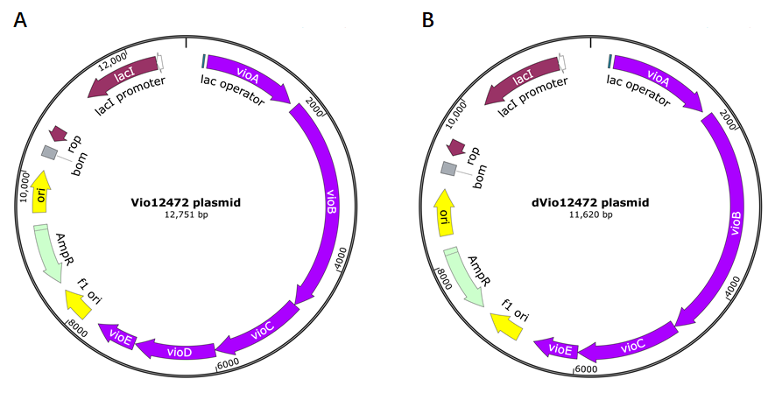
Fig. S1. The two basic plasmid maps of Vio12472 (A) and dVio12472 (B) in this study.

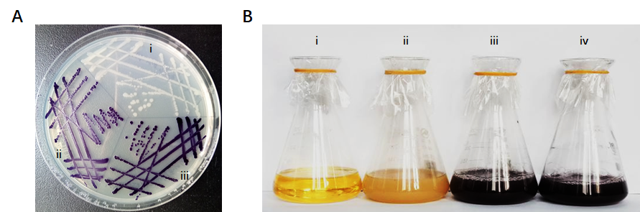
Fig. S2. The phenotypes of Violaceins producing strains compared with the negative controls. A. Phenotypes on the solid plate. i, E. coli BL21(DE3) (pETduet-1); ii, E. coli BL21(DE3) (Vio12472); iii, E. coli BL21(DE3) (dVio12472). B, Phenotypes in the liquid fermentation. i, LB fermentation broth in the flask; ii, E. coli BL21(DE3) (pETduet-1); iii, E. coli BL21(DE3) (Vio12472); iv, E. coli BL21(DE3) (dVio12472).

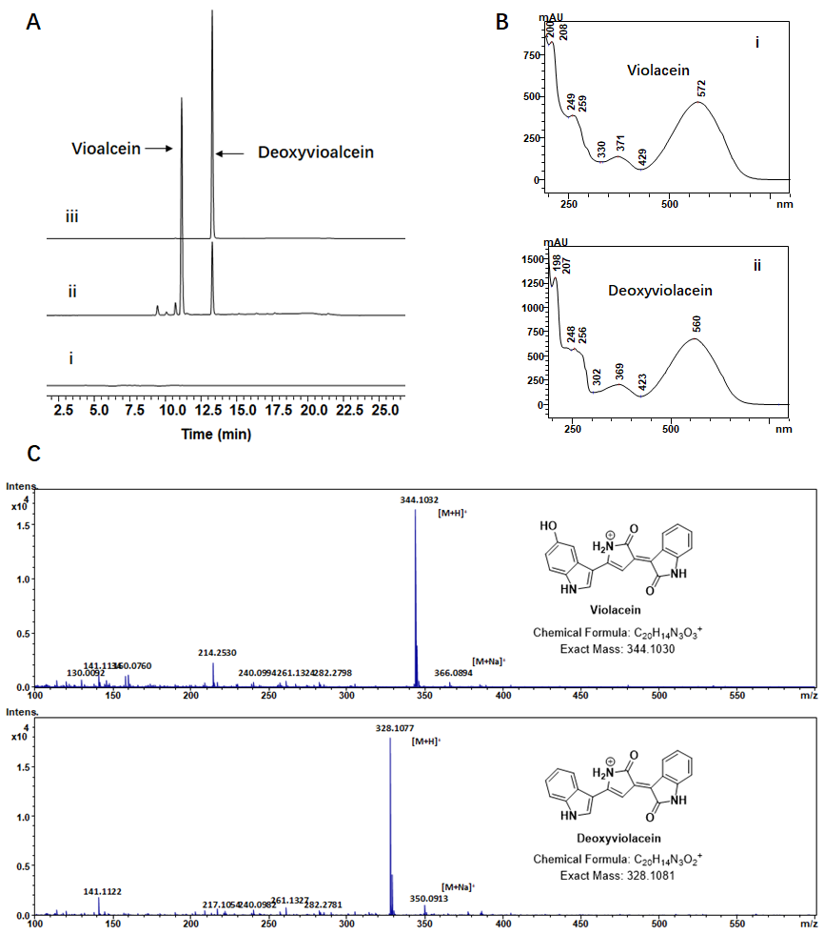
Fig. S3. Characterization of the metabolic products by HPLC and HPLC-MS. A. HPLC profiles (at 575 nm) of violaceins producing strains. i, E. coli BL21(DE3) (pETduet-1). ii, E. coli BL21(DE3) (Vio12472). iii, E. coli BL21(DE3) (dVio12472). B. The UV-Vis spectrum for the peaks of violacein and deoxyviolacein in HPLC. i, violacein; ii, deoxyviolacein. C. The mass spectra of violacein and deoxyviolacein determined by HPLC-MS-TOF (ESI) in this study. The detected molecular ions [M+H]⁺ of violacein was 344.1032 compared with its exact mass (344.1030). The detected molecular ions [M+H]⁺ of deoxyviolacein was 328.1077 compared with its exact mass (344.1081).
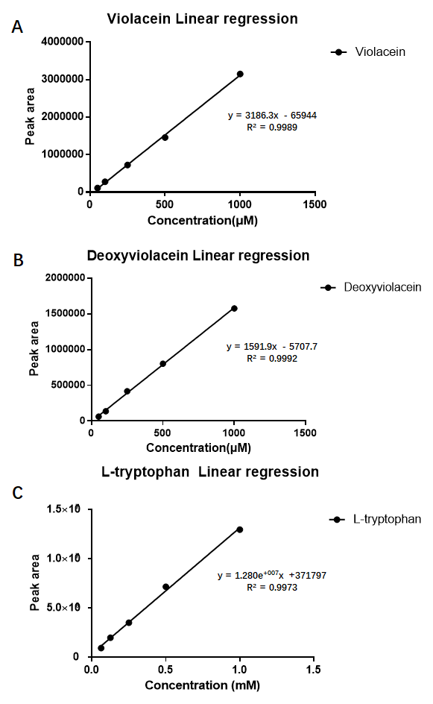
Fig. S4. The standard curves of violacein (A), deoxyviolacein (B) and L-tryptophan (C) in this study.
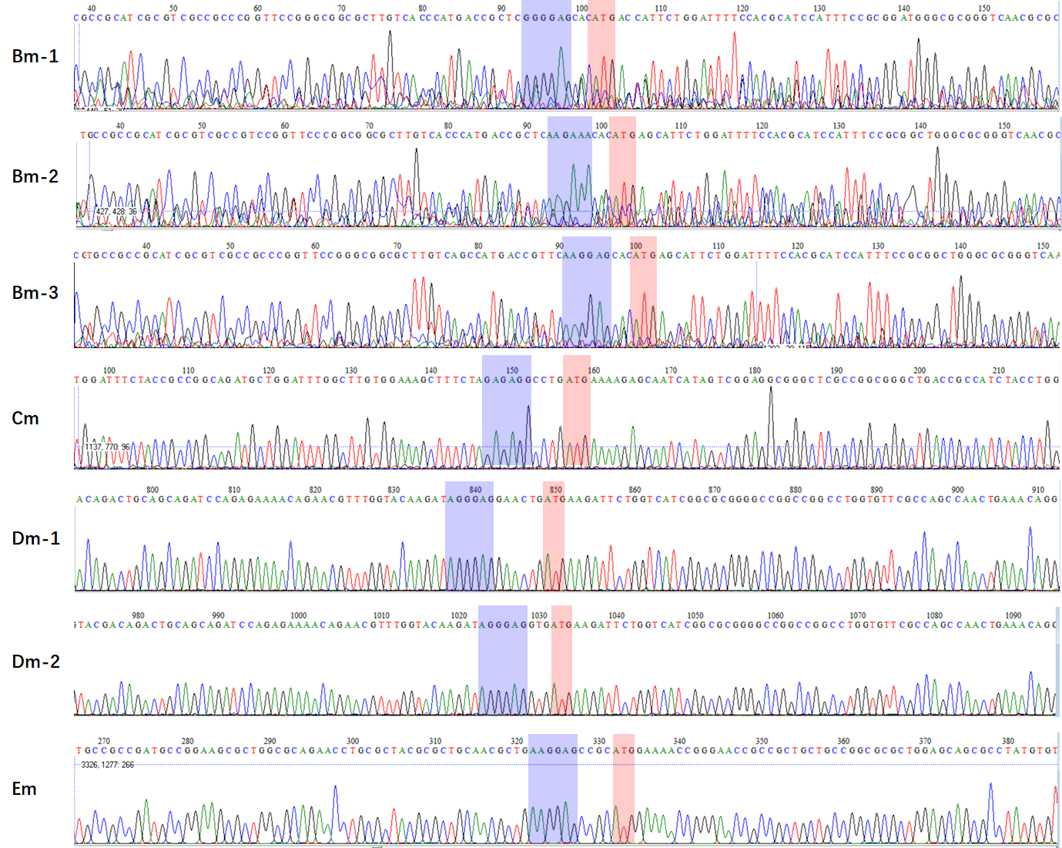
Fig. S5. The original sequencing data for the first round of RBS mutagenesis in this study. Blue boxes represent the RBSs within the mutated Violaciens biosynthetic gene cluster. Red boxes represent the initial codons of the genes, vioB, vioC, vioD and vioE. Note: Sequencing background noises were found in Bm-1, Bm-2 and Bm-3 but not affected the judgment of the results.
Fig. S6. The SDS-PAGE results for the detection of the protein expression in RBS mutants and wild type. M, Prestained protein ladder (Thermo); 1, E. coli BL21(DE3) (pETduet-1); 2, E. coli BL21(DE3) (Vio12472); 3, Bm; 4, Em; 5, (BE)m.

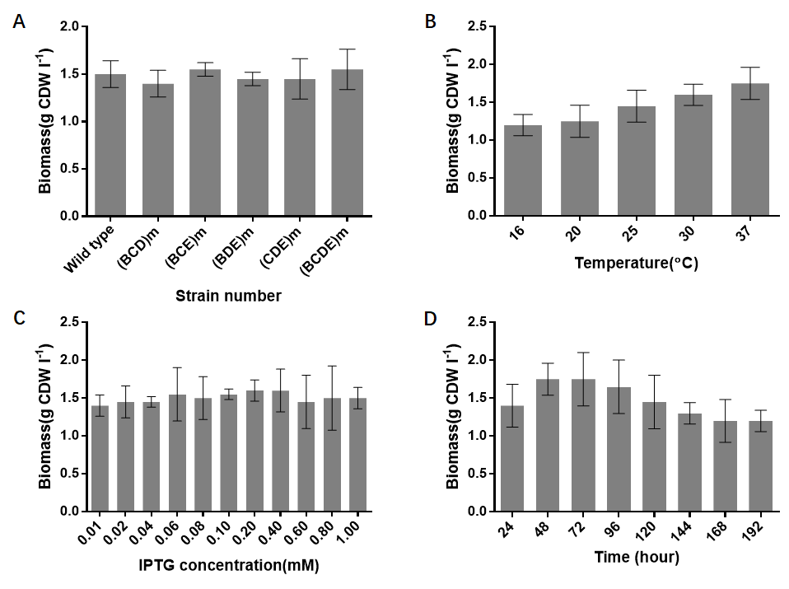
Fig. S7. The biomass data of the strains in the third and fourth round of RBS mutagenesis and (BCDE)m optimized by one-factor-at-one-time method. A. The biomass of (BCD)m, (BCE)m, (BDE)m, (CDE)m and (BCDE)m compared with the wild type strain E. coli BL21(DE3) (Vio12472). B. The biomass of (BCDE)m at different temperatures (16 ℃, 20 ℃, 25 ℃, 30 ℃, 37 ℃). C. The biomass of (BCDE)m at various concentrations of IPTG (0.01, 0.02, 0.04, 0.06, 0.08, 0.10, 0.20, 0.40, 0.60, 0.80 and 1.00 mM). D. The biomass changes of (BCDE)m in the 192 h’s cultivation period.

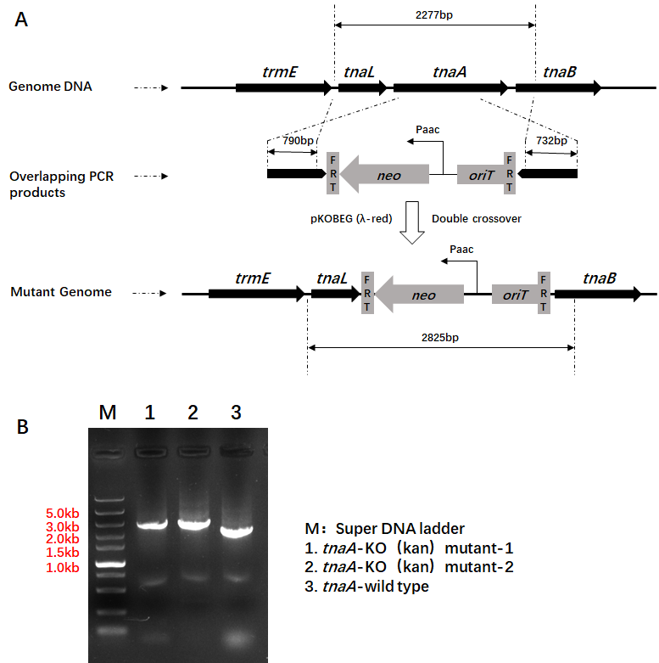
Fig. S8. The construction and verification of the tnaA-knockout mutant in E. coli BL21(DE3) host cell. A. The working principle of λ-red recombination method. The 2277 bp covering the ORF of tnaA gene in the genome of E. coli BL21(DE3) was replaced by the kanamycin resistant gene flanked by homologous arms (2825 bp). B. The DNA electrophoretogram of the PCR products based on tanA-wild type and tanA-KO (kan) mutants.

