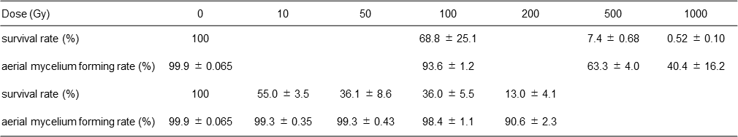
Table 1. Survival rates and aerial mycelium forming rate of the carbon ion irradiated spores of Streptomyces coelicolor JCM4020.

