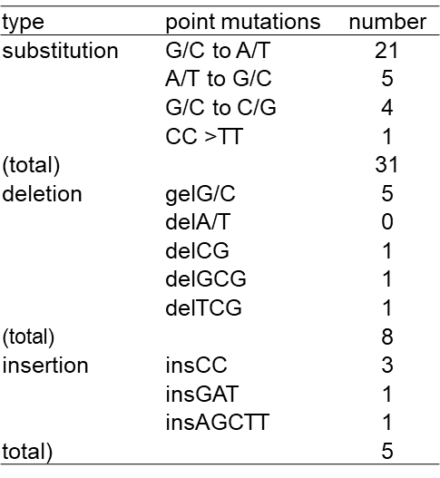
Table 3. Type of point mutations found in the RED deficient mutants of S. coelicolor JCM4020 by carbon ion irradiation.

