Supplementary Data
Table S1 Top 20 most productive authors from South and Southeast Asian Countries publishing in the domain of groundwater during 1970-2020.
SCRª | Authors | TA^{b} | h-index | TC^{c} | Institute
1 | Elango L. | 75 | 24 | 2301 | Department of Geology, CEG Campus, Anna University, Chennai, India
2 | Ahmed S. | 68 | 24 | 2167 | Indo-French Centre for Groundwater Research, CSIR- National Geophysical Research Institute, Hyderabad, India
3 | Chidambaram S. | 66 | 25 | 1880 | Department of Earth Sciences, Annamalai University, Cuddalore, Tamil Nadu, India
4 | Ahmed K.M. | 65 | 33 | 5372 | Department of Geology, University of Dhaka, Bangladesh
5 | Mukherjee A. | 54 | 23 | 1783 | Department of Geology and Geophysics, Indian Institute of Technology Kharagpur, Kharagpur, India,
6 | Prasanna M.V. | 52 | 21 | 1238 | Department of Applied Geology, School of Engineering and Science, Curtin University, Sarawak Malaysia
7 | Srinivasamoorthy K. | 44 | 23 | 1582 | Department of Earth Sciences, Pondicherry University, Pondicherry, India
7 | Subba Rao N. | 44 | 25 | 1818 | Department of Geology, Andhra University, Visakhapatnam, Andhra Pradesh, India
9 | Rahman M.M. | 43 | 22 | 1833 | Department of Environmental Sciences, Jahangirnagar University, Dhaka, Bangladesh
10 | Chakraborti D. | 38 | 27 | 4552 | School of Environmental Studies, Jadavpur University, Kolkata, India
11 | Jha M.K. | 36 | 20 | 1987 | Agricultural and Food Engineering Department (AgFE) Department, Indian Institute of Technology Kharagpur, Kharagpur, India
12 | Bhattacharya P. | 35 | 21 | 2683 | KTH-International Groundwater Arsenic Research Group, Department of Land and Water Resources Engineering, Royal Institute of Technology, Stockholm, Sweden
13 | Subramani T. | 32 | 12 | 848 | Department of Geology, CEG Campus, Anna University, Chennai, India
13 | Van Geen A. | 32 | 21 | 2189 | Lamont-Doherty Earth Observatory, Columbia University, United States,
15 | Singh V.S. | 31 | 19 | 1172 | CSIR- National Geophysical Research Institute Hyderabad, India
16 | Eldho T.I. | 30 | 10 | 276 | Department of Civil Engineering, Indian Institute of Technology Bombay, India
16 | Mondal N.C. | 30 | 14 | 911 | Academy of Scientific and Innovative Research (AcSIR), CSIR-National Geophysical Research Institute, Hyderabad, India
18 | Ramanathan A.L. | 27 | 15 | 848 | School of Environmental Sciences, Jawaharlal Nehru University, New Delhi, India
19 | Ariz A.Z. | 26 | 15 | 562 | Department of Environmental Sciences, Faculty of Environmental Studies, Universiti Putra Malaysia,
19 | Brindha K. | 26 | 16 | 724 | Department of Geology, Anna University, Chennai, India
19 | Elangovan, K. | 26 | 5 | 177 | PSG College of Technology, Department of Civil Engineering, Coimbatore, India
ª The authors are arranged as per standard competition ranking (SCR) based on the total number of articles
^{b} TA– total number of articles by an author
^{c} TC – total citations

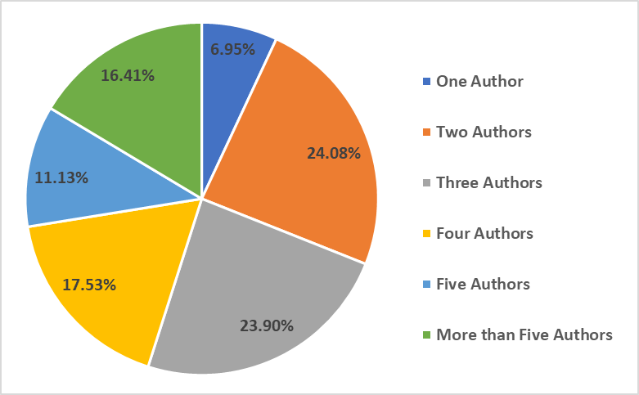
Fig. S1 Authorship patterns

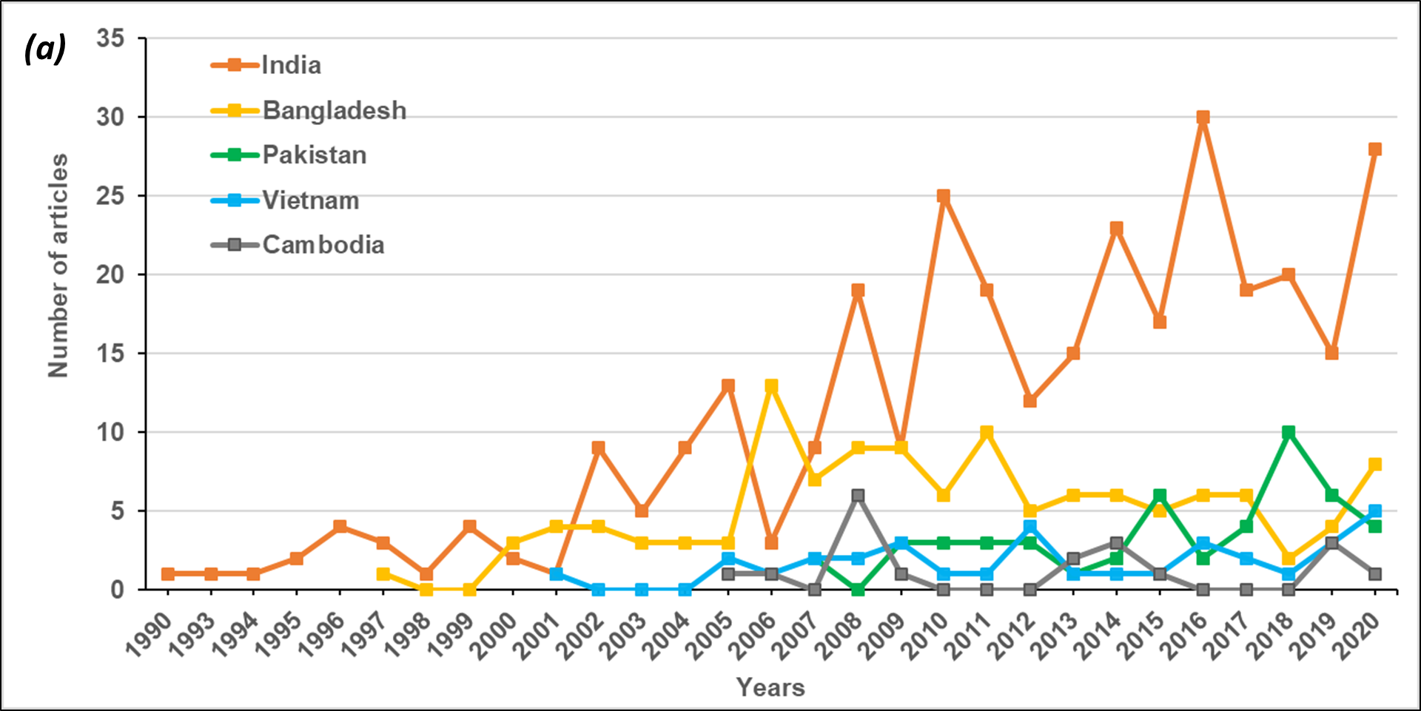
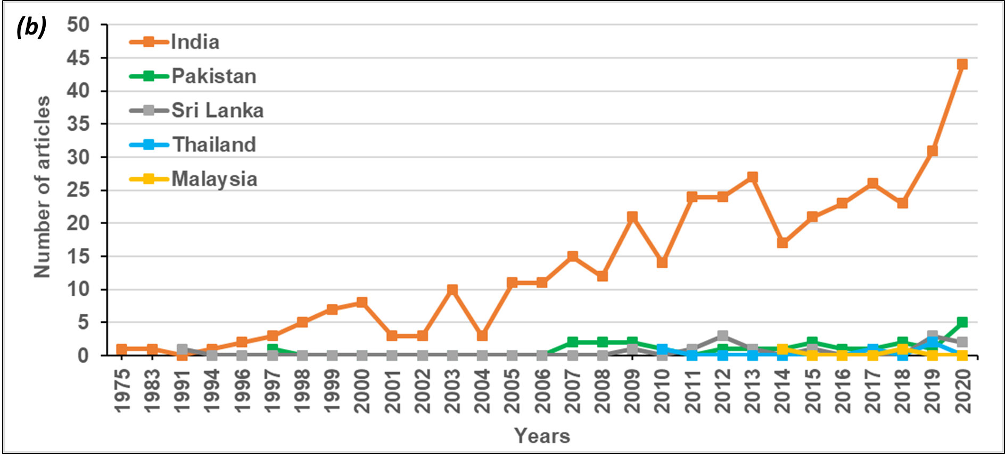
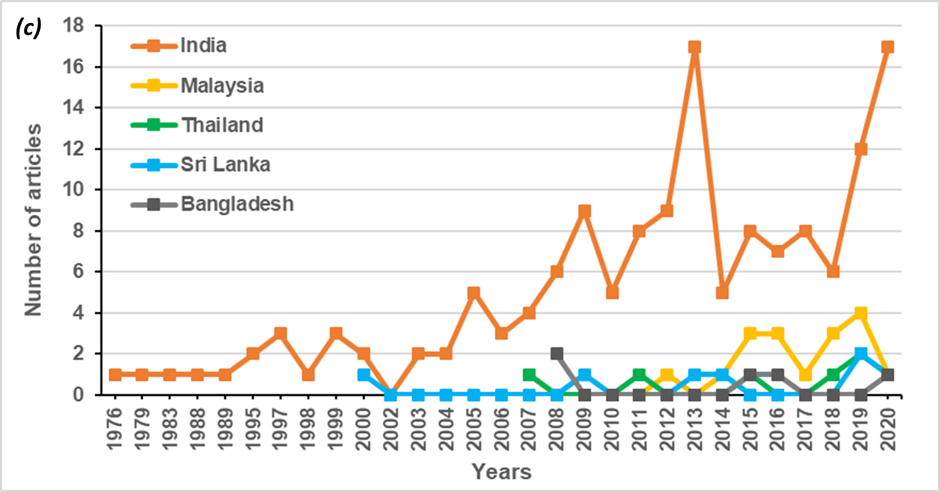
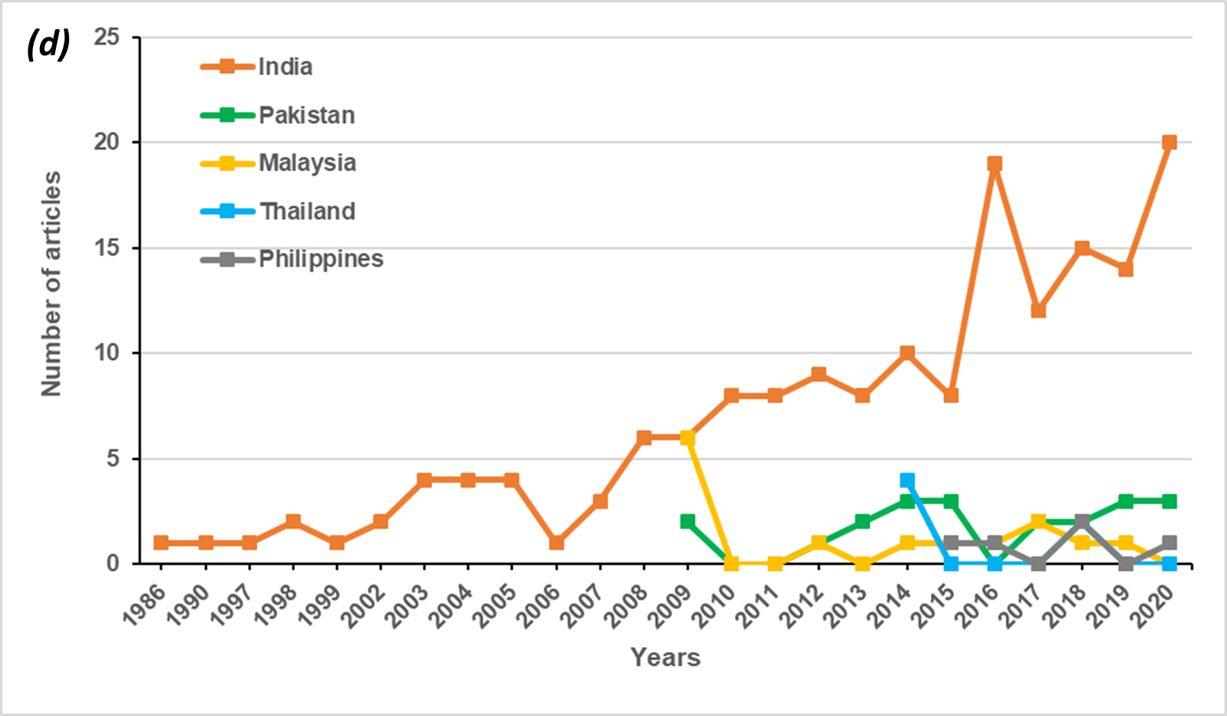
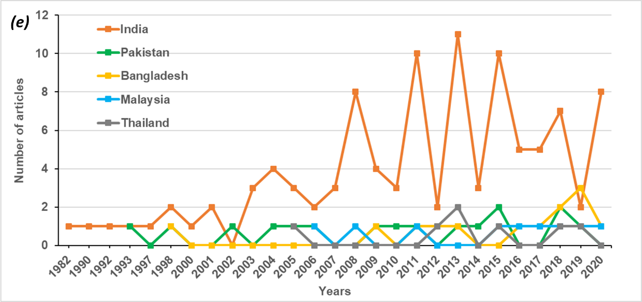
Fig. S2 Trends in groundwater contaminants from the top five contributors from South and Southeast Asia during 1970-2020 a) arsenic, b) fluoride, c) nitrate, d) heavy metals, and e) salinity

