Additional File 1 - Supplementary Figures

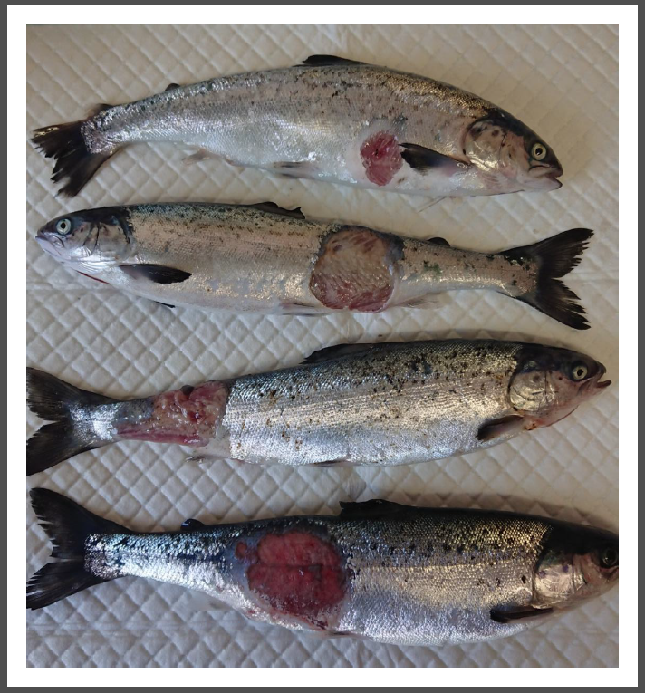
Supplementary Figure 1. Diseased salmon phenotype. The disease manifested itself in the form of large ulcers on the salmon skin and subsequent death of the fish.
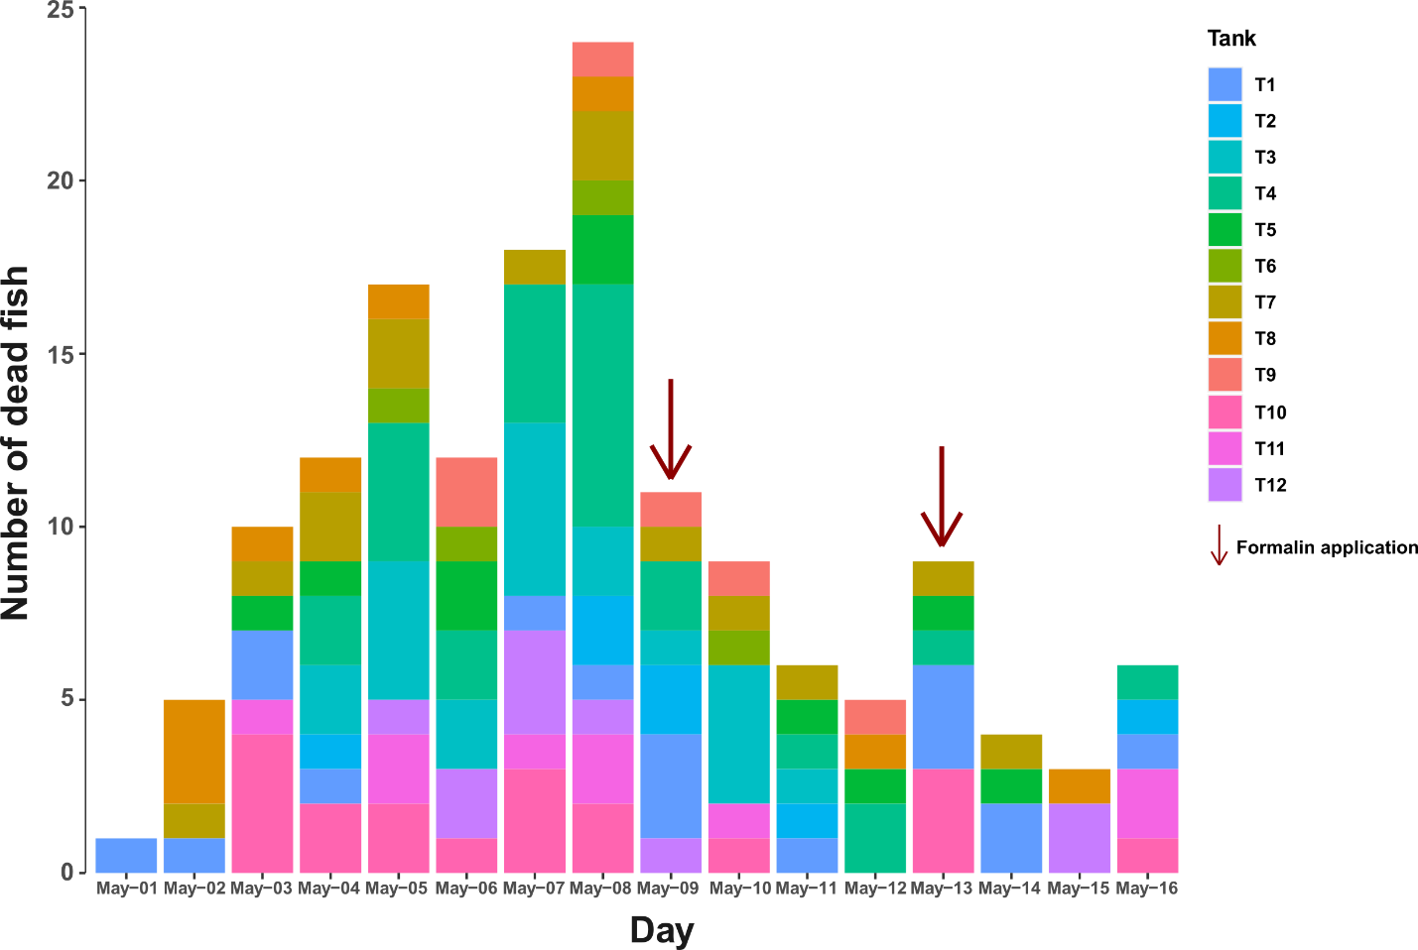

Supplementary Figure 2. Dead fish count. Dead fish count for each day of the trial starting from May-01-2019, day in which the first death caused by the infection was observed, until May-16-2019, day in which the trial was stopped after the second sampling. Formalin application days are indicated with arrows. Colors identify the tanks in which the dead fish were found.

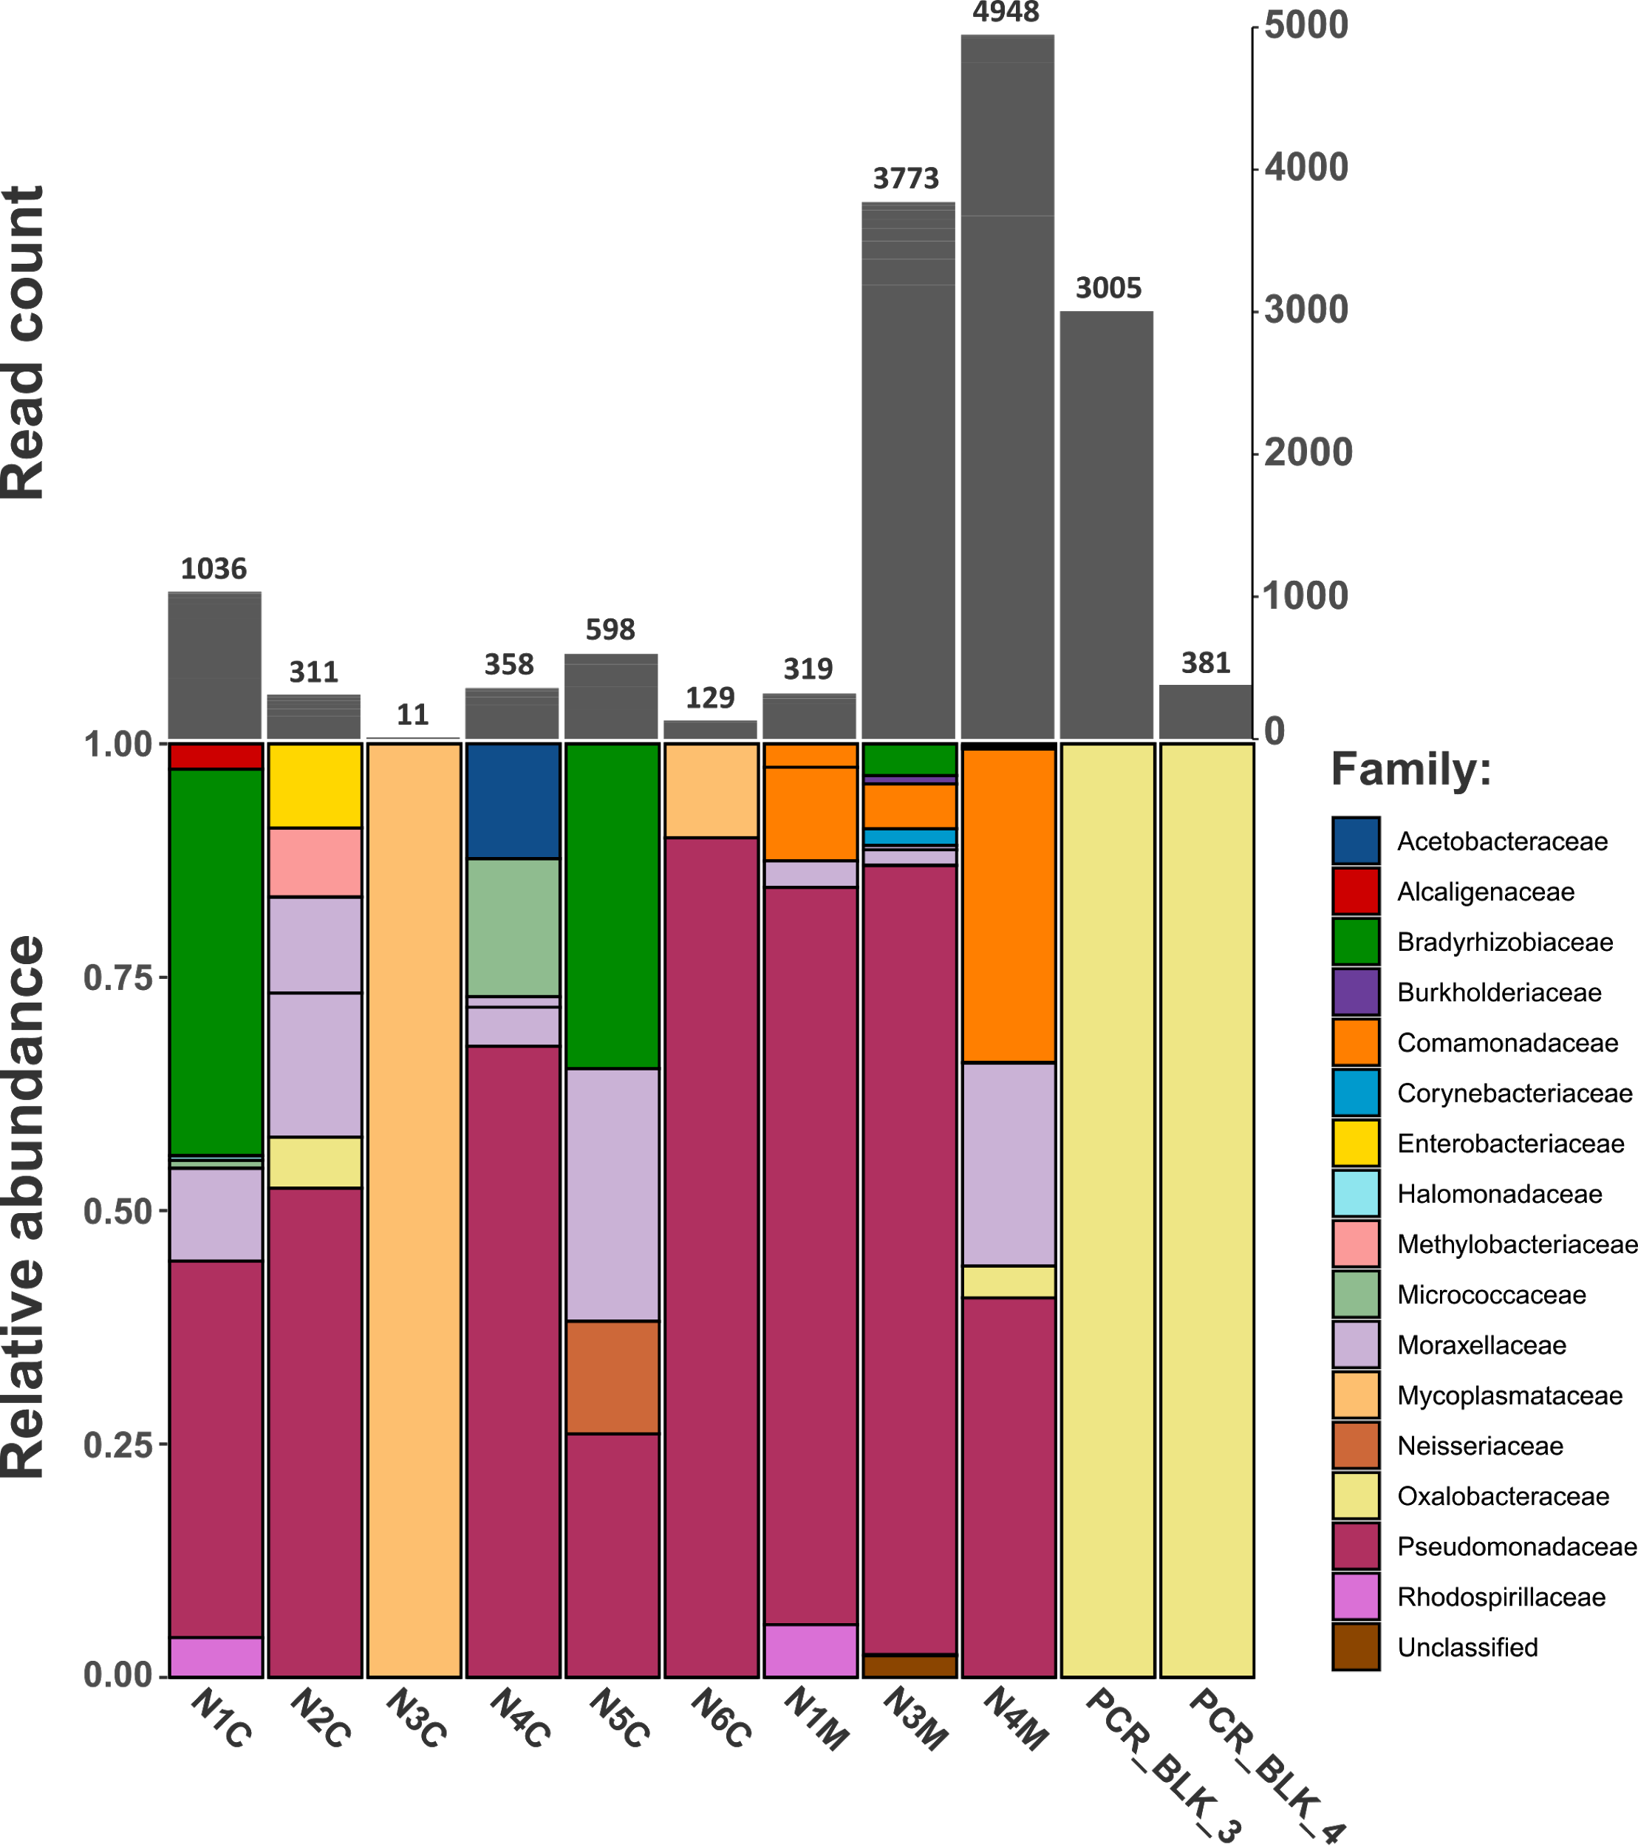
Supplementary Figure 3. DNA extraction and PCR amplification negative controls composition and read count. Relative abundance composition of the DNA extraction negative controls of the gut content samples (N1C, N2C, N3C, N4C, N5C, N6C) and of the gut mucosa samples (N1M, N3M, N4M) and of the negative controls of the PCR amplification (PCR_BLK_3, PCR_BLK_4) (bottom). Putative contaminants are shown at the family taxonomy level. Total read count after the filtering steps for each sample is reported (top). Low numbers of reads were observed for all the negative controls. For comparison, the mean value for a true biological sample is 28007 reads. Pseudomonadaceae (Pseudomonas sp.) represent the major DNA extraction contaminant in our dataset. Other relevant DNA extraction contaminants were members of the Bradyrhizobiaceae, Moraxellaceae and Comamonadaceae families. Ralstonia (Oxalobacteraceae) was instead recognized to be a PCR reagents contaminant. The Mycoplamsataceae family (Mycoplasma sp.) was acknowledged to be a true OTU and its presence here is explained by cross-contamination events between samples during the laboratory handling. Few reads of Mycoplasma sp. can be found in the negative controls and only in two out of 11 negative control samples, indicating that it wasn’t a major contamination event.
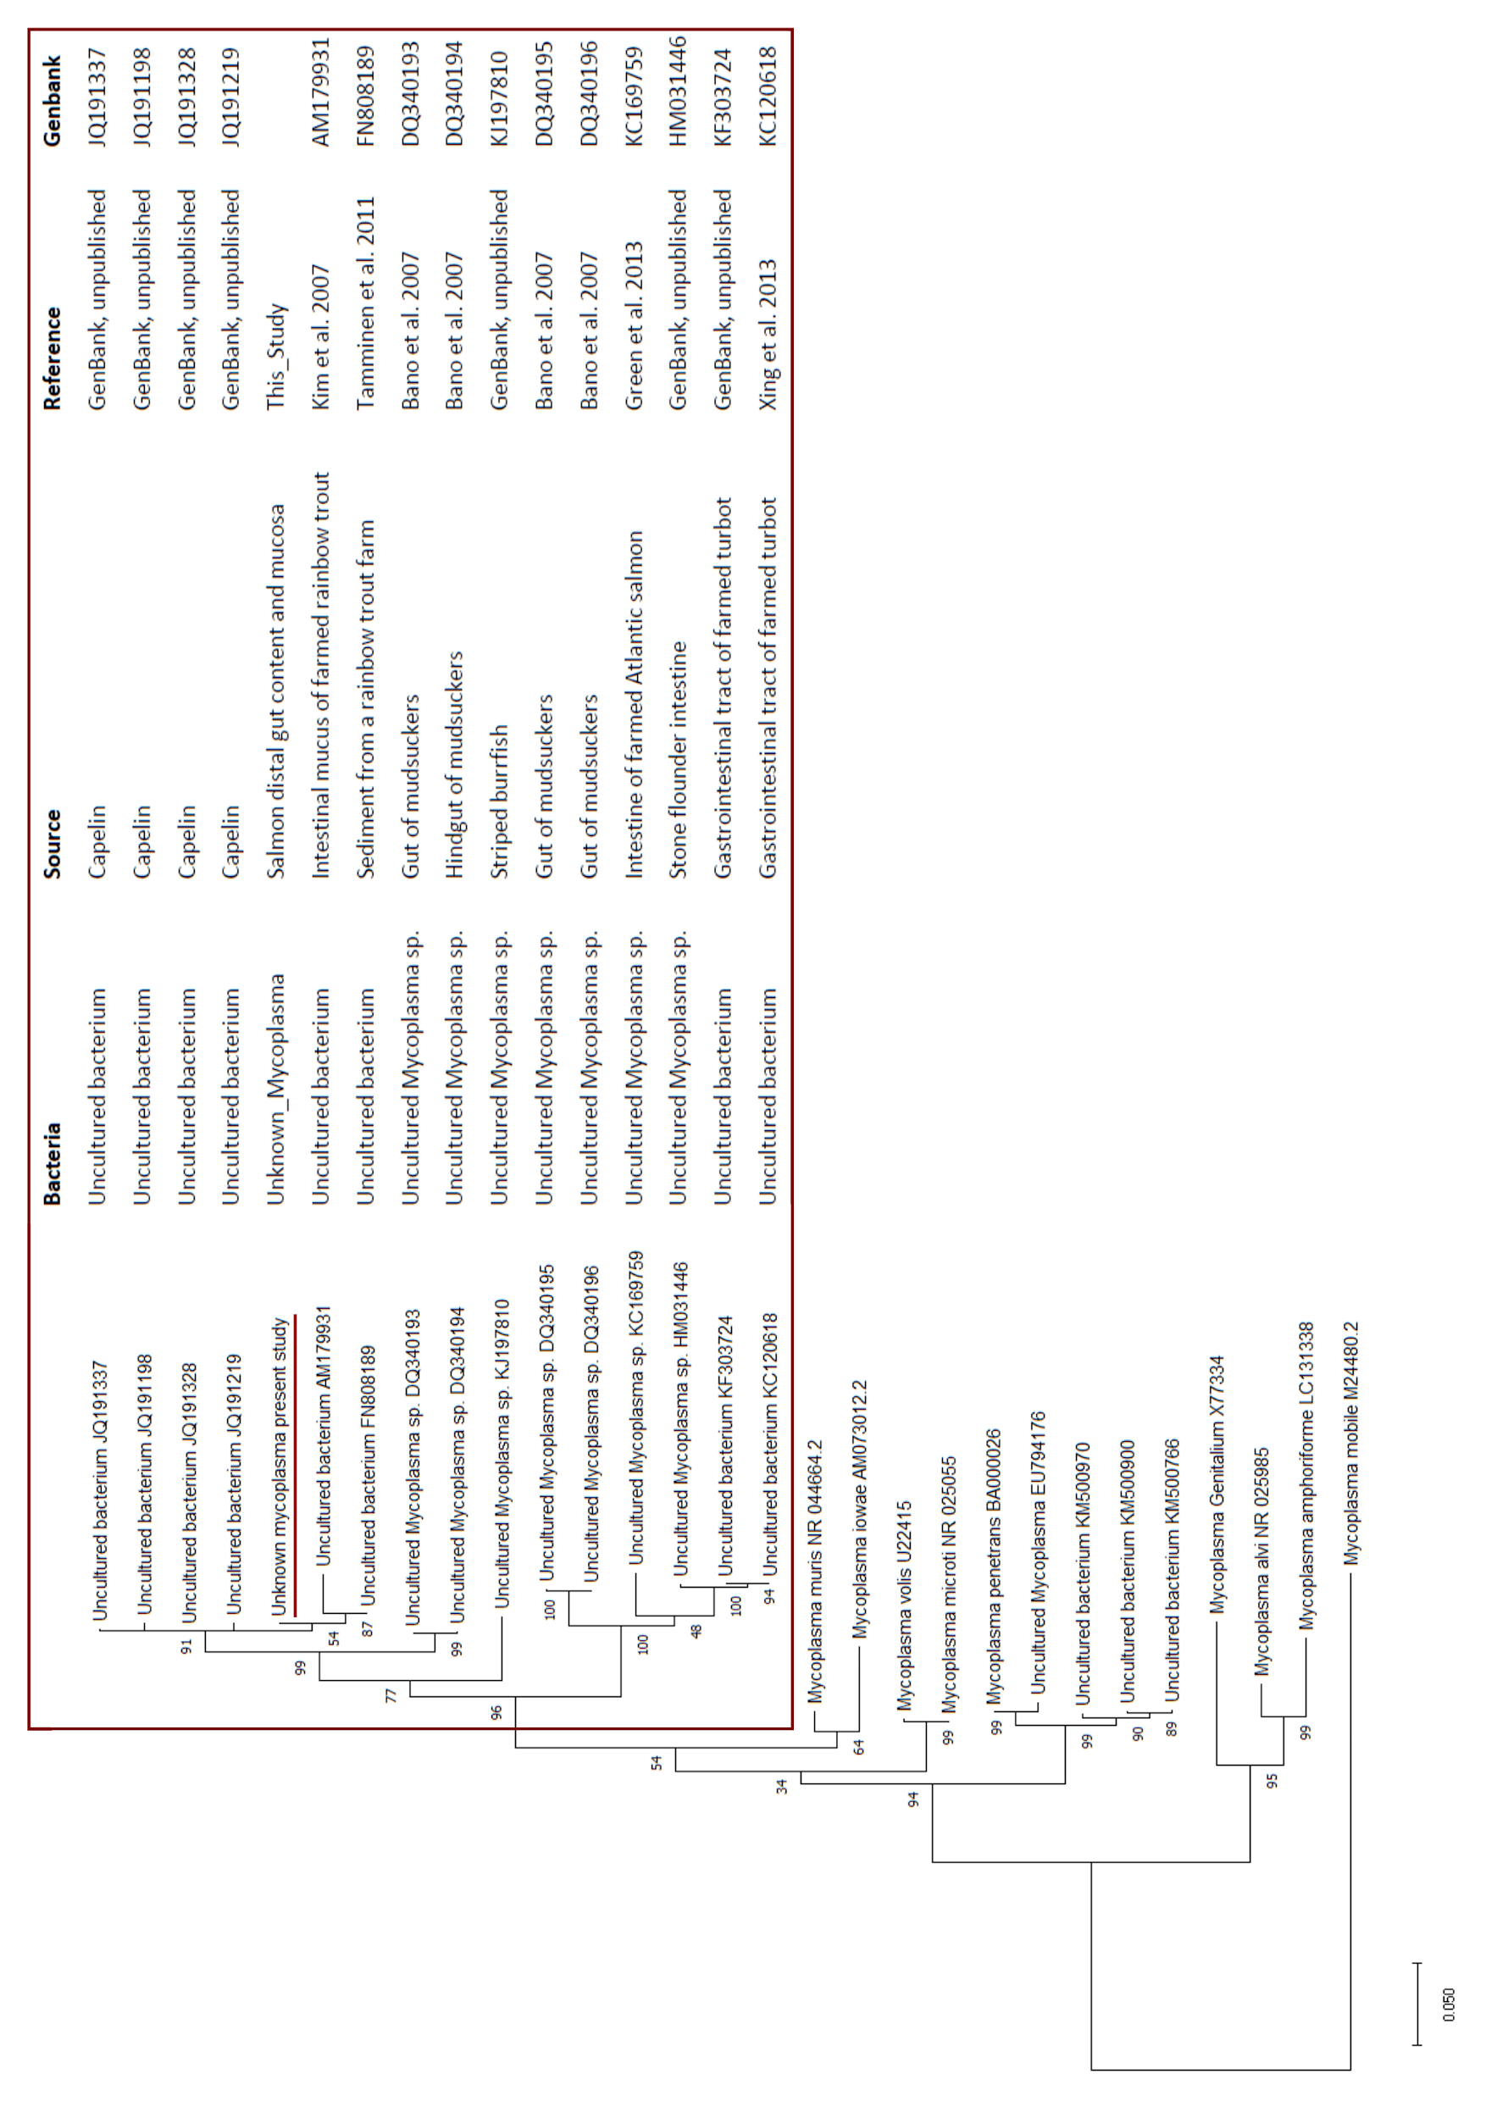
Supplementary Figure 4. Mycoplasma sp. maximum likelihood phylogenetic tree. A maximum likelihood neighbor-joining phylogenetic tree was built using the Mycoplasma sp. sequence and 28 other sequences recovered from NCBI through BLAST search to assess its biological origin. Our sequence cluster with 15 sequences recovered from fish gut or fish-related environments, constituting a coherent clade which separates all the Mycoplasma spp. found in fish from those found in other environments.
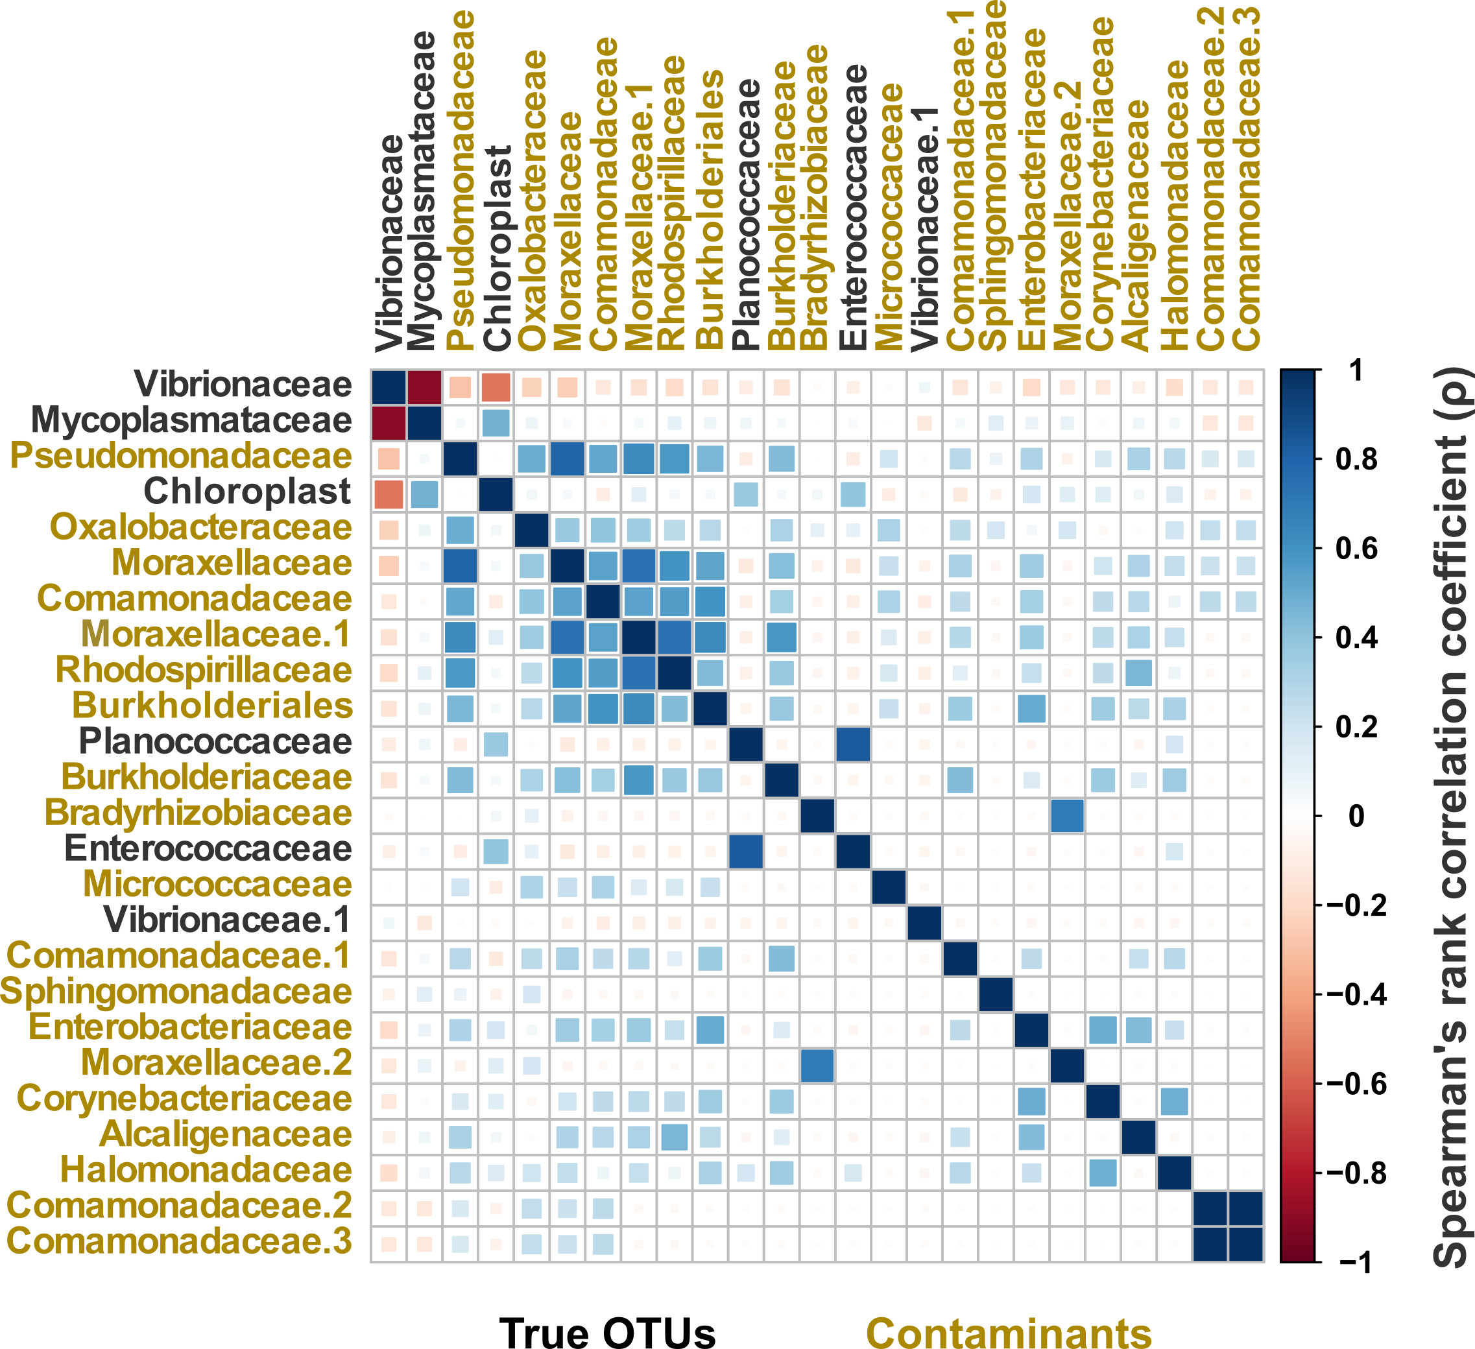
Supplementary Figure 5. OTUs correlation heatmap. Heatmap showing Spearman’s correlation coefficient between some OTUs including the most abundant and those regarded as contaminants. Patterns of co-occurrence are characteristic of the reagent contaminants that usually show up together when the true biological signal is weak. Co-occurrence is visible as a positive correlation. OTUs are indicated at the family level when possible and at the order level when the family is unknown. Positive correlations (blue) are visible between the putative contaminants, while negative correlations (red) are visible between contaminants and true OTUs like Vibrionaceae (Aliivibrio sp).

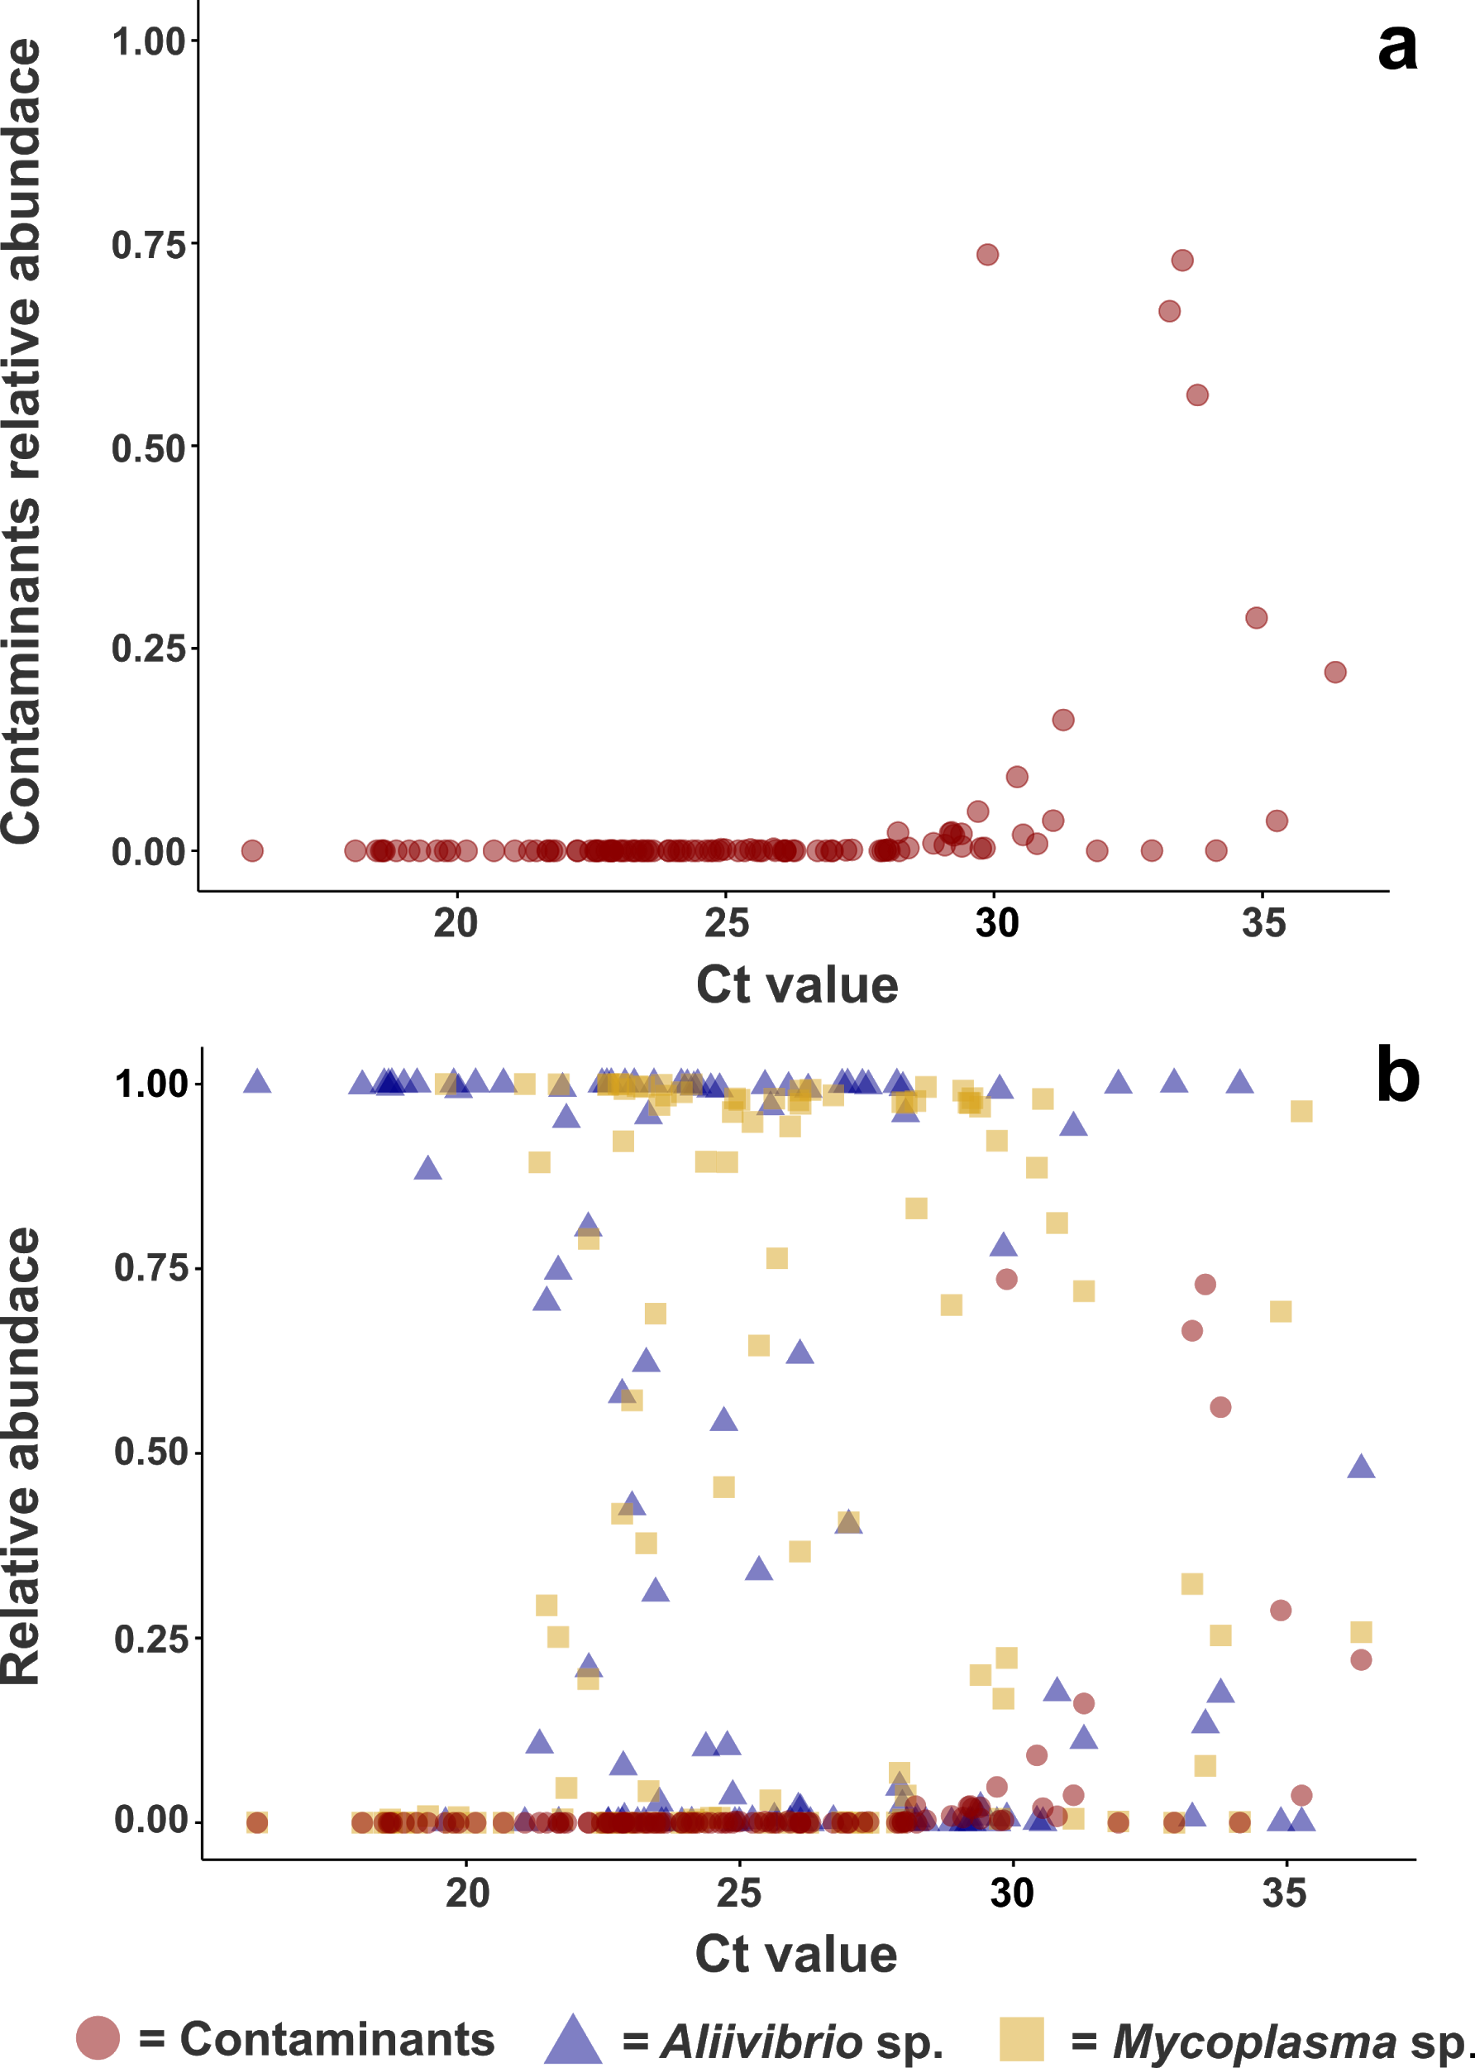
Supplementary Figure 6. Correlations between Ct values and the relative abundance of specific OTUs. When plotting contaminants relative abundances against Ct values (top) it is possible to see that contaminants are insignificant in samples with low Ct values, while increase in relative abundance as the Ct value increases, indicating that contamination is an issue for the samples with lower microbial biomasses. Here the contaminants include all the OTUs identified in the negative controls excluding Mycoplasma sp. For comparison contaminans were plotted together with OTUs recognized as genuine: Aliivibrio sp. and Mycoplasma sp. (bottom). Aliivibrio and Mycoplasma showed to characterize samples with lower Ct values.
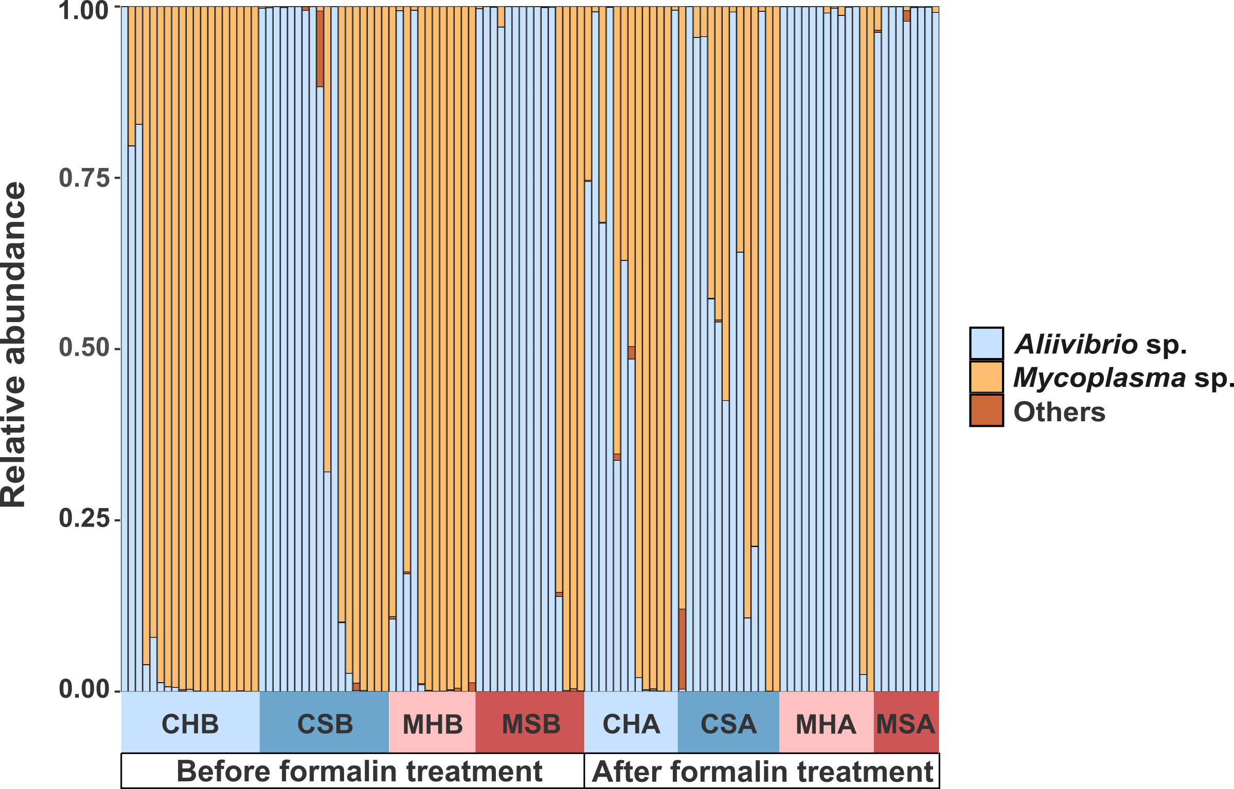
Supplementary Figure 7. Microbial composition of the individual samples plotted according to the group of origin. The composition of the individual samples shows that most of the samples were dominated by just one OTU.

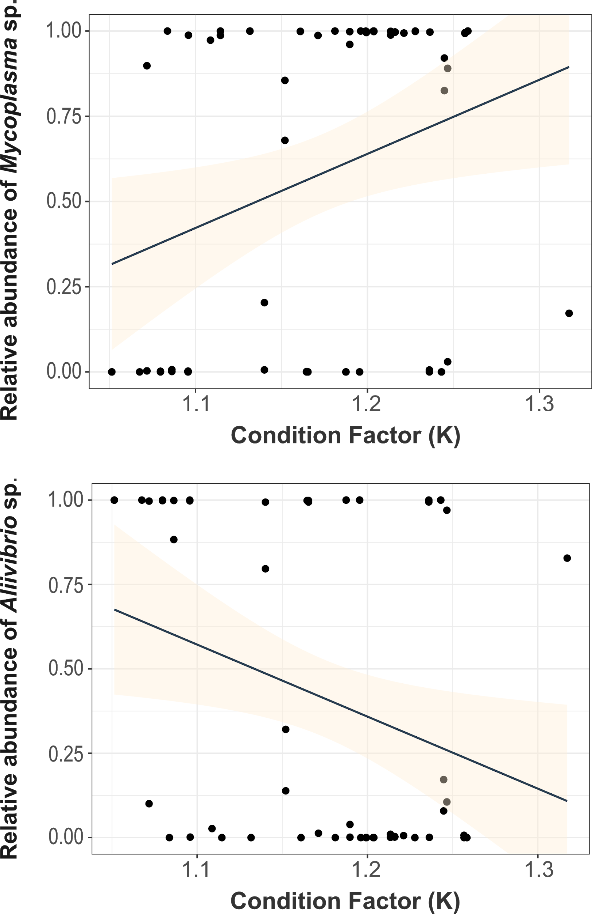
Supplementary Figure 8. Spearman's rank correlation between OTUs relative abundance and condition factor K. A pattern similar to that observed with fish weight was observed for condition factor K, although with less strong correlations. A positive correlation (Spearman’s R = 0.27, p < 0.05) was found when comparing Mycoplasma sp. relative abundance and fish condition factor K (top) and a negative correlation (Spearman’s R = -0.26, p < 0.05) was observed when comparing Aliivibrio sp. relative abundance with fish condition factor K.

