Long-term Mechanical Loading is Required for the Formation of 3D Bioprinted Functional Osteocyte Bone Organoids using Human Mesenchymal Stem Cells

Supporting Information

Jianhua Zhang ^{1, 2}, Marsel Ganeyev¹, Anna-Katharina Zehnder¹, Peng Zeng ³, Gian Nutal Schädli¹, Julia Griesbach¹, Anke de Leeuw¹, Marina Rubert¹ and Ralph Müller¹*

- Institute for Biomechanics, ETH Zürich, Leopold-Ruzicka-Weg 4, 8093 Zürich, Switzerland

- Translational Medicine R&D Center, Institute of Biomedical and Health Engineering, Shenzhen Institutes of Advanced Technology, Chinese Academy of Sciences, Shenzhen 518055, PR China

- Scientific Center for Optical and Electron Microscopy (ScopeM), ETH Zürich, Otto-Stern-Weg 3, 8093 Zürich, Switzerland

* Corresponding author: ram@ethz.ch
Experimental Section
Materials: Alginic acid sodium salt (Mw = 10,000-600,000) was purchased from AppliChem GmbH (Darmstadt, Germany). Type A gelatin from porcine skin (Mw: 50,000-100,000), dexamethasone (Dex), ascorbic acid (AA) and beta-glycerophosphate (β-GP) were purchased from Sigma-Aldrich (Buchs, Switzerland). Glycerol (99.5%) was purchased from Hänseler AG (Herisau, Switzerland). Phosphate buffered saline (PBS) tablets were purchased from Medicago (Uppsala, Sweden). Calcium chloride (CaCl₂) was purchased from VWR International (Dietikon, Switzerland). Dulbecco’s modified Eagle’s media (DMEM), fetal bovine serum (FBS), penicillin-streptomycin-fungizone (P/S/F), non-essential amino acids (NEAA) and fibroblast growth factor-basic (bFGF) were purchased from Life Technologies (Zug, Switzerland). The target osteogenic related genes (Alkaline phosphatase (ALPL), Collagen type I alpha 2 chains (COL1A2), Runx related transcription factor 2 (RUNX2), Bone gamma-carboxyglutamate protein (BGLAP), Phosphate regulating endopeptidase homolog, X-linked (PHEX), Podoplanin (PDPN), Dentin matrix acidic phosphoprotein 1 (DMP1) and Sclerostin (SOST) and housekeeping gene (Glyceraldehyde-3-phosphate dehydrogenase (GAPDH) was purchased from TaqMan Assays (Thermo Fisher Scientific, USA). Phalloidin (Alexa-Fluor 555, Invitrogen) was purchased from Invitrogen and Hoechst 33342 was purchased from Thermo Fisher Scientific. 5 mg/ml graphene oxide (GO) dispersion in water solution was purchased from RoyalElite RoyCarbon (Shanghai, China)
Ink preparation: Firstly, 1.6 ml GO solution was mixed with 5.6 ml 1.5× PBS and 0.8 ml glycerol solution to prepare a homogeneous solution. After that 70.4 mg alginate and 360 mg gelatin were dissolved in the above GO/PBS/glycerol solution at 50 ºC in a water bath (1). The mixture was kept for 12 h to homogenize and fully dissolve the polymer and was pasteurized at 70 ºC for 1 h before bioink preparation.
Cell viability and cell morphology: After sucked away the culture media, compression bioreactors were carefully disassembled and scaffolds were removed from the double-size tape using an autoclaved spatula. After washing twice in PBS, samples were transferred to a 2 μM Calcein AM and 4 μM ethidium homodimer (EthD-1) solution and cultured in the incubator for 40 min. Then the cell-laden scaffolds were thoroughly rinsed with PBS twice and moved in a sterile Chambered Coverglasses (Lab-TekTM, Thermo Scientific) with 1.5 ml cell culture media (DMEM, 10% FBS, 1%PSF). Both living and dead cell numbers, dendrite length were manually counted and analyzed using ImageJ (National Institutes of Health, USA). Cells retaining a strong Calcein staining in the dendrites and the cell body were classified as “active”, while cells that demonstrated a rounded and encapsulated morphology with a cell diameter less than 10 µm were classified as “dormant”, as previously described (2, 3). Using this classification method, cell morphologies were quantified as follows: (1) “dendritic” cells exhibited small cell body and long thin processes, or (2) “spherical” cells that had no cell processes and exhibited a spherical or cuboidal morphology. Cell processes were manually measured using ImageJ and the percentage of dendritic and spherical cells was calculated as dendritic and spherical cells divided by total cell number.

Micro-CT image reconstruction: During the imaging process, lasting approximately 40 minutes, the spring was completely opened and the bioreactor was isolated to maintain sterility. Micro-CT images were taken at an isotropic resolution of 36 µm. The energy was set to 45 kVp, the intensity was 177 µA, integration time was 200 ms and two-fold frame averaging was chosen. The reconstructed images were Gaussian filtered with a filter width of 1.2 and filter support of 1 to suppress the noise. 3D visualizations were generated using in-house software by thresholding at a grey-scale value of 145 (corresponding to a density of 83.44 mg HA/cm³). Unconnected particles smaller than 50 voxels were removed using component labeling.
Mineral histogram distribution, total and peak mineral volume, MSD: Mineral histogram distributions at day 7, 21 and 56 in different groups were generated by HISTO function handled by IPL (Image Processing Language) and python. The histogram distribution of NL, ML01 and ML21 at day 56 were shown in Figure S2 D. The highest possible density peaks were in the range of 0 – 83.44 mg HA/cm³, which indicated the background and noise. Mineral volumes were calculated using BIOR script in IPL and were classified in different mineral stages with different threshold values (83.44 and 135.27 mg HA/cm³). 83.44 mg HA/cm³ was chosen as it allowed the segmented images to best resemble the mineralized structures visible by the eye from the gray value image. Total mineral volume was calculated when the thresholding value was over 83.44 mg HA/cm³, which was the same as our previous works (paper submitted). 135.27 mg HA/cm³ was the interception point in the histogram distribution curve between ML01 and ML21 at day 56. We defined the peak mineral volume was over the 135.27 mg HA/cm³. The resulting 3D volume was evaluated morphometrically for mineral volume and mineral formation rate (mm³/day) ((mineral formation rate = total mineral volume day m – total mineral volume day n) / (m-n)). Mineralized scaffold density (MSD) was defined from tissue mineral density (TMD), which was restricted to within the volume of calcified bone tissue excluding surrounding soft tissue. The value gives us information about the material density of the mineral itself and ignores the surrounding soft material. MSD in different weeks were calculated using TMD script in IPL.
Alizarin Red S staining: sections were incubated for 2 min in Alizarin Red S solution (pH = 4.3), dehydrated in acetone with 20 dips, and then in acetone-xylene (1:1) solution for 20 dips. Clear in xylene and mount in a mounting medium.
Hematoxylin and Eosin (H&E) staining: sections were hydrated firstly, and then stained in Hematoxylin solution for 3 min, washed with running water for 5 min and exposed to Eosin solution for 2 min. The samples were then dehydrated and cleared the samples in three changes of xylene for 2 min per change. Placed a drop of mounting media over the sections on each slide and added a coverslip.
Sirius Red staining: sections were stained in the Picro-Sirius (1:9) solution for 1 h, and then washed two changes in ultra-pure water with 5% acetic acid, dehydrated three times in 100% ethanol and cleared in xylene 5 min.
Osteocalcin immunostaining: sections were washed three times in PBS for 5 min, and blocked sections with 5% goat serum, 5% BSA in NaCl/HEPES- 0.1% Triton-X 100 (pH = 7.5) for 1 h at room temperature, and applied rabbit anti-osteocalcin antibody (1:200, ab93876, Abcam) in NaCl/HEPES solution with 1% BSA overnight at room temperature. Sections were washed with three times of NaCl/HEPES buffer solution, and incubated with goat-anti rabbit secondary antibody (1:1000, ab150082, Abcam) / Hoechst (1:200) in NaCl/HEPES solution with 1% BSA for 1 h, and then washed sections three times with NaCl/HEPES buffer solution, and then mounted sections with Fluoroshield. The quantification of immunochemical staining of osteocalcin was done by applying ImageJ. The protocol was developed to evaluate the intensity of the target dye fluorescence (4, 5). Total osteocalcin fluorescence was calculated dividing the integrated density by selected area. To assess the specificity of the immunostaining, we included a negative control for each reaction by incubating the sections with NaCl/HEPES solution.
Actin staining: sections were washed two times of PBS, and then incubated sections with 0.1% BSA, 0.3% Triton-X 100 in PBS solution for 40 min, and then incubated sections with the Phalloidin (1:100) / Hoechst (1:200) in PBS solution for 50 min, washed sections with PBS and mounted with Fluoroshield. Sections were imaged on the Leica SP8 MP (Leica, Germany).

Table S1. Primer sequences used for the analysis of relative gene expression by RT-qPCR.
Gene symbol | Gene name | Assay ID | Amplicon Length
COL1A2 | Collagen type I alpha 2 chain | Hs01028956_m1 | 71
ALPL | Alkaline phosphatase, liver/bone /kidney | Hs01029144_m1 | 79
RUNX2 | Runt related transcription factor 2 | Hs01047973_m1 | 86
BGLAP | Bone gamma-carboxyglutamate protein | Hs01587814_g1 | 138
PDPN | Podoplanin | Hs00366766_m1 | 58
PHEX | Phosphate regulating endopeptidase homolog, X-linked | Hs01011689_m1 | 91
SOST | Sclerostin | Hs00228830_m1 | 81
DMP1 | Dentin matrix acidic phosphoprotein 1 | Hs01009391_g1 | 106
GAPDH | Glyceraldehyde-3-phosphate dehydrogenase | Hs02758991_g1 | 93

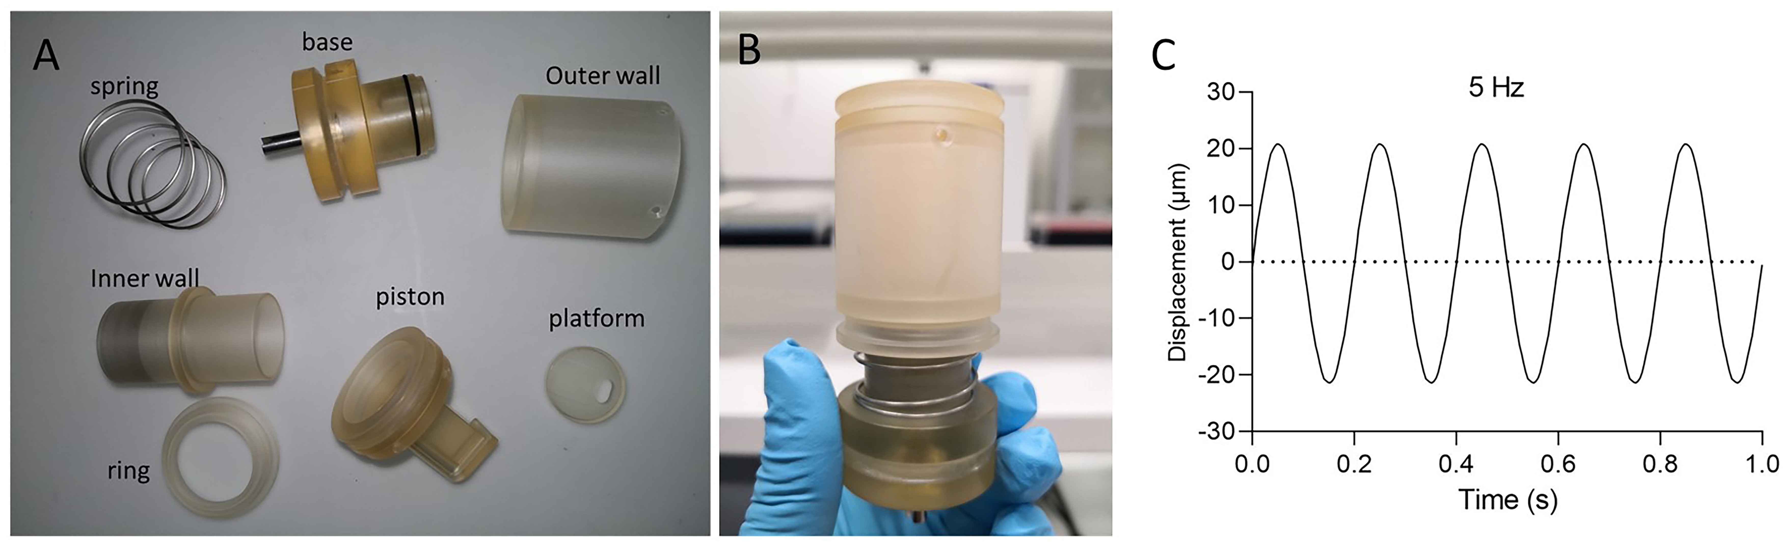
Figure S1. (A) The components of the compression bioreactor, including spring, base, outer wall, inner wall, ring, piston and platform. (B) The assembled compression bioreactor with different components. (C) Loading frequency of the dynamic loading process.

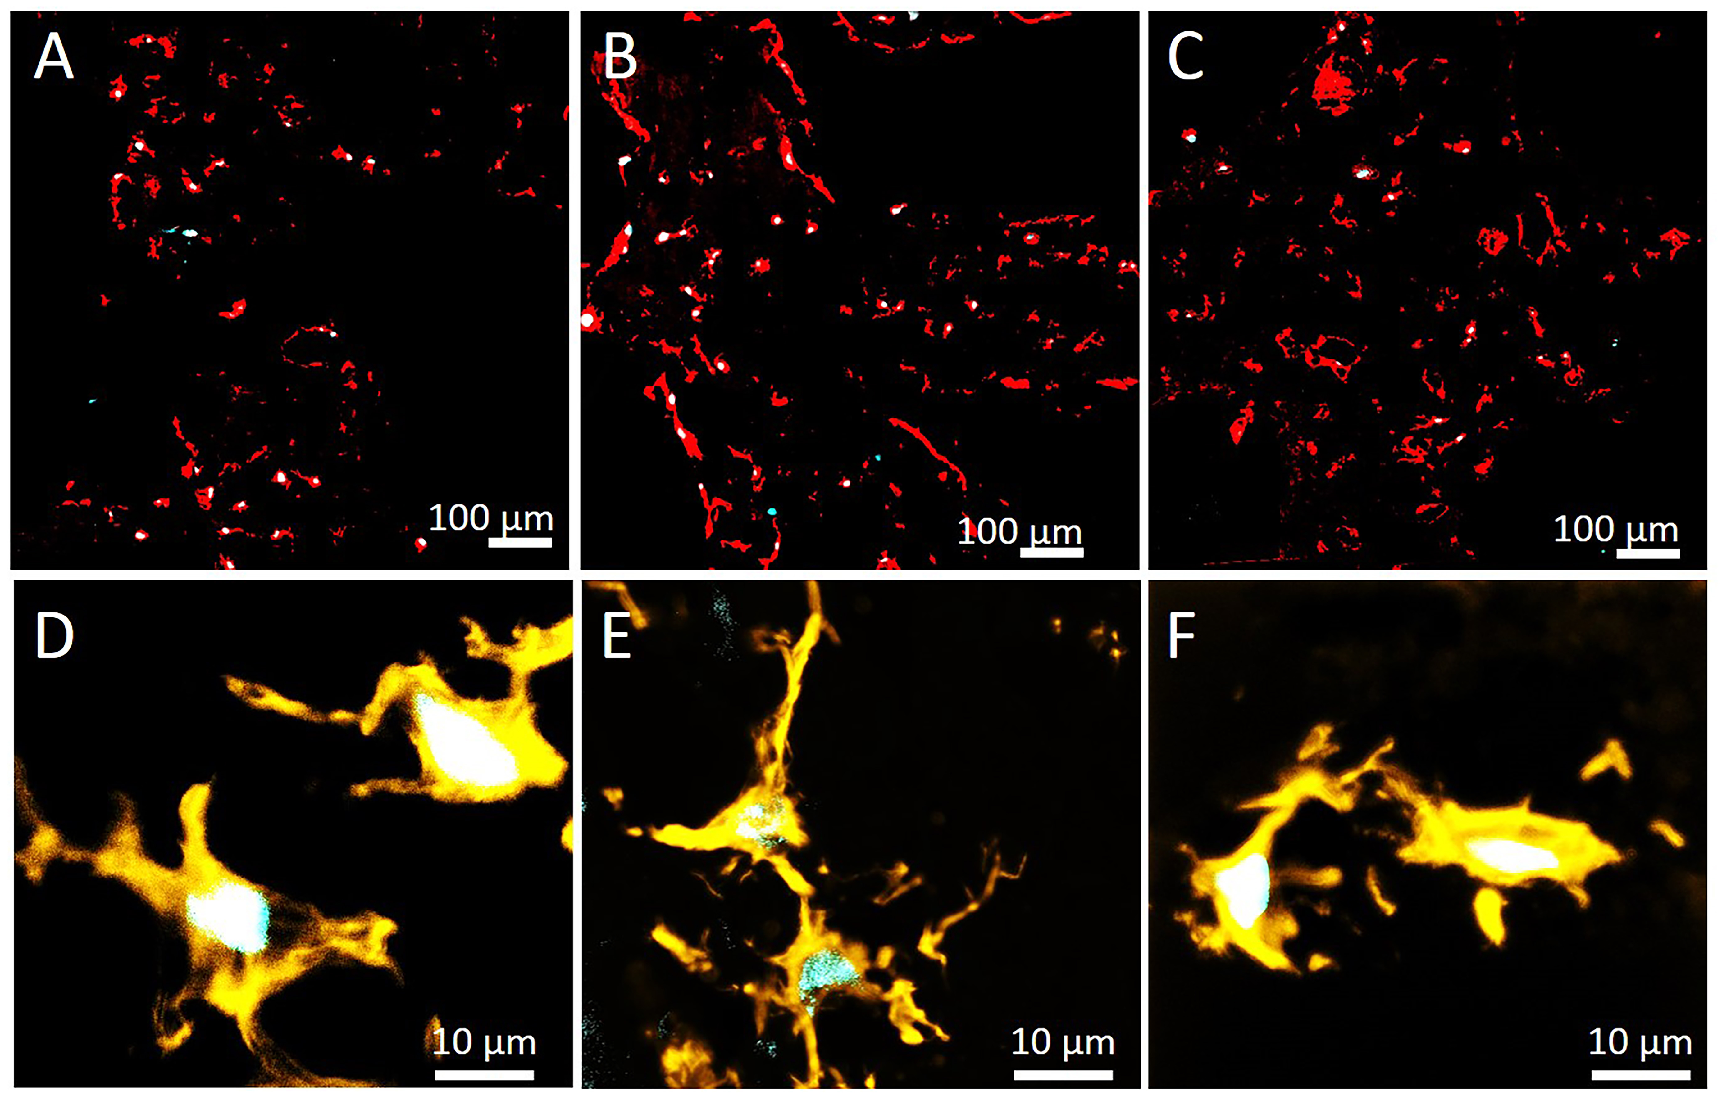
Figure S2. (A-C) Low magnification actin staining images in the top sections of 3D bioprinted cell-laden GO scaffolds with different loading conditions on day 56. (D-F) High magnification actin staining images of the sections from the top region in NL, ML01 and ML21 on day 56. Two cells were connected with each other in the loading groups, while two cells were independent cells in NL group.

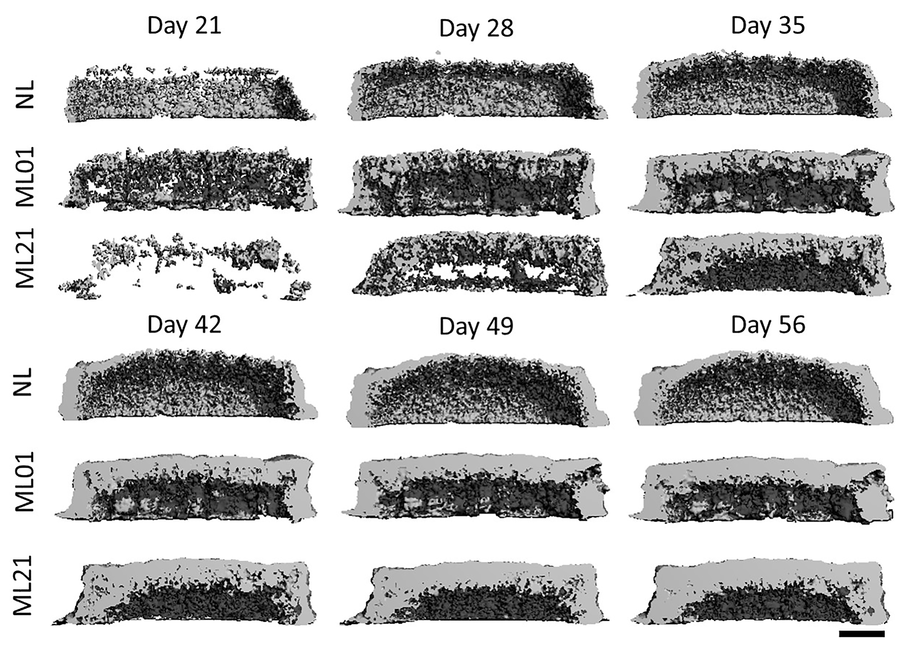
Figrue S3. 3D reconstructed time-lapsed micro-CT images at the middle vertical view of the 3D bioprinted cell-laden scaffolds with different loading conditions from day 21 to day 56, scale bar 2mm.

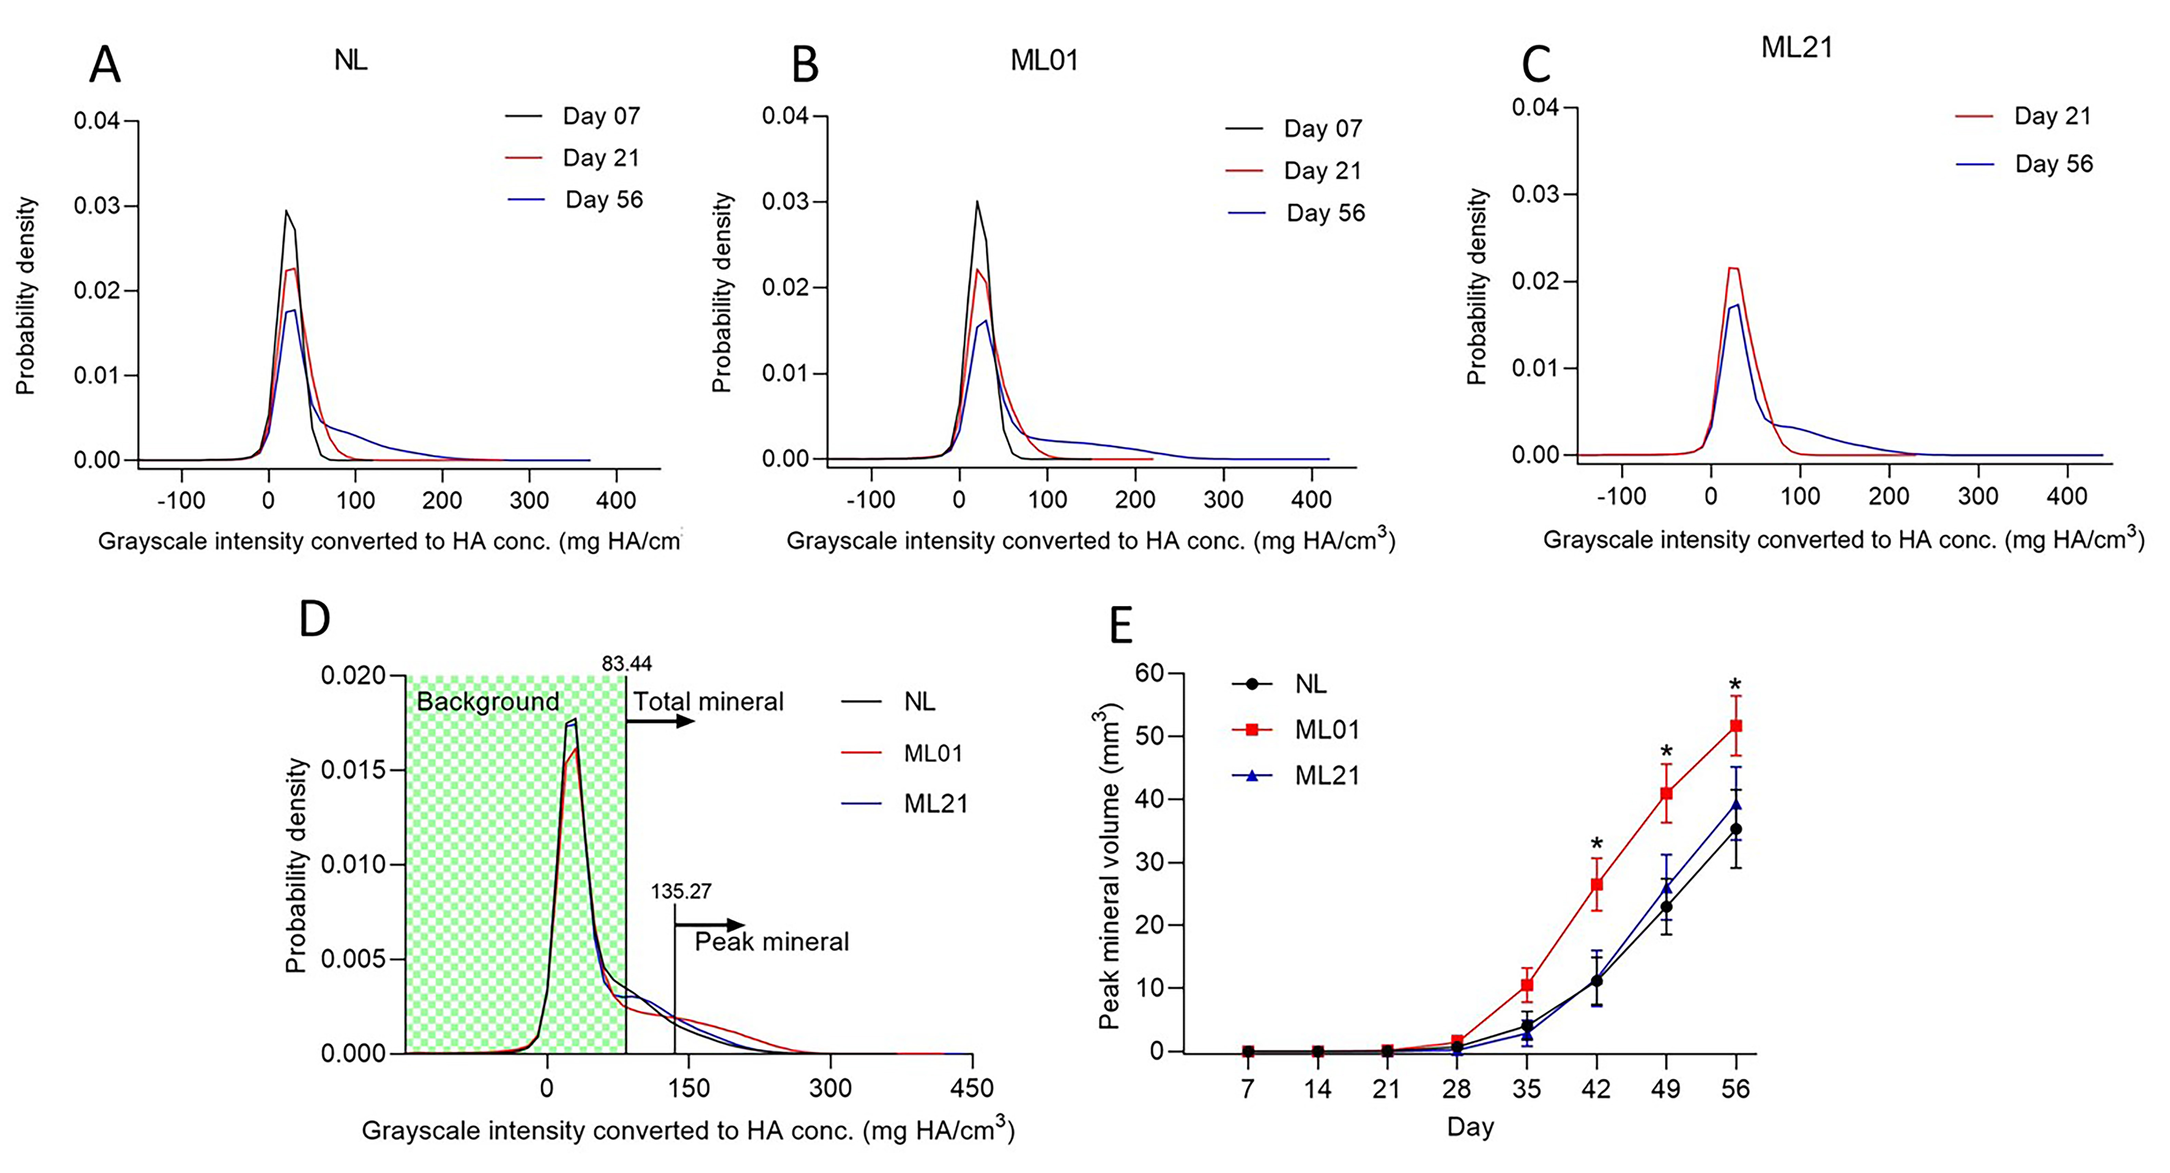
Figure S4. Histogram distribution of grayscale intensity converted to HA concentration in NL (A), ML01 (B) and ML21 (C) at day 7, day 21 and day 56. (D) Histogram distribution of grayscale intensity converted to HA concentration in NL, ML01 and ML21 at day 56. The total mineral volume was defined when the thresholding over 83.44 mg HA/cm³. The peak mineral volume was defined when the thresholding over 135.27 mg HA/cm³. (E) The peak mineral volume changes over time in NL, ML01 and ML21 when cultured in the compression bioreactor for 56 days.

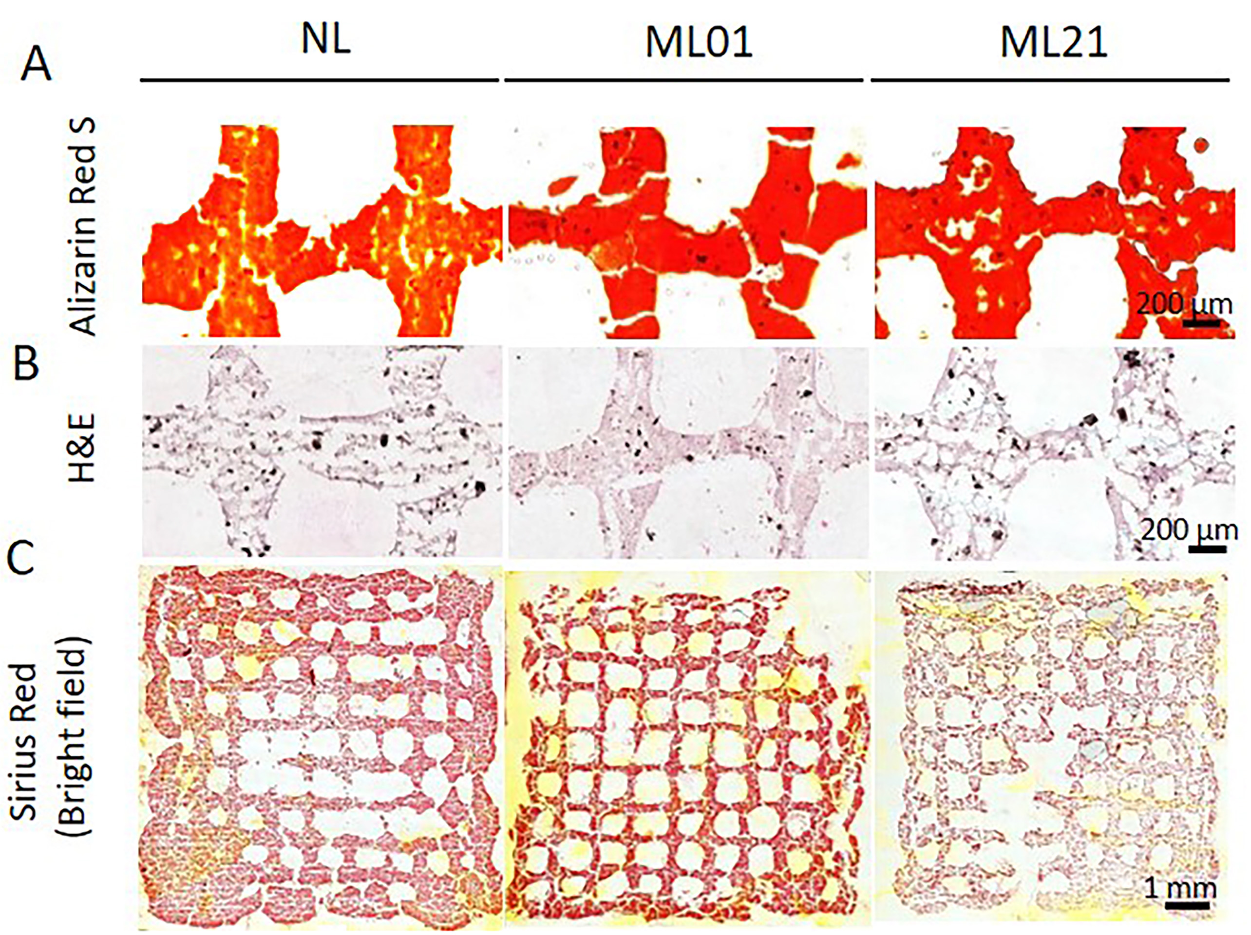
Figure S5. Histology staining of sections from the top region in NL, ML01, ML21 scaffolds at day 56 after culture in the compression bioreactor. (A) Alizarin Red S staining, (B) H&E staining, (C) Sirius Red staining of the whole section under the bright field.

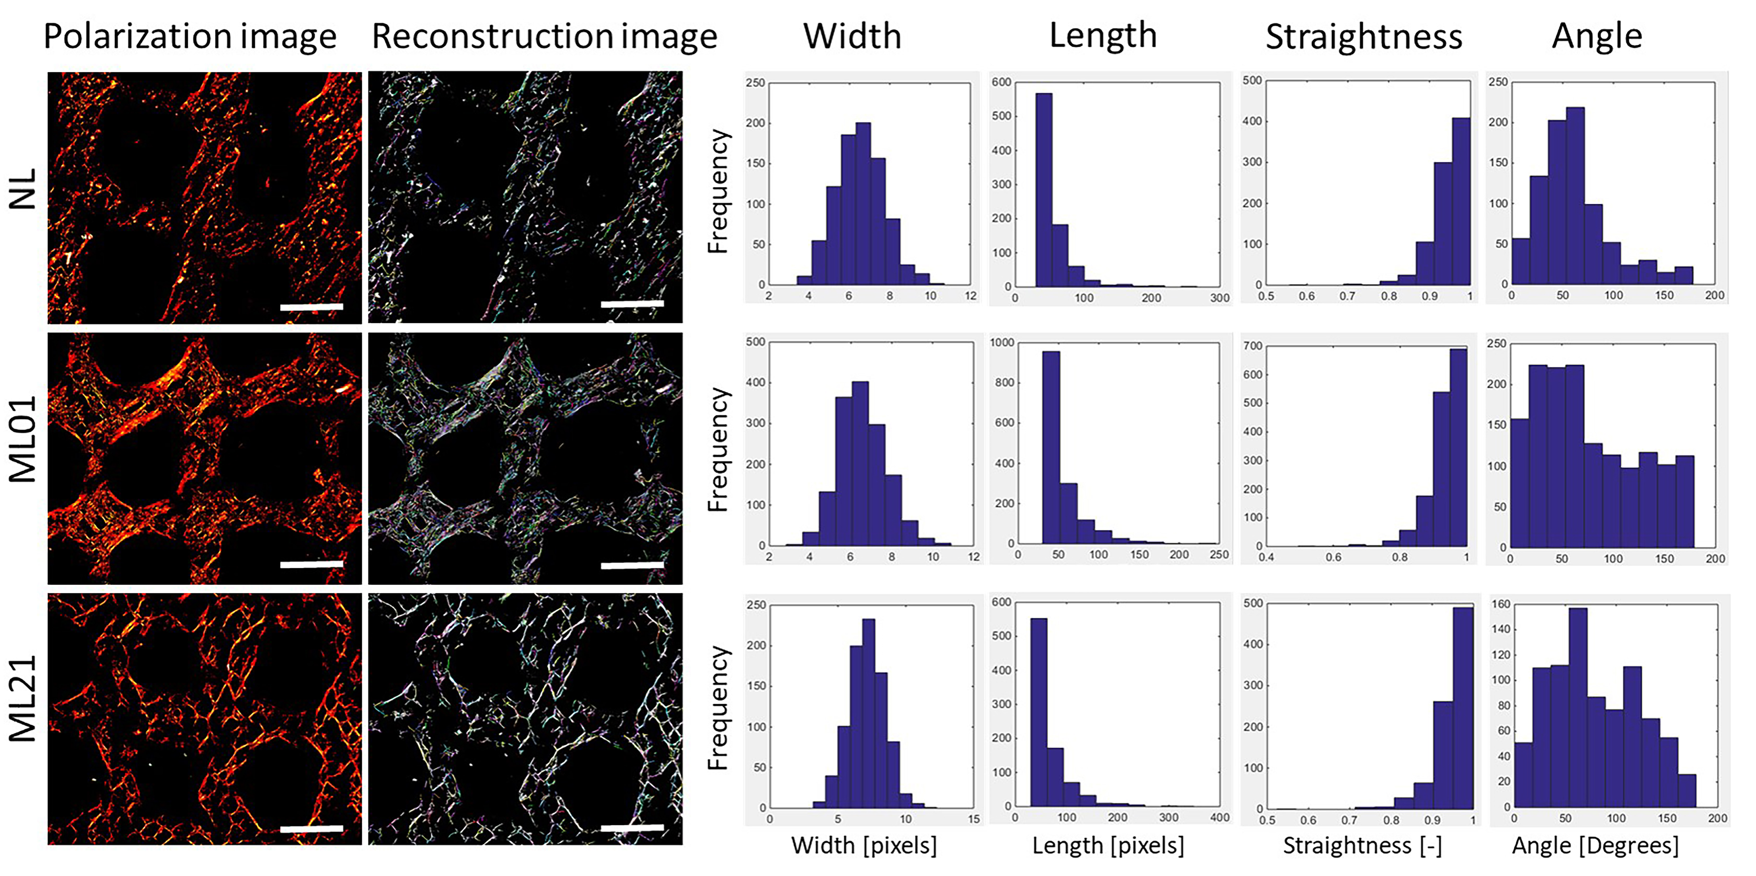
Figure S6. Examples of the quantification of collagen I fiber width, fiber length, fiber straightness and fiber angle from the polarization images of Sirius Red staining in NL, ML01 and ML21 groups, scale bar 500 µm. Collagen I fiber reconstruction images were used CT-fire software (6).

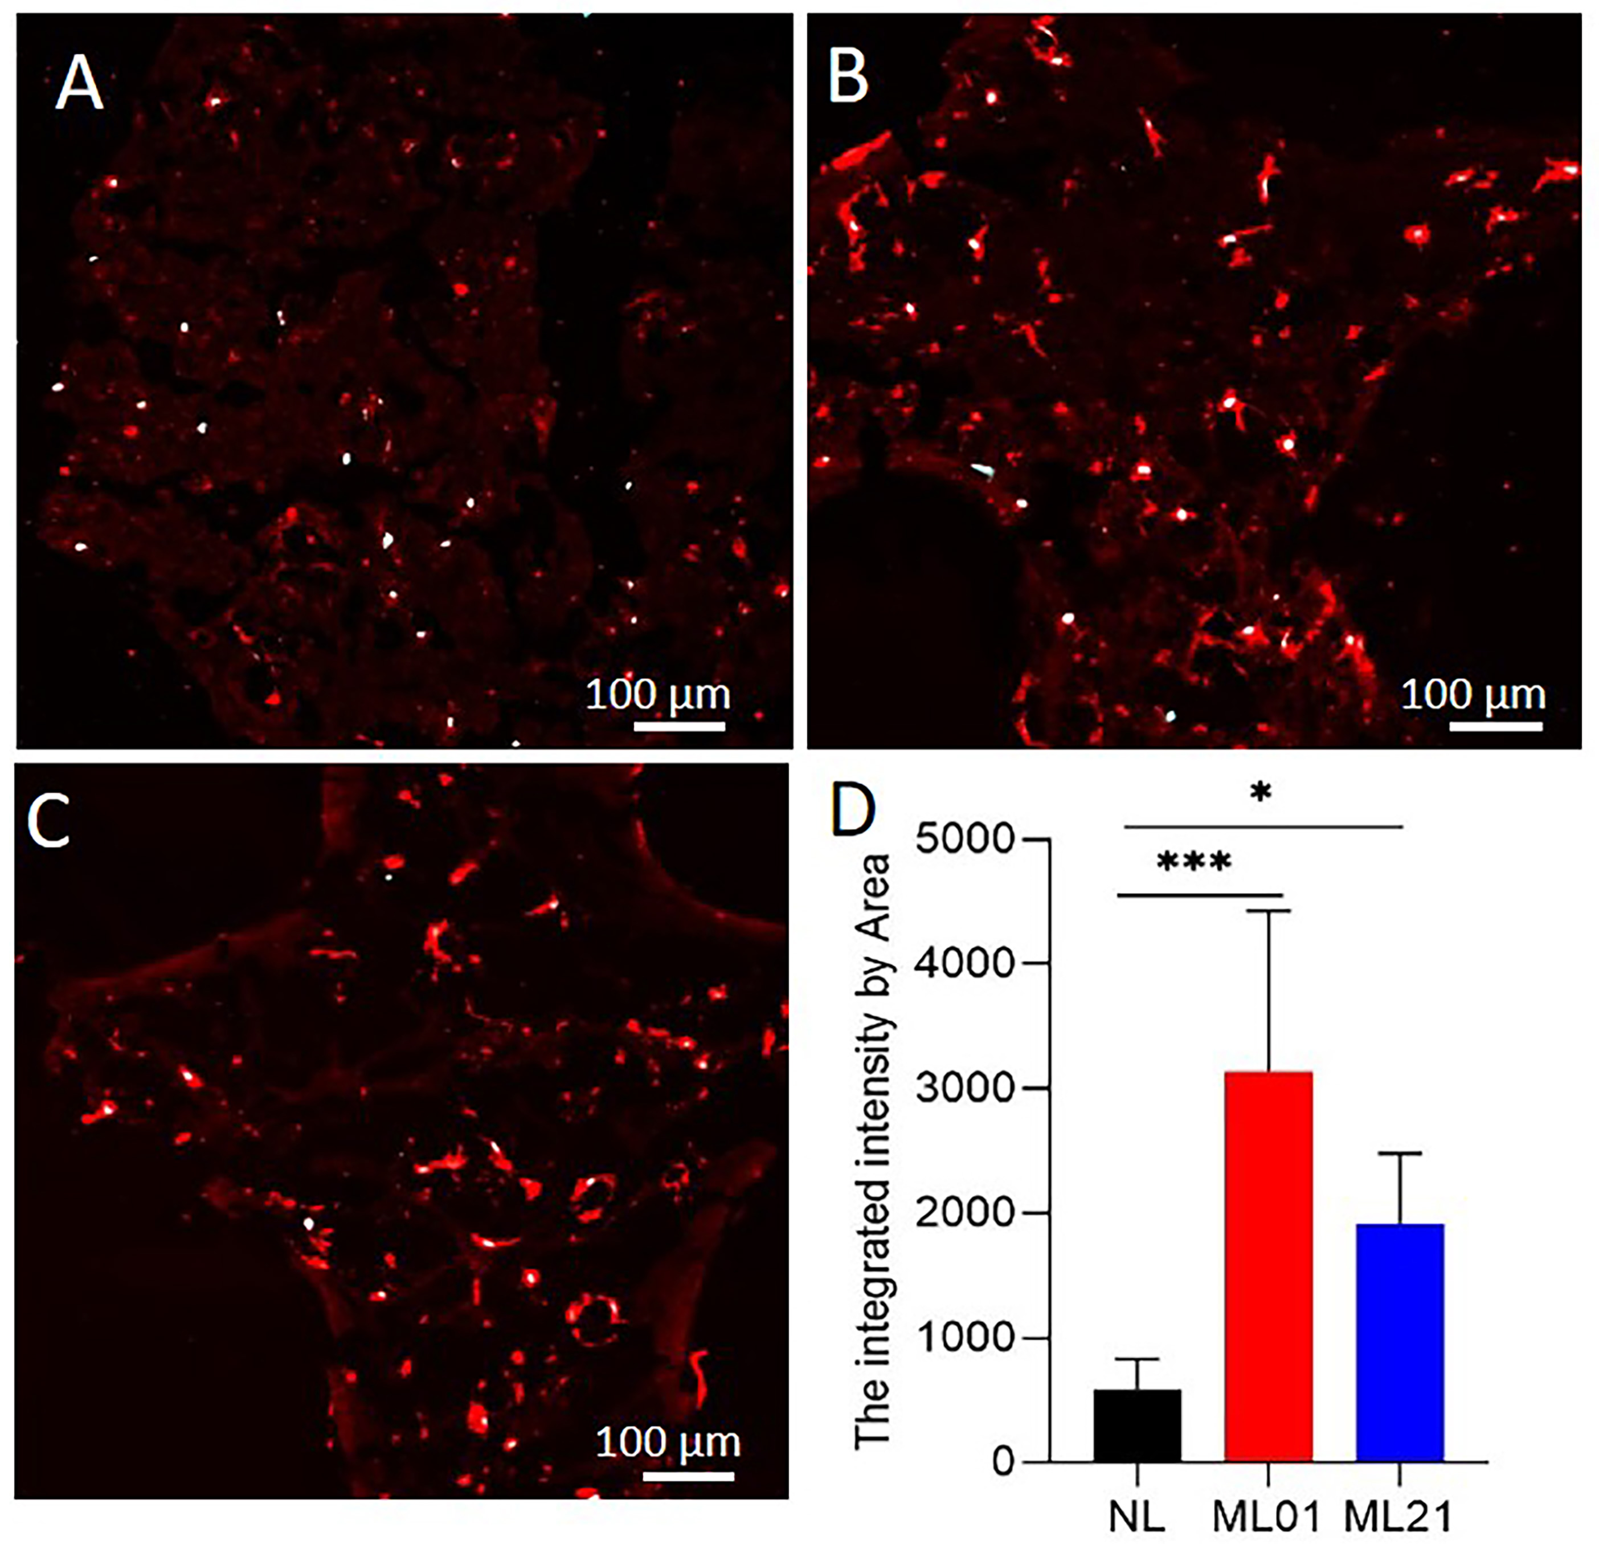
Figure S7. Cell nuclei and osteocalcin immunostaining of the sections from the top region in NL (A), ML01 (B), ML21 (C) scaffoldS at day 56 after culture in the compression bioreactors. (D) The quantification of the integrated intensity of osteocalcin signal by area (mm²) in NL, ML01 and ML21 scaffolds. *P < 0.05, *** P <0.001, data are shown as mean ± standard deviation (N=4).

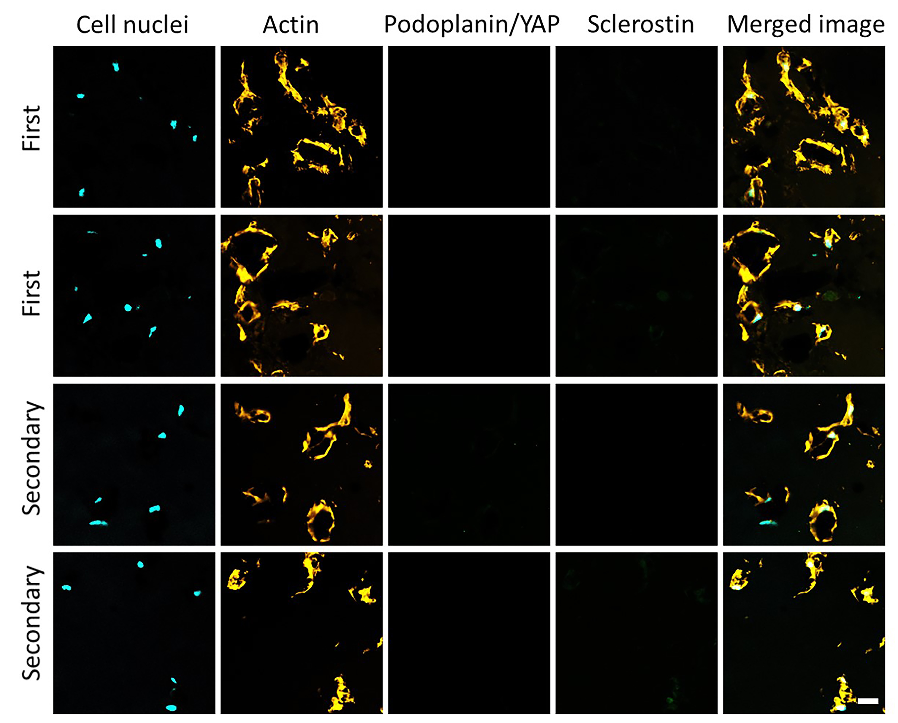
Figure S8. Assessment of the immunostaining specificity for podoplanin, YAP and Sclerostin antibodies in loaded and nonloaded conditions. Scale bar 20 µm.

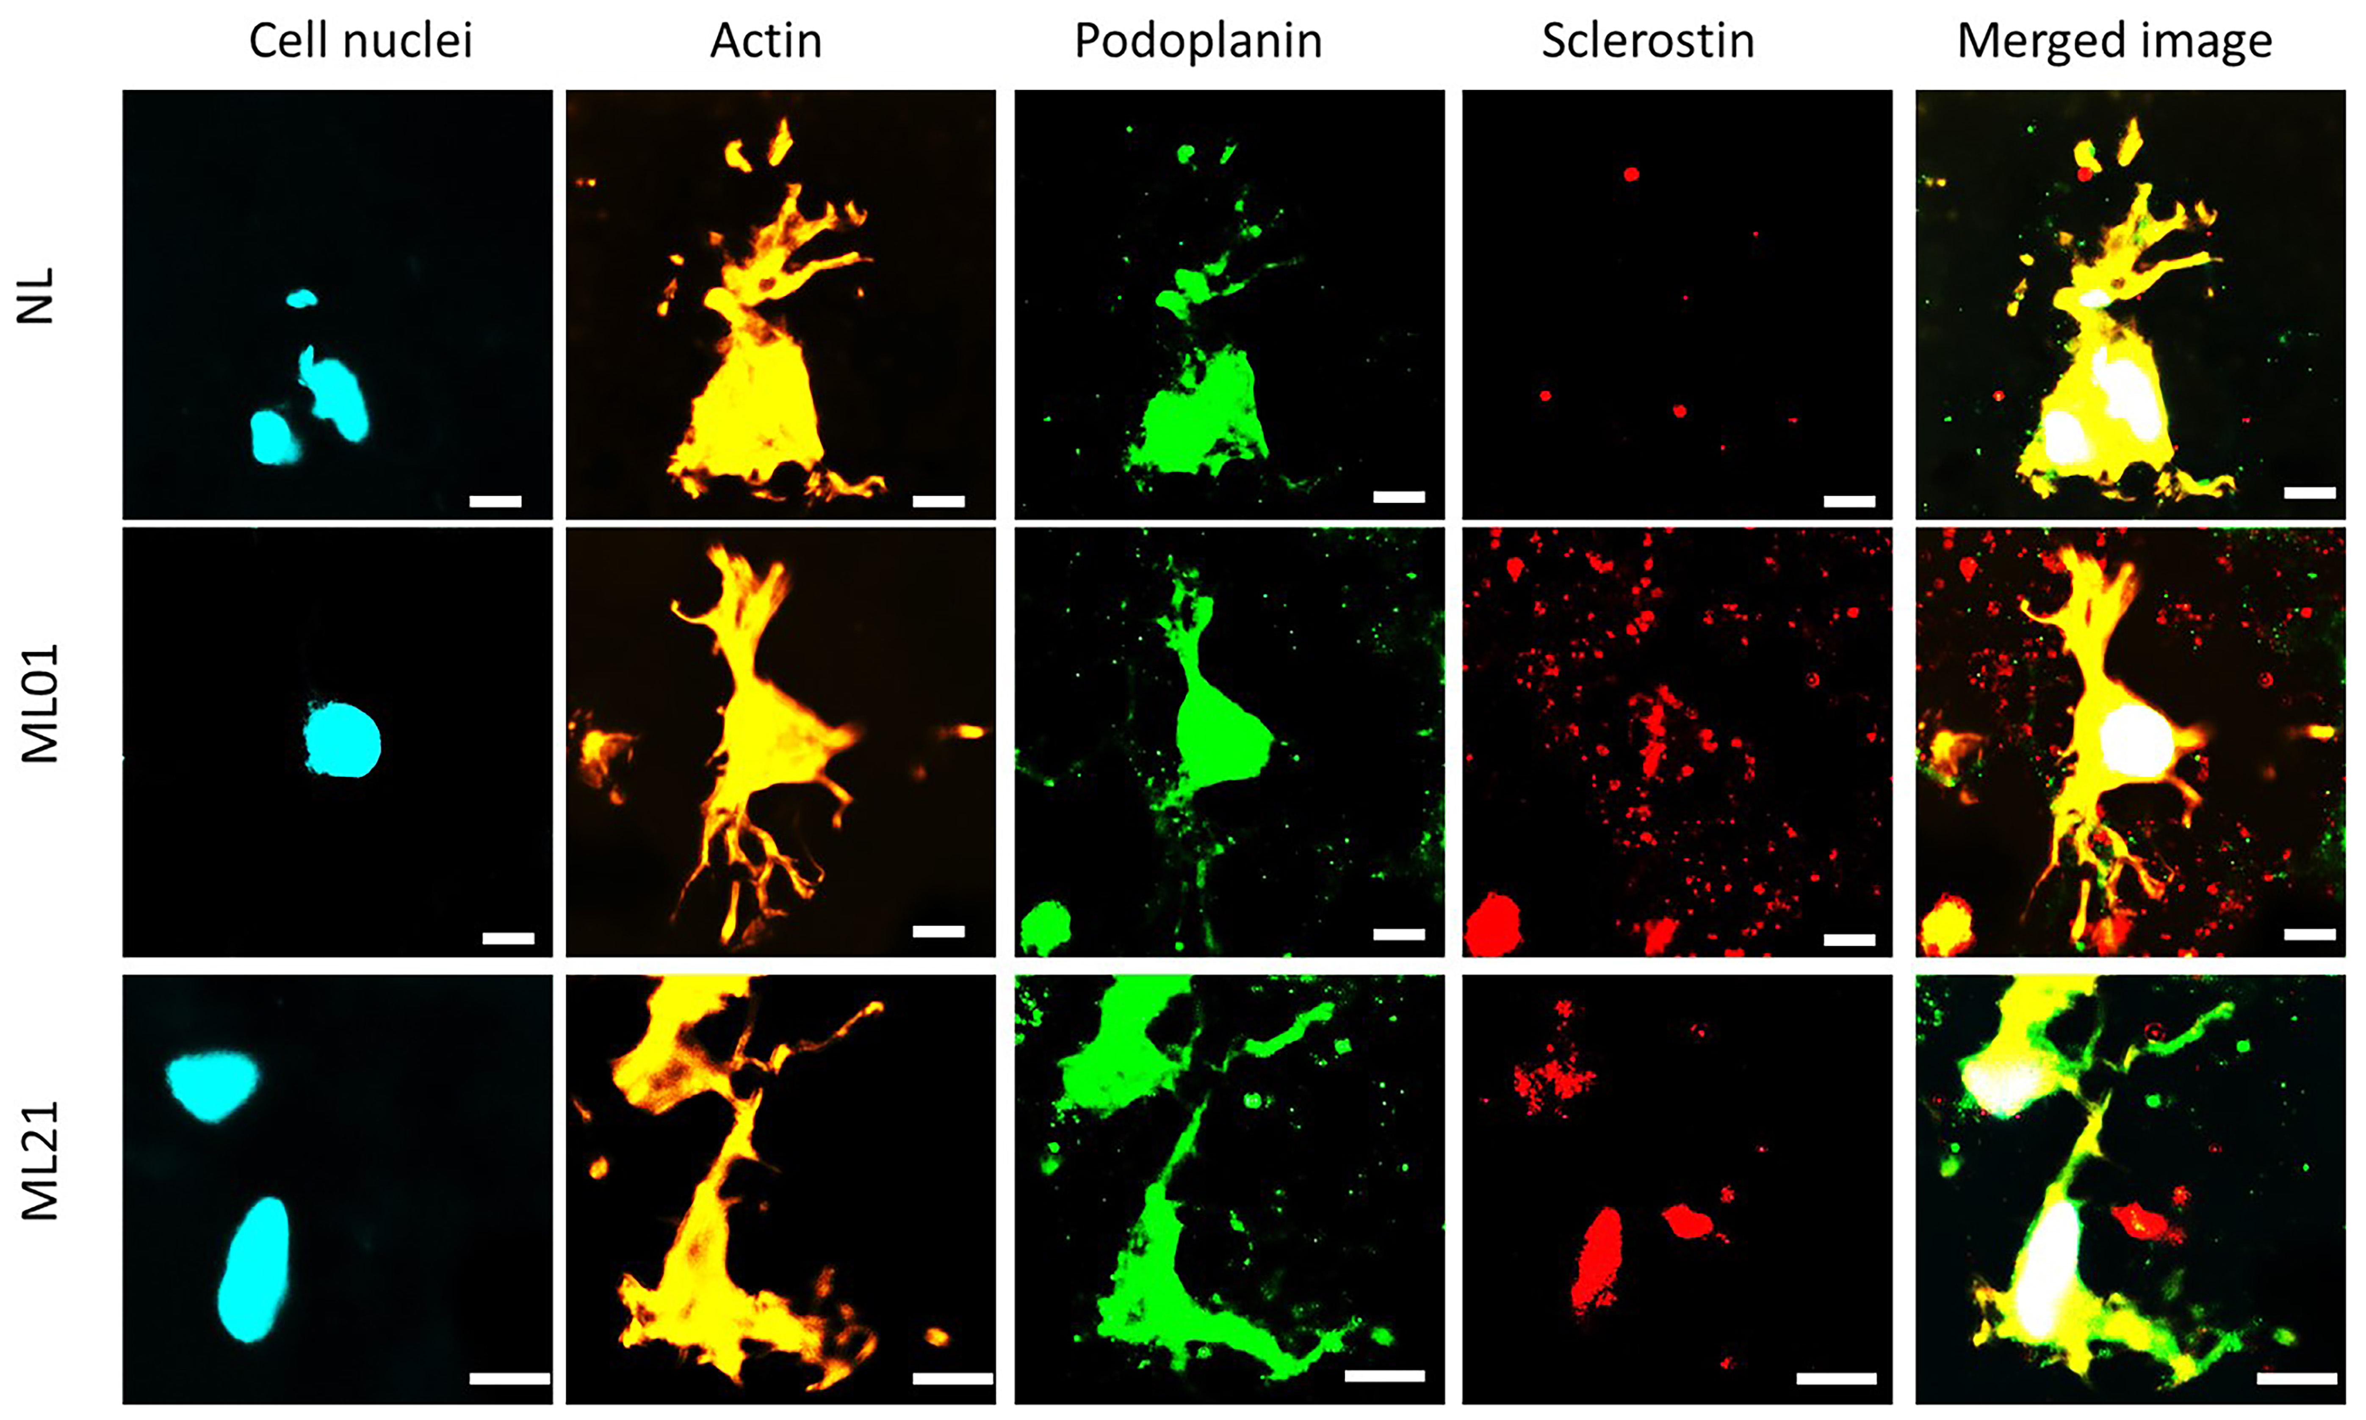
Figure S9. Cell nuclei and actin, podoplanin and sclerostin immunostaining of the sections from the top region in NL, ML01, ML21 scaffold at day 56 after cultured in the compression bioreactors. Scale bar 10 µm.

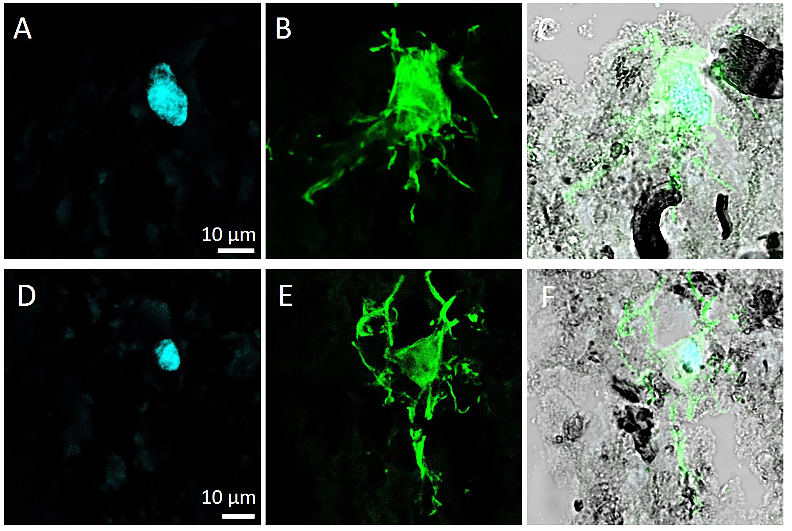
Figure S10. Osteocyte morphology in ML01 group at day 56 after cultured in the compression bioreactors. Cell nuclei (A D), actin staining (B E) and cell nuclei/actin/brightfield merged images (C F).

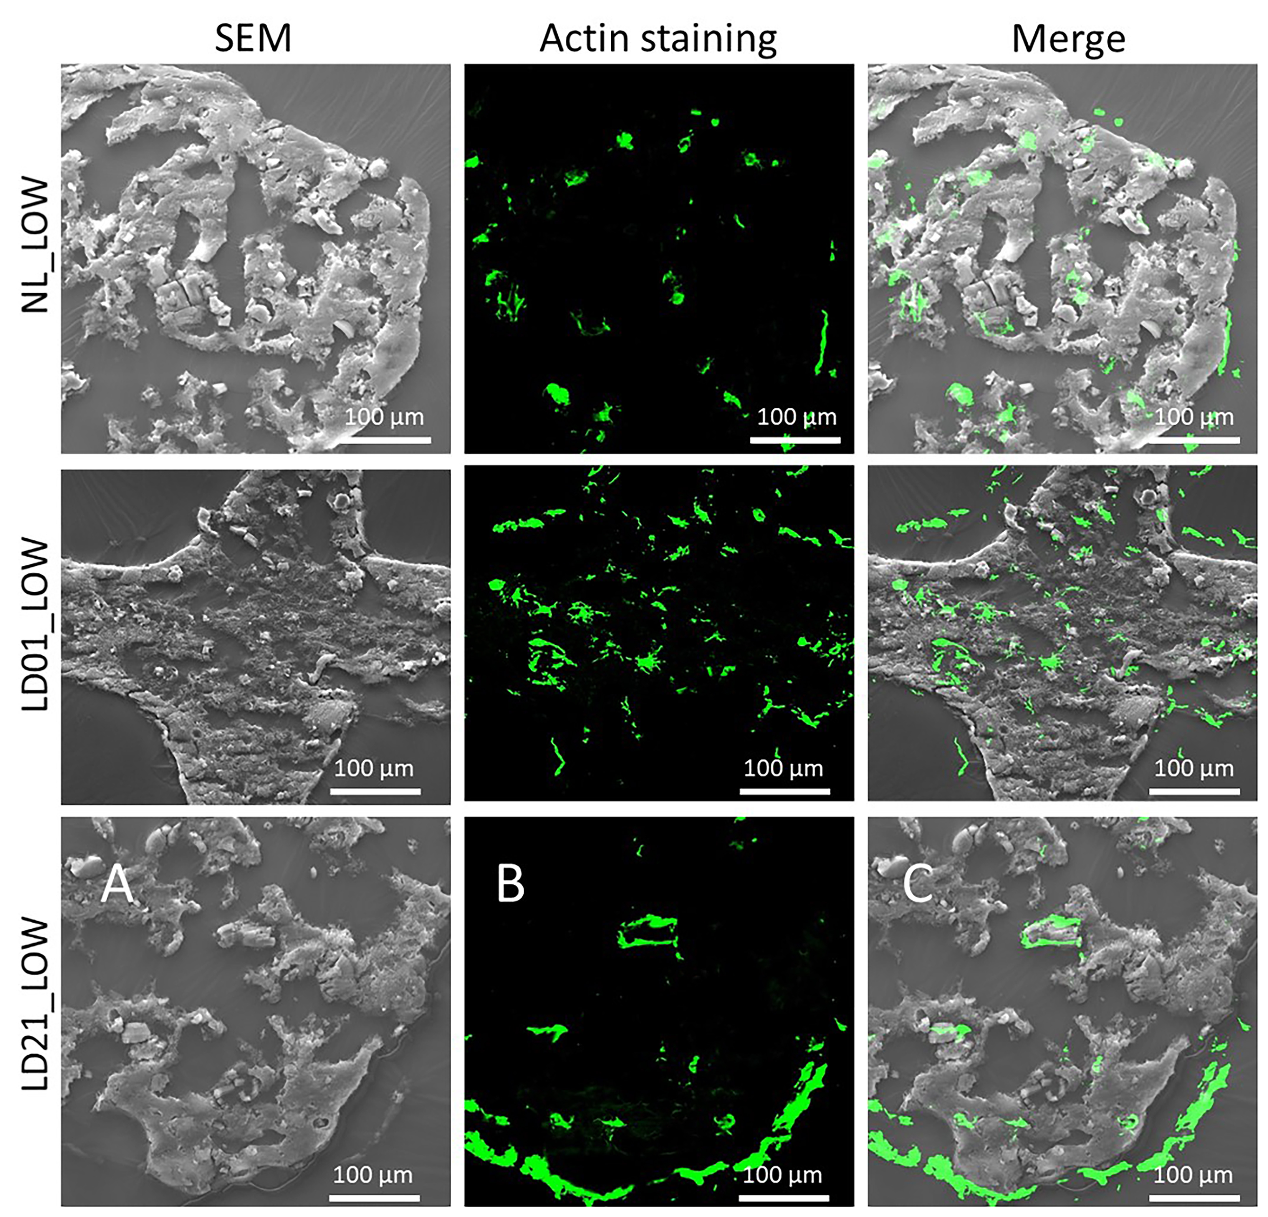
Figure S11. Low magnification of SEM image, actin staining image and actin/SEM merged image in the same position from the sections in NL (A), ML01(B) and ML21 (C) on day 56 after culturing in the compression bioreactor, scale bar 100 µm.

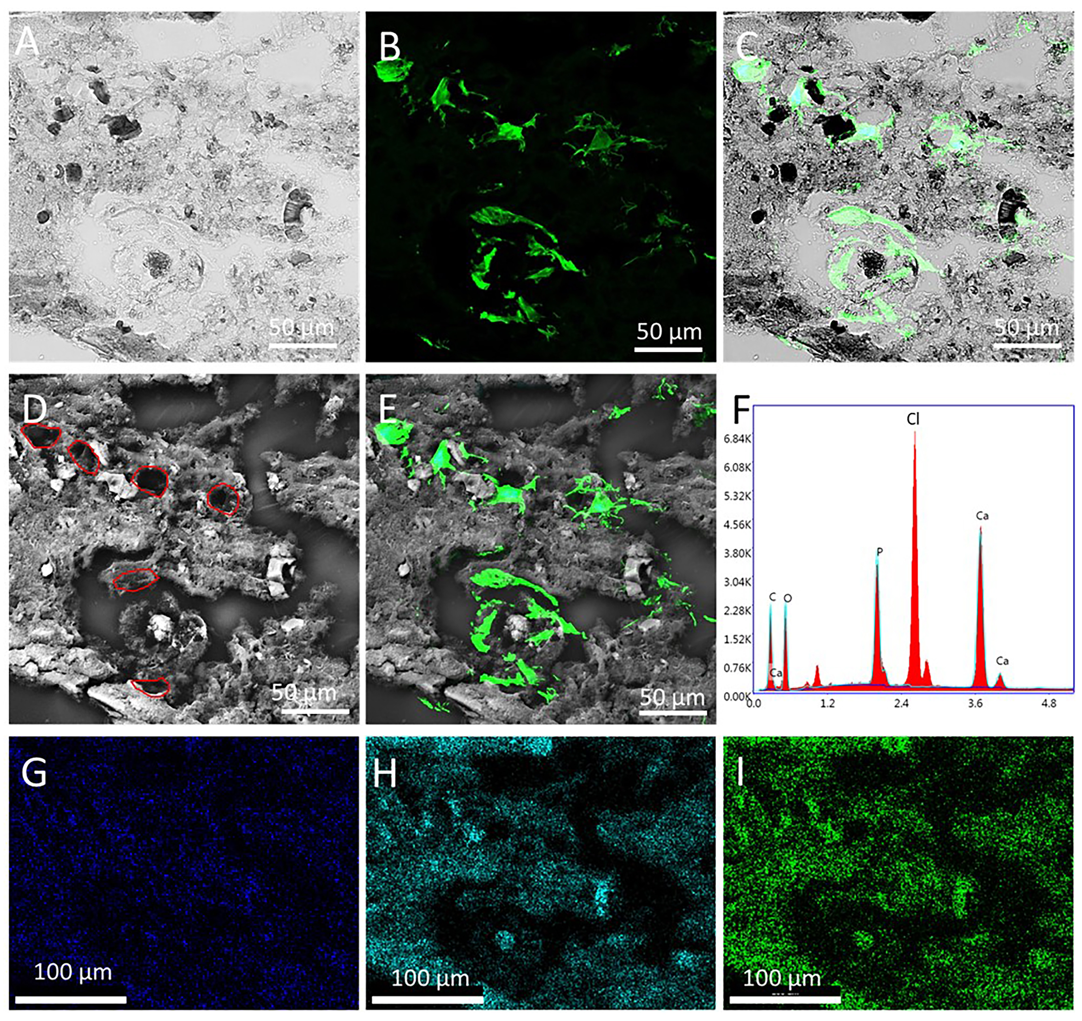
Figure S12. Low magnification of brightfield image (A), actin staining image (B) and cell nuclei/actin/brightfield merged image (C) in the same position from the sections in ML01 on day 56 after culture in the compression bioreactor. (D) Low magnification of SEM image in the same position of brightfield, osteocyte staining images showed in (A B), red freedom rings represent lacunae positions. (E) Low magnification of the merged image of cell nuclei, actin staining and SEM image. Osteocytes were located in the lacunae positions shown in (D). (F) EDS spectrum of (D), Cl was from the Kawamoto’s cryofilm type 2C type. (G) Ca, (H) P and (I) O element distributions in (D).

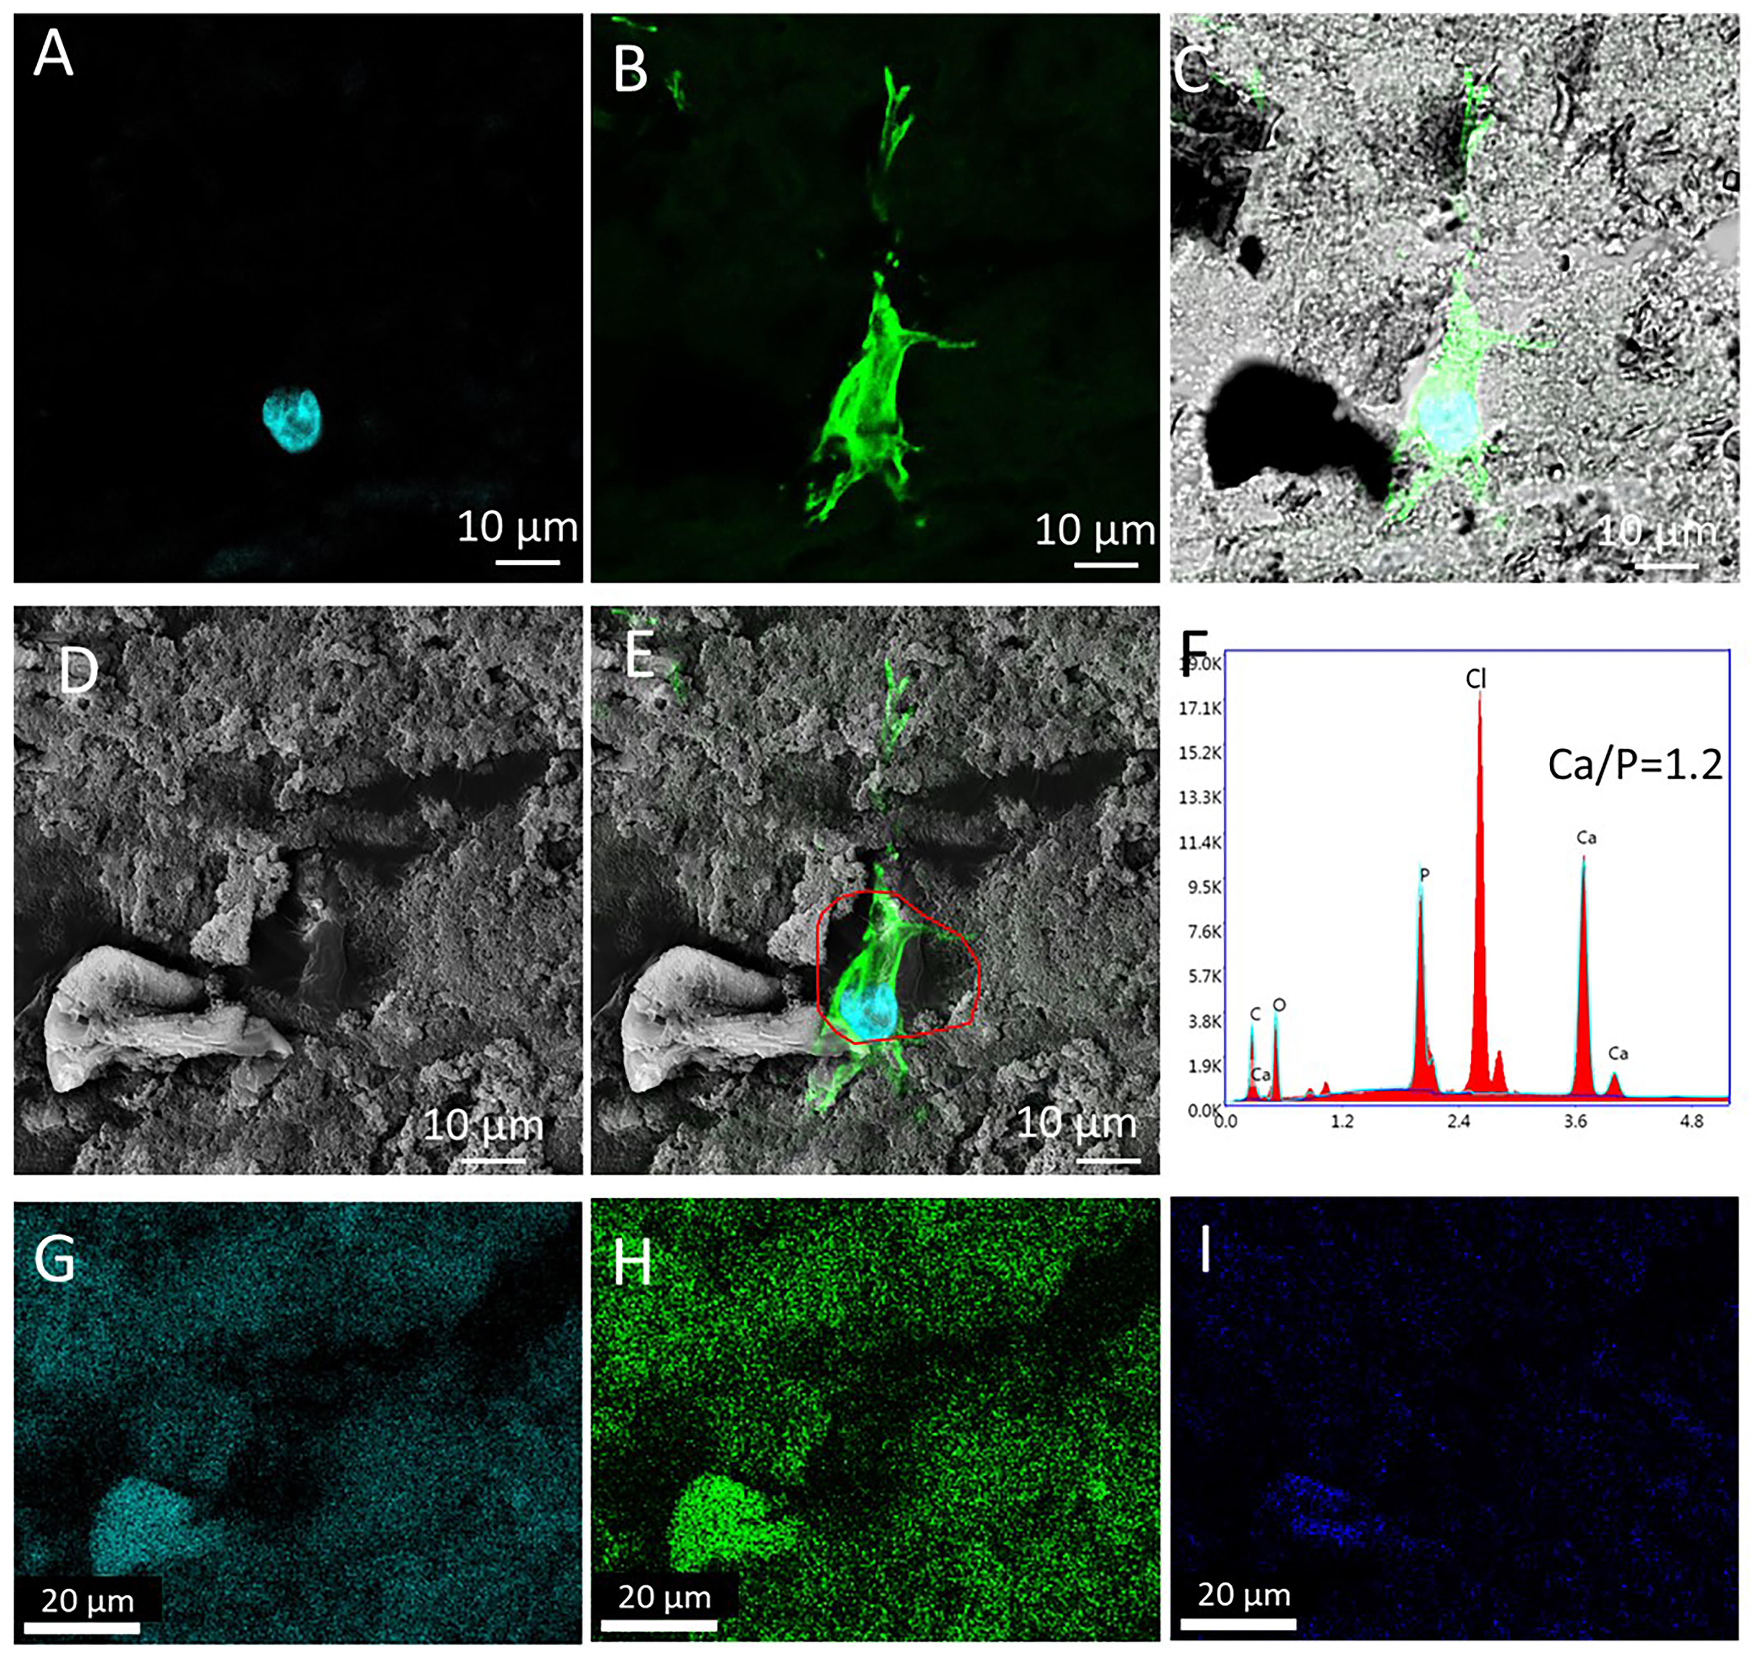
Figure S13. High magnification of cell nuclei (A), actin staining image (B) and cell nuclei/actin/brightfield merged image (C) in the same position from the sections in ML01 on day 56 after culture in the compression bioreactor. (D) SEM image in the same position of osteocyte nuclei and actin staining images showed in (A B). (E) the merged image of cell nuclei, actin staining and SEM image. Osteocyte was located in the lacuna position showed a red freedom ring. (F) EDS spectrum of (D), Cl was from the Kawamoto’s cryofilm type 2C type. Ca/P was 1.2. (G) Ca, (H) P and (I) O mappings in (D).

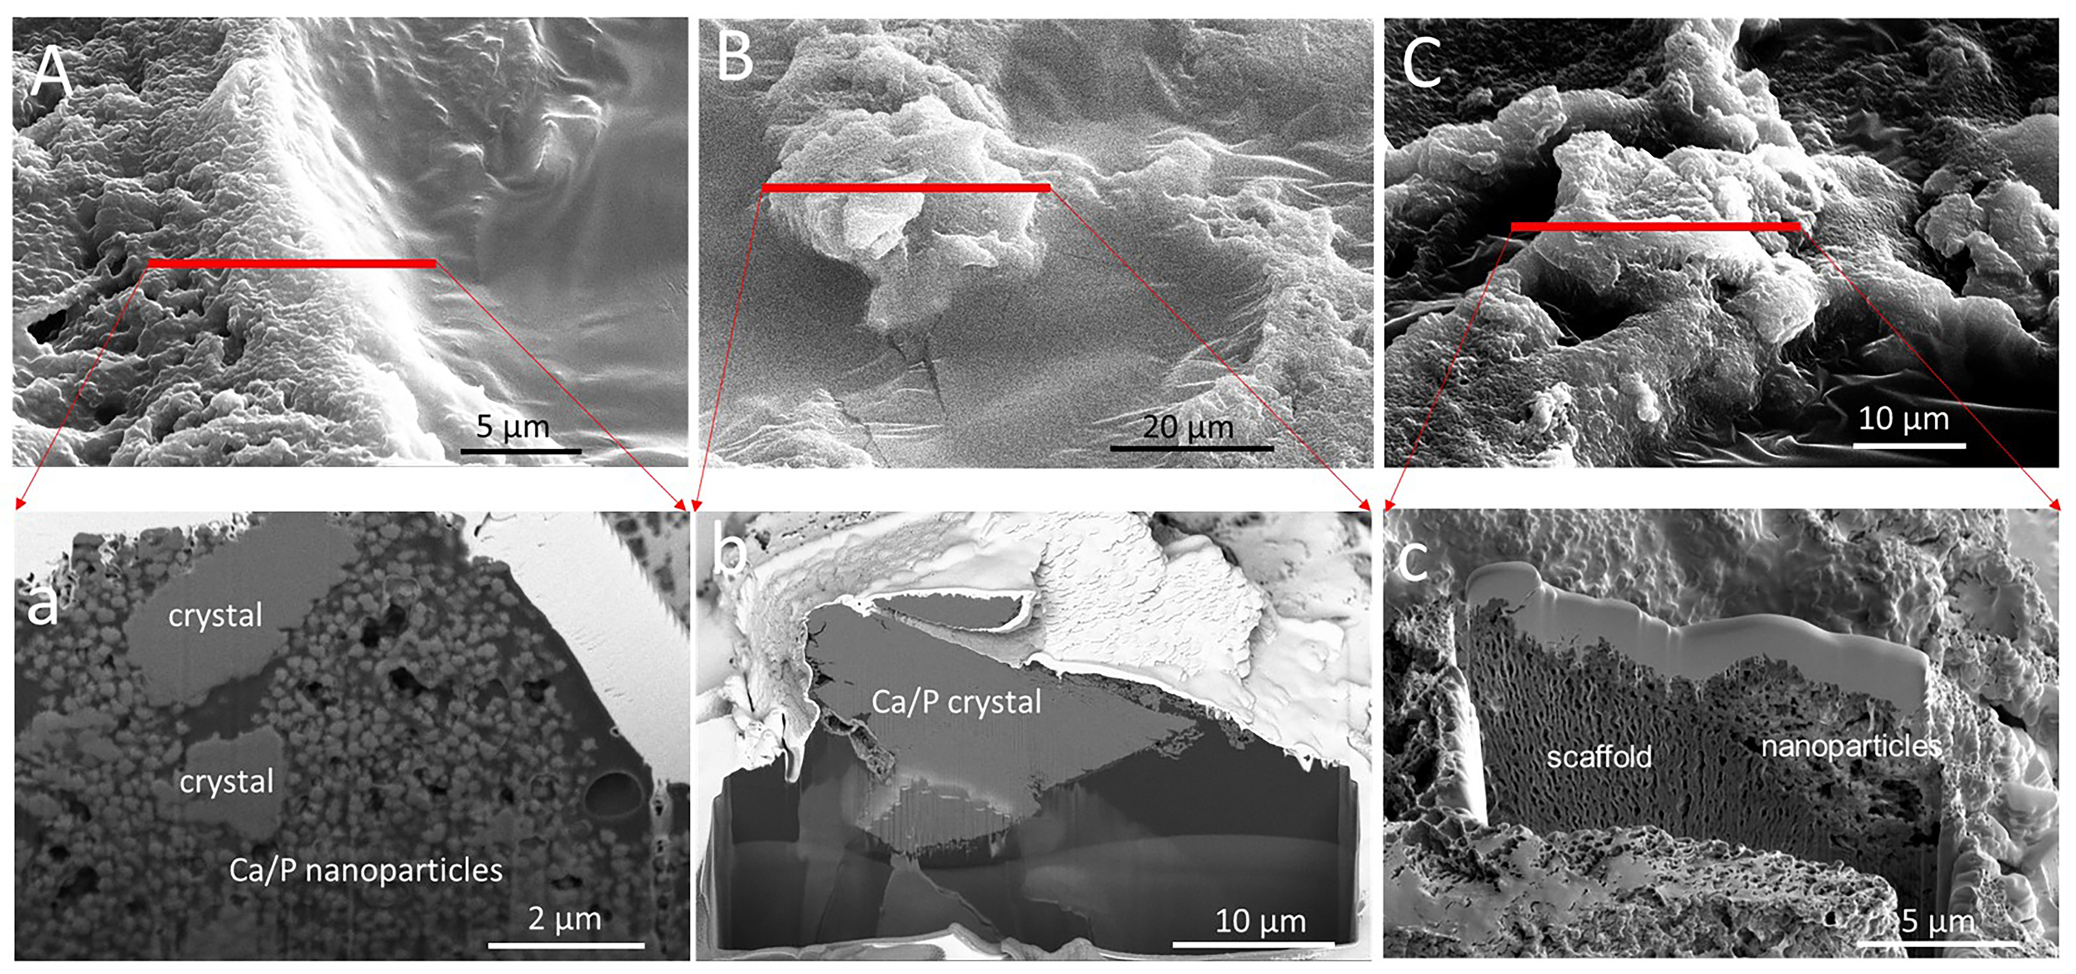
Figure S14. (A-C) Backscattering electron (BSE) images of different positions in the section of the ML01 group after culture in the compression bioreactor for 56 days. (A-C) positions were choose from the bright areas, which indicated the mineral element enrichment areas in BSE images. (a-c) SEM images of FIB cross-sections of the corresponding lines (red lines) in(A-C).

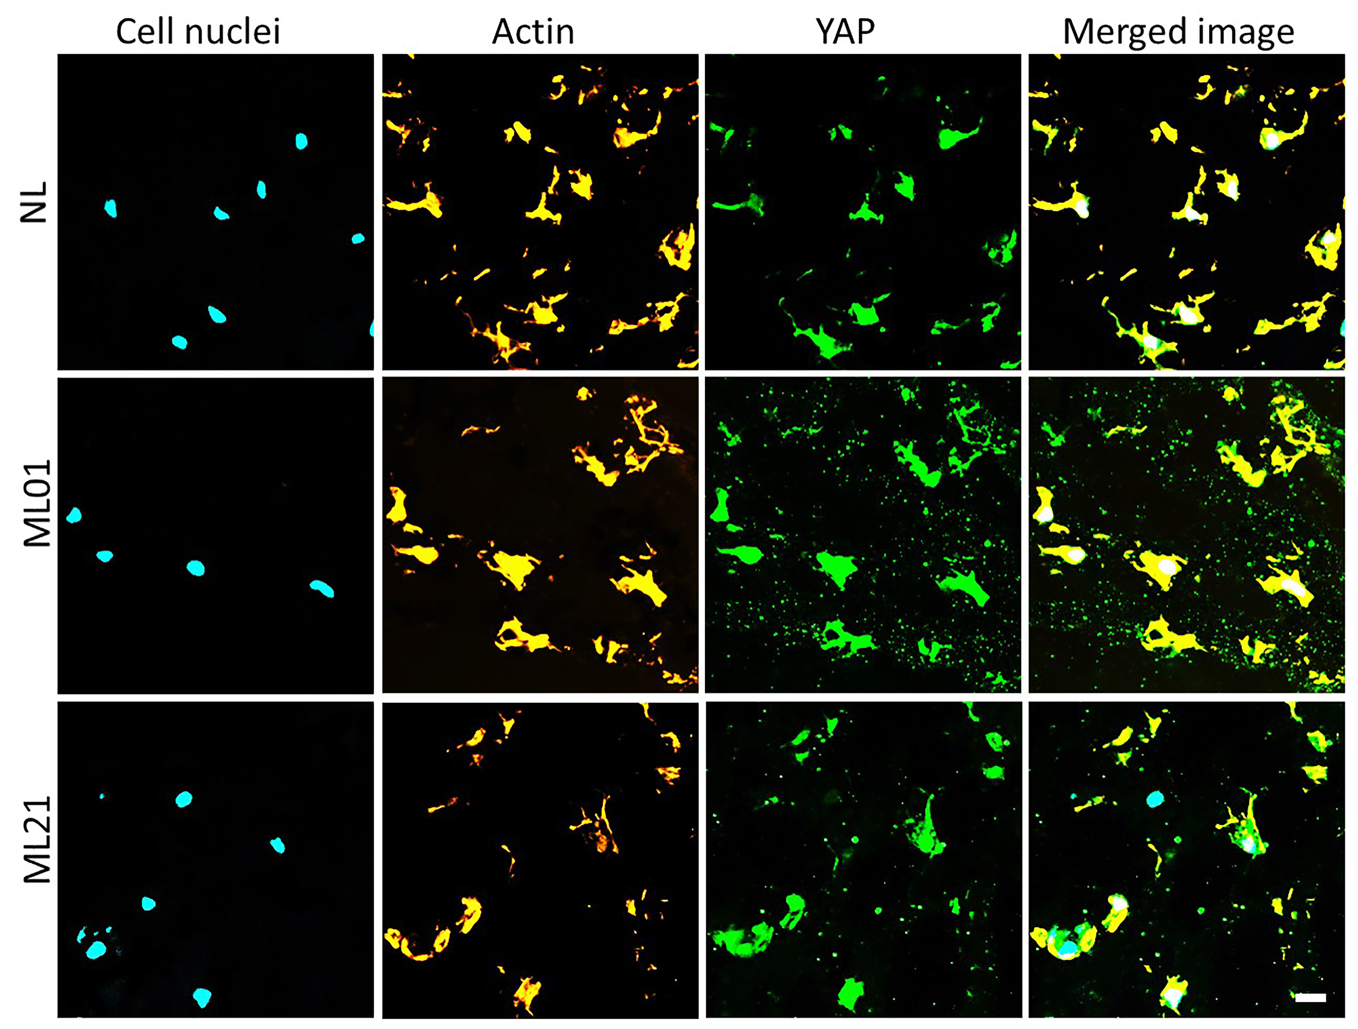
Figure S15. Cell nuclei, actin and YAP immunostaining of the sections from the top region in NL, ML01, ML21 scaffold at day 56 after culture in the compression bioreactors. Scale bar 20 µm.

- J. Zhang, H. Eyisoylu, X. H. Qin, M. Rubert, R. Muller, 3D Bioprinting of Graphene Oxide-Incorporated Cell-laden Bone Mimicking Scaffolds for Promoting Scaffold Fidelity, Osteogenic Differentiation and Mineralization. Acta Biomater, (2020).

- M. J. Mc Garrigle, C. A. Mullen, M. G. Haugh, M. C. Voisin, L. M. McNamara, Osteocyte Differentiation and the Formation of an Interconnected Cellular Network in vitro. Eur Cells Mater 31, 323-340 (2016).

- J. Zhang, E. Wehrle, J. R. Vetsch, G. R. Paul, M. Rubert, R. Mueller, Alginate dependent changes of physical properties in 3D bioprinted cell-laden porous scaffolds affect cell viability and cell morphology. Biomed Mater, (2019).

- E. C. Jensen, Quantitative Analysis of Histological Staining and Fluorescence Using ImageJ. Anat Rec 296, 378-381 (2013).

- T. A. Potapova, S. Sivakumar, J. N. Flynn, R. Li, G. J. Gorbsky, Mitotic progression becomes irreversible in prometaphase and collapses when Wee1 and Cdc25 are inhibited. Molecular Biology of the Cell 22, 1191-1206 (2011).

- J. S. Bredfeldt, Y. M. Liu, C. A. Pehlke, M. W. Conklin, J. M. Szulczewski, D. R. Inman, P. J. Keely, R. D. Nowak, T. R. Mackie, K. W. Eliceiri, Computational segmentation of collagen fibers from second-harmonic generation images of breast cancer. J Biomed Opt 19, (2014).

