Supplementary Information

New Class of Broad-Spectrum Antivirals Improves Influenza Virus Vaccine Development
Armando Pacheco^{§1}, David W. Buchholz^{§2}, I. Abrrey Monreal^{§2}, Shi Xu^{13,14}, Brian Imbiakha², Julie Sahler², Mason Jager², Alex Liqi Lai³, Erik M. Contreras², Brandan Cook¹³, Elshan Ralalage⁸, Qian Liu⁴, Yao Yu Yeo², Andrew Ma², J. Lizbeth Reyes Zamora², Niraj K. Shil⁵, Sara Jones-Burrage⁶, Suzanne M. Pritchard⁵, Chuntao Yang¹³, Yu Zhao¹³, Zeinab J Mohamed⁷, Cheyan Xu⁷, Susan Daniel⁷, Michael J. Jung⁸, Gerlinde R. Van de Walle², Suchetana Mukhopadhyay⁶, Masako Shimamura⁹, Alan Goodman¹⁰, Michele Hardy¹¹, Santanu Bose⁵, Anthony V. Nicola⁵, Jack H. Freed³, Avery August², Jace W. Jones¹², Ming Xian^{13,14}, and Hector C. Aguilar^{2*}

§: Authors contributed equally to this manuscript

* To whom correspondence should be addressed, HAC at email: ha363@cornell.edu

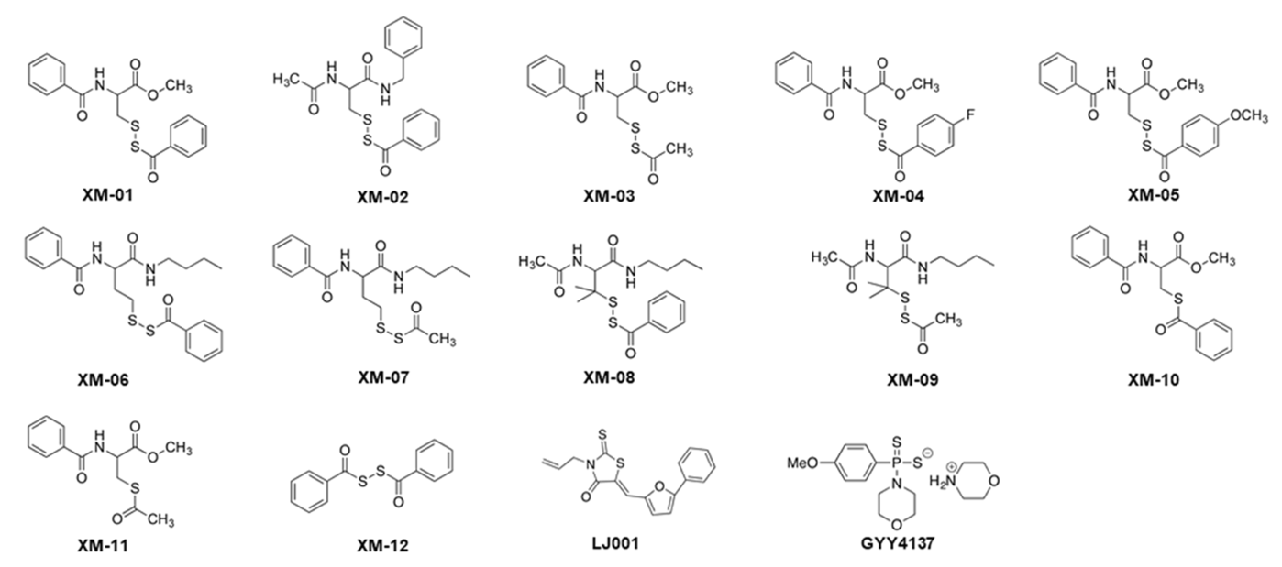

Supplementary Figure 1. Structures of compounds tested (XM- numbers 01-12) and control compounds LJ001 and GYY4137, known to inhibit enveloped viruses and NiV, respectively.

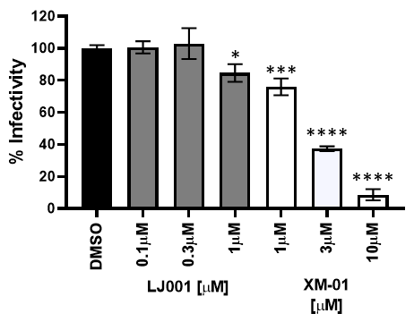
Supplementary Figure 2. Infection of Vero cells by pNiV pre-treated with XM-01 before infecting Vero cells in the dark. While XM-01 did not need light to inhibit viral infections, LJ001 was ineffective without light, as compared to Fig. 1A. N = 3 independent experiments. Statistical analyses were performed with one-ANOVA and Dunnett’s multiple comparisons test (N = 3; *P < 0.05, **P < 0.01, ***P < 0.001, ****P < 0.0001).

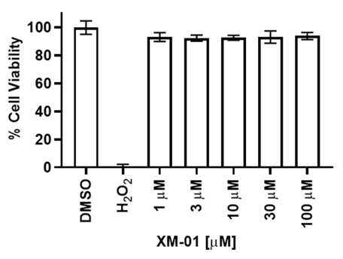
Supplementary Figure 3. XM-01 effect on cell viability was tested from 1 µM – 100 µM in MDCK cells. No statistical differences were observed at any XM-01 concentration.

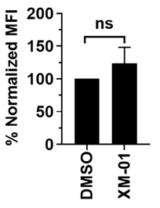
Supplementary Figure 4. 10 µM XM-01 did not interfere with triggering of the NiV F protein in the fusion cascade. Statistical analyses were performed with a student t-test. N = 3 independent experiments.

A B
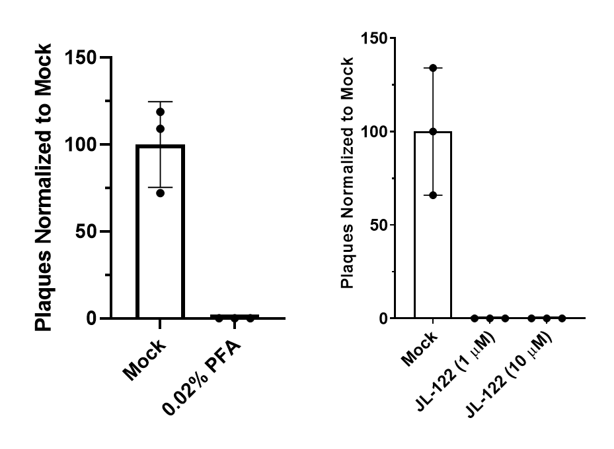
Supplementary Figure 5. (A) PFA treatment at 0.02% completely inactivated virus as determined through plaque assay. (B) JL-122 treatment at 1 and 10 µM completely inactivated virus as determined through plaque assay. Inactivated virus was attempted to be passaged 3 times in cell culture and in mice, with no virus detected upon after these passages by plaque assay or immunofluorescent staining.

A B

Supplementary Figure 6. Hemagglutination and neuraminidase inhibition assays with serum from vaccinated female mice. (A) Female mice serum HA (top) or NA (bottom) inhibition after two vaccinations were statistically significantly different between PFA (traditional) and XM-01 IIV-vaccinated animals for HA (top) and at the 3 highest concentrationos of serum for NA (bottom). (B) Female mice serum HA (top) or NA (bottom) inhibition after three vaccinations. N = 5 females per group. Statistical analyses were performed using standard student t-tests (*p<0.05, **p<0.01, ***p<0.001).

