Observation of strong helical excitons and unexpectedly giant Rashba splitting in single crystal two-dimensional Organic-Inorganic Halide Perovskites
Xiao Chi^{1,2,3}, Kai Leng⁴, Runlai Li⁵, Xiaojiang Yu¹, Ping Yang¹, Mark B.H. Breese^{1,2}, Kian Ping Loh^{3†}, Andrivo Rusydi^{1,2,3,5‡}
¹ Department of Physics, National University of Singapore, 117576, Singapore
² Singapore Synchrotron Light Source, National University of Singapore, 5 Research Link, 117603, Singapore
³Centre for Advanced 2D Materials and Graphene Research Centre, National University of Singapore, 117546, Singapore
⁴Department of Applied Physics, The Hong Kong Polytechnic University, Hung Hom, Kowloon, Hong Kong
⁵Department of Chemistry, National University of Singapore, 3 Science Drive 3, Singapore 117543
⁶NUS Graduate School for Integrative Sciences and Engineering, 117456, Singapore

E-mail: ‡phyandri@nus.edu.sg; †chmlohkp@nus.edu.sg

Supplementary Note 1: High-Resolution X-ray diffraction (HRXRD)
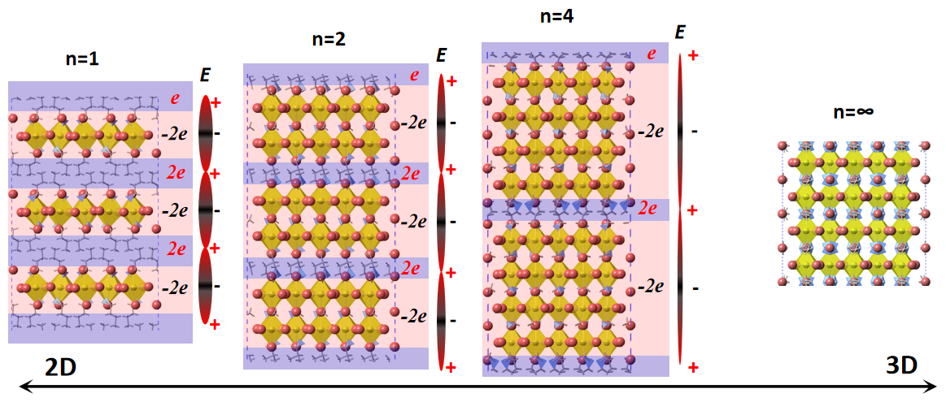
Fig. S1. Schematic of crystal structures of Ruddlesden-Popper perovskites (RPPs) with structural evolutions from two-dimension (2D) to three-dimension (3D). The structure of 2D RPPs can be described in terms of polar semiconductor model, where the long chain molecule R forms positively charged (R₂)⁺ layer, which separates the dielectric ((A)_{n-1}M_{n}X_{3n+1})²⁻ layer. The crystal structure possesses a polar axis along the stacking direction and leads to a potential gradient (or electric dipole field (E_{z})) at the surface due to uncompensated charges. The Rashba effect is directly related to the strength of the potential gradient.

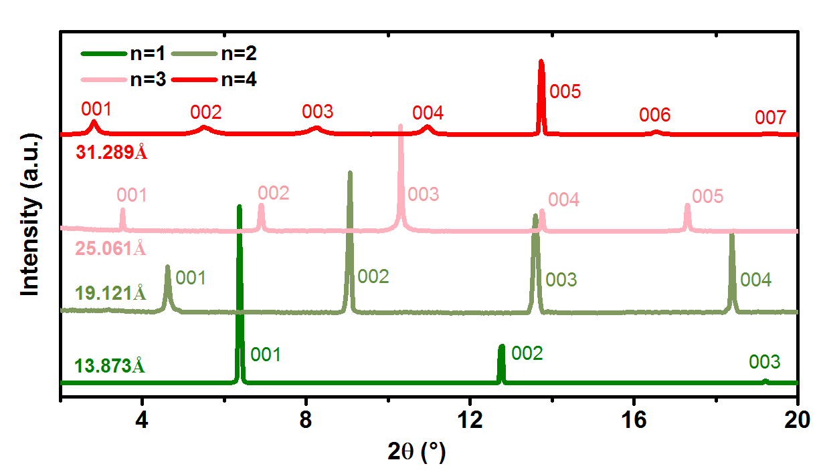
Fig. S2. High-resolution X-ray diffraction patterns for n=1 to 4 Iodides. Phase purity is established by monitoring the position and number of the low-angle peaks in X-ray diffraction patterns for each n value. The diffraction patterns only show (00L) orientation further indicate a highly ordered layered stacking arrangement and high quality of single crystals for all samples. The lattice constant c of each sample can be calculated by Bragg diffraction equation 2dsinθ=nλ, where d is the spacing of the crystal layers, θ is the incident angle of X-ray, λ is wavelength.
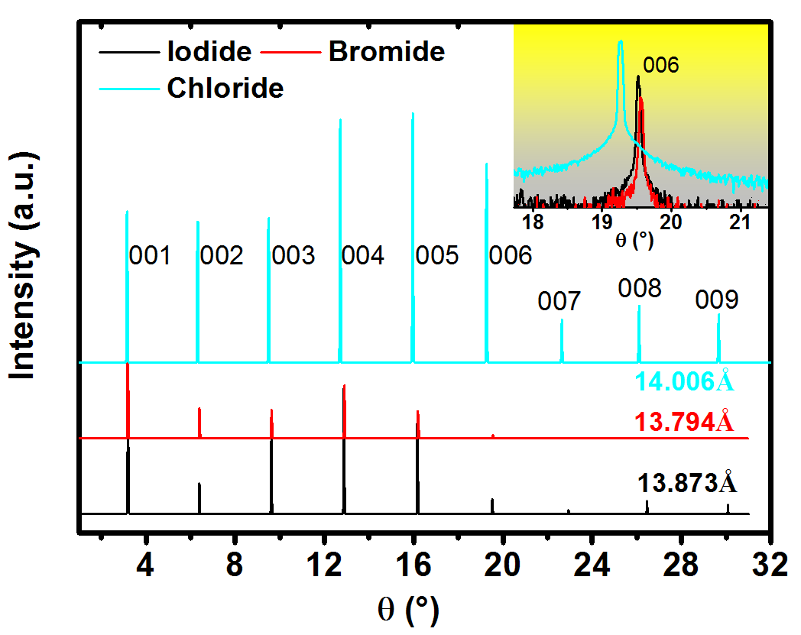
Fig. S3. High-resolution X-ray diffraction patterns for n=1 halide perovskite of Iodide, Bromide and Chloride. Phase purity is established by monitoring the position and number of the low-angle peaks in x-ray diffraction patterns for each n value. The diffraction patterns only show (00L) orientation, further indicating a highly ordered layered stacking arrangement and high quality of single crystals for all samples.

Supplementary Note 2: Optical fine structure of n=1 Bromide and Chloride
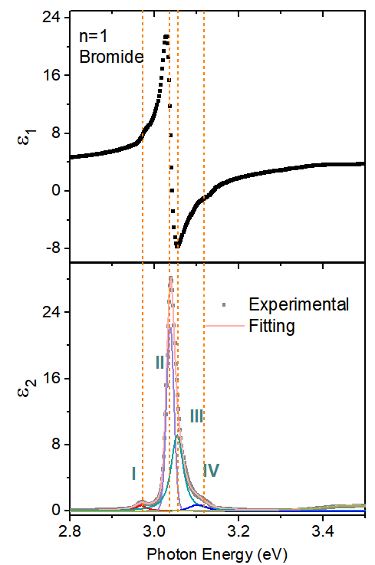
Fig. S4. Real (ε₁) and Imaginary (ε₂) parts of complex dielectric function of n=1 Bromide, respectively, measured at 78 K. The four helical exciton peaks (I, II, III, and IV) are associated with the spin-allowed and -forbidden transitions, which are discussed in the main article.
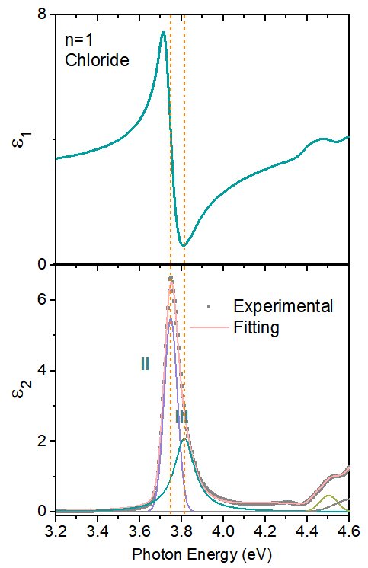
Fig. S5. Real (ε₁) and Imaginary (ε₂) parts of complex dielectric function of n=1 Chloride, respectively, measured at 78 K. The two helical exciton peaks (II and III) are associated with the spin-allowed, which are discussed in the main article. The two spin-forbidden transitions are overlapped with the two spin-allowed transitions as element Cl only has negligible spin-orbital coupling.

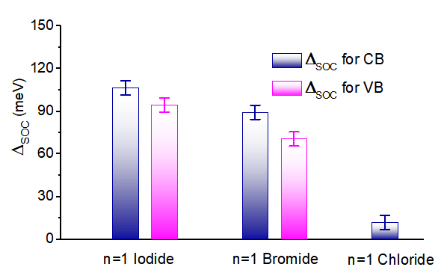
Fig. S6. Rashba splitting energies on both CB and VB n=1 2D RPPs. From the fine structure, the Rashba energy splitting (Δ_{pb} and Δ_{Ι}) of both CB and VB is found by calculating the energy differences between spin-allowed and spin forbidden transitions, namely Ε(CB) = Δ_{pb} = E(III) − E(I) and Ε(CB) = Δ_{Ι} = E(II) − E(I).

Supplementary Note 3: Details of temperature dependent complex dielectric functions for 2D Iodide
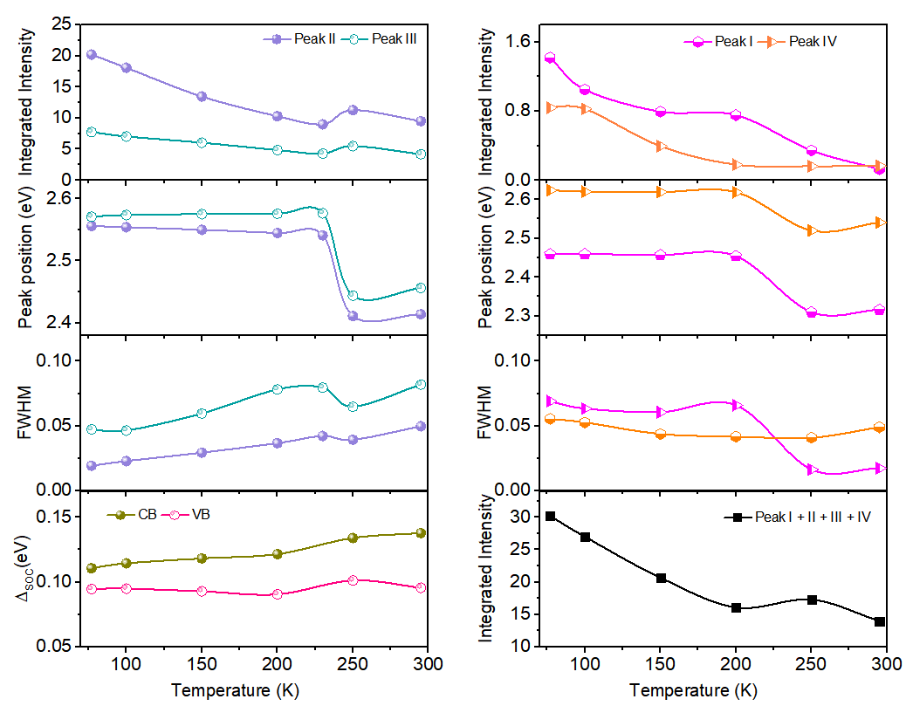
Fig. S7. The fitting results of n=1 Iodide. (a) to (h) are the fitting parameters of four helical excitons, including integrated peak intensity (a) and (e), peak energy (b) and (f), FWHM (c) and (g), Rashba splitting energy (d) and total peak intensity (h).

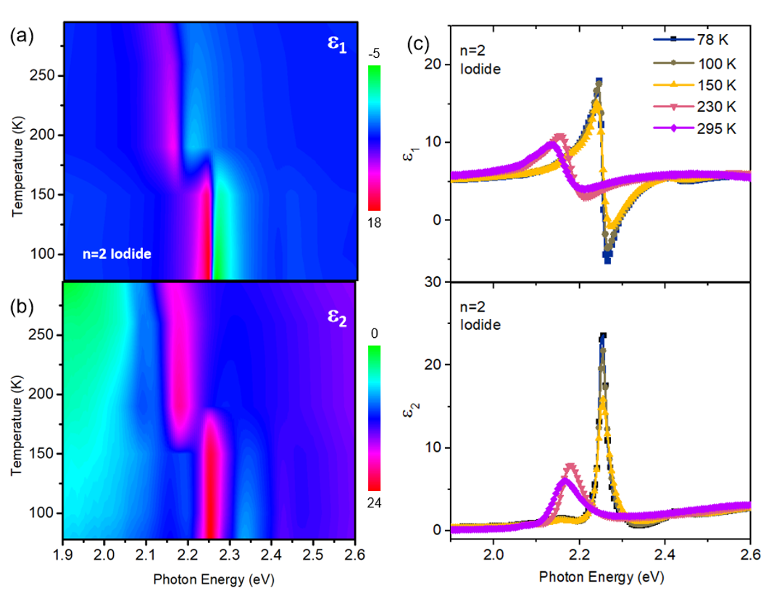
Fig. S8. (a), (b) and (c) are the temperature dependence of Real (ε₁) and Imaginary (ε₂) parts of complex dielectric functions of n=2 Iodide, respectively.
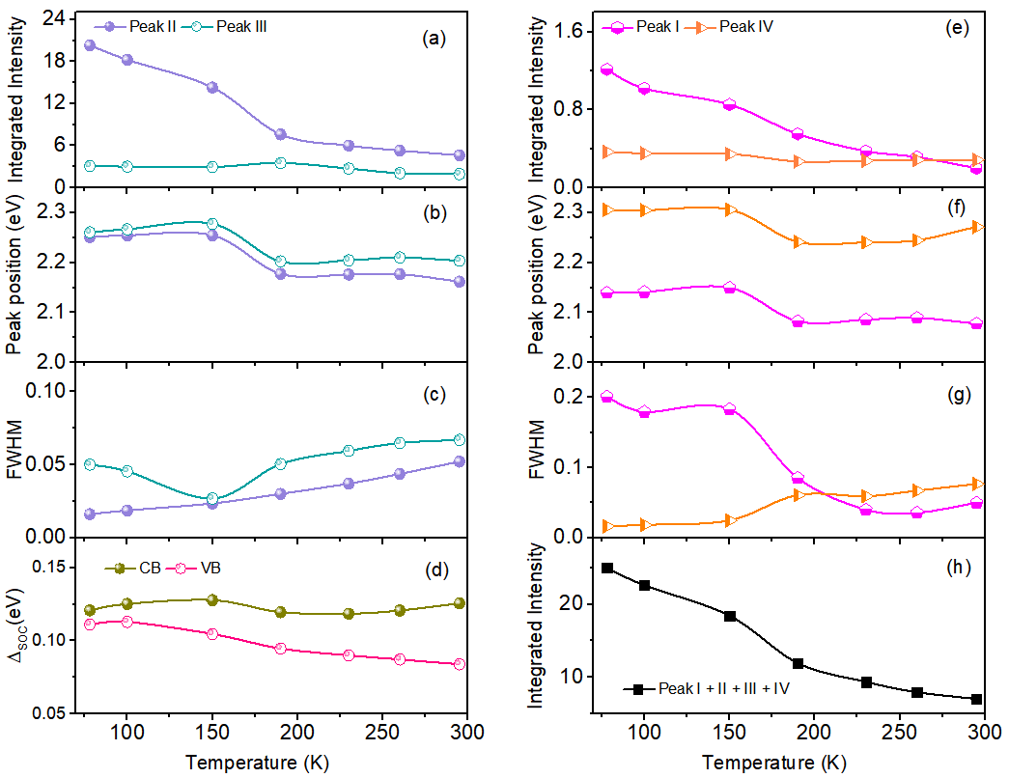
Fig. S9. The fitting results of n=2 Iodide. (a) to (h) are the fitting parameters of four helical excitons, including integrated peak intensity (a) and (e), peak energy (b) and (f), FWHM (c) and (g), Rashba splitting energy (d) and total peak intensity (h).
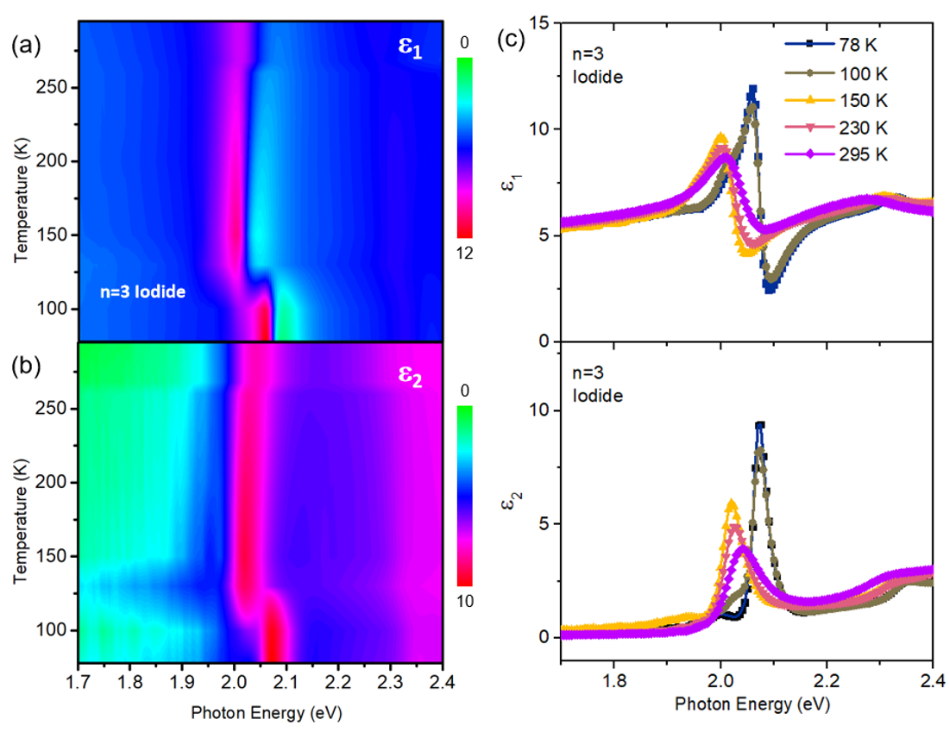
Fig. S10. (a), (b) and (c) are the temperature dependence of Real (ε₁) and Imaginary (ε₂) dielectric functions of n=3 Iodide, respectively.
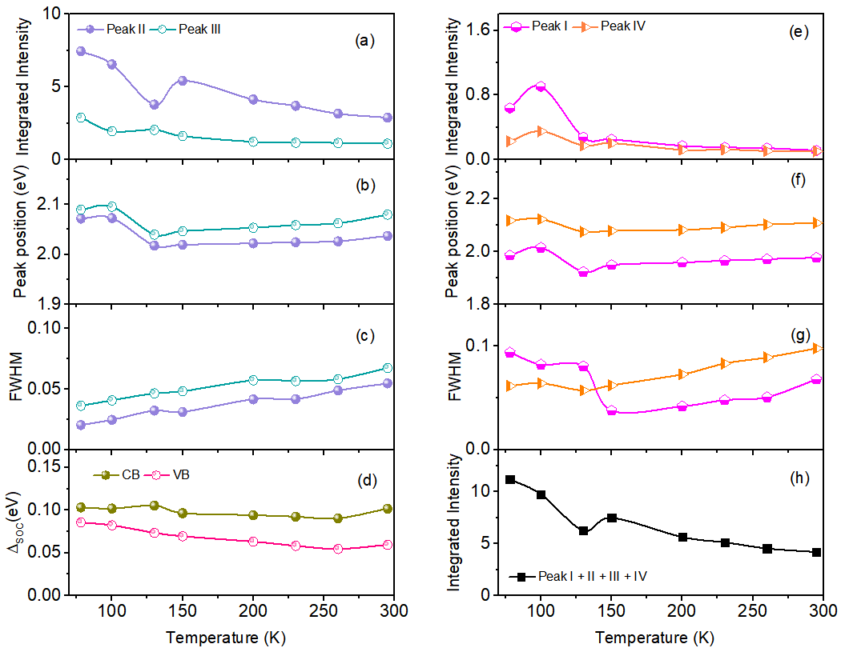
Fig. S11. The fitting results of n=3 Iodide. (a) to (h) are the fitting parameters of four helical excitons, including integrated peak intensity (a) and (e), peak energy (b) and (f), FWHM (c) and (g), Rashba splitting energy (d) and total peak intensity (h).
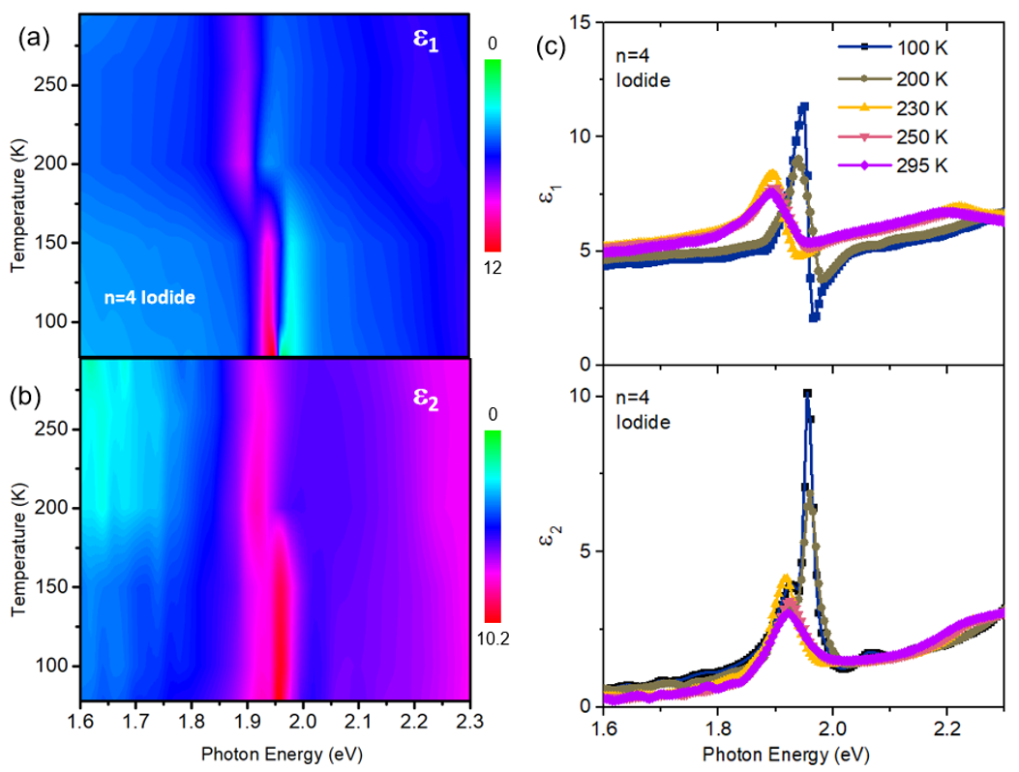
Fig. S12. (a), (b) and (c) are the temperature dependence of Real (ε₁) and Imaginary (ε₂) dielectric functions of n=4 Iodide, respectively.
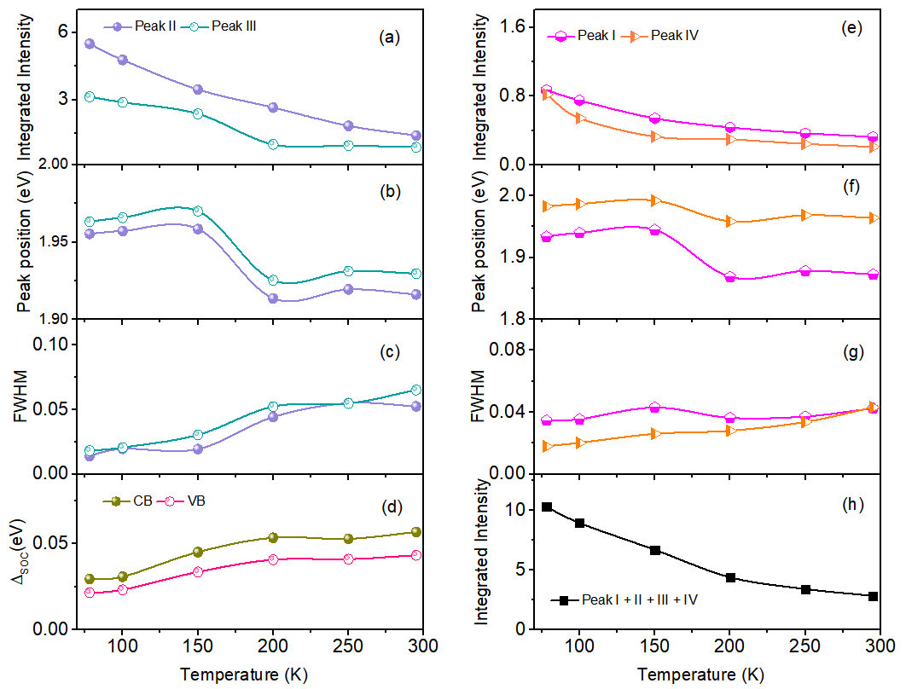
Fig. S13. The fitting results of n=4 Iodide. (a) to (h) are the fitting parameters of four helical excitons, including integrated peak intensity (a) and (e), peak energy (b) and (f), FWHM (c) and (g), Rashba splitting energy (d) and total peak intensity (h).

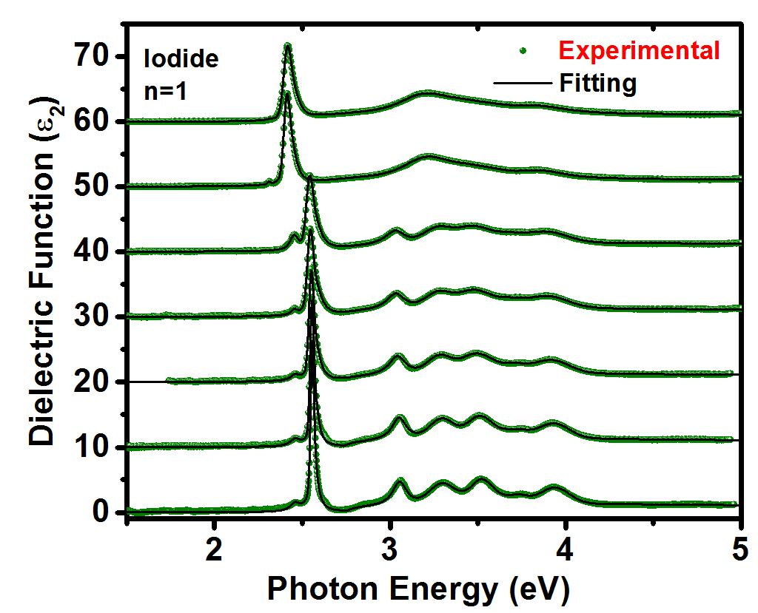
Fig. S14. Temperature dependent of experimental and fitting results of ε₂ for n=1 Iodide. The temperatures of measurements from bottom to top are 78, 100, 150, 200, 230, 250 and 295 K.
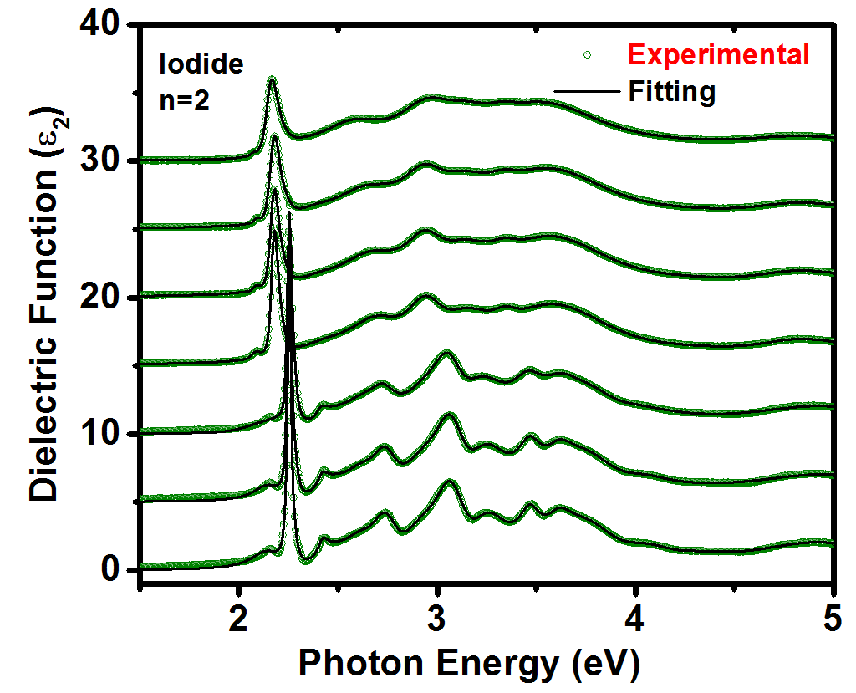
Fig. S15. Temperature dependent of experimental and fitting results of ε₂ for n=2 Iodide. The temperatures of measurements from bottom to top are 78, 100, 150, 190, 230, 260 and 295 K.
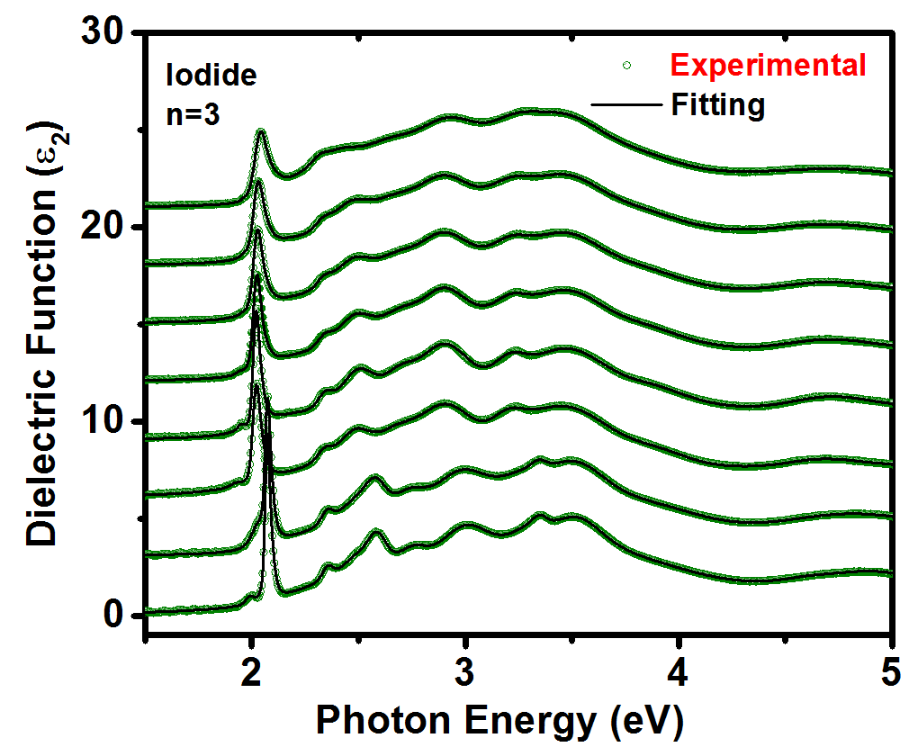
Fig. S16. Temperature dependent of experimental and fitting results of ε₂ for n=3 Iodide. The temperatures of measurements from bottom to top are 78, 100, 130, 150, 200, 230, 260 and 295 K.
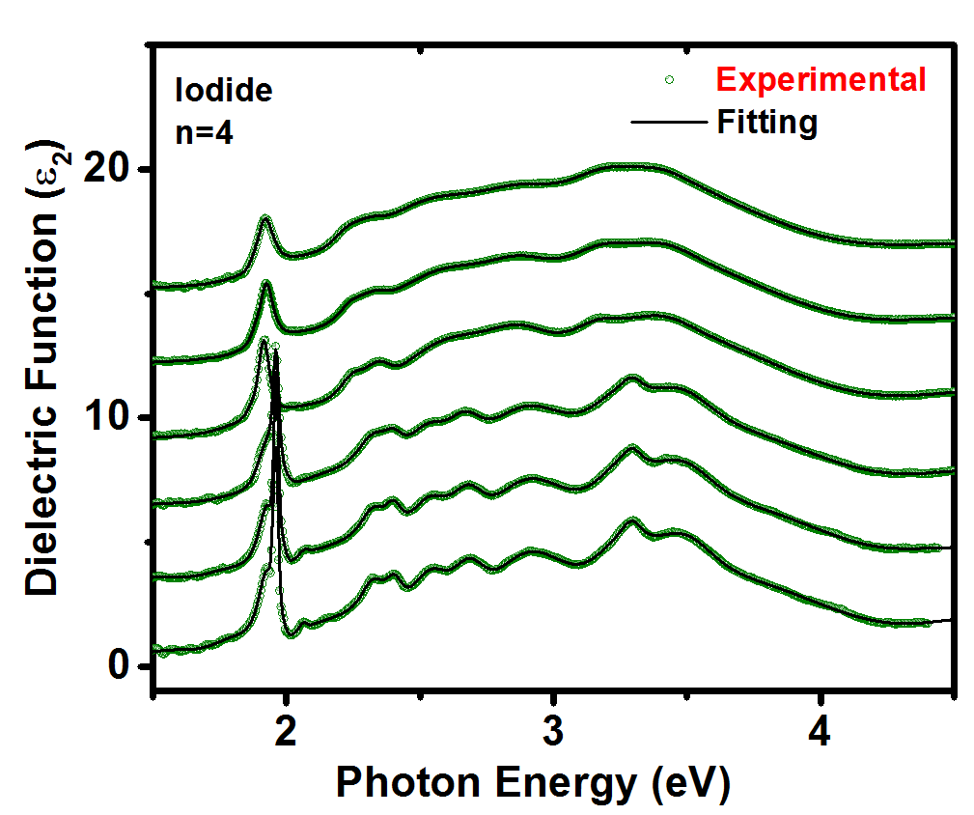
Fig. S17. Temperature dependent of experimental and fitting results of ε₂ for n=1 Iodide. The temperatures of measurements from bottom to top are 78, 100, 150, 200, 260 and 295 K.

Supplementary Note 4: Calculation of Rashba parameters
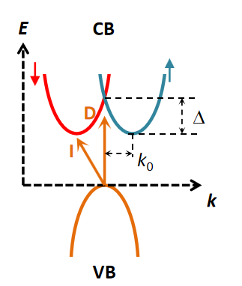
Fig. S18. In the presence of SOC and inversion-symmetry breaking fields, it splits up into two spin-split bands. Take conduction band with Rashba splitting for example, the same conclusion is also applicable for valance band.
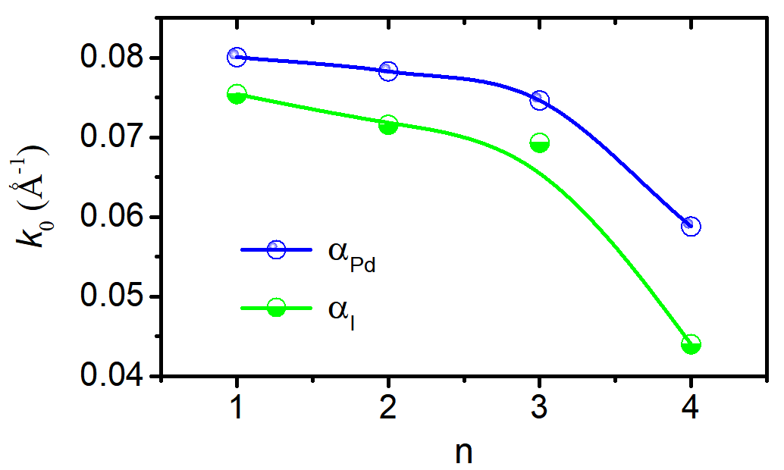
Fig. S19. Conduction and valance band maximum shifted from the high symmetry point k₀.

Supplementary Note 5: Photon penetration depth
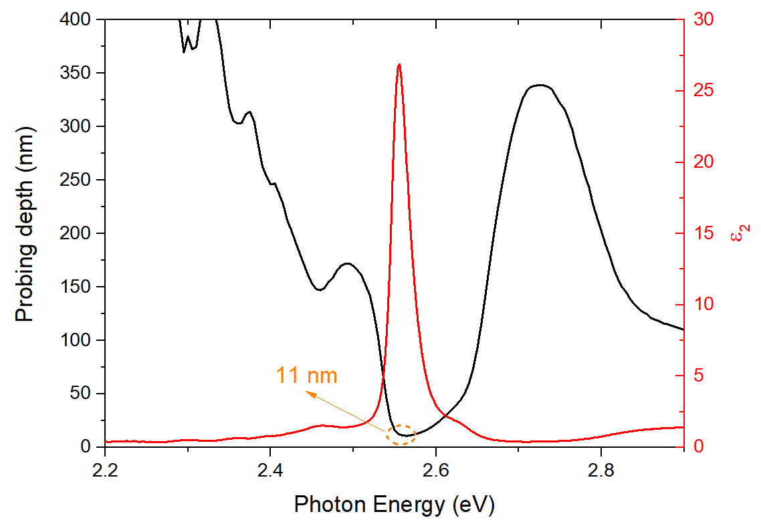
Fig. S20. Calculation of photon energy dependence of probing depth. The minimum probing depth located at the energy of exciton with strongest absorption.

