Supplementary Appendix

- Methods

Data collection
Data collection was done through a computer application using the principle of the blind experiment, in which the individuals who enter the data of the participants do not have access to the result, and the person performing the test does not know the identity of the participant. The information is recorded in a database managed by the Ministry of Health in accordance with Law 15/2003, of 18 December, qualified as personal data protection) complies with all the rules on Privacy Policy established in https: // coronavirus .govern.ad / privacy
The data used in epidemiological studies will be those provided by individuals using these forms, and will receive a legitimate treatment specifically in Article 20.f of the LQPD which requires that the data be kept indefinitely, so action will be taken. specific security features of this treatment such as the encryption of the data as long as there is no study that requires them. In this case, the only recipients of personal (non-anonymized) data that have been provided to date, without limiting that the list may be legitimately expanded in the future, are the Andorra Health Care Service (SAAS) and the Government of Andorra, including its Ministries that have access to the data due to the epidemic.
Note that both the Department of Government Statistics and the World Health Organization (WHO) or other organizations in other countries will receive data of the Ministry of Health.
The following variables were collected.
- Socio-demographic data: age, sex, country of origin, parish of residence, occupation.
- Presence or absence of IgG and IgM immunoglobulins of each participant in the first and second cross.
- Identification number of the family nucleus associated with each participant.
- Symptoms present or absent 15 days before the survey or at the moment of the survey.
- PCR result (positive / negative) of IGM + participants (suitable for PCR following protocol of the Ministry of Health).

Data processing
Data collection is done through a computer application using the principle of the blind experiment, in which the individuals who enter the data of the participants do not have access to the result, and the person performing the test does not know the identity of the participant. The information is recorded in a database managed by the Ministry of Health in accordance with Law 15/2003, of 18 December, qualified as personal data protection) complies with all the rules on Privacy Policy established in https: // coronavirus .govern.ad / privacy
The data used in epidemiological studies will be those provided by individuals using these forms, and will receive a legitimate treatment specifically in Article 20.f of the LQPD which requires that the data be kept indefinitely, so action will be taken. Specific security features of this treatment such as the encryption of the data as long as there is no study that requires them. In this case, the only recipients of personal (non-anonymized) data that have been provided to date, without limiting that the list may be legitimately expanded in the future, are:
The Andorra Health Care Service (SAAS) and The Government of Andorra, including its Ministries that have access to the data due to the epidemic.
Note that both the Department of Government Statistics and the World Health Organization (WHO) or other organizations in other countries will receive data from the Ministry of Health.

- Supplemental tables

Table 1. Serology RDT Livzon validation

A. Samples with a COVID-19 diagnostic by any technique

Antibody | Diag+/  Sero- | Pre-pandemic/  Sero+ | Pre-pandemic/  Sero- | Diag+/  Sero+ | Total | SE (%) | SP (%) | PPV (%) | NPV (%) | Days since onset of symptoms
IgM | 42 | 2 | 125 | 59 | 228 | 58 | 98 | 97 | 75 | Any
IgG | 37 | 1 | 127 | 73 | 238 | 66 | 99 | 99 | 77 | Any
IgM+IgG | 31 | 3 | 124 | 77 | 235 | 71 | 98 | 96 | 80 | Any
IgM | 9 | 2 | 125 | 23 | 159 | 72 | 98 | 92 | 93 | >= 14 days
IgG | 8 | 1 | 127 | 29 | 165 | 78 | 99 | 97 | 94 | >= 14 days
IgM+IgG | 8 | 3 | 124 | 29 | 164 | 78 | 98 | 91 | 94 | >= 14 days
IgM | 9 | 2 | 125 | 17 | 153 | 65 | 98 | 89 | 93 | >= 21 days
IgG | 8 | 1 | 127 | 22 | 158 | 73 | 99 | 96 | 94 | >= 21 days
IgM+IgG | 8 | 3 | 124 | 22 | 157 | 73 | 98 | 88 | 94 | >= 21 days

B. Samples with a COVID-19 diagnostic by PCR

Antibody | Diag+/  Sero- | Pre-pandemic/  Sero+ | Pre-pandemic/  Sero- | Diag+/  Sero+ | Total | SE (%) | SP (%) | PPV (%) | NPV (%) | Days since onset of symptoms
IgM | 40 | 2 | 125 | 53 | 220 | 57 | 98 | 96 | 76 | Any
IgG | 35 | 1 | 127 | 66 | 229 | 65 | 99 | 99 | 78 | Any
IgM+IgG | 29 | 3 | 124 | 70 | 226 | 71 | 98 | 96 | 81 | Any
IgM | 7 | 2 | 125 | 20 | 154 | 74 | 98 | 91 | 95 | >= 14 days
IgG | 6 | 1 | 127 | 25 | 159 | 81 | 99 | 96 | 95 | >= 14 days
IgM+IgG | 6 | 3 | 124 | 25 | 158 | 81 | 98 | 89 | 95 | >= 14 days
IgM | 7 | 2 | 125 | 17 | 151 | 71 | 98 | 89 | 95 | >= 21 days
IgG | 6 | 1 | 127 | 21 | 155 | 78 | 99 | 95 | 95 | >= 21 days
IgM+IgG | 6 | 3 | 124 | 21 | 154 | 78 | 98 | 88 | 95 | >= 21 days

Table 2. Interpretation of SARS-CoV-2 serologic test
Day-0 | Day-14 | Interpretation | Recommendation
IgM - IgG + | IgM- IgG+ | Past and cured infection | No isolate
IgM - IgG - | IgM - IgG - | No infected | No isolate
IgM + IgG + | IgM - IgG + | Past infection | Isolate 7 days or confirming test RT-PCR
IgM + IgG - | IgM - IgG + | Recent infection | Isolate 14 days or confirming test RT-PCR
IgM - IgG - | IgM + IgG - | Acute infection | Isolate 14 days or confirming test RT-PCR

Table 3. Regional distribution by seasonal worker

Parish | Seasonal  worker | No  seasonal workers | p- value
Andorra la vella | 240 ( 1.1%) | 20789 (98.9%) | < 0.0001
Canillo | 1117 (23.7%) | 3606 (76.3%)
Encamp | 787 ( 7.0%) | 10419 (93.0%)
Escaldes d engordany | 213 ( 1.6%) | 13102 (98.4%)
La Massana | 399 ( 4.3%) | 8786 (95.7%)
Ordino | 77 ( 1.8%) | 4244 (98.2%)
Sant Julia | 36 ( 0.4%) | 8807 (99.6%)
Ski Areas |  |  | < 0.0001
Ski area Vallnord (Ordino/La Massana) | 476 ( 3.5%) | 13030 (96.5%)
Ski area Grandvalira (Canillo/Encamp) | 1904 (12.0%) | 14025 (88.0%)
None ski area (others) | 489 ( 1.1%) | 42698 (98.9%)

Figure 1. Survey algorithm
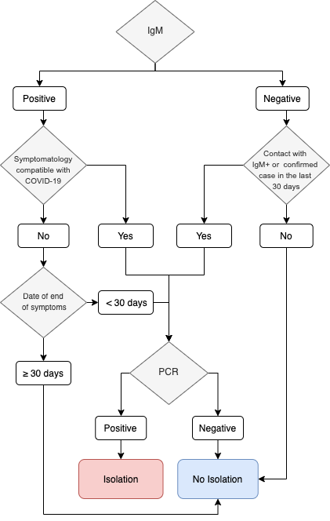

Figure 2. Regional distribution by seasonal worker

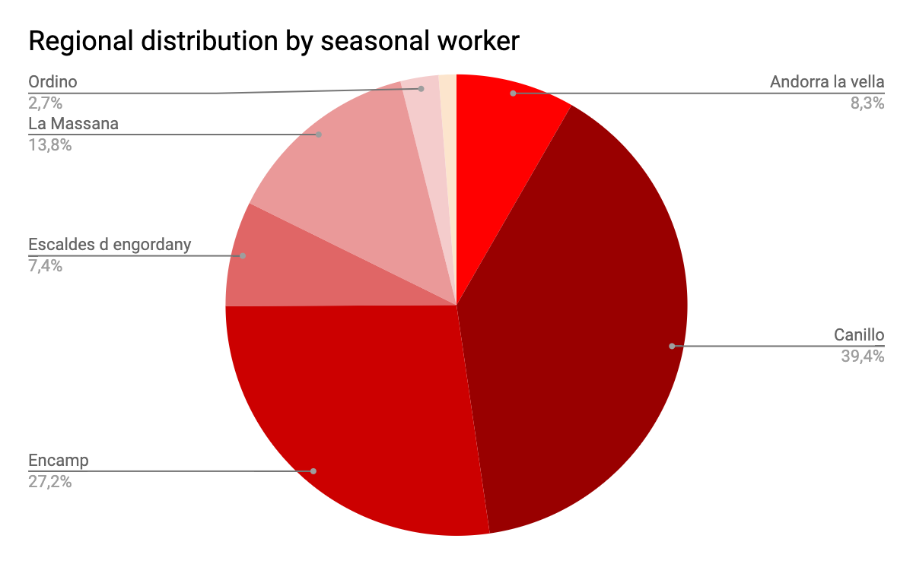

Table 3. Participants situation in front of infection in each contact

Serological Test Combination | First Cross  N=70,500 | Second Cross  N=63,735
IgM-/IgG- | 63,584 (90.19%) | 58,281 (91.44%)
IgM+/IgG- | 4,277 (6.07%) | 3,541 (5.56%)
IgM+/IgG+ | 1,683 (2.39%) | 1,234 (1.94%)
IgM-/IgG+ | 837 (1.19%) | 649 (1.02%)
Not conclusive or miss value | 119 (0.17%) | 30 (0.05%)

