Additional File 2.
SUPPLEMENTARY FIGURES

Supplementary Figure 1. Effects of 1µM gal3 on FSN-gamma phase-lock from the concomitant recordings performed in Fig. 2A.
A) Summary of resultant vector length in control conditions and 30 min after gal3 application (control: 0.56 ± 0.08, gal3: 0.43 ± 0.1, n= 6; p= 0.2188). B) Quantification of the preferred gamma phase-angle (control: 5.33 ± 0.15 radians, gal3: 4.63 ± 0.73 radians, n= 6; p>0.9999). C) Effect of gal3 on FSN firing rate (control: 5.59 ± 1.32 Hz, gal3: 6.54 ± 1.96, n= 6; p= 0.8438). Statistics performed: two-tailed Wilcoxon test. Data is presented as a mean ± SE. n. s: no significant statistical differences.

Supplementary Figure 2. Effects of 2µM gal3 on FSN EPSC rhythmicity and gamma-EPSC relationship.
A) Summary of Cr as a measure of EPSC quality within the gamma frequency (control: 0.82 ± 0.01, gal3: 0.78 ± 0.02, n= 7; p= 0.0156). B) Quantification of the peak from EPSC-LFP cross-correlation analysis evidencing gal3-induced impairment of FSN EPSC and gamma rhythm similarities (control: 0.44 ± 0.09, gal3: 0.27 ± 0.09, n= 7; p= 0.0156). C) Summary of the cross-correlation peak lag (control: -4.74 ± 0.75 ms, gal3: -3.37 ± 4.71 ms, n= 7; p= 0.5781). Statistics performed: two-tailed Wilcoxon test. Data is presented as a mean ± SE. Significance level is shown as * p<0.05. n. s: no significant statistical differences.

Supplementary Figure 3. Effect of 1µM gal3 on FSN firing threshold and spontaneous AP firing in basal state.
A-C show summary bar graphs of firing threshold in control conditions monitored over 15 min (basal: -43.6 ± 0.82 mV, ACSF: -44.2 ± 1.05 mV, n= 17; p= 0.4386), after gal3 (basal: -45.4 ± 2.14 mV, gal3: -40.2 ± 1.25 mV, n= 10; p= 0.0113) or gal3 + TD139 (basal: -44.3 ± 1.84 mV, gal3 + TD139: -42.4 ± 1.12 mV, n= 10; p= 0.1516), respectively. Statistics performed: two-tailed paired t-test. D-F show the firing rate of FSN that were firing APs in basal state in control conditions monitored over 15 min (basal: 0.21 ± 0.07 Hz, ACSF: 0.32 ± 0.09 Hz, n= 12; p= 0.1625, two-tailed paired t-test), after gal3 (basal: 0.58 ± 0.19 Hz, gal3: 0.37 ± 0.14 Hz, n= 7; p= 0.0156, two-tailed Wilcoxon test) and gal3 + TD139 (basal: 0.69 ± 0.31 Hz, gal3 + TD139: 0.61 ± 0.17 Hz, n= 5; p>0.9999, two-tailed Wilcoxon test), respectively. Data is presented as a mean ± SE. Significance level is shown as * p<0.05. n. s: no significant statistical differences.

Supplementary Figure 4. Effect of 1µM gal3 on excitatory input to FSN in basal state.
A) Summary of EPSC amplitude in control conditions (basal: 9.75 ± 1.28 pA, ACSF: 9.0 ± 1.38 pA, n= 17; p= 0.3841). B) Summary of EPSC frequency in control conditions (basal: 29.6 ± 1.1 Hz, ACSF: 29.9 ± 1.15 Hz, n= 17; p= 0.5293). C) Quantification of EPSC charge transfer in control conditions (basal: 115.8 ± 17.5 pC, ACSF: 108.6 ± 17.9 pC, n= 17; p= 0.5372). D) Summary of gal3 effect on EPSC amplitude (basal: 11.9 ± 1.72 pA, gal3: 11.2 ± 1.73 pA, n= 10; p= 0.4209). E) Summary of gal3 effect on EPSC frequency (basal: 34.1 ± 0.79 Hz, gal3: 32.7 ± 0.97 Hz, n= 10; p= 0.0204). F) Quantification of gal3 effect on EPSC charge transfer (basal: 162.7 ± 26.9 pC, gal3: 149.6 ± 27.4 pC, n= 10; p= 0.2567). G) Summary of gal3 + TD139 effect on EPSC amplitude (basal: 9.02 ± 1.73 pA, gal3: 8.32 ± 1.41 pA, n= 10; p= 0.4687). H) Summary of gal3 + TD139 effect on EPSC frequency (basal: 31.4 ± 1.79 Hz, gal3 + TD139: 30.6 ± 1.66 Hz, n= 10; p= 0.2689). I) Quantification of gal3 + TD139 effect on EPSC charge transfer (basal: 106.7 ± 24.3 pC, gal3 + TD139: 100.8 ± 21.9 pC, n= 10; p= 0.5679). Statistics performed: paired two-tailed t test. Data is presented as a mean ± SE. Significance level is shown as * p<0.05. n. s: no significant statistical differences.

Supplementary Figure 5. Excitatory input onto FSN in activated state 45 min after gal3 application.
A) Summary of gal3 effect on EPSC amplitude (ACSF: 17.5 ± 2.39 pA, n= 12; gal3: 26.4 ± 5.35 pA, n= 14; p= 0.8252 vs. control, p> 0.9999 vs. gal3 + TD139, gal3 + TD139: 23.0 ± 5.03 pA, n= 10; p> 0.9999 vs. control, Kruskal-Wallis test followed by Dunn’s multiple comparisons test). B) Summary of gal3 effect on EPSC frequency (ACSF: 36.5 ± 0.73 Hz, n= 12; gal3: 32.4 ± 0.95 Hz, n= 14; p= 0.0040 vs. control, p= 0.0018 vs. gal3 + TD139, gal3 + TD139: 23.0 ± 5.03 Hz, n= 10; p= 0.5571 vs. control, ordinary one-way ANOVA followed by Holm-Sidak’s multiple comparisons test). C) Quantification of charge transfer for each condition (ACSF: 253.6 ± 34.9 pC, n= 12; gal3: 327.9 ± 62.6 pC, n= 14; p> 0.9999 vs. control, p> 0.9999 vs. gal3 + TD139, gal3 + TD139: 349.5 ± 81.6 pC, n= 10; p> 0.9999 vs. control, Kruskal-Wallis test followed by Dunn’s multiple comparisons test). D) Quantification of Cr showing that inhibition of gal3 signaling prevents gal3-mediated impairment of EPSC rhythmicity measured as Cr (ACSF: 0.82 ± 0.01, n= 11; gal3: 0.69 ± 0.02, n= 14; p< 0.0001 vs. control, p< 0.0001 vs. gal3 + TD139, gal3 + TD139: 0.84 ± 0.01, n= 10; p= 0.4115 vs. control). E) Summary of the maximal correlation between FSN EPSCs and concomitant gamma oscillations (ACSF: 0.48 ± 0.07, n= 12; gal3: 0.44 ± 0.08, n= 14; p= 0.7539 vs. control, p= 0.6088 vs. gal3 + TD139, gal3 + TD139: 0.56 ± 0.08, n= 10; p= 0.7539 vs. control). F) Phase relationship between FSN EPSCs and concomitant gamma oscillations (ACSF: -4.18 ± 0.44, n= 12; gal3: -1.33 ± 2.45, n= 14; p= 0.5387 vs. control, p= 0.6376 vs. gal3 + TD139, gal3 + TD139: -3.42 ± 0.56, n= 10; p= 0.7644 vs. control). Statistics performed in D-F: ordinary one-way ANOVA followed by Holm-Sidak’s multiple comparisons test. Data is presented as a mean ± SE. Significance levels are shown as ** p<0.01, **** p< 0.0001. n. s: no significant statistical differences.

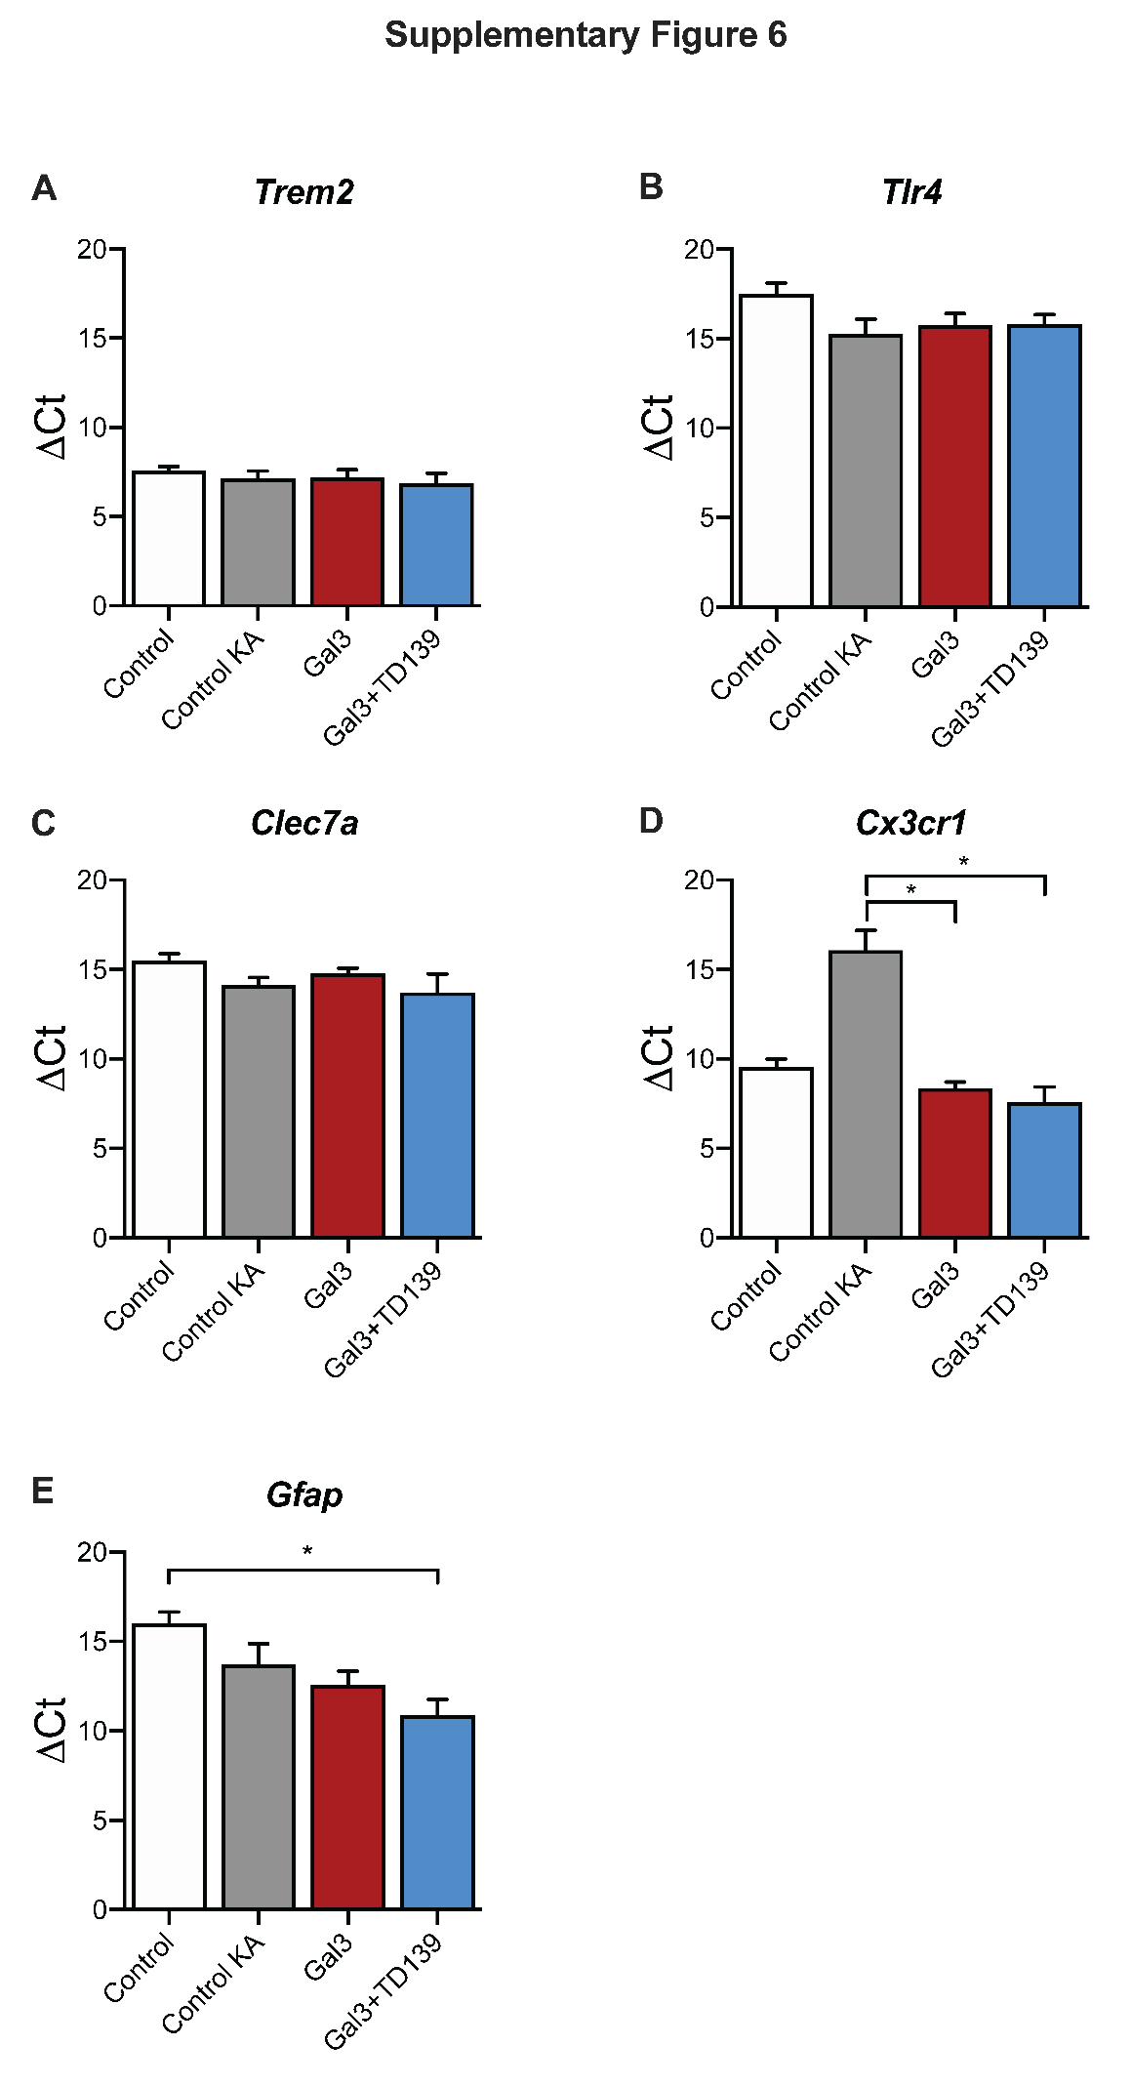
Supplementary Figure 6. Gene expression levels in brain slices treated with gal3 prior to gamma oscillation induction.
Expression levels of the mRNAs of A) Trem2, B) Tlr4, C) Clec7a, D) Cx3cr1, and E) Gfap in frozen hippocampal slices from WT mice under the different conditions taken at the end of recordings performed in Fig. 4: Control (ACSF), Control KA, 1 µM Gal3 and 1 µM Gal3 + 10 µM TD139. No differences were observed in the levels of A) Trem2 (ACSF: 7.58 ± 0.23, n=3; Control KA: 7.14 ± 0.43, n=5; gal3: 7.20 ± 0.43, n=5; gal3 + TD139: 6.85 ± 0.58, n=3; p= 0.8863), B) Tlr4 (ACSF: 17.52 ± 0.58, n=2; Control KA: 15.27 ± 0.82, n=5; gal3: 15.76 ± 0.65, n=4; gal3 + TD139: 15.81 ± 0.52, n=3; p= 0.4455), and C) Clec7a (ACSF: 15.49 ± 0.40, n=3; Control KA: 14.14 ± 0.42, n=5; gal3: 14.80 ± 0.28, n=5; gal3 + TD139: 13.73 ± 1.03, n=3; p= 0.3982). However, statistical differences were found in the ΔCt levels of D) Cx3cr1 (ACSF: 9.56 ± 0.44, n=3; Control KA: 16.08 ± 1.11, n=5; gal3: 8.37 ± 0.33, n=4; gal3 + TD139: 7.58 ± 0.85, n=3; p= 0.0004; KA vs gal3, p=0.046; KA vs gal3 + TD139, p=0.0185) and E) Gfap (ACSF: 16.02 ± 0.63, n=3; Control KA: 13.71 ± 1.17, n=5; gal3: 12.55 ± 0.79, n=5; gal3 + TD139: 10.86 ± 0.89, n=3; p= 0.0344; Control vs gal3 + TD139, p=0.0479). Data is presented as mean ± SE of two independent experiments, normalized to Gapdh and expressed as ΔCt. Kruskal-Wallis non-parametric test followed by Dunn’s multiple comparisons test was performed. Significance level is shown as * p<0.05.

