Supplementary Information:
Direction and Disease | Genes
Upregulated in Exploration Cohorts of PTSD, Moderate Asthma, Severe Asthma | MYL12A, GCNT1, CTSS, SAT1, ZNF224, BHLHE40, ALAS1, RPL15, KPNA2, CCNYL1, GNAQ, PPCDC, LAMP2, DRAM1, EEF1A1, RAB40C, CEBPD, ANKRD12, NOL7, LRMP,  CAT, IFNAR1, PDCD2, CEP350, LRPAP1, THBD, RHOQ, TMEM70, QKI, SERF1A /// SERF1B, SLC39A14, ATP5E, TSNAX, BID, ZBTB3, SCRIB, HIST1H1C, FKBP15, RAB32, LRRC57,  ASRGL1, ARHGAP26, STXBP5, KCNE3, HPSE, TLR4, KLHL6
Downregulated in Exploration Cohorts of PTSD, Moderate Asthma, Severe Asthma | ATM, LARP4, STK38, NBAS, CAMSAP1, PCBP2, NAP1L4, ZNF496, FBXO21, DCAF8, RNF115, FOLR1, CSPP1, SRRM2, RALGAPA1, UNKL, HM13, SEC22C, RBM17, EPT1, BOLA2, PDE7A, PHF20, ANKRD11, CADM4, KCTD5, CD44, GKAP1, RPGRIP1L, TNRC6A, DNASE1, TMEM165, PWWP2A, RBM14, IGF2 /// INS-IGF2, C5orf24, MTUS1, CD47, APOBEC3G, SYMPK, NAA15, CYB561, SIM2, SLC7A1, BICD1, ZFAND5, LIMD1, RANBP10, TRIM66, WDR60, SMARCA4, G3BP1, ST6GALNAC4, RAPGEF2, ITSN2, VPRBP, ACAD10, CD6, SLC13A4, GLS, CCNK, HIPK2, KLF9, SPON1, POLR2J2, COL10A1, GNAS, HUWE1, GOLGA8A, SNED1, SMARCA2, UBE3B, CARS2, MAP2K7, NF2, PDCD2
Upregulated in Exploration Cohorts of PTSD, and Severe Asthma | SLPI, MCTP2, RAB11A, CKLF, GMPR2, KDSR, ANXA3, S100A8, ARPC3, NDUFA1, ZNF33A, PTTG1IP, UBE2J1, ENTPD1, CARD16, BRD8, NRD1, RNASE2, CD24, TP53TG1, SRGN, MAPK1, ARL3, TBCA, SERPINB1, NRG1, MAN2A2, AIF1, H2AFZ, FAM32A, BRCC3, CARD16 /// CASP1, GPCPD1, STEAP4, NSMAF, RAB13, PICALM, ZNF160, TLR6, NDUFB3, LIN7A, CXorf38, NFE4, GDE1, SLC12A9, CFLAR, DCP2, PIN4, RNF7, KIF1B, NDUFB1, RNASE3, MYO5A, PCNX, TXN, TBCC, CSTA, GPR84, RFC2, CD59, ATXN1, COX4I1, GIT2, TOX4, C10orf128, HTRA2, RRAGD, CPEB4, NDUFB6, MLLT10, VPS8, COX17, CLEC4D, PLXDC2, GOLGA7, CRISP3, MTRF1L, ANTXR2, C6orf89, PRR11, GGNBP2, ZEB2, TLR10, SERPINA1, TLR1, EEF1D, UROD, DPH3, SLC12A6, HIST1H2BC, UFC1, KIAA0141, CSF2RA, VPS33A, C14orf2, UQCRQ, PIWIL4, OSBPL1A, MBOAT2, EGLN1, MGAT4A, SAMSN1, MRPS18C, DHRS7B, CD164, ATP5O, CDK13, HAUS2, FAM200A, RALA, TTC30B, RAD18, ZNF271, ZNF253, REEP5, MGC70870, C9orf85, MSL3, GRK5, MED8, BCL2A1, WDFY3, STX8, SYT11, MMP8, MEF2A, KRCC1, ZDHHC3, C11orf58, OLFM4, PDK3, NKAP, SOS2, PPP2R3C, PAG1, ZNF350, WIPI1, GLIPR1, OCIAD1, STX3, G3BP1, SLC35E1, NFX1, HNMT, NSDHL, CLEC5A, MRPS15, BCL2L11, TFDP1, NIPSNAP3B, GABARAPL1, FAR2, AZIN1, CD163, NUDT16P1, SNX2, FRY, COX7B, C9orf66, PDE8A, COX6C, TLR8, THUMPD3, COX7C, FAM63B, AVL9, TLN1, ZNF721, ERGIC2, RPL7, IRAK3, GK3P, SIPA1L1, MGST1, HSBP1, PDHA1, POLR2K, CEACAM8, RASGEF1A, VCAN, TK2, CDC5L, SVIP, CD55, FCGR2B, PAK1, DNAJC15, RPL35A, CHCHD7, GLRX, ZBTB24, RPL22L1, NDUFS1, CPD, BLVRA, TOR1AIP1, C9orf64, TCN1, PLD1, APBB1IP, ABCA1, PRKAA1, SLC8A1, CNIH4, ZFAND2A, RPS27L, TRIB1, ZNF264, SMC1A, RPS24, DACH1, ZNF93, C7orf25 /// PSMA2, TMEM167A, STS, LY96, NDUFA4, PHAX, GRB10, FAM13A, TXNDC17, LOC100049716, XRCC4, PPP1R3D, KIAA0368, CUL4B, LYST, AHNAK, TMEM71, RNASE4, IKBIP, MRPL15, UBE2I, GZMA, UBE2D1, CHD9, AGTPBP1, CA5B, PPID, TMEM67, GNL2, IL18, TANK, SORD, LGALS8, MED23, PITPNA, ZNF254, HSDL2, DBI, PQLC2, PXK, TNFSF10, SKA2, EVI2A, C1orf228, ERO1L, ISCA1, RNF141, FRMD8, FAS, ASAH1, SIK3, C17orf89, IDI1, GK, ZNF268, NUDT16, C16orf72, OSGIN2, ARRB1, RPS7, ATP5C1, ZNF813, UQCRB, CENPW, ANXA1, FAM200B, SCD5, EIF4E3, C2orf76, C1GALT1C1, CD86, HDDC2, PIP5K1B, RPS6KA2, JAK2, IPO11 /// LRRC70, HIPK3, USP48, SFXN4, MS4A3, ATP5J, COMMD8, HIPK2, TMEM45B, MRPL13, RPL11, IL1R1, LPCAT2, EFCAB2, TSPAN2, DOCK4, EID2, PPA2, UBL3, ALG13, ITPR2, SYNE1, EMR1, RPL39, ABHD5, ZNF578, EID1, ADAMTS5, GLUL, NRBF2, NSMCE2, TMEM144, CD58, PFDN5, JAG1, CCDC88A, GPR34, ZAK, ACPP, ASPH, SEC62, HDGFRP3, ZNF230, BCL2L15, RALBP1, APC, SLCO4C1, ARHGAP24, HECW2, PDZD8, ACER3, FBXL13, CCPG1, ANKRD28, ST3GAL6, TAF7, RPL34, TGFA, B3GNT5, IFNGR1, C9orf72, ZNF354A, NDFIP2, ST6GALNAC3, ICOS, GNG10, PRSS23, CLEC2B
Downregulated in Exploration Cohorts of PTSD, and Severe Asthma | PTBP1, SIK1, ZNF747, FOXK1, RARRES1, CCNL2, ATP2A2, FBXW11, WIPI2, CASKIN1, VAV2, SLC38A10, QSOX2, MPRIP, HNRNPA2B1, LILRA4, ZBTB4, DPPA4, WBSCR16, TRAF7, RGS12, TARSL2, SAE1, ZCCHC14, FSCN1, RASA3, TMEM63A, ANKIB1, PRPF31, TCF3, CAMK2D, TAF4, CCDC85C, ZNF445, LETM1, GRSF1, RPS28, MYO9A, SH3PXD2A, HOXB3, EPPK1, CREB3L2, HEATR2, ZFYVE20, TNPO1, TRAFD1, LEF1, SPTBN1, IRAK2, PSMG4, ZNF703, GPC2, SLC16A1, PPIL2, ALG2, SLA2, GPATCH4, ZNF709, IL12RB1, SIPA1L3, EP400, YBX1, KIRREL3, SFTPC, ALKBH7, ARL4C, ANKH, ATP9B, USP40, MAP3K9, SLC35F3, CARHSP1, ELK4, PTPRS, ZNF512B, HAUS5, POU2F2, PELP1, SIRT2, AFF3, LUZP1, USP36, CLN6, USP42, POU6F1, FAIM3, INO80B, CNP, GNL1, CCNE1, SAMD4A, CACNB2, TRA2A, TCF7L2, KANK3, CCNJ, RNASET2, MMP19, LMO7, SLC12A3, ITPRIPL2, MCF2L, CITED2, FABP3, COBLL1, N4BP2L1, ERICH1, EPM2A, ATMIN, RAD52, SEPT7, LOC100131564, ZFP64, TMED4, PDE12, SNX29, UBE3A, PMEPA1, EIF3B, RPL37A, SEPT8, BCL7A, COL5A3, PCGF5, SCUBE3, CD74, PRICKLE1, S1PR2, INPP5D, ATF5, ATXN2L, GATM, TTC17, ZBTB7A, NOLC1, LOC642852, SNX24, TSPYL2, CFL1, DHX30, SNTB2, PPP2R3A, HLA-DOB, HNRNPUL2, CACHD1, ING5, TACC1, ZNF827, FGD2, ORMDL3, ANGPTL1, ATP8B2, SYNJ2, SPRY1, LOC100422781" "OTUD1, AKT2, MLXIP, SFXN4, TYSND1, SEMA6A, PML, PTP4A3, GGA2, XBP1, ZNF3, RAP2B, SHISA4, OCIAD1, KDM4B, C11orf30, UBE2G2, PLG, SLC22A23, ACSS1, RHOF, GPR161, SPTAN1, EGOT, C16orf13, FAM159A, MAPK8, H6PD, IMPAD1, PRPF6, KCNAB1, KIAA1652, CDC5L, DOCK9, PRKAG2, TNRC18, TRIM38, CMIP, HLA-DOA, ZNF469, PHACTR1, PDCD5, CROT, MLLT10, RIPK4, ZNF599, IGF2BP3, SF1, CD79B, MGAT2, PTCH1, CCND3, IGHM, CNPY4, YIPF2, MKL2, FAF1, TGFB3, PCDH9, FAM102A, TACR1, EME2, TAPT1, VASH1, AXIN2, TPH1, SLC38A9, BEND4, ORAI2, SLC2A13, NCAM1, ETV5, TMEM150C, TNIP1, FRMD4A, MTX3, TPPP3, HNRNPU, COL4A4, CD79A, MPZL1, MTSS1, TFAM, RAP2A, PLCXD1, CD40, CARM1, RBBP6, CDC14B, RBMS2, CD22, TCL6, DPM2, RDH13, DNM3, TOX, SMC1A, GATA2, RPAIN, LARGE
Upregulated in Exploration Cohorts of PTSD, and Moderate Asthma | VPS53, FH, CBLL1, CPT2, EP300, CARD8, SNX1, PPIF, ZCCHC11, ZNF318, UBE2Q1, DDX28, KIAA2018, EFCAB4B, MARCKS, SWAP70, HELQ, GRHL1, CCDC93, SDHD, ERLIN2, NFE2L2, SIAE, PIK3C3
Downregulated in Exploration Cohorts of PTSD, and Moderate Asthma | MCM3AP, SNORD8, ASXL2, TRDMT1, DDX17, MAST2, WDR78, OSMR, PDE5A, PIK3C3, WDR59, DYRK1A, JMJD1C, SEZ6L2, CSNK1G1, LIMCH1, PPP1R12B, MED25, PHF21A, STK24, MRE11A, B4GALT1, AGFG2, LNP1, SNRNP70, USP49, CDC42BPA
Upregulated in Exploration Cohorts of Moderate Asthma, and Severe Asthma | MYD88, NACA2, FGR, AMICA1, IL5RA, HBXIP, LAT2, S100A11, NFKBIB, RPS4X /// RPS4XP6, ARHGAP30, ELMO2, HFE, ANXA2P1, SRA1, PIK3R5, GPR109B, SIGLEC7, ACTA2, IDO1, CCL23, LOC100287015, UCN2, PRELID1, KCTD21, VPS24, ARHGDIB, HIST1H3G, PHF19, TPI1, COX5B, HNRNPA1 /// HNRNPA1L2 /// HNRPA1L-2 /// HNRPA1P5 /// LOC642817 /// LOC644037, RGS14, ACSL1, TINF2, PRSS33, RGS19, CNDP2, BAT2, CEBPE, CHPF2, BTK, FTH1, LGALS12, LOC340947, RPL10L, FAM120A, PLIN2, FGFR1, DAPK2, NBEAL2, PIK3R6, SMPD3, LOC100129034, C14orf93, C20orf43, RPL21 /// RPL21P19 /// RPL21P28, TUBA3C, FOLR3, AMBRA1, ALOX5, C17orf44, LOC100288418, LOC441124, DENND3, P2RY13, FAM65A, POTEKP, APOBEC3A, IFITM1, B3GALT4, OLIG2, RPL21 /// RPL21P28, RGL2, NT5C2, CD300A, SFN, ADORA3, STAT6, ZNF467, FAM129A, SH3D20, MRVI1, LOC285771, AQP9, PLAUR, MAPK8IP3, CASP4, TPMT, MYL6B, GNAS, C19orf29, BRI3, ARSB, ADAM8, DAPP1, ARRDC1, SH2D3C, PRIC285, TUBA3C /// TUBA3D /// TUBA3E, RPL23AP32, ATP5J2, SNX27, TIMP2, TRPM6, CLC, HIST1H2BF, WAS, ZC3H10, CYP4F2, C3AR1, CD68, SUSD1, SSH3, ARSD, USP19, FAM13AOS, PLIN5, PHKA2, SCAND1, C15orf52, SPNS3, NF2, RNF216, LILRA2, PMF1, SIRPA, COMTD1, GRK6, RPL18A /// RPL18AP3, C15orf39, SIRPB1, NAT15, RPS10 /// RPS10P5 /// RPS10P7, HIST1H2BI, HIST1H2BK, LILRB2, SIGLEC8, IRF7, CR1, DNTTIP1, XPO6, C1orf91, ALDOA, PGLS, TNFRSF10C, TUBA4B, FERMT3, ABHD4, LOC100289727 /// NCF1 /// NCF1B /// NCF1C, SEMG1, NCF4, BAP1, C7orf47, FAM63A, LRRC25, GDPD5, CD101, LILRB1, ZNF321, LOC100293160 /// PPIA, IRAK1, CXCR1, ZC3H12A, MBOAT7, DOK3, GADD45B, NINJ1, ACAA1, CCDC64B, TSTD1, TMEM38A, LILRA6, PTAFR, RAB11FIP4, CASP5, SLCO3A1, LRP10, DEF6, MTX1, DEDD2, IL4R, NFIL3, OXER1, SLC2A3, GSDMB, LOC440900, SBNO2, CD14, HRASLS5, HIST2H2AA3, PTPN23, CD33, CENPN, EMR3, LOC399904, KIFC1
Downregulated in Exploration Cohorts of Moderate Asthma, and Severe Asthma | SIKE1, AKIRIN1, KRR1, LOC100271836 /// LOC100288704 /// LOC440354 /// LOC595101 /// LOC641298 /// SMG1, ZMYM2, PIAS2, KLHL28, NEK1, FUS, ZNF519, LRRC58, RNF160, MTMR7, TXLNG, LOC100190986, TIA1, MAP3K13, LOC642826, KIAA0562, MED13, GPM6B, LOC100134365, THRAP3, C19orf2, HBP1, LOC283922 /// PDPR, PCNP, ZNF37A, CFLAR, FAM60A /// LOC728115, RAB18, BBX, RBM8A, NASP, CLTC, TNRC6B, HNRNPH1, RUNX1, C2orf56, APOOL, HNRNPD, RHOA, FBXO34, SLC25A13, RNPC3, LARP4B, ARID2, TAF2, ARNT, KIAA0368, TRIP11, ESCO1, FLJ33630, BMS1P1 /// BMS1P5 /// LOC399753, C1orf69, ABI2, MGA, SLC16A7, RASA2, YTHDC1, ZMYND8, INO80D, FLJ10038, TMEM106B, IKZF1, SMC3, ATXN3, XPNPEP3, MATR3, LOC100271836 /// LOC440354 /// LOC595101 /// LOC641298 /// SLC7A5P1 /// SLC7A5P2, FNBP4, DKFZp547G183, SMC5, BCLAF1, PPP2R2A, DDX6, KDM4C, CDK9, CDC14A, RBM39, ZFAND6, VPS13C, PSPC1, TMEM161B, BMP2K, BAT1, CSNK1A1, SFRS8, TAF11, N4BP2L2, PTPLAD1, TRD@, KDELR2, MED31, ZBTB43, TTBK2, ATAD5, C4orf29, TES, CLN8, ESYT2, TOX4, CHD2, LARS, CLK4, PBRM1, SPG7, SFRS18, NDUFA5, PRKD3, ZNF785, PHRF1, YLPM1, STYX, ZNF440, DKC1, C7orf28B, PSME4, ZNF326, PLEKHA1, RBL2, SMAD4, PWP1, PDE4DIP, TUBE1, DGKE, FAM55C, ZKSCAN1, SMEK1, USP13, AKD1, KLHDC5, APC, SERBP1, GPBP1L1, GATAD1, RAD21, CLPTM1L, C5orf44, TBRG1, ACAT1, OSGEP, EIF4A1, GOPC, XPO1, DTWD1, FBXO45, RORA, CYP3A5, ZNF207, ZNF275, SERPINB1, TRAPPC10, CAPN7, INTS7, C15orf29, HELLS, SLC3A1, DLG1, GTF3A, PRDM2, MARCH7, RAD51C, HEATR7A, NXT1, MRPS5, ZNF131, LOC100287024, C6orf106, NKTR, ZBTB20, SMAD5, RBBP4, AKT3, LOC399900, MAK, CCAR1, EIF4G2, RNF125, ZNF451, PSMD7, MAP2K6, PLEKHA2, HMGN3, DNAJC16, USP10, NLK, SNRK, HELZ, MAP4K4, RPP14, CIAPIN1, RAB11FIP3, WASL, KCNQ1OT1, LNPEP, PIK3C2A, PRKAB2, SPCS2, NAPEPLD, CCNC, KRT77, TET2, SUPV3L1, SNX1, SFRS12, ZNF664, NPAT, POLH, CASK, CUL4A, RSRC2, CBX3, HERC4, CRCP, GTF3C3, GOLGA4, PROSC, LUC7L3, RPL37, ELP2, BCOR, SMCHD1, IPO9, FAM120A, GAS1, PTPRC, SLC17A5, AGGF1, SCAMP1, TMEM67, LOC142937, ZC3H11A, KCNA3, SCFD1, LOC401504, RNF19A, CNOT7, USP25, MYNN, GLRX3, ATG2B, NCRNA00219, LOC642869 /// SET, MMD, ZNF346, AGAP4, TMEM87B, METTL3, ZNF551, CMTM7, PPM1A, NSUN4, PZP, NUP62, NCK1, ZMYM5, METT5D1, ZMYND11, KIAA1147, SLC25A36, CHD6, HADHA, RAPGEF6, ZDHHC2, PPA2, JAK1, COX19, DHX9, METTL6, METTL14, FILIP1, YME1L1, MSI2, ZCCHC7, LRRFIP2, RG9MTD3, WDR4, LRPPRC, TLE4, YIPF6, TCF4, LPP, TMPO, RGP1, FBXW2, HIVEP3, PLEKHA3, WDR11, ETS1, MBNL1, ZMYM6, SAR1B, LOC100130175, MDM4, GLCCI1, PPM1K, LMLN, HIST1H1D, PRMT2, ZNF280B, CLASP2, CYLD, NAA25, PTPDC1, SMG1, LOC441259 /// POLR2J2, G2E3, ATP6V1H, FAM20B, MGC24103, COCH, FAM38A, EHBP1, MAGEE1, ATAD2B, STX2, LASS6, LOC100288332 /// LOC100288583 /// NPIPL3, PTGDR, PKN2, ARHGEF7, KIAA1826, KTN1, WDR26, MBTD1, TSPAN3, FGFR1OP2, WASF2, RRAS2, USP16, LOC728163, PRKDC, SART3, ATP8B1, RIMKLB, LOC595101, FAM133B, EWSR1, LOC100129917, RUFY2, NOL9, LOC100133130, FAM164A, FAM118B, C1orf163, ZNF254, METTL2A /// METTL2B, SNX19, NARG2, CIRH1A /// HAS3, ZNF587, C22orf30, VAPB, ARL17A /// ARL17B, AVL9, CXorf56, OSGEPL1, SS18, KLHL10, MYEF2, ZNF264, THUMPD3, SEC61A2, FRYL, HELB, CLCN3, BRWD1, ZNF493, SLC11A2, PMS2L2, CRYGS, GPATCH2, RAB3GAP2, FBXL20, IMPDH2, NSUN6, CATR1, LRCH3, RCAN3, OTUD4, KRAS, MCCC2, CASP2, HTATSF1, TTC3, STIM2, ITPKB, C6orf130, RGS10, SNRPN, SCRN3, CXCR7, EXOSC7, TAOK1, ZNF107, PTPLB, MED7, POLR2J /// POLR2J2 /// POLR2J3, MAP2K5, C17orf108, PRKCI, NUP107, PDPR, SFRS13A, GOLGA8A /// GOLGA8B, FXR1, C1orf43, C8orf59, DDI2, USP24, UBA6, CDADC1, CCT8, CYP2B6 /// CYP2B7P1, SYNJ2BP, LOC254100, NCRNA00182, MED13L, DAPK1, DDX50, CDK13, CCDC132, WDR1, HBS1L, PPP2R1B, LOC642236, URB1, PTCD2, ANKRD20A1 /// ANKRD20A2 /// ANKRD20A3 /// ANKRD20A4 /// ANKRD20A5 /// C21orf81 /// LOC100132733 /// LOC644339, AQP3, TECR, GLG1, IKZF3, PRKRA /// PRKRAP1, C18orf25, SR140, GTPBP8, EIF2C4, KLF12, TCEA1, NFX1, ABCA5, PTPN2, HMGB1, SPATS2, FKBP14, NFATC2IP, MLL, POU2F1, ITCH, NAPB, PARP14, ACTA2, RSF1, FYN, FLJ44606, SBNO1, PCNX, TRAF3IP3, ZADH2, KIAA1632, PYROXD1, LOC100294337, GTPBP4, CD3G, CCNL1, HCG18, HP1BP3, DNAL1, SFRS7, ATP1B3, NGDN, FAM98A, ARMC8, CPNE3, C18orf10, TTC14, STRAP, WHAMML2, SPATA5L1, LOC100190939, HSPD1, AAK1, UHRF1BP1, CAPN2, C8orf44 /// SGK3, WHAMML1 /// WHAMML2, RAB4A, TMF1, LRRFIP1, ZFR, NAAA, ZBED1, REPS1, SLC5A3, SFRS11, RBMX2, IL6ST, TRIM52, PPIG, PDS5A, UCHL5, AGAP10 /// AGAP4 /// AGAP9 /// BMS1P1 /// BMS1P5 /// LOC100133130 /// LOC399753, MUTED, MAP3K1"
Supplementary Table 1: Genes up or downregulated in the same direction between different disease exploration cohorts in comparison to healthy subjects from the respective datasets.

 |  | Q. Explore S | Q. Validate S | Q. Explore M | Q. Validate M
C2 Up
 | TAKEDA_TARGETS_OF_NUP98_HOXA9_FUSION_10D_DN | 3.65E-004 | 1.06E-003 | 1.79E-002 | 1.80E-002
 | ALTEMEIER_RESPONSE_TO_LPS_WITH_MECHANICAL_VENTILATION | 5.54E-003 | 4.43E-006 | 2.08E-004 | 4.84E-002
 | VERHAAK_AML_WITH_NPM1_MUTATED_UP | 8.48E-007 | 1.42E-008 | 1.36E-006 | 8.29E-004
 | SMIRNOV_CIRCULATING_ENDOTHELIOCYTES_IN_CANCER_UP | 1.99E-006 | 1.72E-003 | 1.00E-004 | 1.75E-002
 | REN_ALVEOLAR_RHABDOMYOSARCOMA_DN | 3.09E-003 | 3.23E-002 | 9.36E-003 | 2.12E-002
 | JISON_SICKLE_CELL_DISEASE_UP | 1.44E-003 | 1.15E-006 | 7.58E-005 | 1.35E-002
 | REACTOME_NEUTROPHIL_DEGRANULATION | 7.23E-020 | 1.20E-013 | 3.05E-007 | 1.54E-003
C7 Up
 | GSE10325_CD4_TCELL_VS_MYELOID_DN | 2.24E-005 | 2.24E-004 | 7.93E-007 | 1.61E-004
 | GSE10325_BCELL_VS_MYELOID_DN | 3.83E-012 | 6.76E-010 | 1.15E-010 | 1.34E-003
 | GSE10325_LUPUS_CD4_TCELL_VS_LUPUS_MYELOID_DN | 4.13E-013 | 1.03E-008 | 3.27E-016 | 2.30E-002
 | GSE11057_NAIVE_CD4_VS_PBMC_CD4_TCELL_DN | 1.98E-004 | 2.12E-003 | 1.05E-005 | 8.84E-005
 | GSE11057_CD4_EFF_MEM_VS_PBMC_DN | 2.22E-003 | 4.71E-003 | 4.06E-005 | 8.84E-005
 | GSE11057_CD4_CENT_MEM_VS_PBMC_DN | 8.59E-006 | 3.92E-002 | 8.42E-009 | 3.65E-003
 | GSE11057_PBMC_VS_MEM_CD4_TCELL_UP | 2.00E-005 | 6.57E-003 | 8.51E-011 | 2.81E-004
 | GSE22886_NAIVE_TCELL_VS_DC_DN | 1.13E-002 | 3.63E-002 | 1.26E-002 | 2.26E-004
 | GSE22886_NAIVE_TCELL_VS_MONOCYTE_DN | 4.13E-013 | 5.98E-010 | 5.20E-008 | 6.88E-004
 | GSE22886_NAIVE_CD8_TCELL_VS_MONOCYTE_DN | 9.19E-012 | 7.10E-009 | 8.61E-008 | 2.50E-003
 | GSE22886_NAIVE_CD4_TCELL_VS_MONOCYTE_DN | 4.99E-011 | 5.03E-011 | 1.35E-005 | 1.17E-004
 | GSE24634_TREG_VS_TCONV_POST_DAY3_IL4_CONVERSION_DN | 5.67E-003 | 9.80E-003 | 4.45E-003 | 4.52E-003
 | GSE24634_TREG_VS_TCONV_POST_DAY10_IL4_CONVERSION_DN | 6.69E-005 | 1.16E-003 | 2.71E-005 | 4.65E-003
 | GSE24634_IL4_VS_CTRL_TREATED_NAIVE_CD4_TCELL_DAY10_DN | 5.34E-003 | 1.69E-004 | 1.59E-004 | 7.05E-003
 | GSE29618_BCELL_VS_MONOCYTE_DN | 4.00E-009 | 1.50E-006 | 6.46E-006 | 1.50E-004
 | GSE29618_BCELL_VS_MDC_DN | 1.67E-003 | 5.11E-003 | 2.63E-004 | 4.29E-003
 | GSE29618_MONOCYTE_VS_PDC_UP | 8.75E-012 | 1.23E-009 | 2.20E-008 | 2.27E-003
 | GSE29618_MONOCYTE_VS_MDC_UP | 1.72E-014 | 6.29E-011 | 3.69E-008 | 4.12E-004
 | GSE29618_PDC_VS_MDC_DN | 6.04E-007 | 2.72E-006 | 1.83E-005 | 1.50E-002
 | GSE29618_BCELL_VS_MONOCYTE_DAY7_FLU_VACCINE_DN | 4.91E-013 | 2.42E-007 | 9.08E-009 | 1.56E-002
 | GSE29618_BCELL_VS_MDC_DAY7_FLU_VACCINE_DN | 2.37E-005 | 1.39E-003 | 4.42E-004 | 1.50E-002
 | GSE29618_MONOCYTE_VS_PDC_DAY7_FLU_VACCINE_UP | 1.72E-014 | 4.18E-011 | 1.19E-009 | 1.82E-002
 | GSE29618_MONOCYTE_VS_MDC_DAY7_FLU_VACCINE_UP | 2.15E-013 | 3.46E-010 | 5.79E-006 | 2.81E-004
 | GSE29618_PDC_VS_MDC_DAY7_FLU_VACCINE_DN | 3.32E-006 | 3.48E-004 | 2.58E-006 | 6.48E-003
 | GSE3982_EOSINOPHIL_VS_EFF_MEMORY_CD4_TCELL_UP | 3.59E-006 | 1.18E-004 | 3.00E-005 | 6.60E-004
 | GSE3982_EOSINOPHIL_VS_CENT_MEMORY_CD4_TCELL_UP | 6.39E-008 | 1.51E-005 | 9.46E-006 | 2.67E-004
 | GSE3982_EOSINOPHIL_VS_NKCELL_UP | 3.41E-004 | 1.18E-004 | 3.46E-004 | 6.88E-004
 | GSE3982_BASOPHIL_VS_CENT_MEMORY_CD4_TCELL_UP | 2.31E-005 | 4.40E-006 | 2.46E-002 | 6.97E-003
 | GSE34156_UNTREATED_VS_6H_TLR1_TLR2_LIGAND_TREATED_MONOCYTE_UP | 1.15E-007 | 6.63E-007 | 5.01E-007 | 2.50E-003
 | GSE34156_UNTREATED_VS_24H_NOD2_LIGAND_TREATED_MONOCYTE_DN | 6.95E-006 | 3.01E-005 | 8.21E-007 | 1.90E-003
 | SCHERER_PBMC_APSV_WETVAX_AGE_18_32YO_5_TO_7DY_UP | 1.36E-004 | 3.46E-010 | 6.67E-009 | 4.38E-003
 | HOWARD_PBMC_INACT_MONOV_INFLUENZA_A_INDONESIA_05_2005_H5N1_AGE_19_39YO_AS03_ADJUVANT_VS_BUFFER_1DY_UP | 2.23E-011 | 4.50E-024 | 5.33E-017 | 2.06E-003
 | NAKAYA_PBMC_FLUARIX_FLUVIRIN_AGE_18_50YO_CORRELATED_WITH_HAI_28DY_RESPONSE_AT_3DY_POSITIVE | 4.10E-015 | 1.14E-007 | 1.05E-009 | 1.03E-002
 | GSE22886_NAIVE_TCELL_VS_NEUTROPHIL_DN | 1.72E-014 | 1.24E-012 | 1.31E-008 | 4.74E-002
 | GSE6269_HEALTHY_VS_STAPH_PNEUMO_INF_PBMC_DN | 4.13E-013 | 1.49E-010 | 5.32E-006 | 3.51E-002
 | GSE34156_TLR1_TLR2_LIGAND_VS_NOD2_AND_TLR1_TLR2_LIGAND_24H_TREATED_MONOCYTE_UP | 9.01E-009 | 3.16E-008 | 2.42E-008 | 6.97E-003
 | GSE34156_NOD2_LIGAND_VS_TLR1_TLR2_LIGAND_6H_TREATED_MONOCYTE_DN | 6.29E-010 | 2.20E-007 | 1.57E-007 | 3.46E-002
 | NAKAYA_PBMC_IMUVAC_MALE_AGE_14_27YO_1D_POSTBOOST_VS_0DY_PREIMM_TIV_UP | 1.36E-003 | 4.56E-004 | 2.25E-002 | 2.52E-002
 | FLETCHER_PBMC_BCG_10W_INFANT_PPD_STIMULATED_VS_UNSTIMULATED_10W_DN | 9.57E-004 | 5.64E-003 | 1.85E-003 | 2.52E-002
 | GSE3982_EOSINOPHIL_VS_DC_UP | 1.29E-002 | 1.36E-002 | 2.99E-002 | 2.52E-002
 | GSE3982_EOSINOPHIL_VS_TH2_UP | 2.19E-002 | 3.79E-003 | 3.87E-002 | 7.22E-003
C7 Down
 | GSE11057_CD4_CENT_MEM_VS_PBMC_UP | 3.20E-005 | 3.24E-012 | 2.63E-002 | 1.62E-004
 | GSE11057_PBMC_VS_MEM_CD4_TCELL_DN | 1.05E-004 | 1.72E-010 | 1.27E-003 | 8.02E-003
 | GSE22886_NAIVE_TCELL_VS_MONOCYTE_UP | 2.83E-014 | 1.91E-019 | 2.00E-004 | 4.00E-002
 | GSE22886_NAIVE_CD8_TCELL_VS_DC_UP | 1.54E-003 | 4.35E-006 | 3.71E-002 | 2.22E-002
 | GSE22886_NAIVE_CD8_TCELL_VS_MONOCYTE_UP | 4.24E-012 | 7.60E-011 | 1.68E-004 | 3.33E-002
 | GSE22886_NAIVE_CD4_TCELL_VS_MONOCYTE_UP | 2.30E-009 | 1.95E-011 | 2.29E-004 | 2.22E-002
Supplementary Table 2: Pathways commonly differentially regulated between severe and moderate asthma and adjusted P (Q) values for: severe asthma (S) and moderate asthma (M) exploration and validation cohorts.
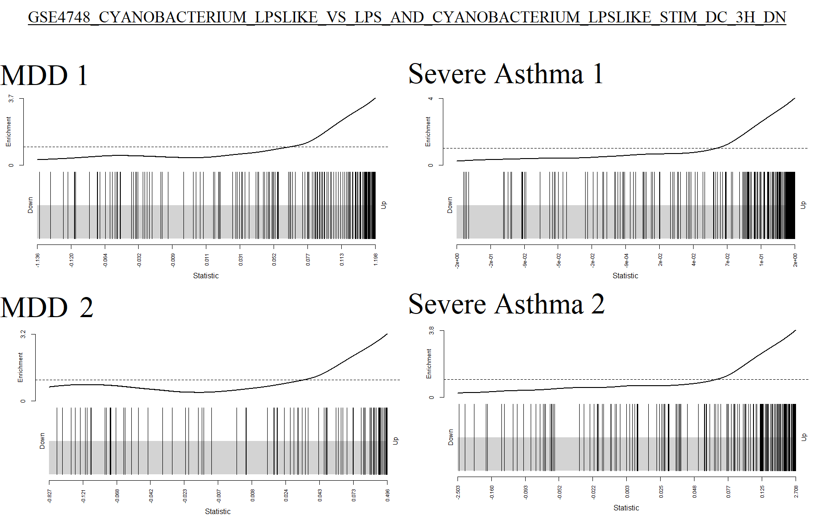
Supplementary Figure 1: Barcode plots showing cumulative individual genes in the “GSE4748_CYANOBACTERIUM_LPSLIKE_VS_LPS_AND_CYANOBACTERIUM_LPSLIKE_STIM_DC_3H_DN” gene set for the exploration and validation datasets of MDD and severe asthma.

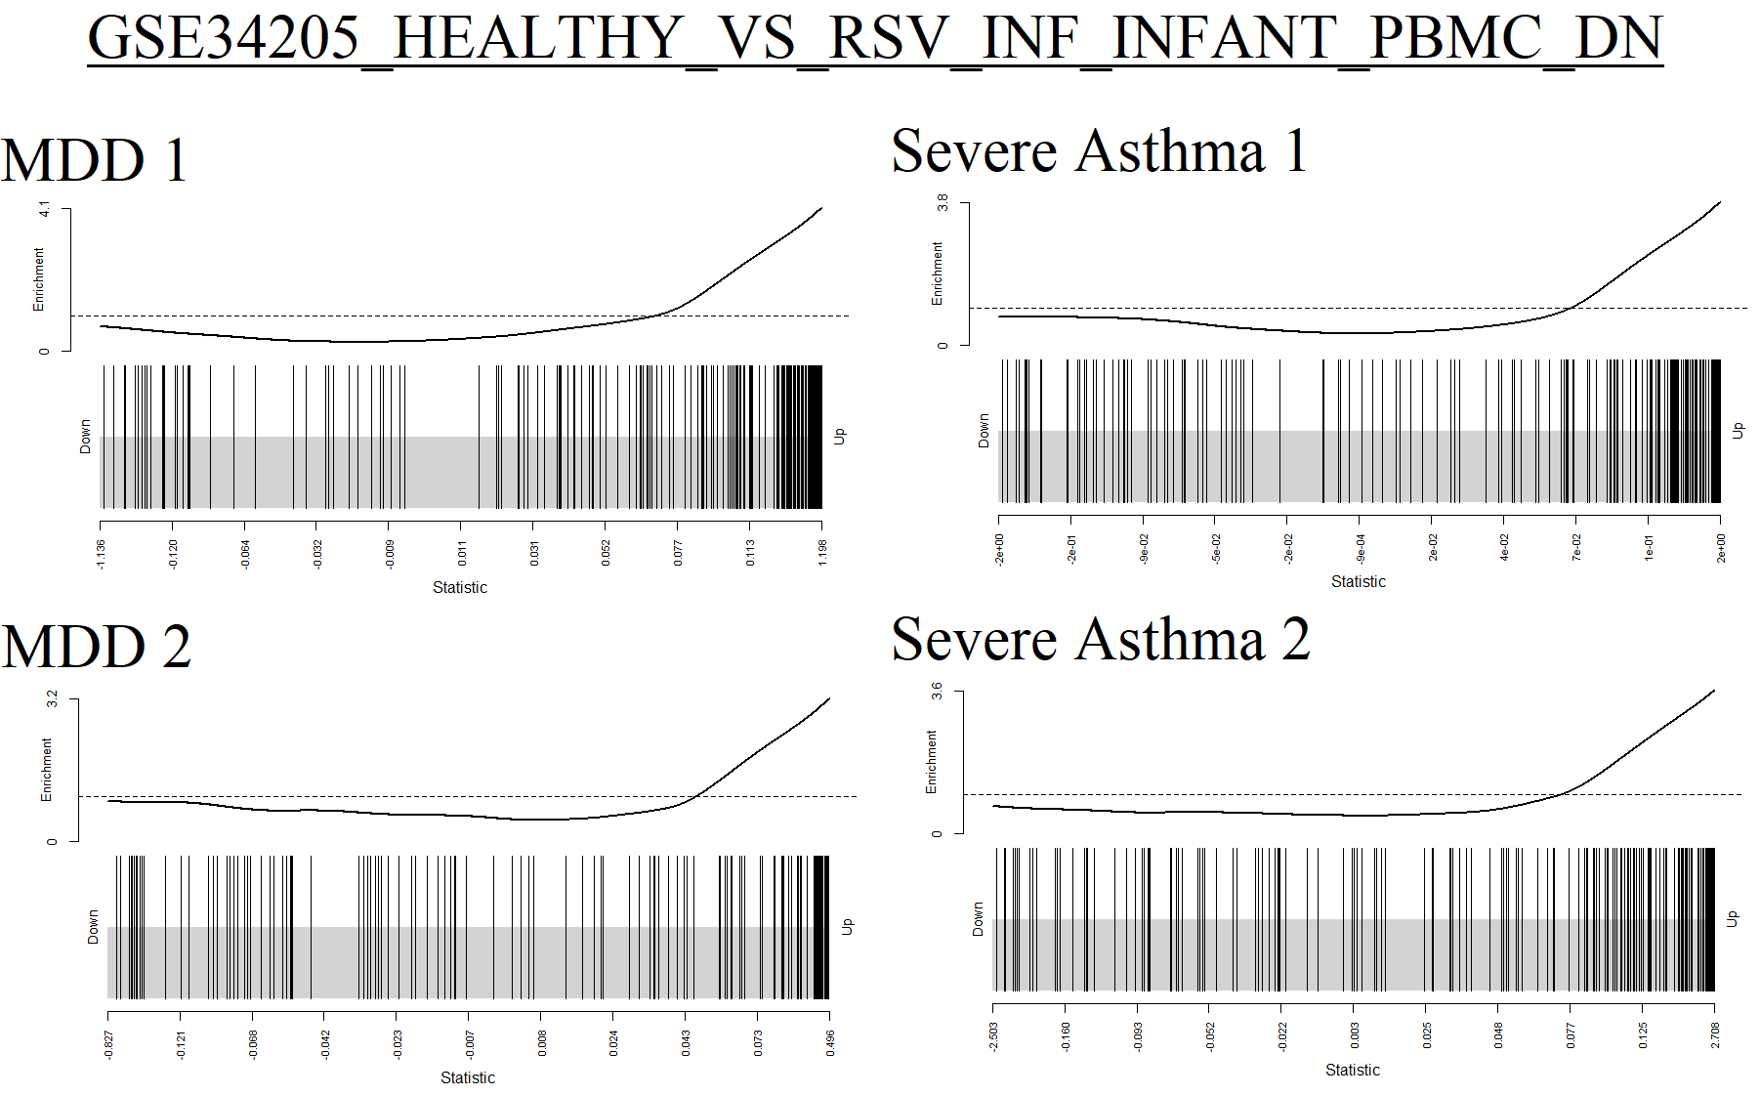
Supplementary Figure 2: Barcode plots showing cumulative individual genes in the “GSE34205_HEALTHY_VS_RSV_INF_INFANT_PBMC_DN” gene set for the exploration and validation datasets of MDD and severe asthma.

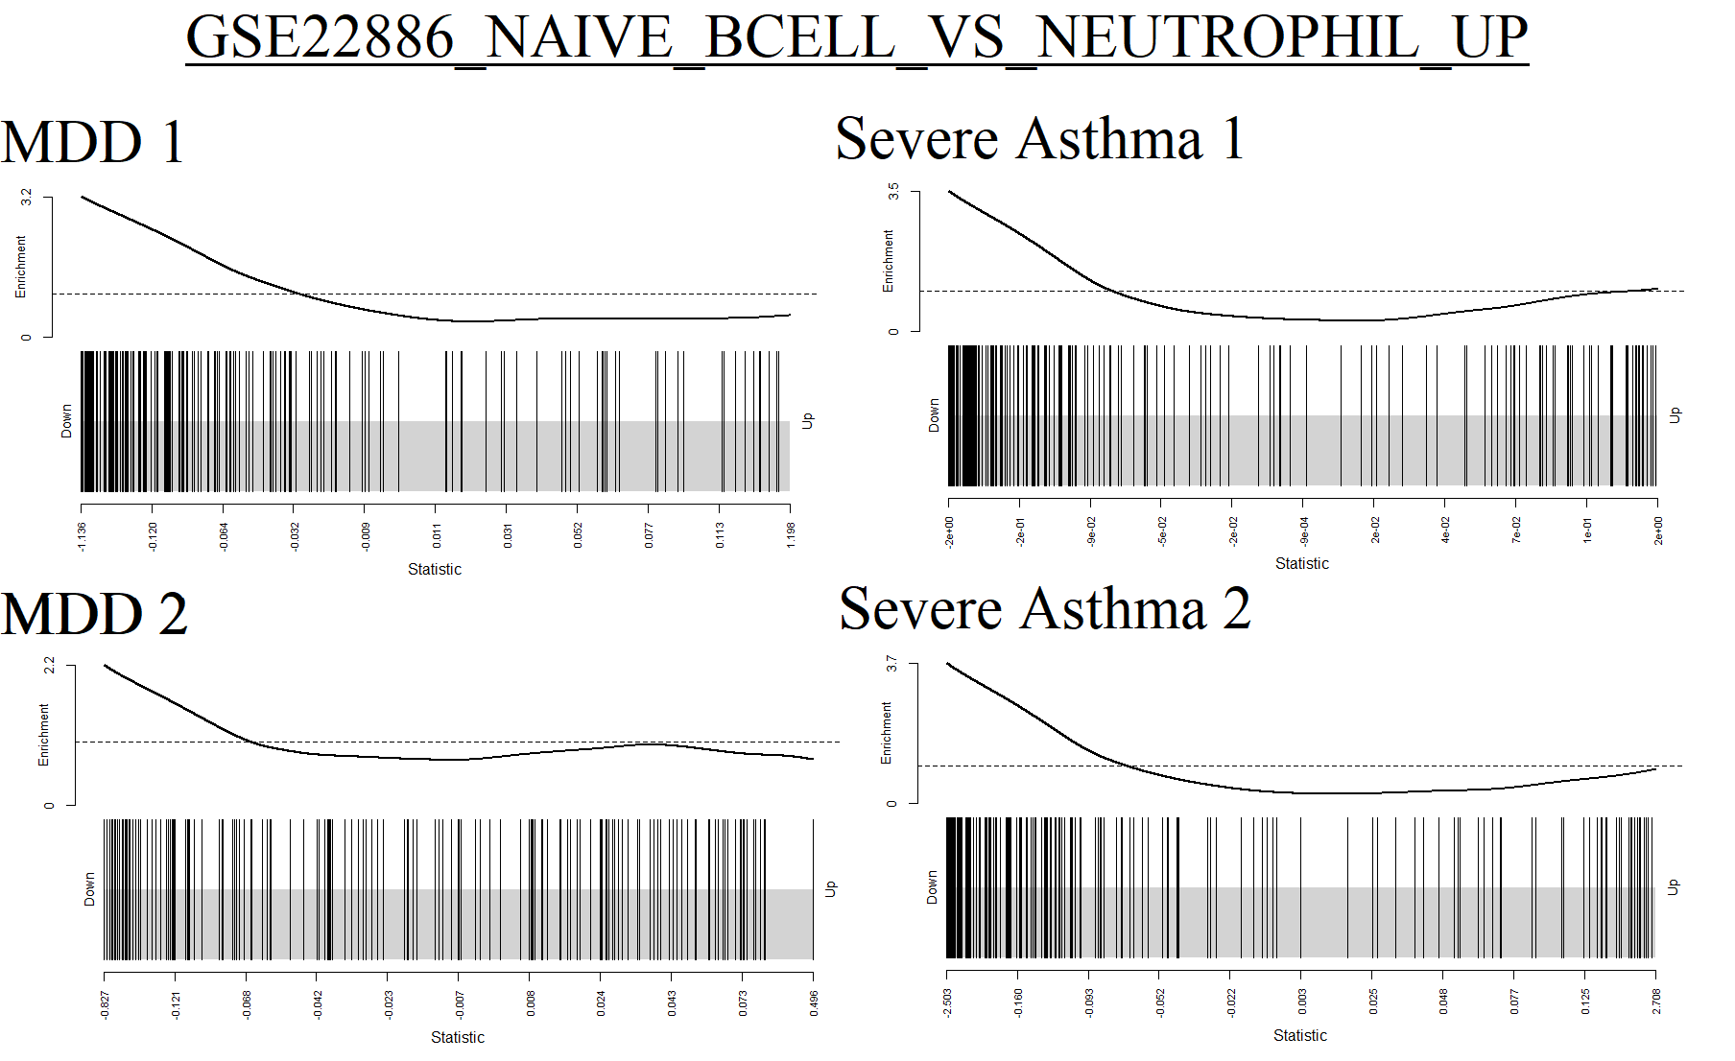
Supplementary Figure 3: Barcode plots showing cumulative individual genes in the “GSE22886_NAIVE_BCELL_VS_NEUTROPHIL_UP” gene set for the exploration and validation datasets of MDD and severe asthma.

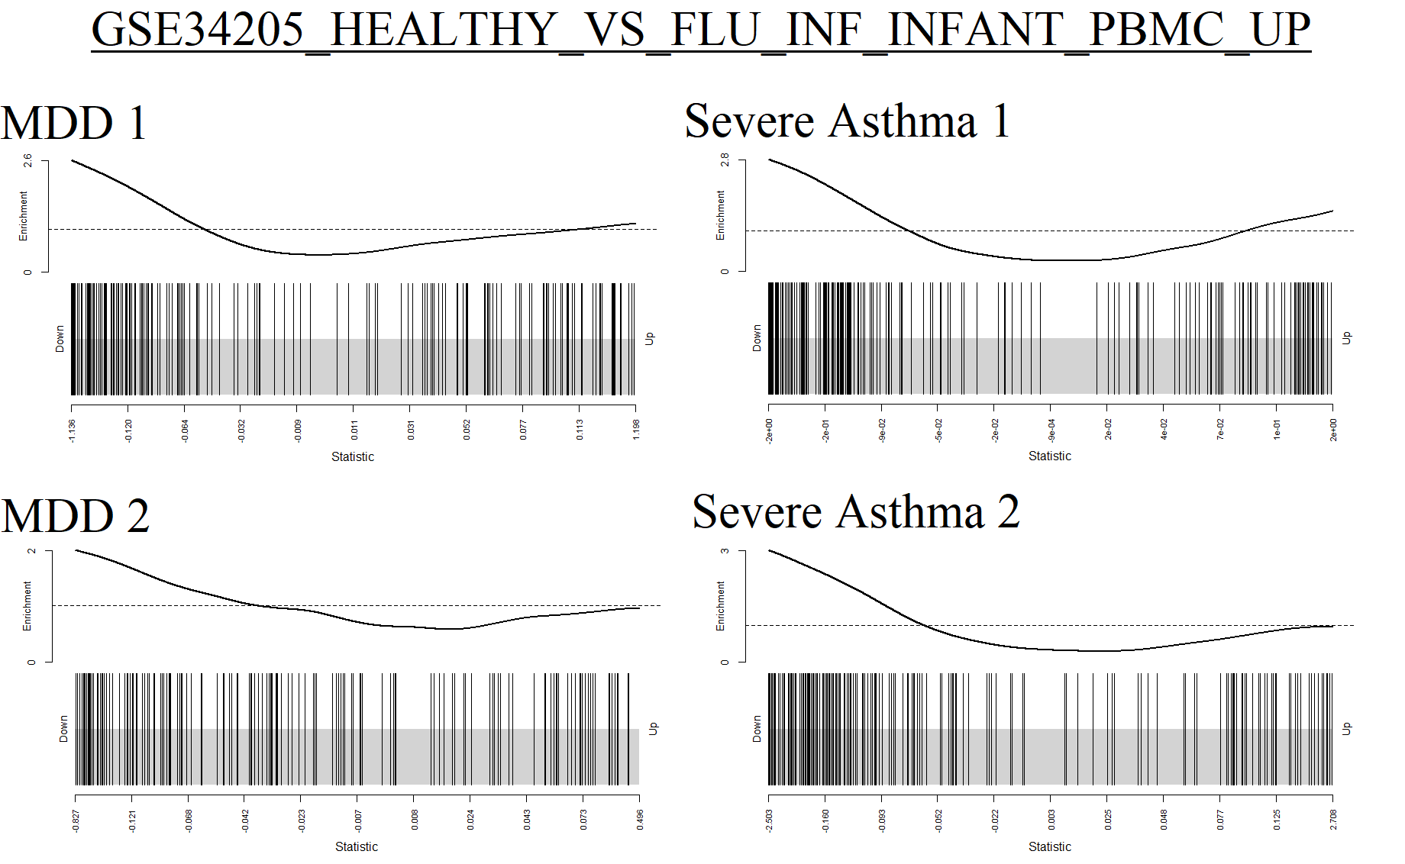
Supplementary Figure 4: Barcode plots showing cumulative individual genes in the “GSE34205_HEALTHY_VS_FLU_INF_INFANT_PBMC_UP” gene set for the exploration and validation datasets of MDD and severe asthma.

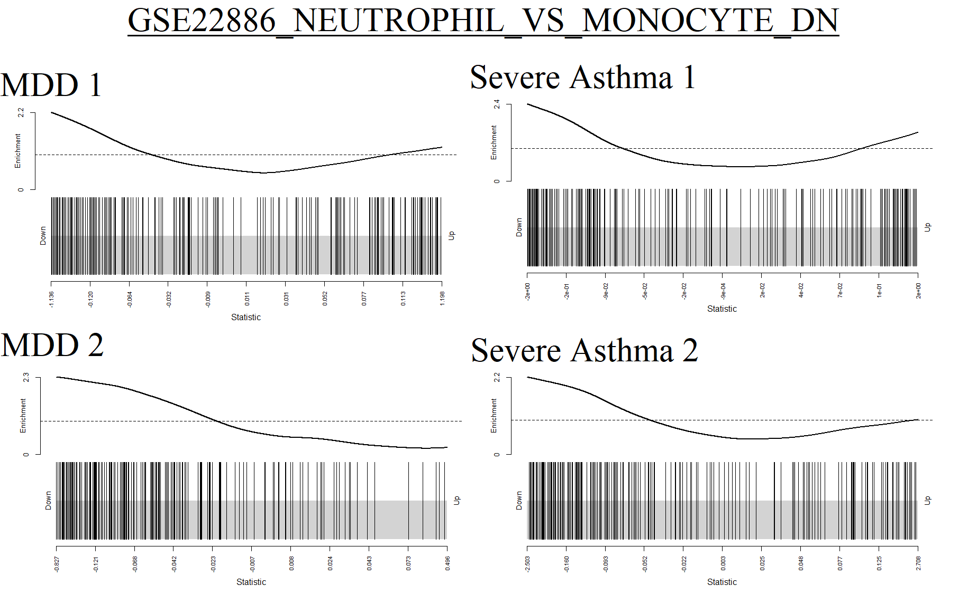
Supplementary Figure 5: Barcode plots showing cumulative individual genes in the “GSE22886_NEUTROPHIL_VS_MONOCYTE_DN” gene set for the exploration and validation datasets of MDD and severe asthma.

