Supporting Information

Carrier-free multifunctional nanomedicine for intraperitoneal disseminated ovarian cancer therapy

Xiuyu Huang^{1†}, Miaojuan Qiu^{1†}, Tianqi Wang², Binbin Li¹, Shiqiang Zhang¹, Tianzhi Zhang¹, Peng Liu¹, Qiang Wang¹, Zhi Rong Qian¹, Chengming Zhu¹*, Meiying Wu²* and Jing Zhao¹*
¹ The Seventh Affiliated Hospital of Sun Yat-sen University, Sun Yat-sen University, Shenzhen, 518107, Guangdong, P. R. China.
² School of Pharmaceutical Sciences (Shenzhen), Sun Yat-sen University, Shenzhen, 518107, Guangdong, P. R. China.

E-mail addresses:
zhuchm3@mail.sysu.edu.cn (C. Zhu)
wumy53@mail.sysu.edu.cn (M. Wu)
zhaoj265@mail.sysu.edu.cn (J. Zhao)

† These authors contributed equally to this work.
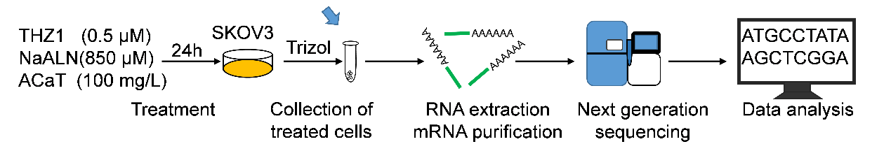

Supplementary Figure 1. Transcriptome sequencing and bioinformatics analysis for ovarian cells SKOV3. Cells were treated with 0.5 μM of THZ1, 850 μM of NaALN and 100 mg/L of ACaT for 24 h before collection. Then cells were washed three times with ice-cold PBS and lysed by the Trizol reagent at a ratio 10 cm²/mL with incubation of 5 min at room temperature. RNA was purified by RNA purification kit (Thermo Fisher Scientific). RNA-seq libraries were generated and sequenced following the standard mRNA protocols on a Hiseq 2500 (Illumina, PE150). Clean reads were obtained from the raw reads by removing the adaptor sequences, low quality sequences and reads containing poly-N with Trimmomatic software.

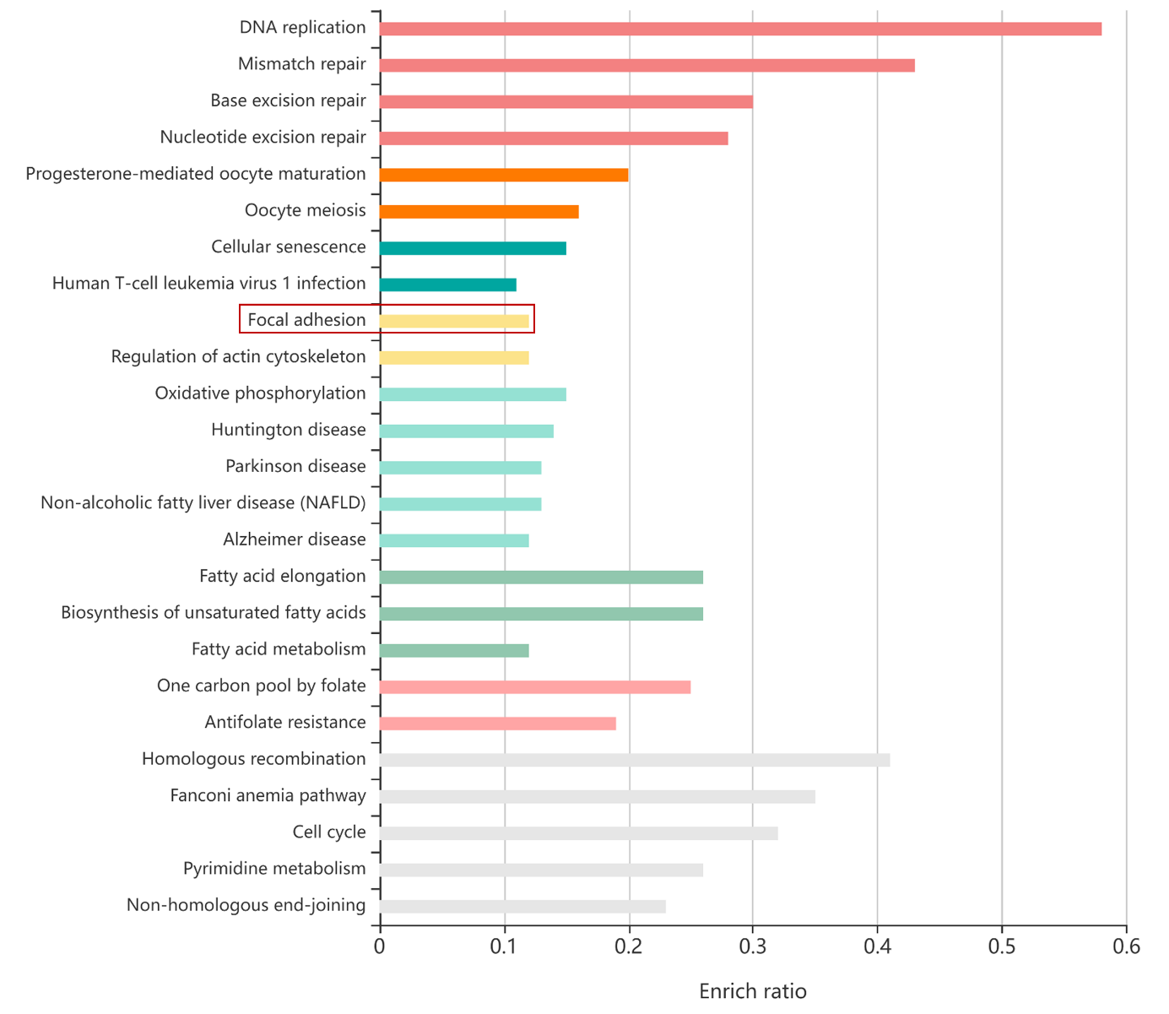
Supplementary Figure 2. KEGG pathway analysis of downregulated genes in SKOV3 cells treated with ACaT (100 mg/L) for 24 h. Each row represents an enriched function, and the length of the bar represents the enrich ratio, which is calculated as "downregulated gene number"/ "backgound gene number". Different colors represent clusters with different functions. Inside the red box is pathway associated with migration.

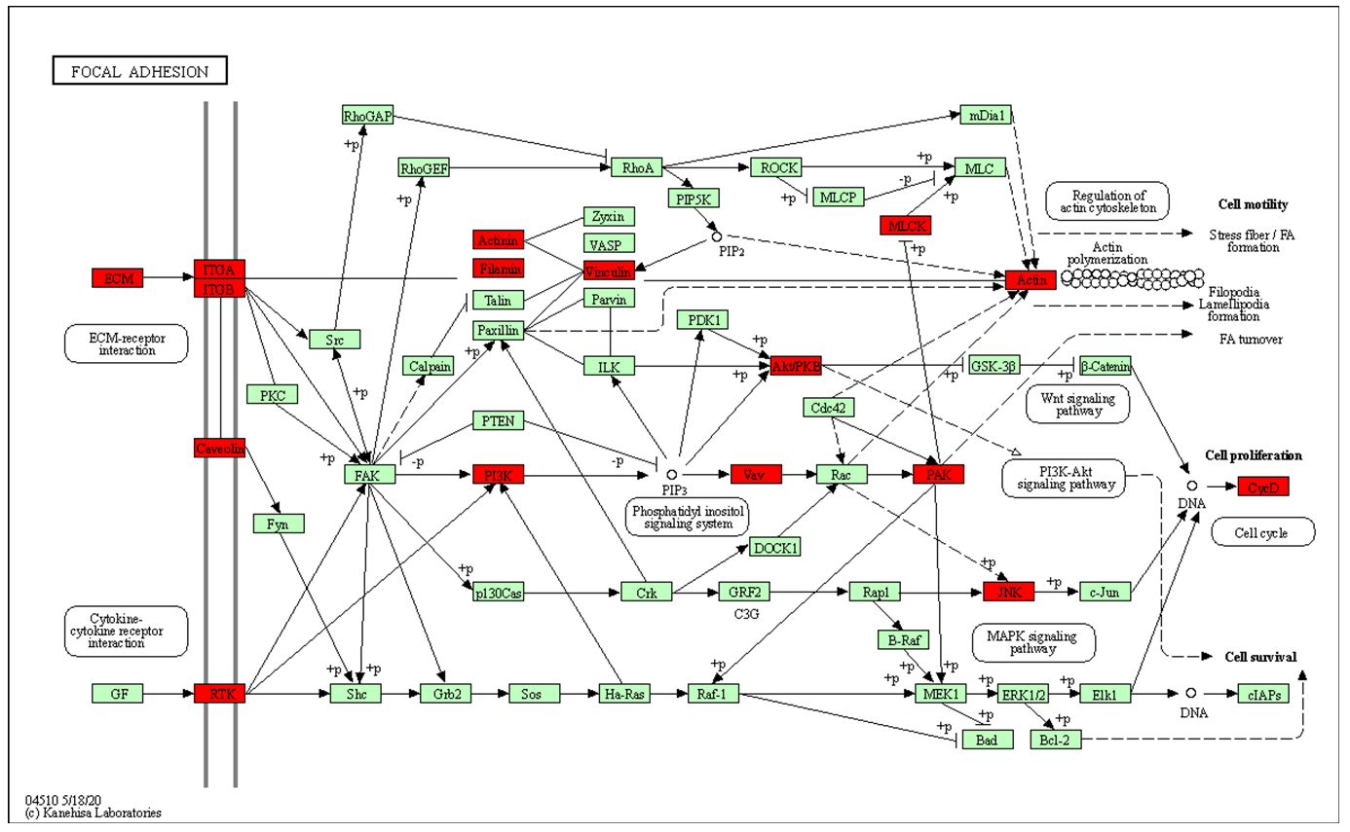

Supplementary Figure 3. KEGG pathway Focal Adhesion signaling pathway (04510). Data were retrieved from the KEGG database (https://www.genome.jp/kegg/). Red boxes represent downregulated genes and green boxes indicate background genes.

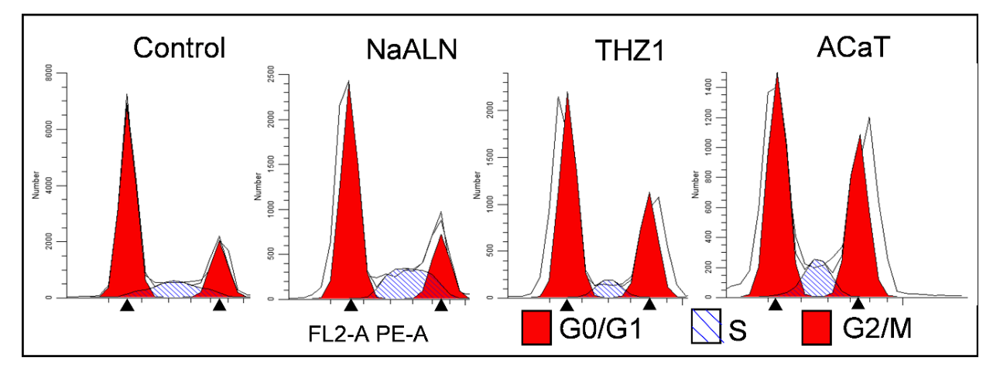
Supplementary Figure 4. Flow cytometric analysis of SKOV3 cells treated with NaALN (400 μM), THZ1 (0.25 μM), ACaT (12.5 mg/L) for 24 h. Percentages of G0/G1, S and G2/M phase cells were determined using ModFit LT5.0 software.

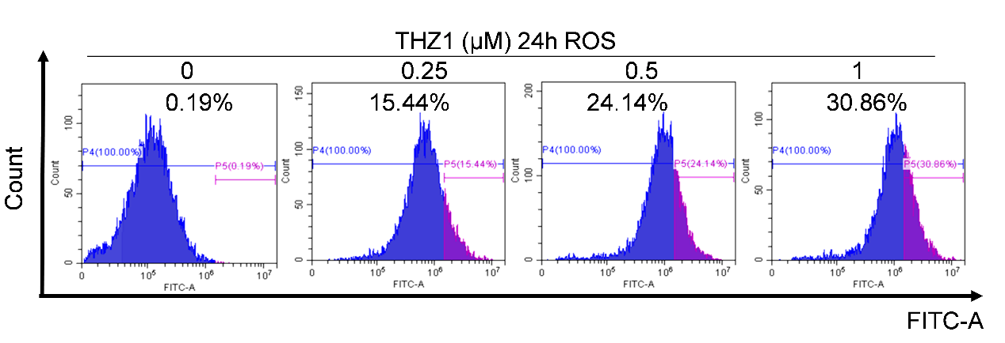
Supplementary Figure 5. SKOV3 cells treated with various concentrations of THZ1 (0, 0.25, 0.5 and 1 μM ) for 24 h. ROS production was measured by flow cytometry.

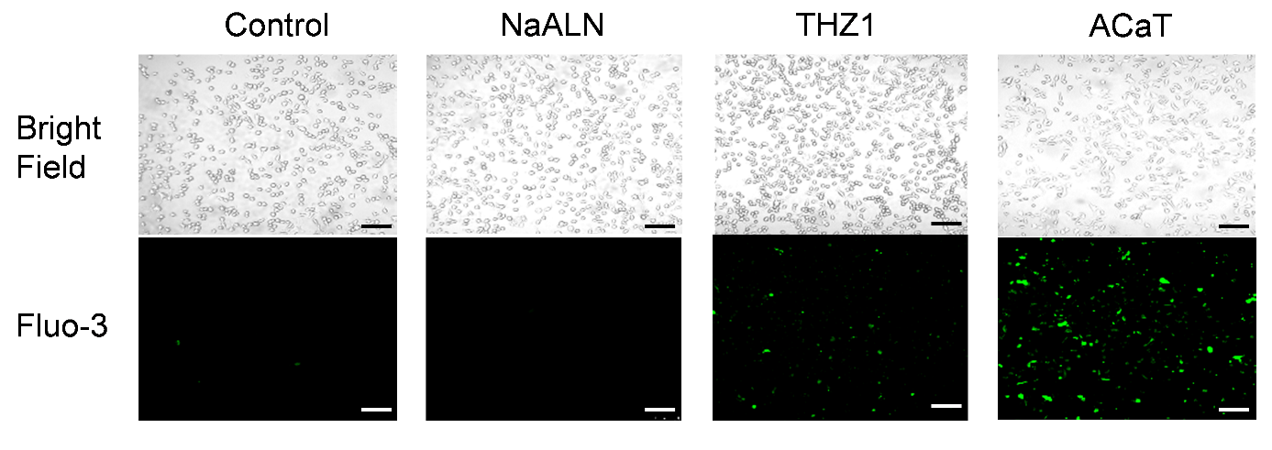
Supplementary Figure 6. The intracellular calcium ions after different treatments (200 μM of NaALN, 0.01 μM of THZ1 and 1.56 mg/L of ACaT for 48 h) were detected by calcium ion probe. Scale bar, 100 μm.

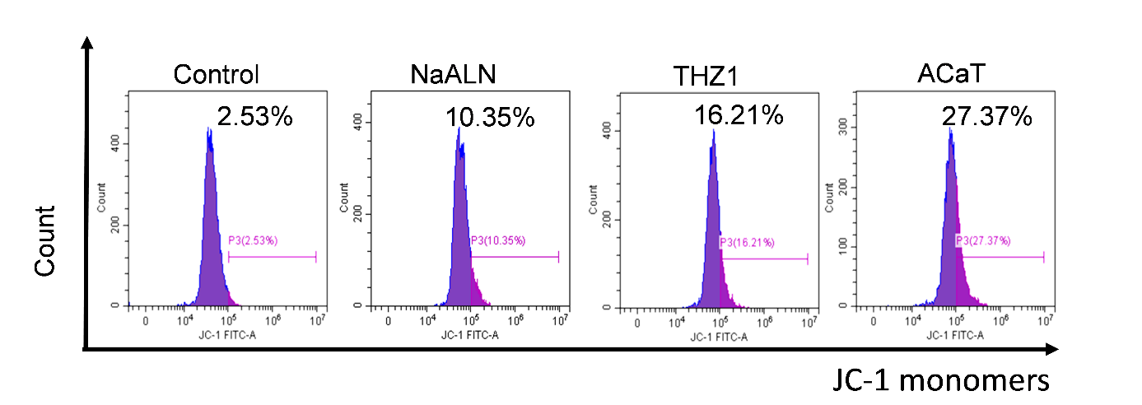
Supplementary Figure 7. Cells were treated with PBS, NaALN (850 μM), THZ1 (0.5 μM), ACaT (100 mg/L) for 6 h. The mitochondrial membrane potential was detected by flow cytometry using JC-1 staining.

Supplementary Figure 8. Cell viability of SKOV3 treated with CaCl₂ at different concentrations for 24 and 48 h. The cell survival curves were plotted by GraphPad Prism 8.0.

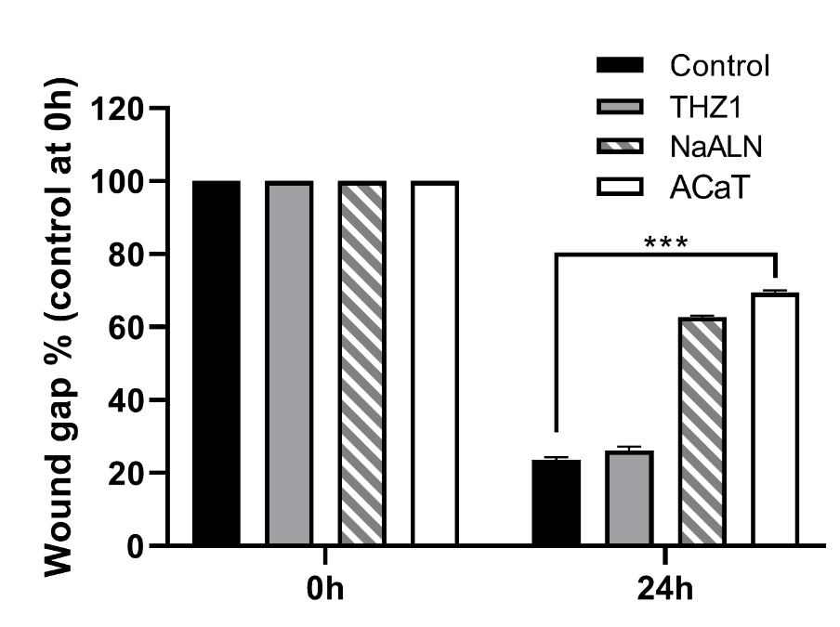
Supplementary Figure 9. Quantitative data from scratch assay. Cells were cultured on 12-well plates to ~80% confluence, and a linear scratch was performed in the single cell layer with a 10 μL pipette tip. Cells were then treated with NaALN (200 μM), THZ1 (0.01 μM) or ACaT (6.25 mg/L). The widths of the scratches in different groups were measured at 24 h. The wound gap% were plotted by GraphPad Prism 8.0.

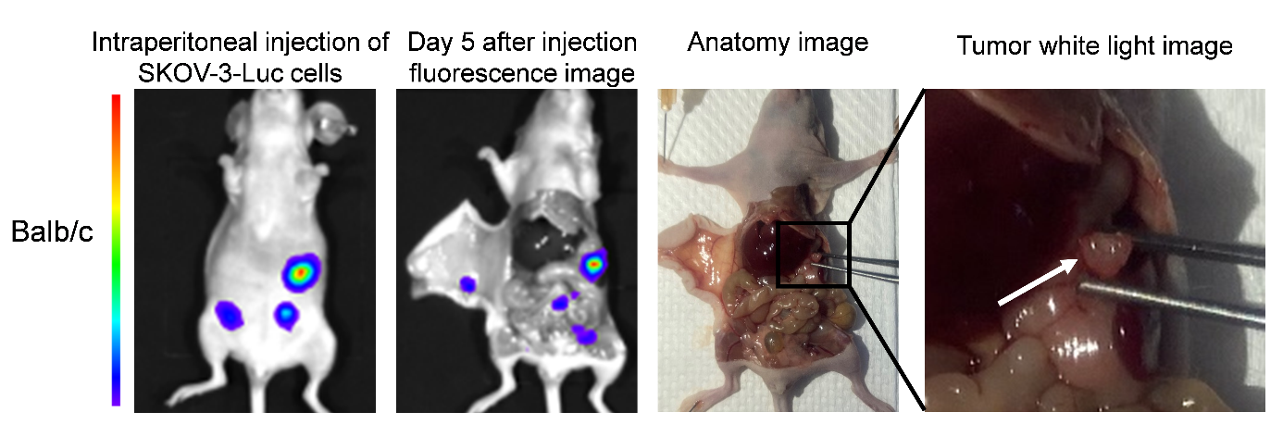
Supplementary Figure 10. BALB/c nude mouse model.SKOV3 cells (5 10⁶ cells/400 μL in PBS) were injected intraperitoneally into BALB/c nude mouse. After 5 day, the mice were killed and dissected for observing tumor location and size.

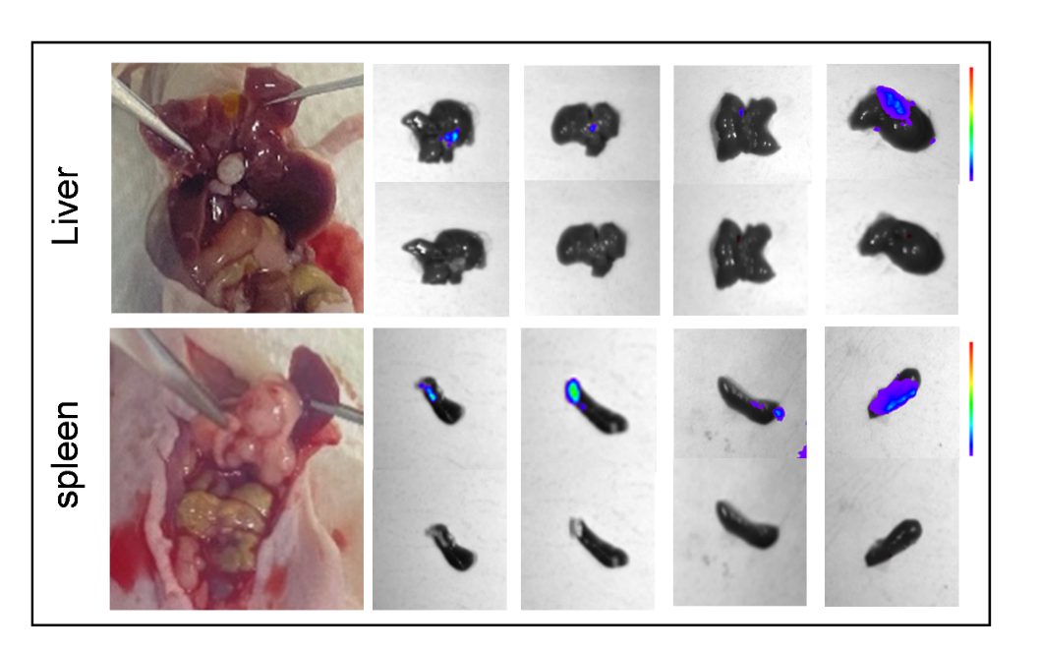
Supplementary Figure 11. Anatomical bioluminescence image and bright field of liver (top) and spleen (bottom) metastasis. SKOV3-Luc cells (5 10⁶ cells/400 μL in PBS) were injected intraperitoneally into BALB/c nude mouse. After 30 d, the mice were killed and dissected for observing tumor location and size. 4 of 10 mice treated with PBS had liver and spleen metastases. 1 of 10 had both liver and spleen metastases.

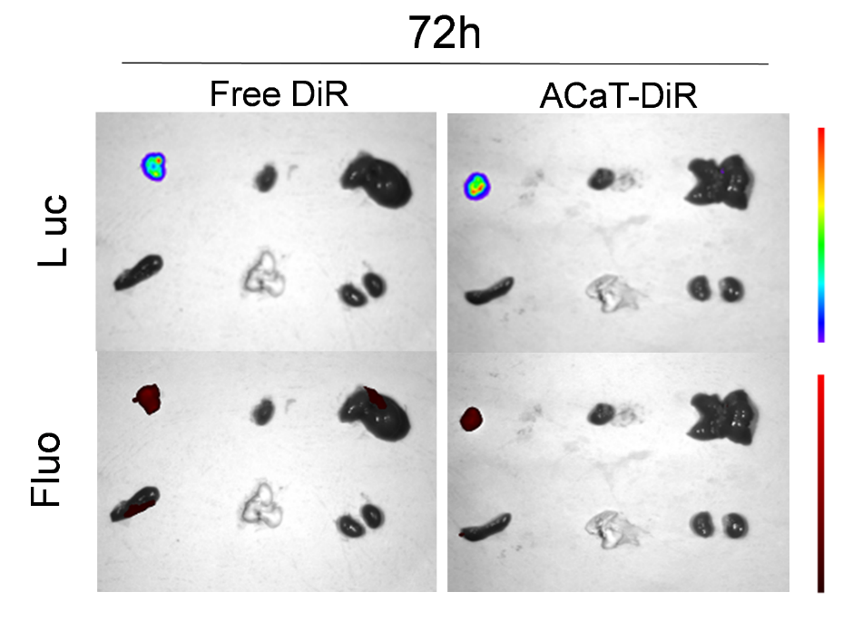
Supplementary Figure 12. Fluorescence photograph of organs and tumors of dissected mice at 72 h post-injection. The images on the top were tumor bioluminescence and bottom were DiR dye fluorescence.

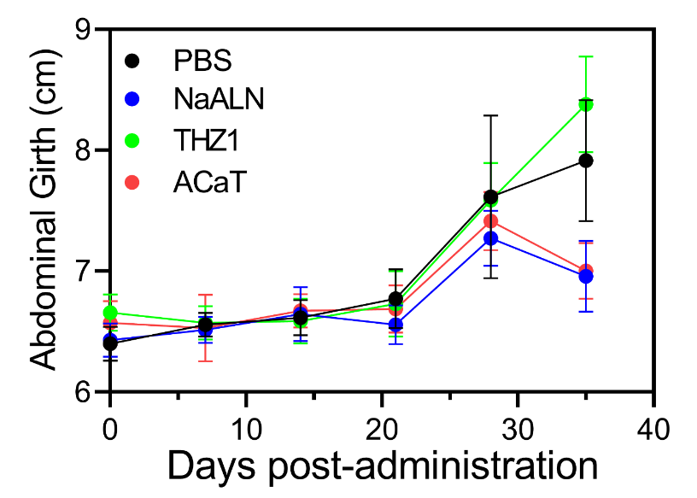
Supplementary Figure S13. The abdominal girth changes of the mice in different treatment groups (n = 5) .

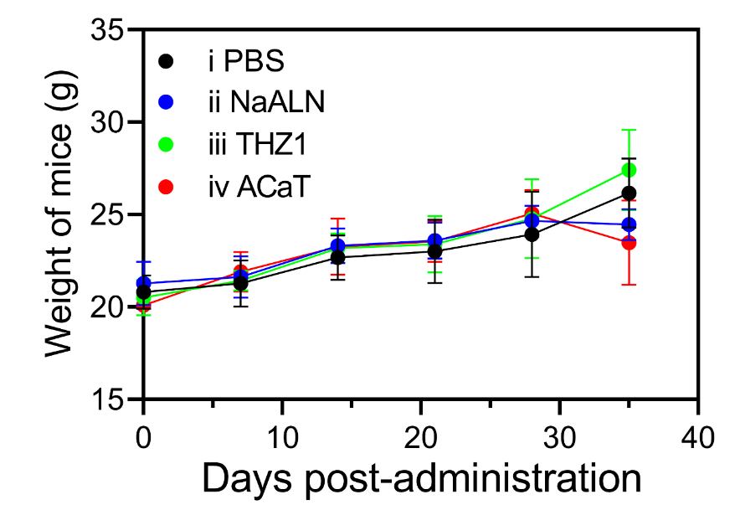
Supplementary Figure S14. The body weight changes in mice bearing SKOV3 tumor after treatment with different drugs (n = 5) .

