Supplementary Information

Alcohols Enrichment Enables Their Electrooxidation Coupled with H₂ Production at High Current Density

Zhenhua Li¹, Yifan Yan¹, Si-Min Xu¹, Hua Zhou², Ming Xu¹, Lina Ma¹, Xianggui Kong¹, Bin Wang³, Lirong Zheng⁴ and Haohong Duan²*

¹State Key Laboratory of Chemical Resource Engineering, Beijing University of Chemical Technology, Beijing 100029, China
²Department of Chemistry, Tsinghua University, 30 Shuangqing Rd, Haidian Qu, Beijing 100084, China
³Beijing Research Institute of Chemical Industry, Sinopec Group, Beijing 100013, People’s Republic of China
⁴Institute of High Energy Physics, the Chinese Academy of Sciences, Beijing 100049, People’s Republic of China

Zhenhua Li, Yifan Yan, Si-Min Xu and Hua Zhou contributed equally to this work.

Correspondence and requests for materials should be addressed to H.D. (email: hhduan@mail.tsinghua.edu.cn).

Supplementary figures
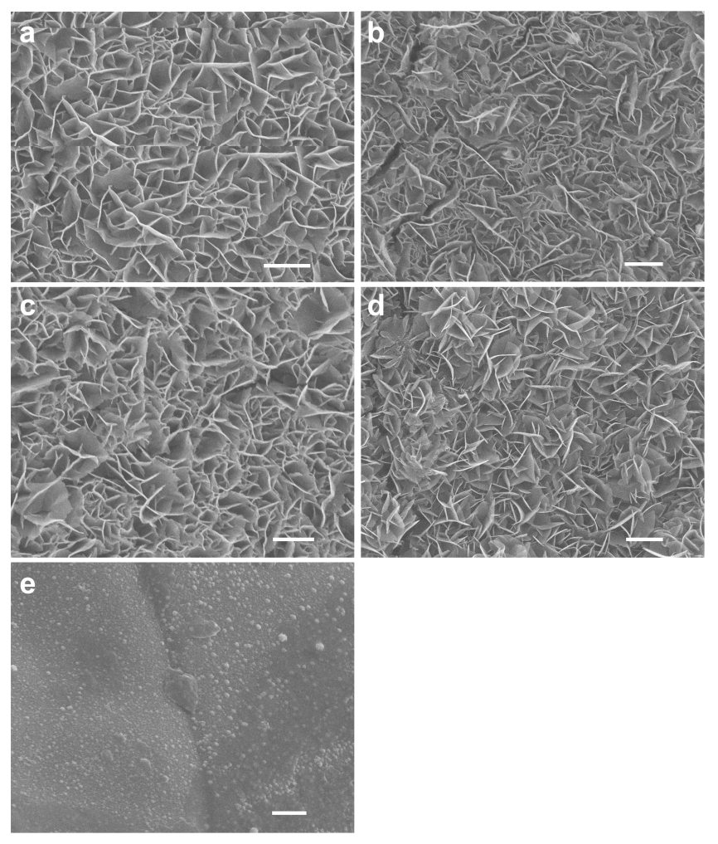
Supplementary Figure 1. SEM images of (a) Au/Co(OH)₂, (b) Au/CoOOH, (c) Co(OH)₂, (d) CoOOH and (e) Au on Ni foam. Scale bar, 1 μm.

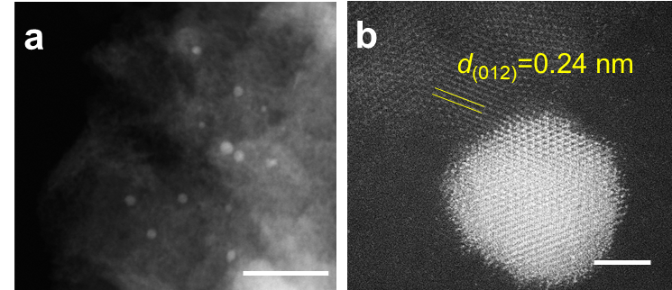
Supplementary Figure 2. High-angle annular dark-field scanning transmission electron microscopy (HAADF-STEM) images of Au/CoOOH: a, a representative region; b, an individual Au nanoparticle. Scale bars, (a) 50 nm, (b) 2 nm.

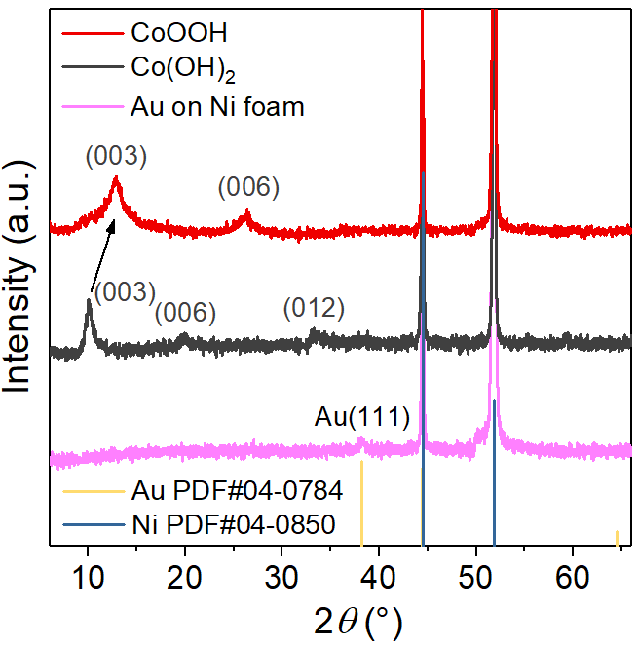
Supplementary Figure 3. XRD patterns of Co(OH)₂, CoOOH and Au on Ni foam.

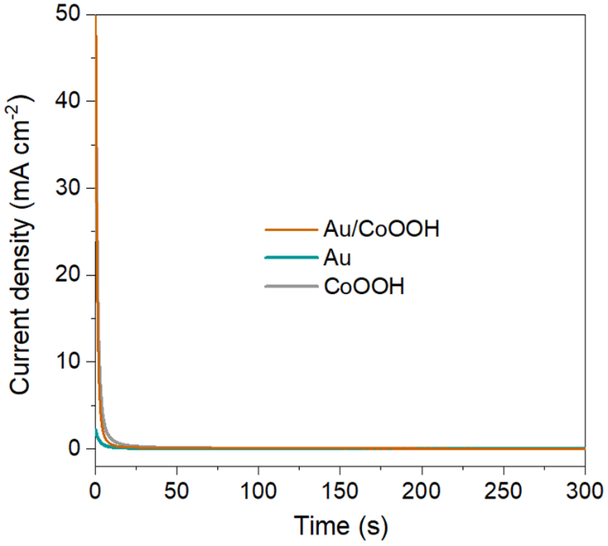
Supplementary Figure 4. I-t curves of Au/CoOOH, CoOOH and Au at 1.3 V vs. RHE in 1 M KOH at r.t.

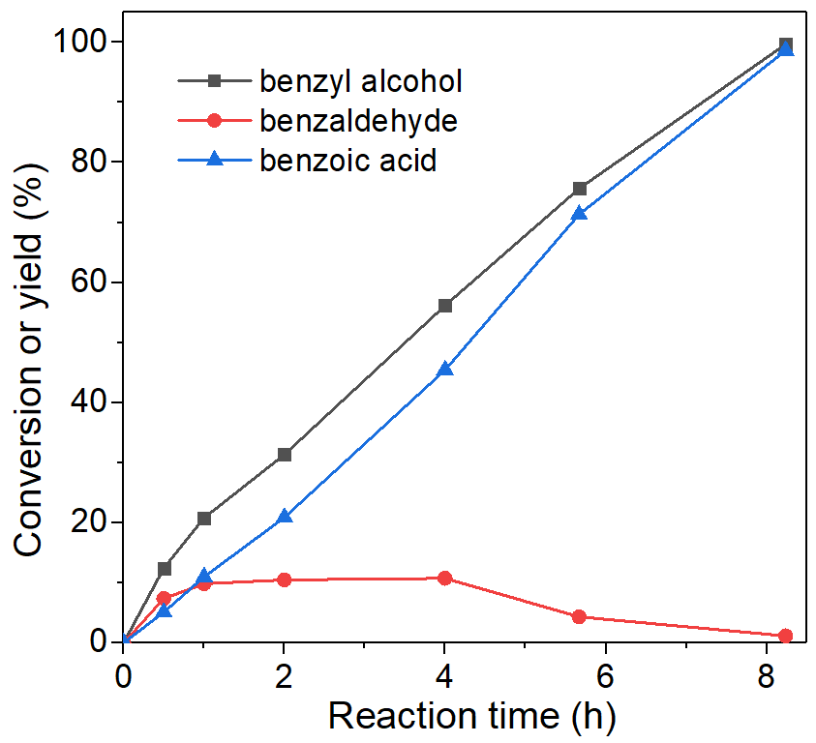
Supplementary Figure 5. The kinetic curves for benzyl alcohol conversion as a function of reaction time over Au/CoOOH in 1 M KOH with 0.1 M benzyl alcohol at 1.3 V vs. RHE at r.t.

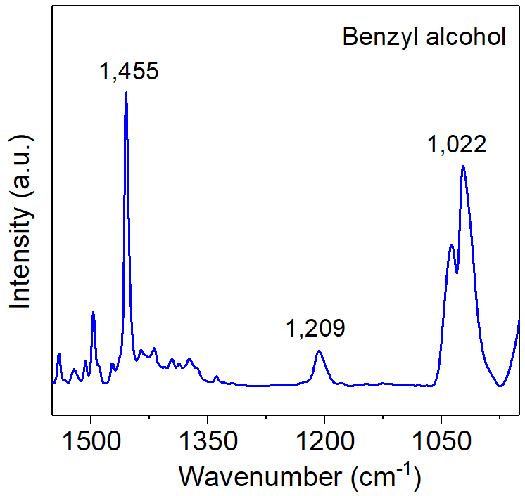
Supplementary Figure 6. FTIR spectra of gaseous benzyl alcohol.

Supplementary Figure 7. Schematic illustration of the adsorption sites on (a) CoOOH (A, B, and C represent top, bridge, and fcc sites, respectively), (b) Au (A, B, and C represent top, bridge, and fcc sites, respectively), and (c) Au/CoOOH (A, B, C, and D represent CoOOH (001), Au (111), Au (001)/CoOOH (001) interface, and Au (111)/CoOOH (001) interface, respectively).

Supplementary Figure 8. (a) Total density of states (TDOS), and partial density of states for Au, and Au-d orbitals for Au/CoOOH. (b) Optimized geometry of Ph-CH₂OH* for Au/CoOOH, the hydrogen bonding between benzyl alcohol and Au/CoOOH is labeled and highlighted.

Supplementary Figure 9. Top and side views of the optimized geometries of reaction intermediates for benzyl alcohol oxidation to benzoic acid on CoOOH.

Supplementary Figure 10. Top and side views of the optimized geometries of reaction intermediates for benzyl alcohol oxidation to benzoic acid on Au.

Supplementary Figure 11. Top and side views of the optimized geometries of reaction intermediates for benzyl alcohol oxidation to benzoic acid on Au/CoOOH.

Supplementary Figure 12. Top and side views of the optimized geometries of the reaction intermediates for benzyl alcohol oxidation to benzoic acid on Au/CoOOH with another four adsorbed benzyl alcohol.

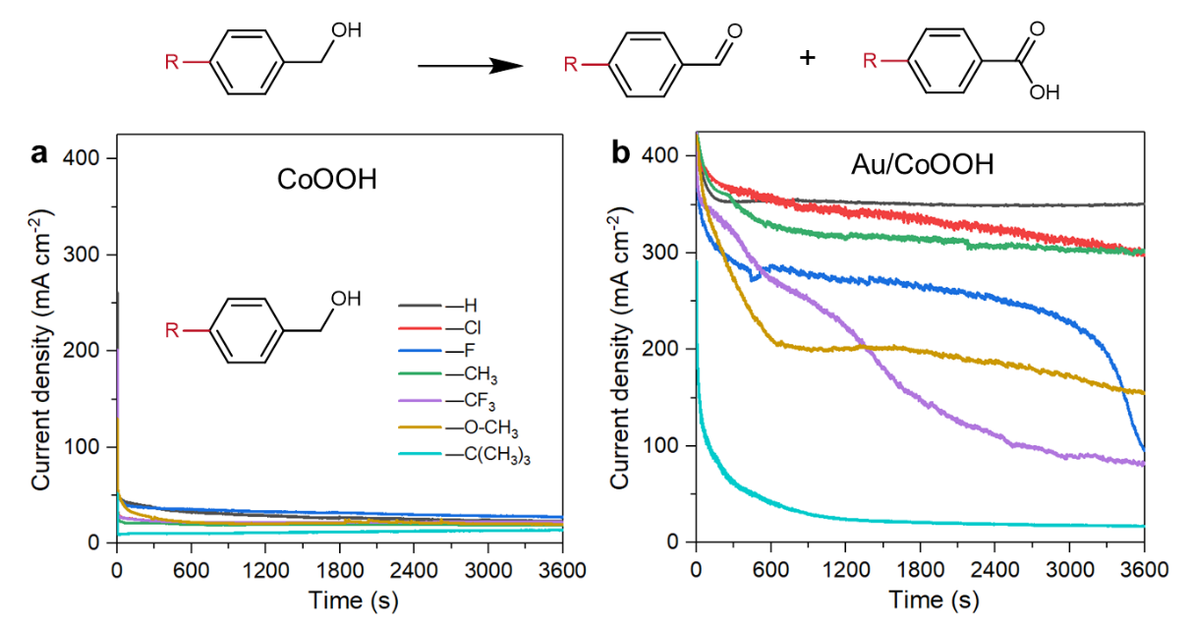
Supplementary Figure 13. I-t curves of (a) CoOOH and (b) Au/CoOOH catalyst for benzyl alcohol and its derivatives with different substituents (−Cl, −F, −CH₃, −CF₃, −OCH₃, −C(CH₃)₃) in 1 M KOH with 0.1 M reactant at 1.3 V vs. RHE at 60 ºC.

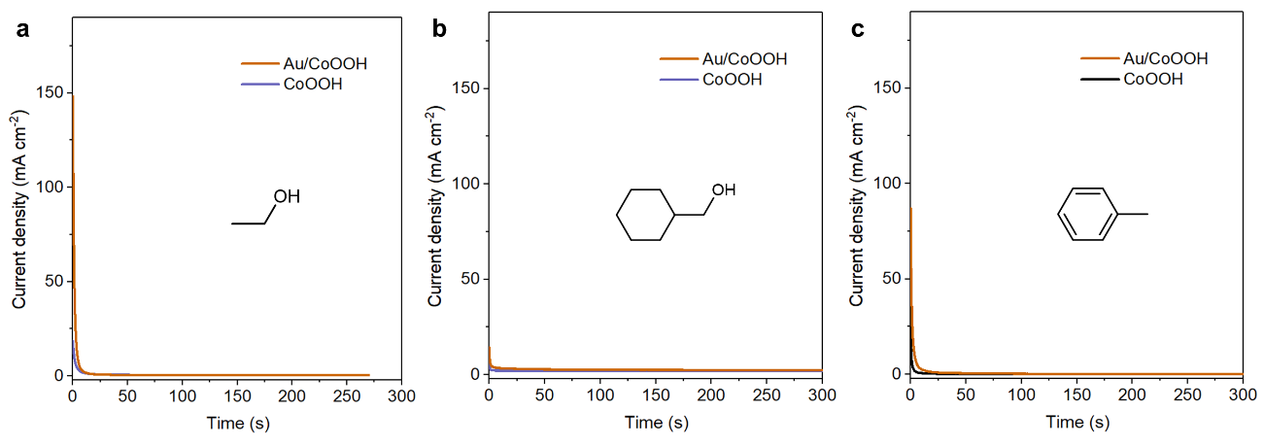
Supplementary Figure 14. I-t curves of Au/CoOOH and CoOOH catalyst for (a) ethanol, (b) cyclohexanemethanol and (c) toluene in 1 M KOH with 0.1 M reactant at 1.3 V vs. RHE at r.t.

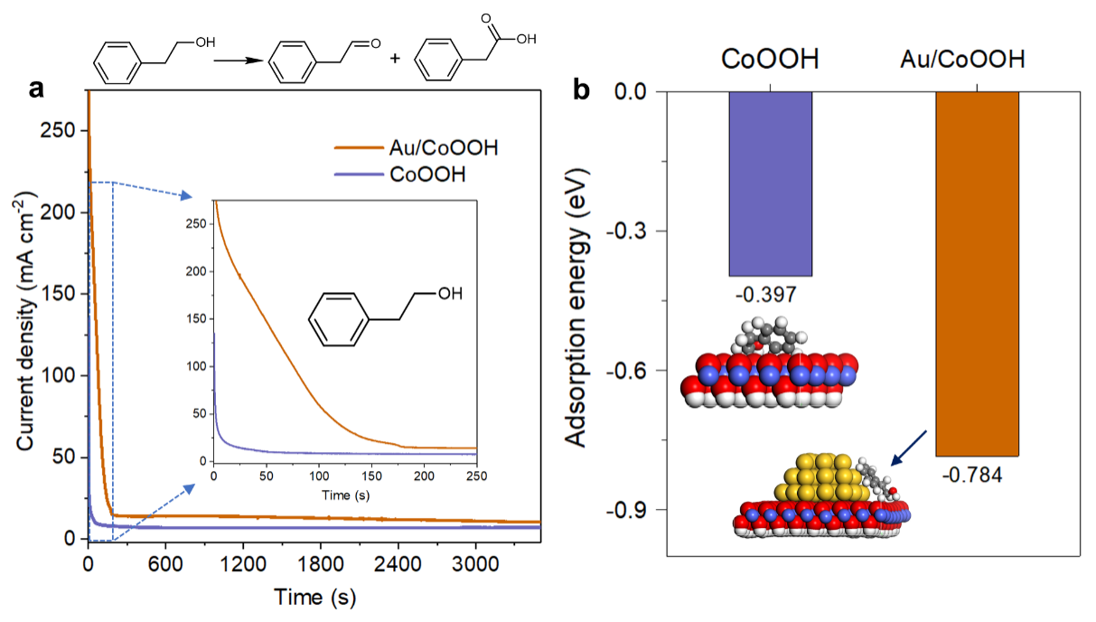
Supplementary Figure 15. a, I-t curves of Au/CoOOH and CoOOH catalyst in 1 M KOH with 0.1 M β-phenethyl alcohol at 1.3 V vs. RHE at 60 ºC. b, Adsorption energies of β-phenethyl alcohol on CoOOH and Au/CoOOH, the optimized geometries of Ph-CH₂CH₂OH* are also displayed.

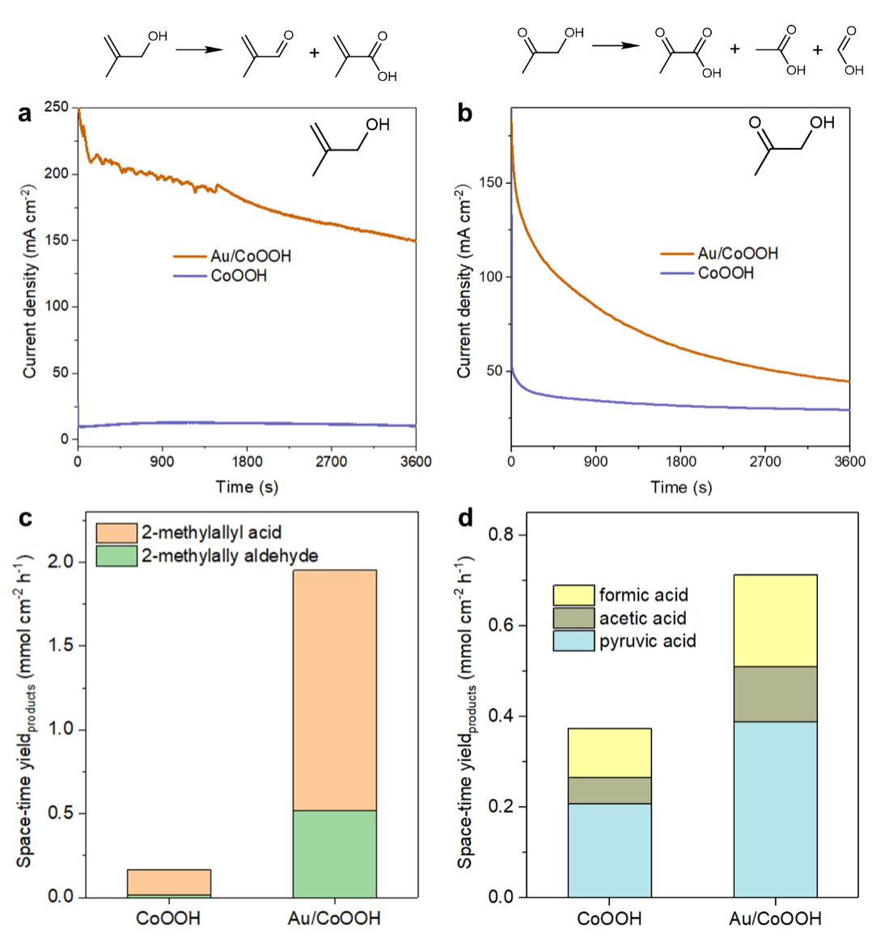
Supplementary Figure 16. I-t curves of Au/CoOOH and CoOOH catalyst for (a) methallyl alcohol and (b) hydroxyacetone in 1 M KOH with 0.3 M reactant at 1.3 V vs. RHE at r.t. The space-time yield of products for (c) methallyl alcohol and (d) hydroxyacetone.

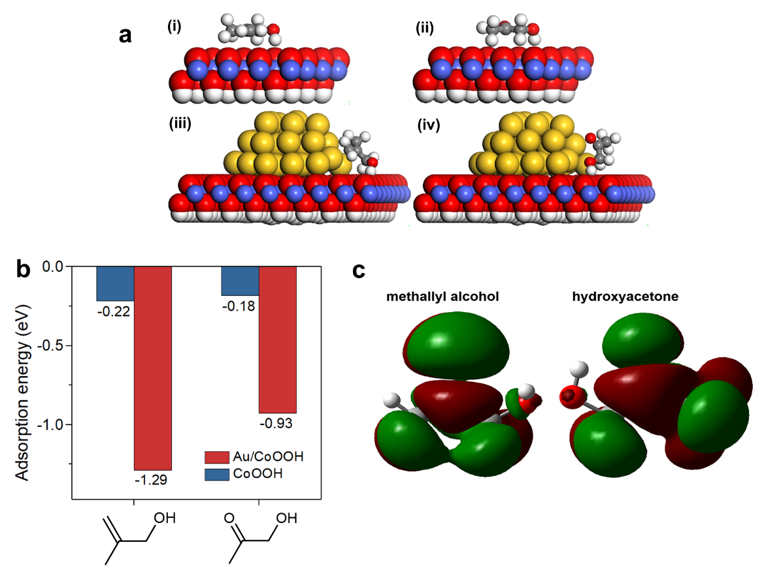
Supplementary Figure 17. a, Optimized geometries of (i) methallyl alcohol adsorbed on CoOOH, (ii) hydroxyacetone adsorbed on CoOOH, (iii) methallyl alcohol adsorbed on Au/CoOOH, and (iv) hydroxyacetone adsorbed on Au/CoOOH. b, Calculated adsorption energies of methallyl alcohol and hydroxyacetone on Au/CoOOH and CoOOH. c, LUMO of methallyl alcohol and hydroxyacetone.

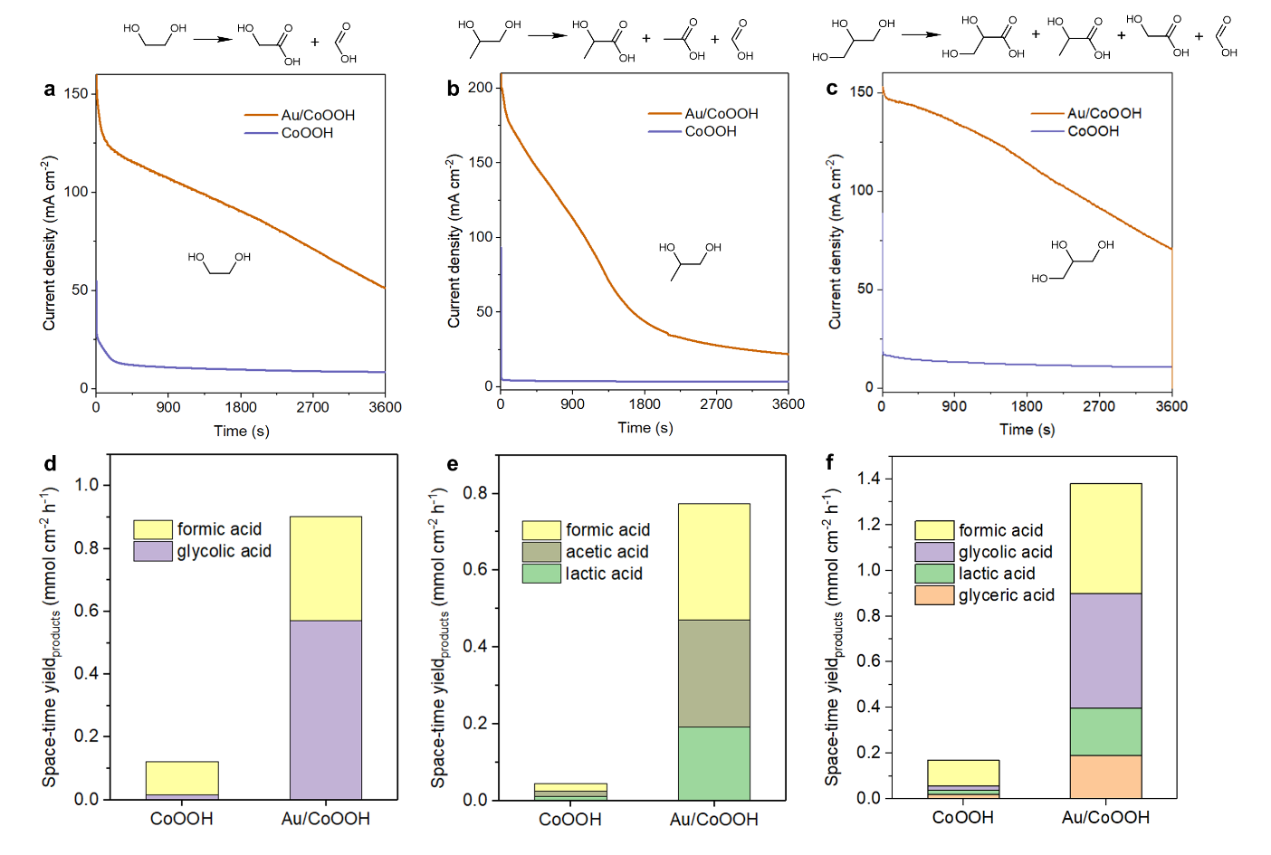
Supplementary Figure 18. I-t curves of Au/CoOOH and CoOOH catalyst for (a) ethylene glycol, (b) 1,2-propanediol and (c) glycerol. The space-time yield of products for (d) ethylene glycol, (e) 1,2-propanediol and (f) glycerol.

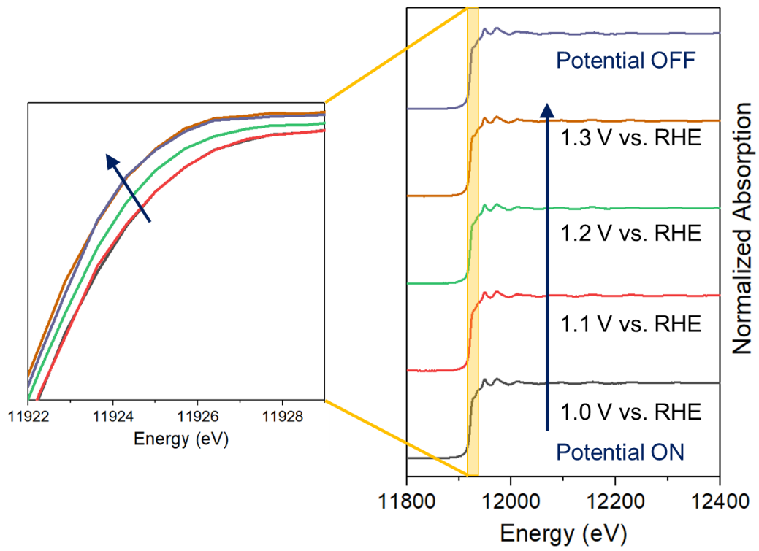
Supplementary Figure 19. Au L₃-edge XANES spectra of Au/CoOOH between different anodic potentials and open circuit in 1 M KOH.

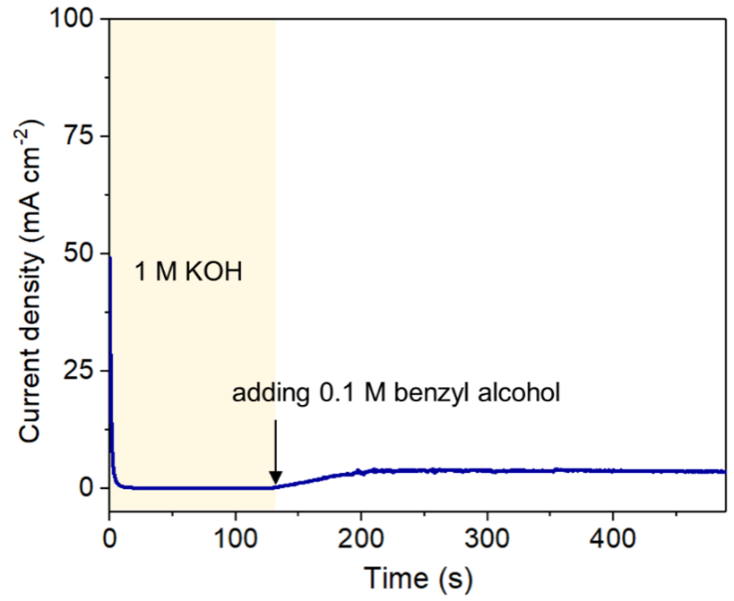
Supplementary Figure 20. I-t curve of Au/CoOOH at 1.3 V vs. RHE in 1 M KOH with 0.1 M benzyl alcohol at r.t. (benzyl alcohol was added at 130 s)

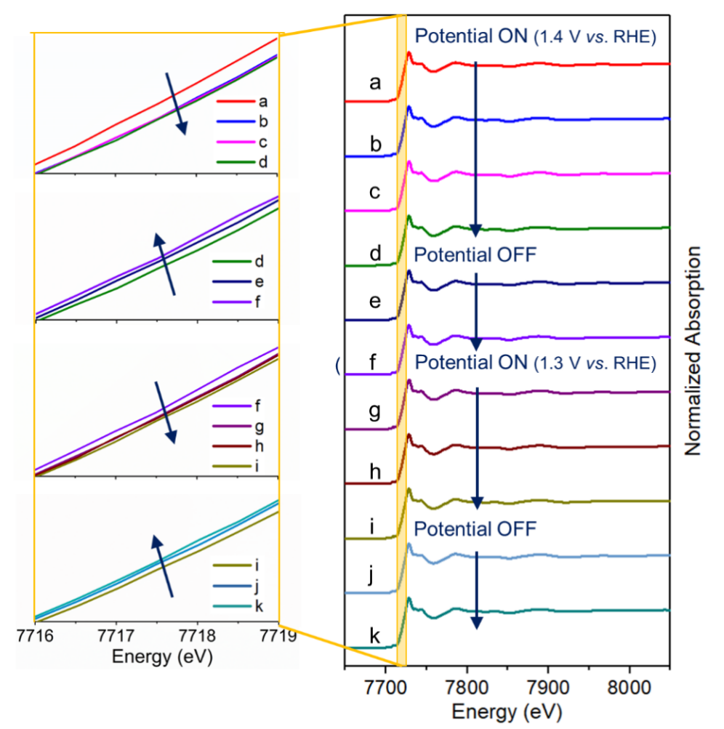
Supplementary Figure 21. Co K-edge XANES spectra of Au/CoOOH between anodic potential and open circuit.

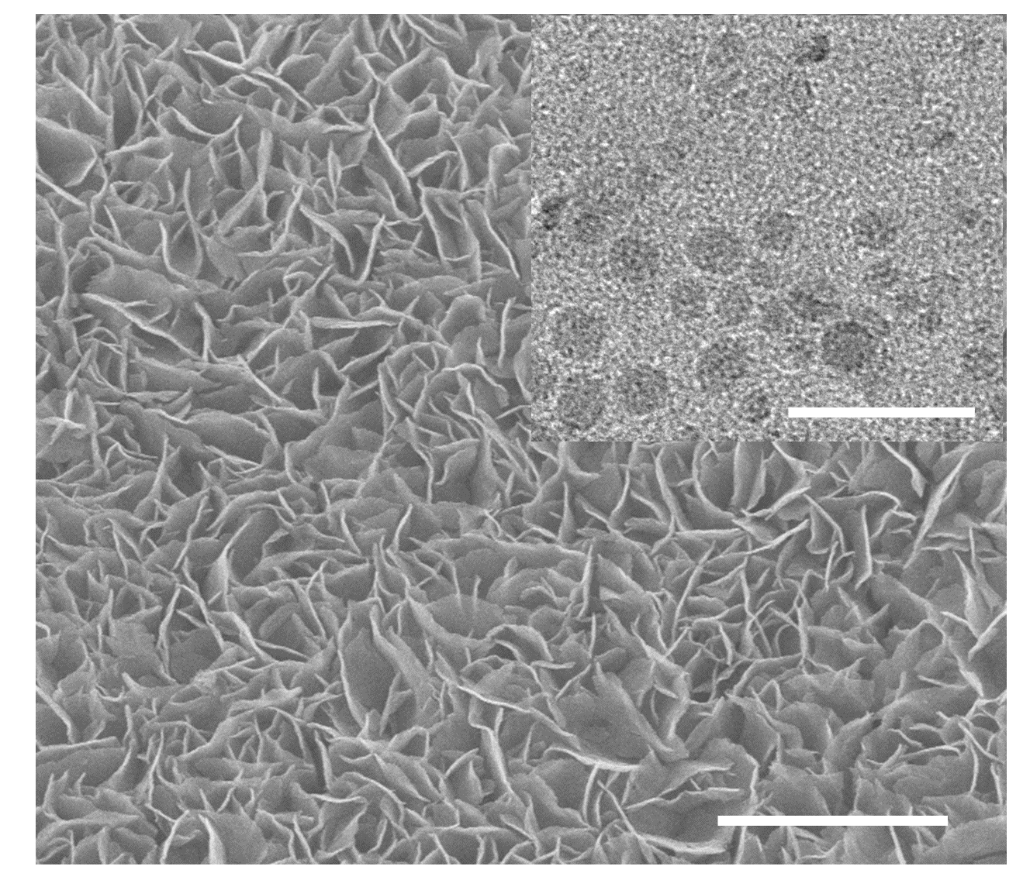
Supplementary Figure 22. SEM image of the Au/CoOOH catalyst after 24 h test. Scale bar, 2 μm. Inset displays a representative region of Au/CoOOH, showing the maintenance of the Au size. Scale bar, 20 nm.

Supplementary Tables

Supplementary Table 1. The mass loading of Au and CoOOH on Ni foam for Au/CoOOH and Au catalysts by inductively coupled plasma mass spectrometry (ICP-MS).
Catalysts | Mass loading of Au  (mg cm⁻²) | Mass loading of CoOOH  (mg cm⁻²) | Au mass loading on CoOOH  (wt%)
Au/CoOOH | 0.17 | 1.5 | 11.3
Au | 0.33 | 0 | -

Supplementary Table 2. Comparison of the catalytic performance of anodic oxidation reactions over different catalysts reported in the literatures and in this work.
Catalysts | Reactant | Electrolyte | Potential  (V vs. RHE) | Current density  (mA cm⁻²) | Ref.*
NC@CuCo₂N_{x}/CF | benzyl alcohol (10 mM) | 1 M KOH | 1.7 | 90 | 8
Ni₂P | tetrahydroisoquinoline  (0.5 mmol) | 1 M KOH | 1.57 | 180 | 13
A-Ni-Mo-H | benzyl alcohol (0.1M) | 1 M KOH | 1.5 | 440 | 15
Ni-Mo-N/CFC | glycerol (0.1 M) | 1 M KOH | 1.88 | 300 | 16
Co₃O₄ NWs/Ti | benzyl alcohol (10 mM) | 0.1 M NaOH | 2.598 | 6.8 | 24
CuCo₂O₄ | HMF (50 mM) | 1 M KOH | 1.5 | 220 | 29
NiSe₂-NiO | Urea (0.33 M) | 1 M KOH | 1.5 | 150 | 30
NiFe-LDH | HMF (50 mM) | 1 M KOH | 1.41 | 100 | 31
Nanocrystalline Cu foam | HMF (5 mM) | 0.1 M KOH | 1.8 | 8 | 32
Ni₃N@C | HMF (10 mM) | 1 M KOH | 1.68 | 250 | 33
M-Ni(OH)₂ | Urea (0.33 M) | 1 M KOH | 2.023 | 50 | 34
Au/CoOOH | benzyl alcohol (0.1M) | 1 M KOH | 1.3 | 331 | This work
Au/CoOOH | benzyl alcohol (0.1M) | 1 M KOH | 1.4 | 439 | This work
Au/CoOOH | benzyl alcohol (0.1M) | 1 M KOH | 1.5 | 523 | This work
Note. *The references were cited in the manuscript.

Supplementary Table 3. Gibbs free energy changes (ΔG) of the elementary steps in benzyl alcohol oxidation to benzoic acid on different catalysts.
elementary step | ΔG / eV
elementary step | CoOOH | Au | Au/CoOOH
* + Ph-CH₂OH → Ph-CH₂OH* | −0.254 | −0.730 | −1.270
Ph-CH₂OH* + OH⁻ → Ph-CHOH* + H₂O + e⁻ | 0.659 | 0.410 | 1.090
Ph-CH₂OH* + OH⁻ → Ph-CH₂O* + H₂O + e⁻ | 2.243 | 1.912 | 1.756
Ph-CHOH* + OH⁻ → Ph-CHO* + H₂O + e⁻ | 1.456 | 1.344 | 0.215
Ph-CH₂O* + OH⁻ → Ph-CHO* + H₂O + e⁻ | −0.128 | −0.158 | −0.452
Ph-CHO* + H₂O → Ph-CH(OH)₂* | −0.553 | −0.006 | −0.039
Ph-CH(OH)₂* + OH⁻ → Ph-C(OH)₂* + H₂O + e⁻ | −0.874 | 0.046 | 0.200
Ph-CH(OH)₂* + OH⁻ → Ph-CHOOH* + H₂O + e⁻ | 1.564 | 0.877 | 1,469
Ph-C(OH)₂* + OH⁻ → Ph-COOH* + H₂O + e⁻ | 1.281 | 0.185 | 1.261
Ph-CHOOH* + OH⁻ → Ph-COOH* + H₂O + e⁻ | −1.157 | −0.646 | −0.008
Ph-COOH* → * + Ph-COOH | 0.282 | 0.748 | 0.539

Supplementary Notes
Supplementary Note 1
For benzyl alcohol adsorption on CoOOH and Au, three adsorption sites were considered: top, bridge, and fcc, respectively. For benzyl alcohol adsorption on Au/CoOOH, four adsorption sites were considered: on CoOOH, upon Au cluster, Au (001)/CoOOH (001) interface, and Au (111)/CoOOH (001) interface, respectively. The schematic illustration of these adsorption sites is displayed in Supplementary Figure 1. By eq 1, the adsorption energy of benzyl alcohol is calculated to be −0.099, −0.254, and −0.017 eV on the top, bridge, and fcc site of CoOOH. Therefore, the bridge site is the optimal adsorption site for benzyl alcohol on CoOOH. For Au, the adsorption site of benzyl alcohol is calculated to be −0.730, −0.610, and −0.672 eV on the top, bridge, and fcc site, respectively. Therefore, the optimal adsorption site for benzyl alcohol is the top site on Au. For Au/CoOOH, the adsorption energy of benzyl alcohol is −0.144, −0.710, −1.228, and −1.270 eV on CoOOH, Au cluster, Au (001)/CoOOH interface, and Au (111)/CoOOH interface, respectively. Therefore, the Au (111)/CoOOH interface is the optimal adsorption site on Au/CoOOH. These obtained optimal adsorption sites would be used in further calculations of reaction mechanisms.
Inspired by the significantly larger adsorption energy of benzyl alcohol on Au/CoOOH (−1.270 eV) than that on CoOOH (−0.254 eV) and Au (−0.730 eV), the Hirshfeld charge and density of states of Au/CoOOH were calculated to reveal the interaction between Au/CoOOH and benzyl alcohol. According to the Hirshfeld charge analysis, the benzyl alcohol is negative after adsorbed on CoOOH, Au, and Au/CoOOH. The number of electron transferred to benzyl alcohol from catalyst is 0.05, 0.08, and 0.25 e for CoOOH, Au, and Au/CoOOH, respectively. It is worth noting that the number of transferred electron from Au/CoOOH to benzyl alcohol (0.25 e) is larger than the sum of those from CoOOH and Au (0.13 e). According to previous literature, there exists a strong d-π* interaction between Au and phenyl group¹. Because of the d-π* interaction between Au 5d orbital and π* orbital of benzyl alcohol, the adsorption energies of benzyl alcohol on Au and Au/CoOOH are larger than that on CoOOH. Moreover, these exists plenty of dangling bonds in Au cluster, which means that there is much more unpaired d electrons in Au cluster than Au, thus the d-π* interaction between Au cluster in Au/CoOOH and benzyl alcohol is stronger than that between Au and benzyl alcohol.
After that, the energy levels of the Au-d orbital in Au/CoOOH and the LUMO in benzyl alcohol were calculated. The energy level of the Au-d orbital was obtained by calculating the density of states for Au/CoOOH, as shown in Supplementary Figure 2. The energy level of the Au-d orbital is in the range from −6.02 eV to −2.85 eV versus the vacuum level. Meanwhile, the energy level of the LUMO in benzyl alcohol, which has been found to be a π orbital according to its orbital shape, is calculated to be −4.95 eV versus the vacuum level. Since part of the Au-d orbital lies higher than the π* orbital of benzyl alcohol energetically, the electron transfer from the Au-d orbital to the π* orbital of benzyl alcohol is reasonable. Furthermore, this d-π* interaction can be visually observed in the isosurface of Ph-CH₂OH* for Au/CoOOH (Supplementary Figure 3).

Supplementary Note 2
The geometries of the reaction intermediates for benzyl alcohol oxidation to benzoic acid on CoOOH, Au, and Au/CoOOH were optimized and displayed in Supplementary Figure 6 to Supplementary Figure 8. After that, with the calculated Gibbs free energies of these reaction intermediates, the ΔG of the elementary steps in benzyl alcohol oxidation to benzoic acid on CoOOH, Au, and Au/CoOOH were calculated and listed in Supplementary Table 1. Thus the optimal reaction pathway with the lowest reaction barrier was determined to be * + Ph-CH₂OH → Ph-CH₂OH* → Ph-CHOH* → Ph-CHO* → Ph-CH(OH)₂* → Ph-C(OH)₂* → Ph-COOH* → * + Ph-COOH for CoOOH, Au, and Au/CoOOH.

Supplementary Note 3
The geometries of methallyl alcohol, and hydroxyacetone adsorbed on CoOOH and Au/CoOOH were optimized and displayed in Figure 10. The adsorption energies of methallyl alcohol and hydroxyacetone on CoOOH were calculated to be −0.218, and −0.184 eV, respectively, while the adsorption energies of methallyl alcohol and hydroxyacetone on Au/CoOOH were −1.288, and −0.928 eV, respectively. The adsorption of both methallyl alcohol and hydroxyacetone on Au/CoOOH is much stronger than that on CoOOH, which is deduced to be deriving from the d-π interaction between Au cluster and anti-bond orbitals of methallyl alcohol and hydroxyacetone. The LUMO of methallyl alcohol and hydroxyacetone showing delocalized property are shown in Figure S11. Therefore the LUMO of both methallyl alcohol and hydroxyacetone can be deduced to be π* orbital. The energy levels of the π* orbital for methallyl alcohol and hydroxyacetone are −4.28 and −4.43 eV versus vacuum level, respectively, which are lower than part of the Au-d orbital. Therefore, the d-π* interaction between Au cluster and methallyl alcohol/hydroxyacetone is reasonable.

Supplementary References
1 Zhao, X., Wang, P., Ma, Z. & Pei, Y. Phenyl ring transfer mechanism of styrene selective oxidation to phenyl acetaldehyde on gold catalysts from density functional theory (DFT) studies. J. Phys. Chem. C 123, 1710-1719 (2019).

