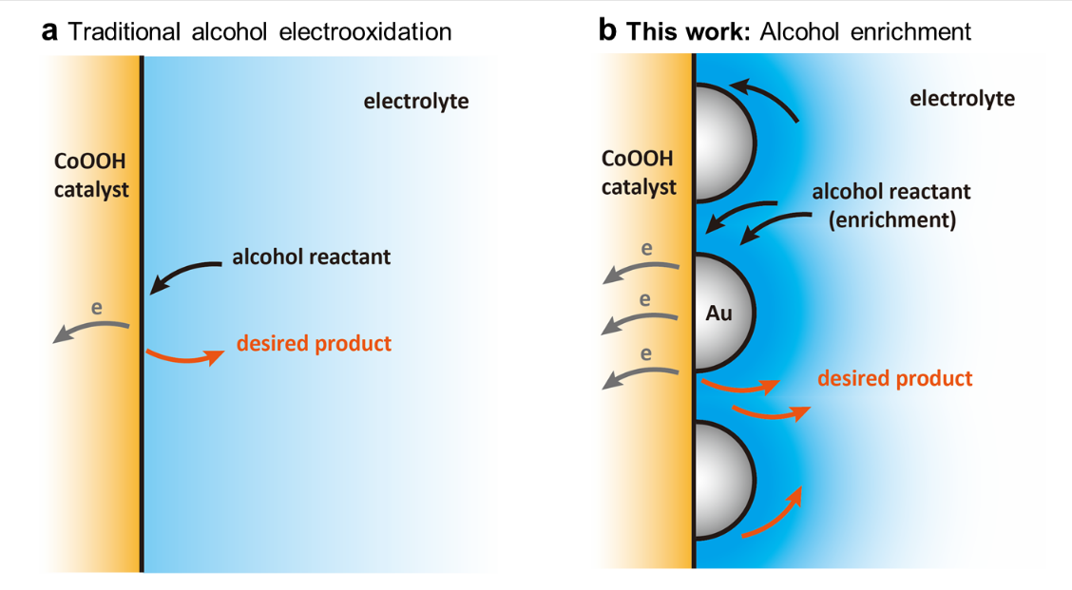
Scheme 1 | Schematic illustration of the alcohol oxidation reactions (AOR) process. a, Traditional AOR process with low alcohol concentration in the vicinity of the CoOOH catalyst at anode. b, Enrichment of alcohols in local environment with enhanced AOR current density over a cooperative Au/CoOOH catalyst.

