Rapid differentiation from human induced pluripotent stem cells into functional oligodendrocytes using synthetic modified Olig2 mRNA
Jian Xu^{1, *}, Rui Wang^{2, *}, Jingxin Zhao¹, Fumei He¹, Yidi Zhang¹, Yuan Xie¹, Lan Shen³, Yichu Nie^{1, 2}, Wenbin Deng^{1, 4}
1 School of Pharmaceutical Science (Shenzhen), Sun Yat-sen University, Shenzhen, 510631, China; 2 Clinical research institute, First People’s Hospital of Foshan, Foshan, 528000, China; 3 Department of pathology, Shenzhen Hospital of Southern Medical University, Shenzhen, 518000, China; 4 Department of Biochemistry and Molecular Medicine, University of California, Davis, Sacramento, CA 95817, USA
* These authors contributed equally to this work

Supplemental Information
Supplemental Tables
Table S1: The concentration and quality of smRNAs
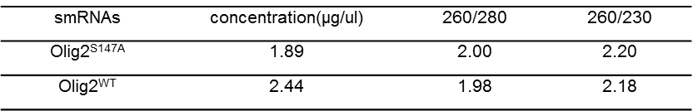
Table S2. Primary antibodies used for immunostainings

Table S3. Sequence of primers for qPCR analysis.
Table S4. Detailed composition of culture medium
 | Media |  | Components |  | Provider |  | Final con.
 | NIM1 |  | DMEM/F12 |  | Life Technologies |  | 50%
 |  |  | Neurobasal |  | Gibco |  | 50%
 |  |  | B27 Supplement (50x) |  | Stem cell technology |  | ECH
 |  |  | N2 Supplement(100x) |  | Stem cell technology |  | 1X
 |  |  | Recombinant hLIF |  | PEPROTech |  | 10ng/ml
 |  |  | SB431542 |  | Med Chem Express |  | 2μM
 |  |  | CHIR99021 |  | Med Chem Express |  | 3μM
 |  |  | GlutaMAX |  | Life Technologies |  | 2mM
 |  |  | Compound E |  | Med Chem Express |  | 0.1 μM
 |  |  | Dorsomorphin |  | Med Chem Express |  | 2μM
NIM2 |  | DMEM/F12 |  | Life Technologies |  | 50%
 |  | Neurobasal |  | Gibco |  | 50%
 |  | B27 Supplement (50x) |  | Stem cell technology |  | 1X
 |  | N2 Supplement(100x) |  | Stem cell technology |  | 1X
 |  | Recombinant hLIF |  | PEPROTech |  | 10ng/ml
 |  | SB431542 |  | Med Chem Express |  | 2μM
 |  | CHIR99021 |  | Med Chem Express |  | 3μM
 |  | GlutaMAX |  | Life Technologies |  | 2mM
 |  | Compound E |  | Med Chem Express |  | 0.1 μM
NSMM |  | DMEM/F12 |  | Life Technologies |  | 50%
 |  | Neurobasal |  | Gibco |  | 50%
 |  | B27 Supplement (50x) |  | Stem cell technology |  | 1X
 |  | N2 Supplement(100x) |  | Stem cell technology |  | 1X
 |  | Recombinant hLIF |  | PEPROTech |  | 10ng/ml
 |  | SB431542 |  | Med Chem Express |  | 2μM
 |  | CHIR99021 |  | Med Chem Express |  | 3μM
 |  | GlutaMAX |  | Life Technologies |  | 2mM

 | GIM | DMEM/F12 | Gibco
 | GIM | B27 supplement lacking vitamin A | Stem cell technologies | 1x
 | GIM | N2 Supplement(100x) | Stem cell technologies | 1X
 | GIM | penicillin/streptomycin | Gibco | 1%
 | GIM | SAG | Med Chem Express | 1μM
 | GIM | PDGF-AA | R&D Systems | 10ng/ml
 | GIM | NT-3 | Millipore | 10ng/ml
 | GIM | IGF-I | R&D Systems | 10ng/ml
 | GIM | AA | Sigma-Aldrich | 200μM
 | GIM | T3 | Sigma-Aldrich | 60ng/ml
DM |  | DMEM/F12 | Gibco
 |  | B27 supplement lacking vitamin A | Stem cell technologies | 1x
 |  | N2 Supplement(100x) | Stem cell technologies | 1X
 |  | penicillin/streptomycin | Gibco | 1%
 |  | NT-3 | Millipore | 10ng/ml
 |  | IGF-I | R&D Systems | 10ng/ml
 |  | AA | Sigma-Aldrich | 200μM
 |  | T3 | Sigma-Aldrich | 60ng/ml
 |  | dbcAMP | Sigma-Aldrich | 100μM

Supplementary Figures

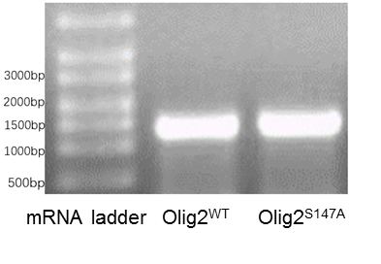
Figure S1 Agarose gel electrophoresis to detect synthetic Olig2WT and Olig2S147A mRNAs.

Figure S2 hiPSC-derived NPCs received one dose (300ng) of eGFP, wild-type Olig2 or mutant Olig2 mRNA transfection or lipid alone as the control. Cells were subjected to CCK8 assay at 24 h and 48h.

Figure S3 Total RNA was isolated after 24 h and 48h to measure markers of the IFN signaling by qPCR assay. Data represents Mean ± SEM (n = 3).

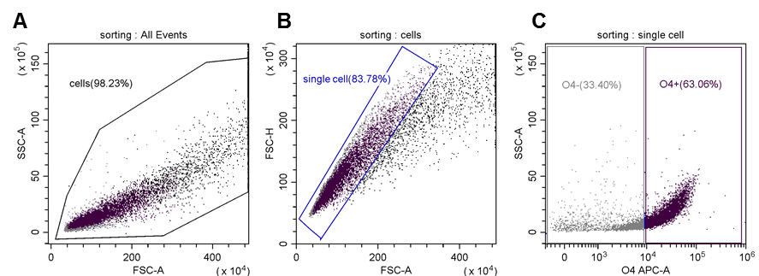
Figure S4: Gating strategy for sorting O4⁺ OPCs for cell transplantation. Single cell gating (B) from total cells (A). C O4⁺ gating. Figure S2 corresponds to Figure 4. Figure (A-C) are representative of 3 independent experiments.

Fig. 1D
tubulin
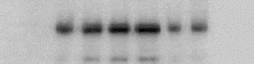Olig2

Fig. 5B
Flag

Fig. 6B
Flag
HSPA8
HSPA9

