Supplementary Materials :

1. Supplement Figure 1: Flow chart Surveillance network and Study sample:
Publicly funded Flemish school-networks:
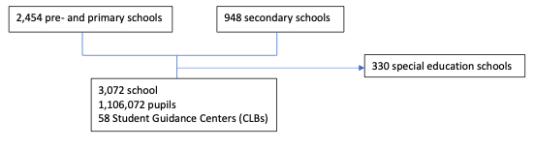

2. Supplement Figure 2:
Ratio reported cases per week per 100,000 relative to grade 7-8
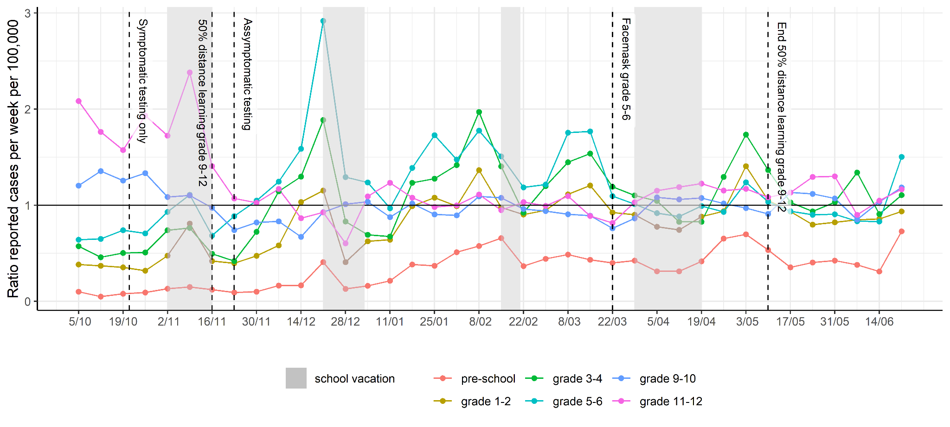

Supplement Figure 3
SARS-CoV-2 test positivity rate adults 19-80 compared to children 6-18 in the community
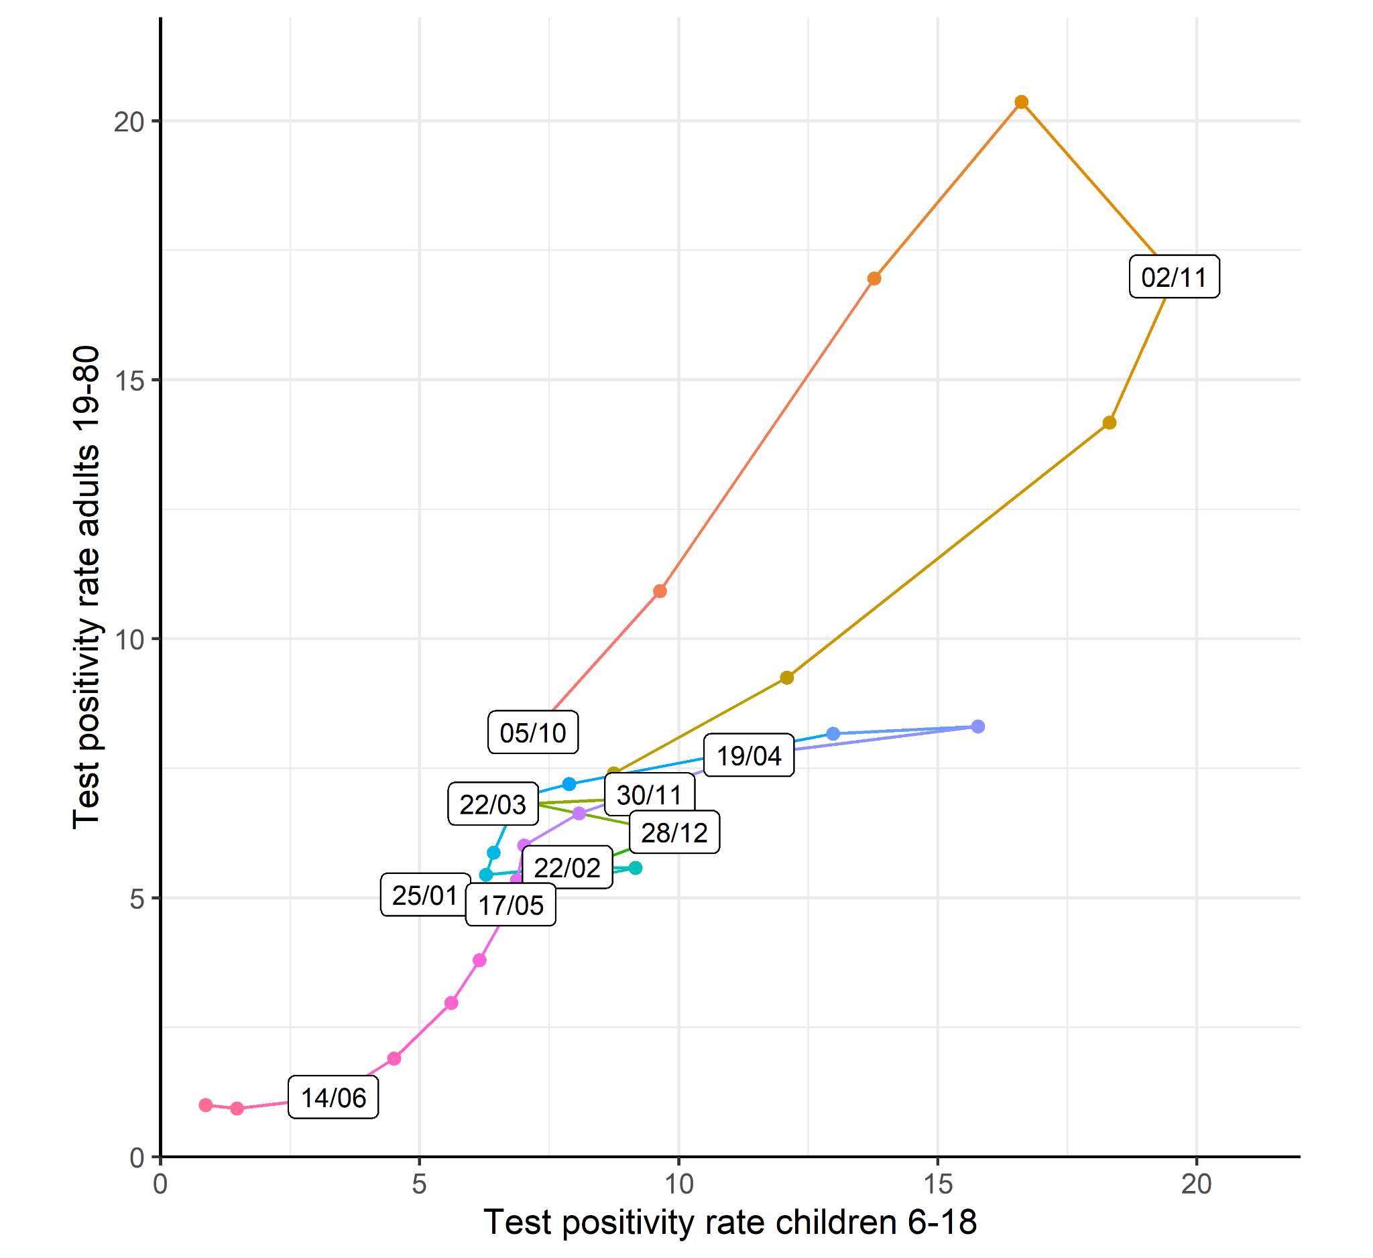

Supplement Figure 4
Moving window ratio cases CLB/Sciensano
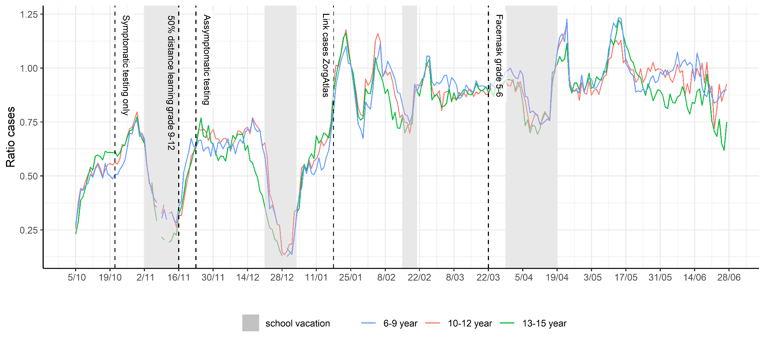
- Supplement Non-Pharmaceutical Infection and Prevention Interventions with relation to the school network - additional details.
Source: Sciencano.

2020-10-23: Special educational activities outside school indoor limited to 40 persons. https://www.premier.be/nl/covid-19-alarmniveau-4-overlegcomit%C3%A9-verstrengt-coronaregels-voor-sport-cultuur-en-hoger-onderwijs
2020-10-28: School excursions forbidden in Brussels Capital. https://www.bruxelles.be/sites/default/files/bxl/Arrete_de_police_bruxellois_-_2020.10.26_-_mesures_COVID_complementaires_.pdf
2020-11-09: School activities outside school are restricted to the minimum for children (exception for sport and swimming), forbidden for adults
2021-02-08: One week online learning for all secondary school children in Flanders. https://onderwijs.vlaanderen.be/nl/nieuws/update-corona-duidelijkheid-over-voorstel-krokusvakantie-en-over-mondmaskers-in-basisonderwijs
2021-03-15: School activities outside school are allowed a maximum of 1 day per week. https://www.info-coronavirus.be/nl/news/occ-0503/
2021-03-15: Vulnerable Children in special needs education and vocational education are allowed 100% in person education.
2021-03-22: Extra school measures agreed by the regions (closure cafeteria, separating classes at playing time, pupils must avoid public transport and exclusion of situations of adult interactions in the school environment. https://www.info-coronavirus.be/nl/news/occ1903/

Procedures Sciensano: https://covid-19.sciensano.be/nl/procedures/contactopvolging-kinderopvang-en-onderwijs

Guidelines education Flemish region:
https://onderwijs.vlaanderen.be/nl/coronavirus/coronavirus-2021-2022

