Supplementary Table 1 Univariate and multivariate analysis of overall survival (OS) in Cox regression analysis.

 |  |  | univariate analysis
 |  |  | OS
 |  | n | HR | 95%CI | P-value
Gender
Male |  | 361 |  |  | 0.006
Female |  | 220 | 0.61 | 0.43-0.87
Age(years)
＜40 |  | 58 |  |  | 0.104
40to<49 |  | 100 | 1.52 | 0.73-3.16
50to<59 |  | 150 | 2.09 | 1.06-4.11
≥60 |  | 273 | 1.48 | 0.76-2.88
T status
T1 |  | 177 |  |  | 0.013
T2 |  | 296 | 1.55 | 1.04-2.32
T3 |  | 66 | 1.63 | 0.93-2.87
T4 |  | 42 | 2.55 | 1.44-4.54
N status
N0 |  | 428 |  |  | ＜0.001
N1 |  | 80 | 1.40 | 0.89-2.21
N2 |  | 69 | 2.88 | 1.96-4.24
N3 |  | 4 | 3.67 | 0.90-14.90
cTNM stage
I |  | 154 |  |  | ＜0.001
II |  | 214 | 1.34 | 0.84-2.14
III |  | 112 | 1.55 | 0.92-2.62
IV |  | 101 | 3.07 | 1.91-4.93
Grade
I |  | 216 |  |  | ＜0.001
II |  | 153 | 2.69 | 1.76-4.12
III |  | 27 | 3.97 | 2.41-6.55
tumor location
buccal |  | 156 |  |  | 0.310
tongue |  | 326 | 0.97 | 0.66-1.41
gingival |  | 99 | 1.32 | 0.83-2.10
TSR
stroma-low |  | 283 |  |  | ＜0.001
stroma-high |  | 298 | 2.76 | 1.94-3.93
 |  |  | multivariate analysis
 |  |  | OS
 |  | n | HR | 95%CI | P-value
Gender
Male |  | 361 |  |  | 0.008
Female |  | 220 | 0.61 | 0.43-0.88
T status
T1 |  | 177 |  |  | 0.650
T2 |  | 296 | 1.47 | 0.66-3.27
T3 |  | 66 | 1.02 | 0.41-2.53
T4 |  | 42 | 1.38 | 0.50-3.80
N status
N0 |  | 428 |  |  | 0.239
N1 |  | 80 | 0.94 | 0.45-1.95
N2 |  | 69 | 1.71 | 0.66-4.45
N3 |  | 4 | 5.71 | 1.00-32.63
cTNM stage
I |  | 154 |  |  | 0.927
II |  | 214 | 0.78 | 0.32-1.94
III |  | 112 | 0.97 | 0.35-2.71
IV |  | 101 | 1.00 | 0.28-3.63
Grade
I |  | 216 |  |  | ＜0.001
II |  | 153 | 2.45 | 1.58-3.80
III |  | 27 | 3.21 | 1.91-5.39
TSR
stroma-low |  | 283 |  |  | ＜0.001
stroma-high |  | 298 | 2.54 | 1.78-3.64
Supplementary Table 2. Overview of the baseline patient and tumor characteristics of the selected patients for Immunohistochemistry.

 |  | Stroma-high | Stroma-low
 | n | n=50 | n=50 | p-value
Gender |  | 50 | 50
Male | 63 | 29 | 34 | 0.3
Female | 37 | 21 | 16
Age(years)
＜40 | 8 | 4 | 4 | 0.871
40to<49 | 17 | 10 | 7
50to<59 | 28 | 14 | 14
≥60 | 47 | 22 | 25
Tstatus
T1 | 35 | 15 | 20 | 0.409
T2 | 44 | 22 | 22
T3 | 10 | 5 | 5
T4 | 11 | 8 | 3
Nstatus
N0 | 66 | 27 | 39 | 0.019
N1 | 16 | 9 | 7
N2 | 16 | 13 | 3
N3 | 2 | 1 | 1
pTNM stage
I | 32 | 14 | 18 | 0.03
II | 26 | 9 | 17
III | 18 | 9 | 9
IV | 24 | 18 | 6
Grade
I | 35 | 9 | 26 | 0.001
II | 48 | 27 | 21
III | 17 | 14 | 3
location tumor
buccal | 28 | 14 | 14 | 0.884
tongue | 58 | 28 | 30
gingival | 14 | 8 | 6

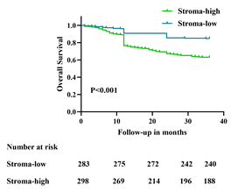
Supplementary Figure 1. Kaplan–Meier curves for overall survival in oral squamous cell carcinoma.

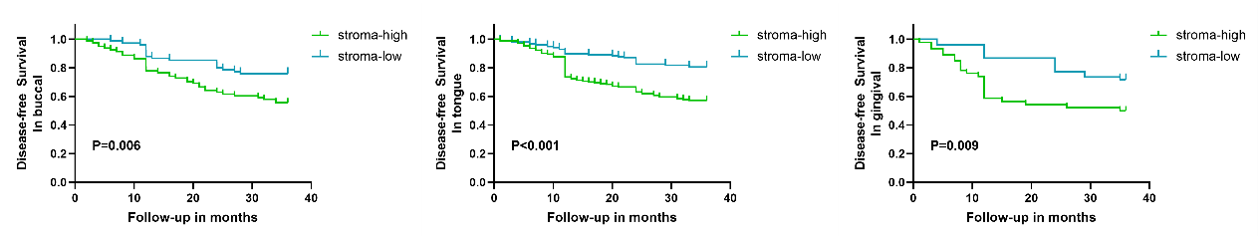
Supplementary Figure 2. Kaplan–Meier curves for disease-free survival in different subgroups (A) Kaplan–Meier curves for oral squamous cell carcinoma in buccal. (B) Kaplan–Meier curves for oral squamous cell carcinoma in tongue. (C) Kaplan–Meier curves for oral squamous cell carcinoma in gingiva.

Supplementary Figure 3. The representative pictures of hematoxylin and eosin stained sections of the selected patients for immunohistochemistry. (a1-c1 original magnification ×10; a2-c2 original magnification ×50; a3-c3, original magnification ×200)

Supplementary Figure 4. The negative controls of the expression of fibroblast activated protein (FAP) and α-smooth muscle actin (a-SMA) and vimentin for immunohistochemistry (IHC). (A) negative staining of FAP. (B) negative staining of a-SMA. (C) negative staining of vimentin. (A-C original magnification ×10)
Supplementary Figure 5. Expression of fibroblast activated protein(FAP) in the tumor cells. High expression of FAP in stroma-low groups compare to the absent expression of FAP in stroma-high group. (a1-b1 original magnification ×10; a2-b2 original magnification ×50; a3-b3, original magnification ×200)

Supplementary Figure 6. Inferior quality slides are difficult to judge the TSR groups. (a1 original magnification ×10; b1 original magnification ×50; c1, original magnification ×200)

